Catchment Rainfall and Reservoir Inflow Relationship (2015–2019)
  - 31 January 2026

Table of Contents
1. Introduction 3
2. Objectives 3
3. Description of Dataset 3
4. Analysis 4
4.1 System storage context (all reservoirs) 4
4.2 Rainfall and inflow time-series behaviour (2017) 5
4.3 Lagged rainfall–inflow correlation (0–14 days) 6
4.4 API calibration (lag = 0 days, missing rainfall treated as 0) 7
4.5 API lead-time analysis (0–14 days) using optimal k 8
4.6 Spatial context: reservoir locations 9
5. Key Findings 10
6. Recommendations 10

Figures
Figure 1 – Total stored water (all reservoirs) versus total usable volume. 4
Figure 2 – 2017 rainfall (catchment) and inflow (streamflow) time series by reservoir (dual y-axis). 5
Figure 3 – Lagged Spearman correlation between rainfall and inflow (rainfall leading, 0–14 days). 6
Figure 4 – API calibration: Spearman correlation versus API decay factor k (lag = 0 days). 7
Figure 5 – API lead-time analysis: Spearman ρ versus lead time (0–14 days) at optimal k. 8
Figure 6 – Reservoir locations derived from the asset register (MGA Zone 55 converted to latitude/longitude). 9

Tables
Table 1 – API calibration summary (optimal k, same-day correlation, and memory time). 7
Table 2 – API lead-time analysis summary at optimal k (selected performance metrics). 9

1. Introduction
This report evaluates the relationship between catchment rainfall and inflow to major Melbourne Water supply reservoirs using daily time-series for 2015–2019. The primary focus is quantifying response timing and persistence using lagged rank correlation and an Antecedent Precipitation Index (API) model, and interpreting implications for short-term inflow predictability and operational planning.

2. Objectives
The objectives of the analysis were to characterise whole-of-system storage behaviour and quantify rainfall–inflow coupling for reservoirs with applicable rainfall and inflow data, including response lags and effective catchment memory.
The specific objectives were:
- Summarise total stored water across all reservoirs relative to combined usable storage.
- Visualise 2017 rainfall and inflow dynamics to qualitatively assess timing and seasonality.
- Quantify lagged rainfall–inflow Spearman correlation for lags 0–14 days (rainfall leading).
- Calibrate an API decay factor (k) to maximise same-day Spearman correlation between inflow and API.
- Assess API-based predictability over 0–14 day lead times and summarise forecast skill.
- Map reservoir locations to support interpretation of spatial rainfall variability and system operations.

3. Description of Dataset
The source dataset is an Excel workbook containing (i) a static asset register for major reservoirs (including usable volume and coordinates) and (ii) daily time-series (2015–2019) for catchment rainfall, streamflow into reservoirs (inflow), and storage volume/percent full. Rainfall and inflow time series were available for Upper Yarra, Thomson, O’Shannassy, and Maroondah. Storage volumes were available for a broader set of service and supply storages and were used to compute total system storage.

4. Analysis

4.1 System storage context (all reservoirs)
Figure 1 summarises total stored water across all reservoirs as a stacked area chart, alongside the summed usable volume. This provides context for the rainfall–inflow relationships by indicating periods of drawdown and refill at a system level.
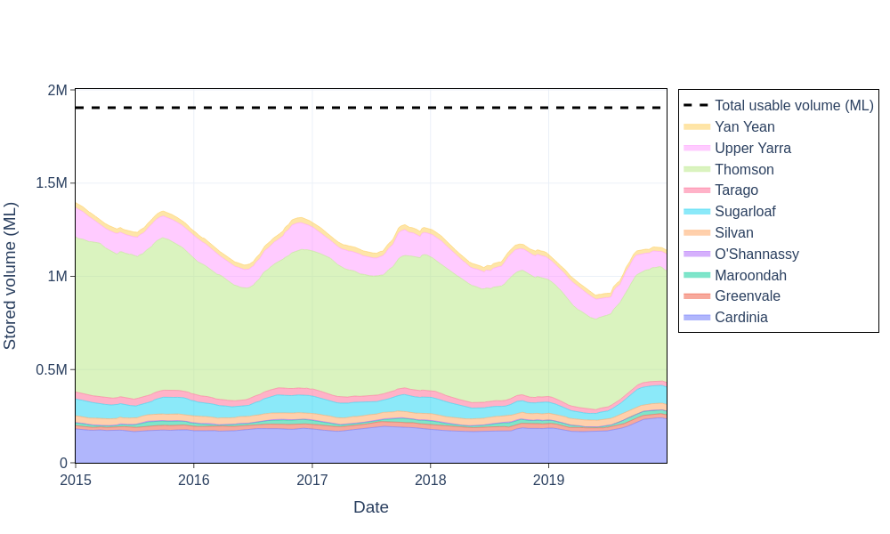
Figure 1 – Total stored water (all reservoirs) versus total usable volume.

Across 2015–2019, total stored water generally remained below combined usable capacity, with a notable drawdown through 2018–2019 before partial recovery late-2019. Storage variability is dominated by Thomson (largest usable volume), with Upper Yarra and Cardinia as secondary contributors. The widening storage-to-capacity gap during 2018–2019 is consistent with reduced catchment yield and/or increased net offtakes during a dry period.

4.2 Rainfall and inflow time-series behaviour (2017)
To examine event timing and seasonal behaviour, Figure 2 presents 2017 daily catchment rainfall (bars) and reservoir inflow (line) using dual y-axes for each of the four catchments with complete rainfall and inflow records.
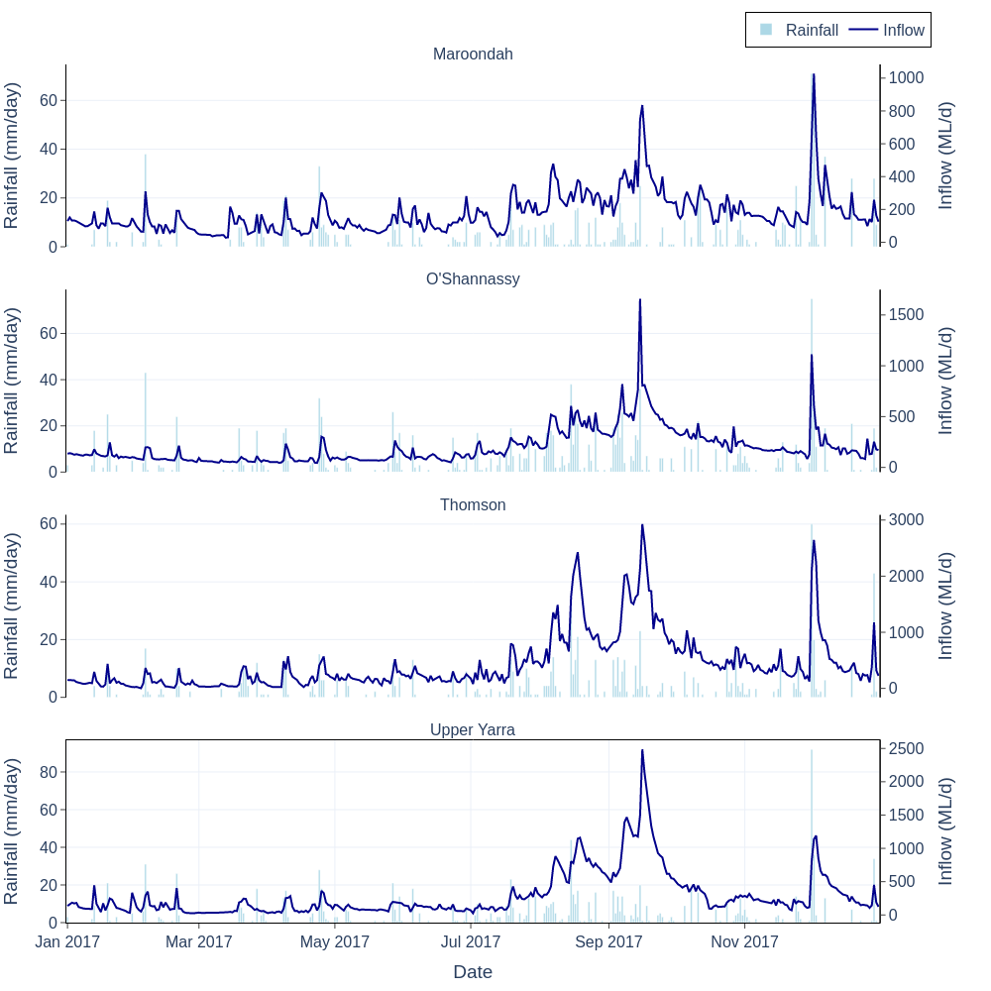
Figure 2 – 2017 rainfall (catchment) and inflow (streamflow) time series by reservoir (dual y-axis).

All catchments show a pronounced wet-season response in late winter to spring (approximately August to October), where frequent rainfall events coincide with sustained elevated inflows. Inflow peaks generally lag rainfall bursts by about 1–3 days, with elevated inflow persisting for weeks during the wet period. This sustained response indicates that baseflow and stored catchment moisture are important controls, rather than a purely event-driven runoff mechanism.

4.3 Lagged rainfall–inflow correlation (0–14 days)
Figure 3 quantifies the rank-based association between daily rainfall and inflow for lags of 0–14 days, where rainfall leads inflow. Spearman correlation is used to reduce sensitivity to non-linearity and extreme events.
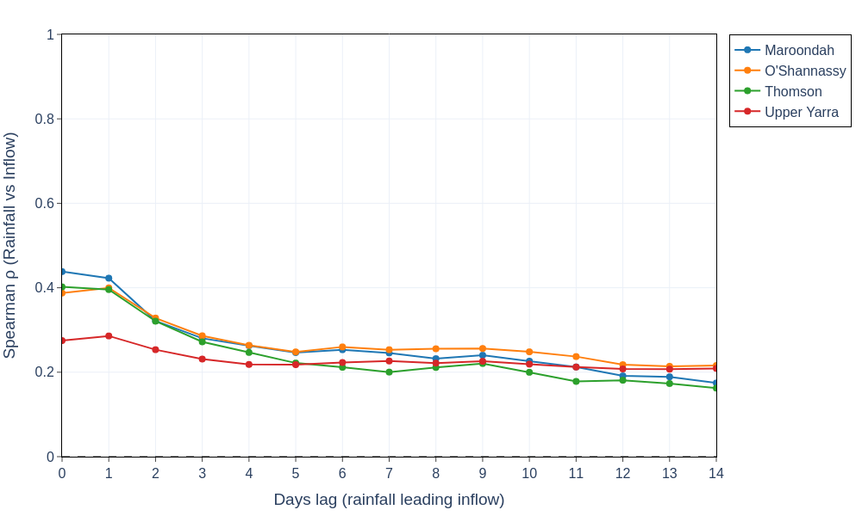
Figure 3 – Lagged Spearman correlation between rainfall and inflow (rainfall leading, 0–14 days).

Raw daily rainfall exhibits only weak-to-moderate correlation with inflow, with peak correlations typically occurring at lag 0–1 days and decaying rapidly thereafter. This behaviour is consistent with the physics of catchment response: inflow reflects both immediate runoff and delayed contributions (soil drainage, groundwater/baseflow), while rainfall is intermittent and spatially heterogeneous. The limited predictive skill of single-day rainfall motivates a state-based index such as API that explicitly represents antecedent wetness.

4.4 API calibration (lag = 0 days, missing rainfall treated as 0)
An Antecedent Precipitation Index (API) was computed for each catchment using a simple exponential decay formulation, treating missing rainfall as zero. The decay factor k was calibrated over 0.85–0.98 (approximately 0.01 steps) to maximise the absolute Spearman correlation between same-day inflow and API.
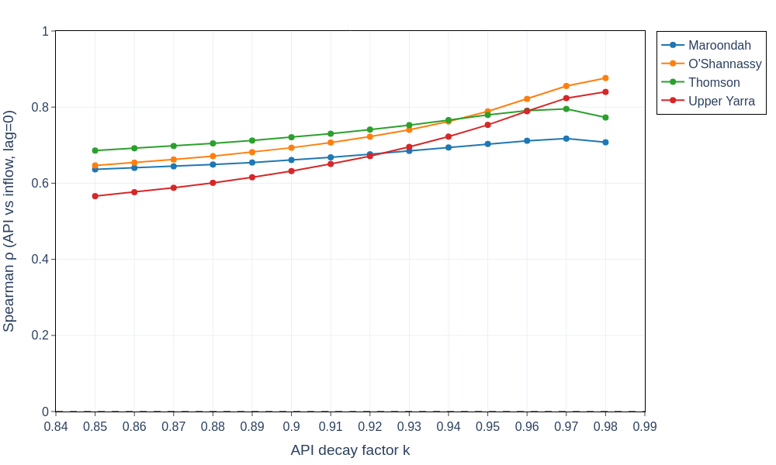
Figure 4 – API calibration: Spearman correlation versus API decay factor k (lag = 0 days).

Figure 4 shows that correlation generally increases as k approaches 0.97–0.98, indicating that inflow is better explained by an index with substantial persistence. In process terms, the catchments behave as systems with significant storage and delayed release, where antecedent wetness sets the efficiency of rainfall-to-runoff transformation.

Table 1 summarises the optimal k, corresponding maximum correlation, and inferred characteristic catchment memory time.
Table 1 – API calibration summary (optimal k, same-day correlation, and memory time).
Reservoir | Optimal k | Spearman ρ (lag 0) | Memory time (days) | n (pairs)
Maroondah | 0.97 | 0.717 | 32.8 | 1,826
O'Shannassy | 0.98 | 0.876 | 49.5 | 1,826
Thomson | 0.97 | 0.795 | 32.8 | 1,826
Upper Yarra | 0.98 | 0.840 | 49.5 | 1,826

The calibrated k values are high (approximately 0.97–0.98), corresponding to characteristic memory times on the order of one to two months. O’Shannassy and Upper Yarra show the longest memory and strongest correlations, consistent with smoother hydrographs and a larger contribution from subsurface storage and baseflow. Maroondah exhibits the lowest peak correlation and shorter memory, indicating a relatively larger share of short-lived variability not captured by a single-parameter API model.

4.5 API lead-time analysis (0–14 days) using optimal k
Using the calibrated decay factors, Figure 5 evaluates how correlation changes when API is used to predict inflow at lead times of 0–14 days. This provides a practical indication of near-term forecast skill attributable to catchment wetness state.
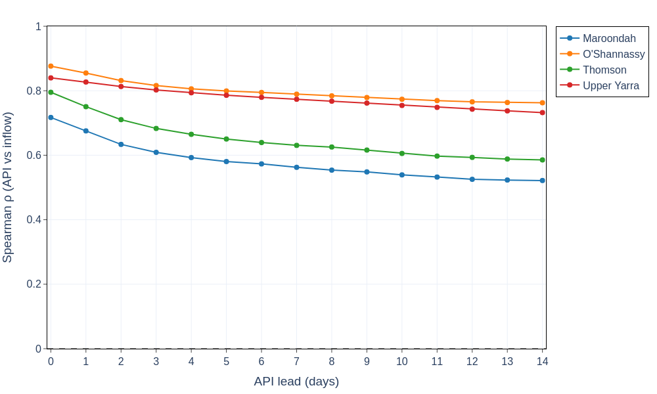
Figure 5 – API lead-time analysis: Spearman ρ versus lead time (0–14 days) at optimal k.

Compared with Figure 3, API-based correlations are substantially higher and decay more gradually with lead time. This indicates that catchment wetness is a strong predictor of inflow persistence. In operational terms, a well-calibrated wetness index can support short-term yield outlooks and risk-based decision-making (e.g., supply planning and contingency triggers) even when event rainfall forecasts are uncertain.

Table 2 summarises key API lead-time performance metrics at the calibrated k values.
Table 2 – API lead-time analysis summary at optimal k (selected performance metrics).
Reservoir | Optimal k | ρ (lag 0) | ρ (lag 14) | Horizon at ρ ≥ 0.75 (days)
Maroondah | 0.97 | 0.717 | 0.522
O'Shannassy | 0.98 | 0.876 | 0.763 | 14
Thomson | 0.97 | 0.795 | 0.585 | 1
Upper Yarra | 0.98 | 0.840 | 0.732 | 10

All catchments achieve maximum correlation at lag 0, indicating that API is most informative for same-day inflow. However, forecast skill differs markedly by catchment. O’Shannassy maintains strong correlation through 14 days, while Upper Yarra maintains high correlation out to approximately 10 days. Thomson decays more quickly, and Maroondah remains below the 0.75 threshold across all lead times, suggesting either greater flashiness, localised rainfall not captured by the catchment average rainfall series, and/or operational or measurement effects.

4.6 Spatial context: reservoir locations
Figure 6 maps reservoir locations based on the asset register coordinates. Spatial separation is relevant because storms can be localised; catchment-average rainfall signals may represent different synoptic regimes across the system, influencing comparative rainfall–inflow behaviour.
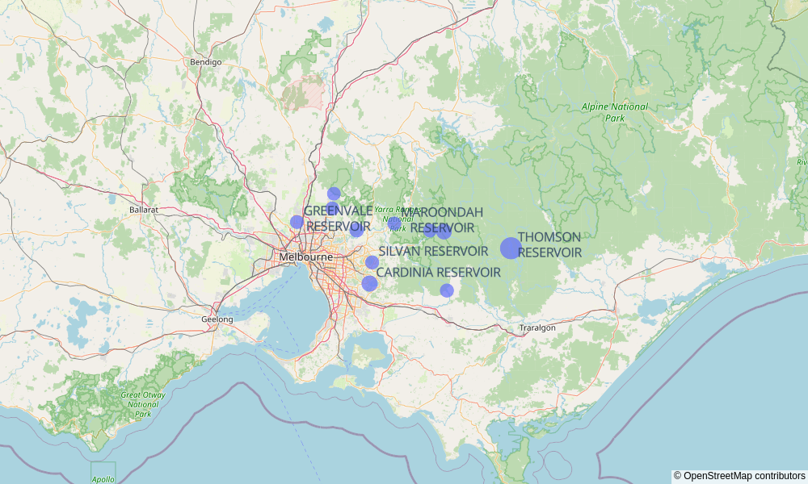
Figure 6 – Reservoir locations derived from the asset register (MGA Zone 55 converted to latitude/longitude).

5. Key Findings
The key findings below synthesise results across Figures 1–6 and Tables 1–2, linking system storage behaviour with catchment response timing and persistence.
- System storage remained below combined usable capacity throughout 2015–2019, with a material drawdown during 2018–2019 largely driven by Thomson (Figure 1).
- 2017 time series show a wet-season regime with sustained inflow elevation beyond individual rainfall events, consistent with catchment wetting-up and baseflow contributions (Figure 2).
- Raw rainfall is a weak predictor of inflow at daily resolution; peak Spearman correlation is modest and largely confined to lag 0–1 days (Figure 3).
- API calibration yields high optimal decay factors (k ≈ 0.97–0.98) and long catchment memory times (~33–49 days), indicating strong dependence on antecedent wetness (Figure 4, Table 1).
- API substantially improves correlation and retains predictive skill to 14 days, particularly for O’Shannassy and Upper Yarra, which exhibit the most persistent behaviour (Figure 5, Table 2).
- Reservoirs are geographically dispersed, supporting the interpretation that spatial rainfall variability and differing catchment characteristics contribute to differences in correlation and persistence (Figure 6).

6. Recommendations
The analyses indicate that a persistent wetness state explains inflow substantially better than raw daily rainfall. The following recommendations support improved operational use and further technical refinement.
- Extend API calibration beyond k = 0.98 (e.g., up to 0.995) for catchments that peaked at the current upper bound (Table 1), to confirm whether longer memory further improves performance.
- Test alternative wetness indices (e.g., multi-store API, soil moisture accounting, or rainfall–runoff models with slow/fast stores) to better capture flashiness in catchments such as Maroondah (Figure 5, Table 2).
- Incorporate seasonality explicitly (e.g., separate calibration for wet/dry seasons or temperature-based evapotranspiration proxies) to account for changing runoff efficiency.
- Evaluate spatial rainfall representation (e.g., multiple gauges, gridded rainfall, or radar products) to reduce mismatch between catchment-average rainfall and true effective precipitation, particularly for localised storm events (Figure 6).
- Assess operational influences and data artefacts (e.g., flow regulation, diversions, measurement timing) where lag-1 rainfall correlation peaks or where event responses appear inconsistent (Figure 3).
- Develop a simple operational forecasting tool using calibrated API with lead-time performance benchmarks (Table 2), complemented by rainfall forecast scenarios for event-driven peaks.

Further analyses that would strengthen confidence include: quantile-based performance (high-flow versus low-flow regimes), event separation analysis to estimate unit hydrograph characteristics, and evaluation of non-stationarity (e.g., 2015–2016 versus 2018–2019) to link storage drawdown periods to shifts in catchment response and yield.

