Wastewater Microbial Indicators and Pathogens: Prevalence, Removal, and Surrogate Assessment
  - 08 February 2026

Table of Contents
1. Introduction 4
2. Objectives 4
3. Description of Dataset 4
4. Analysis 5
4.1 Detection prevalence (influent vs effluent) 5
4.2 Influent and effluent concentration statistics 5
4.3 Log-removal values by plant 6
4.4 Pooled LRV patterns and summary statistics 8
4.5 Surrogate effectiveness: pathogen LRV vs indicator LRV 9
5. Key Findings 12
6. Recommendations 12
Appendix A. Full Tables by Plant 14
Appendix A.1 Detection prevalence (by plant and pooled) 14
Appendix A.2 Concentration statistics (by plant and pooled) 15
Appendix A.3 LRV statistics (by plant and pooled) 17

Figures
Figure 1 – Indicator microorganism LRVs by plant (non-detect and detect effluent markers). 7
Figure 2 – Protozoan parasite LRVs by plant (non-detect and detect effluent markers). 7
Figure 3 – Adenovirus LRVs by plant (non-detect and detect effluent markers). 8
Figure 4 – LRV distribution pooled across plants for all microorganisms. 9
Figure 5 – Event-matched scatter: adenovirus LRV versus indicator LRVs (all plants pooled). 10
Figure 6 – Event-matched scatter: Giardia LRV versus indicator LRVs (all plants pooled). 10
Figure 7 – Event-matched scatter: Cryptosporidium LRV versus indicator LRVs (all plants pooled). 11

Tables
Table 1 – Wastewater treatment plants included in the dataset and their disinfection configurations. 4
Table 2 – Influent detection prevalence (all plants pooled). 5
Table 3 – Effluent detection prevalence (all plants pooled). 5
Table 4 – Influent concentrations summary (all plants pooled; original units). 5
Table 5 – Effluent concentrations summary (all plants pooled; original units). 6
Table 6 – Log-removal value (LRV) summary statistics (all plants pooled; log10). 9
Table 7 – Correlation between indicator LRVs and pathogen LRVs (all plants pooled; matched events). 11
Table 8 – Influent detection prevalence by plant and pooled (all targets). 14
Table 9 – Effluent detection prevalence by plant and pooled (all targets). 14
Table 10 – Influent concentrations summary by plant and pooled (original units). 15
Table 11 – Effluent concentrations summary by plant and pooled (original units). 16
Table 12 – Log-removal value (LRV) summary statistics by plant and pooled (log10). 17

1. Introduction
This report summarizes indicator microorganisms and pathogenic targets measured across three wastewater treatment plants between March 2015 and June 2016. The dataset includes bacterial indicators (total coliform, fecal coliform, E. coli), bacteriophages (somatic and male-specific coliphages), aerobic endospores, protozoan parasites (Giardia and Cryptosporidium), and adenovirus. Results are interpreted in terms of detection prevalence and log-removal values (LRVs) to support treatment performance understanding and surrogate selection for pathogen control.

2. Objectives
The assessment focuses on three questions that directly support process performance evaluation and monitoring strategy development:
- Quantify prevalence of indicator and pathogen detections in influent and effluent across plants.
- Evaluate microbial removal through treatment (LRVs), including plant-to-plant comparisons.
- Assess the extent to which indicator LRVs track pathogen LRVs (surrogate effectiveness) when plants are pooled.

3. Description of Dataset
The source workbook (WWTP_microbial_loads_and_removal.xlsx) contains event-based measurements by plant, sampling month, sample type (influent grab, effluent grab, UF effluent), and microorganism target. Non-detects are represented as BDL or numeric zero; these were treated as method detection limit (MDL) values in the underlying analysis. For protozoa and coliphages, the UF effluent sample was used as the effluent representation; for all other targets, the effluent grab sample was used.
The three plants and their major treatment and disinfection configurations are summarized below to support interpretation of plant-to-plant differences:
Table 1 – Wastewater treatment plants included in the dataset and their disinfection configurations.
Plant (short name) | Plant (full name) | Primary/secondary treatment train | Disinfection
NoWe | Northwest El Paso | Primary clarification, activated sludge, secondary clarification, disc filter microscreens | UV
BiSp | Big Spring | Primary clarification, activated sludge/trickling filter, secondary clarification | Chlorine
BrWo | Brownwood | Primary clarification, activated sludge, secondary clarification | Chlorine

Plant short names used throughout are: NoWe (Northwest El Paso), BiSp (Big Spring), and BrWo (Brownwood).

4. Analysis

4.1 Detection prevalence (influent vs effluent)
Detection prevalence provides a first-pass view of how consistently each target occurs and whether effluent results are frequently censored by the MDL. Tables 2 and 3 summarize pooled detection prevalence across all plants. Full by-plant prevalence tables are provided in the Appendix (Tables 8 and 9).
Table 2 – Influent detection prevalence (all plants pooled).
Microorganism | n | Detections | Prevalence (%)
Adenovirus | 48 | 46 | 95.8
Aerobic endospores | 45 | 45 | 100.0
Cryptosporidium | 47 | 31 | 66.0
E. coli | 45 | 45 | 100.0
Fecal coliform | 45 | 45 | 100.0
Giardia | 47 | 46 | 97.9
Male-specific coliphage | 45 | 45 | 100.0
Somatic coliphage | 44 | 44 | 100.0
Total coliform | 42 | 42 | 100.0

Table 3 – Effluent detection prevalence (all plants pooled).
Microorganism | n | Detections | Prevalence (%)
Adenovirus | 48 | 28 | 58.3
Aerobic endospores | 45 | 45 | 100.0
Cryptosporidium | 47 | 39 | 83.0
E. coli | 44 | 31 | 70.5
Fecal coliform | 44 | 33 | 75.0
Giardia | 47 | 45 | 95.7
Male-specific coliphage | 46 | 5 | 10.9
Somatic coliphage | 46 | 9 | 19.6
Total coliform | 41 | 39 | 95.1

Across all plants, influent detections are near-universal for bacterial indicators and both coliphage groups, whereas influent Cryptosporidium prevalence is materially lower than other targets. In effluent, coliphages show frequent non-detects while aerobic endospores remain consistently detected, indicating persistence through the treatment train and limited sensitivity to disinfection.

4.2 Influent and effluent concentration statistics
Concentration summaries in original units provide context for interpreting LRVs, particularly where effluent values are censored at the MDL. Tables 4 and 5 present pooled influent and effluent statistics. Full by-plant concentration statistics are provided in the Appendix (Tables 10 and 11).
Table 4 – Influent concentrations summary (all plants pooled; original units).
Microorganism | n | Median | Mean | P25 | P75
Adenovirus | 48 | 107 | 4,541 | 17 | 5,819
Aerobic endospores | 45 | 210 | 568 | 110 | 445
Cryptosporidium | 47 | 10 | 269 | 0 | 50
E. coli | 45 | 7,120,000 | 82,054,222 | 4,000,000 | 53,400,000
Fecal coliform | 45 | 17,900,000 | 188,166,444 | 6,200,000 | 137,000,000
Giardia | 47 | 410 | 2,078 | 120 | 2,510
Male-specific coliphage | 45 | 2,310 | 3,003 | 1,060 | 5,000
Somatic coliphage | 44 | 1,430 | 2,174 | 906 | 2,784
Total coliform | 42 | 83,900,000 | 426,861,190 | 25,732,500 | 327,650,000

Table 5 – Effluent concentrations summary (all plants pooled; original units).
Microorganism | n | Median | Mean | P25 | P75
Adenovirus | 48 | 0 | 15 | 0 | 0
Aerobic endospores | 45 | 8 | 19 | 4 | 18
Cryptosporidium | 47 | 0 | 2 | 0 | 1
E. coli | 44 | 2 | 16 | 1 | 9
Fecal coliform | 44 | 7 | 52 | 1 | 46
Giardia | 47 | 4 | 15 | 3 | 20
Male-specific coliphage | 46 | 1 | 6 | 1 | 1
Somatic coliphage | 46 | 1 | 7 | 1 | 1
Total coliform | 41 | 345 | 673 | 68 | 1,120

Pooled results indicate that bacterial indicators occur at very high influent levels (orders of magnitude higher than protozoa and adenovirus). Effluent distributions for coliphages are strongly influenced by MDL censoring (median effluent values at or near the MDL), whereas adenovirus shows evidence of episodic breakthrough in some events (reflected by a high effluent mean relative to the median). These patterns are consistent with strong baseline treatment performance punctuated by event-driven variability that is more apparent for pathogens than for bacterial indicators.

4.3 Log-removal values by plant
Figures 1 to 3 compare LRV distributions by plant, separated into indicator organisms, protozoan parasites, and adenovirus. Markers differentiate events where the effluent was non-detect (MDL-censored) versus detected, which is important for interpreting upper tails that may be driven by substitution at low effluent values.
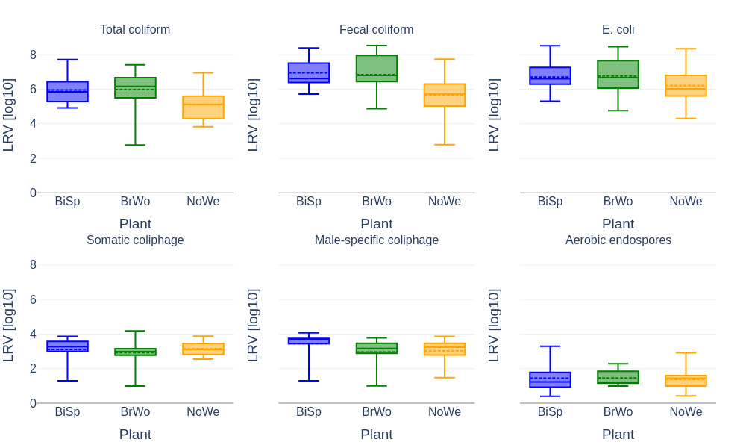
Figure 1 – Indicator microorganism LRVs by plant (non-detect and detect effluent markers).

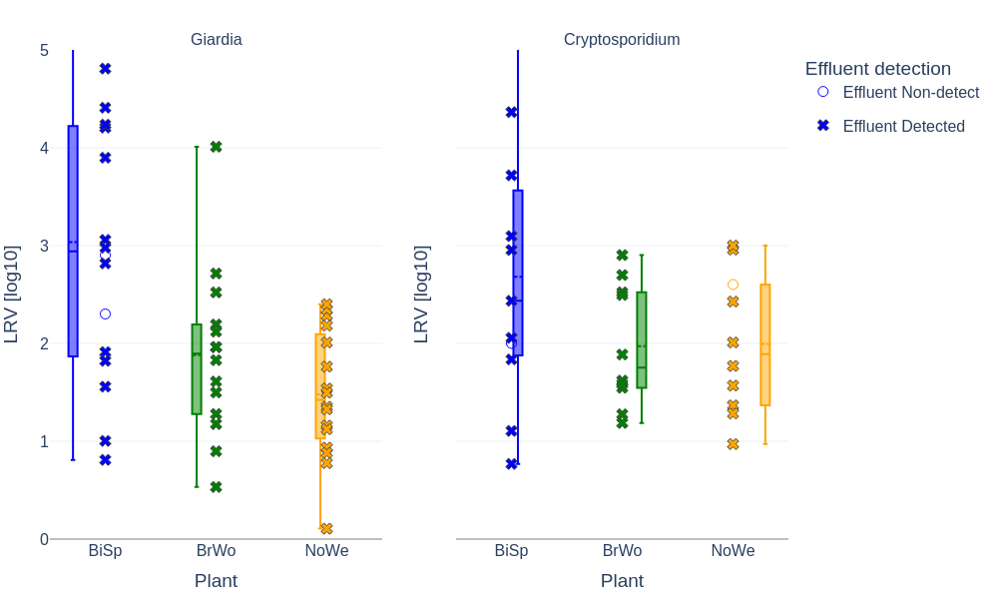
Figure 2 – Protozoan parasite LRVs by plant (non-detect and detect effluent markers).

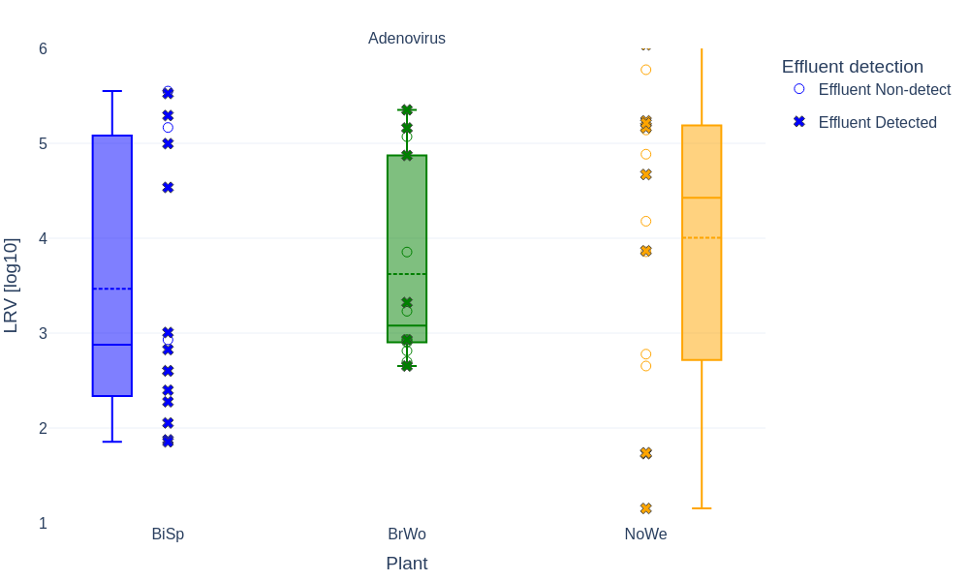
Figure 3 – Adenovirus LRVs by plant (non-detect and detect effluent markers).

Bacterial indicators exhibit consistently high LRVs (typically around 5 to 7 log10), indicating strong reduction through the combined primary and secondary trains and disinfection. In contrast, protozoa show substantially lower and more variable removal, consistent with greater reliance on physical separation and solids/particle capture rather than disinfection. Adenovirus exhibits wide within-plant spread, consistent with disinfection sensitivity and episodic performance excursions.

4.4 Pooled LRV patterns and summary statistics
Figure 4 shows LRVs pooled across plants, highlighting distinct LRV bands by microorganism group. Table 6 summarizes pooled LRV statistics (median, mean, and interquartile range). Full by-plant LRV statistics are provided in the Appendix (Table 12).
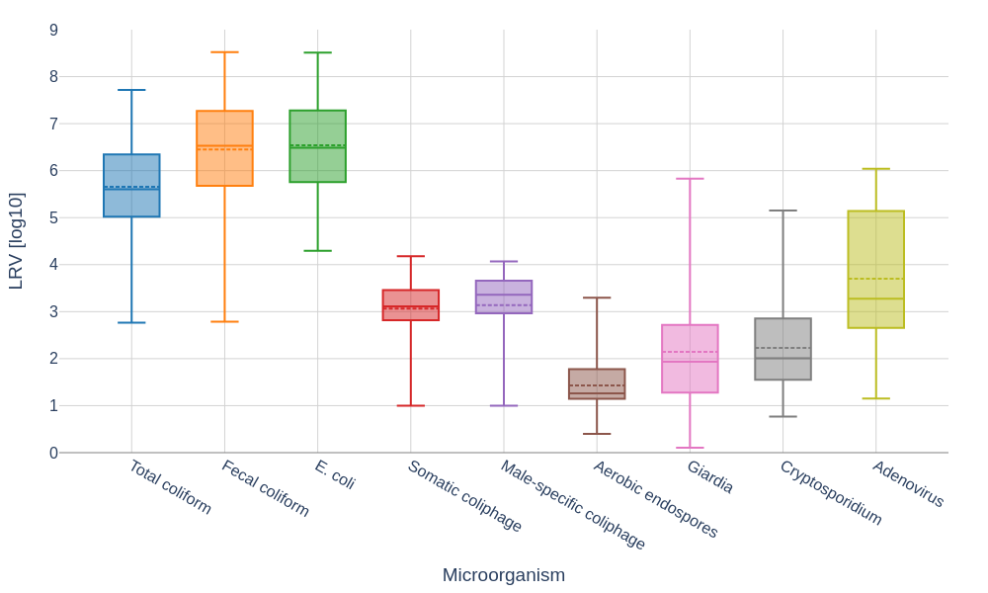
Figure 4 – LRV distribution pooled across plants for all microorganisms.

Table 6 – Log-removal value (LRV) summary statistics (all plants pooled; log10).
Microorganism | n pairs | Median LRV (log10) | Mean LRV (log10) | P25 LRV (log10) | P75 LRV (log10)
Adenovirus | 46 | 3.3 | 3.7 | 2.7 | 5.1
Aerobic endospores | 45 | 1.3 | 1.4 | 1.1 | 1.8
Cryptosporidium | 31 | 2 | 2.2 | 1.6 | 2.8
E. coli | 44 | 6.5 | 6.5 | 5.8 | 7.3
Fecal coliform | 44 | 6.5 | 6.4 | 5.7 | 7.2
Giardia | 46 | 1.9 | 2.1 | 1.3 | 2.7
Male-specific coliphage | 45 | 3.4 | 3.1 | 3 | 3.6
Somatic coliphage | 44 | 3.1 | 3.1 | 2.8 | 3.4
Total coliform | 41 | 5.6 | 5.7 | 5 | 6.3

Pooled LRV patterns indicate that aerobic endospores have the lowest removal among the indicators, consistent with persistence and association with solids. Coliphages occupy an intermediate removal band. Bacterial indicators show the highest LRVs and the most compressed spread, which limits their ability to resolve pathogen removal variability when data are pooled across plants and events.

4.5 Surrogate effectiveness: pathogen LRV vs indicator LRV
Surrogacy was evaluated using event-matched comparisons of pathogen LRVs versus indicator LRVs with all plants pooled. Figures 5 to 7 show scatter plots for adenovirus, Giardia, and Cryptosporidium, respectively. Table 7 summarizes Spearman and Pearson correlations for the same matched datasets.
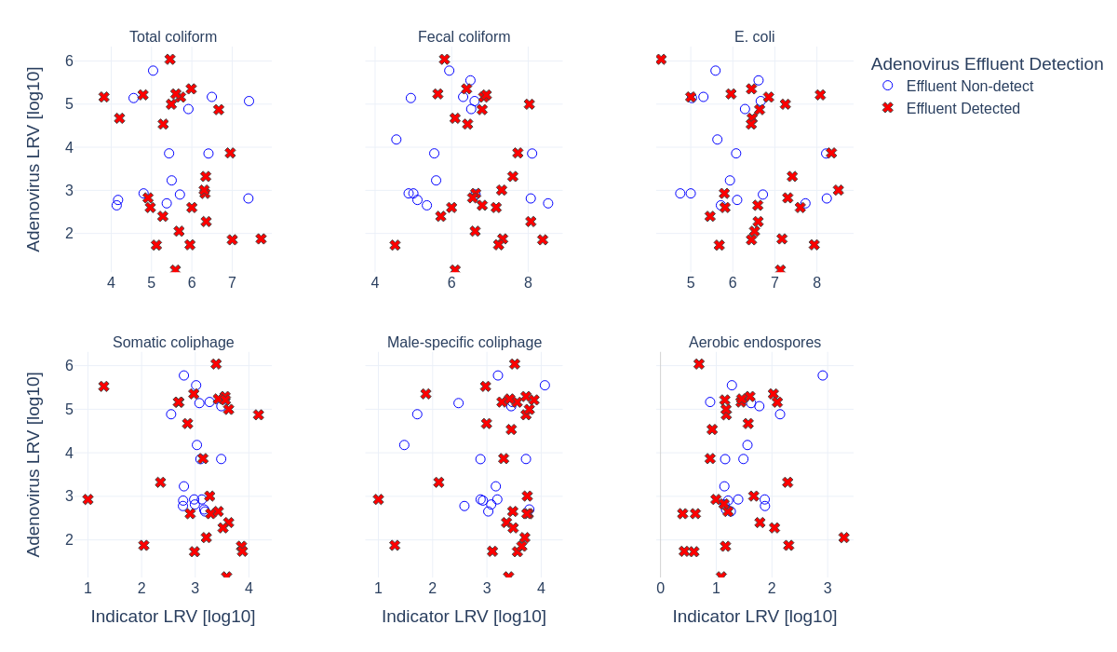
Figure 5 – Event-matched scatter: adenovirus LRV versus indicator LRVs (all plants pooled).

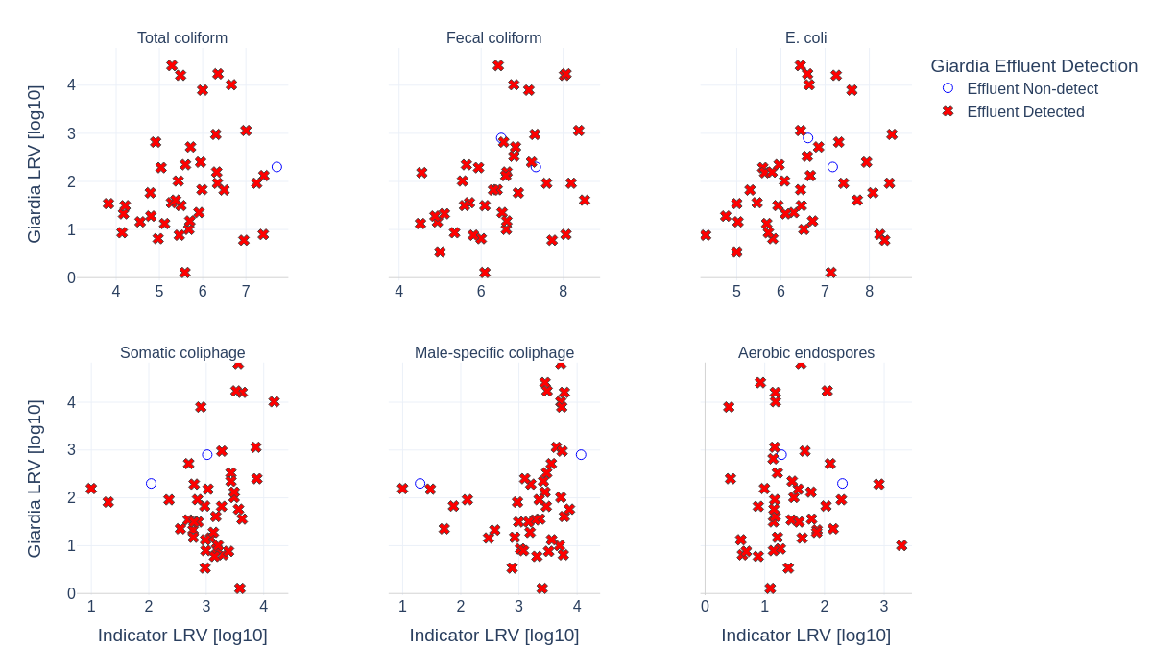
Figure 6 – Event-matched scatter: Giardia LRV versus indicator LRVs (all plants pooled).

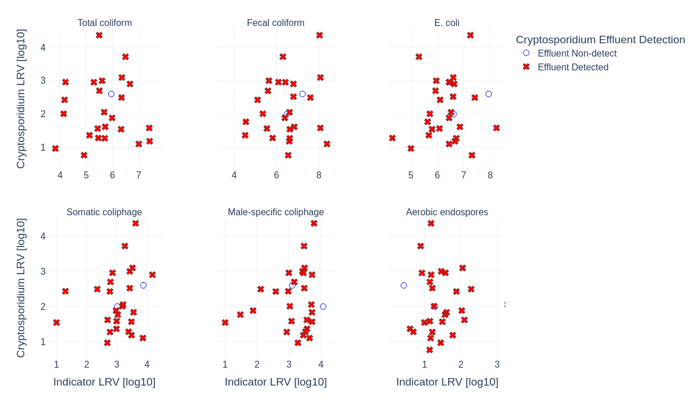
Figure 7 – Event-matched scatter: Cryptosporidium LRV versus indicator LRVs (all plants pooled).

Table 7 – Correlation between indicator LRVs and pathogen LRVs (all plants pooled; matched events).
Pathogen | Indicator | n pairs | Spearman ρ | Pearson r
Adenovirus | Aerobic endospores | 44 | 0.187 | 0.125
Adenovirus | E. coli | 43 | -0.202 | -0.238
Adenovirus | Fecal coliform | 43 | -0.201 | -0.189
Adenovirus | Male-specific coliphage | 44 | 0.026 | 0.055
Adenovirus | Somatic coliphage | 43 | -0.158 | -0.067
Adenovirus | Total coliform | 40 | -0.085 | -0.095
Cryptosporidium | Aerobic endospores | 29 | 0.071 | -0.008
Cryptosporidium | E. coli | 28 | 0.077 | 0.142
Cryptosporidium | Fecal coliform | 28 | 0.144 | 0.283
Cryptosporidium | Male-specific coliphage | 29 | 0.068 | 0.155
Cryptosporidium | Somatic coliphage | 28 | 0.231 | 0.186
Cryptosporidium | Total coliform | 25 | 0.068 | 0.01
Giardia | Aerobic endospores | 44 | 0.093 | -0.023
Giardia | E. coli | 43 | 0.312 | 0.263
Giardia | Fecal coliform | 43 | 0.426 | 0.392
Giardia | Male-specific coliphage | 44 | 0.32 | 0.219
Giardia | Somatic coliphage | 43 | 0.205 | 0.202
Giardia | Total coliform | 40 | 0.365 | 0.305

When pooled across plants, surrogate relationships are generally weak. Bacterial indicator LRVs are consistently high and compressed, producing vertical point clouds against pathogen LRVs that vary more widely. Coliphages provide more spread in indicator LRV but still show substantial pathogen variability at similar coliphage LRV. These results support using indicators primarily for operational verification within a defined treatment context, rather than as stand-alone predictors of virus or protozoa removal across different plants and configurations.

5. Key Findings
Key findings are summarized below, integrating pooled detection prevalence (Tables 2 and 3), pooled concentration context (Tables 4 and 5), removal performance (Figure 4 and Table 6), and surrogate analyses (Figures 5 to 7 and Table 7).
- Influent detections were near-universal for bacterial indicators and coliphages, while Cryptosporidium influent prevalence was materially lower than other targets (Table 2).
- Effluent detections differed strongly by organism group: aerobic endospores remained detected in essentially all effluents, while coliphages were frequently non-detect, indicating strong reduction and/or MDL censoring (Table 3).
- Bacterial indicators achieved the highest LRVs overall (typically around 5 to 7 log10), demonstrating robust removal of bacterial targets, but with limited ability to resolve event-to-event pathogen variability (Figure 4 and Table 6).
- Protozoan removal (Giardia and Cryptosporidium) was substantially lower than bacterial indicators, indicating that fecal indicator LRVs overstate protozoa removal performance when used as surrogates (Figure 4 and Table 6).
- Adenovirus removal showed high variability relative to indicators, consistent with disinfection sensitivity and episodic performance excursions (Figure 4).
- Correlations between indicator LRVs and pathogen LRVs were generally weak when pooled across plants, indicating limited surrogate performance without additional process context (Table 7).

6. Recommendations
Recommendations are provided to strengthen performance assessment and improve the practical use of indicators for operational control and risk-based decision-making across the three plants.
- Maintain direct pathogen monitoring for protozoa and viruses where risk targets depend on these organisms; bacterial fecal indicators alone are not sufficient to infer protozoa or adenovirus removal across different treatment trains (Figures 5 to 7 and Table 7).
- Use coliphages as a potential intermediate indicator where viral surrogacy is desired, but validate performance relationships within each plant and treatment configuration rather than relying on pooled relationships (Table 7).
- For plants with disinfection-driven variability in virus removal, prioritize verification of disinfection performance during low-LRV events (e.g., UV dose delivery and UV transmittance for UV systems; disinfectant residual and contact time for chlorine systems), and link microbial excursions to operational records where possible.
- For protozoa control, focus on unit processes responsible for physical removal and particle capture (e.g., clarification, filtration/microscreens). Where available, add complementary surrogates tied to physical removal (turbidity, particle counts, TSS, filter headloss) to support mechanistic interpretation of protozoa LRV variability.
- Further analyses recommended: (1) plant-specific surrogate assessments (correlations and conditional performance) rather than pooled; (2) seasonal/monthly stratification to identify weather- or temperature-linked performance changes; (3) censoring-aware statistics for MDL-heavy targets such as coliphages; and (4) event-based investigations linking low LRVs to operational changes, hydraulics, and unit process performance.

Appendix A. Full Tables by Plant
This appendix provides the full by-plant tables that underpin the pooled summaries presented in the main body of the report.

Appendix A.1 Detection prevalence (by plant and pooled)
Tables 8 and 9 provide influent and effluent detection prevalence by plant and pooled across all plants.
Table 8 – Influent detection prevalence by plant and pooled (all targets).
Plant | Microorganism | n | Detections | Prevalence (%)
BiSp | Adenovirus | 16 | 16 | 100.0
BiSp | Aerobic endospores | 14 | 14 | 100.0
BiSp | Cryptosporidium | 16 | 11 | 68.8
BiSp | E. coli | 14 | 14 | 100.0
BiSp | Fecal coliform | 14 | 14 | 100.0
BiSp | Giardia | 16 | 16 | 100.0
BiSp | Male-specific coliphage | 14 | 14 | 100.0
BiSp | Somatic coliphage | 13 | 13 | 100.0
BiSp | Total coliform | 13 | 13 | 100.0
BrWo | Adenovirus | 16 | 14 | 87.5
BrWo | Aerobic endospores | 15 | 15 | 100.0
BrWo | Cryptosporidium | 15 | 10 | 66.7
BrWo | E. coli | 15 | 15 | 100.0
BrWo | Fecal coliform | 15 | 15 | 100.0
BrWo | Giardia | 15 | 14 | 93.3
BrWo | Male-specific coliphage | 15 | 15 | 100.0
BrWo | Somatic coliphage | 15 | 15 | 100.0
BrWo | Total coliform | 14 | 14 | 100.0
NoWe | Adenovirus | 16 | 16 | 100.0
NoWe | Aerobic endospores | 16 | 16 | 100.0
NoWe | Cryptosporidium | 16 | 10 | 62.5
NoWe | E. coli | 16 | 16 | 100.0
NoWe | Fecal coliform | 16 | 16 | 100.0
NoWe | Giardia | 16 | 16 | 100.0
NoWe | Male-specific coliphage | 16 | 16 | 100.0
NoWe | Somatic coliphage | 16 | 16 | 100.0
NoWe | Total coliform | 15 | 15 | 100.0
All plants pooled | Adenovirus | 48 | 46 | 95.8
All plants pooled | Aerobic endospores | 45 | 45 | 100.0
All plants pooled | Cryptosporidium | 47 | 31 | 66.0
All plants pooled | E. coli | 45 | 45 | 100.0
All plants pooled | Fecal coliform | 45 | 45 | 100.0
All plants pooled | Giardia | 47 | 46 | 97.9
All plants pooled | Male-specific coliphage | 45 | 45 | 100.0
All plants pooled | Somatic coliphage | 44 | 44 | 100.0
All plants pooled | Total coliform | 42 | 42 | 100.0

Table 9 – Effluent detection prevalence by plant and pooled (all targets).
Plant | Microorganism | n | Detections | Prevalence (%)
BiSp | Adenovirus | 16 | 13 | 81.2
BiSp | Aerobic endospores | 14 | 14 | 100.0
BiSp | Cryptosporidium | 16 | 12 | 75.0
BiSp | E. coli | 13 | 8 | 61.5
BiSp | Fecal coliform | 13 | 10 | 76.9
BiSp | Giardia | 16 | 14 | 87.5
BiSp | Male-specific coliphage | 15 | 1 | 6.7
BiSp | Somatic coliphage | 15 | 2 | 13.3
BiSp | Total coliform | 12 | 11 | 91.7
BrWo | Adenovirus | 16 | 6 | 37.5
BrWo | Aerobic endospores | 15 | 15 | 100.0
BrWo | Cryptosporidium | 15 | 14 | 93.3
BrWo | E. coli | 15 | 7 | 46.7
BrWo | Fecal coliform | 15 | 7 | 46.7
BrWo | Giardia | 15 | 15 | 100.0
BrWo | Male-specific coliphage | 15 | 1 | 6.7
BrWo | Somatic coliphage | 15 | 2 | 13.3
BrWo | Total coliform | 14 | 13 | 92.9
NoWe | Adenovirus | 16 | 9 | 56.2
NoWe | Aerobic endospores | 16 | 16 | 100.0
NoWe | Cryptosporidium | 16 | 13 | 81.2
NoWe | E. coli | 16 | 16 | 100.0
NoWe | Fecal coliform | 16 | 16 | 100.0
NoWe | Giardia | 16 | 16 | 100.0
NoWe | Male-specific coliphage | 16 | 3 | 18.8
NoWe | Somatic coliphage | 16 | 5 | 31.2
NoWe | Total coliform | 15 | 15 | 100.0
All plants pooled | Adenovirus | 48 | 28 | 58.3
All plants pooled | Aerobic endospores | 45 | 45 | 100.0
All plants pooled | Cryptosporidium | 47 | 39 | 83.0
All plants pooled | E. coli | 44 | 31 | 70.5
All plants pooled | Fecal coliform | 44 | 33 | 75.0
All plants pooled | Giardia | 47 | 45 | 95.7
All plants pooled | Male-specific coliphage | 46 | 5 | 10.9
All plants pooled | Somatic coliphage | 46 | 9 | 19.6
All plants pooled | Total coliform | 41 | 39 | 95.1

Appendix A.2 Concentration statistics (by plant and pooled)
Tables 10 and 11 provide combined concentration statistics (median, mean, and interquartile range) for influent and effluent, by plant and pooled.
Table 10 – Influent concentrations summary by plant and pooled (original units).
Plant | Microorganism | n | Median | Mean | P25 | P75
BiSp | Adenovirus | 16 | 64 | 3,047 | 16 | 6,087
BiSp | Aerobic endospores | 14 | 158 | 629 | 88 | 391
BiSp | Cryptosporidium | 16 | 40 | 736 | 0 | 1,182
BiSp | E. coli | 14 | 9,530,000 | 95,076,429 | 3,085,000 | 45,125,000
BiSp | Fecal coliform | 14 | 23,750,000 | 179,161,429 | 7,400,000 | 238,750,000
BiSp | Giardia | 16 | 2,400 | 4,576 | 198 | 6,958
BiSp | Male-specific coliphage | 14 | 5,125 | 4,985 | 2,975 | 5,738
BiSp | Somatic coliphage | 13 | 1,865 | 2,548 | 1,300 | 3,600
BiSp | Total coliform | 13 | 145,000,000 | 631,692,308 | 47,100,000 | 461,100,000
BrWo | Adenovirus | 16 | 18 | 904 | 15 | 479
BrWo | Aerobic endospores | 15 | 265 | 709 | 98 | 1,075
BrWo | Cryptosporidium | 15 | 10 | 21 | 0 | 20
BrWo | E. coli | 15 | 5,200,000 | 49,584,667 | 3,355,000 | 39,715,000
BrWo | Fecal coliform | 15 | 8,500,000 | 106,242,667 | 5,130,000 | 83,340,000
BrWo | Giardia | 15 | 410 | 971 | 105 | 1,245
BrWo | Male-specific coliphage | 15 | 1,555 | 2,135 | 805 | 2,902
BrWo | Somatic coliphage | 15 | 985 | 2,171 | 660 | 1,780
BrWo | Total coliform | 14 | 32,550,000 | 261,225,714 | 19,337,500 | 180,675,000
NoWe | Adenovirus | 16 | 3,025 | 9,672 | 262 | 11,471
NoWe | Aerobic endospores | 16 | 218 | 383 | 140 | 310
NoWe | Cryptosporidium | 16 | 10 | 35 | 0 | 50
NoWe | E. coli | 16 | 9,850,000 | 101,100,000 | 4,737,500 | 59,202,500
NoWe | Fecal coliform | 16 | 19,850,000 | 272,849,375 | 6,035,000 | 124,175,000
NoWe | Giardia | 16 | 270 | 619 | 150 | 658
NoWe | Male-specific coliphage | 16 | 1,432 | 2,082 | 835 | 2,789
NoWe | Somatic coliphage | 16 | 1,458 | 1,873 | 908 | 2,784
NoWe | Total coliform | 15 | 101,700,000 | 403,934,000 | 21,100,000 | 318,600,000
All plants pooled | Adenovirus | 48 | 107 | 4,541 | 17 | 5,819
All plants pooled | Aerobic endospores | 45 | 210 | 568 | 110 | 445
All plants pooled | Cryptosporidium | 47 | 10 | 269 | 0 | 50
All plants pooled | E. coli | 45 | 7,120,000 | 82,054,222 | 4,000,000 | 53,400,000
All plants pooled | Fecal coliform | 45 | 17,900,000 | 188,166,444 | 6,200,000 | 137,000,000
All plants pooled | Giardia | 47 | 410 | 2,078 | 120 | 2,510
All plants pooled | Male-specific coliphage | 45 | 2,310 | 3,003 | 1,060 | 5,000
All plants pooled | Somatic coliphage | 44 | 1,430 | 2,174 | 906 | 2,784
All plants pooled | Total coliform | 42 | 83,900,000 | 426,861,190 | 25,732,500 | 327,650,000

Table 11 – Effluent concentrations summary by plant and pooled (original units).
Plant | Microorganism | n | Median | Mean | P25 | P75
BiSp | Adenovirus | 16 | 0 | 0 | 0 | 0
BiSp | Aerobic endospores | 14 | 7 | 24 | 3 | 11
BiSp | Cryptosporidium | 16 | 0 | 4 | 0 | 2
BiSp | E. coli | 13 | 1 | 22 | 1 | 4
BiSp | Fecal coliform | 13 | 3 | 18 | 1 | 15
BiSp | Giardia | 16 | 1 | 7 | 0 | 4
BiSp | Male-specific coliphage | 15 | 1 | 2 | 1 | 1
BiSp | Somatic coliphage | 15 | 1 | 5 | 1 | 1
BiSp | Total coliform | 12 | 406 | 853 | 132 | 1,446
BrWo | Adenovirus | 16 | 0 | 0 | 0 | 0
BrWo | Aerobic endospores | 15 | 9 | 19 | 6 | 18
BrWo | Cryptosporidium | 15 | 0 | 0 | 0 | 1
BrWo | E. coli | 15 | 1 | 14 | 1 | 1
BrWo | Fecal coliform | 15 | 1 | 18 | 1 | 3
BrWo | Giardia | 15 | 5 | 17 | 3 | 17
BrWo | Male-specific coliphage | 15 | 1 | 16 | 1 | 1
BrWo | Somatic coliphage | 15 | 1 | 15 | 1 | 1
BrWo | Total coliform | 14 | 61 | 208 | 14 | 92
NoWe | Adenovirus | 16 | 0 | 45 | 0 | 0
NoWe | Aerobic endospores | 16 | 9 | 16 | 5 | 20
NoWe | Cryptosporidium | 16 | 0 | 1 | 0 | 1
NoWe | E. coli | 16 | 9 | 14 | 4 | 15
NoWe | Fecal coliform | 16 | 49 | 113 | 27 | 122
NoWe | Giardia | 16 | 10 | 20 | 4 | 24
NoWe | Male-specific coliphage | 16 | 1 | 2 | 1 | 1
NoWe | Somatic coliphage | 16 | 1 | 1 | 1 | 1
NoWe | Total coliform | 15 | 816 | 963 | 500 | 1,120
All plants pooled | Adenovirus | 48 | 0 | 15 | 0 | 0
All plants pooled | Aerobic endospores | 45 | 8 | 19 | 4 | 18
All plants pooled | Cryptosporidium | 47 | 0 | 2 | 0 | 1
All plants pooled | E. coli | 44 | 2 | 16 | 1 | 9
All plants pooled | Fecal coliform | 44 | 7 | 52 | 1 | 46
All plants pooled | Giardia | 47 | 4 | 15 | 3 | 20
All plants pooled | Male-specific coliphage | 46 | 1 | 6 | 1 | 1
All plants pooled | Somatic coliphage | 46 | 1 | 7 | 1 | 1
All plants pooled | Total coliform | 41 | 345 | 673 | 68 | 1,120

Appendix A.3 LRV statistics (by plant and pooled)
Table 12 provides combined LRV summary statistics (median, mean, and interquartile range) by plant and pooled across all plants.
Table 12 – Log-removal value (LRV) summary statistics by plant and pooled (log10).
Plant | Microorganism | n pairs | Median LRV (log10) | Mean LRV (log10) | P25 LRV (log10) | P75 LRV (log10)
BiSp | Adenovirus | 16 | 2.9 | 3.5 | 2.4 | 5
BiSp | Aerobic endospores | 14 | 1.2 | 1.5 | 1 | 1.8
BiSp | Cryptosporidium | 11 | 2.4 | 2.7 | 1.9 | 3.4
BiSp | E. coli | 13 | 6.6 | 6.7 | 6.4 | 7.3
BiSp | Fecal coliform | 13 | 6.6 | 7 | 6.4 | 7.3
BiSp | Giardia | 16 | 2.9 | 3 | 1.9 | 4.2
BiSp | Male-specific coliphage | 14 | 3.7 | 3.4 | 3.5 | 3.7
BiSp | Somatic coliphage | 13 | 3.3 | 3.1 | 3 | 3.6
BiSp | Total coliform | 12 | 5.8 | 6 | 5.3 | 6.4
BrWo | Adenovirus | 14 | 3.1 | 3.6 | 2.9 | 4.6
BrWo | Aerobic endospores | 15 | 1.2 | 1.5 | 1.2 | 1.8
BrWo | Cryptosporidium | 10 | 1.8 | 2 | 1.6 | 2.5
BrWo | E. coli | 15 | 6.7 | 6.8 | 6.2 | 7.6
BrWo | Fecal coliform | 15 | 6.8 | 6.8 | 6.5 | 7.8
BrWo | Giardia | 14 | 1.9 | 1.9 | 1.3 | 2.2
BrWo | Male-specific coliphage | 15 | 3.2 | 3 | 2.9 | 3.5
BrWo | Somatic coliphage | 15 | 3 | 2.9 | 2.8 | 3.1
BrWo | Total coliform | 14 | 6.2 | 6 | 5.6 | 6.6
NoWe | Adenovirus | 16 | 4.4 | 4 | 2.7 | 5.2
NoWe | Aerobic endospores | 16 | 1.5 | 1.4 | 1 | 1.6
NoWe | Cryptosporidium | 10 | 1.9 | 2 | 1.4 | 2.6
NoWe | E. coli | 16 | 6 | 6.2 | 5.6 | 6.6
NoWe | Fecal coliform | 16 | 5.7 | 5.7 | 5.1 | 6.2
NoWe | Giardia | 16 | 1.4 | 1.5 | 1.1 | 2.1
NoWe | Male-specific coliphage | 16 | 3.2 | 3 | 2.9 | 3.4
NoWe | Somatic coliphage | 16 | 3.1 | 3.2 | 2.8 | 3.4
NoWe | Total coliform | 15 | 5.1 | 5.1 | 4.4 | 5.6
All plants pooled | Adenovirus | 46 | 3.3 | 3.7 | 2.7 | 5.1
All plants pooled | Aerobic endospores | 45 | 1.3 | 1.4 | 1.1 | 1.8
All plants pooled | Cryptosporidium | 31 | 2 | 2.2 | 1.6 | 2.8
All plants pooled | E. coli | 44 | 6.5 | 6.5 | 5.8 | 7.3
All plants pooled | Fecal coliform | 44 | 6.5 | 6.4 | 5.7 | 7.2
All plants pooled | Giardia | 46 | 1.9 | 2.1 | 1.3 | 2.7
All plants pooled | Male-specific coliphage | 45 | 3.4 | 3.1 | 3 | 3.6
All plants pooled | Somatic coliphage | 44 | 3.1 | 3.1 | 2.8 | 3.4
All plants pooled | Total coliform | 41 | 5.6 | 5.7 | 5 | 6.3

