Eastern Treatment Plant Discharge Compliance Assessment 2014–2018
  - 26 November 2025

Table of Contents
1 Introduction 3
2 Objectives 3
3 Description of Dataset 3
4 Analysis 3
4.1 Discharge Flow Compliance 3
4.2 Effluent Ammonia Compliance 4
4.3 Effluent BOD Compliance 6
4.4 Integrated Performance and Process Interpretation 8
4.5 Data Quality Considerations 8
4.6 Further Analysis Opportunities 8
5 Key Findings 8
6 Recommendations 9

Figures
Figure 1 – Daily influent flow to the Eastern Treatment Plant (2014–2018) with the 540 ML/d annual mean discharge limit indicated. 4
Figure 2 – Annual mean and 90th percentile effluent ammonia concentrations compared with licence limits (2014–2018). 5
Figure 3 – Daily effluent ammonia concentration with annual mean and 90th percentile limits (2014–2018). 6
Figure 4 – Annual effluent BOD 90th percentile compared with the 10 mg/L discharge limit (2014–2018). 7
Figure 5 – Daily effluent BOD concentrations with the 10 mg/L 90th percentile limit (2014–2018). 8

Tables
Table 1 – Annual mean discharge flow compared with the 540 ML/d licence limit. 3
Table 2 – Annual effluent ammonia statistics compared with the 0.5 mg/L mean and 2.0 mg/L 90th percentile discharge limits. 4
Table 3 – Annual effluent BOD 90th percentile compared with the 10 mg/L discharge limit. 6

1 Introduction
This report presents a discharge limit compliance assessment for the Melbourne Water Eastern Treatment Plant (ETP) over the period 2014 to 2018. The assessment focuses on treated effluent discharged from the plant, comparing actual performance against the regulatory limits for flow, ammonia, and biochemical oxygen demand (BOD). Results are based on daily flow and effluent quality data and are summarised as annual statistics supported by detailed time series plots.

2 Objectives
The objectives of this assessment are to quantify the ETP’s compliance with licensed discharge limits and to identify any periods of non‑compliance or emerging risk that may warrant operational or process improvements.
The specific objectives are:
- Tabulate annual mean flow and effluent quality statistics for ammonia and BOD against their respective discharge limits for 2014–2018.
- Visualise annual compliance margins using bar charts for each regulated parameter and full‑period time series for flow, ammonia, and BOD.
- Interpret trends and anomalies from a process engineering perspective, including likely causes of any excursions.
- Provide key findings and recommendations for ongoing compliance management and further investigation.

3 Description of Dataset
The assessment uses five years of operational data from the Eastern Treatment Plant (1 January 2014 to 31 December 2018), extracted from the file MWC_ETP_Data.xlsx. Daily influent flow records and irregularly sampled effluent quality measurements for ammonia and BOD were analysed to derive annual statistics. Regulatory discharge limits were sourced from the “Discharge Limits” sheet and applied to the corresponding parameters. Electricity usage data are available in the dataset but are not used in this compliance assessment.

4 Analysis

4.1 Discharge Flow Compliance
Annual mean discharge flow was calculated from the daily influent flow series and compared with the licensed annual mean limit of 540 ML/d. Flows ranged between approximately 337 and 358 ML/d, corresponding to 62–66% of the allowable limit. This indicates substantial available hydraulic capacity and comfortable compliance margins in all years, as summarised in Table 1.
Table 1 – Annual mean discharge flow compared with the 540 ML/d licence limit.
Year | Annual Mean Flow (ML/d) | Discharge Limit (ML/d) | Flow as % of Limit
2014 | 337.4 | 540 | 62.5
2015 | 342.5 | 540 | 63.4
2016 | 358.1 | 540 | 66.3
2017 | 354.5 | 540 | 65.6
2018 | 343.1 | 540 | 63.5

Daily flow behaviour is illustrated in Figure 1 and shows pronounced variability with recurrent wet‑weather peaks, including several events above 800 ML/d and a major storm in January 2018 reaching approximately 1,330 ML/d. Despite these short‑term surges, the annual means remain well below the limit, confirming that the plant’s hydraulic design and wet‑weather management strategies are effective.
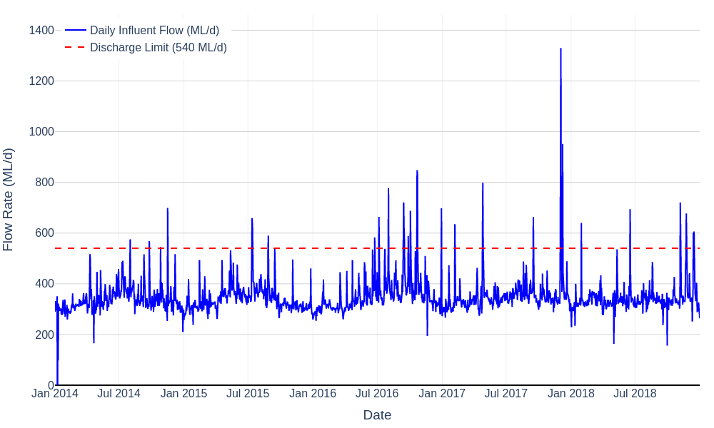
Figure 1 – Daily influent flow to the Eastern Treatment Plant (2014–2018) with the 540 ML/d annual mean discharge limit indicated.

4.2 Effluent Ammonia Compliance
Effluent ammonia is regulated by both an annual mean limit of 0.5 mg/L and a 90th percentile limit of 2.0 mg/L. Annual statistics were computed from the irregularly sampled effluent ammonia dataset. The results are presented in Table 2.
Table 2 – Annual effluent ammonia statistics compared with the 0.5 mg/L mean and 2.0 mg/L 90th percentile discharge limits.
Year | Annual Mean (mg/L) | Mean as % of 0.5 mg/L Limit | 90th Percentile (mg/L) | 90th Percentile as % of 2.0 mg/L Limit
2014 | 0.091 | 18.1 | 0.132 | 6.6
2015 | 0.086 | 17.2 | 0.110 | 5.5
2016 | 0.094 | 18.8 | 0.130 | 6.5
2017 | 1.321 | 264.3 | 0.130 | 6.5
2018 | 0.127 | 25.4 | 0.180 | 9.0

For four of the five years (2014–2016 and 2018), the annual mean ammonia concentration remained between 0.086 and 0.128 mg/L, equivalent to only 17–25% of the 0.5 mg/L limit. In all years, the 90th percentile values remained very low at 0.11–0.18 mg/L (6–9% of the 2.0 mg/L limit). These results confirm consistently strong nitrification performance except in 2017, when the annual mean increased to 1.32 mg/L (264% of the limit) while the 90th percentile remained at 0.13 mg/L. This combination points to a limited number of very high ammonia events rather than a sustained loss of process performance.
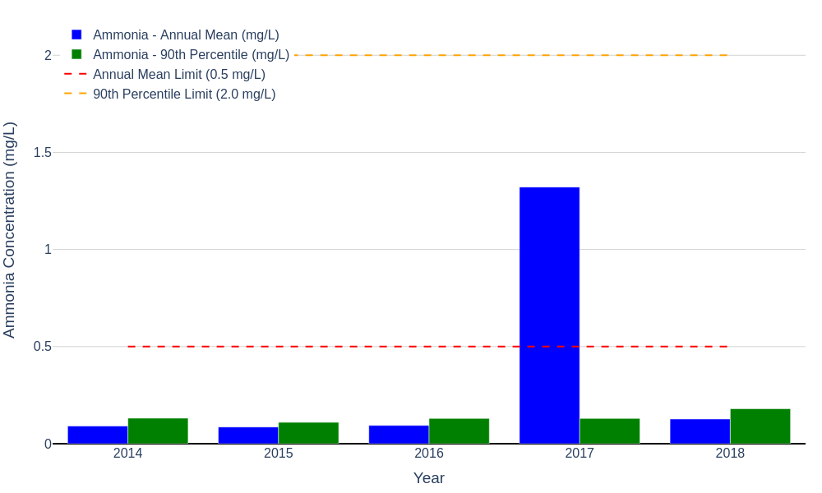
Figure 2 – Annual mean and 90th percentile effluent ammonia concentrations compared with licence limits (2014–2018).
The underlying daily effluent ammonia time series in Figure 3 shows that ammonia was typically below 0.5 mg/L, but several major nitrification failures occurred. A catastrophic event in mid‑2017 produced a single measurement around 316 mg/L, accompanied by multiple excursions between 3 and 10 mg/L in 2017 and 2018. Isolated spikes also appear early in 2014. These episodic failures explain the elevated 2017 annual mean while the 90th percentile remained low.
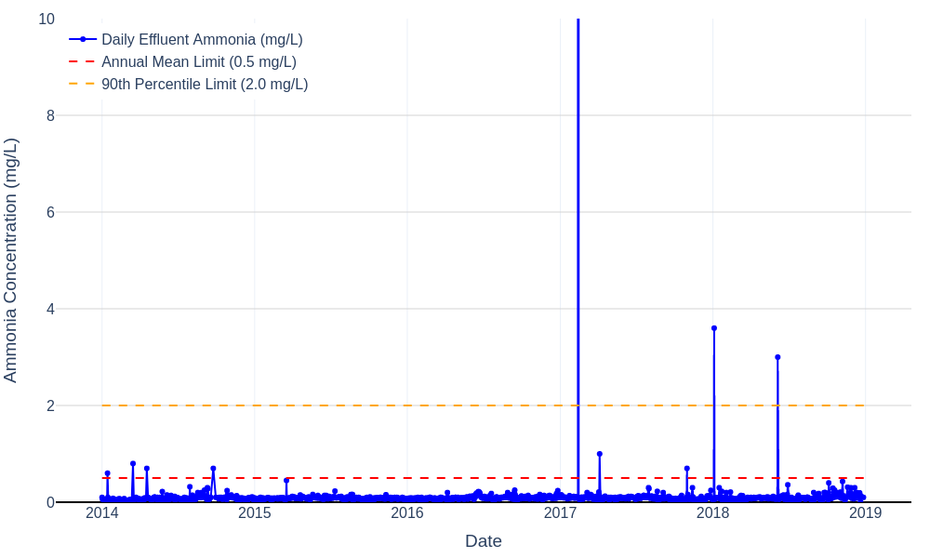
Figure 3 – Daily effluent ammonia concentration with annual mean and 90th percentile limits (2014–2018).
From a process engineering perspective, the pattern suggests intermittent nitrification upsets rather than chronic under‑design. Potential causes include low dissolved oxygen in aeration tanks during peak load events, temperature‑related nitrifier inhibition in winter, sudden toxic shocks from industrial discharges, or insufficient active biomass following sludge wasting or maintenance activities. The recurrence of elevated events in 2017–2018 indicates that additional process control measures may be required.

4.3 Effluent BOD Compliance
Effluent BOD is controlled by a 90th percentile limit of 10 mg/L. Annual statistics were derived from the effluent BOD measurements. The results are summarised in Table 3.
Table 3 – Annual effluent BOD 90th percentile compared with the 10 mg/L discharge limit.
Year | BOD 90th Percentile (mg/L) | 90th Percentile as % of 10 mg/L Limit | Compliance Comment
2014 | 3.0 | 30.0 | Within limit with large margin
2015 | 4.0 | 40.0 | Within limit with large margin
2016 | 4.0 | 40.0 | Within limit with large margin
2017 | 3.0 | 30.0 | Within limit with large margin
2018 | 3.0 | 30.0 | Within limit with large margin

Across all five years, the BOD 90th percentile remained between 3 and 4 mg/L, corresponding to only 30–40% of the 10 mg/L limit. This demonstrates very robust carbonaceous removal and process stability in the secondary treatment system.
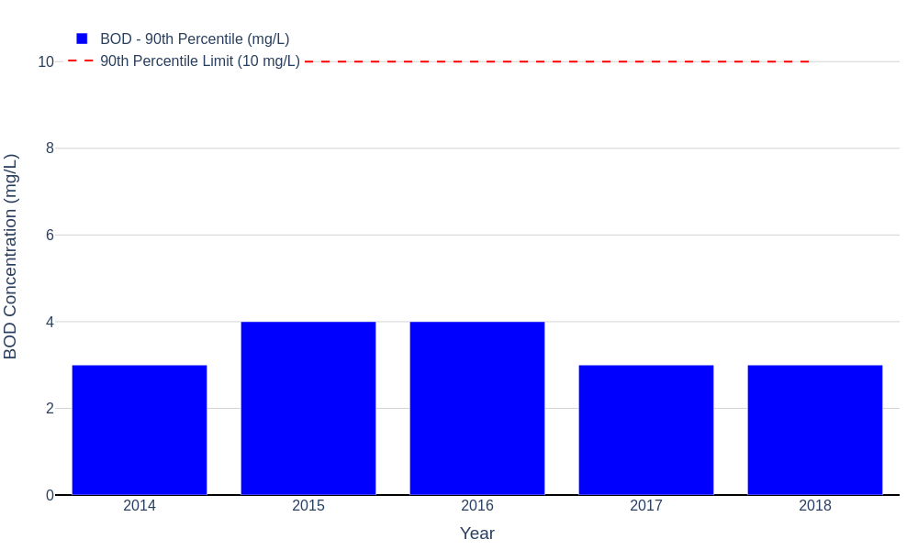
Figure 4 – Annual effluent BOD 90th percentile compared with the 10 mg/L discharge limit (2014–2018).
Figure 5 presents the full effluent BOD time series. Measurements cluster at or near the typical detection limit of 2 mg/L, with occasional excursions up to 5–6 mg/L distributed across the monitoring period. No measurements approach the 10 mg/L limit, and there is no evidence of sustained process deterioration, confirming excellent and consistent organic removal.
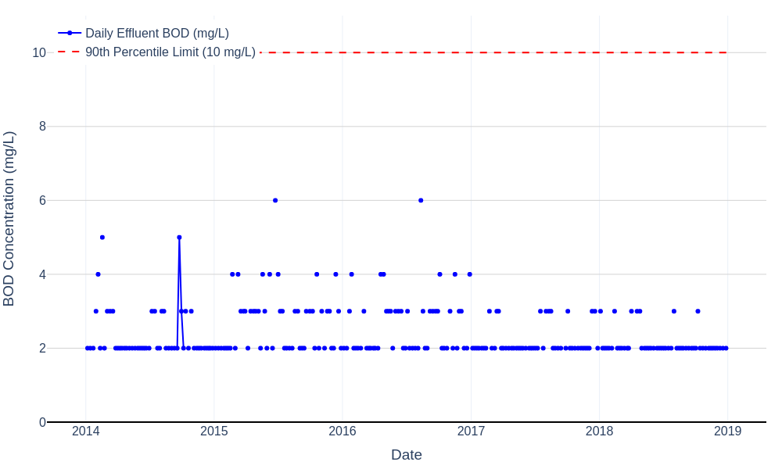
Figure 5 – Daily effluent BOD concentrations with the 10 mg/L 90th percentile limit (2014–2018).

4.4 Integrated Performance and Process Interpretation
When considered together, the flow, ammonia, and BOD results indicate that the Eastern Treatment Plant generally operates with substantial capacity and strong process robustness. Hydraulic loads are well below the design limit, and BOD performance is consistently excellent. The only material compliance concern identified is the 2017 ammonia annual mean exceedance, driven by a small number of extreme events.
The lack of corresponding deterioration in BOD performance during the high ammonia episodes suggests that the organic removal pathway remained intact while the specialised nitrifying biomass was temporarily impaired. This is consistent with short‑term inhibition of nitrifiers due to low dissolved oxygen, toxic compounds, or rapid changes in loading or temperature. Given the recurrence of elevated ammonia events in 2018, it is likely that underlying causes were not fully resolved following the 2017 incidents.

4.5 Data Quality Considerations
The daily flow series contains a small number of anomalous negative or very low values in early 2014, which are not physically plausible and most likely reflect data logging or transcription errors. These points have negligible impact on annual statistics but should be flagged for correction in the source systems. Similarly, the extremely high ammonia concentration in mid‑2017 should be verified as a genuine event (for example, by cross‑checking laboratory records and concurrent process data) before being used in any design or risk assessments.

4.6 Further Analysis Opportunities
Several additional analyses could be performed to deepen understanding of the plant’s performance and the root causes of the ammonia excursions.
- Undertake seasonal analysis of ammonia and BOD performance to separate temperature effects from load‑related impacts.
- Correlate ammonia spikes with influent load, flow peaks, and electricity usage (as a proxy for aeration intensity) to identify potential oxygen limitation or shock loading.
- Review process events during 2017–2018 (maintenance, bypasses, industrial trade waste incidents) using plant logs and supervisory control and data acquisition (SCADA) records.
- Evaluate nitrification safety margins under design‑storm conditions using dynamic process modelling calibrated to the observed data.
- Assess redundancy and resilience of aeration and mixed liquor recycle systems to confirm the plant’s ability to manage extreme events without breaching ammonia limits.

5 Key Findings
The main findings from the 2014–2018 discharge compliance assessment are summarised below.
- Annual mean flows were consistently between 337 and 358 ML/d, representing 62–66% of the 540 ML/d licence limit, with significant remaining hydraulic capacity.
- Effluent BOD performance was excellent, with 90th percentile values of 3–4 mg/L (30–40% of the 10 mg/L limit) and daily data largely at the analytical detection limit, indicating robust biological treatment.
- Effluent ammonia performance was generally very good, with annual mean concentrations below 0.13 mg/L and 90th percentile values below 0.18 mg/L for four of the five years.
- In 2017 the annual mean ammonia concentration increased to 1.32 mg/L (264% of the limit) due to a small number of extreme nitrification failures, while the 90th percentile remained compliant.
- The ammonia upsets do not coincide with any observable deterioration in BOD performance, suggesting selective impairment of nitrifying biomass rather than global process failure.
- Data quality is generally good, but anomalous negative flow readings and extreme ammonia outliers should be validated and, where appropriate, corrected or annotated.

6 Recommendations
Based on the analysis and findings, the following recommendations are proposed to maintain and enhance discharge compliance at the Eastern Treatment Plant.
- Investigate the 2017–2018 ammonia excursions in detail, including review of SCADA trends, plant logs, and trade waste records, to confirm root causes such as dissolved oxygen limitation, toxic shocks, or operational constraints.
- Develop and implement targeted nitrification resilience measures, such as improved aeration control strategies, minimum dissolved oxygen set‑points, and contingency protocols for high‑risk industrial discharges.
- Formalise data validation procedures for flow and effluent quality data to systematically identify and correct non‑physical values before compliance reporting.
- Continue routine performance monitoring using annual statistics and time series plots similar to those in this report to detect emerging trends early.
- Consider complementary monitoring of key process parameters (for example, dissolved oxygen, mixed liquor suspended solids, and sludge age) to support proactive management of nitrification capacity.
- Use dynamic process modelling or targeted pilot trials to assess the plant’s response to extreme wet‑weather and high‑load events and to optimise operational strategies for maintaining ammonia compliance.

