Anglian Water 2022 Domestic Water Quality – UK Regulatory Compliance Assessment
  - 17 December 2025

Table of Contents
1 Introduction 4
2 Objectives 4
3 Description of Dataset 4
4 Analysis 4
4.1 Overall compliance against UK PCVs 4
4.2 Microbiological determinands 5
4.3 Turbidity and aesthetic/operational metals 8
4.4 Consumer tap metals: lead and nickel 10
4.5 Radiological parameters 12
4.6 Pesticides and organic contaminants 12
5 Key Findings 12
6 Recommendations 13
7 Appendix A – Detailed compliance tables 14

Figures
Figure 1 – Coliform bacteria time series at consumer taps (PCV 0 number/100 ml). 6
Figure 2 – Coliform bacteria exceedance rate by LSOA, 2022 (capped at 0.5 failures/total samples). 6
Figure 3 – E. coli time series at consumer taps (PCV 0 number/100 ml). 7
Figure 4 – Enterococci time series at consumer taps (PCV 0 number/100 ml). 8
Figure 5 – Turbidity time series with UK PCV limit of 1 NTU. 8
Figure 6 – Aluminium time series with PCV 200 µg/l. 9
Figure 7 – Iron time series with PCV 200 µg/l. 9
Figure 8 – Manganese time series with PCV 50 µg/l. 10
Figure 9 – Lead time series at consumer taps with PCV 10 µg/l. 11
Figure 10 – Nickel time series at consumer taps with PCV 20 µg/l. 11
Figure 11 – Gross alpha time series with screening value 0.1 Bq/l. 12

Tables
Table 1 – Summary of determinands with PCV failures. 4
Table 2 – Regulatory limits and compliance status by determinand (part 1). 14
Table 3 – Monitoring statistics and result distribution by determinand (part 2). 17

1 Introduction
This report evaluates Anglian Water’s 2022 domestic potable water quality results against the requirements of the Water Supply (Water Quality) Regulations in England. The assessment uses the Anglian Water domestic water quality monitoring dataset for consumer taps, focusing on compliance with prescribed concentration or value (PCV) limits for microbiological, chemical, radiological and aesthetic parameters, including all regulated pesticides.

2 Objectives
The specific objectives of this compliance assessment are set out below.
- Check compliance of all determinands with applicable UK Water Supply (Water Quality) Regulations PCVs for 2022 domestic tap samples.
- Summarise, for each determinand, the regulatory requirement, observed mean and maximum concentrations, total number of samples, number of failures and overall pass/fail status, including all pesticide parameters.
- Characterise temporal behaviour of any non-compliant determinands using time series plots with PCV limits where relevant.
- Identify patterns that may indicate treatment process issues, distribution system impacts or premise-specific plumbing effects.
- Provide practical recommendations and suggestions for further analysis, sampling or operational investigation.

3 Description of Dataset
The assessment is based on the file "Anglian_Water_Domestic_Water_Quality.csv", containing 130,664 individual laboratory results from consumer tap samples taken between 03/01/2022 and 30/12/2022. Each record is identified by a unique Sample_Id and includes sampling date and time, DWI determinand code, determinand description, unit, operator qualifier, numeric result, Lower Super Output Area (LSOA) code and provider metadata. Sampling is irregular, with multiple determinands reported per sample event and frequencies varying by parameter.
Regulatory compliance in this report uses a pre-processed summary table that maps determinands to their statutory PCVs and aggregates sample counts, failures and summary statistics.

4 Analysis

4.1 Overall compliance against UK PCVs
Table 1 summarises only those determinands that recorded at least one sample above their prescribed concentration or value (PCV) in 2022. The table highlights the regulatory requirement, monitoring intensity and extent of exceedance for each non-compliant parameter. The full compliance suite for all determinands, including pesticides and parameters with zero failures, is provided in Tables 2 and 3 in Appendix A.
Table 1 – Summary of determinands with PCV failures.
Determinand | PCV (value and units) | Total samples | Failures | Max result
Aluminium (Total) | 200 µg/l | 4,464 | 2 | 251.5000
Coliform Bacteria (Indicator) | 0 number/100ml | 13,375 | 41 | 95
E.Coli (faecal coliforms Confirmed) | 0 number/100ml | 13,375 | 4 | 89
Enterococci (Confirmed) | 0 number/100ml | 1,314 | 2 | 1
Gross Alpha | 0.100 Bq/l | 9 | 1 | 0.1520
Iron (Total) | 200 µg/l | 4,484 | 7 | 1,495
Lead (10 - will apply 25.12.2013) | 10 µg/l | 1,325 | 5 | 39.6690
Manganese (Total) | 50 µg/l | 4,484 | 2 | 185.9000
Nickel (Total) | 20 µg/l | 1,320 | 6 | 299.8300
Turbidity | 1 NTU | 5,058 | 17 | 2.7300

The summary shows that non-compliance is restricted to a small group of determinands: microbiological indicators (coliform bacteria, Escherichia coli and enterococci), turbidity, certain aesthetic or operational metals (aluminium, iron and manganese), lead and nickel at consumer taps, and a single gross alpha screening exceedance. All other determinands listed in Appendix A comply fully with their statutory limits.

4.2 Microbiological determinands
Microbiological performance is a primary public health concern. For coliform bacteria, E. coli and enterococci the PCV is 0 number/100 ml, so any detection constitutes non-compliance at the sample level. The dataset includes 13,375 samples for coliform bacteria and E. coli and 1,314 samples for enterococci.
Coliform bacteria failures (41 out of 13,375 samples) are scattered throughout the year, with a small number of pronounced spikes indicating localised contamination or sampling events rather than sustained problems.
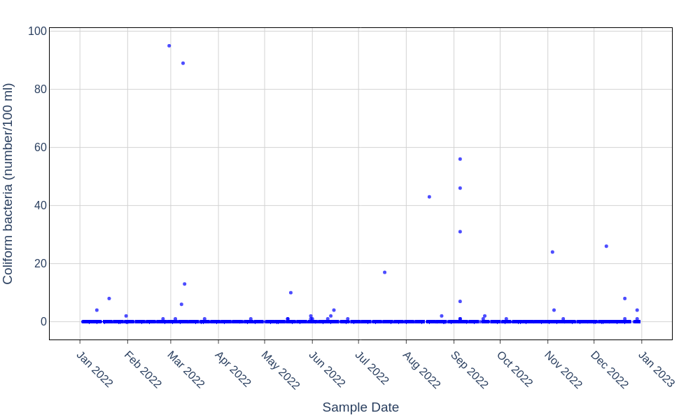
Figure 1 – Coliform bacteria time series at consumer taps (PCV 0 number/100 ml).
Spatial patterns of coliform exceedance are illustrated in Figure 2, which maps failure rates by LSOA. Almost all LSOAs show very low exceedance fractions, typically well below 0.1, with a few small clusters approaching 0.2–0.4 where monitoring density is often low. This supports the view that microbiological non-compliance is restricted to isolated locations.
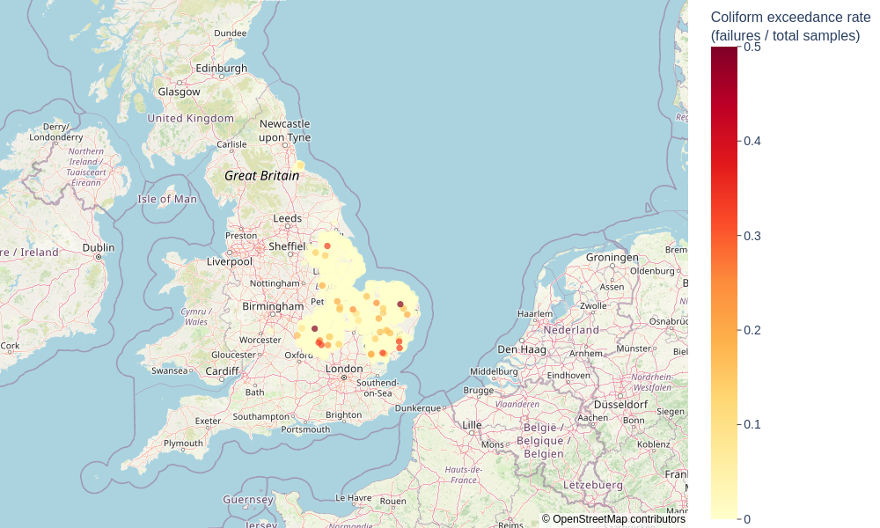
Figure 2 – Coliform bacteria exceedance rate by LSOA, 2022 (capped at 0.5 failures/total samples).
E. coli results are overwhelmingly compliant: only four failures are observed out of 13,375 samples. As shown in Figure 3, three discrete events are visible, including one high outlier around late March (approximately 90 number/100 ml). These incidents warrant incident-level review but do not indicate systemic treatment breakdown.
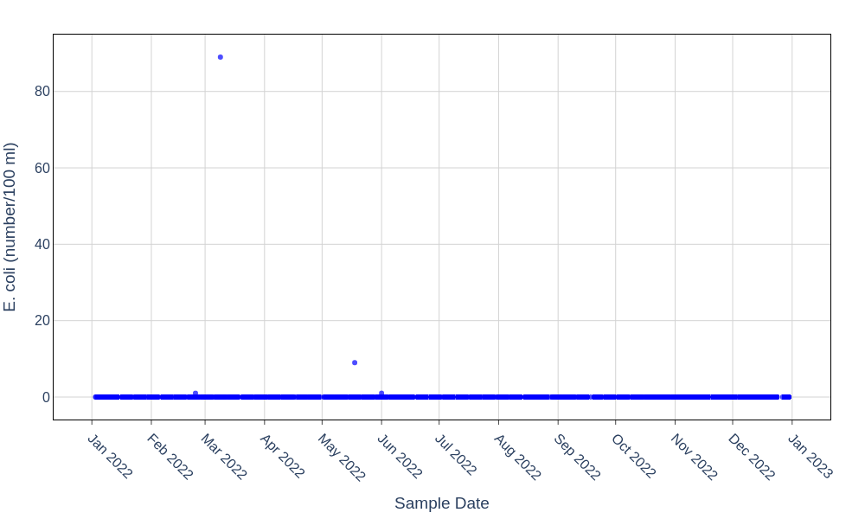
Figure 3 – E. coli time series at consumer taps (PCV 0 number/100 ml).
Enterococci monitoring shows a single low-level failure (1 number/100 ml) within 1,314 samples. Figure 4 confirms that this was an isolated event, consistent with a transient contamination or sampling artefact rather than a persistent faecal contamination issue.
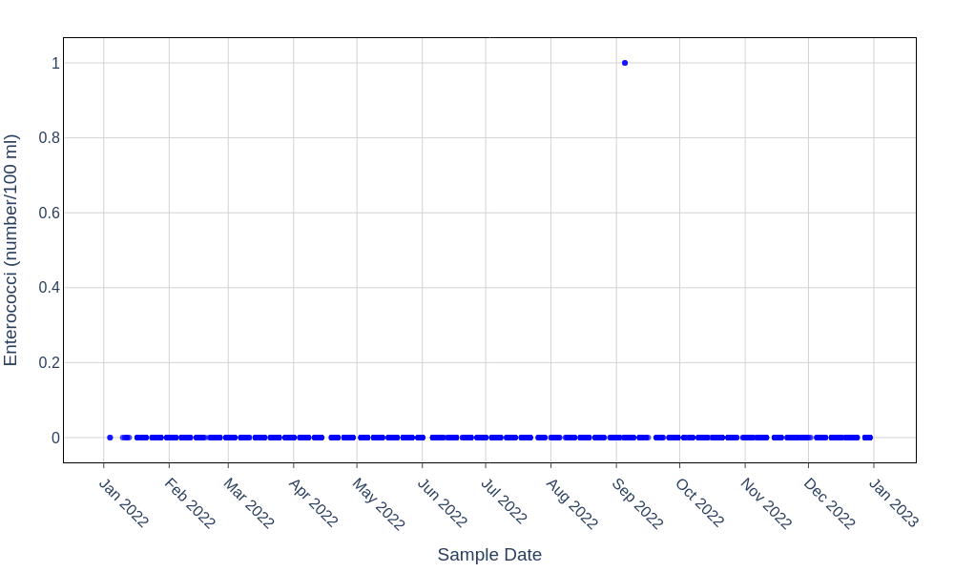
Figure 4 – Enterococci time series at consumer taps (PCV 0 number/100 ml).

4.3 Turbidity and aesthetic/operational metals
Operational parameters such as turbidity and metals (aluminium, iron and manganese) are sensitive indicators of treatment performance and distribution system condition. While exceedances mainly affect appearance and customer acceptability, high values can correlate with particle breakthrough and microbiological risk if not well controlled.
Turbidity exhibits generally low values, with most results between about 0.05 and 0.4 NTU. The PCV is 1 NTU. Figure 5 shows infrequent exceedances above this limit (17 out of 5,058 samples) and a small number of higher outliers up to approximately 2.7 NTU. These peaks are scattered through the year, suggesting short-lived local disturbances such as mains operations, flushing or filter backwash carry-over.
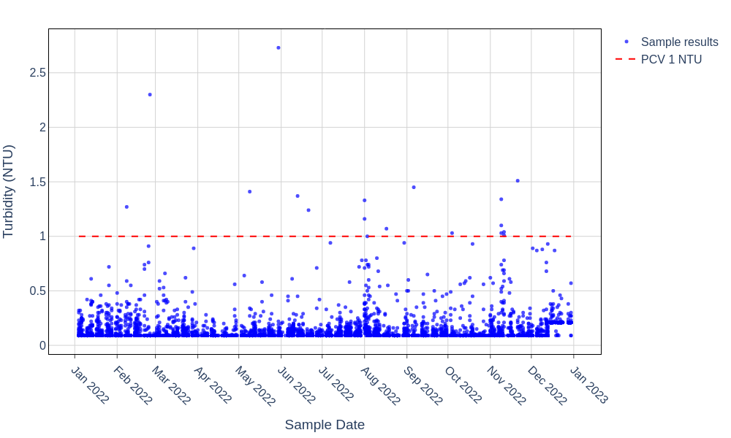
Figure 5 – Turbidity time series with UK PCV limit of 1 NTU.
Aluminium performance is generally good, but the compliance summary records two failures out of 4,464 samples against the 200 µg/l PCV. Figure 6 reveals a distinct mid-year period (approximately March to July) with elevated aluminium concentrations and several results approaching or exceeding the PCV, including one value slightly above 250 µg/l. After August, levels return to a low baseline, implying that process conditions at one or more treatment works were temporarily sub-optimal during that period.
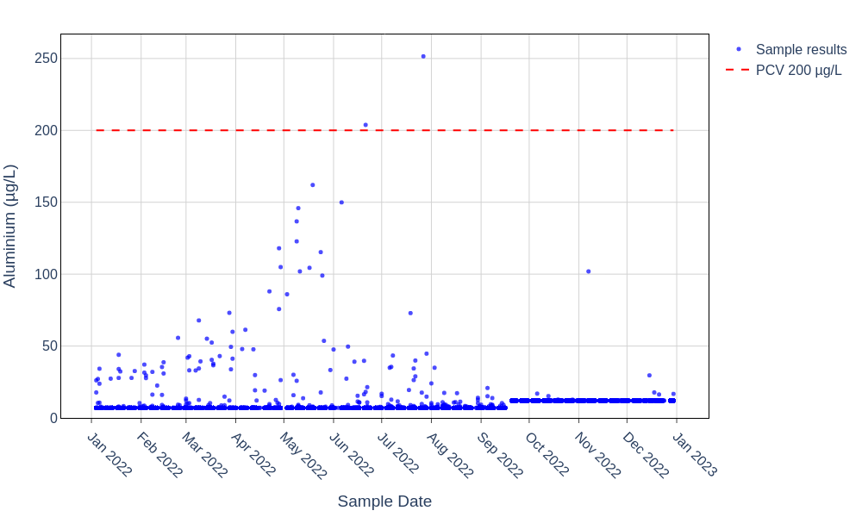
Figure 6 – Aluminium time series with PCV 200 µg/l.
Iron results are predominantly below 80 µg/l, yet seven samples out of 4,484 exceed the 200 µg/l PCV. Figure 7 shows sporadic high events during May–June, August and late in the year. One extreme outlier exceeds 1,400 µg/l, indicative of significant deposit mobilisation or disturbance in local iron pipework or storage assets. The absence of sustained high background levels suggests that these are distribution-side rather than treatment works problems.
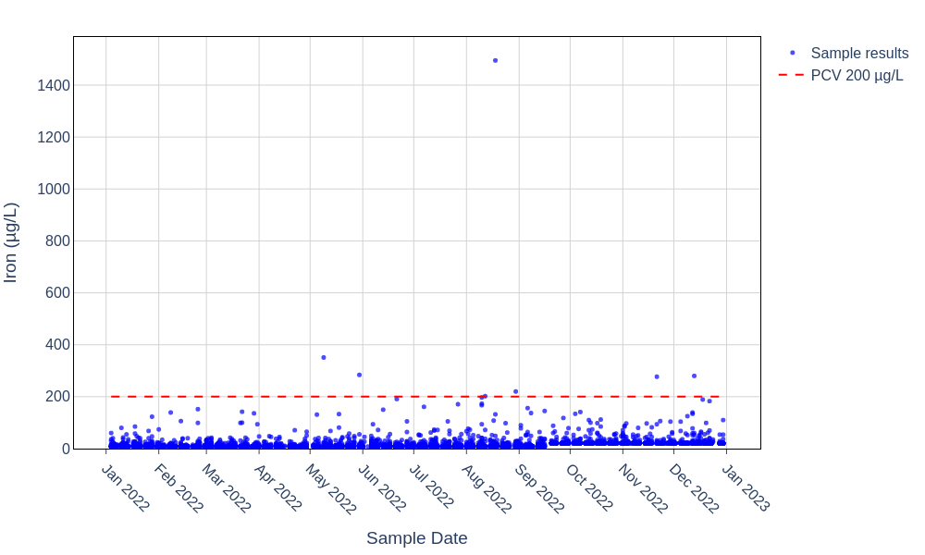
Figure 7 – Iron time series with PCV 200 µg/l.
Manganese concentrations are mostly between about 0.5 and 6 µg/l, well below the 50 µg/l PCV. Only two failures occur among 4,484 samples. Figure 8 highlights a small number of pronounced spikes, including a peak around 185 µg/l in late June–July and another high result near 125 µg/l. These are consistent with localised deposit mobilisation in low-turnover mains or reservoirs.
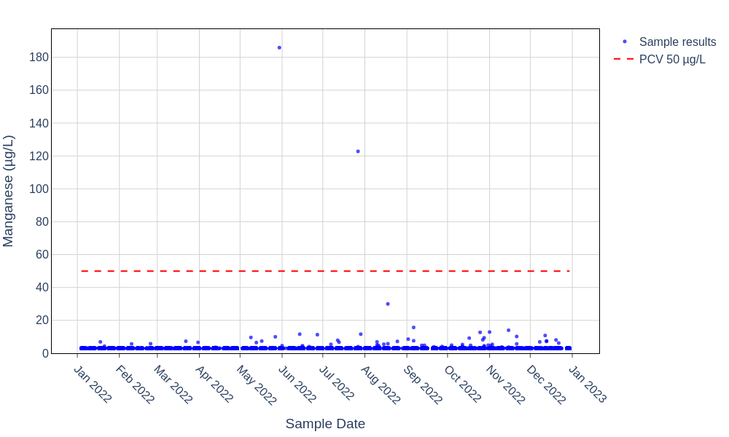
Figure 8 – Manganese time series with PCV 50 µg/l.

4.4 Consumer tap metals: lead and nickel
Lead and nickel are primarily associated with premise and distribution pipework materials rather than treatment processes. Compliance performance is therefore strongly influenced by plumbing configuration, stagnation and asset replacement programmes.
Lead exhibits very low concentrations for the majority of samples (typically below 2 µg/l). Five failures are recorded out of 1,325 samples against the 10 µg/l PCV. Figure 9 shows isolated exceedances spread across the year, including one high outlier approaching 40 µg/l in late autumn. The pattern indicates premise-specific plumbing or occasional stagnation rather than a systemic issue.
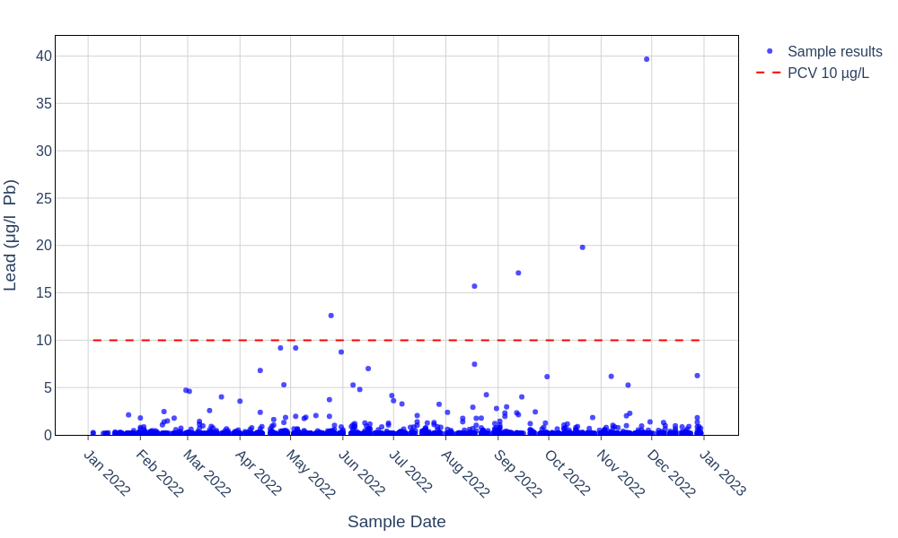
Figure 9 – Lead time series at consumer taps with PCV 10 µg/l.
Nickel performance is similarly strong overall, with most results below 5–6 µg/l and only six failures among 1,320 samples when compared with the 20 µg/l PCV. Figure 10 shows a few moderate exceedances in late summer to autumn and a single very high value approaching 300 µg/l. These concentrations are consistent with localised nickel-containing fittings or stagnation in particular properties.
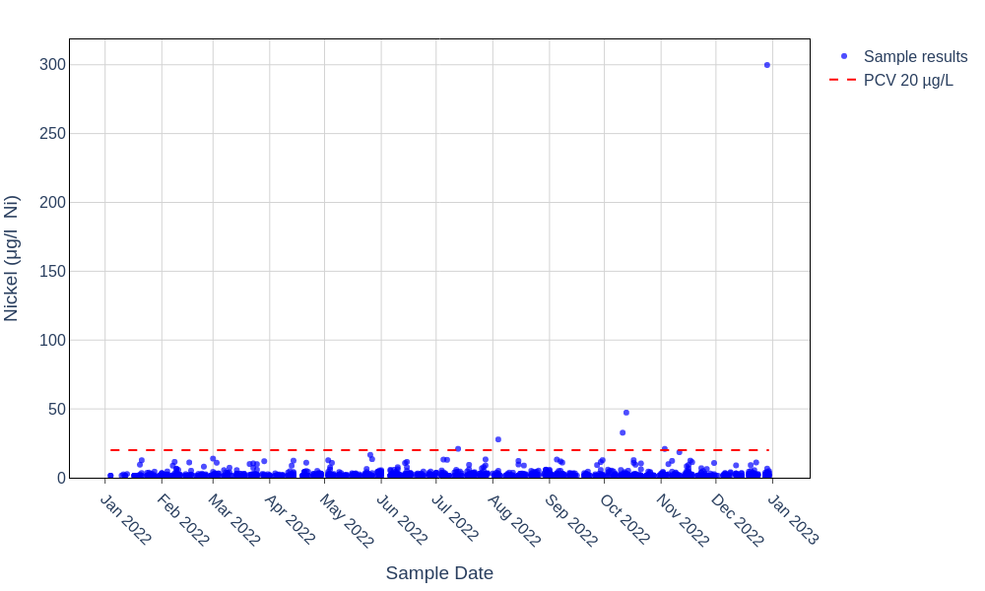
Figure 10 – Nickel time series at consumer taps with PCV 20 µg/l.

4.5 Radiological parameters
Radiological screening is represented by gross alpha and gross beta activity measurements, supported by tritium monitoring. The regulatory approach uses screening levels (0.1 Bq/l for gross alpha and 1.0 Bq/l for gross beta) to determine whether more detailed radionuclide-specific assessments are required.
All gross beta and tritium results are comfortably below their screening values. For gross alpha, eight of nine samples lie between about 0.02 and 0.053 Bq/l, but one sample at LSOA E01017616 on 25 January 2022 reaches 0.152 Bq/l, exceeding the 0.1 Bq/l screening threshold. This is treated as a failure in the summary table, triggering follow-up investigation as required by the Regulations.
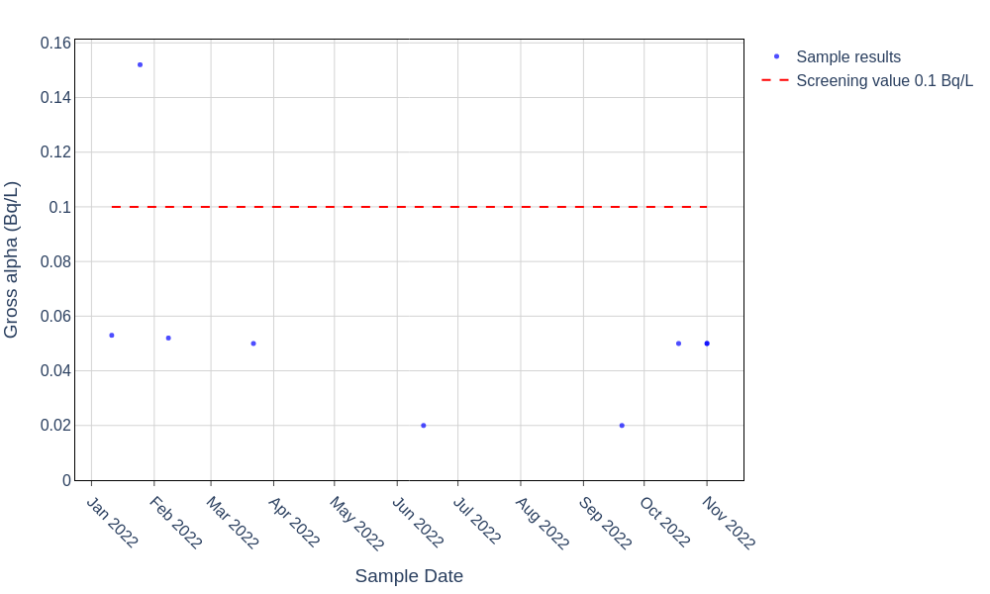
Figure 11 – Gross alpha time series with screening value 0.1 Bq/l.

4.6 Pesticides and organic contaminants
The dataset includes a comprehensive suite of regulated pesticides and related organic contaminants. As detailed in the full compliance tables in Appendix A, all pesticide determinands, the total pesticides parameter and trihalomethanes comply with their respective PCVs. Observed concentrations are typically one to two orders of magnitude below the 0.1 µg/l individual pesticide limit and the 0.5 µg/l total pesticides limit, with low variability across the monitoring period.
Polycyclic aromatic hydrocarbons, benzo[a]pyrene and related organic indicators are also consistently below their regulatory limits, implying effective control of raw water quality, treatment processes and material selection within the distribution system.

5 Key Findings
The principal findings from the 2022 Anglian Water domestic compliance assessment are summarised below.
- Overall regulatory compliance is high: most determinands, including all monitored pesticides, nitrate, nitrite, bromate, trihalomethanes and the majority of metals, show zero failures against their statutory PCVs.
- Microbiological performance is strong, with very low failure rates for coliform bacteria (41/13,375), E. coli (4/13,375) and enterococci (2/1,314). Failures are sporadic in time and geographically localised, consistent with isolated premise or small-zone events rather than widespread contamination.
- Turbidity, aluminium, iron and manganese exhibit occasional exceedances and outliers. Aluminium shows a mid-year cluster of elevated values consistent with a temporary coagulation or filtration issue, while iron and manganese spikes point towards local deposit mobilisation in the distribution system.
- Lead and nickel concentrations are generally very low, but isolated exceedances and rare high outliers indicate ongoing exposure risks for a small number of properties, likely associated with legacy plumbing or fittings.
- A single gross alpha sample exceeds the 0.1 Bq/l screening value, requiring radionuclide-specific follow-up, but subsequent samples remain below the threshold, suggesting a transient or localised cause rather than a systemic radiological issue.
- Spatial mapping of coliform failures demonstrates that LSOAs with the highest exceedance rates tend to have relatively few samples, emphasising the need to interpret apparent high rates in the context of sample numbers and to prioritise zones with both repeated detections and adequate monitoring coverage.

6 Recommendations
On the basis of the observed patterns and regulatory performance, the following actions and further analyses are recommended.
- Investigate individual microbiological failures (coliforms, E. coli and enterococci) using Sample_Id and LSOA to review local plumbing, sampling conditions and any concurrent operational events such as bursts, repairs or changes in supply configuration.
- Review treatment works performance during the mid-2022 period of elevated aluminium, including coagulation control, sludge management and filter optimisation, and confirm whether any process changes or corrective actions coincided with the return to baseline levels.
- Use event logs, customer contacts and asset records to correlate high iron and manganese results with specific mains, service reservoirs or premise connections, and target cleaning, flushing or asset renewal where repeated spikes occur.
- Undertake property-level investigations for addresses associated with lead and nickel exceedances, including plumbing surveys, stagnation assessments and consideration of point-of-use flushing advice or replacement of lead or nickel-containing fittings.
- Carry out a radionuclide-specific investigation for the gross alpha exceedance sample, including follow-up sampling and analysis for individual alpha-emitting radionuclides, and assess the resulting indicative dose in line with regulatory guidance.
- Extend spatial analysis beyond coliforms to include turbidity, iron, manganese, lead and nickel, using exceedance maps and control charts by supply zone or district metered area to identify recurring hotspots.
- Consider targeted additional sampling in LSOAs with high-coliform exceedance rates based on few samples, to distinguish between random single events and genuine local vulnerability.
- Develop integrated dashboards linking laboratory data with operational telemetry, works performance indicators and network events, enabling near real-time detection and response to emerging compliance risks.

7 Appendix A – Detailed compliance tables
This appendix presents the full determinand-by-determinand compliance summary used in the assessment. Tables 2 and 3 list the regulatory parameters, monitoring statistics and result distributions for all determinands with defined PCVs, including those that were fully compliant throughout 2022.
Table 2 – Regulatory limits and compliance status by determinand (part 1).
Determinand | Reg. name | PCV value | PCV units | Compliance
Aluminium (Total) | Aluminium | 200 | µg/l | Fail
Ammonium (Total) | Ammonium | 0.500 | mgNH4/l | Pass
Antimony | Antimony | 5 | µg/l | Pass
Benzo[a]Pyrene (Total) | benzo[a]pyrene | 0.010 | µg/l | Pass
Boron | Boron | 1 | mg/l | Pass
Bromate | Bromate | 10 | µg/l | Pass
Chloride | Chloride | 250 | mg/l | Pass
Chromium (Total) | Chromium | 50 | µg/l | Pass
Clostridum Perfringens (Sulphite-reducing Clostridia) (Confirmed) | Clostridium perfringens | 0 | Number/100ml | Pass
Coliform Bacteria (Indicator) | Coliform bacteria | 0 | number/100ml | Fail
Colour | Colour | 20 | mg/l Pt/Co | Pass
Conductivity (Electrical Conductivity) | Conductivity | 2,500 | µS/cm @ 20°C | Pass
Copper (Total) | Copper | 2 | mg/l | Pass
Cyanide (Total) | Cyanide | 50 | µg/l | Pass
E.Coli (faecal coliforms Confirmed) | Escherichia coli | 0 | number/100ml | Fail
Enterococci (Confirmed) | Enterococci | 0 | number/100ml | Fail
Fluoride (Total) | Fluoride | 1.500 | mg/l | Pass
Gross Alpha | gross alpha | 0.100 | Bq/l | Fail
Gross Beta | gross beta | 1 | Bq/l | Pass
Hydrogen ion (pH) - Indicator (Hydrogen ion) (pH) | pH
Iron (Total) | Iron | 200 | µg/l | Fail
Lead (10 - will apply 25.12.2013) | Lead | 10 | µg/l | Fail
Manganese (Total) | Manganese | 50 | µg/l | Fail
Mercury (Total) | Mercury | 1 | µg/l | Pass
Nickel (Total) | Nickel | 20 | µg/l | Fail
Nitrate (Total) | Nitrate | 50 | mgNO3/l | Pass
Nitrite - Consumer's Taps | Nitrite | 0.500 | mgNO2/l | Pass
Nitrite/Nitrate formula | Nitrate+Nitrite formula | 1 |  | Pass
Odour | Odour
Pesticides (Total by Calculation) | Pesticides: total | 0.500 | µg/l | Pass
Pesticides 2 4-D (Total) | Other pesticides | 0.100 | µg/l | Pass
Pesticides 2 4-DB (Total) | Other pesticides | 0.100 | µg/l | Pass
Pesticides Aldrin | Aldrin | 0.030 | µg/l | Pass
Pesticides Atrazine (Total) | Other pesticides | 0.100 | µg/l | Pass
Pesticides Benazolin (Total) | Other pesticides | 0.100 | µg/l | Pass
Pesticides Bentazone (Total) | Other pesticides | 0.100 | µg/l | Pass
Pesticides Bromacil | Other pesticides | 0.100 | µg/l | Pass
Pesticides Carbetamide | Other pesticides | 0.100 | µg/l | Pass
Pesticides Chlorfenvinphos (Total) | Other pesticides | 0.100 | µg/l | Pass
Pesticides Chloridazon | Other pesticides | 0.100 | µg/l | Pass
Pesticides Chlormequat | Other pesticides | 0.100 | µg/l | Pass
Pesticides Chlorothalonil | Other pesticides | 0.100 | µg/l | Pass
Pesticides Chlortoluron (Total) | Other pesticides | 0.100 | µg/l | Pass
Pesticides Clopyralid (Total) | Other pesticides | 0.100 | µg/l | Pass
Pesticides Cyanazine | Other pesticides | 0.100 | µg/l | Pass
Pesticides Dichlorprop (Total) | Other pesticides | 0.100 | µg/l | Pass
Pesticides Dieldrin (Total) | Dieldrin | 0.030 | µg/l | Pass
Pesticides Fluroxypyr | Other pesticides | 0.100 | µg/l | Pass
Pesticides Glyphosate | Other pesticides | 0.100 | µg/l | Pass
Pesticides Heptachlor (Total) | Heptachlor | 0.100 | µg/l | Pass
Pesticides Heptachlor Epoxide - Total (Trans, CIS) (Heptachlor Epoxide) | Heptachlor epoxide | 0.100 | µg/l | Pass
Pesticides Isoproturon (Total) | Other pesticides | 0.100 | µg/l | Pass
Pesticides Linuron (Total) | Other pesticides | 0.100 | µg/l | Pass
Pesticides MCPA (Total) 4-chloro-o-tolyloxyacetic acid | Other pesticides | 0.100 | µg/l | Pass
Pesticides MCPB (Total) | Other pesticides | 0.100 | µg/l | Pass
Pesticides MCPP(Mecoprop) (Total) | Other pesticides | 0.100 | µg/l | Pass
Pesticides Metaldehyde | Other pesticides | 0.100 | µg/l | Pass
Pesticides Metamitron | Other pesticides | 0.100 | µg/l | Pass
Pesticides Metazachlor | Other pesticides | 0.100 | µg/l | Pass
Pesticides Monuron | Other pesticides | 0.100 | µg/l | Pass
Pesticides Pirimicarb | Other pesticides | 0.100 | µg/l | Pass
Pesticides Prometryne | Other pesticides | 0.100 | µg/l | Pass
Pesticides Propazine | Other pesticides | 0.100 | µg/l | Pass
Pesticides Propyzamide (Total) | Other pesticides | 0.100 | µg/l | Pass
Pesticides Quinmerac | Other pesticides | 0.100 | µg/l | Pass
Pesticides Simazine (Total) | Other pesticides | 0.100 | µg/l | Pass
Pesticides Terbutryn | Other pesticides | 0.100 | µg/l | Pass
Pesticides Triclopyr (Total) | Other pesticides | 0.100 | µg/l | Pass
Pesticides Trietazine | Other pesticides | 0.100 | µg/l | Pass
Polycyclic Aromatic Hydrocarbons (Total by Calculation) | PAH | 0.100 | µg/l | Pass
Selenium (Total) | Selenium | 10 | µg/l | Pass
Sodium (Total) | Sodium | 200 | mg/l | Pass
Sulphate | Sulphate | 250 | mg/l | Pass
Taste (Taste Quant) | Taste
Total Organic Carbon | TOC
Trihalomethanes (Total by Calculation) | THM (total) | 100 | µg/l | Pass
Tritium | tritium | 100 | Bq/l | Pass
Turbidity | Turbidity | 1 | NTU | Fail

Table 3 – Monitoring statistics and result distribution by determinand (part 2).
Determinand | Total samples | Failures | Mean result | Max result
Aluminium (Total) | 4,464 | 2 | 9.4549 | 251.5000
Ammonium (Total) | 2,921 | 0 | 0.1559 | 0.4820
Antimony | 1,322 | 0 | 0.1805 | 0.8000
Benzo[a]Pyrene (Total) | 1,295 | 0 | 0.0020 | 0.0080
Boron | 49 | 0 | 0.0613 | 0.1870
Bromate | 142 | 0 | 0.7594 | 2.0400
Chloride | 51 | 0 | 48.3482 | 78.9000
Chromium (Total) | 1,321 | 0 | 0.5507 | 4
Clostridum Perfringens (Sulphite-reducing Clostridia) (Confirmed) | 51 | 0 | 0 | 0
Coliform Bacteria (Indicator) | 13,375 | 41 | 0.0390 | 95
Colour | 5,057 | 0 | 1.3074 | 4.4000
Conductivity (Electrical Conductivity) | 1,920 | 0 | 649.4300 | 887
Copper (Total) | 1,279 | 0 | 0.0685 | 1.2300
Cyanide (Total) | 52 | 0 | 3.3330 | 3.3330
E.Coli (faecal coliforms Confirmed) | 13,375 | 4 | 0.0075 | 89
Enterococci (Confirmed) | 1,314 | 2 | 0.0015 | 1
Fluoride (Total) | 1,329 | 0 | 0.3811 | 1.3660
Gross Alpha | 9 | 1 | 0.0552 | 0.1520
Gross Beta | 9 | 0 | 0.1859 | 0.3000
Hydrogen ion (pH) - Indicator (Hydrogen ion) (pH)
Iron (Total) | 4,484 | 7 | 17.0205 | 1,495
Lead (10 - will apply 25.12.2013) | 1,325 | 5 | 0.4640 | 39.6690
Manganese (Total) | 4,484 | 2 | 3.1267 | 185.9000
Mercury (Total) | 51 | 0 | 0.0921 | 0.0970
Nickel (Total) | 1,320 | 6 | 2.8167 | 299.8300
Nitrate (Total) | 2,928 | 0 | 19.5823 | 49
Nitrite - Consumer's Taps | 2,937 | 0 | 0.0619 | 0.4070
Nitrite/Nitrate formula | 2,863 | 0 | 0.3812 | 0.9800
Odour
Pesticides (Total by Calculation) | 45 | 0 | 0.0087 | 0.0370
Pesticides 2 4-D (Total) | 2 | 0 | 0.0130 | 0.0160
Pesticides 2 4-DB (Total) | 2 | 0 | 0.0080 | 0.0080
Pesticides Aldrin | 30 | 0 | 0.0030 | 0.0030
Pesticides Atrazine (Total) | 11 | 0 | 0.0040 | 0.0040
Pesticides Benazolin (Total) | 2 | 0 | 0.0100 | 0.0100
Pesticides Bentazone (Total) | 7 | 0 | 0.0080 | 0.0080
Pesticides Bromacil | 5 | 0 | 0.0060 | 0.0060
Pesticides Carbetamide | 5 | 0 | 0.0140 | 0.0140
Pesticides Chlorfenvinphos (Total) | 2 | 0 | 0.0070 | 0.0070
Pesticides Chloridazon | 2 | 0 | 0.0120 | 0.0120
Pesticides Chlormequat | 2 | 0 | 0.0050 | 0.0050
Pesticides Chlorothalonil | 1 | 0 | 0.0100 | 0.0100
Pesticides Chlortoluron (Total) | 2 | 0 | 0.0100 | 0.0100
Pesticides Clopyralid (Total) | 14 | 0 | 0.0180 | 0.0180
Pesticides Cyanazine | 2 | 0 | 0.0080 | 0.0080
Pesticides Dichlorprop (Total) | 2 | 0 | 0.0040 | 0.0040
Pesticides Dieldrin (Total) | 29 | 0 | 0.0030 | 0.0030
Pesticides Fluroxypyr | 2 | 0 | 0.0200 | 0.0200
Pesticides Glyphosate | 2 | 0 | 0.0070 | 0.0070
Pesticides Heptachlor (Total) | 30 | 0 | 0.0020 | 0.0020
Pesticides Heptachlor Epoxide - Total (Trans, CIS) (Heptachlor Epoxide) | 30 | 0 | 0.0030 | 0.0030
Pesticides Isoproturon (Total) | 5 | 0 | 0.0060 | 0.0060
Pesticides Linuron (Total) | 24 | 0 | 0.0140 | 0.0140
Pesticides MCPA (Total) 4-chloro-o-tolyloxyacetic acid | 2 | 0 | 0.0080 | 0.0080
Pesticides MCPB (Total) | 2 | 0 | 0.0060 | 0.0060
Pesticides MCPP(Mecoprop) (Total) | 7 | 0 | 0.0060 | 0.0060
Pesticides Metaldehyde | 18 | 0 | 0.0208 | 0.0370
Pesticides Metamitron | 2 | 0 | 0.0170 | 0.0170
Pesticides Metazachlor | 2 | 0 | 0.0300 | 0.0300
Pesticides Monuron | 24 | 0 | 0.0120 | 0.0120
Pesticides Pirimicarb | 2 | 0 | 0.0066 | 0.0070
Pesticides Prometryne | 2 | 0 | 0.0100 | 0.0100
Pesticides Propazine | 2 | 0 | 0.0100 | 0.0100
Pesticides Propyzamide (Total) | 5 | 0 | 0.0126 | 0.0240
Pesticides Quinmerac | 2 | 0 | 0.0130 | 0.0130
Pesticides Simazine (Total) | 5 | 0 | 0.0100 | 0.0100
Pesticides Terbutryn | 2 | 0 | 0.0100 | 0.0100
Pesticides Triclopyr (Total) | 2 | 0 | 0.0120 | 0.0120
Pesticides Trietazine | 24 | 0 | 0.0160 | 0.0160
Polycyclic Aromatic Hydrocarbons (Total by Calculation) | 1,293 | 0 | 0.0000 | 0.0360
Selenium (Total) | 1,322 | 0 | 0.9012 | 3.6800
Sodium (Total) | 1,322 | 0 | 32.2581 | 98.6000
Sulphate | 50 | 0 | 60.1860 | 125.5400
Taste (Taste Quant)
Total Organic Carbon
Trihalomethanes (Total by Calculation) | 1,324 | 0 | 15.9668 | 80
Tritium | 9 | 0 | 5.3144 | 6
Turbidity | 5,058 | 17 | 0.1353 | 2.7300

