Ontario Surface Water Quality Screening Assessment - 2024
  - 22 February 2026

Table of Contents
1. Introduction 4
1.1 Background 4
1.2 Scope of Assessment 4
1.3 Focus Analytes (Phosphorus and Iron) 4
1.4 Regulatory Context (Ontario PWQO Framework) 4
2. Data and Methods 4
2.1 Dataset Description 4
2.2 Treatment of Non-Detects 4
2.3 PWQO Objectives Applied 4
2.4 Exceedance Definition 5
2.5 Limitations of Screening Approach 5
3. Provincial Summary Results 5
4. Prioritisation Risk Framework and Results 6
4.1 Risk Classification Framework 6
4.2 Risk Classification Results 6
5. Phosphorus Analysis 7
6. Iron Analysis 9
7. Conclusions and Recommendation 12
Appendix A. Detailed Analytes Table 13
Appendix A. Detailed Analytes Table 14

Figures
Figure 1 – PWQMN 2024 stations map (risk tier). 6
Figure 2 – PWQMN 2024 stations map (Total Phosphorus percent exceedance of PWQO). 7
Figure 3 – Monthly box plot – Total Phosphorus (all sites combined, 2024). 9
Figure 4 – PWQMN 2024 stations map (Iron percent exceedance of PWQO). 10
Figure 5 – Monthly box plot – Iron (all sites combined, 2024). 11
Figure 6 – Time series – Iron (all samples, 2024; log scale). 12

Tables
Table 1 – Analyte summary (PWQO screening, 2024) 5
Table 2 – Station counts by risk tier and screening exceedance criteria (PWQO screening, 2024). 6
Table 3 – Top 10 stations – Total Phosphorus PWQO exceedance (2024). 8
Table 4 – Top 10 stations – Iron PWQO exceedance (2024). 10
Table 5 – Detailed analytes screening summary 14

1. Introduction

1.1 Background
The Provincial (Stream) Water Quality Monitoring Network (PWQMN) measures surface-water quality in rivers and streams across Ontario. This report summarises a 2024 screening assessment of PWQMN results against applicable Provincial Water Quality Objectives (PWQO) and Interim PWQO values for analytes with province-wide objectives.

1.2 Scope of Assessment
This assessment is a screening-level evaluation based on individual sample results collected between 05 January 2024 and 11 December 2024. The approach flags exceedance signals on a per-sample basis and then aggregates results across stations and analytes to support prioritisation. It does not replace the formal application requirements associated with some objectives (e.g., multi-sample geometric means).

1.3 Focus Analytes (Phosphorus and Iron)
While multiple analytes are screened where PWQO (or Interim PWQO) values are available, this report places additional focus on Total Phosphorus and Iron because they are among the most frequently exceeded objectives and are strongly linked to common watershed and process drivers (e.g., erosion/sediment mobilisation, runoff, and nutrient loading).

1.4 Regulatory Context (Ontario PWQO Framework)
PWQO values provide environmental quality benchmarks intended to protect aquatic life and other water uses under typical conditions. Objective applicability depends on parameter-specific requirements (e.g., pH-dependent objectives, hardness-adjusted metals, or geometric mean criteria). Accordingly, results in this report are framed as a conservative screen to identify potential areas of concern requiring follow-up.

2. Data and Methods

2.1 Dataset Description
The source dataset is an Excel workbook (Ontario_PWQMN_2024.xlsx) with two worksheets: (i) a Data sheet containing individual sample results by station and analyte, including result qualifiers and detection limits, and (ii) a Stations sheet containing station metadata (name, latitude/longitude, and status).

2.2 Treatment of Non-Detects
Non-detect (below detection limit) results were handled using a simple substitution approach for summary statistics: non-detects were assigned a value of one-half the method detection limit (½MDL) when calculating mean, median, and percentile metrics. For exceedance screening, exceedances were evaluated on detected results as a conservative indicator of objective exceedance signals.

2.3 PWQO Objectives Applied
Screening was performed only for analytes with a provincial objective (PWQO or Interim PWQO). Where objectives are conditional (e.g., hardness-adjusted metals or pH-dependent objectives), screening required the relevant supporting data (e.g., same-day hardness or pH). Where supporting data were missing, those samples were excluded from exceedance screening for that parameter.

2.4 Exceedance Definition
A sample exceedance was defined as a measured (detected) result above the applicable objective threshold. For pH, an exceedance was defined as values outside the PWQO range of 6.5 to 8.5. For E. coli, samples above 100 MPN/100 mL were flagged; this is more conservative than the formal PWQO application, which is based on a geometric mean of at least five samples.

2.5 Limitations of Screening Approach
Key limitations relevant to interpreting screening results include: per-sample screening does not incorporate flow conditions or event context; some objectives have formal aggregation requirements not applied here; and detection limits can prevent meaningful assessment when objectives are lower than MDLs. Consequently, the output should be used to prioritise follow-up investigations rather than to conclude definitive compliance status.
The next section summarises screening results across the network, followed by a risk-tier prioritisation framework and detailed analyses for Total Phosphorus and Iron.

3. Provincial Summary Results
Network-wide screening results indicate that objective exceedances are concentrated in a subset of analytes and stations. Table 1 summarises results for all PWQO-screened analytes, including objectives, sample counts, exceedance rates (detected-only screen), and upper-tail concentrations (P95). Detailed analyte screening and censoring metrics are provided in Appendix A (Table 5).
Table 1 – Analyte summary (PWQO screening, 2024)
Analyte | Objective | N samples | Exceedances [%] | P95
Aluminum | pH-dependent | 2,134 | 42.5 | 643.0 µg/L
Arsenic | 5.0 µg/L | 199 | 14.1 | 21.1 µg/L
Boron | 200.0 µg/L | 93 | 0.0 | 75.6 µg/L
Cadmium | Hardness-adjusted | 2,134 | 5.2 | 1.01 µg/L
Chromium | 1.0 µg/L | 2,070 | 9.7 | 2.5 µg/L
Copper | Hardness-adjusted | 2,133 | 9.3 | 6.552 µg/L
E. coli | 100 MPN/100 mL | 216 | 56.9 | 3,275.0
Iron | 300.0 µg/L | 2,132 | 28.8 | 919.8 µg/L
Lead | Hardness-adjusted | 2,132 | 0.0 | 3.5 µg/L
Mercury | 0.2 µg/L | 142 | 0.0 | 2.5 ng/L (½MDL)
Nickel | 25.0 µg/L | 2,134 | 1.5 | 6.277 µg/L
Total Phosphorus | 30.0 µg/L | 3,666 | 40.1 | 237.75 µg/L
Selenium | 100.0 µg/L | 95 | 0.0 | 2.5 µg/L (½MDL)
Silver | 0.1 µg/L | 2,117 | 0.0 | 4.5 µg/L (½MDL)
Zinc | 20.0 µg/L | 2,114 | 8.6 | 29.835 µg/L
pH | 6.5–8.5 SU | 3,669 | 4.3 | 8.49

At the provincial scale, the strongest per-sample exceedance signals were observed for E. coli (56.9% of 216 samples), Aluminum (42.5% of 2,134 samples), Total Phosphorus (40.1% of 3,666 samples), and Iron (28.8% of 2,132 samples). For Total Phosphorus and Iron, the combination of high exceedance frequency and elevated upper-tail concentrations indicates that exceedances are not restricted to rare, extreme outliers and warrants station-level prioritisation.
Detection-limit constraints can materially affect the ability to assess compliance. A notable example is Silver: 100% of results were non-detect and 100% of method detection limits exceeded the 0.1 µg/L objective, meaning that compliance cannot be concluded from these data. Where the objective is below typical MDLs, future monitoring may require lower reporting limits or targeted analytical methods to support meaningful assessment.

4. Prioritisation Risk Framework and Results

4.1 Risk Classification Framework
Stations were classified into screening risk tiers based on the overall percent of PWQO-screened sample results exceeding objectives across all objective-screened analytes. The tier definitions are summarised in Table 2.

4.2 Risk Classification Results
Figure 1 shows the geographic distribution of station risk tiers. Tier 3–4 stations are concentrated in Southern Ontario, consistent with higher pressures from intensive land use, urban runoff, and agricultural drainage in several watersheds. Table 2 summarises the number of stations in each tier for the screened station set (n=435), together with the exceedance criteria used to define each tier.
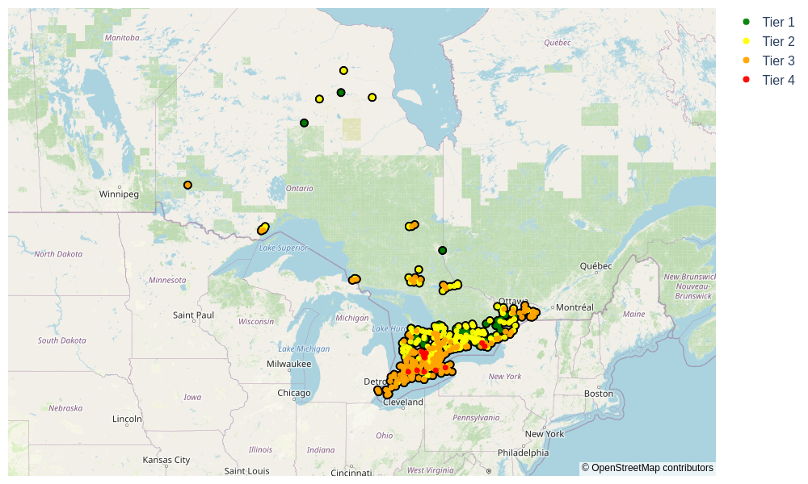
Figure 1 – PWQMN 2024 stations map (risk tier).

Table 2 – Station counts by risk tier and screening exceedance criteria (PWQO screening, 2024).
Risk tier | Exceedance criterion | Stations | Share [%]
Tier 1 | 0% of screened results exceed objectives | 47 | 10.8
Tier 2 | ≤15% of screened results exceed objectives | 186 | 42.8
Tier 3 | 15–50% of screened results exceed objectives | 191 | 43.9
Tier 4 | ≥50% of screened results exceed objectives | 11 | 2.5
Total | All tiers | 435 | 100.0

The station-level results used for tiering include parameter-by-parameter exceedance summaries. The full station table is provided as a CSV file: station_risk_classification_pwqo_2024_v2.csv.

5. Phosphorus Analysis
Total Phosphorus was screened against the river PWQO of 30 µg/L. At the provincial scale, 40.1% of screened samples exceeded the objective (1,469 exceedances of 3,666 samples), and 312 stations recorded at least one exceedance during 2024. Figure 2 maps station-level exceedance frequency, highlighting clusters of persistent exceedance in Southern Ontario.
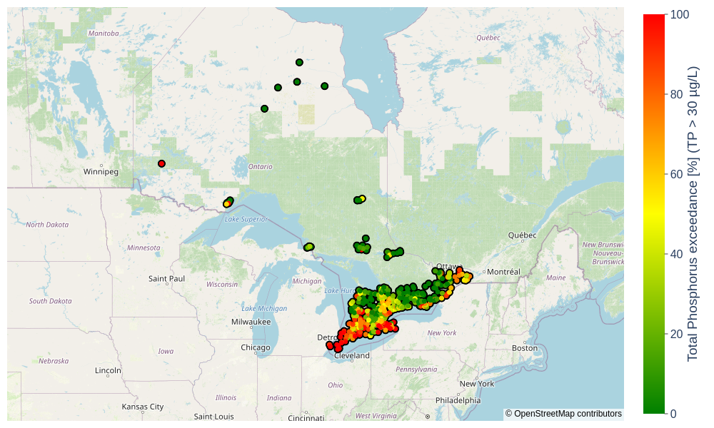
Figure 2 – PWQMN 2024 stations map (Total Phosphorus percent exceedance of PWQO).

Table 3 lists the top 10 stations by Total Phosphorus exceedance performance. All listed stations show 100% per-sample exceedance, indicating a persistent screening signal rather than a small number of isolated event-driven samples. These stations are efficient candidates for follow-up investigations, including upstream source screening (point sources, tile drainage, and stormwater inputs) and pairing Total Phosphorus with turbidity or suspended solids to distinguish particulate-bound versus dissolved contributions.
Table 3 – Top 10 stations – Total Phosphorus PWQO exceedance (2024).
Station | N | Median [µg/L] | P95 [µg/L] | Max [µg/L]
16002700102 (Sturgeon River) | 10 | 1,135.0 | 4,494.5 | 5,030.0
16003000302 (Lebo Drain) | 7 | 737.0 | 963.8 | 974.0
11000101302 (Oswego Creek) | 10 | 562.5 | 1,051.1 | 1,290.0
4001303302 (Big Creek) | 6 | 466.0 | 2,162.5 | 2,400.0
6000300102 (Four Mile Creek) | 9 | 364.0 | 3,500.8 | 5,400.0
4001000302 (Ruscom River) | 10 | 331.0 | 1,947.4 | 2,860.0
11000100702 (Welland River) | 10 | 278.0 | 496.9 | 500.0
6002400802 (Twenty Mile Creek) | 14 | 242.5 | 590.2 | 598.0
4001308102 (Mcgregor Creek) | 7 | 236.0 | 507.1 | 565.0
16007200102 (Dutton Drain) | 7 | 216.0 | 291.8 | 293.0

Figure 3 summarises monthly Total Phosphorus distributions (all sites combined). Medians are near the 30 µg/L PWQO in most months, while the upper whiskers exceed the PWQO throughout the year. This indicates that exceedances are frequent across the network and not solely driven by extreme outliers. Seasonal structure is visible in the spread: winter and mid-summer months show broader interquartile ranges, consistent with a combination of event-driven runoff (including snowmelt and storm events) and summer conditions that can amplify concentration variability through lower dilution and biological cycling.
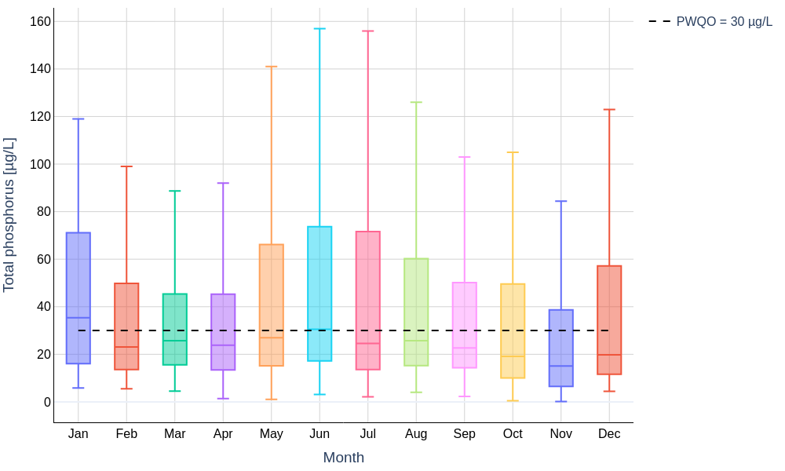
Figure 3 – Monthly box plot – Total Phosphorus (all sites combined, 2024).

6. Iron Analysis
Iron was screened against the PWQO of 300 µg/L. Provincially, 28.8% of screened samples exceeded the objective (613 exceedances of 2,132 samples), and 186 stations recorded at least one exceedance. Figure 4 maps station-level exceedance frequency, with higher frequencies concentrated in Southern Ontario.
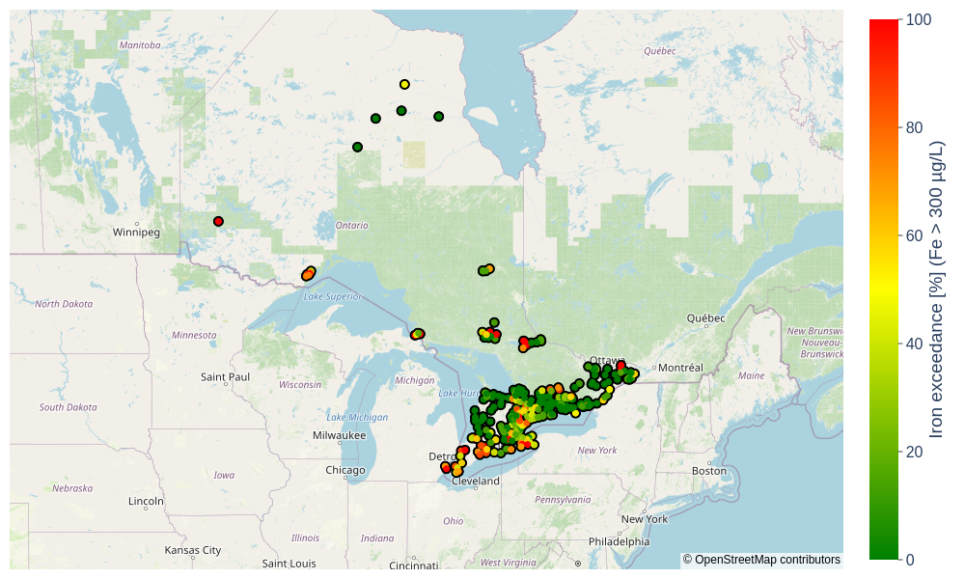
Figure 4 – PWQMN 2024 stations map (Iron percent exceedance of PWQO).

Table 4 lists the top 10 stations by iron exceedance performance. All listed stations show 100% per-sample exceedance, indicating persistent elevation at those sites. In practice, elevated iron can reflect particulate mobilisation (erosion, resuspension, and fine sediment transport) and/or natural sources such as groundwater influence in iron-rich geologies or peat-influenced catchments. Differentiating dissolved versus particulate iron is essential for selecting effective management responses.
Table 4 – Top 10 stations – Iron PWQO exceedance (2024).
Station | N | Median [µg/L] | P95 [µg/L] | Max [µg/L]
18207000802 (Cobbs Lake Creek) | 5 | 1,570.0 | 2,526.0 | 2,660.0
3013400302 (Emery Creek) | 7 | 1,320.0 | 2,385.0 | 2,400.0
1010700402 (Neebing River) | 8 | 1,085.0 | 1,899.5 | 1,910.0
13000300102 (Big Carp River) | 6 | 1,045.0 | 2,132.5 | 2,450.0
3013301502 (La Vase River) | 7 | 976.0 | 1,519.0 | 1,630.0
11000101302 (Oswego Creek) | 7 | 967.0 | 1,849.0 | 1,960.0
11000100702 (Welland River) | 7 | 948.0 | 1,480.0 | 1,540.0
3013301302 (Duchesnay River) | 7 | 803.0 | 1,071.0 | 1,080.0
16018409302 (Fairchild Creek) | 6 | 756.5 | 971.2 | 1,020.0
14002802802 (Whitson River) | 11 | 667.0 | 1,118.0 | 1,280.0

Figure 5 summarises monthly iron distributions (all sites combined). Medians are typically below 300 µg/L, indicating that typical conditions at many sites are compliant; however, the upper quartile frequently approaches or exceeds the PWQO, and upper whiskers exceed the PWQO in every month. The broader spreads in July and December are consistent with a combination of event/flow-driven mobilisation and seasonal changes in water chemistry and dilution. Pairing iron results with turbidity or suspended solids and sample flow condition (baseflow versus stormflow) would improve attribution of exceedance drivers.
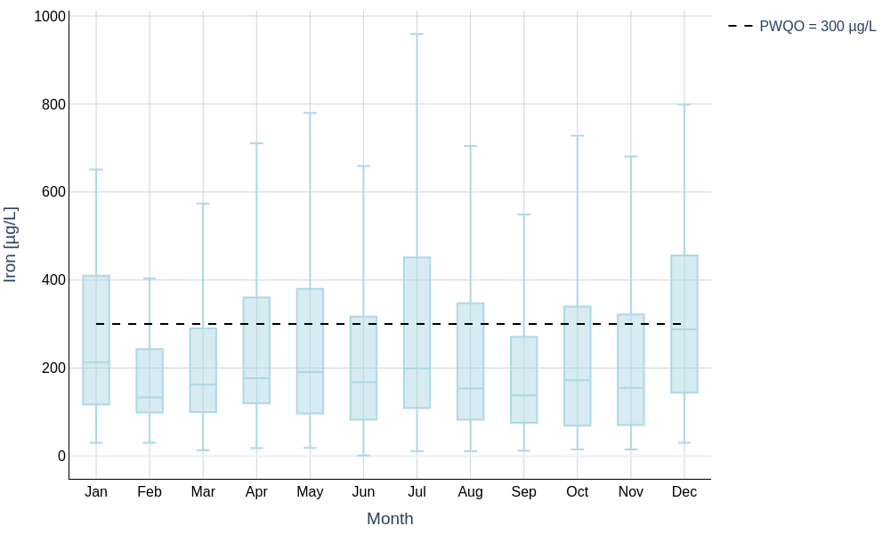
Figure 5 – Monthly box plot – Iron (all sites combined, 2024).

Figure 6 provides an all-sample time series view (log scale). The PWQO line is crossed throughout the year, supporting the interpretation that iron exceedances are not confined to one season and are driven by a mixture of baseline station characteristics and episodic events.
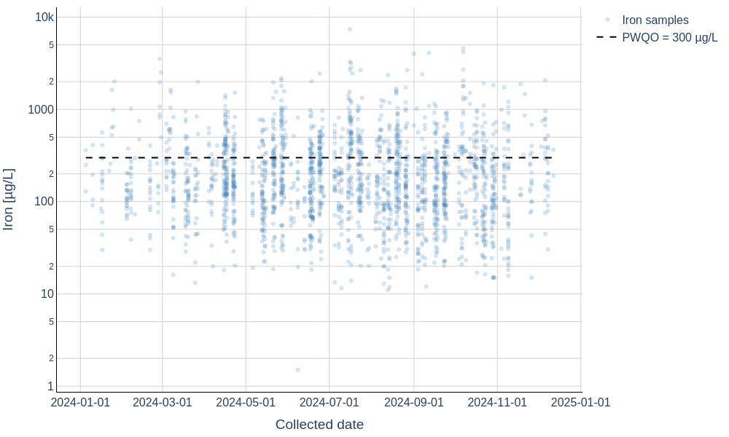
Figure 6 – Time series – Iron (all samples, 2024; log scale).

7. Conclusions and Recommendation
This 2024 screening assessment identified widespread objective exceedance signals for Total Phosphorus and Iron across the PWQMN network, with clear spatial clustering of higher-risk stations in Southern Ontario. The risk-tier framework (Table 2 and Figure 1) supports efficient prioritisation by focusing follow-up on Tier 4 and upper Tier 3 sites where chronic per-sample exceedances are most likely.
Key conclusions from the 2024 screen include:
- Total Phosphorus shows a strong, network-wide exceedance signal (40.1% per-sample exceedance) and multiple stations with 100% exceedance and high medians (Table 3), indicating persistent enrichment at priority sites.
- Iron exceedances (28.8% per-sample exceedance) are widespread, with several stations exhibiting 100% exceedance and high upper tails (Table 4), consistent with both sediment mobilisation and possible natural-source contributions.
- Detection limits can prevent compliance assessment for some analytes (notably Silver), requiring improved reporting limits if compliance screening is desired for those parameters.

Recommended follow-up actions (highest value first) are:
- Tier 4 and upper Tier 3 station review: confirm repeatability across years, review upstream land use and potential point sources, and confirm whether sampling is biased toward storm events or specific seasons.
- Phosphorus source attribution at priority sites: pair Total Phosphorus with suspended solids/turbidity and, where feasible, dissolved (filtered) phosphorus fractions to determine whether exceedances are predominantly particulate-driven.
- Iron speciation and transport assessment: add dissolved/filtered iron where feasible and routinely capture turbidity or suspended solids at sampling to distinguish sediment-associated transport from groundwater-driven dissolved iron.
- Objective-application refinements: apply formal objective requirements where applicable (e.g., geometric mean criteria for E. coli where sufficient sample counts exist), and evaluate sensitivity to non-detect treatment choices for summary statistics.
- Address detection-limit constraints: for analytes where objectives fall below typical MDLs, evaluate laboratory methods and reporting limits needed to support meaningful compliance assessment.

Additional analyses that could further strengthen interpretation include trend comparisons to prior years, watershed-scale aggregation by basin, event versus baseflow stratification (where flow data are available), and multivariate screening (e.g., correlation of Total Phosphorus and Iron exceedances with suspended solids and turbidity).

Appendix A. Detailed Analytes Table
Appendix A provides detailed screening metrics by analyte for parameters with provincial objectives. Statistics are based on the ½MDL substitution approach for non-detect results as described in Section 2.2.

Appendix A. Detailed Analytes Table
Table 5 summarises detailed screening metrics by analyte. For pH-dependent and hardness-adjusted objectives, screening was applied only where required supporting data were available.
Table 5 – Detailed analytes screening summary
Analyte | Objective | N Samples | N exceedances | % exceedances | N stations >=1 exceedance | % non-detect | Median | 95th percentile
Aluminum | pH-dependent | 2,134 | 906 | 42.5 | 218 | 3.0 | 56.7 µg/L | 643.0 µg/L
Arsenic | 5.0 µg/L | 199 | 28 | 14.1 | 7 | 39.2 | 1.0 µg/L | 21.1 µg/L
Boron | 200.0 µg/L | 93 | 0 | 0.0 | 0 | 48.4 | 10.0 µg/L | 75.6 µg/L
Cadmium | Hardness-adjusted | 2,134 | 112 | 5.2 | 86 | 94.8 | 0.45 µg/L | 1.01 µg/L
Chromium | 1.0 µg/L | 2,070 | 200 | 9.7 | 113 | 90.0 | 0.5 µg/L | 2.5 µg/L
Copper | Hardness-adjusted | 2,133 | 199 | 9.3 | 80 | 8.0 | 1.79 µg/L | 6.552 µg/L
E. coli | 100 MPN/100 mL | 216 | 123 | 56.9 | 21 | 0.0 | 131.5 | 3,275.0
Iron | 300.0 µg/L | 2,132 | 613 | 28.8 | 186 | 0.4 | 168.0 µg/L | 919.8 µg/L
Lead | Hardness-adjusted | 2,132 | 1 | 0.0 | 1 | 99.3 | 3.5 µg/L | 3.5 µg/L
Mercury | 0.2 µg/L | 142 | 0 | 0.0 | 0 | 95.8 | 2.5 ng/L | 2.5 ng/L
Nickel | 25.0 µg/L | 2,134 | 31 | 1.5 | 7 | 82.1 | 1.0 µg/L | 6.277 µg/L
Total Phosphorus | 30.0 µg/L | 3,666 | 1,469 | 40.1 | 312 | 0.1 | 23.6 µg/L | 237.75 µg/L
Selenium | 100.0 µg/L | 95 | 0 | 0.0 | 0 | 100.0 | 2.5 µg/L | 2.5 µg/L
Silver | 0.1 µg/L | 2,117 | 0 | 0.0 | 0 | 100.0 | 4.5 µg/L | 4.5 µg/L
Zinc | 20.0 µg/L | 2,114 | 182 | 8.6 | 76 | 5.8 | 4.86 µg/L | 29.835 µg/L
pH | 6.5–8.5 SU | 3,669 | 157 | 4.3 | 90 | 0.0 | 8.23 | 8.49

