Municipal WWTP Anaerobic Digester Stability Assessment (Jun 2018–Jan 2019)
  - 16 March 2026

Table of Contents
1. Introduction 4
2. Objectives 4
3. Description of Dataset 4
4. Analysis 4
4.1 Stability indicators (VFA, alkalinity, VFA/alkalinity, and pH) 8
4.2 Performance indicators (biogas and volatile solids destruction) 8
4.3 Cross-digester comparison 8
4.4 Quantitative event summary 8
5. Key Findings 9
6. Recommendations 10
6.1 Immediate operational controls (protect stability) 10
6.2 Root-cause investigation (plant-wide drivers) 10
6.3 Targeted unit follow-up (Digester 3 recovery lag) 10
6.4 Further analysis to strengthen conclusions 11

Figures
Figure 1 – VFA/alkalinity ratio time series for Digesters 1–3, including stability and instability thresholds. 5
Figure 2 – VFA time series for Digesters 1–3 with typical stress and upset thresholds. 5
Figure 3 – pH time series for Digesters 1–3 with a typical stable operating band. 6
Figure 4 – Alkalinity time series for Digesters 1–3 with indicative lower and upper buffering targets. 6
Figure 5 – Biogas production time series for Digesters 1–3 showing synchronised decline and recovery. 7
Figure 6 – Volatile solids destruction time series for Digesters 1–3 with indicative performance band. 7

Tables
Table 1 – Key stability and performance extreme points and threshold exceedance dates (derived from daily monitoring). 8
Table 2 – Selected minima during the upset (biogas and volatile solids destruction). 9
Table 3 – Average biogas production by phase (indicative windows based on observed trends). 9

1. Introduction
This report assesses anaerobic digester stability for a municipal wastewater treatment plant using daily monitoring data for three digesters. The analysis focuses on indicators of process imbalance (volatile fatty acids and buffering), biological response (pH and volatile solids destruction), and outcome performance (biogas production). Emphasis is placed on identifying plant-wide process issues, likely causes, and operational actions to prevent recurrence.

2. Objectives
The objectives of this assessment are to quantify the timing and severity of any instability event(s), evaluate how the three digesters responded, and identify plausible plant-wide drivers consistent with the observed trends.
Specifically, this report aims to:
- Characterise stability using VFA/alkalinity ratio, VFA concentration, and pH.
- Quantify performance impacts using biogas production and volatile solids destruction.
- Identify evidence for common-cause versus unit-specific issues and propose operational controls and investigations.

3. Description of Dataset
The dataset (digester_data_3.csv) contains 221 daily records from 01 Jun 2018 to 07 Jan 2019. For each of three anaerobic digesters, the following parameters are provided: VFA (mg/L as acetic), alkalinity (mg/L as CaCO3), VFA/alkalinity ratio, pH, volatile solids destruction (%), and biogas production (m³/day). The time step is one day and all series are complete (no missing values).

4. Analysis
Time-series review indicates a synchronised process upset affecting all three digesters. Based on the first day all units exceeded a VFA/alkalinity ratio of 0.30 (instability trigger), the common upset onset is estimated at 09 Oct 2018. A partial recovery is indicated by the first return below a ratio of 0.10 among the digesters by 07 Jan 2019. These boundaries are indicative and should be reconciled against operating logs (feed rates, temperature, mixing, and chemical dosing).
Figures 1 to 6 summarise the primary stability and performance indicators. Taken together, the trends are consistent with a plant-wide organic overload or methanogenic inhibition beginning in late September, followed by operational response (buffering restoration) and gradual biological recovery. The coherence across digesters reduces the likelihood of a single instrument error or isolated unit upset.
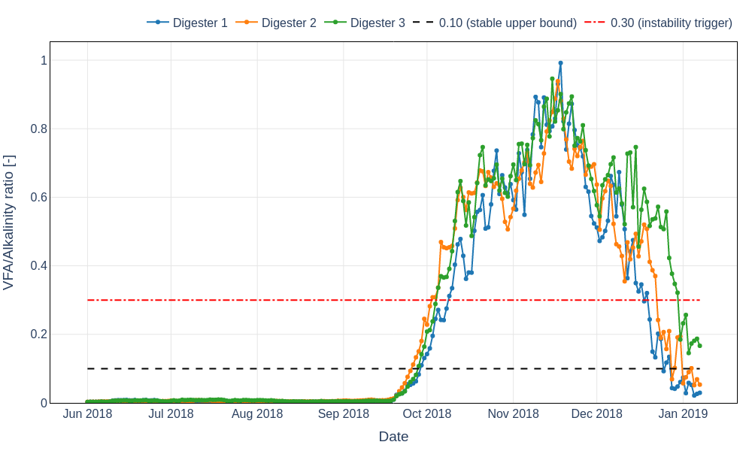
Figure 1 – VFA/alkalinity ratio time series for Digesters 1–3, including stability and instability thresholds.

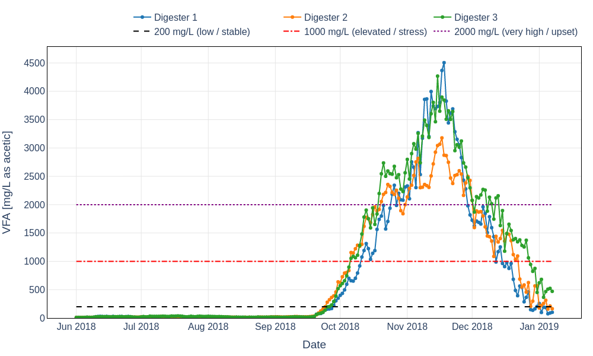
Figure 2 – VFA time series for Digesters 1–3 with typical stress and upset thresholds.

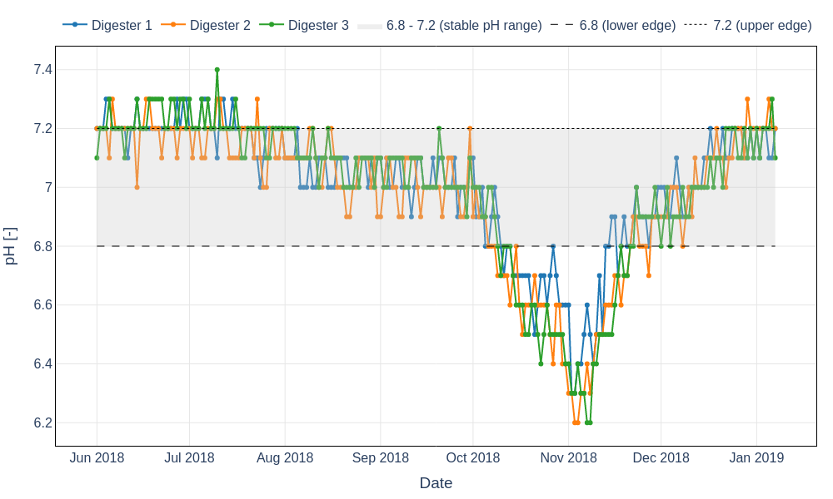
Figure 3 – pH time series for Digesters 1–3 with a typical stable operating band.

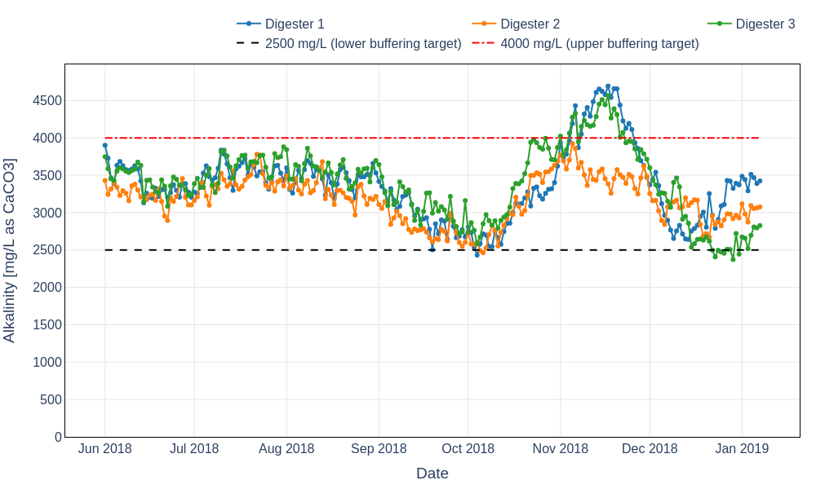
Figure 4 – Alkalinity time series for Digesters 1–3 with indicative lower and upper buffering targets.

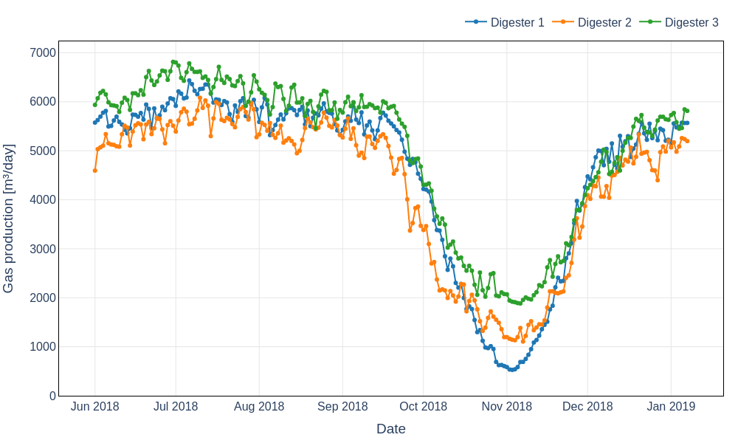
Figure 5 – Biogas production time series for Digesters 1–3 showing synchronised decline and recovery.

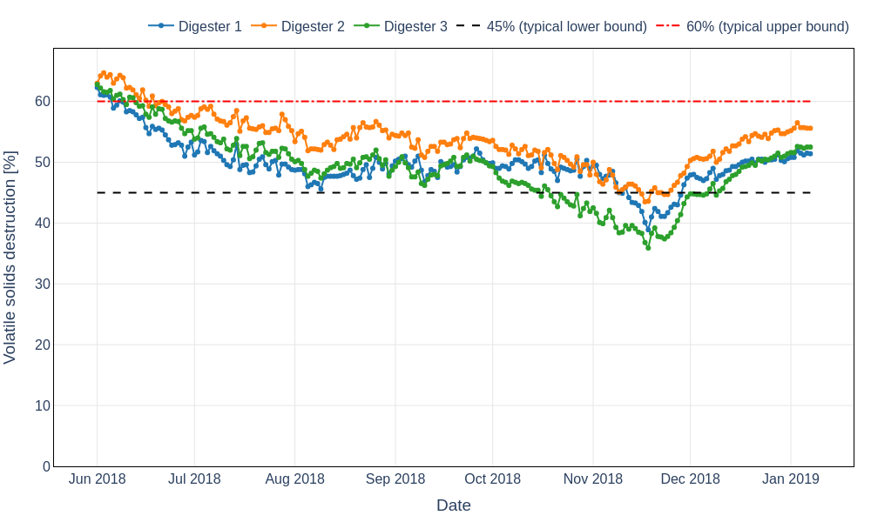
Figure 6 – Volatile solids destruction time series for Digesters 1–3 with indicative performance band.

4.1 Stability indicators (VFA, alkalinity, VFA/alkalinity, and pH)
Figure 1 shows a step-change in VFA/alkalinity ratio from very low values through mid-September to sustained instability across all digesters in October and November, with peaks approaching 1.0. Figure 2 confirms that this ratio increase is driven by a rapid VFA accumulation to several thousand mg/L, while Figure 4 indicates alkalinity was initially consumed (reduced buffering) and later increased sharply, consistent with a corrective buffering response (e.g., restored chemical addition or operational changes). Figure 3 shows concurrent pH depression to approximately 6.2–6.3 in early November, consistent with acid accumulation.
The combined pattern (high VFA and VFA/alkalinity ratio, depressed pH, and subsequent alkalinity increase) is typical of a digester imbalance where acidogenesis outpaces methanogenesis. Given all three digesters moved together, the most probable drivers are plant-wide: a step increase in organic loading rate, a change in sludge blend (e.g., increased primary solids or FOG), interruption/reduction of alkalinity addition, temperature/heating disturbance, or an inhibitory/toxic input that reduced methanogenic activity.

4.2 Performance indicators (biogas and volatile solids destruction)
Figure 5 shows a pronounced and synchronised biogas production crash beginning late September/early October, aligned with the onset of VFA accumulation and pH decline (Figures 2 and 3). This is strong evidence of biological inhibition or overload rather than a sampling artifact. Figure 6 shows volatile solids destruction trending downward through summer and then dropping further during the peak upset period, consistent with reduced conversion efficiency and methane yield.
Notably, gas production begins recovering by late November to December while VFA/alkalinity ratio remains elevated for longer (Figure 1). This is consistent with a phased recovery where buffering and operating conditions improved first, followed by gradual conversion of accumulated intermediates. Alternatively, it may reflect changes in loading, gas capture efficiency, or operational strategies (e.g., temporary feed reduction) that improved gas output before full stabilisation of the VFA inventory.

4.3 Cross-digester comparison
Digesters 1 and 2 show a faster return to lower VFA/alkalinity ratio by late December to early January compared to Digester 3 (Figure 1). Digester 3 also maintains higher VFAs into late December (Figure 2) and experiences a late-December alkalinity dip (Figure 4), which would elevate its ratio and slow apparent recovery. This suggests either (a) different feed allocation during the recovery period, (b) local limitations such as mixing/heating effectiveness, or (c) residual inhibition specific to Digester 3.

4.4 Quantitative event summary
Table 1 summarises the peak severity and minimum performance points for each digester, including the timing of key threshold exceedances. These values support the interpretation that the upset was severe, prolonged, and synchronised, with some differences in recovery trajectory.
Table 1 – Key stability and performance extreme points and threshold exceedance dates (derived from daily monitoring).
Metric | Digester 1 | Digester 2 | Digester 3
First VFA/Alk > 0.30 | 09 Oct 2018 | 03 Oct 2018 | 05 Oct 2018
First VFA > 1,000 mg/L | 11 Oct 2018 | 06 Oct 2018 | 06 Oct 2018
Max VFA (mg/L) (date) | 4,505 (18 Nov 2018) | 3,178 (17 Nov 2018) | 4,268 (15 Nov 2018)
Max VFA/Alk ratio (date) | 0.99 (18 Nov 2018) | 0.94 (17 Nov 2018) | 0.95 (15 Nov 2018)
Min pH (date) | 6.3 (02 Nov 2018) | 6.2 (03 Nov 2018) | 6.2 (07 Nov 2018)

Additional performance minima during the upset are summarised in Table 2.
Table 2 – Selected minima during the upset (biogas and volatile solids destruction).
Metric | Digester 1 | Digester 2 | Digester 3
Min gas (m³/day) (date) | 528 (03 Nov 2018) | 1,107 (07 Nov 2018) | 1,884 (06 Nov 2018)
Min VS destruction (%) (date) | 38.9 (18 Nov 2018) | 43.5 (17 Nov 2018) | 35.9 (18 Nov 2018)

Table 3 – Average biogas production by phase (indicative windows based on observed trends).
Metric | Digester 1 | Digester 2 | Digester 3
Mean gas (m³/day) stable | 5,786 | 5,449 | 6,190
Mean gas (m³/day) upset | 2,008 | 2,004 | 2,752
Mean gas (m³/day) recovery | 5,341 | 4,966 | 5,545

5. Key Findings
The following findings synthesise the evidence across Figures 1 to 6 and Tables 1 to 3. They are framed as process-engineering observations that can be traced to specific indicators in the monitoring data.
- A plant-wide instability event began in late September 2018, evidenced by simultaneous increases in VFA and VFA/alkalinity ratio and a pH decline across all digesters (Figures 1 to 3; Table 1).
- VFA/alkalinity ratios exceeded 0.30 across all units and peaked near 1.0, indicating severe buffering imbalance and high risk of sustained methanogenic inhibition (Figure 1; Table 1).
- Biogas production collapsed synchronously, with the most severe absolute minimum in Digester 1, confirming a true biological/process performance failure rather than isolated measurement noise (Figure 5; Tables 2 and 3).
- Alkalinity decreased during upset onset and later increased significantly, consistent with buffering consumption followed by corrective alkalinity restoration; pH recovered faster than VFA/alkalinity ratio, indicating partial control recovery before full biological conversion (Figures 3 and 4).
- Volatile solids destruction declined prior to the main upset (summer trend), suggesting reduced resilience before the shock load/inhibition, and reached minima concurrent with peak VFA/ratio conditions (Figure 6; Table 2).
- Digester 3 showed the slowest recovery in VFA and VFA/alkalinity ratio, consistent with a local limitation (mixing/heating, feed allocation) or a later reduction in alkalinity relative to VFA (Figures 1, 2, and 4).

6. Recommendations
Recommendations below are prioritised to (i) prevent recurrence of the observed late-September upset, (ii) shorten recovery if a future shock occurs, and (iii) improve diagnostic capability to isolate root causes.

6.1 Immediate operational controls (protect stability)
Given the magnitude of VFA accumulation and gas crash (Figures 2 and 5), stability protection should focus on controlling loading rate, maintaining buffering capacity, and ensuring temperature and mixing are robust during seasonal transitions.
- Implement an operating action plan triggered by VFA/alkalinity ratio thresholds (e.g., 0.10 early warning; 0.30 instability), including staged feed reduction, increased monitoring frequency, and verification of alkalinity dosing systems.
- Maintain a minimum alkalinity target and review alkalinity addition capacity and reliability; ensure dosing and instrumentation are alarmed and trended with operator response requirements (Figure 4).
- Review digester temperature control and mixing availability around late September to early November (heater status, mixing outages, foam events), as these are common-cause drivers consistent with the synchronised response (Figures 1 to 5).

6.2 Root-cause investigation (plant-wide drivers)
The synchronised onset across all three digesters strongly suggests a shared upstream or site-wide change. The investigation should concentrate on changes that occurred in the 2–3 weeks preceding the onset of the VFA rise.
- Compile a timeline of sludge feed rate, feed VS/TS, primary-to-WAS blend ratio, FOG inputs, and any hauled waste acceptance changes; test whether a step change aligns with the first exceedance dates in Table 1.
- Review sidestream returns (e.g., dewatering centrate) and chemical additions (polymer, metal salts) for indirect inhibition pathways and buffering impacts.
- Screen for toxicity/inhibition signals (e.g., industrial discharges, cleaning events, high sulfide or ammonia episodes if data exist) that could suppress methanogenesis while allowing acidogenesis to continue.

6.3 Targeted unit follow-up (Digester 3 recovery lag)
Digester 3’s slower recovery (Figures 1 and 2) warrants a targeted check for unit-specific limitations that can be corrected without plant-wide changes.
- Verify digester-specific mixing intensity, heat exchanger performance, and short-circuiting risk; compare temperature profiles and mixing runtime to Digesters 1 and 2 during the recovery period.
- Confirm feed distribution and any operational constraints that could have resulted in higher effective loading or less buffering to Digester 3 in December (Figure 4).

6.4 Further analysis to strengthen conclusions
The dataset is sufficient to identify the upset and quantify its severity, but additional analyses would improve root-cause discrimination and provide more defensible operating limits.
- Perform lagged correlation analysis between VFA/alkalinity ratio and biogas production (and VS destruction) to estimate response time constants and recovery kinetics.
- Segment the time series into regimes (stable, upset, recovery) and compute control-chart style statistics to define site-specific early-warning thresholds beyond generic guidance.
- If feed and temperature data are available, calculate organic loading rate and compare against estimated digester capacity; evaluate whether the upset is consistent with overload versus inhibition.

