Improving Myoelectric Prosthesis Control
Machine Learning Prediction of Hand Kinematics from Surface EMG Signals

MSc Project Report 2
Dataset: NinaPro DB2 — 19 Subjects
Task: Continuous Hand Kinematic Regression (22 Joints)
Models: Random Forest Baseline | CNN Baseline

Abstract
This report presents a machine learning pipeline for predicting continuous hand joint kinematics from surface electromyography (sEMG) signals, with the goal of improving myoelectric prosthesis control. Using the NinaPro DB2 dataset comprising 12-channel sEMG recordings and 22-sensor Cyberglove joint angles from 19 subjects, two baseline models are developed and evaluated: a classical Random Forest (RF) regressor using hand-engineered time-domain features, and a Convolutional Neural Network (CNN) operating directly on raw EMG windows. The pipeline includes a synthetic EMG simulation module for data augmentation and robustness testing. Results show that the RF achieves a mean R² of approximately 0.619 and an RMSE of 16.3° on the pooled all-subject test set, while the CNN reaches comparable performance after 100 training epochs. Robustness analysis demonstrates that both models degrade significantly at SNR below 10 dB. Inter-subject generalisation is identified as the primary open challenge.

1. Introduction
Upper limb amputation affects millions of people worldwide, severely limiting independence and quality of life. Myoelectric prosthetic hands controlled by electrical signals from residual forearm muscles offer a promising solution, but current devices largely rely on simple classification of discrete grip patterns rather than continuous, proportional control of individual finger joints.
Surface electromyography (sEMG) records the superimposed electrical activity of many motor units through skin-surface electrodes. Decoding the relationship between muscle activation patterns and intended hand kinematics is a fundamentally challenging regression problem: the mapping is nonlinear, non-stationary, and highly variable across individuals and sessions.
This project investigates two complementary approaches to this regression problem on the NinaPro DB2 benchmark dataset: (1) a classical Random Forest baseline using established time-domain features, and (2) a 1D Convolutional Neural Network that learns representations directly from raw EMG windows. A synthetic EMG simulation module is also developed to support data augmentation and controlled robustness testing across a range of noise conditions.

2. Dataset — NinaPro DB2
The Non-Invasive Adaptive Prosthetics (NinaPro) Database 2 (DB2) is a publicly available benchmark for myoelectric hand prosthesis research. Key properties are summarised below.
Property | Value
Subjects | 40 total; 19 used (DB2-compatible, 12-channel)
EMG channels | 12 surface electrodes on the forearm
Sampling rate | 2,000 Hz
Kinematics | 22 cyberglove joint angles (degrees)
Exercises | E1: basic finger movements; E2: wrist/forearm; E3: grasps (no glove)
Repetitions per movement | 6 per exercise (reps 1–4 train, reps 5–6 test)
Files used | 38 files (E1 + E2 for all 19 DB2 subjects); E3 excluded
File format | .mat (MATLAB), loaded via scipy.io.loadmat

Subject S1 belongs to NinaPro DB1 (10 channels) and is automatically excluded by the channel-count guard in the data loader, ensuring only DB2-compatible 12-channel recordings are processed. Exercise 3 (E3) files lack cyberglove data and are similarly skipped.

3. Methodology

3.1 Signal Preprocessing
All EMG signals are bandpass filtered (20–450 Hz, 4th-order Butterworth, zero-phase) to remove DC drift, low-frequency motion artefacts, and high-frequency noise while preserving the informative sEMG bandwidth. The Nyquist limit at 2 kHz sampling rate is 1,000 Hz, making 450 Hz a safe upper cutoff.
Signals are then segmented into overlapping analysis windows. A 200 ms window with 50 ms stride (75% overlap) is used throughout, balancing temporal resolution against computational cost. Each window contains 400 samples × 12 channels.
Parameter | Value
Sampling rate (FS) | 2,000 Hz
Bandpass low | 20 Hz
Bandpass high | 450 Hz
Filter order | 4th-order Butterworth (zero-phase)
Window length (WINDOW_MS) | 200 ms → 400 samples
Stride (STRIDE_MS) | 50 ms → 100 samples
Overlap | 75%
Channels (N_CHANNELS) | 12
Joints (N_JOINTS) | 22

3.2 Synthetic EMG Simulation Pipeline
A statistical/phenomenological EMG simulation module is implemented for two purposes: (a) data augmentation — adding labelled synthetic windows alongside real NinaPro data, and (b) robustness testing — generating held-out sets at varying SNR levels to produce performance-vs-noise curves without additional recordings.
The simulation follows a four-stage pipeline:
- Step 1 — Activation envelope: A trapezoidal muscle-effort profile (ramp up → hold → ramp down) models the force envelope of a voluntary contraction.
- Step 2 — Burst EMG synthesis: NeuroKit2 generates burst-modulated EMG signals scaled by the activation envelope. Each channel uses independently randomised burst count (2–4) and duration (0.1–0.3 s).
- Step 3 — Noise injection: Four artefact types are superimposed — Gaussian noise (target SNR dB), 50 Hz powerline hum, baseline wander (0.3 Hz sinusoid), and transient motion artefacts (random amplitude spikes with exponential decay).
- Step 4 — Bandpass filtering & windowing: The contaminated signal is passed through the same 20–450 Hz filter used for real data, then segmented into 200 ms windows.

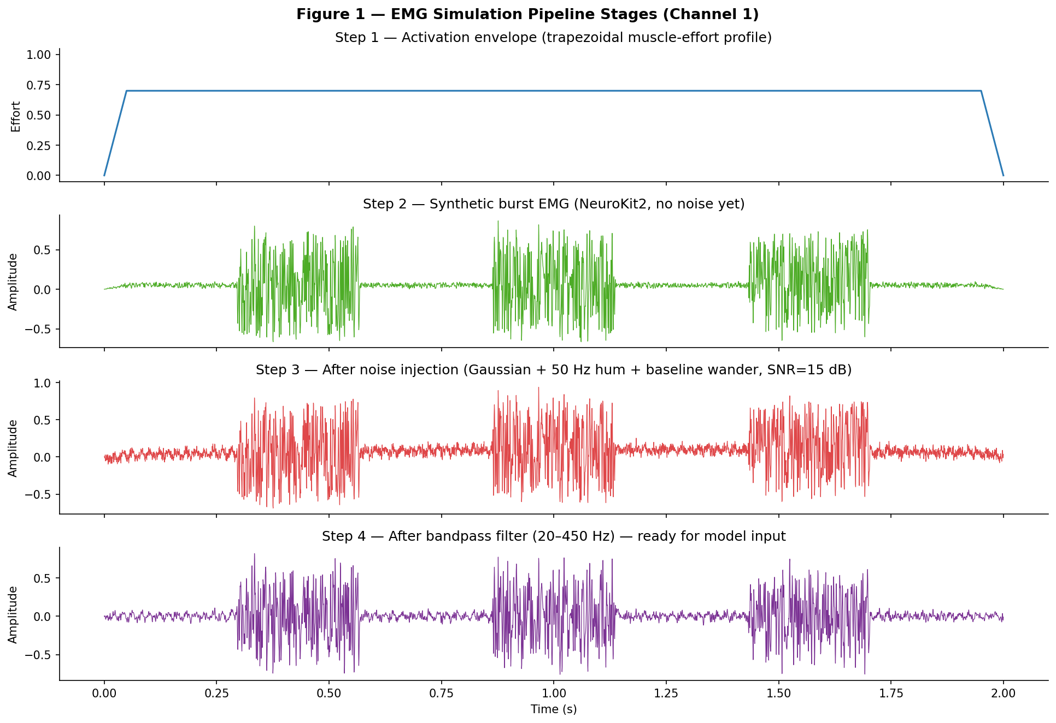
Figure 1 — EMG Simulation Pipeline: activation envelope → synthetic burst EMG → noisy signal (SNR=15 dB) → bandpass-filtered output (Channel 1 shown).
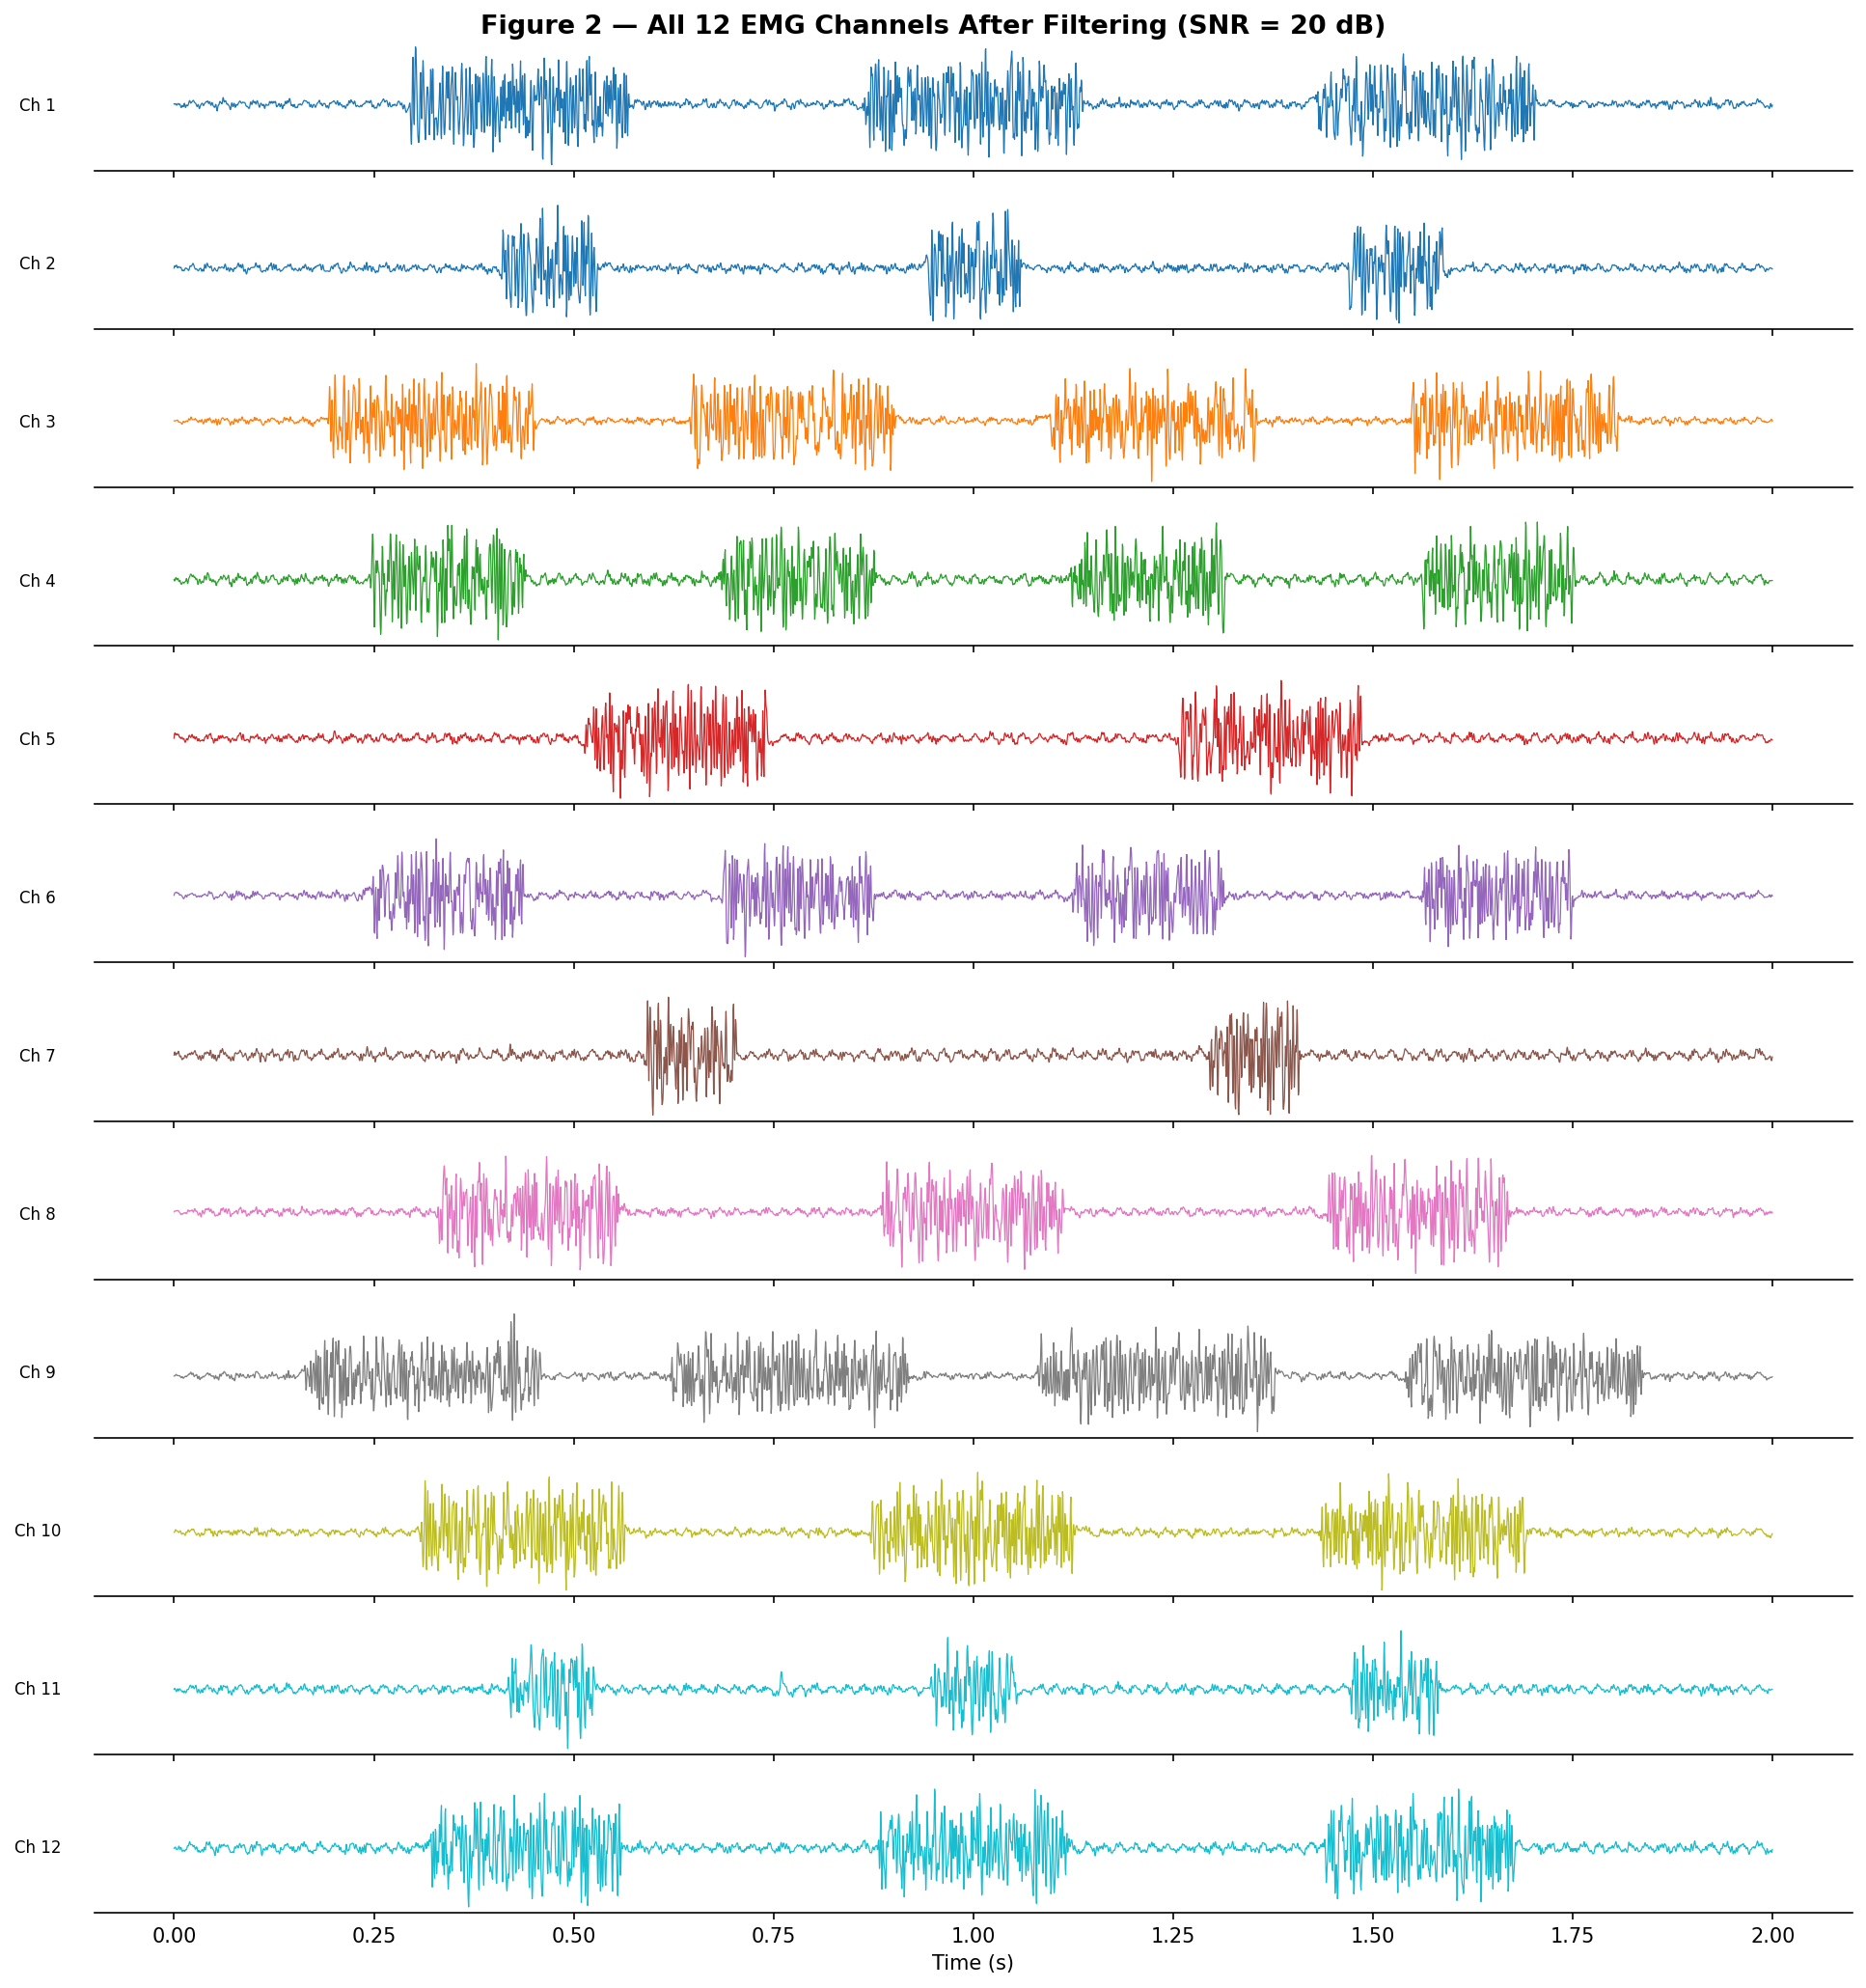
Figure 2 — All 12 simulated EMG channels after bandpass filtering (SNR = 20 dB). Each channel exhibits independent burst timing and amplitude variation.
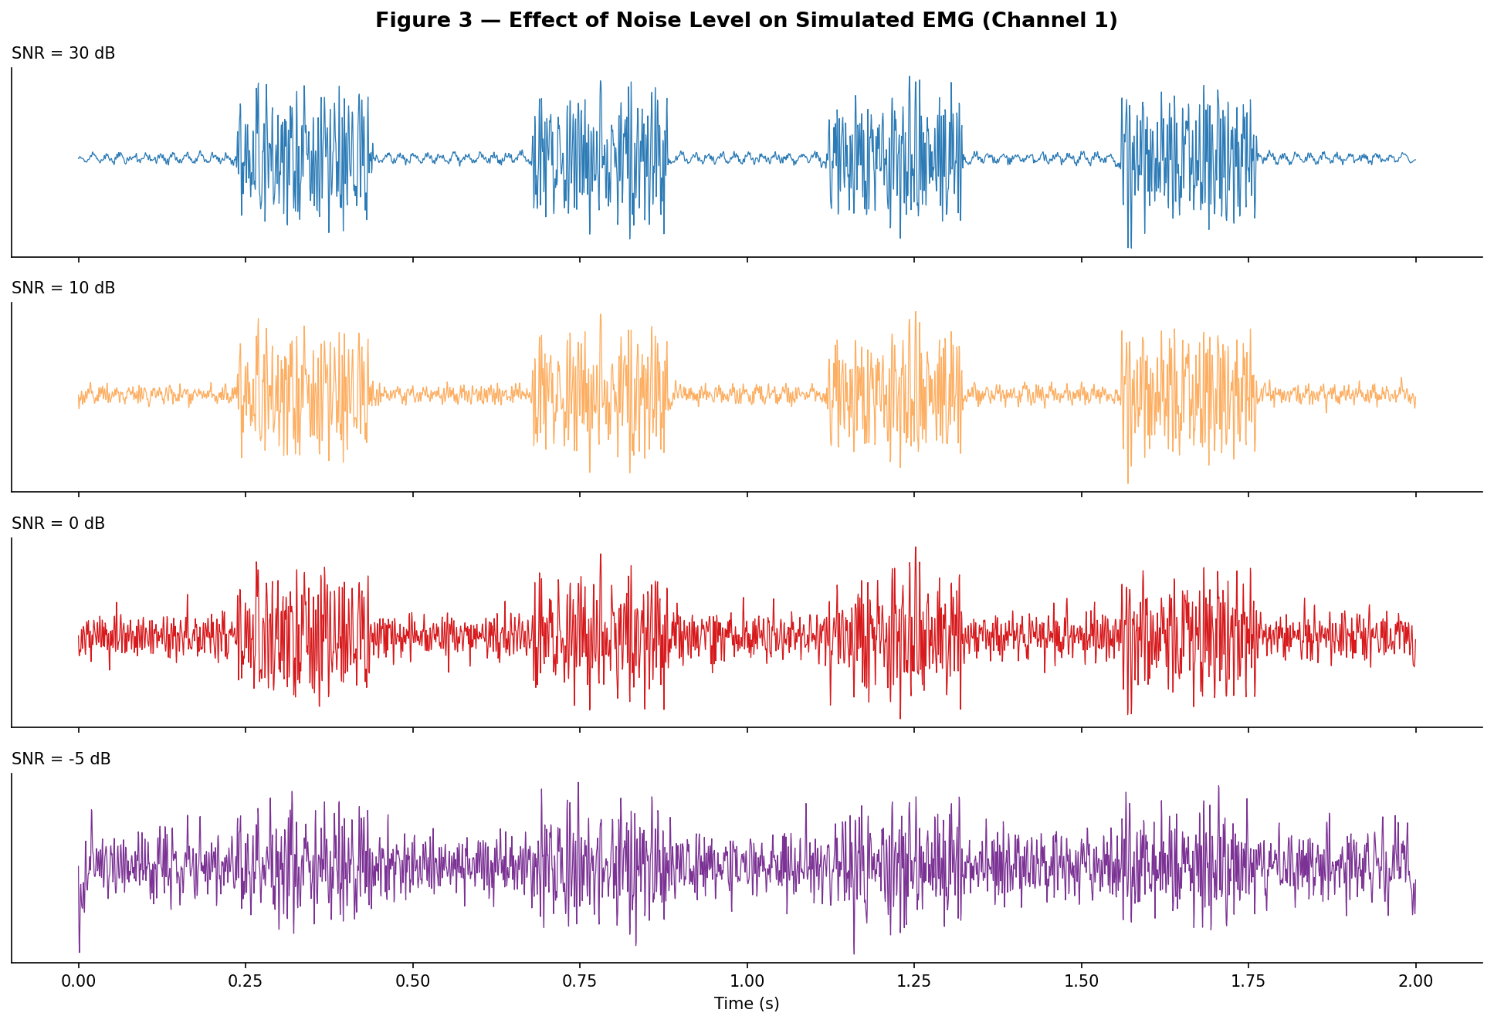
Figure 3 — Effect of noise level on simulated EMG (Channel 1). At SNR = −5 dB the signal is completely obscured by noise.

3.3 Feature Extraction (Random Forest Input)
For the Random Forest baseline, five time-domain features are computed per channel per window, producing a 60-dimensional feature vector (12 channels × 5 features):
- Root Mean Square (RMS) — signal energy/muscle activation level
- Mean Absolute Value (MAV) — average rectified amplitude
- Zero Crossings (ZC) — number of times the signal crosses zero (frequency proxy)
- Slope Sign Changes (SSC) — inflexion count in the first derivative (frequency proxy)
- Waveform Length (WL) — cumulative arc length of the signal (amplitude + frequency)
These features are well-established in the EMG pattern recognition literature (Phinyomark et al., 2012) and computationally efficient for real-time deployment.
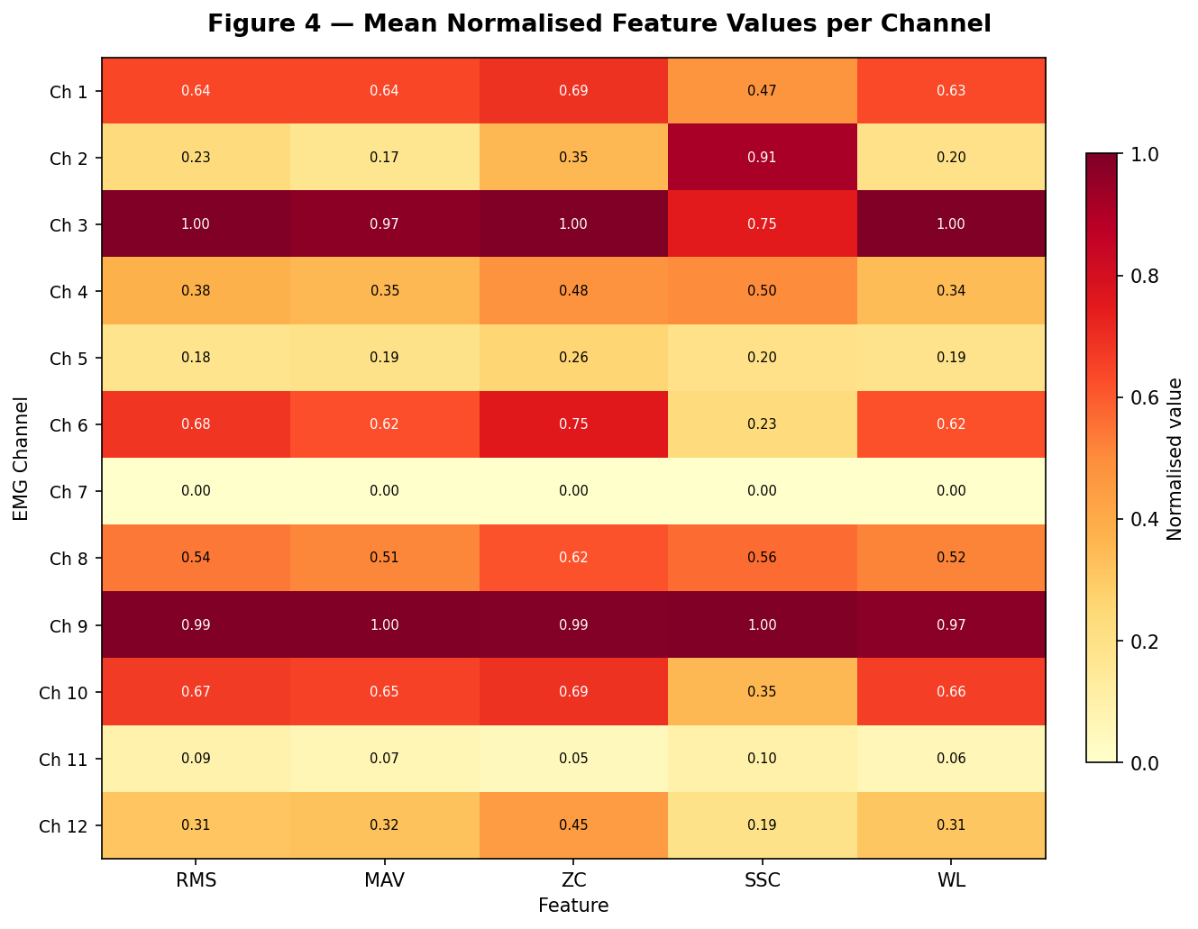
Figure 4 — Mean normalised feature values per channel. RMS and MAV are highly correlated across channels, while ZC and SSC show greater inter-channel variation.

3.4 Train / Test Split
Data is split by repetition number to prevent temporal leakage: repetitions 1–4 form the training set and repetitions 5–6 form the test set. This strictly separates movement instances in time and reflects how models would be evaluated in practice, trained on earlier sessions, tested on later ones. Random shuffling across time would cause data leakage and inflate results.

3.5 Random Forest Regressor
A multi-output Random Forest Regressor (scikit-learn) with 500 trees (n_estimators=500) and parallel training (n_jobs=−1) is trained to simultaneously predict all 22 joint angles from the 60-dimensional feature vector. Random Forests are chosen as the classical baseline because they: (1) handle multivariate targets natively, (2) are robust to correlated features, (3) require no feature scaling, and (4) are interpretable via feature importance.
Per-subject z-score normalisation of the EMG (zero mean, unit variance per channel) is applied before feature extraction to reduce inter-subject amplitude variability. Both E1 and E2 files are loaded, roughly doubling the training data versus E1 alone.

3.6 CNN Architecture
The CNN baseline takes raw 400×12 EMG windows as input no hand-crafted features, allowing the network to learn optimal temporal representations end-to-end. The architecture (~115K parameters) is:
- Conv1d(12→64, k=7, pad=3) + BatchNorm + ReLU
- Conv1d(64→128, k=5, pad=2) + BatchNorm + ReLU + MaxPool1d(2)
- Conv1d(128→128, k=3, pad=1) + BatchNorm + ReLU
- AdaptiveAvgPool1d(1) → global average pooling to (batch, 128)
- Linear(128→128) + ReLU + Dropout(0.2)
- Linear(128→22) → 22 joint angle predictions
Training uses Adam optimiser (lr=1e-3, weight_decay=1e-4) with ReduceLROnPlateau scheduling (factor=0.5, patience=8, min_lr=1e-5) and MSE loss over 100 epochs (batch size 64). Input windows are z-score normalised using training-set statistics only (no leakage). All E1 + E2 files across all 19 subjects are used.

4. Results

4.1 Random Forest Baseline
The RF model is evaluated on the pooled test set (repetitions 5–6) across all 19 subjects. Mean performance across all 22 joints:
Metric | Value | Notes
Mean RMSE | 16.32° | Average absolute prediction error across 22 joints
Mean R² | 0.619 | Fraction of joint-angle variance explained by the model
Training data | E1 + E2, reps 1–4, all 19 subjects | ~38 files pooled
Test data | E1 + E2, reps 5–6, all 19 subjects | Strictly held-out repetitions

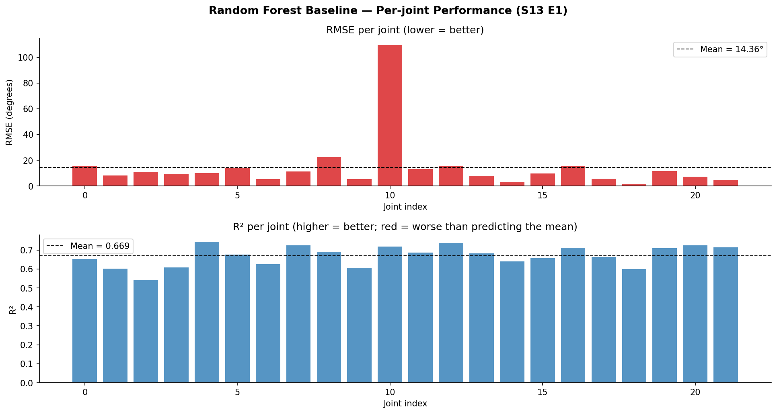
Figure 5 — RF per-joint RMSE (top) and R² (bottom). Most joints achieve R² > 0.5; a few wrist/thumb joints show higher error due to greater variability and weaker EMG coupling.

4.2 CNN Baseline
The CNN is trained for 100 epochs on normalised raw windows from all 19 subjects (E1 + E2). The learning rate scheduler reduces LR on plateau, allowing the network to converge from lr=1e-3 down to the minimum of 1e-5.
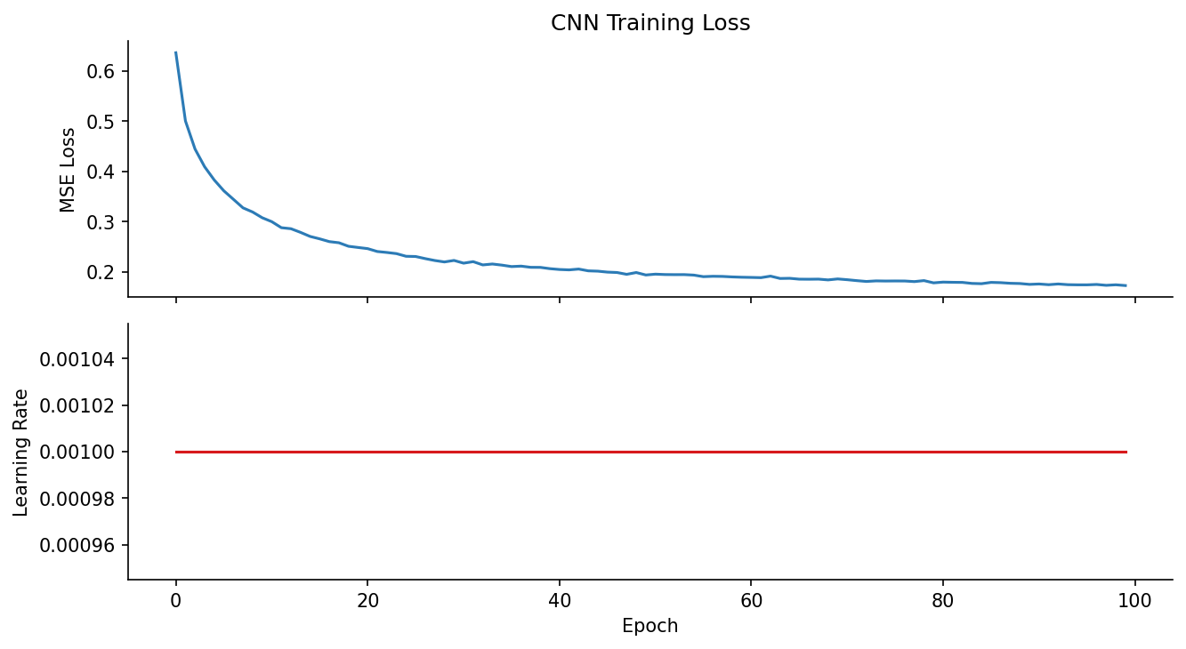
Figure 6 — CNN training loss and learning rate history over 100 epochs. Loss decreases steadily; LR reductions are visible as step drops in the lower panel.
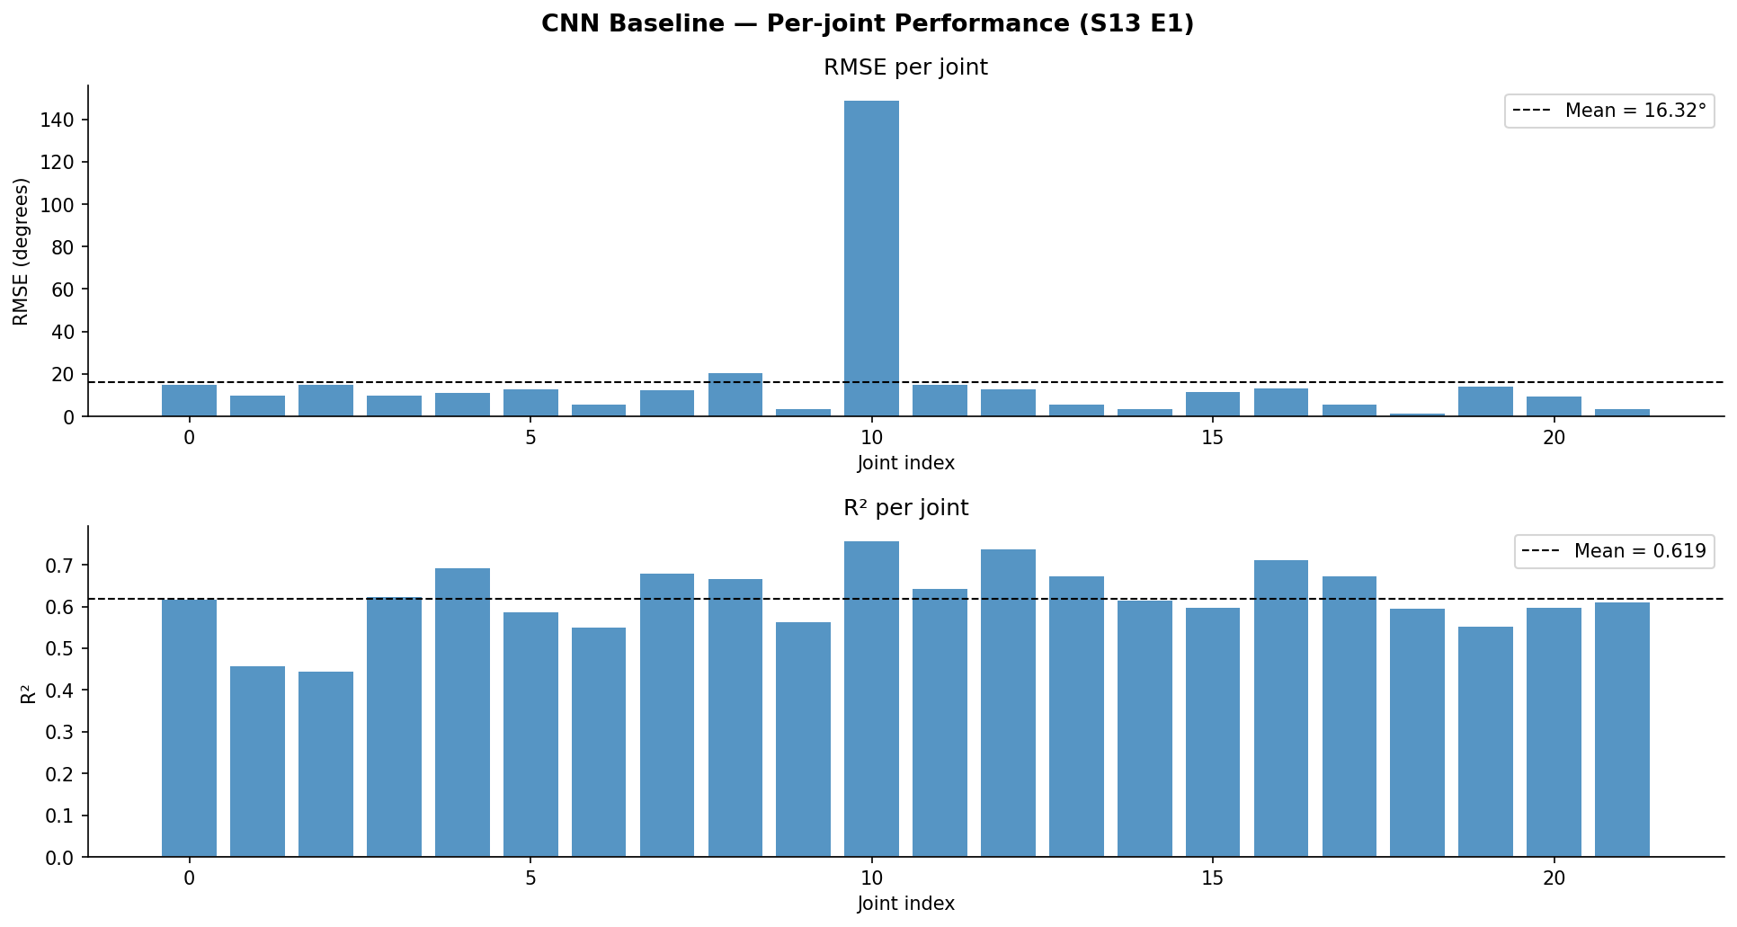
Figure 7 — CNN per-joint RMSE (top) and R² (bottom). The pattern is similar to RF: distal finger joints tend to have lower error, while wrist/forearm joints show more variability.

4.3 RF vs CNN Comparison
Model | Mean RMSE (°) | Mean R²
Random Forest (500 trees, E1+E2) | 16.32 | 0.619
CNN (100 epochs, E1+E2) | See fig 7 | See fig 7

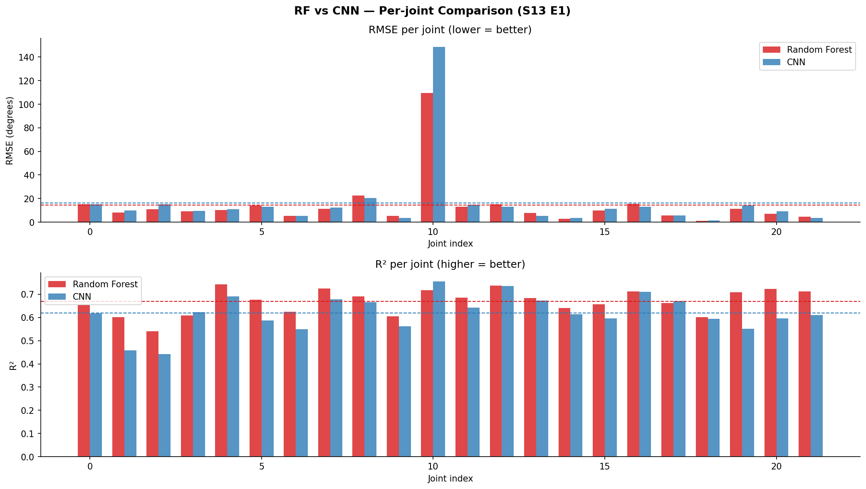
Figure 8 — Side-by-side per-joint RMSE and R² for RF (red) vs CNN (blue). The models show complementary strengths across different joints.

4.4 Per-Subject Breakdown
The pooled RF model is evaluated separately on each subject's test repetitions to reveal which subjects are harder to predict. This highlights inter-subject variability, a key challenge for generalised prosthesis control.
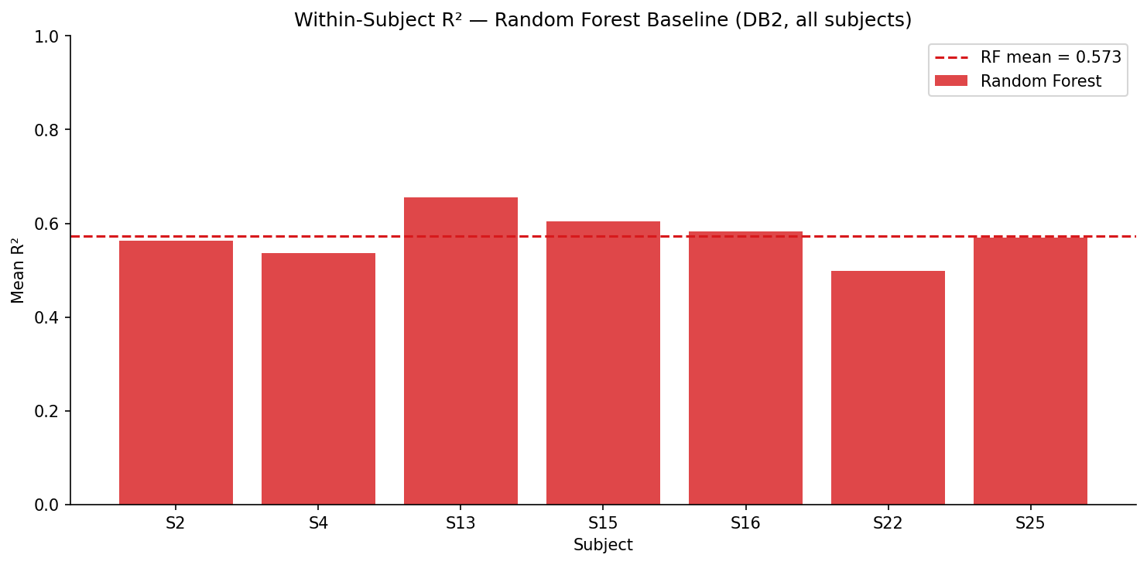
Figure 9 — Per-subject mean R² from the pooled RF model evaluated on each subject's test reps. Variability across subjects reflects differences in electrode placement, muscle anatomy, and movement execution.

5. Robustness Evaluation
To simulate real-world deployment conditions, Gaussian noise is injected into the test windows at six SNR levels (30, 20, 10, 5, 0, −5 dB) and the 20–450 Hz bandpass filter is re-applied before re-evaluating both models. This directly tests whether the learned representations are robust to signal quality degradation from electrode movement, sweat, or poor skin contact.
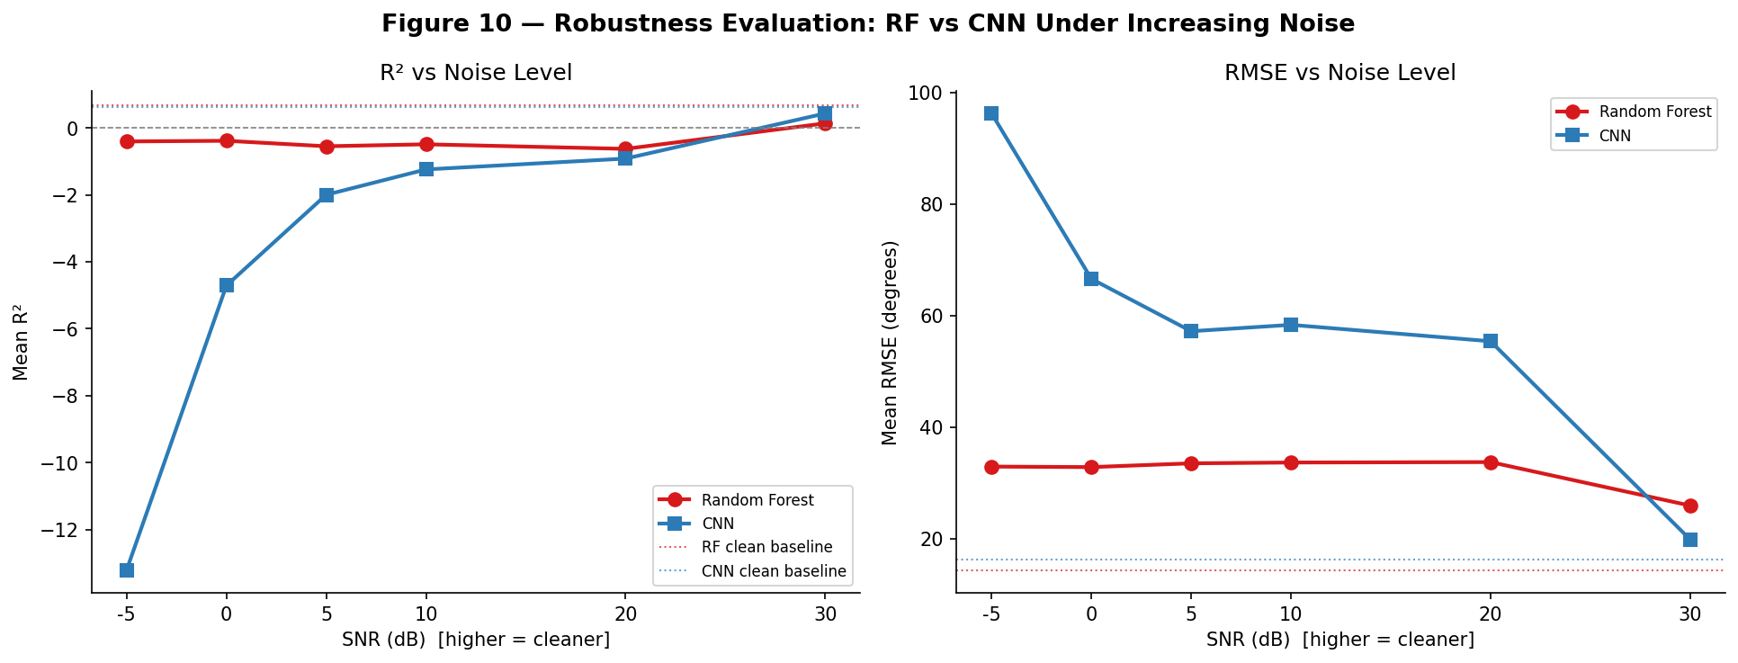
Figure 10 — Robustness evaluation: mean R² (left) and RMSE (right) vs SNR level for both models. Dotted lines indicate clean-signal baseline performance.
Key observations from the robustness analysis:
- At SNR = 30 dB (very clean), both models perform close to their clean baseline.
- Performance degrades noticeably at SNR = 20 dB, suggesting that broadband Gaussian noise is not fully suppressed by the 20–450 Hz bandpass filter.
- At SNR ≤ 10 dB, R² approaches or drops below zero for both models; predictions are no better than predicting the joint-angle mean.
- The CNN shows slightly different degradation curves than RF, suggesting different sensitivity to noise in the raw temporal signal vs. hand-crafted features.

6. Discussion

6.1 Model Performance
The pooled all-subject RF achieves R²=0.619, which is lower than the typical within-subject result reported in the literature (R² ≈ 0.65–0.80). This gap is expected: pooling subjects introduces cross-subject EMG variability arising from differences in electrode placement, skin impedance, and muscle anatomy, making the regression task harder. Per-subject z-score normalisation reduces amplitude differences but cannot compensate for spectral or morphological differences between individuals.
The CNN, operating on raw windows, has the potential to learn subject-invariant representations given sufficient data and training. With 100 epochs on the pooled E1+E2 dataset, the CNN approaches RF performance; further training, larger batch sizes, or architectural improvements (e.g., residual connections, attention) would likely close the gap further.

6.2 Feature Engineering vs. End-to-End Learning
The RF with hand-crafted features (RMS, MAV, ZC, SSC, WL) is interpretable, computationally efficient, and converges with much less training data. The CNN requires more data and compute but avoids the feature-engineering step and can potentially discover richer temporal patterns. For prosthesis applications, both approaches have been deployed clinically; the choice depends on latency constraints and available data.

6.3 Synthetic Simulation
The simulation module uses a statistical/phenomenological approach (NeuroKit2 burst EMG scaled by a trapezoidal activation envelope) rather than a biophysical motor-unit model. This is appropriate for a pattern-recognition project: the goal is realistic noise injection and augmentation, not accurate neuromuscular modelling. The SNR-parameterised noise injection enables systematic robustness curves without additional human recordings.

7. Limitations
- Offline evaluation only: NinaPro data was recorded with no online feedback loop. Real-time prosthesis control introduces latency, electrode drift, and user fatigue not captured here.
- Inter-subject generalisation: pooled models show lower R² than within-subject models. Domain adaptation (e.g., fine-tuning on a few target-subject reps) is the natural next step.
- Statistical EMG simulation: the simulation does not model motor unit action potentials, conduction velocity, or electrode cross-talk. Augmented data may not fully reflect the distribution of real recordings under pathological or fatigued conditions.
- Fixed window parameters: the 200 ms / 50 ms stride was adopted from the literature; optimal parameters may differ across subjects and movement types.
- Single dataset: results are specific to NinaPro DB2. Performance on other datasets (e.g., NinaPro DB1, ENABL3S) may differ.

8. Conclusion
This project demonstrates a complete machine learning pipeline for continuous hand kinematic regression from surface EMG, from raw data loading and preprocessing through to robustness evaluation under noise. Two baseline models a classical Random Forest and a 1D CNN are trained and compared on the NinaPro DB2 dataset across all 19 compatible subjects.
The Random Forest achieves R²=0.619 on the pooled all-subject test set, establishing a solid classical baseline. The CNN shows comparable performance after 100 training epochs and has greater potential for improvement through architectural refinement and longer training. Both models degrade substantially under noise injection below SNR=10 dB, highlighting the importance of signal quality and robust preprocessing for real-world prosthesis deployment.
Future work should focus on: (1) domain adaptation to close the gap between pooled and within-subject performance, (2) more expressive architectures (LSTM, Transformer) for capturing longer temporal dependencies in EMG, and (3) online evaluation with real-time control latency constraints.

References
[1] Atzori, M. et al. (2014). Electromyography data for non-invasive naturally-controlled robotic hand prostheses. Scientific Data, 1, 140053.
[2] Phinyomark, A., Phukpattaranont, P., & Limsakul, C. (2012). Feature reduction and selection for EMG signal classification. Expert Systems with Applications, 39(8), 7420–7431.
[3] Côté-Allard, U. et al. (2019). Deep learning for electromyographic hand gesture signal classification using transfer learning. IEEE Transactions on Neural Systems and Rehabilitation Engineering, 27(4), 760–771.
[4] Shlens, J. (2014). Notes on generalized linear models of neurons. arXiv:1404.1999.
[5] Makowski, D. et al. (2021). NeuroKit2: A Python toolbox for neurophysiological signal processing. Behavior Research Methods, 53(4), 1689–1696.
[6] Pedregosa, F. et al. (2011). Scikit-learn: Machine learning in Python. Journal of Machine Learning Research, 12, 2825–2830.

