Improving Myoelectric Prosthesis Control
Machine Learning Prediction of Hand Kinematics from EMG Signals
Project Plan and Methodology Report
Prepared: June 2026

Table of Contents

Table of Contents 2
1. Project Overview 3
1.1 Aim 3
1.2 Objectives 3
2. Literature Review Approach 3
3. Dataset Selection 4
3.1 Selected Subset 4
3.2 Data Handling Principles 4
4. EMG Simulation Approach 5
4.1 Why Simulate EMG 5
4.2 Level of Simulation Fidelity 5
4.3 Simulation Pipeline 5
5. Software and Tools 6
6. Methodology 6
6.1 Overall Workflow 6
6.2 Model Comparison Strategy 7
7. Evaluation Plan 7
7.1 Metrics 7
8. Flowchart 7
9. Anticipated Limitations and Future Work 9
10. Summary 9

1. Project Overview
Myoelectric prostheses restore hand function for people with forearm or hand limb difference by translating electrical activity recorded from the remaining forearm muscles (surface electromyography, or EMG) into motor commands. Despite advances in motor hardware, the mapping between recorded muscle signals and the intended hand motion remains a major bottleneck: existing pattern recognition systems struggle with generalisation, robustness, and the level of fine control that natural hand movement requires.
This project develops and evaluates a machine learning approach to predict hand kinematics directly from EMG signals, with the long-term goal of improving the usability of myoelectric prosthetic control. The work uses a publicly available benchmark dataset (NinaPro) supplemented by a synthetic EMG simulation pipeline, which is used to test the robustness of the trained model under controlled, repeatable conditions that are difficult to obtain from real recordings alone.

1.1 Aim
To develop and evaluate an improved EMG pattern recognition algorithm capable of predicting continuous hand kinematics for use in myoelectric hand prosthesis control.

1.2 Objectives
- Review recent literature on myoelectric prosthesis control and EMG pattern recognition.
- Select an appropriate machine learning approach and a suitable public dataset for development and evaluation.
- Construct a prediction algorithm mapping EMG activity to hand kinematics.
- Build a synthetic EMG simulation to support controlled testing, data augmentation, and robustness evaluation.
- Evaluate algorithm performance, identify limitations, and propose improvements.

2. Literature Review Approach
The literature review will focus on four specific threads rather than attempting a broad survey, so that the findings directly motivate the methodological choices made later in the project.

Theme | Focus
Classical pattern recognition | LDA, SVM and Random Forest classifiers on hand-engineered EMG features (time-domain and frequency-domain), used as baseline comparators.
Deep learning approaches | CNN and LSTM/temporal architectures applied to raw or minimally processed EMG, benchmarked on NinaPro subsets.
Regression vs. classification framing | The shift from discrete grip classification toward continuous kinematic (joint angle) regression for proportional, simultaneous control.
Generalisation and robustness | Inter-subject and inter-session variability, electrode shift, and the gap between offline accuracy and real-world clinical usability.

Findings from this review will be used to justify the model architecture selected in Section 4 and to frame the limitations discussed in Section 6.

3. Dataset Selection
The project uses the NinaPro database, a publicly available, widely benchmarked collection of EMG and hand kinematic recordings designed for prosthetic control research.

3.1 Selected Subset
NinaPro DB2 has been selected as the primary dataset. It provides high-resolution EMG (12 channels, 2 kHz sampling via Delsys Trigno electrodes), continuous hand kinematics recorded via a 22-sensor cyberglove, and grasp force data, across 40 intact subjects performing 49 movements. The higher sampling rate compared to alternatives such as DB1 (100 Hz) is important given the project's focus on continuous kinematic regression rather than discrete movement classification.

3.2 Data Handling Principles
- Train/test splits performed by movement repetition (not randomly), following established NinaPro convention, to avoid inflated accuracy from correlated adjacent samples.
- EMG bandpass filtered (approx. 20–450 Hz) and segmented into overlapping analysis windows (200 ms window, 50 ms increment), consistent with standard practice in the literature.
- Kinematic (glove) channels resampled/aligned to the EMG window rate to provide continuous regression targets.

4. EMG Simulation Approach
In addition to the NinaPro dataset, the project includes a synthetic EMG simulation component. This is not intended to replace real recordings, but to support three specific needs that real datasets cannot easily satisfy: generating additional training examples (data augmentation), creating controlled test conditions that isolate specific failure modes, and stress-testing the trained model under realistic but adverse signal conditions.

4.1 Why Simulate EMG
Purpose | Description
Data augmentation | Generate additional labelled training examples beyond what NinaPro provides, particularly for under-represented movement classes.
Controlled robustness testing | Systematically vary noise level, electrode shift, and motion artifact to evaluate model degradation under known, repeatable conditions not achievable with fixed real-world recordings.
Edge-case coverage | Test scenarios outside the recorded dataset (e.g. very low signal-to-noise ratio, partial channel dropout) representative of real prosthetic use.

4.2 Level of Simulation Fidelity
EMG simulation can be approached at two levels of fidelity. A biophysical (motor-unit) simulation models individual motor unit action potentials, recruitment order, and firing rates, and is appropriate for neuromuscular physiology research. A statistical/phenomenological simulation instead generates signals that reproduce the amplitude, frequency, and noise characteristics of real EMG without modelling underlying physiology.
This project adopts the statistical/phenomenological approach. This is the appropriate scope for a pattern-recognition project: it provides realistic signals for augmentation and robustness testing without requiring detailed physiological parameters that are not the focus of this work.

4.3 Simulation Pipeline
- Generate a baseline activation envelope representing simulated muscle effort for a given movement label.
- Use NeuroKit2's EMG simulation function to generate burst-structured synthetic EMG aligned to the activation envelope, with configurable burst count, duration and amplitude.
- Inject realistic noise and artifacts using custom signal processing: baseline wander, 50/60 Hz powerline interference, and motion artifact transients.
- Pass simulated signals through the same preprocessing and windowing pipeline used for real NinaPro data, ensuring like-for-like comparison.
- Use simulated data in two ways: (a) as additional augmented training samples, and (b) as held-out robustness test sets with systematically varied noise/artifact levels.

5. Software and Tools
All components of the project are implemented in Python, keeping the data pipeline, model development, and simulation components within a single ecosystem to avoid integration overhead between languages or platforms.
Component | Tool / Library | Purpose
Data handling | NumPy, SciPy, pandas | Loading NinaPro .mat files, signal filtering, windowing, array operations.
Classical ML baseline | scikit-learn | LDA, SVM, Random Forest baseline models and evaluation metrics.
Deep learning | PyTorch | CNN / CNN-LSTM architectures for kinematic regression from EMG windows.
EMG simulation | NeuroKit2 | Synthetic EMG burst generation for augmentation and robustness testing.
Signal/noise injection | NumPy / SciPy (custom) | Adding baseline wander, powerline interference, and motion artifacts to simulated signals.
Visualisation | Matplotlib / Seaborn | Signal plots, confusion matrices, performance curves.
Development environment | Jupyter Notebook / VS Code | Iterative development, exploratory analysis, and final pipeline scripts.
Version control | Git / GitHub | Tracking code changes and maintaining a reproducible project history.

MATLAB was considered, given its established use in neuromuscular and biomechanics research, but was not selected: the project's pipeline (data loading, model training, and simulation) is more efficiently implemented as a single Python codebase, and Python's ecosystem (PyTorch, scikit-learn, NeuroKit2) directly covers all required components without licensing constraints.

6. Methodology

6.1 Overall Workflow
The project follows a staged pipeline so that each component can be developed, tested, and validated independently before integration.
- Literature review and approach selection (Section 2).
- Data acquisition and preprocessing of the NinaPro DB2 dataset (Section 3).
- Development of the EMG simulation pipeline for augmentation and robustness testing (Section 4).
- Baseline model development: feature extraction and classical regression (LDA/SVM/Random Forest) to establish a reference performance level.
- Deep learning model development: CNN or CNN-LSTM architecture trained to predict continuous joint kinematics from raw or lightly processed EMG windows.
- Training and validation, including training on combined real and simulated data where augmentation is used.
- Performance evaluation on held-out real data (Section 7) and on simulated robustness test sets with varying noise conditions.
- Analysis of limitations and recommendations for further work (Section 8).

6.2 Model Comparison Strategy
Rather than developing a single model in isolation, the project compares a classical baseline against a deep learning approach. This provides a clear reference point for evaluating whether the proposed approach offers genuine improvement, and allows limitations to be discussed in the context of established methods rather than in isolation.

7. Evaluation Plan
Evaluation will be conducted separately for real (NinaPro) test data and simulated robustness test data, since each addresses a different question: real data evaluation measures absolute predictive performance, while simulated data evaluation measures resilience to controlled signal degradation.

7.1 Metrics
Evaluation Type | Metrics
Kinematic regression accuracy | Root mean square error (RMSE) and R² per joint angle; correlation coefficient between predicted and measured trajectories.
Classification (if discrete grips also evaluated) | Accuracy, per-class F1 score, confusion matrix.
Generalisation | Performance when training and testing on disjoint subject groups (inter-subject evaluation).
Robustness | Performance degradation curve across simulated noise/artifact severity levels.
Practical feasibility | Inference latency relative to analysis window size, as an indicator of real-time suitability.

8. Flowchart

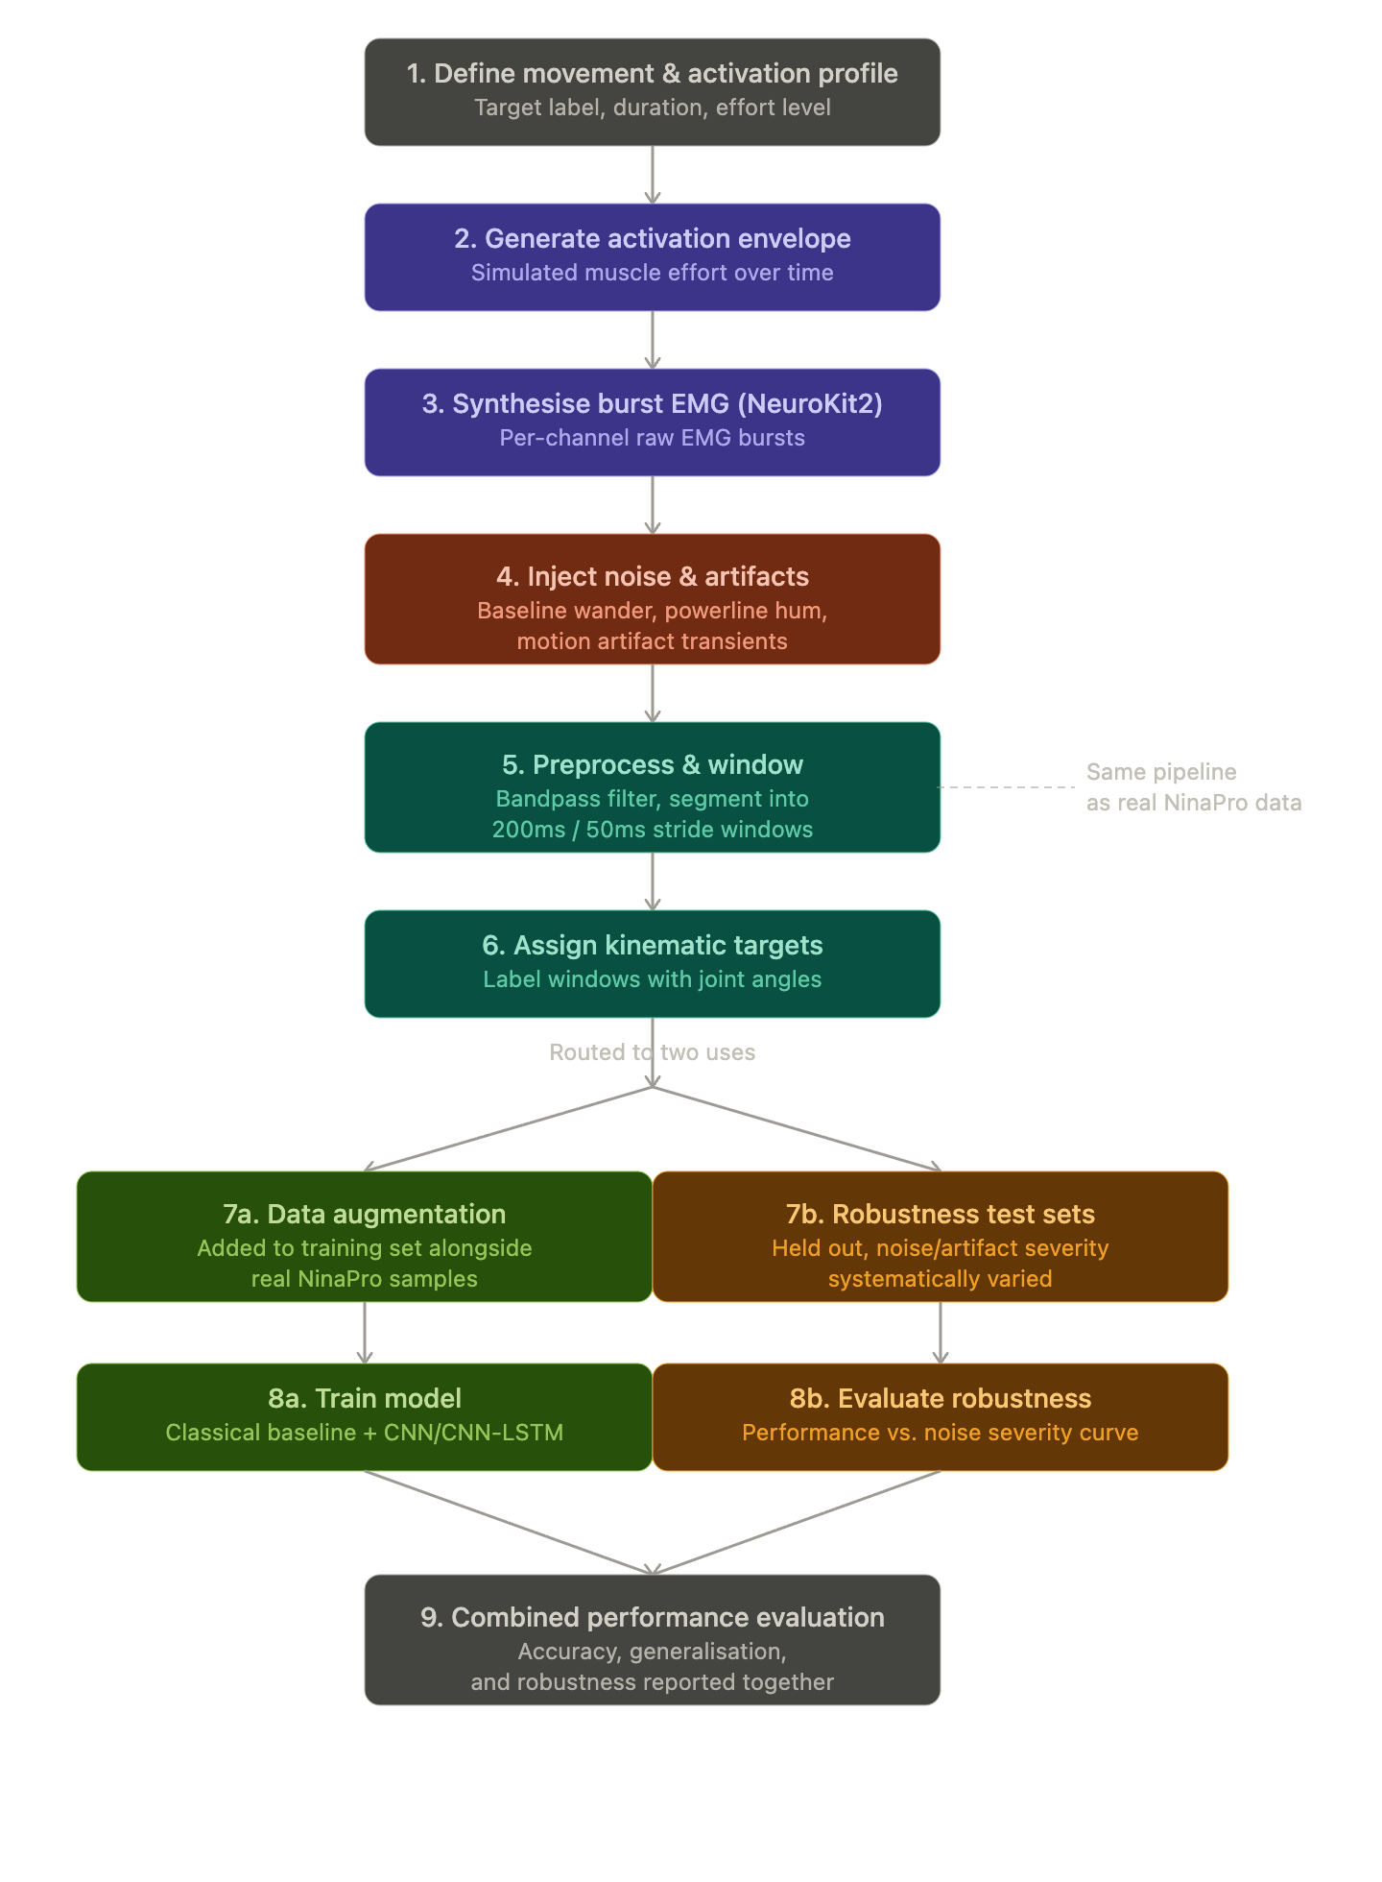

9. Anticipated Limitations and Future Work
- Offline accuracy on benchmark datasets such as NinaPro does not necessarily translate to real-time clinical usability; this gap will be explicitly discussed rather than assumed away.
- Statistical EMG simulation does not capture true neuromuscular physiology, so simulated robustness results should be interpreted as indicative rather than a substitute for real-world testing.
- Inter-subject and inter-session variability (e.g. electrode shift) remain open challenges in the field; the project will report where the model is most affected by these factors rather than presenting only best-case results.
- Future work could extend the simulation to incorporate sensor fusion (e.g. IMU/accelerometer data) and explore domain adaptation techniques to improve cross-subject generalisation.

10. Summary
This project combines a real benchmark dataset (NinaPro DB2) with a purpose-built synthetic EMG simulation to develop and rigorously evaluate a machine learning approach to continuous hand kinematic prediction from muscle activity. The simulation component is scoped deliberately at a statistical/phenomenological level of fidelity — sufficient for data augmentation and controlled robustness testing — while the modelling work centres on a comparison between classical pattern recognition and deep learning approaches, evaluated with explicit attention to generalisation and real-world feasibility rather than offline accuracy alone.

