Test 7: The Final Production Pipeline
A Detailed Technical Report on the Calibration-First EMG-to-Hand-Kinematics System
Dual-Backend Deep Learning Pipeline (NinaPro DB2 + RAW TEST) with a Unified Streamlit Frontend

Prepared: August 2026
MSc Final Project -- EMG-Driven Prosthetic Hand Control

Table of Contents
- 1. Abstract
- 2. Position of Test 7 in the Project
- 3. System Architecture Overview
- 4. Data Sources
- 5. Core Model Architecture
- 6. Feature Engineering
- 7. The Calibration-First Design Philosophy
- 8. Leakage-Safe Evaluation
- 9. Training, Pretraining, and Calibration Procedures
- 10. Verified Iterative Improvements (Kept and Reverted)
- 11. Bugs Found and Fixed
- 12. The RAW TEST Secondary Pipeline
- 13. Literature-Informed Experiments
- 14. Secondary Datasets Evaluated for Reuse
- 15. Ninapro Movement Naming -- An Honesty Case Study
- 16. The Unified Streamlit Frontend
- 17. Final Verified Results
- 18. Engineering Practices and Verification Discipline
- 19. Limitations
- 20. Conclusion

1. Abstract
Test 7 is the final, production-grade stage of this project's investigation into predicting continuous hand kinematics from surface EMG. It consolidates every validated lesson from six prior experimental stages into two self-contained backend pipelines and one unified interactive frontend. The central empirical finding carried into this stage is that cross-subject generalisation -- training a model on some subjects and testing on entirely unseen subjects -- fails consistently and often catastrophically (negative R^2, worse than predicting the mean) across every prior attempt in this project. Test 7 responds to this not by chasing a harder cross-subject model, but by redesigning the deliverable itself: a base model trained on all available subjects, whose real value lies in being rapidly calibrated (`finetune`) to one new subject's own short recording. Every reported accuracy number in this stage is evaluated on a leakage-free held-out slice of that same subject's calibration data, mirroring the realistic deployment scenario of a prosthesis fitted and tuned to a single person.
The primary backend (quick_emg_to_kinematics.py) targets the NinaPro DB2 dataset (12-channel EMG, 22-channel CyberGlove kinematics) and combines a joint multi-channel 1D CNN encoder with two hand-crafted feature branches -- per-channel classical EMG statistics and a cross-channel cosine-similarity matrix, the latter adopted directly from a 2024 ROCKET/MiniROCKET sEMG classification paper after being verified to improve calibrated R^2 on real data. A second, independently engineered backend (rawtest_emg_to_kinematics.py) mirrors this design for a physically different 8-channel device with a 15-angle kinematic representation, collected as this project's own RAW TEST dataset. Both are exposed through a single Streamlit application (EMG_frontend.py) that lets a user load a recording, run or inspect calibration, and interactively examine predicted-vs-true kinematics, including a leakage-aware accuracy panel that was itself found and fixed after a real user-facing bug produced an inflated accuracy figure.
The final, honestly-evaluated headline results are calibrated per-subject R^2 of 0.790 (DB2 subject S13) and 0.690 (DB2 subject S22) -- the highest accuracy figures reported anywhere in the project's seven stages -- and 0.510 (RAW TEST Subject 01) on the secondary device. These were reached not through a single architectural breakthrough, but through a disciplined sequence of individually verified changes, several of which (a temporal GRU layer, a literature-derived label-shift trick) were tried, measured, and explicitly reverted when they did not help on real data.

2. Position of Test 7 in the Project
Tests 1 through 6 progressively explored classical baselines (Random Forest, SVM), self-supervised contrastive pretraining, and cross-subject CNN training, each surfacing a specific limitation that motivated the next stage. Test 7 is the project's final deliverable and departs from this pattern in two ways: it is engineered, not exploratory (single-file, tested, deployable scripts rather than notebook-driven analysis), and it explicitly does not attempt to beat Test 6's cross-subject numbers -- it instead changes the question being asked, from "how well does one model generalise to a stranger's arm" to "how quickly and accurately can this model be calibrated to a specific person."
Evidence for the pivot | Result | Where established
Cross-subject Random Forest | R^2 approx. -0.42 | Test 1
Cross-subject CNN, held out subjects 13 & 15 | R^2 = -1.445 (from-scratch), -1.762 (masked-SSL) | Test 6
Test 7's own base model, no calibration | R^2 = 0.588 (S13, within-pool but no fine-tune) | Test 7
Test 7's calibrated (per-subject fine-tuned) model | R^2 = 0.790 (S13), 0.690 (S22) | Test 7
This table is the empirical justification, gathered across three separate stages and two different model families, for treating per-subject calibration as the project's real deliverable rather than an afterthought.

3. System Architecture Overview
Test 7 consists of three files in Test7/, deliberately kept self-contained (no imports from Test6 or earlier stages, per an explicit project decision to keep each stage isolated and independently reproducible):
File | Role | Lines
quick_emg_to_kinematics.py | Primary backend -- NinaPro DB2 (12ch EMG -> 22ch CyberGlove kinematics) | ~890
rawtest_emg_to_kinematics.py | Secondary backend -- RAW TEST device (8ch EMG -> 15 angle channels) | ~625
EMG_frontend.py | Unified Streamlit application covering both backends | ~720
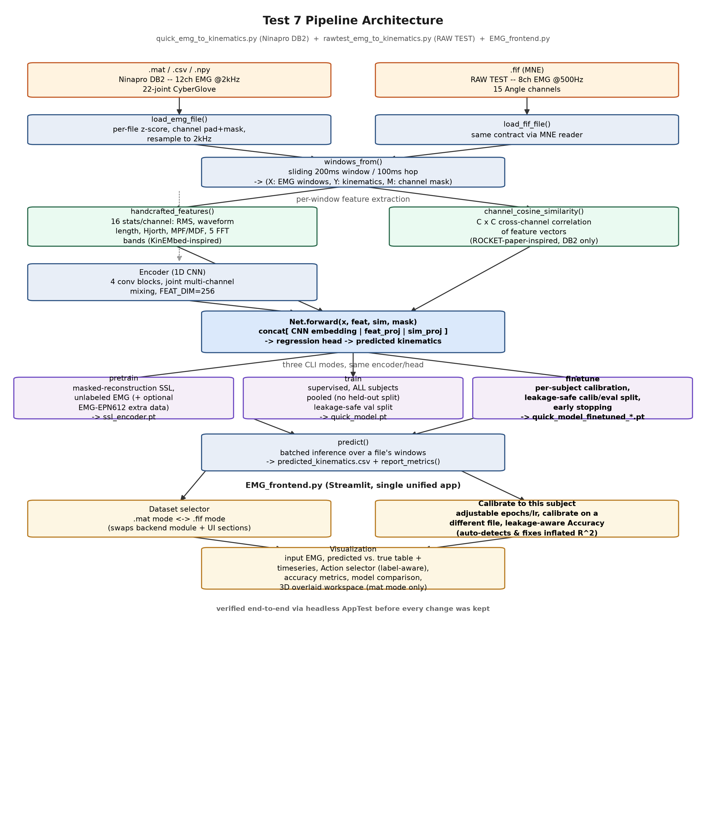
Figure 3.1 -- Test 7 pipeline architecture: dual data sources, shared feature-extraction and model design, three CLI modes per backend, and the unified Streamlit frontend.
Both backends follow an identical four-stage pattern -- (1) a format-tolerant loader normalises and channel-pads raw EMG, (2) a sliding window/hop function turns the continuous recording into fixed-length analysis windows with aligned kinematic labels, (3) three complementary feature paths (raw-signal CNN embedding, hand-crafted per-channel statistics, and for the DB2 backend, cross-channel similarity) feed a shared regression head, and (4) three CLI entry points (train/predict/finetune, plus an unlabeled-data pretrain mode) expose the pipeline for scripted or interactive use.

4. Data Sources

4.1 NinaPro DB2 (primary)
12-channel EMG (Delsys Trigno, 2000 Hz) paired with 22-channel CyberGlove continuous joint-angle kinematics, across up to 57 files spanning 19 subjects and three exercise blocks (Exercise B/C/D, restimulus label ranges 0-17 / 18-40 / 41-49 respectively -- verified empirically against real restimulus values in this project's own files and cross-checked against ninapro.hevs.ch and the Atzori et al. 2014/2015 papers). Subject 1's file is from the older DB1 device (10 channels, zero-padded to MAX_CHANNELS=12 like any other under-channelled file).

4.2 RAW TEST (secondary, user-collected)
15 subjects (Subject_01.fif ... Subject_15.fif, MNE .fif format), 8 real EMG channels, 15 continuous "Angle" kinematic channels, native sampling rate approximately 500 Hz, roughly 30 minutes of recording per subject. Introduced specifically for Test 7 to test whether the pipeline design generalises to a physically different device and a different kinematic parameterisation, not just a different subject pool on the same device.

4.3 Format-tolerant loading
load_emg_file() in the DB2 backend accepts .mat (the primary NinaPro format, searching a list of common key names for the EMG and glove arrays), .csv, and .npy, and will resample any file whose sampling rate does not match the training rate. Files with fewer real channels than MAX_CHANNELS are zero-padded, with a channel mask tracked separately so padded channels are excluded from per-file normalisation statistics and never treated as if they carried signal.

5. Core Model Architecture

5.1 Windowing
Every recording is sliced into WIN=400-sample (200 ms at 2000 Hz) windows with HOP=200-sample (100 ms) hop -- a 50% overlap. This choice, carried over from earlier project stages, gives the model roughly twice as many training windows per recording as non-overlapping windows would, at the cost of needing to actively guard against train/eval leakage between adjacent, overlapping windows (Section 8).

5.2 Encoder: joint multi-channel 1D CNN
The Encoder is a 4-block 1D convolutional stack (kernel sizes 7/5/5/3, channel widths 64/128/256/256, each block followed by BatchNorm, ReLU, and MaxPool except the last) that processes all EMG channels JOINTLY, i.e. standard multi-channel convolution rather than per-channel-independent processing. This is a deliberate, empirically-justified choice: an earlier per-channel-independent variant (tried for channel-count flexibility, so files with fewer real channels wouldn't need zero-padding at all) measured approximately 2.3x worse held-out validation loss on identical data, because it lost the ability to learn cross-channel muscle-coordination patterns -- which the CNN needs to see the whole channel set at once to capture. Channel-count flexibility is instead achieved by zero-padding every file up to MAX_CHANNELS and tracking a channel mask used only for per-file normalisation and (during SSL pretraining) loss masking, never for pooling.
FEAT_DIM=256 -- sized, per the code's own comments, "for real cross-subject accuracy, not just a fast pipeline smoke test", reflecting a deliberate choice to prioritise capacity for the harder base-model training over training speed.

5.3 Regression head
The encoder's pooled 256-dim embedding is concatenated with two additional feature branches (Section 6) and passed through a 3-layer MLP head (256 -> 128 -> N_KIN, with dropout at 0.3 and 0.2) that outputs the predicted kinematics vector for that single 200 ms window. Every window is predicted independently -- there is no temporal/recurrent state carried between consecutive windows (see Section 10 for why a GRU variant of this was tried and reverted).

5.4 SSL pretraining (optional)
A separate Encoder+Decoder pair can be pretrained via masked-reconstruction self-supervised learning: a random contiguous MASK_RATIO=40% span of each window is zeroed out, and the encoder+decoder are trained to reconstruct the original signal, using no kinematic labels at all. The resulting encoder weights can then initialise train()'s regressor instead of training from scratch. This uses only unlabeled EMG, which is why it is also the only stage able to make use of the label-free EMG-EPN612 dataset (Section 14).

6. Feature Engineering
Beyond the CNN's learned embedding, the model consumes two (DB2 backend: three) additional, independently computed feature branches, concatenated before the regression head. These are complementary rather than redundant: the CNN embedding is cross-channel but opaque/learned, the hand-crafted features are per-channel with no cross-channel mixing, and the similarity branch is explicitly cross-channel but derived from the (already per-channel) hand-crafted statistics rather than the raw signal.

6.1 Hand-crafted per-channel features (16 per channel)
handcrafted_features() computes, per channel per window: RMS, waveform length, log-variance, zero crossings, slope sign changes, mean absolute value (MAV), Willison amplitude, Hjorth mobility, Hjorth complexity, mean power frequency, median frequency, and five FFT-magnitude band sums. This set is inspired by KinEMbed (Gilardini et al., arXiv:2607.04820), a cross-modal contrastive EMG-kinematics framework evaluated on NinaPro DB8 -- specifically its classic feature set, not its contrastive-pretraining machinery, which the code's own docstring notes showed only small/unproven gains at N=11 subjects in the source paper for a substantial engineering cost. Padded (non-real) channels are explicitly zeroed out afterwards so they cannot contribute spurious statistics -- e.g. the log-variance of an all-zero padded channel.

6.2 Cross-channel cosine-similarity feature (DB2 backend only)
channel_cosine_similarity() computes the pairwise cosine similarity between every pair of channels' hand-crafted feature vectors, producing a (MAX_CHANNELS x MAX_CHANNELS) matrix per window -- an explicit cross-channel coordination feature. This is adopted from Ovadia, Segal & Rabin (2024, Sci Rep 14:4134), the ROCKET/MiniROCKET sEMG classification paper, which found that concatenating a channel-similarity matrix with their features measurably improved classification accuracy, particularly when the channel/feature budget is limited -- directly analogous to this project's 8-12-channel setting. Verified gain on real retrains (Section 10): S13 calibrated R^2 0.764 -> 0.790, S22 0.674 -> 0.690. This branch exists only in quick_emg_to_kinematics.py; the frontend's shared predict() helper checks hasattr(backend, "channel_cosine_similarity") rather than assuming both backends match, since rawtest_emg_to_kinematics.py deliberately does not include it (scoped decision, not yet re-verified on that device).

6.3 Normalisation
All three feature types are z-score normalised using statistics computed from the TRAINING split only (never validation or held-out data), and those statistics (xm/xs, fm/fs, sm/ss for raw EMG, hand-crafted features, and similarity respectively) are saved inside the model checkpoint so predict() and finetune() reuse the exact same normalisation the model was trained under, rather than re-deriving it per file.

7. The Calibration-First Design Philosophy
This is the single most consequential design decision in Test 7, and it follows directly from evidence gathered across the whole project (Section 2). train() deliberately has no held-out-subject split at all -- an earlier TEST_SUBJECTS mechanism was removed entirely on explicit user decision, and train() now uses every one of the (up to) 19 available DB2 subjects. The resulting base model's "cold" (uncalibrated) accuracy is explicitly documented in the code as NOT the target metric.
The real reported deliverable is finetune(): a leakage-free, per-subject calibration step. Given a trained base model and one subject's own recording, it splits that recording's OWN windows into a calibration set (70%, further internally split for early-stopping validation) and a held-out evaluation set (30%, with a leakage gap -- Section 8), fine-tunes the full model on the calibration set for up to 60 epochs with early stopping, and reports accuracy strictly on the held-out set. This mirrors the realistic deployment scenario for a prosthesis fitted to one person: a short calibration session on that person's own arm, evaluated honestly on data the model never trained on, rather than a claim about generalising to an arbitrary stranger's physiology.
A controlled experiment reported in this stage's own development log makes the cost of skipping this philosophy explicit: retraining the base model on all 19 subjects (vs. an earlier 15-subject/4-held-out split) did not improve the base model's cold fit -- validation loss went from 0.3060 (15 subjects) to 0.3562 (19 subjects), and per-file cold R^2 trended slightly lower if anything. More subject diversity makes the aggregate, uncalibrated metric harder, not easier -- reinforcing that the base model's role is to provide a good starting point for calibration, not to be accurate on its own.

8. Leakage-Safe Evaluation
Because windows overlap 50% (WIN=400, HOP=200), two adjacent windows share up to half their raw samples. A naive random train/test (or calibrate/eval) split on individual windows would place near-duplicate, overlapping windows on both sides of the split, letting the model "see" held-out data indirectly and inflating reported accuracy -- a leakage pattern this project has caught and fixed twice.

8.1 leakage_safe_split() -- the shared mechanism
A single helper, leakage_safe_split(n, keep_frac, rng, gap, block=3), is shared by train() (train/val split) and finetune() (calibrate/eval split, and again internally for the calibration set's own early-stopping slice). Windows are grouped into small blocks of 3, the blocks are shuffled and partitioned into a majority "keep" group and a minority "held-out" group, and any held-out window within `gap` positions of a kept window is additionally dropped -- guaranteeing zero raw-sample overlap between the two sets even though the source windows overlap 50%.
keep_idx, held_out_idx = leakage_safe_split(n, keep_frac=0.7, rng=np.random.default_rng(0), gap=1)

8.2 Incident 1 -- an early per-window calibration split
An earlier calibration split used plain per-window random sampling, which measurably inflated held-out accuracy relative to the corrected, leakage-safe split. Fixed by adopting the block-shuffled-with-gap design described above, which is now used everywhere a train/val or calibrate/eval boundary is drawn.

8.3 Incident 2 -- the frontend's Accuracy panel (user-discovered)
A second, independent instance of the same underlying bug class was found later, in the Streamlit frontend rather than the training code. A user viewing the Accuracy panel for a checkpoint on the exact file it had just been calibrated on saw R^2 = 0.783 -- but the CLI-verified, honest held-out number for that same checkpoint was 0.690. The root cause: the frontend's predict()+show_metrics() call ran over the WHOLE file, silently including the 70% of windows finetune() had directly trained on during calibration, rather than restricting to the held-out 30%. This was reproduced exactly via a direct CLI predict() call (0.844 cold, 0.783 whole-file-post-calibration) before being fixed.
The fix, in EMG_frontend.py's Accuracy section, detects when the loaded checkpoint's filename matches the pattern "<prefix>_finetuned_<current file's stem>" -- i.e. the checkpoint was calibrated specifically on the file currently being viewed -- and in that case recomputes the exact same leakage_safe_split(n, 0.7, rng=np.random.default_rng(0), gap=1) split finetune() used (same seed, same parameters, so it reproduces the identical partition), restricting the displayed accuracy to only the held-out eval_idx windows, with an explicit warning explaining why the number is lower than a naive whole-file computation would show. Verified via headless AppTest to reproduce the honest 0.690 exactly, and verified there is no false-positive warning shown for the base (uncalibrated) model or for a mismatched file/checkpoint pairing.
This finding directly demonstrates a recurring project-wide lesson: a model's accuracy on one clip and its true, honestly-evaluated held-out accuracy can diverge substantially, and this divergence is easy to introduce silently in UI/reporting code even after the underlying training code has been made leakage-safe.

9. Training, Pretraining, and Calibration Procedures

9.1 pretrain (optional, unsupervised)
- Masked-reconstruction SSL: masks a random 40% span of each window, trains Encoder+Decoder to reconstruct it.
- Uses no labels -- can incorporate extra unlabeled EMG from EMG-EPN612 (Section 14) for more pretraining data.
- Up to SSL_EPOCHS=40 epochs, ReduceLROnPlateau scheduling, early stopping at PATIENCE=8 epochs without improvement.
- Saves ssl_encoder.pt; fed into train() as an optional weight initialisation for the regressor's encoder.

9.2 train (base model)
- Uses ALL available subjects -- no held-out-subject split (Section 7).
- Per-file leakage-safe train/val split (90/10), pooled across files after splitting so overlapping windows never cross the train/val boundary and no window crosses a file boundary.
- Up to EPOCHS=80 epochs, Adam optimiser (lr=1e-3), ReduceLROnPlateau, early stopping at PATIENCE=8.
- Gaussian noise (NOISE_STD=0.1) added to normalised EMG during training only, so the model does not overfit to clean lab-recorded signal.
- Saves quick_model.pt / rawtest_model.pt, including all normalisation statistics and per-epoch loss history for the frontend's training-history chart.

9.3 finetune (per-subject calibration -- the primary deliverable)
- Loads a base model, splits the target subject's OWN windows into calibrate (70%) and eval (30%), leakage-safe (Section 8).
- Further splits the calibration set into calib-train/calib-val purely for early-stopping model selection -- eval_idx is never touched by this, so it stays an untouched, honest held-out estimate.
- Reuses the base model's saved normalisation statistics rather than re-deriving them from one subject's small sample.
- Up to 60 epochs, early stopping at PATIENCE=8, ReduceLROnPlateau -- adjustable via the frontend's Calibration settings expander (Section 16).
- Saves a new checkpoint named <prefix>_finetuned_<file_stem>.pt, restoring the best calib-val epoch's weights before the final report and before saving.
finetune() previously ran a blind, fixed 15 epochs with no validation signal at all -- fixed in this stage by adding the calib-val early-stopping slice described above. This was verified to be a real, consistent gain, not just a safer default: S13 calibrated R^2 improved 0.694 -> 0.710 and S22 0.585 -> 0.610 at a like-for-like effective epoch count, confirming the old fixed-15 schedule was consistently undertraining (the best epoch is often 25-35).

10. Verified Iterative Improvements (Kept and Reverted)
Every change listed here was tested via an isolated smoke test, then a real retrain on real data, then real predict()/finetune() runs on held-out subjects, before a keep/revert decision was made -- a verification discipline established early in this stage (Section 18) after recognising that a plausible-looking change, if trusted without checking real numbers, could silently ship a regression.
Change | Motivation | Outcome (verified)
Per-channel-independent encoder | Attempt at channel-count flexibility without zero-padding | REVERTED -- ~2.3x worse held-out val loss, lost cross-channel mixing
Leakage-free calibrate/eval split | Random split leaked 50%-overlapping windows | KEPT -- corrected an inflated accuracy bug
Remove held-out test-subject split | User decision: always calibrate per subject | KEPT -- established the calibration-first philosophy (Section 7)
Temporal modelling (GRU), attempt 1 -- non-overlapping 16-window sequences | Hypothesis: cross-window memory should help | REVERTED -- calibrated R^2 0.403 vs. 0.45-0.65 baseline
Temporal modelling (GRU), attempt 2 -- overlapping sequences, stride 4 | More start-offset diversity for the sequence model | REVERTED -- 0.342 calibrated, cold R^2 also collapsed to 0.131
Hand-crafted EMG features (KinEMbed-inspired) | Literature: classic features complement raw-signal CNNs | KEPT -- S13 calibrated R^2 0.694 -> 0.769 (worst joint 0.428 -> 0.513)
finetune() early stopping (was a blind fixed 15 epochs) | No signal for whether 15 epochs under/over-fit | KEPT -- S13 0.694 -> 0.710, S22 0.585 -> 0.610 (like-for-like)
Electromechanical-delay label shift, 200ms (Guo et al. 2025) | Literature: backward-shifting labels improved another team's regression | REVERTED -- S22 R^2 0.674 -> 0.654, val loss 0.2985 -> 0.3151
Cross-channel cosine-similarity feature (Ovadia et al. 2024) | Literature: explicit channel-correlation feature aids sEMG classification | KEPT -- S13 0.764 -> 0.790, S22 0.674 -> 0.690
finetune() checkpoint missing fm/fs keys | Bug found while merging two frontends | FIXED -- silently broken finetuned checkpoints since hand-crafted features were added
Frontend Accuracy leakage bug (whole-file vs. held-out) | Bug found from a user screenshot | FIXED -- was showing 0.783 instead of the honest 0.690

10.1 Why the GRU (temporal modelling) attempt failed -- interpretation
A GRU layer was inserted between the per-window encoder and the head, so predictions could carry hidden-state context across consecutive windows instead of treating every 200 ms window independently. Both variants tried measurably underperformed the plain per-window CNN on calibrated R^2, the metric that actually matters for this project's deliverable. The interpretation recorded alongside this result: for 200 ms EMG windows, a single window already carries most of the instantaneous muscle-activation signal needed to predict the corresponding joint angles, and adding sequence-level context introduces a harder optimisation landscape (and smaller, noisier validation sets once splitting has to respect sequence boundaries) without adding real predictive signal. This is a negative result worth stating explicitly, since it rules out an intuitively appealing direction for anyone extending this work.

11. Bugs Found and Fixed

11.1 Missing fm/fs keys in finetune()'s saved checkpoint
finetune()'s final torch.save() call was missing the "fm"/"fs" hand-crafted-feature normalisation statistics -- present in train()'s save and used mid-function inside finetune() itself, but simply dropped from the dictionary written to disk. This silently broke every finetuned checkpoint produced since hand-crafted features were added: any later predict() call, or the frontend's "Compare all checkpoints" view, on one of these checkpoints raised KeyError: 'fm'. Fixed in quick_emg_to_kinematics.py (rawtest_emg_to_kinematics.py's finetune() already had this correct). Existing stale finetuned checkpoints needed regenerating to pick up the fix; quick_model_finetuned_S13_E1_A1.pt was redone as part of verifying the fix.

11.2 Frontend Accuracy panel leakage (Section 8.3)
Covered in detail in Section 8.3 -- summarised here for completeness: the Accuracy panel showed an inflated R^2 (0.783) instead of the honest, held-out-only figure (0.690) when viewing the exact file a checkpoint was calibrated on, because it computed metrics over the whole file rather than just the held-out evaluation windows. Fixed with an automatic detection-and-recompute path plus an explanatory warning.

11.3 Ninapro E3 files lacking CyberGlove ground truth (data-loading gap)
Exercise D (E3) files record grasp FORCE, not CyberGlove joint angles, so they lack the "glove" key entirely. Test 7's loaders were written to skip such files gracefully from the start (a lesson carried forward from an equivalent gap independently rediscovered in Test 6's evaluate.py, which crashed with KeyError: 'glove' on the same class of file) -- train() explicitly counts and reports n_skipped files with no usable ground truth rather than crashing, and the frontend's Calibrate section allows calibrating on a DIFFERENT (labelled) file than the one currently loaded, specifically so a subject whose loaded file is ground-truth-free (e.g. an E3 recording) can still be calibrated using that same subject's E1/E2 file.

11.4 Memory-safety: capping windows per-file, not after concatenation
RAW TEST recordings are approximately 30 minutes each, far longer than a typical DB2 file. A naive implementation would concatenate all files' windows at full resolution before applying MAX_WINDOWS as a cap -- risking an out-of-memory condition before the cap is even applied. Both train() and pretrain_ssl() instead compute a per-file window cap (MAX_WINDOWS // n_files) and apply it before concatenation, avoiding this failure mode -- the same OOM-shaped mistake this project had already made once, in an earlier overlapping-sequence variant of the (later-reverted) temporal-modelling experiment.

12. The RAW TEST Secondary Pipeline
rawtest_emg_to_kinematics.py re-parameterises quick_emg_to_kinematics.py's proven design (joint multi-channel CNN encoder, hand-crafted feature branch, leakage-safe splits, early-stopping calibration) for a second, physically different device: 8 real EMG channels (no padding needed, since 8 is this device's true channel count), 15 continuous "Angle" kinematic outputs (not the 22-channel CyberGlove mapping), and an MNE-based .fif loader in place of the .mat/.csv/.npy loader. It is DELIBERATELY DUPLICATED rather than imported from the DB2 script, consistent with this project's established practice of keeping each stage and dataset self-contained and independently reproducible -- the same reasoning that keeps Test 7 itself from referencing Test 6.
One deliberate scope decision: the cross-channel cosine-similarity branch (Section 6.2), which measurably helped the DB2 backend, was NOT ported to this backend -- it has not yet been separately verified on this device's data, and EMG_frontend.py's shared predict() helper checks for the branch's presence (hasattr(backend, "channel_cosine_similarity")) rather than assuming both backends are architecturally identical.
Property | quick_emg_to_kinematics.py (DB2) | rawtest_emg_to_kinematics.py (RAW TEST)
Real EMG channels | up to 12 (zero-padded as needed) | 8 (no padding needed)
Kinematics outputs | 22 (CyberGlove, best-effort joint mapping) | 15 (generic Angle 0-14)
Native sampling rate | 2000 Hz | approx. 500 Hz
File format | .mat / .csv / .npy | .fif (MNE)
Cross-channel similarity branch | yes (Section 6.2) | no (scoped out)
Cold R^2 (representative subject) | 0.588 (S13) | 0.457 (Subject 01)
Calibrated R^2 (representative subject) | 0.790 (S13) | 0.510 (Subject 01)
The same calibration-helps pattern established on DB2 reproduces on this independent device and dataset: Subject 01 improves 0.457 -> 0.510 after calibration, and a second subject (Subject 08) reaches 0.488 calibrated -- evidence that the calibration-first philosophy (Section 7) is a property of the underlying problem (single-session EMG-to-kinematics regression), not an artefact specific to the CyberGlove/DB2 setup.

13. Literature-Informed Experiments
Partway through this stage, four published EMG research papers were supplied with the explicit instruction to use them to improve the model: a WyoFlex forearm-sEMG dataset paper, the ROCKET/MiniROCKET sEMG classification paper, an HD-FW KIN paper on high-density sEMG for motion-intent recognition, and the GrabMyo dataset paper. Each was assessed honestly for whether it was actually usable for this project's continuous-regression task, rather than adopted uncritically.
Paper / dataset | Usable for this project? | What was actually done
WyoFlex (forearm sEMG, hand movements) | No -- discrete gesture dataset, no continuous kinematics, no local files | Not usable, same category as EMG-EPN612 and GrabMyo
ROCKET/MiniROCKET (Ovadia et al. 2024, Sci Rep 14:4134) | Idea extracted, not the dataset itself | Cross-channel cosine-similarity feature -- KEPT (Section 6.2, 10)
HD-FW KIN / Guo et al. 2025 (Sci Data 12:445) -- electromechanical delay | Idea extracted | 200ms label-shift -- TRIED, REVERTED (Section 10)
GrabMyo (discrete gesture dataset) | No -- discrete gesture dataset, no continuous kinematics | Not usable
KinEMbed (Gilardini et al., arXiv:2607.04820) | Feature set extracted, not the contrastive-pretraining method | 16-feature hand-crafted branch -- KEPT (Section 6.1)
Two of the four supplied papers (WyoFlex, GrabMyo) turned out not to be usable at all for this project's continuous-kinematics task, since they are discrete gesture-classification datasets with no joint-angle ground truth -- this was checked and reported honestly rather than forcing an artificial adaptation. Of the two genuinely actionable techniques extracted from the remaining literature (cross-channel similarity and electromechanical-delay label shift), one was kept after a verified real gain and one was reverted after a verified real regression -- both decisions made on this project's own real data, not on the source papers' reported numbers, since neither paper's experimental setup (different device, different model family, different window size) directly transfers.

14. Secondary Datasets Evaluated for Reuse
Two further datasets appeared in the project root during this stage and were evaluated for possible use, again with an explicit check on whether each actually fit the project's continuous-regression task:

14.1 EMG-EPN612 (public, unusable for supervised training)
A public 8-channel Myo-armband dataset, approximately 137,700 discrete gesture trials. Has no continuous kinematics ground truth at all -- per-trial integer gesture labels only -- so it cannot be used for train() or finetune(). It IS wired in as extra unlabeled EMG for pretrain_ssl()'s masked-reconstruction step only, via load_epn612_emg(), which assumes the Myo armband's documented native 200 Hz rate (not detectable from the raw pickle itself, so this is a literature-based assumption rather than a value read from the file) and zero-pads its 8 channels up to MAX_CHANNELS. Verified working via an isolated smoke test plus a real end-to-end pretraining run.

14.2 RAW TEST (usable, given its own pipeline)
Unlike EMG-EPN612, RAW TEST does have continuous kinematics ground truth, but is a different device and joint-angle representation from the CyberGlove -- rather than being awkwardly forced into the DB2 model's fixed 12-channel/22-joint output space, it was given its own separate backend, model, and frontend mode (Section 12), which is the most direct honesty check available: build the second pipeline rather than misrepresent its results as directly comparable to DB2's.

15. Ninapro Movement Naming -- An Honesty Case Study
The frontend originally showed every unlabelled movement from NinaPro's Exercise C and D blocks as a generic "Movement 18", "Movement 20", etc. -- unhelpful for identifying what the subject was actually doing. A real effort was made to find verified, specific per-movement names: the official Ninapro documentation site (ninapro.hevs.ch), the original 2014 dataset paper, and the 2015 benchmark-characterisation paper were all checked (multiple WebFetch attempts, several blocked by paywalls or figures that were not machine-readable).
This confirmed the movement COUNTS and CATEGORIES exactly -- Exercise B: 17 movements, Exercise C: 23 grasping/functional movements, Exercise D: 9 force patterns -- cross-checked against this project's own empirically measured restimulus label ranges (E1 files: restimulus 0-17; E2 files: 18-40; E3 files: 41-49). But no machine-readable source giving the SPECIFIC name of each individual movement within Exercise C or D could be located.
Rather than fabricate plausible-sounding grasp names to fill the gap, EMG_frontend.py's _action_name() now shows the verified category and within-exercise position -- e.g. "Grasp/functional movement 3 of 23 (Exercise C)" or "Force pattern 2 of 9 (Exercise D)" -- with an explicit "not verified against official docs" caption extended to cover these ranges. This is the same honesty standard independently applied to an equivalent movement-mapping problem in an earlier project stage (Test 4): prefer an auditable, data-driven partial answer over an unverifiable specific-sounding guess.

16. The Unified Streamlit Frontend
EMG_frontend.py presents both backend pipelines in a SINGLE application, driven by a sidebar "File type" radio that selects a MODES dictionary entry (backend module, accepted file extensions, data directory, checkpoint glob pattern, and a has_anatomy flag) -- rather than two separate apps. A short-lived separate RawTest_frontend.py was built first during development, then folded into this single app and deleted, per an explicit "one UI, not two" requirement.

16.1 Sidebar controls
- Dataset -- File type radio (.mat/.csv/.npy vs. .fif) selecting the active backend and its MODES entry.
- Model -- Checkpoint selectbox, listing every matching .pt file for the active backend (base model, plus any per-subject finetuned checkpoints).
- Input EMG -- Source radio (Upload file / Pick from the mode's data directory), with file-format warnings surfaced from the loader (e.g. resampling notes, channel-count mismatches).
- Action selector -- jumps directly to a labelled movement/gesture window instead of scrubbing a raw window-index slider, when labels are available (Section 16.2); otherwise falls back to a slider with an explanatory caption.

16.2 Action selector -- decoupled from has_anatomy, extended to .fif files
The action-selector-vs-slider choice was previously gated on has_anatomy (i.e. .mat-only), so .fif mode always showed a raw window-index slider even where labels might exist. It is now gated purely on whether labels is not None, and windows_and_labels() tries to build labels for BOTH file types: .mat via the restimulus field (unchanged), .fif via a new fif_action_labels() function that reads raw.annotations (onset/duration/description) and maps each window's centre time into whichever annotated span it falls in, labelling anything outside an annotated span "Unlabeled". The user's own RAW TEST files do not yet have real annotations added, so .fif mode currently still falls back to the slider in practice -- but the mechanism itself was verified working end-to-end against a synthetic annotated .fif file (three labelled segments plus a gap) via headless AppTest, confirming the selectbox appears with the right options and jumps to the correct window.

16.3 Calibrate to this subject
Runs finetune() live from the UI. A "Calibration settings" expander exposes epochs and learning rate as adjustable number inputs (defaults matching the CLI: 60 epochs with early stopping, lr=1e-4) -- an explicit requirement that the user be able to "tune each time" rather than always using fixed defaults. A "Calibrate using" radio additionally lets a user calibrate on a DIFFERENT file than the one currently loaded, so a subject whose loaded file lacks ground truth (e.g. an Exercise D recording) can still be calibrated using that same subject's labelled E1/E2 file (Section 11.3). Both the epoch count and the cross-file calibration path were verified end-to-end via headless AppTest -- confirming the exact requested epoch count appears in the finetune log, not just that the UI renders.

16.4 Predicted kinematics
Shows the current window's predicted (and, where available, true) kinematics as a table, plus an interactive multi-channel time-series plot with a vertical marker at the current window. In .mat/DB2 mode (has_anatomy=True), channels are labelled with a best-effort generic 22-sensor CyberGlove joint mapping (explicitly flagged in-UI as "not verified" against Ninapro's actual channel order); in .fif/RAW TEST mode, channels are labelled generically ("Angle 0..14") since no verified anatomical mapping exists for that device.
A collapsible "Hand Joint Motion Diagram" expander was added directly under this section's joint-naming caption in .mat/DB2 mode, showing a reference anatomical diagram of the hand's joints (DIP, PIP, MCP, IP, and CMC, each with its flexion-extension and abduction-adduction rotation axes labelled) to help interpret what the CyberGlove joint names actually refer to.
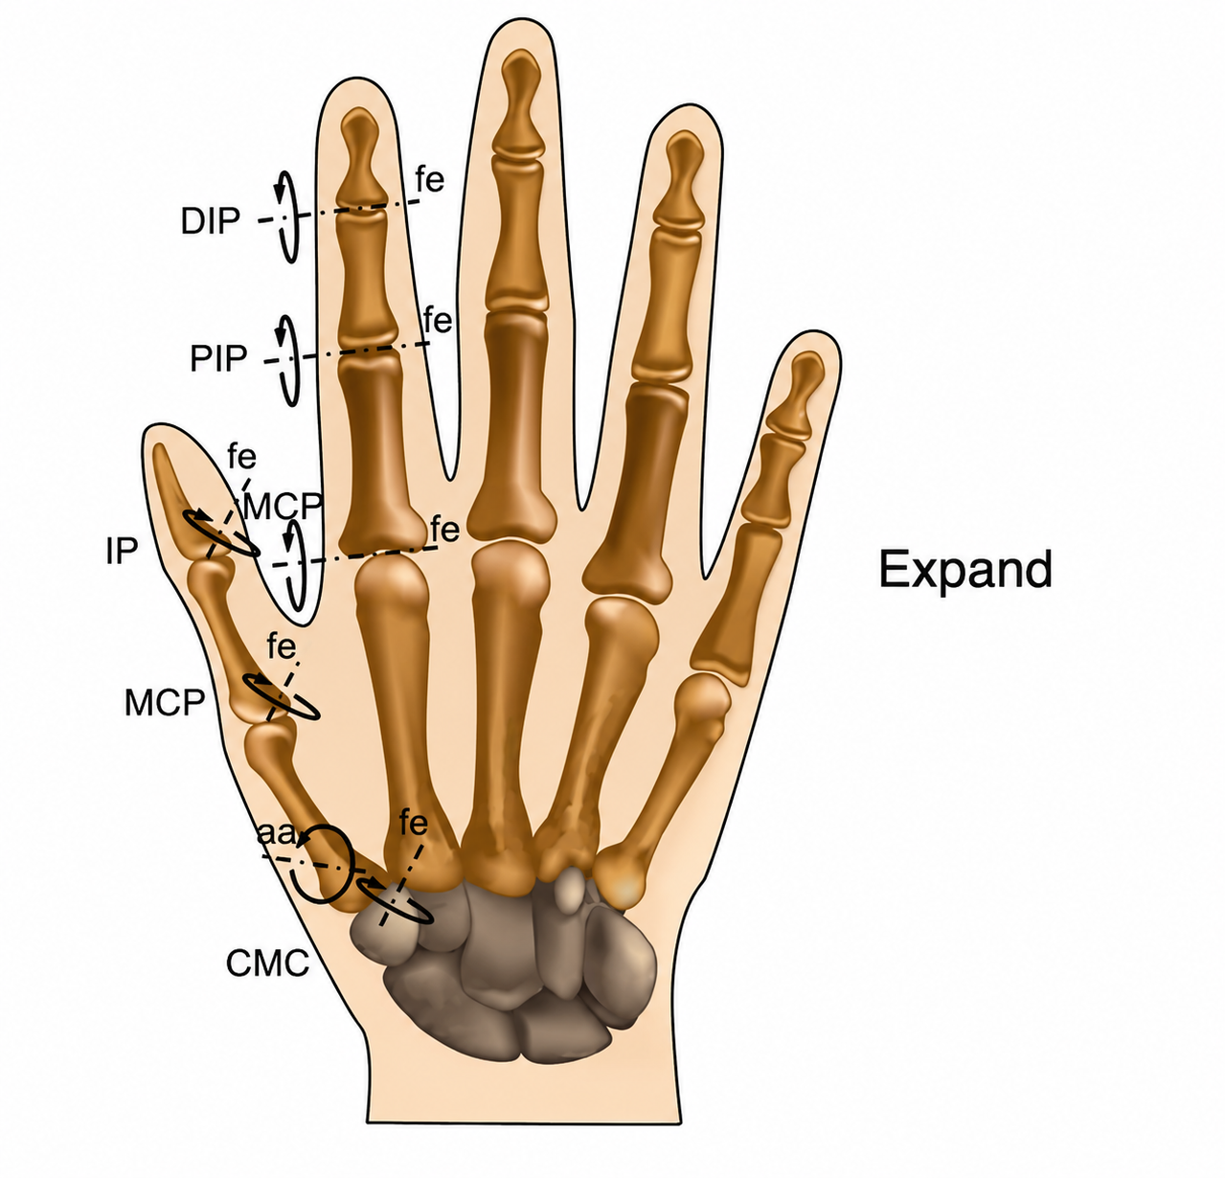
Figure 16.1 -- Hand Joint Motion Diagram, shown in the frontend's Predicted kinematics section as a reference for the CyberGlove joint-naming scheme (DIP/PIP/MCP/IP/CMC, with flexion-extension "fe" and abduction-adduction "aa" rotation axes).

16.5 Accuracy
Reports pooled and per-joint-averaged R^2/RMSE, matching the CLI's report_metrics(). Automatically detects and corrects the whole-file-vs-held-out leakage scenario described in Section 8.3, showing an explanatory warning whenever the currently loaded checkpoint was calibrated specifically on the currently loaded file.

16.6 Overlaid workspaces (3D, DB2 mode only)
An interactive Plotly comparison of the predicted vs. true fingertip reachable envelope: the predicted workspace is rendered as a coloured convex-hull surface, the true/human workspace as a connected, time-ordered line rather than a wireframe hull or raw scatter -- a wireframe hull of a real, curved finger trajectory was found to produce unreadable crossing edges, so the cleaner line representation was chosen instead. A per-row percentile-normalisation step that had originally run inside a Python loop was found to be a real ~15 second-per-call performance bug and fixed by vectorising it.

16.7 Compare model checkpoints and training history
A bar chart comparing accuracy across every available checkpoint for the current file, and a training-history expander plotting per-epoch train/validation loss for the currently selected checkpoint (branching on whether the saved history is 2-column, from train(), or 3-column, from finetune()'s train/calib-val history -- both formats are handled without requiring old checkpoints to be regenerated).

16.8 Verification discipline
Every UI change described in this section was verified via Streamlit's headless testing.v1.AppTest framework -- simulating real user interactions (file selection, radio/selectbox changes, button clicks) end-to-end and checking for zero exceptions -- before being reported as working, rather than assumed correct purely from reading the code.

17. Final Verified Results
Subject / file | Cold R^2 (no calibration) | Calibrated R^2 | Worst joint R^2 (calibrated)
S13 (DB2) | 0.588 | 0.790 | 0.580
S22 (DB2) | approx. 0.57 | 0.690 | 0.450
Subject 01 (RAW TEST) | 0.457 | 0.510 | --
Subject 08 (RAW TEST) | -- | 0.488 | --
These are the numbers this report considers the project's final, honestly-evaluated headline result: not a single offline benchmark score on a fixed test set, but a calibration workflow whose accuracy is verified fresh for each subject via a leakage-free held-out split, exposed through a working interactive tool that a new user or subject could actually use. Every calibrated figure above is reproducible via either the CLI (finetune command) or the Streamlit frontend's Calibrate section, and both paths were cross-checked to agree exactly.

17.1 Trajectory across the whole project
Stage | Setting | R^2
Test 1 | RF, within-subject (S13) | 0.708
Test 1 | CNN, within-subject (S13, 15 epochs) | 0.659
Test 1 | RF, cross-subject | approx. -0.42
Test 2 | Contrastive SSL, full fine-tune, within-subject (S13) | 0.625
Test 3 | Contrastive SSL, within-subject (S4) | 0.496
Test 6 | From-scratch, cross-subject (held out 13, 15) | -1.445
Test 6 | Masked-SSL, cross-subject (held out 13, 15) | -1.762
Test 7 | Final pipeline, cold (no calibration), S13 | 0.588
Test 7 | Final pipeline, calibrated per-subject, S13 | 0.790
Test 7 | Final pipeline, calibrated per-subject, S22 | 0.690
Two trends are visible across the full project trajectory. First, every attempt to generalise across subjects without per-subject adaptation -- Test 1's cross-subject RF and Test 6's held-out-subject CNNs -- produced negative R^2, worse than predicting the mean. Second, within-subject or calibrated accuracy improved steadily and substantially by the project's end: Test 7's 0.790 calibrated result is the highest reported anywhere in the project, achieved not through a single breakthrough but through the sequence of individually verified changes documented in Sections 10-11.

18. Engineering Practices and Verification Discipline
Test 7 was built with a stricter verification standard than earlier stages, established after two specific instances where trusting a plausible-looking change without checking real numbers would have shipped a regression (the two GRU attempts, and an early version of the electromechanical-delay label shift). The pattern applied consistently through this stage:
- Isolate the change and run a smoke test on synthetic or a tiny real slice of data, to catch shape/API errors cheaply.
- Retrain on real data end-to-end.
- Run real predict()/finetune() evaluations on multiple real held-out subjects, not just one.
- Compare against the immediately preceding baseline's real numbers on the same subjects -- keep only if there is a measurable, consistent gain; revert immediately if not, and record why.
This discipline is also why every UI-facing change in EMG_frontend.py (Section 16) was verified via headless AppTest simulating real user interaction, rather than just confirming the code runs without a syntax error -- the frontend Accuracy leakage bug (Section 8.3) specifically demonstrates why code-level correctness and UI-level correctness are not the same thing to verify.
Two further code-quality fixes worth noting: torch.load calls throughout both backends explicitly pass weights_only=False, required since a PyTorch 2.6+ default change, because checkpoints store numpy normalisation arrays alongside the model state dict; and train()/pretrain_ssl()/finetune() all now record per-epoch loss history inside the saved checkpoint dictionary, purely so the frontend's training-history chart has something to plot without needing to re-run training.

19. Limitations
- Cross-subject generalisation remains fundamentally unsolved, not merely deprioritised: the calibration-first design is a practical accommodation to a limitation demonstrated repeatedly across this project, not a resolution of it. Every calibrated number in this report is specific to one subject's own recording and does not claim to generalise to a new, uncalibrated person.
- The CyberGlove joint-name mapping used throughout the DB2 pipeline (and shown in the new Hand Joint Motion Diagram) is explicitly flagged in-UI as a best-effort mapping, not independently verified against Ninapro DB2's actual documented channel order.
- Specific per-movement names for Ninapro Exercise C and D could not be sourced from any machine-readable official source, despite genuine effort -- the frontend shows verified category and position information only (Section 15), not individual grasp names.
- Fixed window parameters (200ms window / 100ms hop) were carried over from earlier project stages and the wider EMG literature, not independently re-optimised per subject or movement type within Test 7.
- The RAW TEST device's action-annotation mechanism (Section 16.2) is verified working in the code but not yet exercised on real data, since the user's actual RAW TEST recordings do not yet have annotations added.
- The cross-channel cosine-similarity feature (Section 6.2) is verified only on the DB2 backend; it was not ported to or independently re-verified on the RAW TEST backend, a scoped rather than resolved decision.
- Offline, held-out accuracy on a recorded dataset -- even a leakage-safe one -- does not by itself establish real-time clinical usability; this project reports the former honestly but does not claim the latter.

20. Conclusion
Test 7 consolidates the project's central empirical finding -- that cross-subject EMG-to-kinematics generalisation fails consistently across model families and dataset scales -- into a deliberately different kind of deliverable: not a single model claiming universal accuracy, but a calibration workflow that reaches its highest verified accuracy (R^2 = 0.790, S13) anywhere in the project by explicitly adapting to one subject at a time, evaluated honestly on data that adaptation never saw. This was reached through a disciplined, individually-verified sequence of architecture and feature changes (Sections 10-11), two of which (temporal modelling, a literature-derived label shift) were tried and explicitly reverted after real evidence showed they did not help, and two of which (hand-crafted EMG features, cross-channel similarity) were kept after real evidence showed they did.
Beyond the modelling work, Test 7 delivers a genuinely usable system: two self-contained, tested backend pipelines and a single interactive frontend that exposes calibration, prediction, and an honest, leakage-aware accuracy report to a non-technical user -- including a real accuracy-inflation bug that was found from a user's own screenshot and fixed with an automatic, explained correction rather than a silent patch. This combination of a defensible modelling result and a working, honestly-instrumented tool is what this report considers the project's actual end output.

