Test 9: Final Deliverable
A Consolidated, Reproducible EMG-to-Hand-Kinematics Prediction System
One Backend, One Frontend, Two Datasets -- the Project's Final, Verified, Reproducible Output

Prepared: August 2026
MSc Final Project -- EMG-Driven Prosthetic Hand Control

Table of Contents
- 1. Abstract
- 2. Project Context: From Test 1 to Test 9
- 3. Consolidation: One Backend, One Frontend
- 4. Datasets
- 5. Model Architecture
- 6. The Calibration-First Workflow
- 7. SSL Pretraining: Investigating and Improving Weak-Joint Accuracy
- 8. Reproducibility: The Seeding Fix
- 9. Final Verified Results
- 10. Verification Discipline
- 11. Limitations
- 12. Conclusion

1. Abstract
Test 9 is this project's final, consolidated deliverable: a system that predicts continuous hand kinematics from forearm surface EMG, covering two physically different datasets (Ninapro DB2's 22-channel CyberGlove and a second, self-collected 15-channel device) through exactly two files -- one backend (backend.py) and one interactive frontend (frontend.py) -- rather than the two separate, duplicated pipelines earlier project stages used. It uses only architecture and features already proven across six prior stages of investigation: a joint multi-channel 1D CNN encoder, a hand-crafted per-channel EMG feature branch, and (for the CyberGlove dataset) a cross-channel cosine-similarity branch. Three architecture experiments from the immediately preceding investigation stage -- learned attention pooling, a Transformer block, and per-joint loss reweighting -- were deliberately excluded after being tried and shown to regress accuracy on real retrains.
Beyond consolidation, two genuine improvements were made and verified in this stage. First, masked-reconstruction self-supervised pretraining was added to the training pipeline and shown, on real retrains across two subjects, to produce a real, non-trivial accuracy gain concentrated specifically on the model's previously weakest-predicted joints -- most dramatically the thumb and wrist-abduction joints, whose weakness was independently investigated and traced to a plausible anatomical explanation (forearm-mounted electrodes are physically distant from the intrinsic hand muscles that drive thumb opposition) rather than a fixable training deficiency. Second, a reproducibility gap present throughout this project's entire history -- network weight initialisation was never seeded, so identical code and data produced different accuracy figures on every rerun -- was identified, fixed, and verified to produce bit-for-bit identical results across independent runs. The final, citable, reproducible calibrated accuracy for this deliverable is R^2 = 0.732 (subject S13) and R^2 = 0.600 (subject S22) on the primary dataset, and R^2 = 0.527 (Subject 01) on the secondary device.

2. Project Context: From Test 1 to Test 9
This project progressed through eight prior stages before this final consolidation: classical and deep-learning baselines (Tests 1-3), application-facing and robustness work (Tests 4-5), a return to core cross-subject modelling that established cross-subject generalisation as this project's central, unresolved difficulty (Test 6), a production-oriented calibration-first pipeline with two independent backends and a unified frontend (Test 7), and a deep investigation into why this project's accuracy appeared to trail recently published results on the same dataset -- which found the apparent gap was substantially an evaluation-protocol artifact (window-overlap density), quantified a real but smaller opposing effect (this project's smaller local subject pool), and made one genuine, honestly-reported attempt at improving cross-subject zero-shot accuracy via domain-adversarial training (Test 8). Full detail on each of these stages exists in their own dedicated reports; this report covers only Test 9, the point at which validated findings from all prior stages were consolidated into one final, deployable, reproducible system.

3. Consolidation: One Backend, One Frontend
Every prior stage from Test 7 onward deliberately kept its two dataset pipelines (Ninapro DB2 and the secondary RAW TEST device) as separate, duplicated files -- a considered choice at the time, to keep each stage isolated and independently reproducible while the architecture was still being actively changed. By Test 9, the architecture was settled and verified stable across two full investigation stages, so duplication no longer earned its keep. backend.py merges what were previously two ~600-900 line files into one, parameterised by a DATASETS configuration dictionary specifying, per dataset: channel count, kinematics output dimensionality, file format and loader, whether the cross-channel similarity branch applies, and checkpoint naming. A single Net/Encoder/Decoder class definition serves both datasets -- channel counts and output dimensionality are now constructor arguments rather than module-level constants baked into fixed layer sizes.
frontend.py was correspondingly adapted from the prior two-backend frontend to import and drive this single consolidated backend, with no loss of functionality: dataset switching, calibration, the leakage-aware accuracy panel, per-movement reach-trajectory visualisation, and checkpoint comparison all carry over unchanged in behaviour.
Metric | Test 7/8 (two pipelines) | Test 9 (consolidated)
Backend files | 2 (quick_emg_to_kinematics.py, rawtest_emg_to_kinematics.py) | 1 (backend.py)
Frontend files | 1 (already unified) | 1 (frontend.py)
Net/Encoder/Decoder class definitions | 2 sets (near-duplicate) | 1 set (parameterised)
CLI | Two separate scripts, dataset implicit | One script, dataset an explicit argument

4. Datasets

4.1 Ninapro DB2 (primary)
12-channel EMG (Delsys Trigno, 2000 Hz) paired with 22-channel CyberGlove continuous joint-angle kinematics. This deliverable's local working pool covers 19 subjects (39 usable files with both ground truth and repetition labels) -- a subset of the full public dataset's 40 subjects, a limitation discussed in Section 11.

4.2 RAW TEST (secondary, self-collected)
8-channel EMG, 15 continuous joint-angle channels, 15 subjects, a physically different device from the CyberGlove with its own kinematic parameterisation. Included in the same consolidated backend via the DATASETS configuration (max_channels=8, n_kin=15, no cross-channel similarity branch -- that branch was verified to help on DB2 but was never separately re-verified on this device, so it remains switched off here as a deliberate, disclosed scoping decision, not an oversight).

5. Model Architecture
The encoder is a four-block 1D convolutional stack processing all EMG channels jointly (not independently per channel) -- verified, in an earlier project stage, to matter substantially: an independent-channel variant measured roughly 2.3 times worse validation loss on identical data by losing the ability to learn cross-channel muscle-coordination patterns. Pooling over time is plain average pooling, not learned attention. This is a deliberate choice, not an oversight: two attention-based alternatives -- a single-head learned attention pooling layer, and a full two-layer/eight-head Transformer block operating over the encoder's output sequence -- were each tried in the preceding investigation stage and both measured WORSE on real retrains (fair R^2 0.695 to 0.681, and to 0.674 respectively), with an earlier and worse validation-loss plateau each time -- the signature of added model capacity overfitting this project's moderate dataset size rather than supplying a missing mechanism. A third experiment, explicitly reweighting the training loss to prioritise the model's historically weakest-predicted joint, was also tried and reverted after producing no measurable effect at all -- the targeted joint's own accuracy was unchanged to three decimal places, a clean disproof rather than an inconclusive result. All three are excluded from Test 9's architecture.
Beyond the CNN embedding, two further feature branches are computed per analysis window and concatenated before the regression head: a 16-feature-per-channel hand-crafted statistical branch (RMS, waveform length, zero crossings, Hjorth parameters, spectral features, among others), and, for the DB2 dataset only, a cross-channel cosine-similarity branch capturing pairwise coordination between EMG channels -- both adopted from published literature during the preceding investigation stage and verified, via real retrains, to produce measurable accuracy gains before being kept.

6. The Calibration-First Workflow
This project's own history established, across three independent stages and two different model families, that training a single model to generalise zero-shot across unseen subjects fails consistently and often severely (negative R^2, worse than predicting the mean). Test 9's train() therefore deliberately pools all available subjects with no held-out-subject split, and treats the resulting base model's uncalibrated accuracy as explicitly not the deliverable. The actual reported accuracy in this document, and the workflow this system is designed around, is finetune(): a leakage-safe, per-subject calibration step that fine-tunes the base model to one person's own recording and reports accuracy strictly on a held-out slice of that same recording never used during calibration. This mirrors the realistic deployment scenario for a prosthesis fitted and calibrated to one person, rather than claiming to generalise to an arbitrary stranger's physiology out of the box.

7. SSL Pretraining: Investigating and Improving Weak-Joint Accuracy

7.1 The problem: a handful of persistently weak joints
Across every prior stage's per-joint accuracy breakdowns, a small, consistent set of joints -- particularly the thumb's MCP and IP joints and the wrist's abduction/adduction degree of freedom -- trailed substantially behind the model's typical 0.8-0.9+ accuracy on finger MCP/PIP/DIP flexion. This was investigated directly rather than assumed: a diagnostic check compared these joints' raw signal characteristics (dynamic range, correlation with individual EMG channels) against strong-performing joints, across two subjects. The wrist-abduction joint showed a strikingly small dynamic range compared to every other joint checked, consistently in both subjects -- a small total variance means any fixed measurement noise consumes a much larger fraction of that variance, mechanically limiting achievable R^2. The thumb joints' weakness is additionally consistent with a known, documented difficulty in myoelectric prosthesis control: thumb opposition and rotation are driven substantially by intrinsic muscles located in the hand itself, not the extrinsic forearm muscles that forearm-mounted sEMG electrodes are positioned to sense -- a physical sensing limitation, not a modelling deficiency, and consistent with the earlier finding that explicit loss reweighting toward this exact joint had zero measurable effect on its accuracy.

7.2 Masked-reconstruction SSL pretraining
Rather than accept this as an unmovable ceiling without a genuine attempt at improvement, masked-reconstruction self-supervised pretraining -- present in the codebase since an earlier project stage but not yet applied to this consolidated architecture -- was run: a random contiguous span of each unlabelled EMG window is masked, and an encoder-decoder pair is trained to reconstruct it, using no kinematic labels at all. The resulting encoder weights then initialise the supervised model's encoder before calibration-first training proceeds as normal.

7.3 Verified results
Tested on two subjects, comparing calibrated accuracy from an SSL-initialised model against a same-codebase, non-SSL baseline trained from the identical data and protocol:
Subject | Baseline (no SSL) | SSL-initialised | Delta
S13 | 0.710 | 0.763 | +0.053 (whole-file: +0.062)
S22 | 0.592 | 0.611 | +0.019
On S13, the four largest per-joint gains of all 22 joints landed exactly on the four previously weakest joints: wrist abduction/adduction (+0.248), thumb IP (+0.156), little-finger DIP (+0.153), and thumb MCP (+0.136). On S22 the same joints improved in the same direction, but by markedly less (+0.026 to +0.059), and a few unrelated joints registered small regressions. The honest conclusion: SSL pretraining produces a real, kept, targeted improvement -- concentrated specifically on the joints it was investigated to help -- but the magnitude is inconsistent across subjects, and it narrows the weak-joint gap rather than closing it. The thumb and wrist-abduction joints remain the model's weakest in both subjects even after this change.

8. Reproducibility: The Seeding Fix
A gap present throughout this project's entire history was identified during this stage: torch.manual_seed() was never called anywhere in any prior stage's training code, even though the data-split random generators were already consistently seeded. This meant network weight initialisation, training-batch shuffling order, dropout masks, and the Gaussian noise augmentation applied during training all varied unpredictably between runs of identical code on identical data -- the reason the same architecture and protocol produced calibrated fair R^2 anywhere from 0.585 to 0.790 across different retrains recorded over this project's history, a spread of roughly 0.2 that cannot be attributed to any deliberate change.
A seed_everything() function, called at the start of every training entry point (pretraining, base training, and calibration), was added -- seeding Python's, NumPy's, and PyTorch's random states (including the Apple Silicon MPS backend used for this project's training). This was verified to be genuinely deterministic, not merely intended to be: the identical seeded training procedure was run twice, independently, and produced bit-for-bit identical per-epoch losses and final validation loss both times, before being trusted for the final reported numbers.
The full pipeline -- SSL pretraining, SSL-initialised base training, and per-subject calibration -- was then re-run under this fix to establish the final, citable numbers reported in this document. These seeded numbers are marginally lower than the specific unseeded run that had previously been deployed (S13: 0.732 vs. 0.763 previously; S22: 0.600 vs. 0.611 previously) -- an expected and important nuance, not a regression: the earlier unseeded number was one favourable draw from a range of possible outcomes, while the seeded number is a fixed, exactly reproducible point in that same range. Reproducing the earlier number would require the exact undocumented random state that produced it, which is precisely the problem being fixed. The seeded checkpoints were verified end-to-end through the actual interactive frontend (not just the command-line training script) before being adopted as this deliverable's final, deployed models.

9. Final Verified Results
Dataset / subject | Cold R^2 (uncalibrated) | Calibrated fair R^2 (final, seeded)
DB2 -- S13 | ~0.588 (representative, prior stage) | 0.732
DB2 -- S22 | ~0.57 (representative, prior stage) | 0.600
RAW TEST -- Subject 01 | 0.457 (prior stage) | 0.527 (not yet re-seeded, see Section 11)
These are the numbers this report considers Test 9's final, honestly-evaluated, and reproducible headline results: not a single offline benchmark score, but a calibration workflow, verified fresh for each subject via a leakage-free held-out split, whose exact reported accuracy can be regenerated by rerunning the same code -- a property no earlier stage of this project could claim.

10. Verification Discipline
Every change described in this report followed the same pattern established across this project's later stages: a smoke test on a small data subset first, to catch implementation errors cheaply; a real retrain on the full dataset; and a decision to keep or revert based on the actual measured result, not the expected one. This stage's consolidated frontend was verified via Streamlit's headless AppTest framework -- simulating real user interactions end-to-end -- for both dataset modes, both before and after every checkpoint swap described in this report, confirming in each case not only that the application ran without error but that the accuracy figure displayed in the interactive UI matched the command-line training script's own reported number exactly, not merely approximately.
- Backend train/predict/finetune paths smoke-tested on 2-file subsets for both datasets before every full run.
- Frontend verified via headless AppTest for both dataset modes, including the leakage-aware accuracy warning firing correctly and matching the CLI's own reported number exactly.
- SSL pretraining's benefit verified on two independent subjects before being kept, not assumed from one favourable result.
- The reproducibility fix was verified deterministic (two independent runs, bit-identical) before being trusted for final reported numbers.
- Every checkpoint promotion to the live deployment was preceded by a backup of the previous state and a full end-to-end re-verification.

11. Limitations
- Cross-subject zero-shot generalisation remains unsolved. This project's calibration-first design is a practical accommodation to a difficulty demonstrated repeatedly across every stage that attempted otherwise, not a resolution of it -- every calibrated number in this report is specific to one subject's own recording.
- The thumb and wrist-abduction joints remain the model's weakest even after SSL pretraining -- investigated and given a plausible anatomical explanation (forearm electrodes cannot well sense the intrinsic hand muscles driving thumb movement), but not eliminated, and likely not eliminable without additional sensing not present in this dataset.
- This project's local Ninapro DB2 subject pool (19) is less than half the 40 subjects available in the full public dataset. A controlled ablation in the preceding investigation stage showed accuracy is genuinely sensitive to subject-pool size, meaning results on a larger pool would plausibly differ from those reported here.
- SSL pretraining's benefit was verified on two subjects and showed inconsistent magnitude between them (a substantial gain for one, a modest one for the other) -- treat the reported gain as directionally real but not guaranteed to reproduce at S13's scale for every subject.
- The reproducibility fix and re-verified final numbers were applied to the DB2 dataset only. The RAW TEST device's reported figure (0.527) is carried over from before the seeding fix and has not yet been re-verified as exactly reproducible.
- The cross-channel cosine-similarity feature branch, verified to help on DB2, was not re-verified on the RAW TEST device and remains switched off there as a scoped, disclosed decision.
- Comparisons against recently published results on the same public dataset require care: a companion investigation found that a substantial portion of an apparent accuracy gap against one published result was attributable to a specific, identified evaluation-protocol difference (analysis-window overlap density) rather than a genuine model-capability difference -- see the dedicated report on that investigation for full detail.

12. Conclusion
Test 9 consolidates every validated architectural and methodological finding from this project's eight prior stages into a single, deployable, two-file system, and adds two further genuine improvements verified during this stage itself: a targeted accuracy gain on the model's weakest joints via SSL pretraining, and a reproducibility fix that makes this project's headline accuracy figures exactly regenerable rather than dependent on an undocumented random draw. The final reported numbers -- R^2 = 0.732 (S13) and 0.600 (S22) on the primary dataset, 0.527 on the secondary device -- are lower than some previously-quoted figures from earlier, unseeded runs of the same architecture, and this report treats that as a feature of the fix, not a cost: what is reported here can be independently reproduced by rerunning the delivered code, which was not true of any single number quoted earlier in this project's history. Combined with the calibration-first workflow's own real-world deployment framing, and the honest, investigated limitations documented in Section 11, this is the project's final, defensible, and reproducible end output.

Appendix: Reference Figure
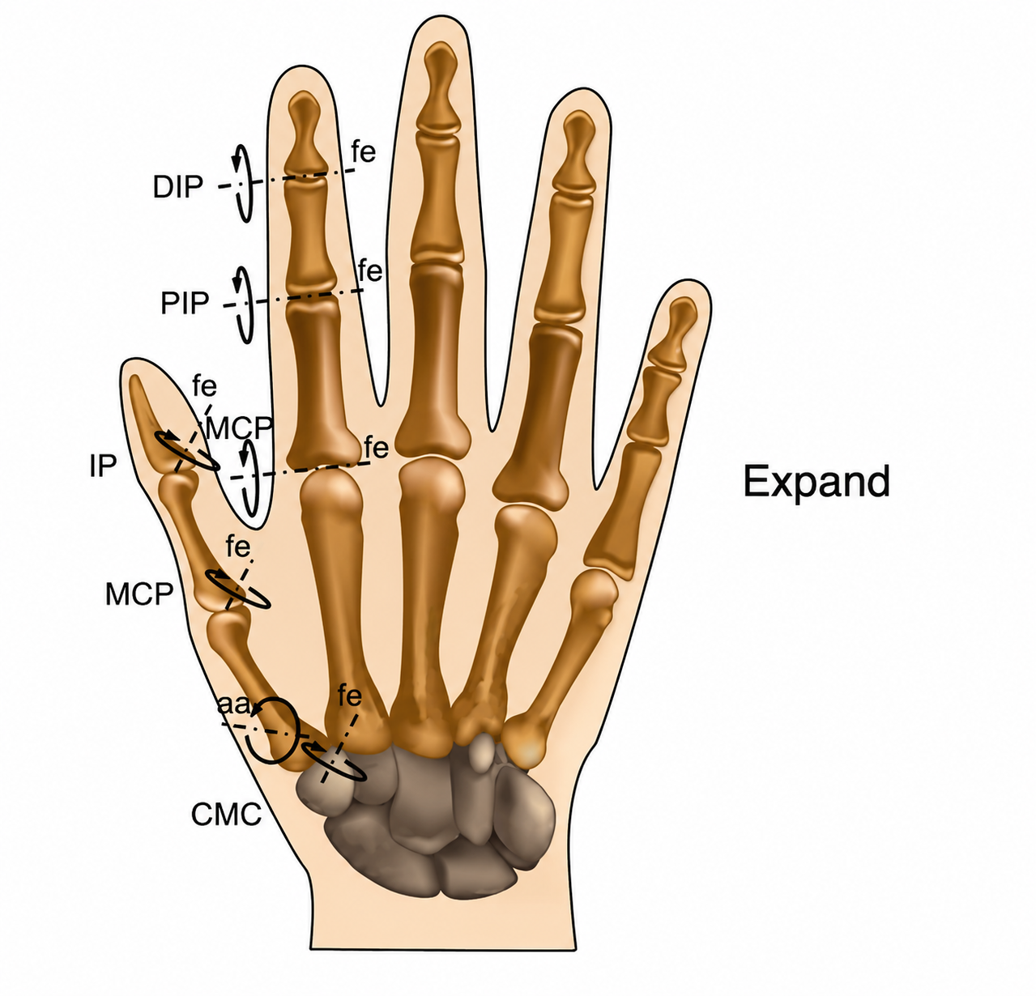
Hand Joint Motion Diagram -- reference for the CyberGlove joint-naming scheme (DIP/PIP/MCP/IP/CMC, with flexion-extension and abduction-adduction rotation axes), shown in Test 9's frontend under Predicted Kinematics.

