SafeRide School
Comprehensive End-to-End Project Report (Full Inclusive Edition)
Date: 2026-04-14
Prepared from repository implementation and provided source documents.

Table of Contents
1. Executive Summary
2. Project Background and Problem Definition
3. Vision, Scope, Stakeholders, and Success Criteria
4. Requirements Analysis (Functional + Non-Functional)
5. End-to-End User Flows and Operational Scenarios
6. System Architecture Overview
7. Backend Architecture and Implementation (NestJS)
8. Mobile Architecture and Implementation (Flutter)
9. API Surface and Contract Summary
10. Database Design and Data Integrity
11. Security, Validation, and Reliability Controls
12. Realtime Tracking and Notification Strategy
13. Testing, Quality, and Current Gaps
14. Deployment and Operational Readiness
15. Risks, Limitations, and Improvement Roadmap
16. Conclusion
Appendix A: Full Source Diagram Pages (Embedded)
Appendix B: Endpoint Catalogue by Domain
Appendix C: Data Dictionary

1. Executive Summary
SafeRide School is a role-driven school transport platform designed to improve safety, accountability, and communication across parents, drivers, and school administrators. The solution is implemented as a Flutter mobile application backed by a NestJS service with PostgreSQL data persistence via Prisma ORM.
The platform currently delivers the core lifecycle of school transport operations: authentication, role-based dashboards, trip lifecycle management, attendance capture, notifications, and administrative data workflows including CSV onboarding of students. The implementation is functionally meaningful and beyond prototype-only UI stubs, but still contains areas requiring hardening for enterprise-scale production.

2. Project Background and Problem Definition
School transport operations are often fragmented across phone calls, paper attendance, informal WhatsApp updates, and delayed issue escalation. This creates uncertainty for parents, operational burden for schools, and weak auditability for incidents.
SafeRide addresses this by centralizing transport state into a single digital system with role-specific access and controlled data visibility. The product goals include real-time situational awareness, trip accountability, and workflow consistency.

3. Vision, Scope, Stakeholders, and Success Criteria

3.1 Product Vision
Provide confidence that every student journey is visible, trackable, and auditable while preserving data security and role-based restrictions.

3.2 Stakeholders
- Parents: need timely transport status and alerts for assigned children.
- Drivers: need low-friction tools for trip execution and student attendance actions.
- School admins: need operational controls, monitoring, and reporting.
- School management: needs compliance evidence and incident traceability.

3.3 Scope
- In-scope: mobile role dashboards, route/trip operations, attendance, notifications, CSV student import, role-based APIs.
- In-scope: backend REST + websocket support, relational data model, session auth, guard-based authorization.
- Out-of-scope (current stage): fully mature incident escalation pipeline, complete map telemetry for all role views, enterprise SSO, and complete test automation coverage.

4. Requirements Analysis (Functional + Non-Functional)

4.1 Functional Requirements Coverage
- Secure login and session-backed access for all roles.
- Role-specific dashboard rendering and data visibility boundaries.
- Driver trip start/end controls and progress updates.
- Student attendance marking per trip with idempotent write behavior.
- Parent-facing tracking and notification awareness flows.
- Admin operations for students, buses, trips, and CSV onboarding.
- Notification listing, unread count tracking, and read-state updates.

4.2 Non-Functional Requirements
- Security: authenticated routes, role checks, server-side validation, password hashing.
- Maintainability: modular NestJS domains + provider/service/model layering in Flutter.
- Reliability: structured exception handling and request validation guards.
- Scalability baseline: modular API and relational model ready for extension.

5. End-to-End User Flows and Operational Scenarios

5.1 Parent Journey
Parent users authenticate, access a role-routed dashboard, inspect child-level trip context, review notifications, and open live map tracking for trip movement context.

5.2 Driver Journey
Driver users authenticate, start assigned trips, report attendance status for students, and maintain active trip operations until completion. During active trip state, location reporting attempts run periodically.

5.3 Admin Journey
Admin users maintain operational entities (students, buses, trips), monitor dashboards, review recent events, inspect fleet-level map views, and bulk import student records via CSV preview+commit workflow.

6. System Architecture Overview
Architecture follows a client-server model with clearly separated concerns: Flutter mobile app for presentation and interaction, NestJS backend for business logic and policy enforcement, and PostgreSQL for durable relational data.
- Mobile: UI + provider state + service contracts + API client.
- Backend: modular controllers/services + guards + validation + persistence + sockets.
- Data: normalized relational entities with key uniqueness and relationship constraints.

7. Backend Architecture and Implementation (NestJS)

7.1 Bootstrapping Pipeline
- Nest app initialization with global /api prefix.
- Socket.IO adapter registration for realtime gateway support.
- Global ValidationPipe with whitelist + transform + forbidden unknown properties.
- Global exception filter for standardized error response envelope.
- Environment-driven CORS policy and optional OpenAPI docs in non-production.

7.2 Domain Modules
The backend is decomposed into auth, users, parents, students, buses, trips, attendance, notifications, dashboard, routes, csv-import, database, and common modules. This structure limits coupling and supports feature evolution by domain ownership.

7.3 Authentication + Authorization
Authentication is session-token based with server-side token persistence. Bearer tokens are verified against Session records with expiry checks. Authorization is role-driven via decorators and global guards, ensuring route-level access boundaries.

7.4 Business Flows
- Trip lifecycle: scheduled -> in progress -> completed with controlled transitions.
- Attendance: student+trip upsert semantics preventing duplicates.
- CSV import: parse/normalize/validate/preview/commit with duplicate skipping.
- Notifications: role and student-targeted retrieval with unread count support.

8. Mobile Architecture and Implementation (Flutter)

8.1 Startup Lifecycle
The app initializes bindings, retains splash, loads persisted token from shared preferences, validates session via /auth/me, and selects initial route based on restore result.

8.2 State Layer
- AuthProvider manages identity, token lifecycle, and auth status transitions.
- DashboardProvider orchestrates role-specific data loading and operational actions.
- CsvUploadProvider handles CSV parsing/preview/upload status machine.
- OnboardingProvider currently includes mocked behavior and requires full API integration.

8.3 UI Layer by Role
- Parent dashboard: child status, tracking summary, notification preview.
- Driver dashboard: trip controls, attendance actions, route/emergency shortcuts.
- Admin dashboard: fleet metrics, event overview, reports, and CSV entry point.

8.4 Map + Realtime Experience
Parent live map combines polling with websocket subscription for trip updates. Additional admin/driver map experiences include demo coordinate datasets indicating partial telemetry integration maturity.

9. API Surface and Contract Summary
The API is grouped by business capability and role needs. Representative paths include /auth, /users, /students, /buses, /trips, /driver/trips, /parent/tracking, /attendance, /notifications, /dashboard, /csv-import, and /routes.
Request/response contracts are DTO-driven with class-validator enforcement at the backend boundary.

10. Database Design and Data Integrity
The relational schema includes User, Session, Parent, Driver, Student, Bus, Trip, TripLocation, Attendance, and Notification models with enum-backed role and lifecycle states.
- Uniqueness constraints on user email, session token, student code, and bus plate number.
- Composite unique attendance(studentId, tripId) to enforce one attendance record per student per trip.
- Indexes on trip date/status and trip location time series for operational reads.

11. Security, Validation, and Reliability Controls
- Global input validation with strict DTO field policy.
- Role-based route authorization and authenticated session checks.
- Password hashing via bcryptjs.
- Global exception normalization and request logging for observability.

12. Realtime Tracking and Notification Strategy
Realtime tracking uses Socket.IO namespace /tracking with token-authenticated subscription to trip rooms. Driver location reports are persisted and emitted to subscribed clients. Notification workflows support role-targeted and student-targeted visibility with unread-state management.

13. Testing, Quality, and Current Gaps
The architecture is structured for testing but current project maturity indicates selective coverage and reliance on manual verification across some user flows.
- Strengths: robust domain decomposition, clear role routing, meaningful implemented workflows.
- Gaps: some mock/simulated flows, partial map telemetry coverage, unfinished UX actions.
- Gap impact: lowers confidence for high-scale production readiness without further hardening.

14. Deployment and Operational Readiness
Backend supports standard Nest build/start scripts and environment-based runtime configuration. Production readiness requires tightened CORS origins, stronger mobile token storage posture, and comprehensive monitoring/test strategy.

15. Risks, Limitations, and Improvement Roadmap
- Implement complete emergency alert backend integration and escalation paths.
- Replace demo map datasets with live fleet telemetry in all relevant screens.
- Migrate mobile token persistence to secure keystore/keychain-backed storage.
- Introduce session refresh/renewal strategy and consistent retry/backoff policy.
- Expand automated tests across backend domain logic and Flutter UI/service integration.
- Eliminate placeholder UX routes and fully complete onboarding and recovery flows.

16. Conclusion
SafeRide is a solid MVP-stage system with a credible technical backbone and real user-facing functionality across core school transport operations. The project can evolve to full production by completing identified hardening and integration items while preserving its existing architecture strengths.

Appendix A: Full Source Diagram Pages (Embedded)
All pages extracted from the provided PDFs are embedded below for complete visual inclusion and traceability.
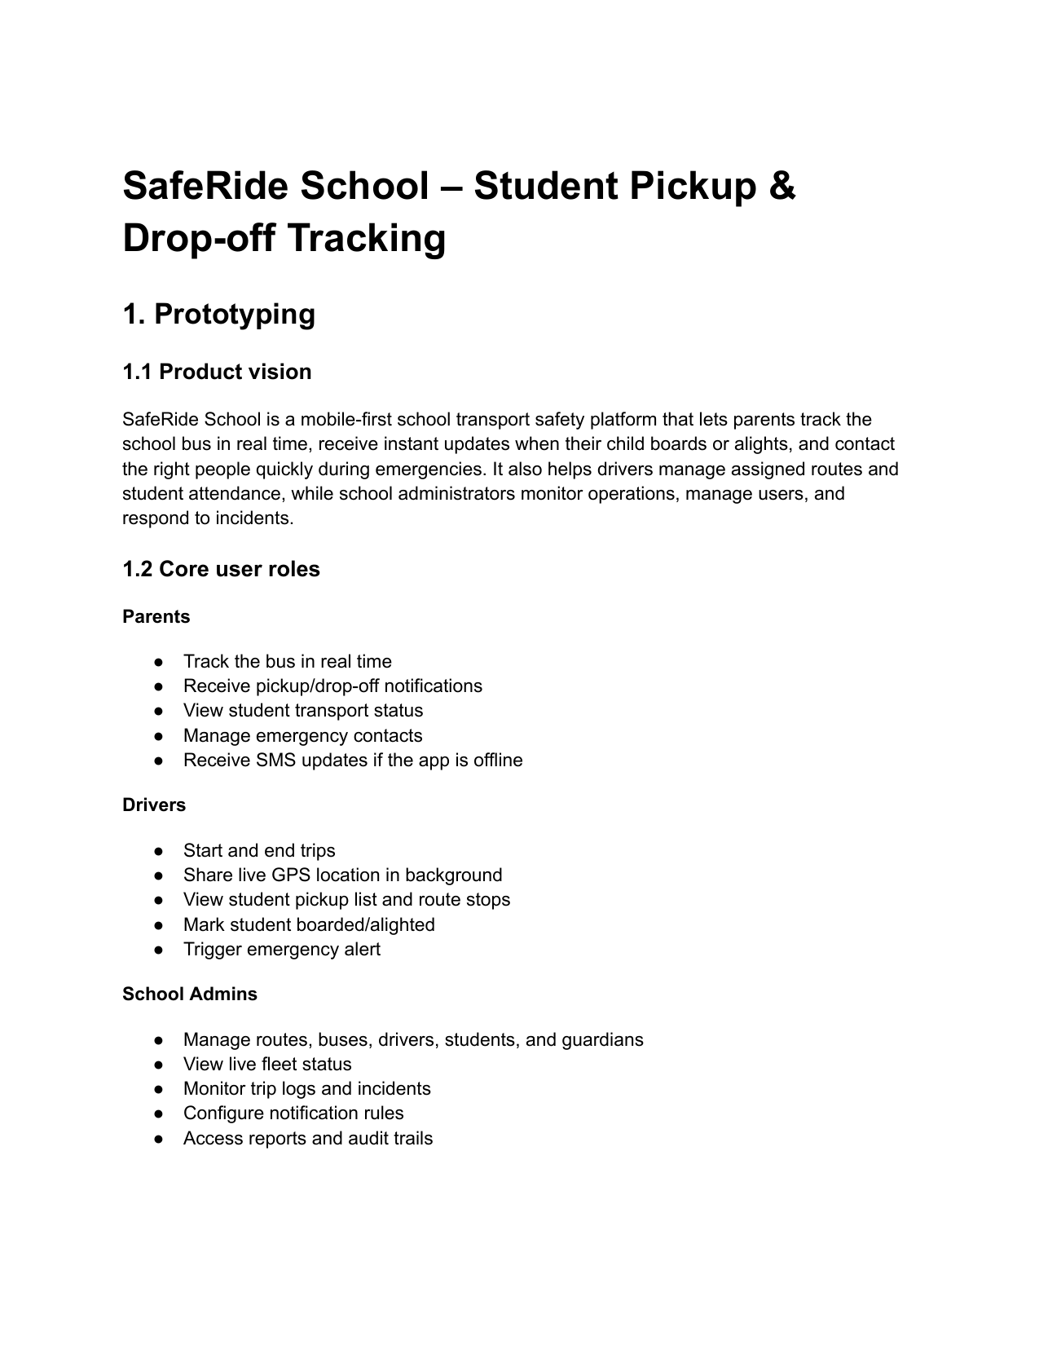
Figure: Source page 1: mobile-01.png
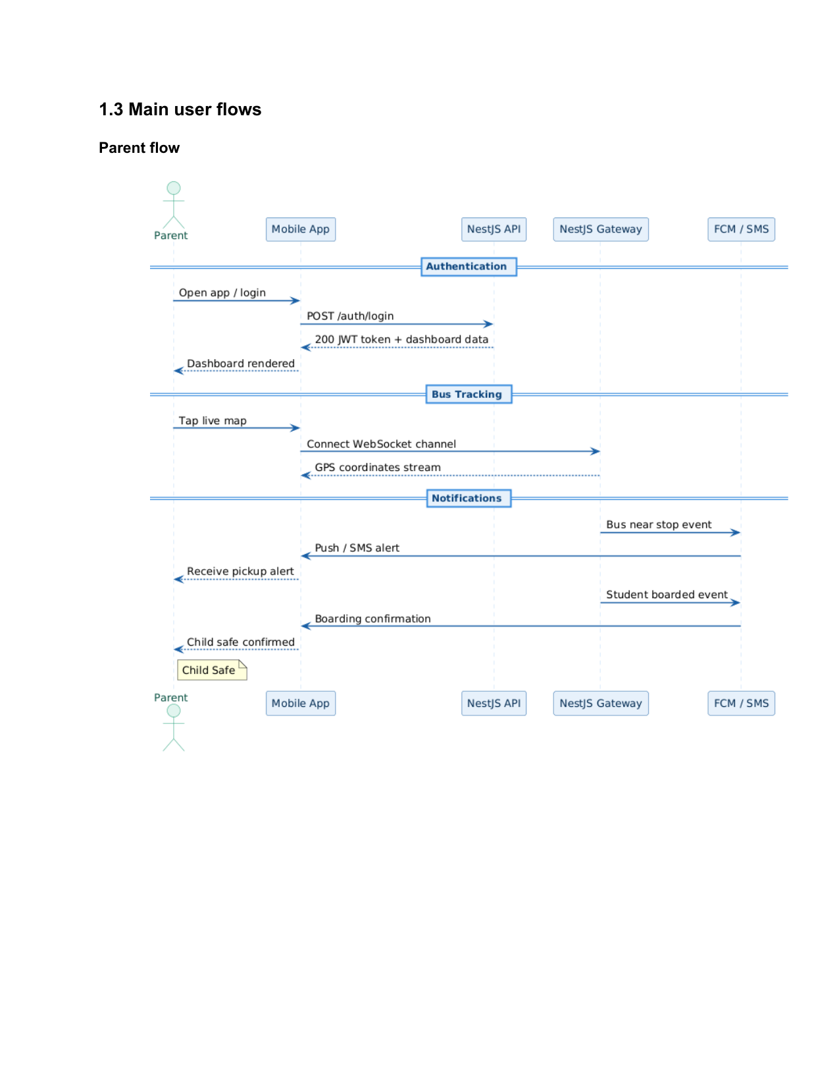
Figure: Source page 2: mobile-02.png
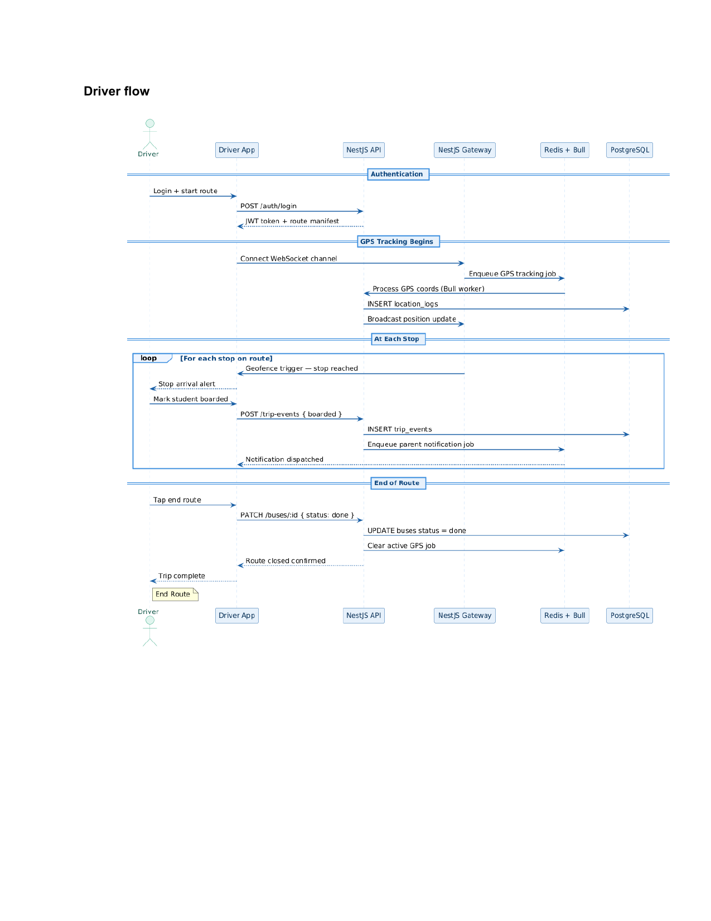
Figure: Source page 3: mobile-03.png
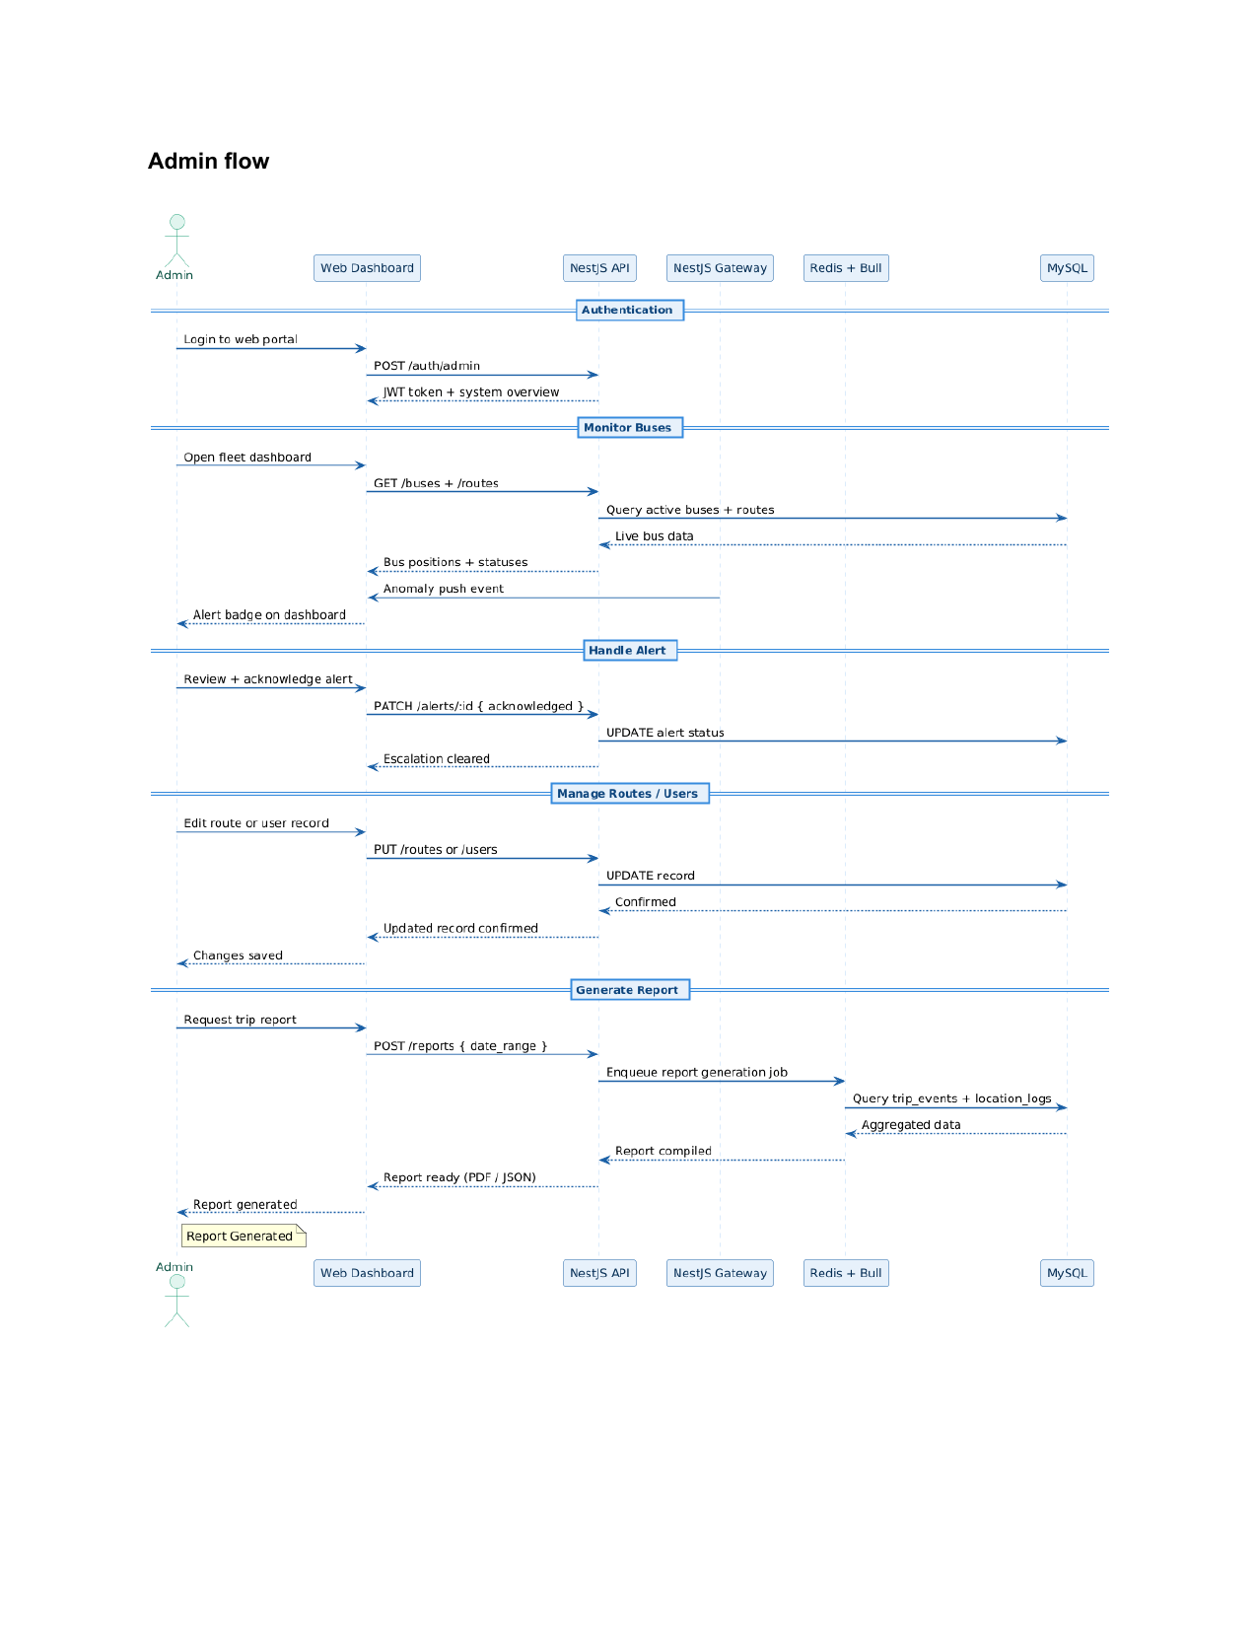
Figure: Source page 4: mobile-04.png
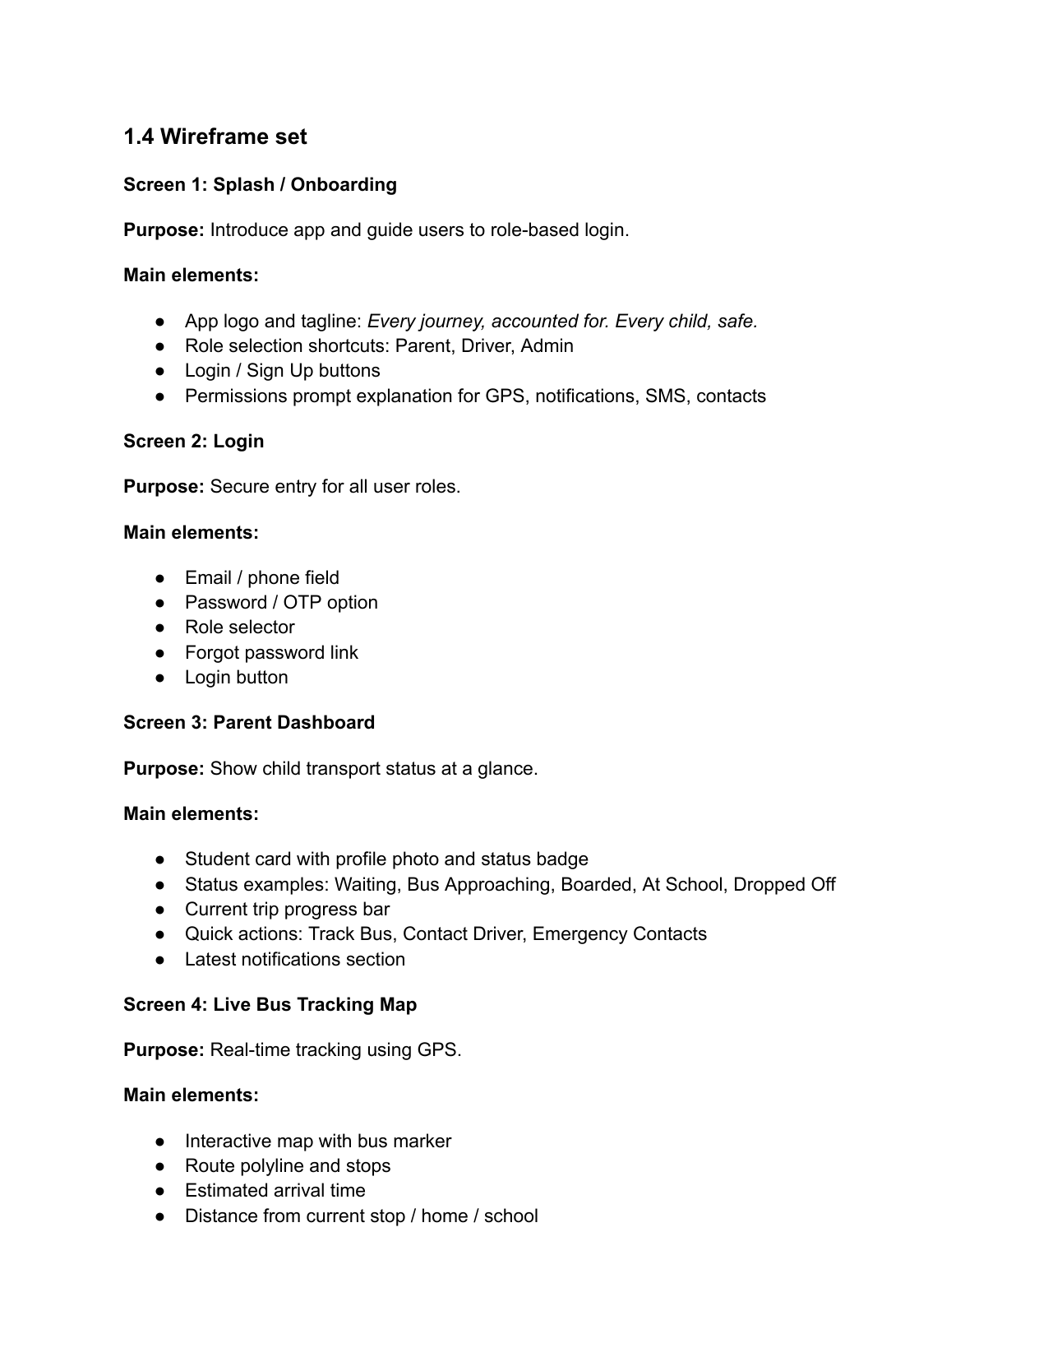
Figure: Source page 5: mobile-05.png
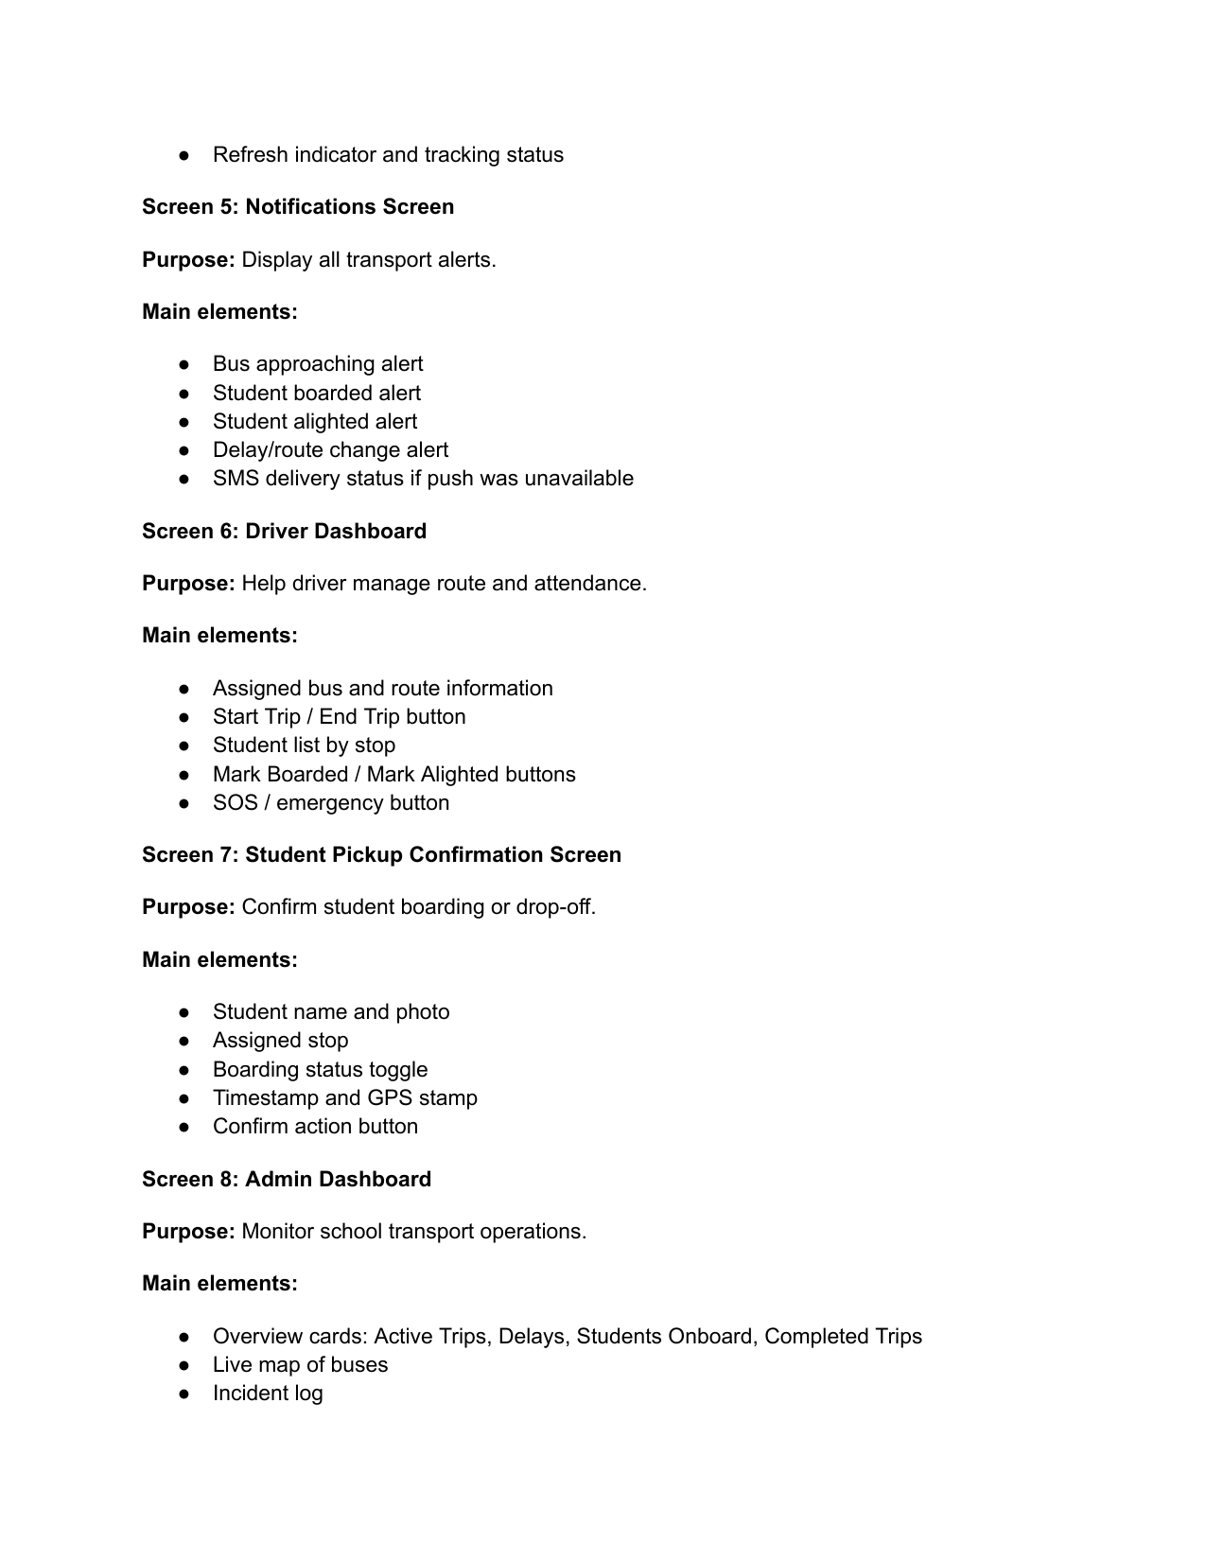
Figure: Source page 6: mobile-06.png
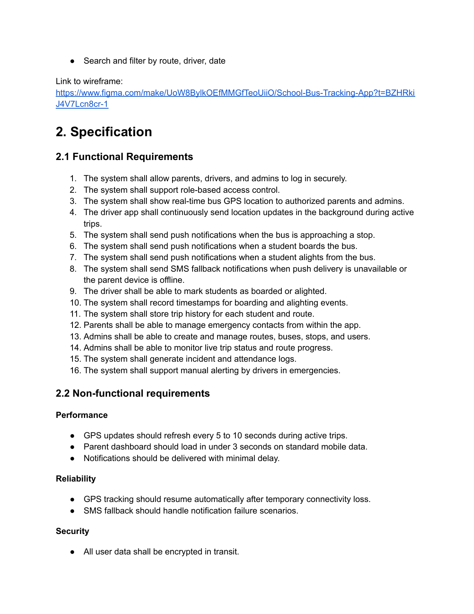
Figure: Source page 7: mobile-07.png
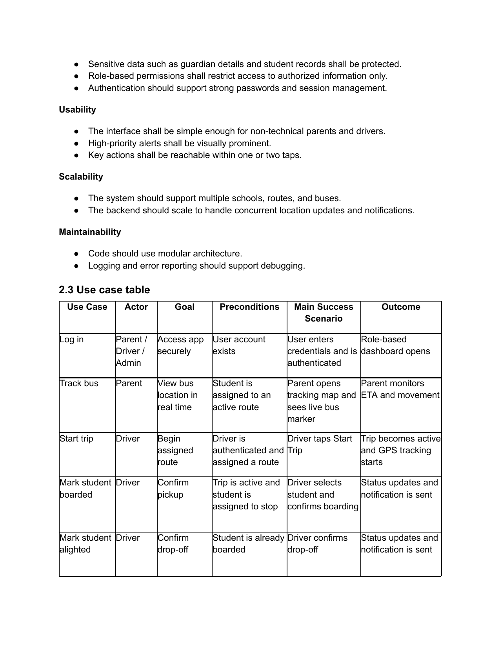
Figure: Source page 8: mobile-08.png
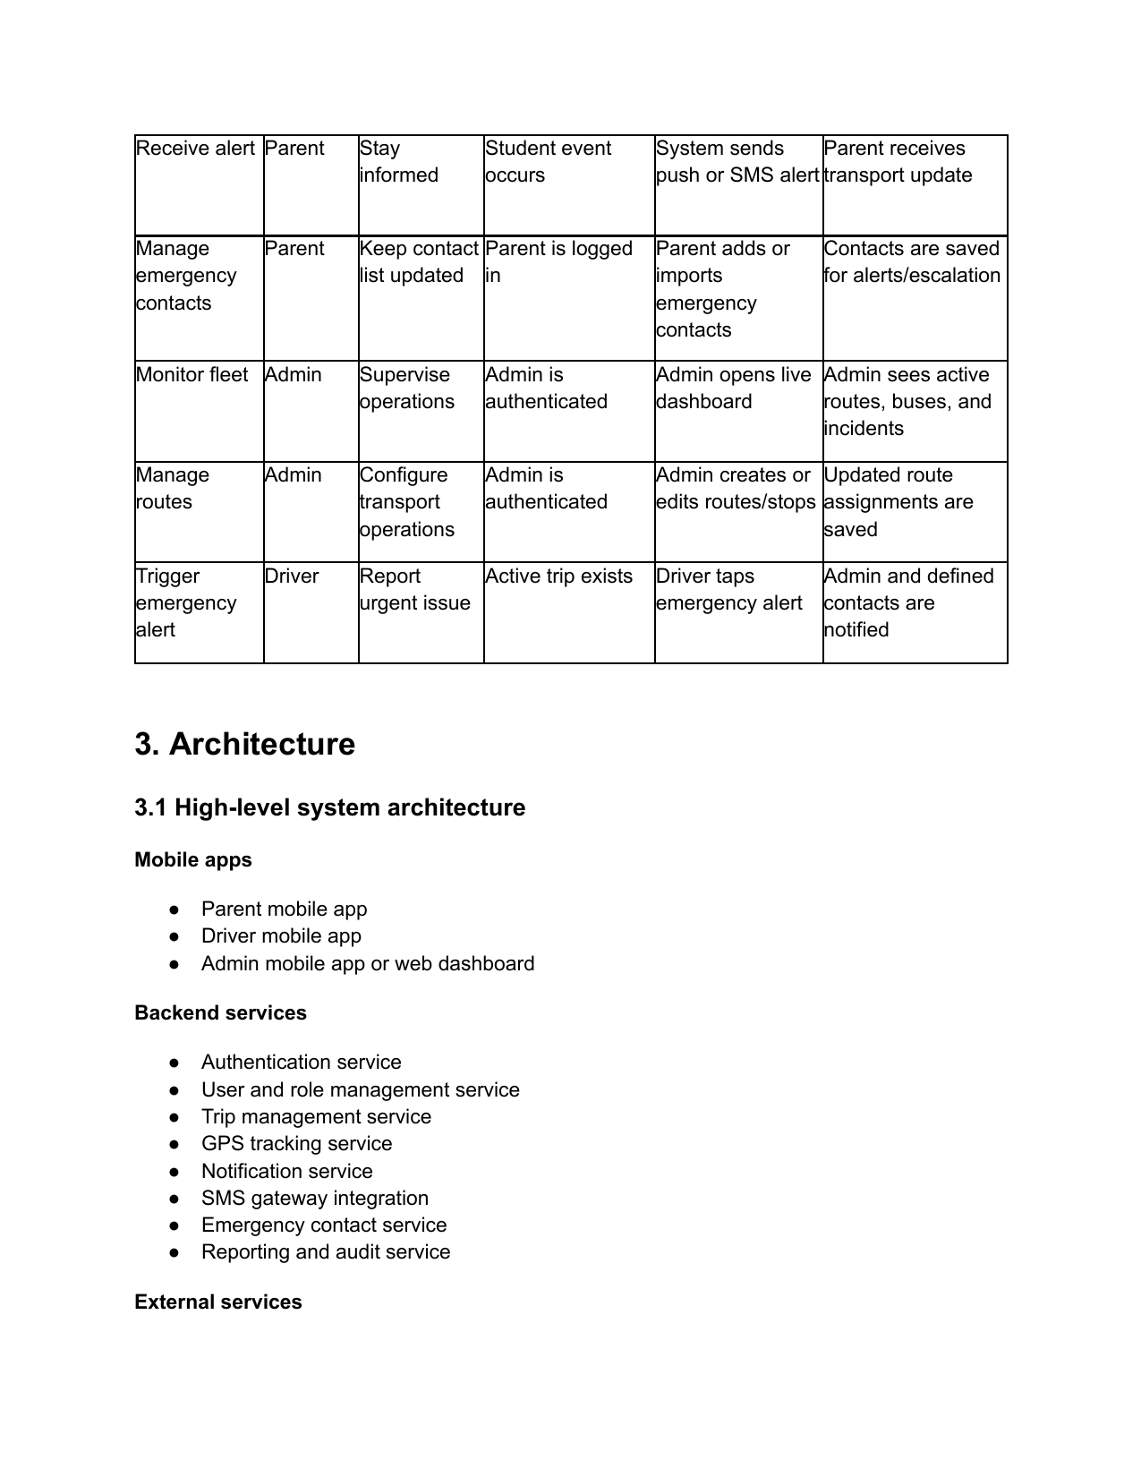
Figure: Source page 9: mobile-09.png
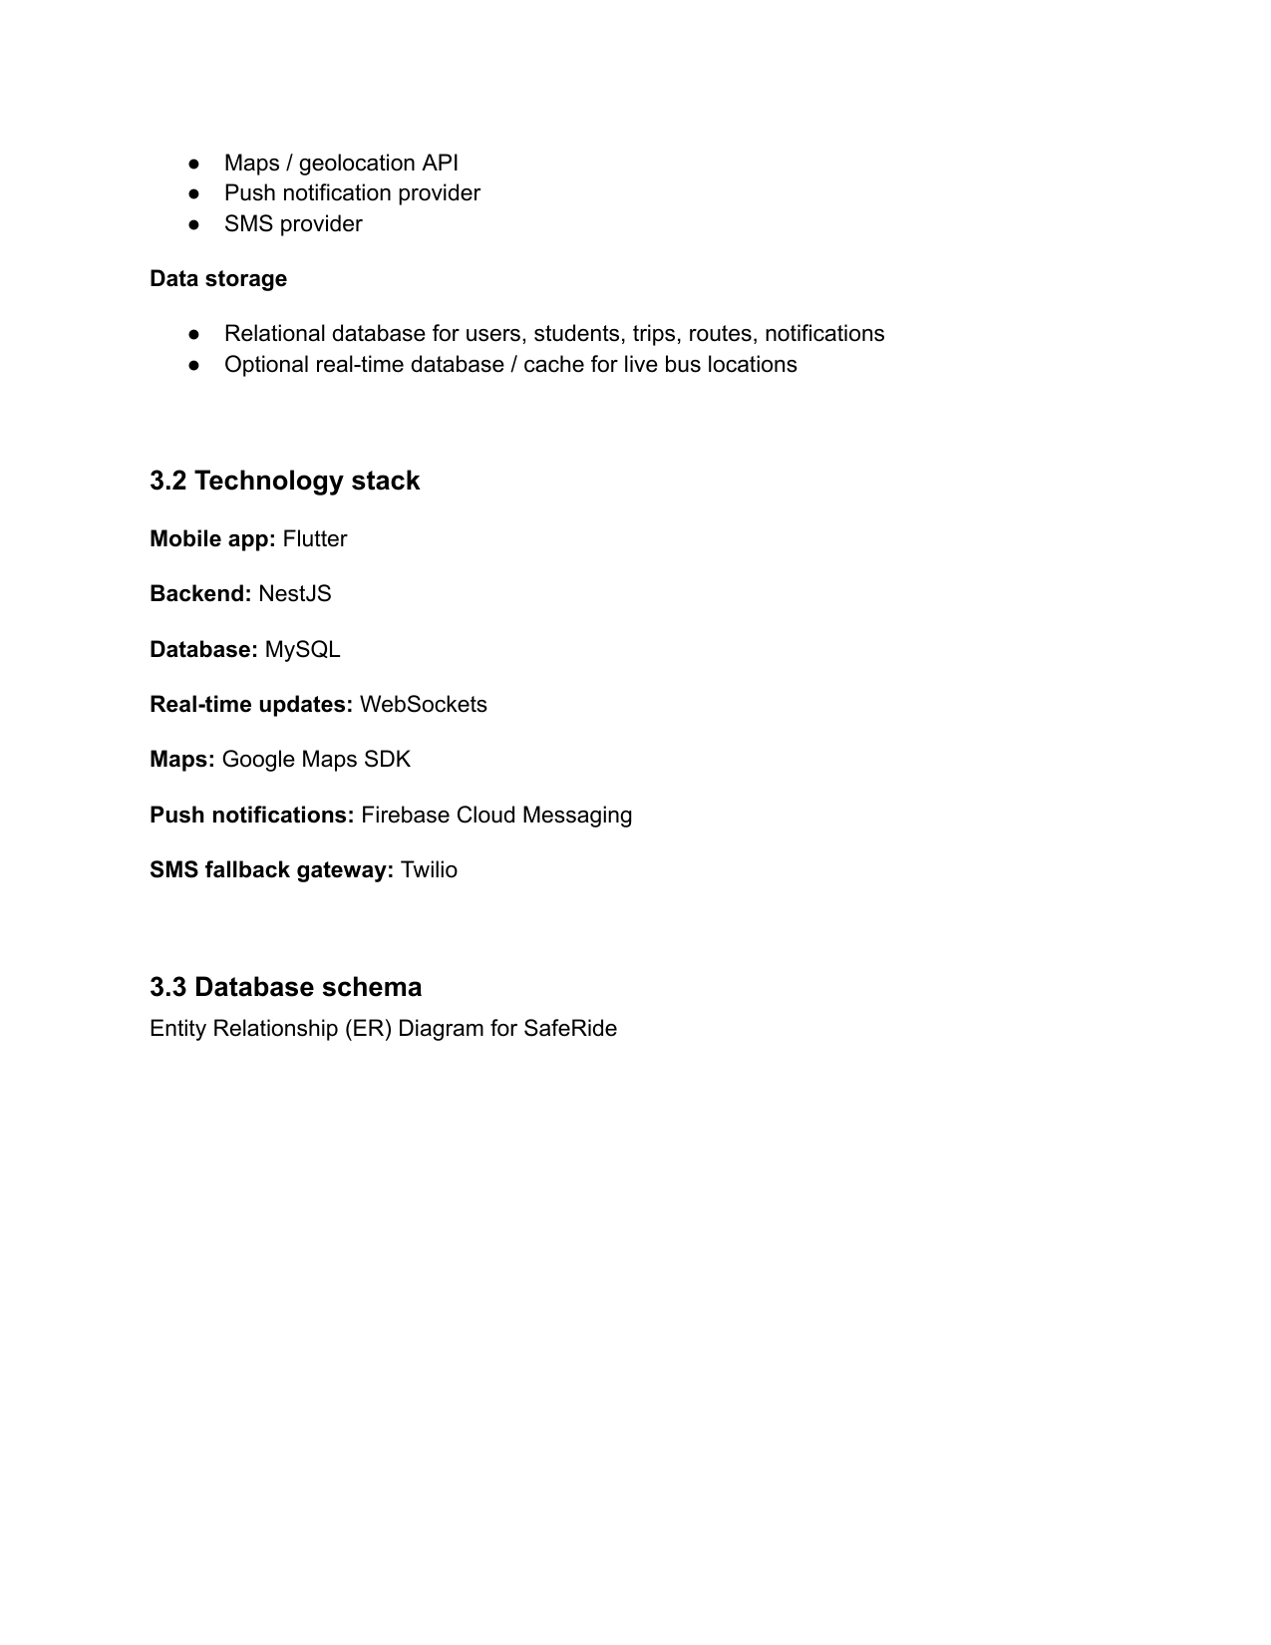
Figure: Source page 10: mobile-10.png
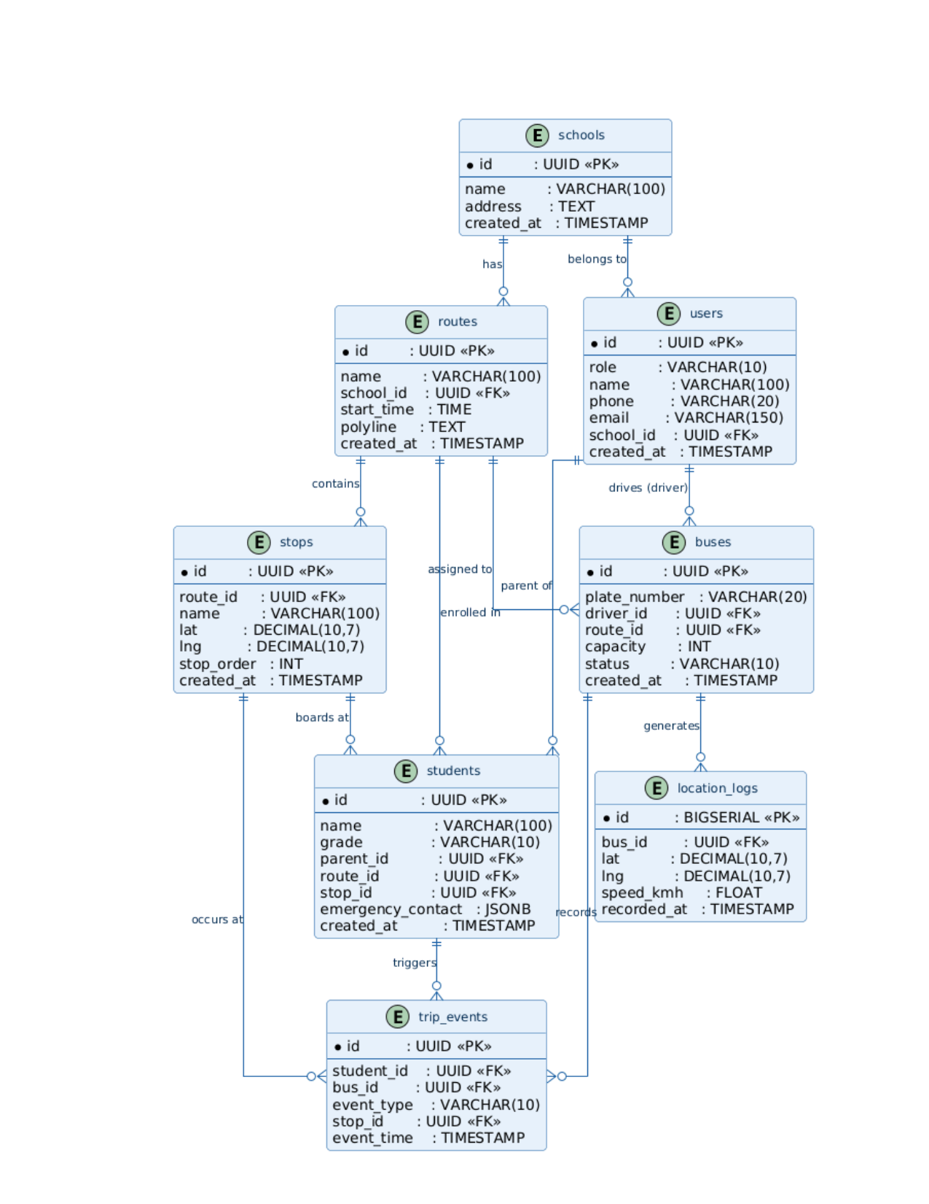
Figure: Source page 11: mobile-11.png
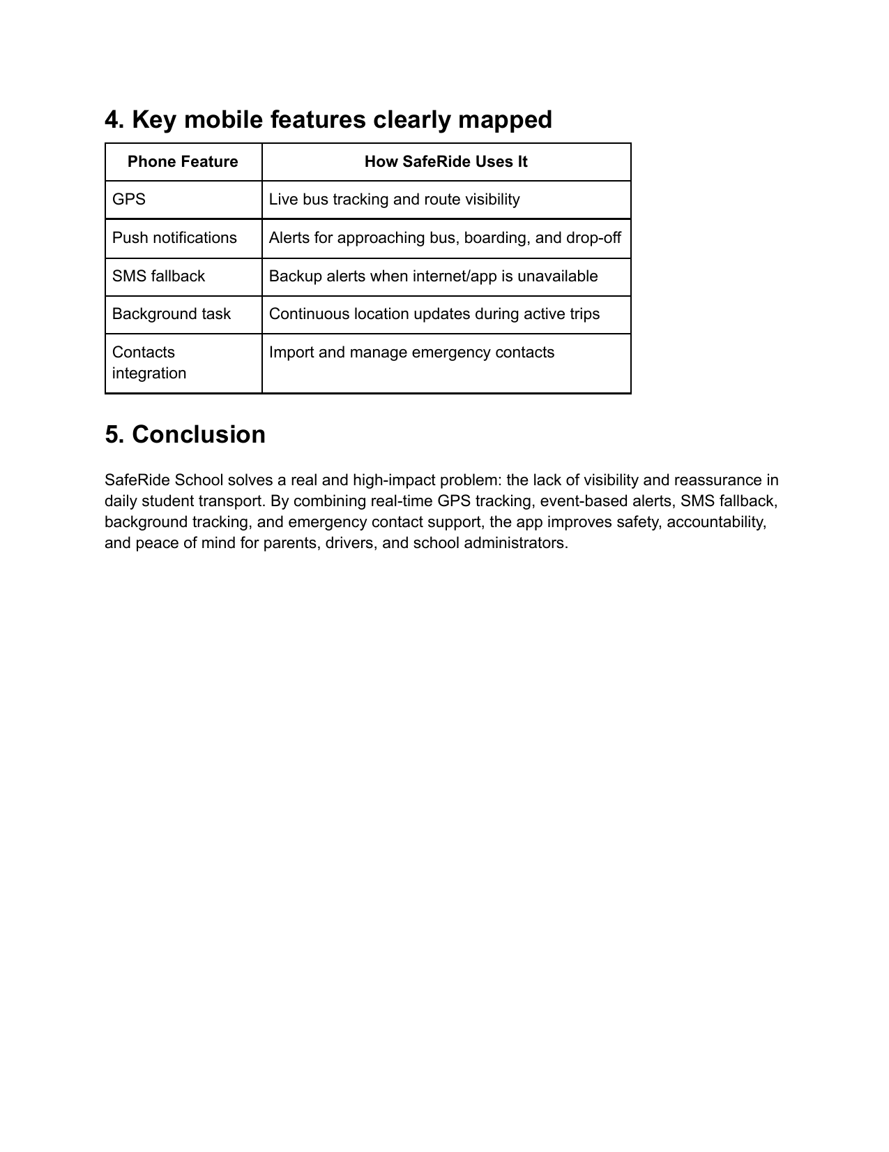
Figure: Source page 12: mobile-12.png
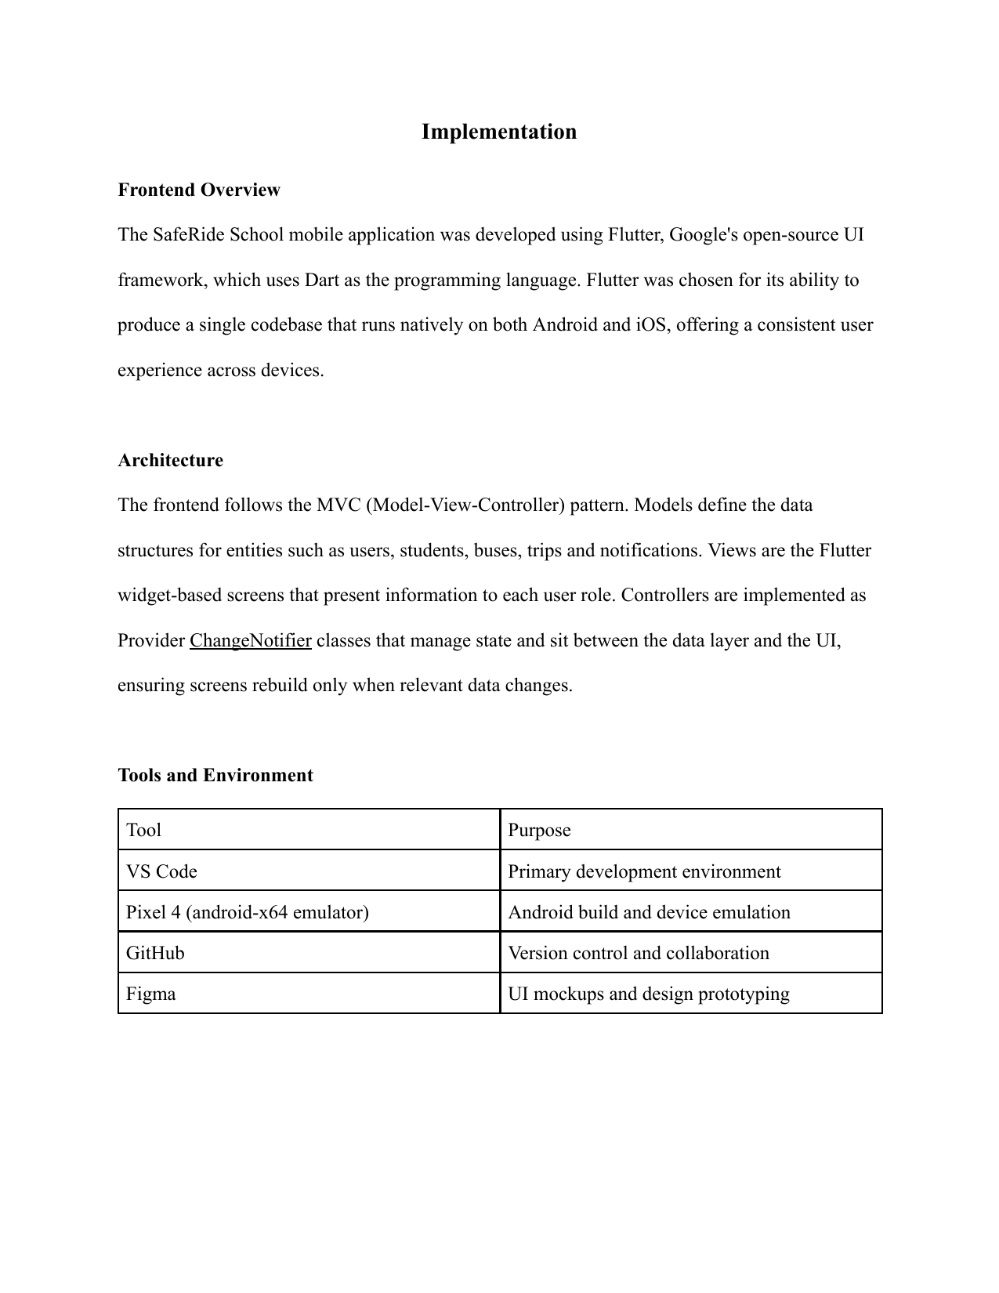
Figure: Source page 13: implementation-1.png
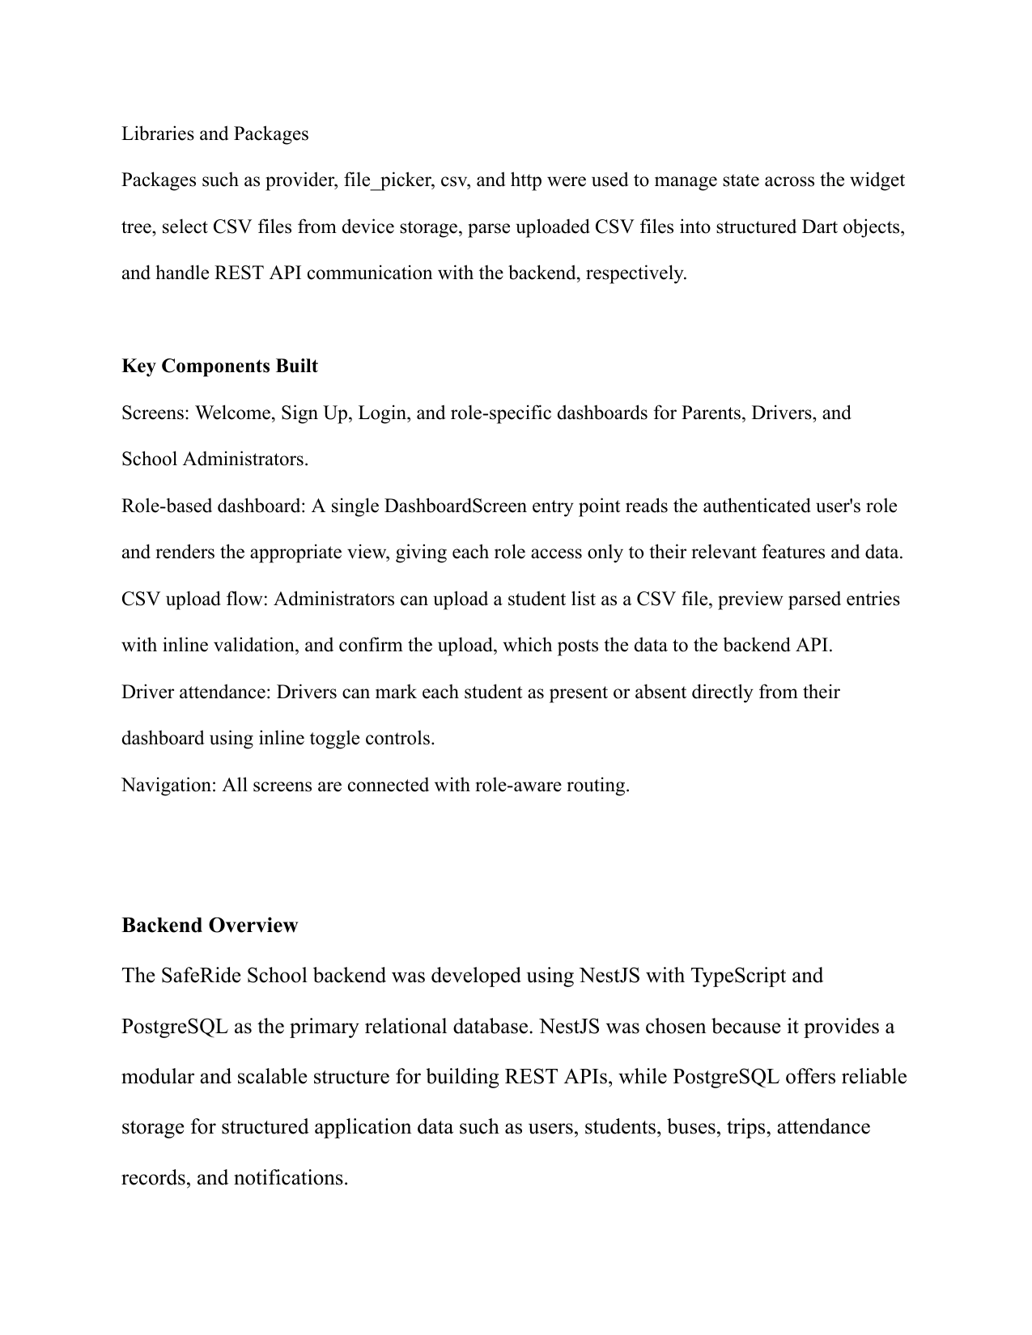
Figure: Source page 14: implementation-2.png
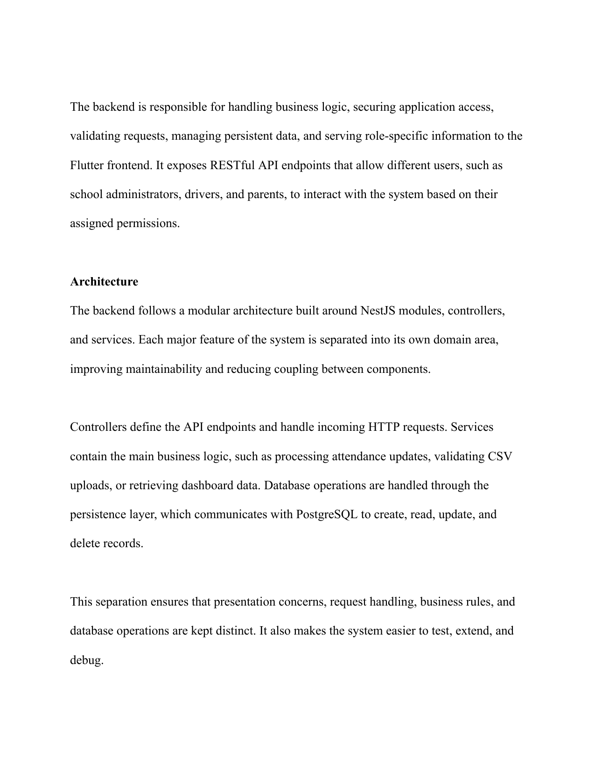
Figure: Source page 15: implementation-3.png
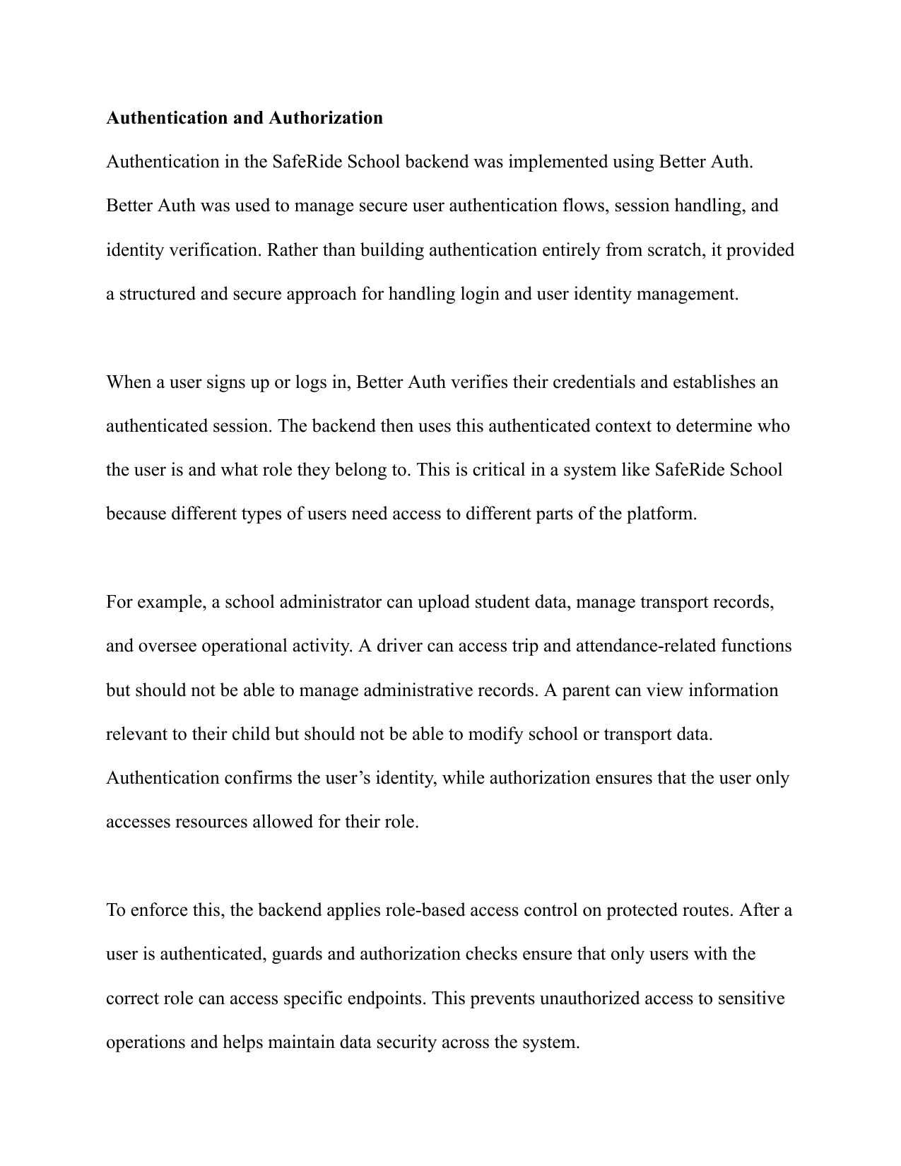
Figure: Source page 16: implementation-4.png

Figure: Source page 17: implementation-5.png
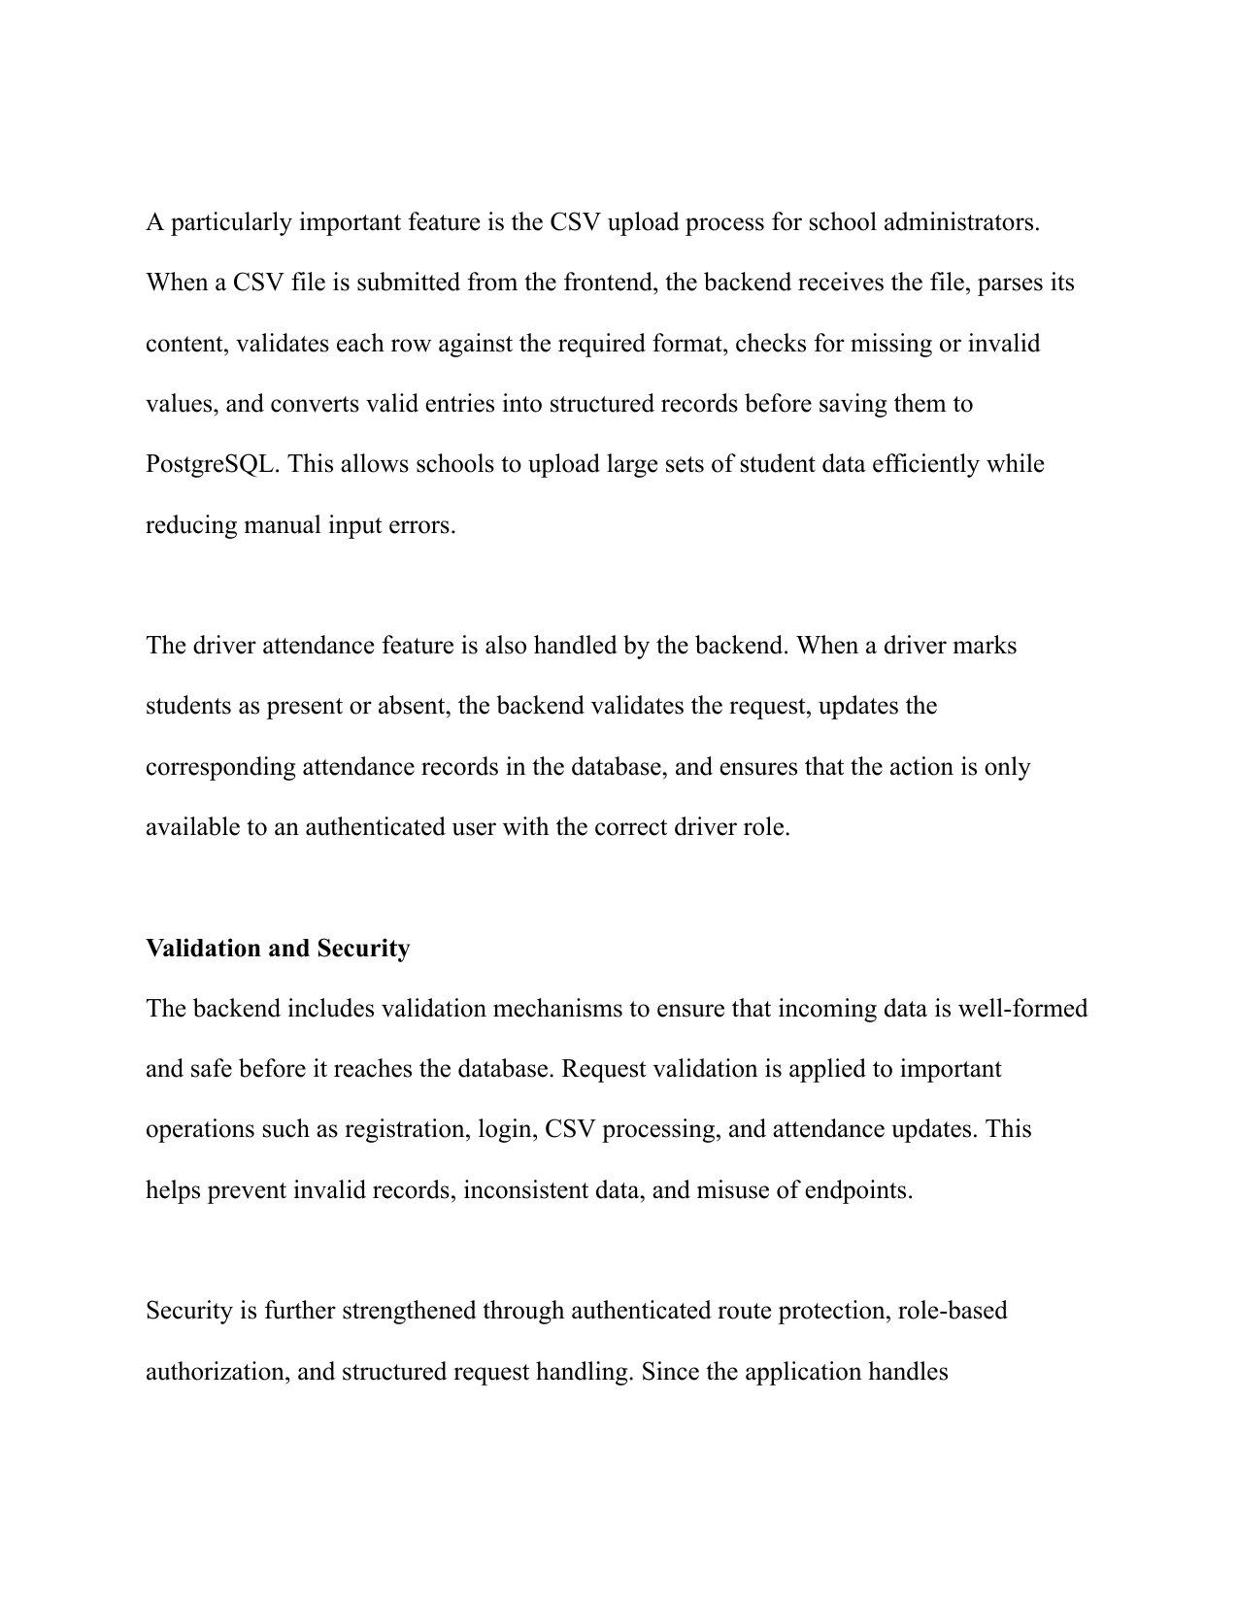
Figure: Source page 18: implementation-6.png
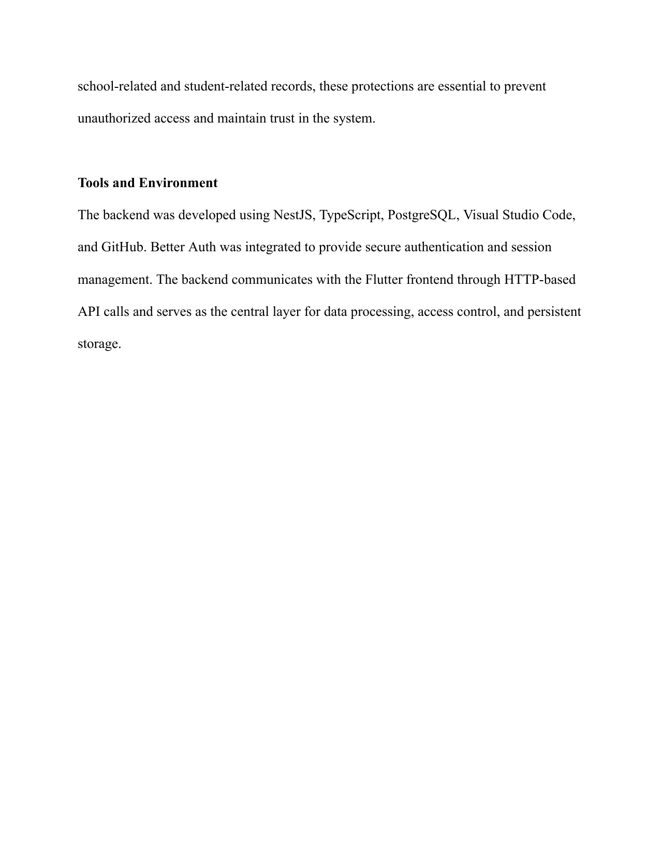
Figure: Source page 19: implementation-7.png

Appendix B: Endpoint Catalogue by Domain
Authentication: /auth/signup, /auth/login, /auth/me, /auth/logout
Users: /users/me, /users/me (PATCH), /users, /users/:id
Parents: /parents/me, /parents/me/students/search, /parents/me/students/:studentId
Students: /students CRUD set
Buses: /buses CRUD set, /buses/:id/students
Trips: /trips CRUD set, /driver/trips/:tripId/start|end|location|progress
Tracking: /parent/tracking/trips/:tripId, websocket namespace /tracking
Attendance: /attendance, /attendance/trip/:tripId, /attendance/student/:studentId
Notifications: /notifications, /notifications/unread-count, /notifications/:id/read
Dashboard: /dashboard/admin, /dashboard/driver, /dashboard/parent
CSV import: /csv-import/students/preview, /csv-import/students/commit
Routes: /routes

Appendix C: Data Dictionary (Condensed)
User: identity, role, hashed password, profile fields.
Session: bearer token, expiry, user relationship.
Parent/Driver: role extensions attached to user.
Student: transport and guardian-related profile attributes.
Bus: vehicle identity and route assignment fields.
Trip: operational lifecycle, timing, stop and ETA metadata.
TripLocation: timestamped geolocation point per trip.
Attendance: student-trip status record with marked metadata.
Notification: title/body with optional role or student targeting.

