DHL EXPRESS · AMKAD FINANCE

AMKAD AR Report — Maintenance Guide
Everything you need to keep the accounts-receivable dashboard running, written for whoever inherits it next. Skim sections 1–2 once, then live in the Troubleshooting playbook.
SECTION 01

What this automation does
It turns a daily Excel file into an interactive HTML dashboard — automatically, with no manual steps in between. Data flows one direction:
STEP | COMPONENT | WHAT HAPPENS
1 · Build | Cust Sol import flow | Reads the raw source file and builds that day's Daily_Performance_Report .xlsm, carrying history forward (Section 5F)
2 · Load | Power Query | Picks the latest file, reads its RawData table in AMKAD_Current_Input.xlsm
3 · Calculate | Office Script | Does the maths, builds tables + a JSON result. Also reads the SPR sheets and MonthEndAR (Section 5G)
4 · Assemble | Power Automate | Drops the JSON into the HTML template
5 · Deliver | HTML report | Emailed, saved, or shared

The golden rule. The report can only show what is in RawData. When a number looks wrong, work backwards along that chain — report → RawData → the source Excel file — until you find where the number first goes wrong.

SECTION 02

The one concept that matters: "latest snapshot per month"
The daily file's RawData table doesn't hold just today's numbers — it holds a running history: many daily captures for every month, going back to 2024. If you simply added all of June's rows together you'd count June twenty-plus times over, and every figure would be roughly 20× too big.
So for each month the script keeps only the latest date that is a real, full extract with actual amount in it, and ignores every earlier day. That produces a true point-in-time (Month-to-Date) view. You can always see exactly which date it chose in Data Quality → Snapshot Audit.
SECTION 03

The pieces & where they live
Technical INFO
COMPONENT | WHAT IT IS | WHERE IT RUNS
Power Query query: RawData | Picks the latest daily file, loads RawData | Excel → Power Query
Office Script: AMKAD AR report | All calculations + builds the tables & JSON | Excel Online → Automate
Office Script: refresh trigger | No-op script that forces the RawData refresh (Section 5E) | Excel Online → Automate
HTML template (report flow) | Dashboard layout, charts, interactivity | Power Automate → HTML action
Email body (Send an email V2) | The automated email body (Section 5D) | Power Automate → Send an email
This document | This guide | —
Office Script: custsol read daily | Reads the raw source file, returns its rows as JSON (5F) | Excel Online → Automate
Office Script: custsol append rawdata eur | Appends those rows to the new daily file's RawData (5F) | Excel Online → Automate
Power Query query: MonthEndAR | Pulls the latest closed month from Debits into MonthEndAR (5G) | Excel → Power Query
SPR_<CC> sheets in the input workbook | Collector commentary: SPRIssues_<CC> and SPRForecast_<CC> (5G) | Excel (typed by collectors)
Master copies. Keep the current text of every script, query and template in the shared SharePoint folder next to the workbooks, and update it whenever you change one. That folder is the only source of truth for this automation — there is no build step and no other copy to fall back on.

SECTION 04

Routine maintenance calendar
WHEN | DO THIS
Every review | Open the Data Quality tab in HTML report. Confirm 'Latest snapshot date used' is what you expect and 'Rows used' is in the thousands, not tens.  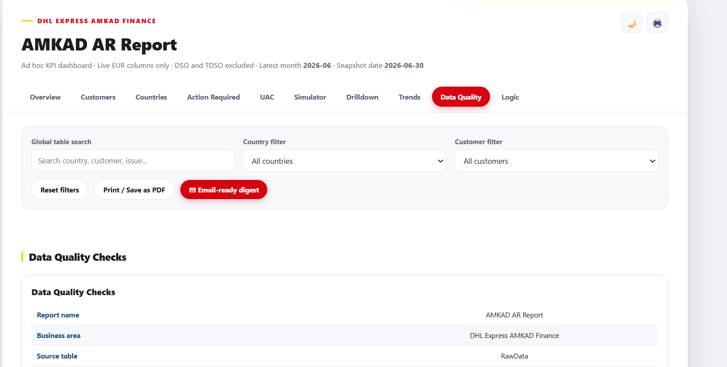
Start of each year | The Power Query path is hard-coded to 2026 AMKAD Summaries/Daily. Change 2026 to the new year. This is the #1 thing that will suddenly 'break' the report.  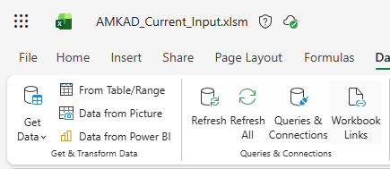  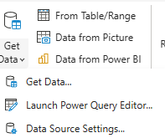  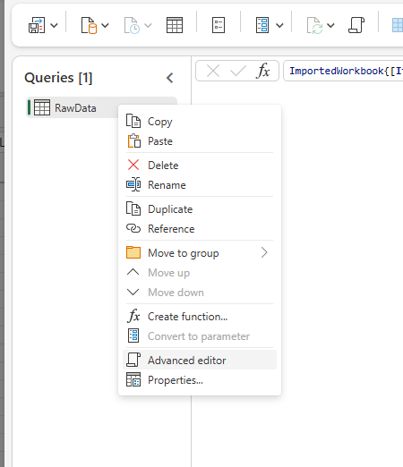  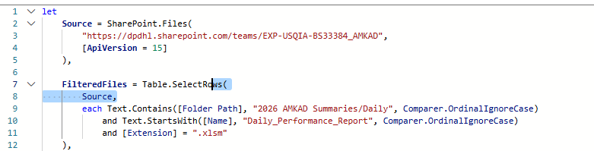
If file names change | Update the filename date-parsing in the RawData query.
If the layout needs a change | Edit the HTML template and re-paste into Power Automate.  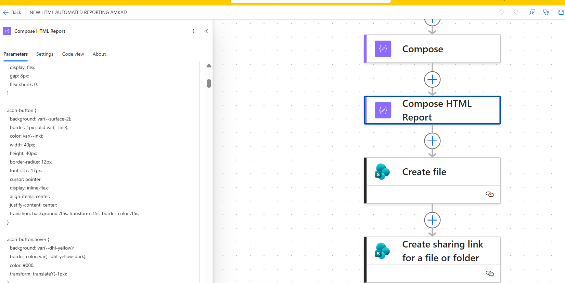
Occasionally | Confirm the 'AMKAD – Trigger Daily Refresh' flow (5E) is still enabled and still scheduled before the main report flow, with a healthy gap between them.
Each month, before the review | Collectors fill the SPR sheets for their country. The SPR tab's country strip shows a coverage count (e.g. '7 of 9') so gaps are visible beforehand.
After each month close | Refresh the MonthEndAR query so the SPR tab shows the new closed month. It holds one month only and is replaced on each refresh.
If a daily run fails | Re-trigger the flow on that day's source file. Output files are named from the SOURCE file's date, so backfilling produces the correct name (5F).

SECTION 05

How to update each component

A · The dashboard look & behaviour
File: HTML template (report flow)

- In Power Automate, open the HTML/Compose action, paste over it, Save.
- Run the flow once and open the output to check.
Two hard rules. Never touch the @{outputs('Run_script')…} placeholders — they're where real values get injected. And never add anything loaded from the internet (external fonts, chart libraries, images): SharePoint/Outlook preview blocks it, so the page must stay fully self-contained.

The Simulator tab is calibrated, not guessed. The conservative/moderate/aggressive aging roll-forward rates are computed client-side from the report's own historical trend data (see calibrateAgingRates()), not hardcoded round numbers. The Simulator tab displays the sample size and computed rates directly, so it stays auditable.

B · The calculations & tables
File: Office Script: AMKAD AR report

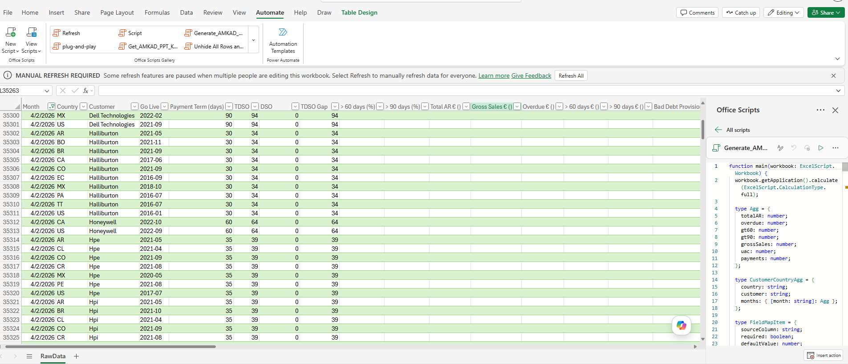
- Edit the file and copy the entire contents.
- Excel Online → Automate → open the AMKAD script → Code Editor → paste → Save → Run once.
- The flow uses this same script, so it picks up the change on its next run.
Field mapping: the script matches columns by name (e.g. Total AR € (Live)). If a column is renamed in the source, that metric reads blank → €0 for every month. Fix by updating the expected name in the script's mapping section.

C · Which daily file is read
Where it lives: the input workbook → Data → Queries.
- Year rollover: change the folder year in the path.
- Naming change: files are 'Daily_Performance_Report- June 30 2026 AMKAD.xlsm' — the query reads the Month Day Year from the name. Update the parse if the format changes.
- To see which file it picked: temporarily set the query's last line to `Ranked` and read the top row's Name & FileDate. Revert after.

D · The automated email
File: Email body (Send an email V2)
The email is a short, email-safe KPI summary with a button linking to the full report — not the full interactive dashboard, since Outlook strips the scripts/CSS that make it work.
- Edit the file and copy the entire contents.
- In Power Automate, open Send an email (V2) → Body → code view (</>) → select all → paste → Save.
The report link is an expression, not the dynamic-content picker: @{outputs('Create_sharing_link_for_a_file_or_folder')?['body/link/webUrl']}. If that action is ever renamed, update the expression to match. Power Automate's code-view editor strips some HTML on save — always re-paste the whole file rather than patching a fragment.

E · Automatic daily refresh
File: Office Script: refresh trigger
Office Scripts cannot trigger a Power Query refresh from inside a script — there is no supported API for it. The fix is two separate scheduled Power Automate flows, not one:
FLOW | TRIGGER | WHAT IT DOES
AMKAD – Trigger Daily Refresh (new) | Recurrence, runs first | Runs the refresh-trigger script — a no-op whose only job is to open the workbook, which (with 'Refresh data when opening the file' enabled) triggers the refresh.
AMKAD AR Report (existing) | Recurrence, runs after, with a gap | Runs the real report script, builds the HTML, sends the email.

The time gap between the two flows (start with 20–30 minutes) is what guarantees the refresh finishes before the report reads the data — the two flows don't share a session, so there's no race condition. To verify it's working: after a scheduled run, check the Data Quality tab's 'Latest snapshot date used'.

F · The daily file build (Stage 1)
Where it lives: Excel Online → Automate → the 'custsol read daily' and 'custsol append rawdata eur' scripts.
This flow creates the Daily_Performance_Report .xlsm that everything else reads. It replaced a manual routine of copying the emailed report into a template, calculating, copying two column ranges out, refreshing and saving a new file.
Trigger: a file is created in …/Daily/Cust_Sol Daily File.
Two Initialize variable actions build the output file name and the month folder.
Get files → Filter array → Compose picks the newest existing daily file.
Get file content + Create file copy it forward under the new name. This is what carries the full history into the new file.
Run script 'custsol read daily' on the SOURCE file returns its rows as JSON.
Run script 'custsol append rawdata eur' on the NEW file appends those rows to RawData.
Why two scripts: an Office Script can only touch the workbook it runs on, so it cannot read the source and write the daily file in one pass. Power Automate carries the JSON between them.
Naming. The output file is named from the SOURCE file's date (its MMDDYYYY prefix), not today's date. That is what makes backfilling work: re-trigger the flow on an old source file and the output gets that day's correct name. It also means a misnamed source file fails the run rather than silently producing a wrongly dated file — keep flow-failure notifications on.
Built-in safety: the append skips rows already present (matched on Date + Country + Customer), so re-running the same day cannot double-count — check skippedDuplicates in the last action's output. Rows with blank EUR columns (normal for a day or two after close) are appended anyway and counted in missingEuroRows. Columns are matched by header name, so reordering columns in the source is harmless; renaming one is not.

G · The SPR tab (commentary + month-end figures)
Files: the SPR_<CC> sheets in the input workbook + Power Query query: MonthEndAR
The SPR tab shows an Account Business Review per customer: Main Issues, Actions, cash forecasting and the AR figures. It has two inputs.
1 · Commentary. Each country has a sheet (SPR_US, SPR_MX, …) with two tables: SPRIssues_<CC> (Month, Country, Customer, Issue, Action — one row per issue) and SPRForecast_<CC> (Month, Country, Customer + the five cash figures — one row per customer). Month is YYYY-MM and history is kept by month: to start a new cycle, copy the rows down and change the Month.
Adding customers and countries. The report finds these tables by NAME PREFIX, so a new country needs no code change — create a sheet with tables named SPRIssues_XX and SPRForecast_XX and it appears. A new customer needs nothing at all: once it shows in the AR data it is listed, tagged 'No commentary' until someone writes some. Names are matched ignoring case and extra spaces, so 'nokia' and 'Nokia ' still attach; genuinely different names (Nokia vs Nokia Corp) stay separate accounts by design.
2 · Month-end figures. SPRs are reported on month-end numbers, but the daily pipeline only holds daily snapshots, and month close can shift by days — so the last daily snapshot of a month is NOT the close. spr_month_end_ar.m pulls the latest closed month from the Debits source into a MonthEndAR table in the input workbook.
Requires a text parameter SharePointSite_Url.
The query name AND the loaded table name must both be exactly MonthEndAR.
It holds one month — the latest close — and each refresh replaces it.
What the tab shows: each account lists Financial Performance twice — month-end close above, daily/current below — each labelled with the table it was read from. The country strip totals ONE declared basis, switchable between month-end and current, and never blends the two.
SECTION 06

Troubleshooting playbook
Always start at the report's Data Quality tab, then match your symptom.
CRITICAL Every number is ~20× too big
CHECK 'Rows used' is huge; Snapshot Audit shows many dates combined.
CAUSE The latest-snapshot filter isn't applied, so multiple daily extracts get summed.
FIX Redeploy the current Office Script — the snapshot logic lives there.

DATA GAP One month is blank / all 0.0% (the 'April' case)
CHECK Snapshot Audit → that month shows €0 on every date.
CAUSE That month has no money in the source — the rows exist but the live EUR column is blank/zero.
FIX It's a source-data problem, not the report. Fix the daily file upstream. The current script already hides a fully-empty month automatically.

MAPPING One metric (e.g. UAC) is €0 for every month
CAUSE A RawData column was renamed, so the script can't find it.
FIX Update the field mapping in the Office Script (Section 05).

REFRESH The whole report failed / Power Query errors
CAUSE Most often year rollover — the path still has the old year. Also: naming change, no files matched, or SharePoint sign-in expired.
FIX Update the path/parse; confirm you can open the folder; re-authenticate SharePoint.

DISPLAY Charts blank + red 'issue running scripts' banner
CAUSE A sandboxed preview (SharePoint/Outlook) restricting scripts, or an external resource was added to the HTML.
FIX Open it in a real browser tab to confirm it works. Make sure no https:// script/font/image was added to the template.

SELECTION 'Latest month' is wrong / an old month shows as newest
CAUSE Power Query picked the wrong daily file (often a copied/re-uploaded one).
FIX Use the 'which file is it using?' check (Section 05) and confirm the newest file is named with the correct date.

STALE DATA Data still looks a day (or more) stale despite the refresh setup
CHECK Power Automate run history for the trigger flow — did it run, and when, relative to the report flow?
CAUSE The 'AMKAD – Trigger Daily Refresh' flow (5E) didn't run, was disabled, or the gap before the report flow was too short.
FIX Re-enable/reschedule the trigger flow; widen the gap between the two flows if refresh is taking longer than expected.

EMAIL LINK The 'Open the report' button/link in the email doesn't show or work
CAUSE Power Automate's code-view editor stripped some HTML on save, or the sharing-link action produced no URL / was renamed.
FIX Re-paste the entire email_body.html file (5D). Check run history → 'Create sharing link…' → Outputs to confirm link.webUrl has a real value.

MISSED DAY A daily run failed, so there is no file for that date. Most gaps are harmless: the report picks the latest valid snapshot per month, so a mid-month hole does not change any month-end figure. The one that matters is a gap on the last business day(s) of a month, because the month then resolves to an earlier date and its 'close' is quietly wrong. Fix: the source file is still in Cust_Sol Daily File — re-trigger the flow on it and the output is named for that day.
SPR BLANK The SPR tab shows no accounts, or commentary does not appear. Check, in order: the country has a sheet with tables named SPRIssues_<CC> / SPRForecast_<CC> (prefix must match exactly); the Month cell is YYYY-MM; and the Customer spelling matches the AR data. Case and extra spaces are tolerated, different names are not. The coverage count on the country strip ('7 of 9') is the quickest way to spot a customer whose commentary did not attach.
NO MONTH-END TABLE An account shows only the daily figures. MonthEndAR has no row for that customer. Confirm the MonthEndAR query refreshed after the close and that the table is named exactly MonthEndAR. Note the tab shows the most recent close available even when the commentary is dated a later, still-open month — it names both periods when they differ, which is expected mid-month.
SECTION 07

Before you change anything

- ☐ Change one component at a time, then re-run and check the report.
- ☐ After any change, open the Data Quality tab and sanity-check the snapshot date and rows used.
- ☐ Keep every @{outputs('Run_script')…} placeholder intact in the HTML.
- ☐ Never add internet-loaded resources to the HTML.
SECTION 08

Hand-off & escalation
Fill these in for whoever comes after you.
ROLE / QUESTION | NAME & CONTACT
Report owner / business contact
SharePoint site owner (for access issues)
Who produces the daily .xlsm (for source-data gaps like empty months)
Power Automate environment + flow name

When in doubt: the report shows what's in RawData · RawData comes from the latest daily file · the Data Quality tab tells you what the script actually used. Follow that chain and you'll find almost any problem.

