John S. Kaminski Jr.
EECE 5500: Advanced Digital Systems Design
14 November 2022

Project 3: The Julia and Fatou Sets

I. Introduction

The Mandelbrot set is the set of numbers in the complex domain that do not diverge with the polynomial f_{c}(z)=z²+c,where c is the complex point, and z is the output of the previous iteration, starting at zero. The Mandelbrot set can be used to generate an interesting piece of art if the iteration when each complex point diverges is captured, and assigned a color. Each pixel in the image is mapped to a complex point, and the iteration of divergence is measured, which is used to create the image. An example of the Mandelbrot set image is shown in figure 1 below.


Figure 1: The Mandelbrot Set

The Julia and Fatou sets are extensions of the Mandelbrot set. Unlike the Mandelbrot set, the polynomial f_{c}(z)=z²+c is set such that c is a constant and z is the output of the previous iteration, starting at the complex point in the grid. The constant c is chosen from the Mandelbrot set. The Fatou set contains the points for a constant c that do not converge, while the Julia set is the points around the boundary of the Fatou set. Eight points from the Mandelbrot set were provided as reference, and are shown below in Figure 2.

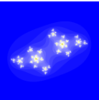
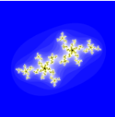
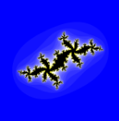
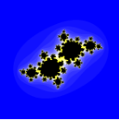

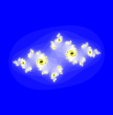
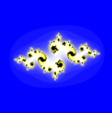
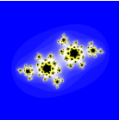
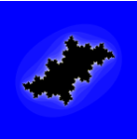

Figure 2: Reference output plots for the Julia and Fatou sets for reference points c = {-0.7+0.6i, -0.6+0.6i, -0.5+0.6i, -0.4+0.6i, -0.8+0.3i, -0.8+0.2i, -0.6+ 0.5i, -0.3+0.6i}

II. System Implementation
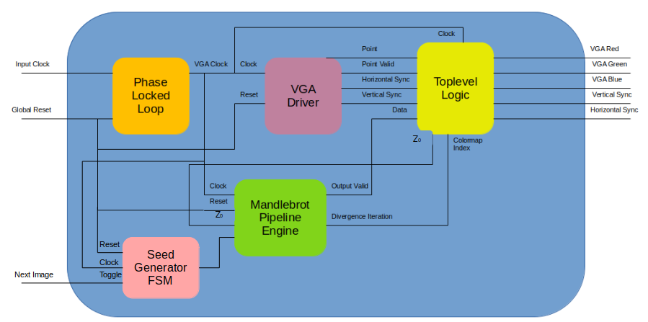
Figure 3: High Level System Diagram

This project focused on using an FPGA to generate the Julia and Fatou images shown above in Figure 2. The high level diagram for this implementation is shown above in Figure 3. Each component is described below.

Phase Locked Loop

VGA sized at 640x480 pixels has a 60 Hz refresh rate, which requires a 25.175 MHz clock. The Intel Max10 FPGA has a 50 MHz clock, therefore a PLL is required to convert it to the required frequency for VGA operations.

VGA Driver

The VGA driver computes the current pixel coordinate that is being output to the VGA port on the board. This involves extending the coordinates beyond the 640x480 grid to include the horizontal and vertical sync pulses. After reaching the bottom right corner of the plot, the point is reset back to the top left corner. Additionally, it provides a boolean output to inform whether or not the current point is part of the actual image, or part of the sync pulses or the porches. Lastly, the driver outputs a high polarity logic signal for the vertical and horizontal sync pulses at the appropriate times.

Seed Generator FSM

The seed generator provides the constant that is used to compute the Julia and Fatou sets. It was desired to be able to quickly switch between the reference images shown in Figure 2. Therefore, an additional button input was included in the design, which toggles between all of the images. The generator also includes an edge detector, so that only one image is indexed at a time. The output of the seed generator is the complex seed that corresponds to each image.

Mandelbrot Pipeline Engine

The Mandelbrot Pipeline Engine from Project 2 was modified to generate the Julia and Fatou sets. The diagram for the pipeline engine is shown below in Figure 4.
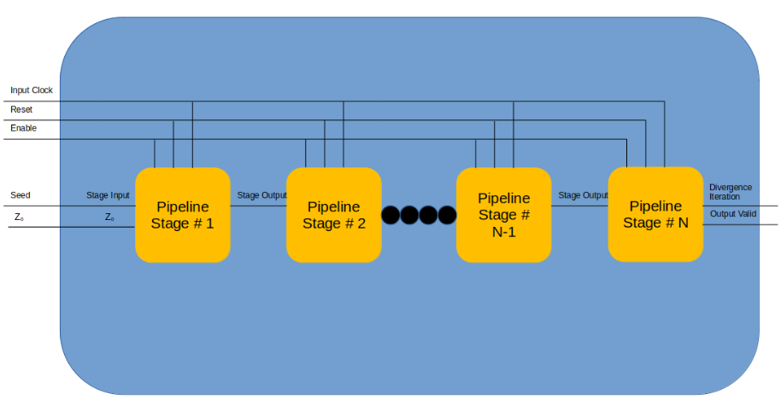
Figure 4: Pipeline Diagram

The pipeline takes the VGA clock, a reset signal, an enable signal, a seed, and an initial value for z. Each stage in the pipelien takes a record called the stage input and outputs a record called the stage output. These two records have the same entries, described in the following table.

Entry Name | Data Type | Description
c | ads_complex | The seed used in the Mandelbrot polynomial
z | ads_complex | The output of the previous iteration.
Stage Data | natural | The current iteration, or the iteration of divergence
Stage Overflow | boolean | Whether or not the point has diverged.
Stage Valid | boolean | True if the pipeline has completed one valid computation
Table 1: Stage Input / Output Record Description

At each stage, the output is conditioned on the input. The following table describes the relationship.

Stage Output Entry | Conditioned On | Value
c | N/A | Stage Input → c
z | Stage Input → overflow | (Stage Input → z)² + c if false  else Stage Input → z
Stage Data | Stage Input → overflow | Current Stage # if false  else Stage Input → data
Stage Overflow | Stage Input → z | true if > threshold  else false
Stage Valid | N/A | Stage Input → valid

Table 2: Stage Output Values

If the final stage in the pipeline is valid, then the output valid signal is driven high. This means that the data on the output of the last stage corresponds to the iteration at which each point in the complex plane diverged.

Top level Logic

In the top level design file for this project, the components described above are connected in order to output the correct image to the VGA display port on the board. Two processes occur in this design file. The first updates the initial value for the Julia and Fatou set polynomial as the complex point that corresponds to each pixel on the screen.

The second process sends the color data to the VGA display port. The digital to analog converter on the display port requires 4-bit values for each color. However, the data read from the pipeline only provides the iteration at which the point on the graph diverged. Each point is ran through the accumulator up to 22 iterations. Therefore, a colormap with 22 entries was created that maps the iteration of divergence to the pixel color on the VGA display. Each color is assigned a 4-bit value, and that value is sent as a 4-bit standard logic vector to the VGA display port. This is done only if the current pixel is in the active area of the plot. If the point lies within the sync pulses or porches, the outputs are set to ‘0’.

Verification

A testbed was setup to ensure that the output image was correct. This script is included in the attached code, and its output is shown below in Figure 5. The output images should be compared to the reference images in Figure 2.

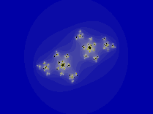
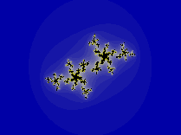
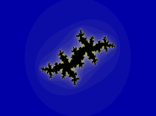
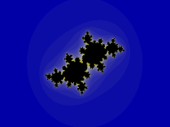

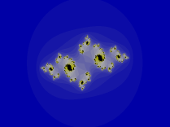
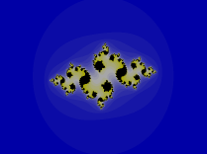
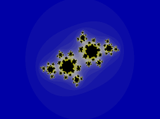
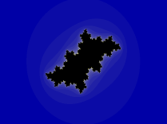

Figure 5: Verification Output Images FFor Reference Points
c = {-0.7+0.6i, -0.6+0.6i, -0.5+0.6i, -0.4+0.6i, -0.8+0.3i, -0.8+0.2i, -0.6+ 0.5i, -0.3+0.6i}or Reference Points
c = {-0.7+0.6i, -0.6+0.6i, -0.5+0.6i, -0.4+0.6i, -0.8+0.3i, -0.8+0.2i, -0.6+ 0.5i, -0.3+0.6i}

Compilation & Results

The compilation report is shown in Figure 6.

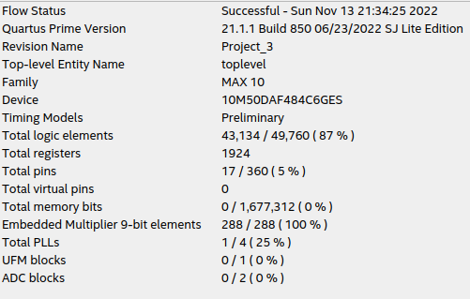

Figure 6: Compilation Report

Unfortunately, all of the multiplier elements are used, as well as 82% of the logic cells. This limits the FPGA from supporting any other function besides generation the Mandelbrot image. The outputs from the VGA display for the reference images are shown below in Figure 7.

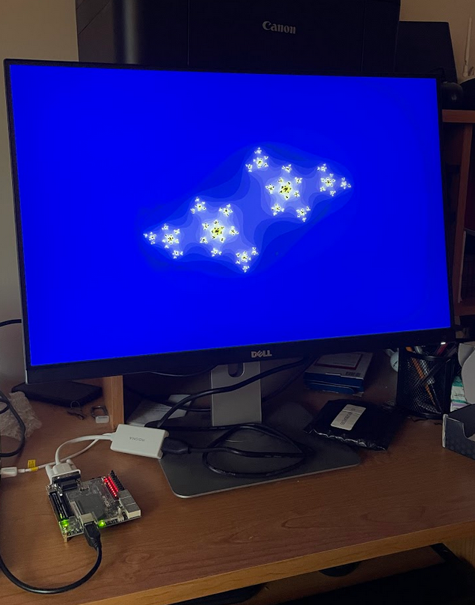
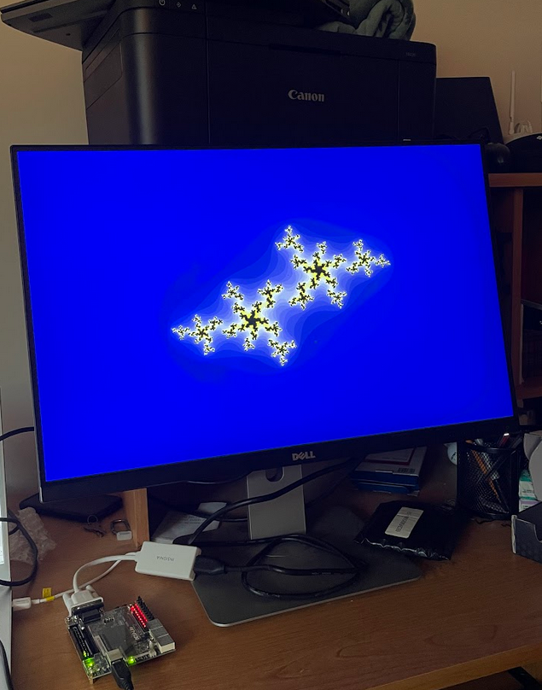
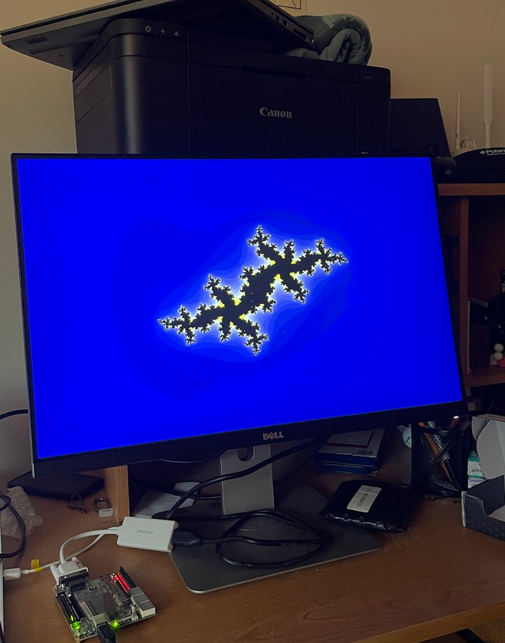
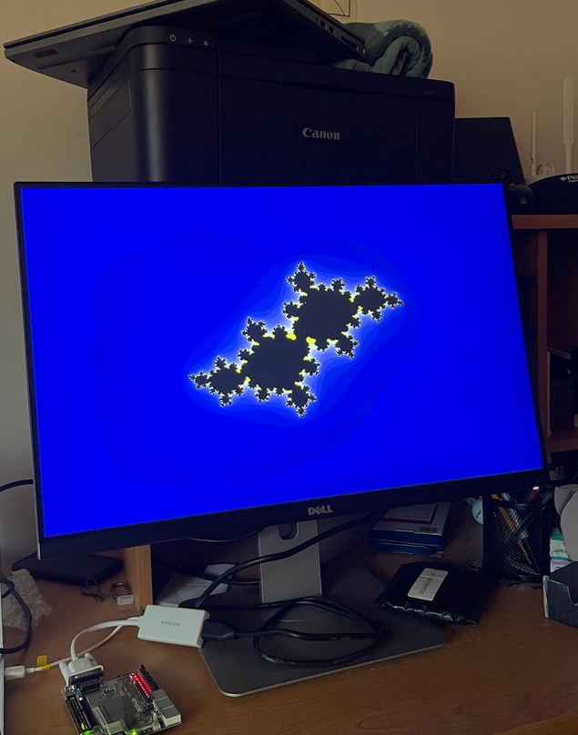

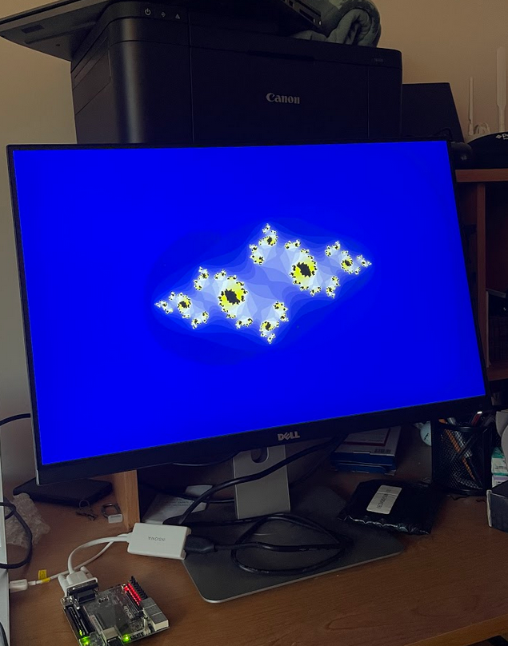
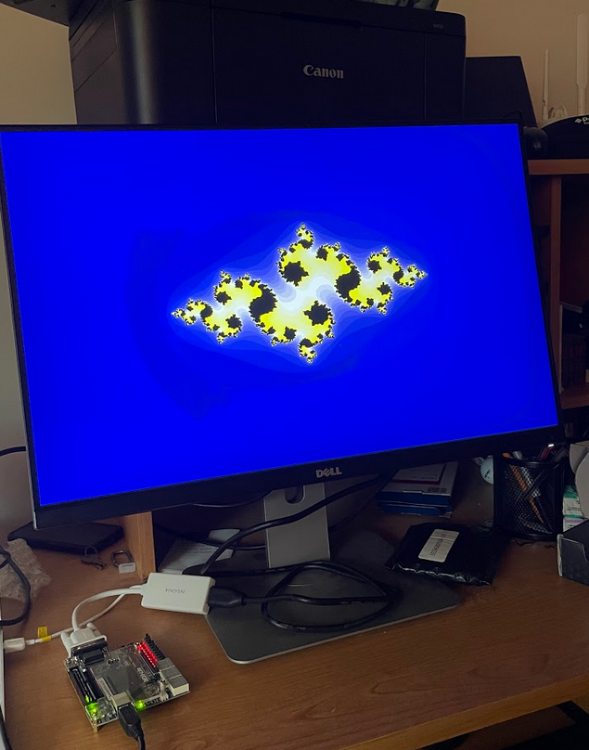
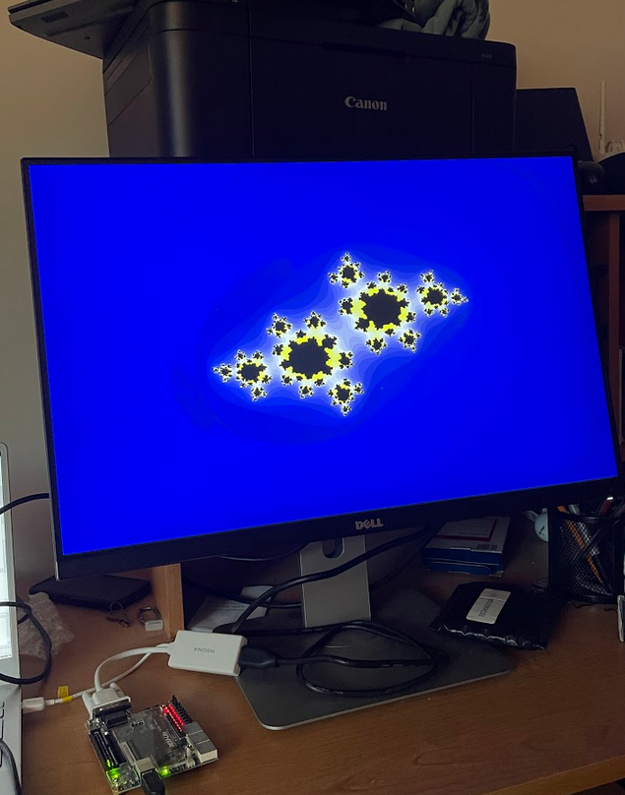
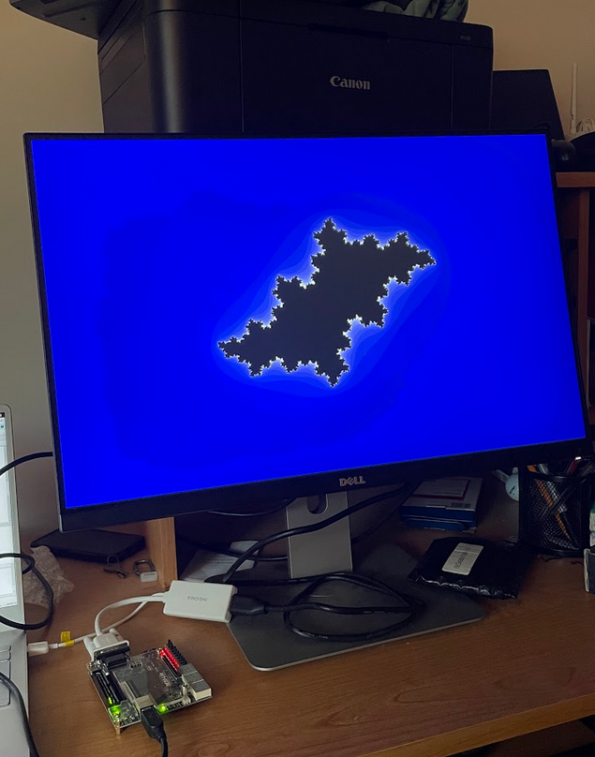

Figure 7: VGA Output For Reference Points
c = {-0.7+0.6i, -0.6+0.6i, -0.5+0.6i, -0.4+0.6i, -0.8+0.3i, -0.8+0.2i, -0.6+ 0.5i, -0.3+0.6i}

III. Animation

The Julia and Fatou sets can also make for an entertaining animation. A sequence of 10 points in the Mandelbrot set were chosen, and 100 intermediate points between each of them were computed in Python. On the VGA display, every time the current pixel reaches the end of the image, the seed to the pipeline is indexed to the next Mandelbrot point. This generates the animation that is attached to this project submission.

