John S. Kaminski Jr.
EECE 5500: Advanced Digital Systems Design
7 October 2022

Project 1: Physical Unclonable Functions

I. SPICE Simulations

Integrated circuits using CMOS technology are subject to process variations. As a result, manufactured transistors will have different lengths, widths, and thickness parameters. When constructing physical unclonable functions (PUFs), a ring oscillator is constructed out of a series of inverter gates. An example is shown in Figure 1. The NAND gate is used to allow for an enable pulse to trigger the oscillator. Each transistor in this sequence of inverters will have a unique set of parameters due to manufacturing process variations. As a result, two ring oscillators will output waveforms at two different frequencies.

Figure 1: RTL Diagram of a Ring Oscillator

To demonstrate this phenomenon, several ring oscillators were constructed in NGSPICE. Each transistor was simulated to have a manufacturing process that resulted in the gate lengths and widths having a standard deviation of 6.5%, and the oxide thickness having a standard deviation of 5%. An inverter that would create a perfect oscillator would have an PMOS transistor with a length of 65nm, a width of 215nm, and an oxide layer thickness of 1.95nm. Additionally, the NMOS transistor would have a length of 65nm, a width of 130nm, and an oxide layer thickness of 1.85nm. The DC sweep of this inverter is shown in Figure 2.
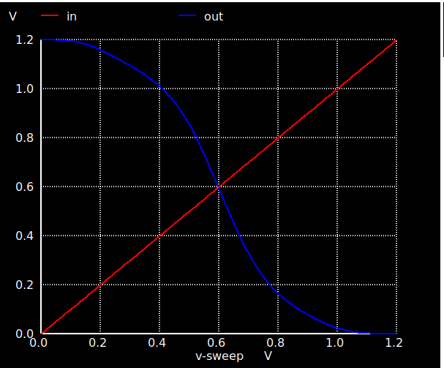

Figure 2: Ideal DC Sweep of an Inverter Gate

A transient analysis was run with one oscillator to confirm the the ideal output waveform was achieved. This result is shown in Figure 3. Then, eight ring oscillators were created using the simulated process variations described above. The waveforms from each oscillator are compared in Figure 4.
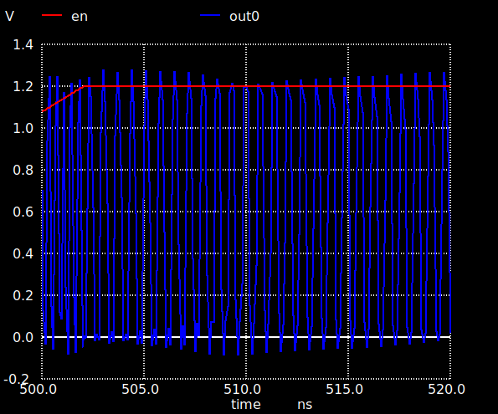

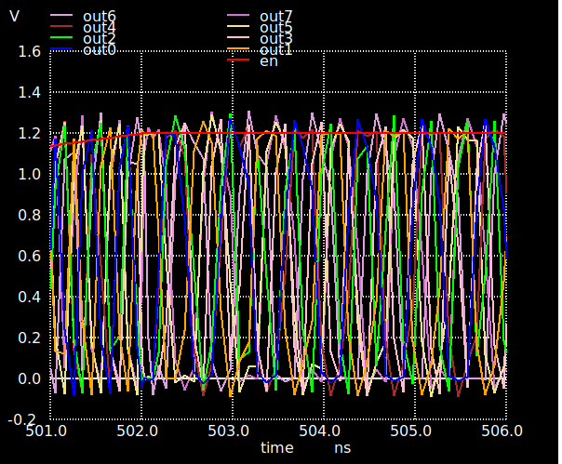
Figure 3: Output of a Single Ring Oscillator

Figure 4: Output of a Eight Ring Oscillators

If the inverters were all characterized with the same parameters, then each waveform would look identical. In fact, since every transistor manufactured will have different parameters, it is not possible that two oscillators will have the same output frequency. A PUF takes advantage of this fact. First, 2^{n} ring oscillators are created, and sectioned off into two groups. Next a sequence of challenges are provided, each one representing indices of two oscillators to be compared. Each oscillator is connected to a counter, where the driving clock comes from the oscillator. The output of the counters are compared after a set time, resulting in a binary output. After sequencing through all of the challenges, a unique binary sequence is obtained, which is the output of the PUF.

It could be assumed that the PUF would return a constant value each time it is run. However, environmental factors like ambient temperature and input voltage can also impact the output of the PUF. The oscillators shown in Figure 4 were run with an ambient temperature of 27 degrees Celsius, and a supply voltage of 1.2 Volts. Figure 5 shows the same plots with different environmental factors.

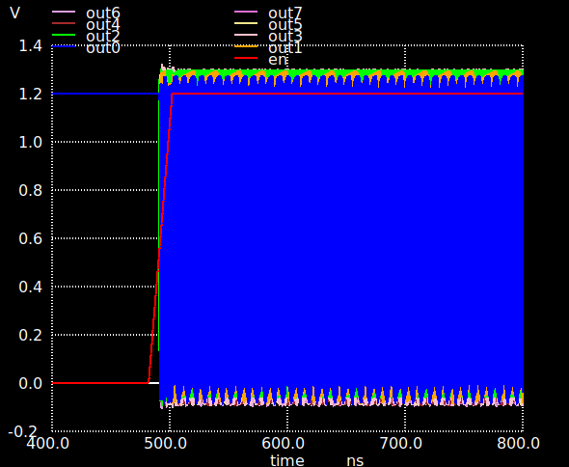
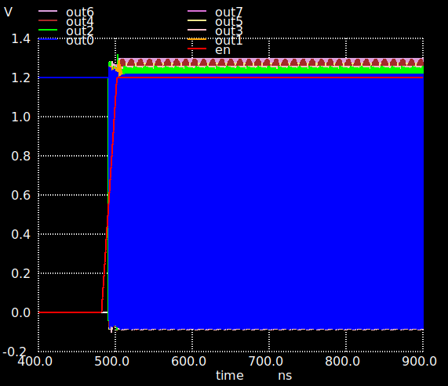
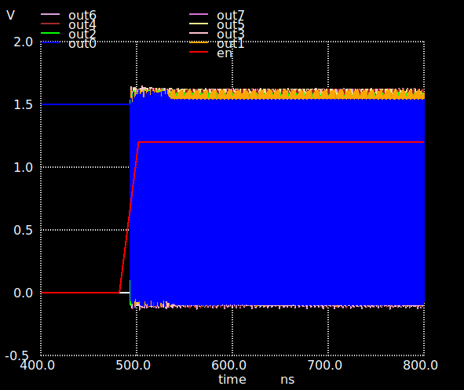
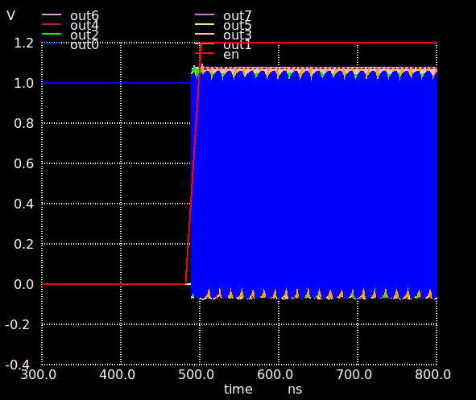
Figure 5: Ring Oscillator Outputs with 27ºC and 1.2V (Top Left), 54ºC and 1.2V (Top Right), 27ºC and 1.5V (Bottom Left), and 27ºC and 1.0V (Bottom Right)

It can be seen that when the temperature is raised to 54ºC or the voltage is raised to 1.5V, there is an initial spike in the peak voltage that settles after several nanoseconds. Additionally, the frequencies in all four plots are completely different. This presents an issue, as PUFs are proposed as a method of hardware authentication. In order to be used for authentication, the output of a PUF should be reasonably static. A simple way to prevent this phenomenon from altering the output of the PUF is described in [1]. It is highlighted that the change in frequency between two oscillators may not change at the same rate due to environmental factors. There could be a significant enough change such that the output of the PUF is now opposite of its previous value. To prevent this, it is proposed that ring oscillators that are designed to operate at different base frequencies are used rather than oscillators that all operate at the same frequency. This way, a deviation in a base frequency will be less likely to result in a bit flip in the response of the PUF.

The above method for increasing the reliability of a PUF does have a fundamental flaw. The advantage of the PUF is its uniqueness. Two PUFs that are designed identically will respond to a sequence of challenges completely differently. This makes their outputs unclonable. However, by creating oscillators that operate at different frequencies, two PUFs that are designed identically will likely respond to a sequence of challenges the same. This flaw removes the unclonable aspect of PUFs.

II. FPGA Implementation

After simulating several ring oscillators in NGSPICE, a PUF was programmed onto an FPGA. A high level diagram of the components written in VHDL is shown in Figure 6. Each component is described below.
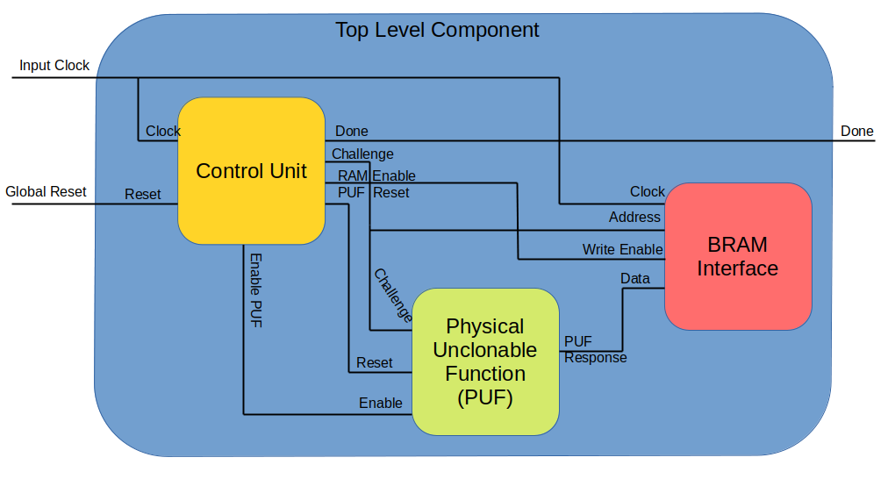
Figure 6: Top Level Diagram
The PUF component actualizes the system described in the previous section. 2^{n}
ring oscillators are created, and each ring oscillator is connected to the clock input of a counter. Each counter has an active low reset, an active high reset, and increments on each clock cycle. The active low reset and the active high enable come from the control unit. The enable signal also is used to trigger the ring oscillators. The ring oscillators with their counters are sectioned into two groups. At each iteration, a challenge vector is fed from the control unit to the PUF that commands which two oscillators from each group will be compared. The PUF will then output which of the two counters has a higher value. If the counter from the first group is lower than that of the second group, then the output is a logic ‘1’, otherwise it is a logic ‘0’.

The control unit is a finite state machine that allows the PUF to compute a response for all possible challenge vectors, and stores each to memory. The state machine diagram is shown below in Figure 7. The objective of the state machine is to follow the below procedure:
- Reset the PUF counters.
- Increment the challenge vector and provide it to the PUF.
- Enable the PUF and wait for a parameterized number of clock cycles.
- Write the PUF response to memory.
- Revert to step one if there are more challenge vectors to compute. Otherwise, assert the done signal and wait for a global reset.
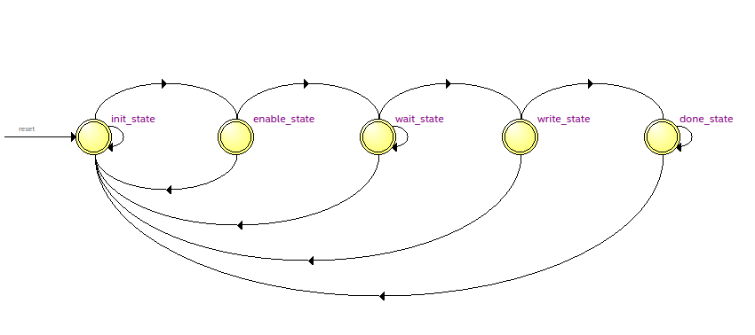
Figure 7: Finite State Machine Diagram

The following table describes each state in the state machine. If at any point the global reset is asserted, then the challenge vector is set to all zeros, and the state is set back to the initial state.

State Name | State Description
init_state | Assert the reset signal to the PUF. Increment the challenge vector. Move to enable_state.
enable_state | Assert the PUF enable signal. Move to wait_state.
wait_state | Continue to assert the PUF enable signal. Stay in wait_state until a parameterized number of clock cycles has occurred. Then move to write_state.
write_state | Assert the BRAM write enable signal. If all challenge vectors have been fed to the PUF, move to done_state. Otherwise, move to init_state.
done_state | Assert the done signal. Stay in done_state until the global reset is asserted. Then move to init_state.

Table 1: State Descriptions

The BRAM component writes the PUF response to the FPGA’s memory if the enable signal is asserted. The address is simply the challenge fed to the PUF.

Once this code was constructed in VHDL, it was programmed onto an FPGA. However, FPGA implementation is pseudo random, and the placement will not be consistent each time. Therefore, the output from the PUF will not be consistent. Therefore, each component in the PUF was manually placed using a TCL script. This output is shown below in Figure 8, and it was consistent after reprogramming the device.
Figure 8: PUF output in BRAM

III. Final Remarks

In this project, the theory behind a physical unclonable function was demonstrated using NGSPICE. Next, one was implemented using VHDL, and programmed onto an FPGA board. It was shown that this would yield a consistent result after manually placing each gate using TCL.

