John S. Kaminski Jr.
EECE 5500: Advanced Digital Systems Design
2 November 2022

Project 2: The Mandelbrot Set

I. Intermediate Memory Design

The Mandelbrot set is the set of numbers in the complex domain that do not diverge with the polynomial f_{c}(z)=z²+c,where c is the complex point, and z is the output of the previous iteration, starting at zero. The Mandelbrot set can be used to generate an interesting piece of art if the iteration when each complex point diverges is captured, and assigned a color. Each pixel in the image is mapped to a complex point, and the iteration of divergence is measured, which is used to create the image. An example of the Mandelbrot set image is shown in figure 1 below.


Figure 1: The Mandelbrot Set
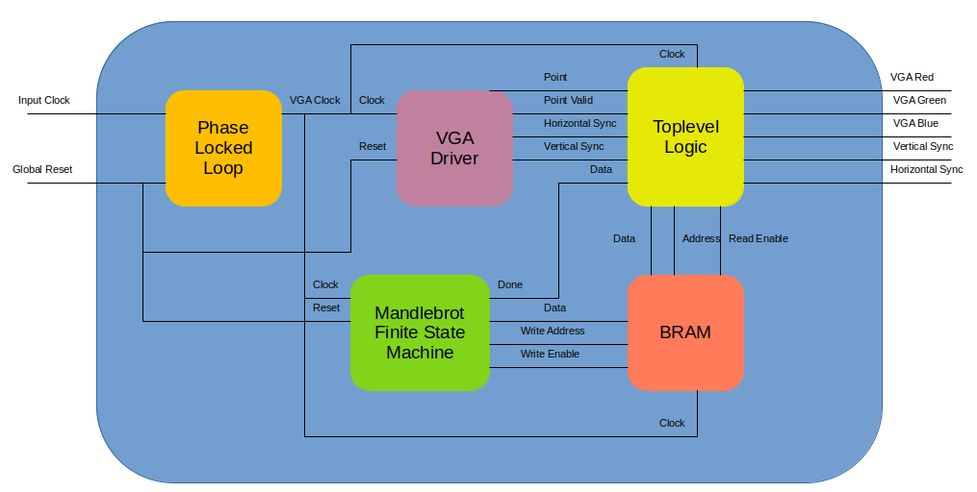
Figure 2: High Level System Diagram

This project focused on using an FPGA to generate the Mandelbrot image shown above. This first section focuses on a design approach that computed the value for each pixel in the image and stored it to memory. Next, a VGA driver reads each value from memory to display the image. A finite state machine was created to iterate through the complex points in the graph and find the iteration that they diverge. The high level diagram for this implementation is shown above in figure 2. Each component is described below.

Phase Locked Loop

VGA sized at 640x480 pixels has a 60 Hz refresh rate, which requires a 25.175 MHz clock. The Intel Max10 FPGA has a 50 MHz clock, therefore a PLL is required to convert it to the required frequency for VGA operations.

VGA Driver

The VGA driver computes the current pixel coordinate that is being output to the VGA port on the board. This involves extending the coordinates beyond the 640x480 grid to include the horizontal and vertical sync pulses. After reaching the bottom right corner of the plot, the point is reset back to the top left corner. Additionally, it provides a boolean output to inform whether or not the current point is part of the actual image, or part of the sync pulses or the porches. Lastly, the driver outputs a high polarity logic signal for the vertical and horizontal sync pulses at the appropriate times.

Mandelbrot Finite State Machine

The state machine component also includes an accumulator that is used to compute each iteration in the Mandelbrot equation. The following table describes each state in the machine.

State Name | State Description
init_state | Assert the reset signal to the accumulator Move to enable_state.
enable_state | Assert the accumulator enable signal. Move to compute_state.
compute_state | Continue to assert the enable signal. Stay in current state until the accumulator has hit the max number of iterations or the current output of the accumulator has begun to diverge. Then move to write_state.
write_state | Assert the BRAM write enable signal. If all pixels in the plot have been computed, move to done_state. Otherwise, move to init_state and iterate to the next pixel.
done_state | Assert the done signal. Stay in done_state until the global reset is asserted. Then move to init_state.

Table 1: Mandelbrot FSM State Descriptions

Each pixel coordinate must be mapped to a point on the complex plane. This is done during the write state, when the pixel is iterated. The minimum and maximum values for the real axis were chosen to be -3 and +3. The minimum and maximum values for the imaginary axis were chosen to be -2 and +2. The spacing between coordinates is defined as the difference between the maximum and minimum values of each axis divided by the number of pixels in each axis.

For ease of accessing the memory, the address is simply the following formula based on the pixel coordinates: Addr = Vertical_Area*pixel.y + pixel.x.

When trying to implement this method, the design failed during place and route. This was due to the fact that the synthesized BRAM exceeded the number of BRAM cells available on the FPGA. To combat this, the following fact was used. It is known that the Mandelbrot set is confined to a circle with radius 4 about the origin. Therefore, it is not required to compute the iterations to divergence for points outside that circle, since they begin to diverge at the first iteration. Therefore, the memory was decreased to only include points that lie within the square around the origin with sides of length 4.

Top level Logic

In the top level design file for this project, the components described above are connected in order to output the correct image to the VGA display port on the board. Two processes occur in this design file. The first updates the address to read from memory. Fortunately, the VGA driver outputs the current pixel being sent to the display port. Therefore, the memory can be indexed the same way it was written two using the formula described in the above section. However, only 480x480 entries were written to memory. Therefore, the address is only indexed if the current point lies in the 480x480 square about the origin.

The second process sends the color data to the VGA display port. The digital to analog converter on the display port requires 4-bit values for each color. However, the data read from the BRAM only provides the iteration at which the point on the graph diverged. Each point is ran through the accumulator up to 32 iterations. Therefore, a colormap with 32 entries was created that maps the iteration of divergence to the pixel color on the VGA display. Each color is assigned a 4-bit value, and that value is sent as a 4-bit standard logic vector to the VGA display port. This is done only if the current pixel is in the active area of the plot. If the point lies within the sync pulses or porches, the outputs are set to ‘0’. Additionally, if the current pixel does not lie within the 480x480 square about the origin for which the iteration of divergence is stored in memory, the color output is the first entry in the colormap, since the point diverged at the first iteration.

Compilation & Results

With the changes made to the data sent to the BRAM described above, the project was able to be synthesized, implemented, and programmed onto an FPGA. The compilation report is shown below in figure 3.

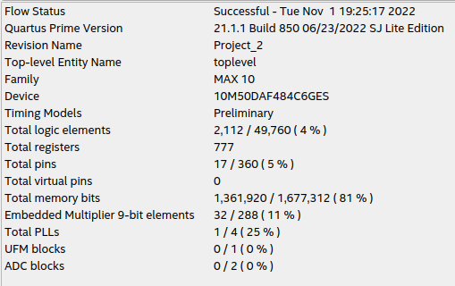

Figure 3: Compilation Report

As seen above, this implementation of computing the Mandelbrot set utilizes 81% of the available memory on the FPGA. However, the number of logic elements and multipliers utilized are very low comparatively. Therefore, this design is memory limited. The output on a VGA display for this design is shown below in figure 4. A few rogue pixels do not have colors that match the Mandelbrot set, however the image is mostly correct.

One issue with this implementation is that it is static. Once the pixel values are stored to memory, the image cannot be updated. If one wanted to output an animation to the VGA display port, this implementation would not be able to keep up with the 60 Hz refresh rate. A better solution is described in the next section.

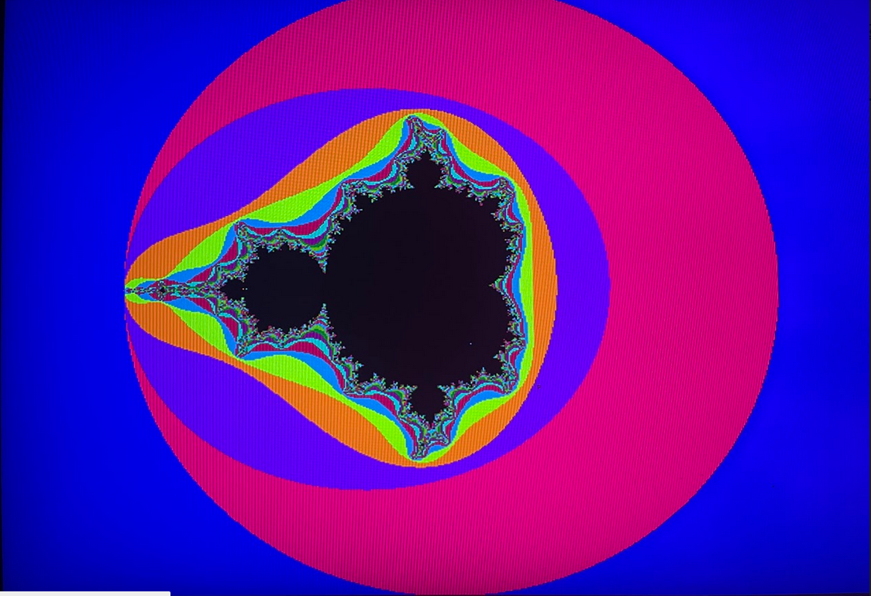

Figure 4: VGA Output with an Intermediate Memory Design

II. Pipeline Design

As described above, the intermediate memory based implementation of this project is limited by the amount of BRAM blocks on the FPGA. To combat this, a pipeline based implementation can be used instead. With this implementation, there is no need for any use of the BRAM blocks, as the value for each pixel is readily output to the VGA display port from the pipeline. The new high level design is shown below in figure 5.
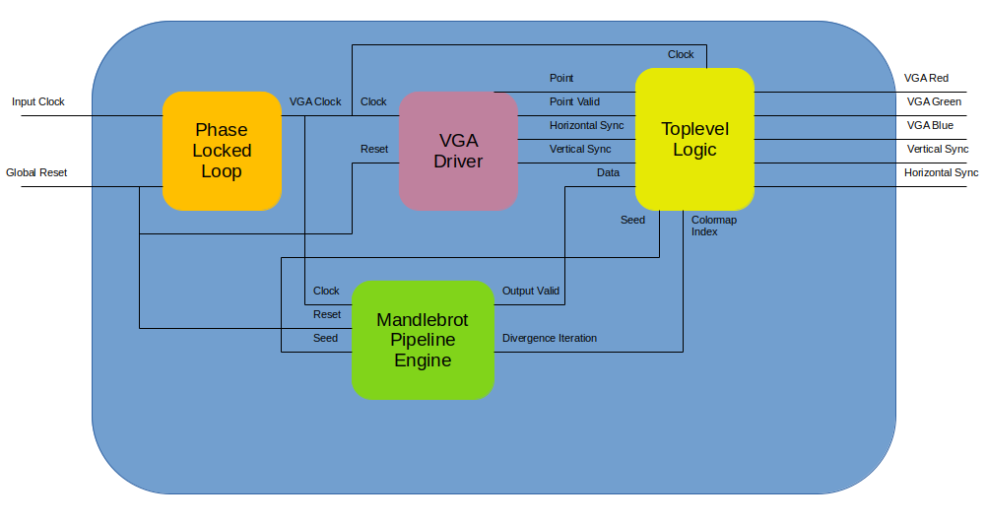

Figure 5: Pipeline Based High Level System Overview

The changes to the blocks in Section I as well as the description of the new components are described below.

Top level Logic

The top level logic now only converts the pixel coordinate provided from the VGA driver to the complex coordinate used in the Mandelbrot calculation. This value, called the seed, is fed as the input to the pipeline.

Mandelbrot Pipeline Engine

The diagram for the pipeline engine is shown below in figure 6.
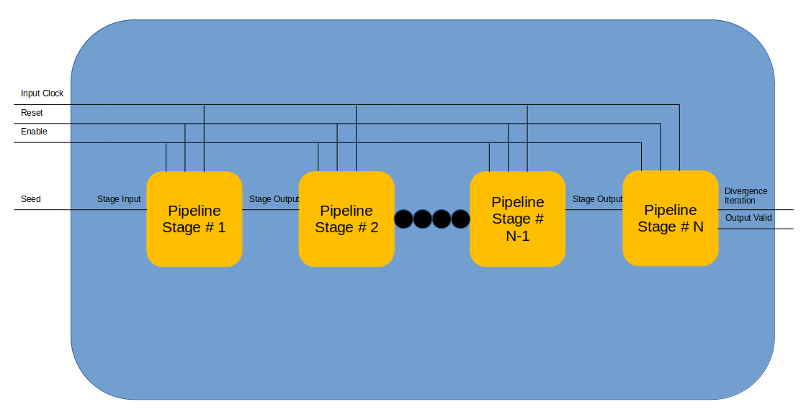
Figure 6: Pipeline Diagram

The pipeline takes the VGA clock, a reset signal, and an enable signal to feed to each stage in the pipeline. Each state takes a record called the stage input and outputs a record called the stage output. These two records have the same entries, described in the following table.

Entry Name | Data Type | Description
c | ads_complex | The seed used in the Mandelbrot polynomial
z | ads_complex | The output of the previous iteration.
Stage Data | natural | The current iteration, or the iteration of divergence
Stage Overflow | boolean | Whether or not the point has diverged.
Stage Valid | boolean | True if the pipeline has completed one valid computation
Table 2: Stage Input / Output Record Description

At each stage, the output is conditioned on the input. The following table describes the relationship.

Stage Output Entry | Conditioned On | Value
c | N/A | Stage Input → c
z | Stage Input → overflow | (Stage Input → z)² + c if false  else Stage Input → z
Stage Data | Stage Input → overflow | Current Stage # if false  else Stage Input → data
Stage Overflow | Stage Input → z | true if > threshold  else false
Stage Valid | N/A | Stage Input → valid

Table 3: Stage Output Values

If the final stage in the pipeline is valid, then the output valid signal is driven high. This means that the data on the output of the last stage corresponds to a pixel value. Additionally, the data is the index into a colormap as described in the previous section.

Verification

This setup was less straightforward than the intermediate memory implementation. Therefore, a testbed was setup to ensure that the output image was correct. This script is included in the attached code, and its output is shown below in figure 7.
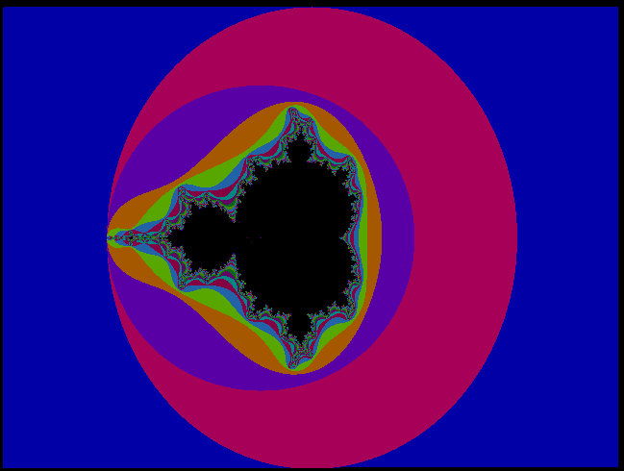

Figure 7: Verification Output Image

Compilation & Results

When compiling this design, it failed during place and route. This is because of the large number of multipliers needed to implement the pipeline. Consequently, the number of Mandelbrot iterations was reduced from 32 down to 25. This resulted in the following compilation report, shown in figure 8.
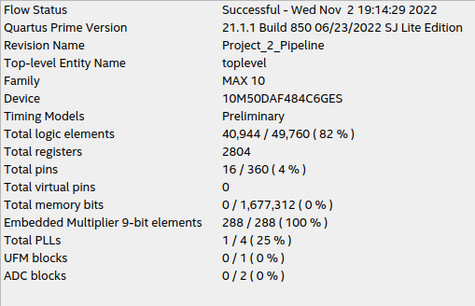

Figure 8: Compilation Report with Pipeline Implementation

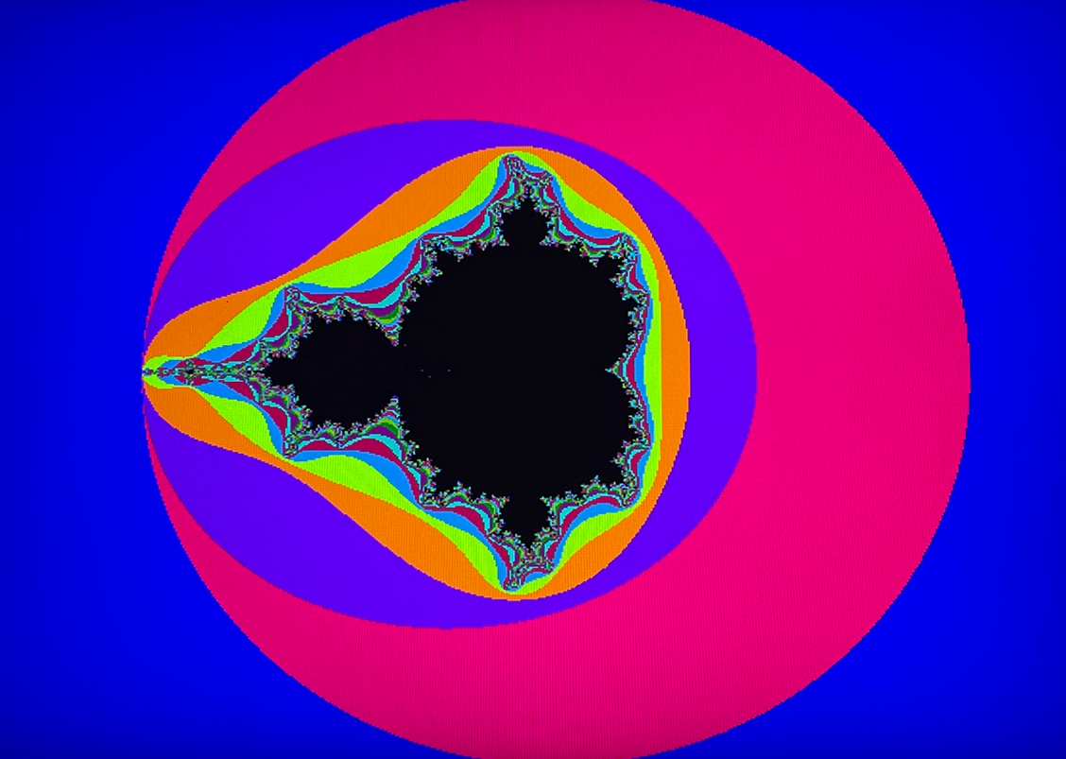
Conversely to the intermediate memory implementation, this compilation results in none of the BRAM blocks being utilized. However, all of the multiplier elements are used, as well as 82% of the logic cells. This limits the FPGA from supporting any other function besides generation the Mandelbrot image. The output from the VGA display is shown in figure 9.

Figure 10: VGA Output with a Pipeline Design

III. Final Remarks

In this project, the Mandelbrot set was computed on an FPGA and displayed on a VGA monitor using two separate implementations. The first implementation used an intermediate memory to store the pixel values to be processed, while the separate created a pipeline such that every pixel value was available at each clock iteration. It was shown that the two implementations resulted in a trade off between the FPGA’s BRAM memory blocks and the logic cells and multipliers.

