Draft Bruneau FO 2015-2016 Project Analysis Report

Report date: 15 May, 2017

Table of Contents

# Introduction

Information about the health of the landscapes we manage is essential to achieve the BLM mission (Federal Land Policy and Management Act of 1976). It enables BLM to measure the benefits that these lands and waters provide, understand the effects of multiple uses, and thus create management plans to sustain these landscapes for future generations.

This report provides information about the health of terrestrial and aquatic ecosystems. This information was collected on-the-ground by field biologists who measure and assess important indicators related to ecosystem health. In terrestrial ecosystems, they focus on cover and composition of plant species, plant height, gaps between plant canopies, and stability of soils. In aquatic ecosystems, they focus on water quality, stream morphology, and biological characteristics. These quantitative measurements and qualitative assessments were collected under the BLM Assessment, Inventory, and Monitoring (AIM) program. For more information about AIM, see <http://aim.landscapetoolbox.org/learn-3/about/>.

This report also includes relevant standard geospatial datasets. Some relate to ecosystem health, while others provide contextual information about landscapes such as the management activities occurring there.

This report was generated through partnership among the BLM National Operations Center, USDA-ARS Jornada, and the BLM National Aquatic Monitoring Center.

## Report Purpose and use

The purpose of this report is to describe key indicators of ecosystem health across an area of interest. This information can be used to evaluate whether or not goals or desired conditions are being achieved across BLM lands, an essential step in adaptive management. Specific management applications include but are not limited to: treatment effectiveness, Land Health Standards evaluation, sage-grouse habitat analysis and Resource Management Plan effectiveness. Tables, graphs, and other content from this report can be pasted into decision-making documents, or the entire report can be used as an appendix to such documents.

The standard core indicators contained in this report are relevant to management questions across all BLM ecosystem types, as identified through the BLM AIM Strategy and related efforts (TN440, TR1735-1). This report also contains standard national geospatial datasets managed by the BLM National Operations Center and partners. These geospatial datasets provide spatial and management context for the standard AIM core indicators.

## Report Organization

This report has five main sections. The **introduction** sets the stage. The **data summary** provides contextual information that is helpful for interpreting the results, including the list of indicators, time period, timing of sampling, and maps.

Report results begin with the **goals, monitoring objectives, benchmarks, and results summary** section. This contains tables of which indicators met specified objectdives by reporting unit, and a summary of the stated objectdives. These table can be used by BLM land managers to evaluate whether goals or management objectives were achieved. This table is a summary of results for all indicators.

The **indicator estimates by reporting unit for monitoring objectives** section identifies the condition of each indicator for each area of interest or reporting unit. Condition refers to the proportion of land or water resources that is achieving desired values known as benchmarks. This section provides further detail about each row of the table in the previous section and can be used as supporting information for the conclusions drawn from that table. This is followed by the **spatial distribution of core indicators** section which provides remote-sensing-derived maps of various core indicators for the study area.

Finally, the **appendices** contain additional background information on AIM, the core indicators and methods, and the analysis approaches used to generate this reports.

## Information Sources

This report summarizes and analyzes information collected from an AIM project. The following information sources were used in the analysis presented in this report:

* The Monitoring Design Worksheet summarises the goals and objectives of the monitoring project.
* The AIM Data Analysis Template provides data summaries of the AIM data collected for the project and clearly states the objectives, indicators, benchmarks, and required landscape proportions for each objective.
* AIM data from TerrADat are the quantitative data collected in the field for the project.
* The project's Sample Design Database captures all of the technical details of the project sample design (e.g., sample frame, stratification, initial point selections, fate of the sample points, and design weights). This information is used to adjust the sample point weights to produce unbiased estimates.
* Spatial data files defining the different levels of reporting units for which estimates will be generated from the AIM data.
* Spatial or tabular Information defining benchmark classes (i.e., categories assigned to each sample point for the purpose of evaluating an indicator against a benchmark that may change across a landscape).
* (OPTIONAL) - Additional sample points from the BLM Landscape Monitoring Framework to supplement the AIM project data.
* (OPTIONAL) - Remote sensing products such as the Grass/Shrub continuous variable predictions or the Landfire EVT map to supplement the quantitative field-derived estimates.

## Interpreting the Results

Results in this report can be used to evaluate whether goals regarding ecosystem health are being achieved across a landscape. Success criteria for each goal are specified as measureable monitoring objectives that include a natural resource indicator of interest, a benchmark that identifies desired values of that indicator, and the proportion of the landscape that should meet the benchmark. This report provides statistical estimates of the proportion of the landscape achieving the monitoring objectives, in the form of tables, graphs and other information (see summary in objectives, benchmarks, and landscape thresholds or detailed info in condition estimates by objective). BLM land managers requesting the report supplied relevant goals, monitoring objectives and reporting units as part of the process of designing their monitoring effort (see <http://aim.landscapetoolbox.org/design>). Upon receipt, it will be the responsibility of BLM land managers to evaluate whether goals are achieved and make management recommendations.

Consider important contextual information when you evaluate whether goals are achieved:

* Monitoring objectives: Are benchmarks well-justified and based on best available knowledge? Are desired proportions informed by management goals and landscape context?
* Reporting unit: Is this appropriate to evaluate whether goals are achieved?
* Timing of sampling: Is sample timing appropriate for the ecosystem type as well as the goals and objectives for the reporting unit? Does sample timing vary between years? Does sample timing affect your results?
* Sample spread/point fates: Are monitoring sites distributed across the area of interest? Were some areas systematically missed, which could lead to bias?

## Analysis Outputs

In addition to this report from which charts and tablar data can be copied/pasted, the following standard outputs are created as part of this analysis:

* Data table containing the plot-level raw data from TerrADat combined with the adjusted point weights (input for analysis).
* Data table listing each monitoring objective with its indicator(s), benchmarks, and required landsdcape proportions (input for analysis).
* Data table listing the categories assigned by indicator to each point based on the benchmarks (input for analysis).
* Data table containing the analysis results of the category analyses by reporting unit (spsurvey cat.analysis output table).

## Additional Information

For additional information, please see <http://aim.landscapetoolbox.org> or contact [ekachergis@blm.gov](mailto:ekachergis@blm.gov).

# Data Summary

The following tabs contain tables and graphs describing the information in this report and the sampling effort. This includes the indicators being considered, the time period of sampling, descriptions of the actual sampling effort relative to the original sampling design, and a map of the sample points and reporting units.

## Map of Study Area, Reporting Units, and Sample Points

The map below is provided for general reference only. It was created from the spatial data stored in the project's Sample Design Database, the reporting units provided for this analysis, and the actual sample point locations recorded in TerrADat. The map is dynamic - you can pan and zoom it. Layers may also be toggled on/off to view specific features.

## Indicators included in the report

The following indicators were specified in the AIM data analysis template and are included in this report:

* Average Non-invasive Perennial Grass Height (cm)
* Average Sagebrush Height (cm)
* Bare Soil (%)
* Between-Canopy Herbaceous and Woody Litter (%)
* Invasive Annual Grass Cover (%, any hit)
* Non-invasive Perennial Grass Cover (%, any hit)
* Overall Soil Stability Rating
* Percent in Gaps > 200 cm
* Percent in Gaps 101-200 cm
* Percent in Gaps 51-100 cm
* Sagebrush Cover (%, any hit)

## Time period of the report

This report covers data collected between **2015-06-02** and **2016-08-03**. Timing of the data collection in each year is shown below.

## Plot Sampling Summary

Not all points originally selected as part of a design can be sampled. Selected points may not be accessible or when evaluated may be deemed to not even be part of the population. The [Rejection Criteria page on the AIM Landscape Toolbox website](http://aim.landscapetoolbox.org/office-sample-point-evaluation/) describes the rejection criteria for evaluating plots. To properly adjust the sampling weights and ensure unbiased estimates, it is important to know the fate of each of the originally-selected points. The graph below summarizes the point fates for the sample design(s) considered in this report.

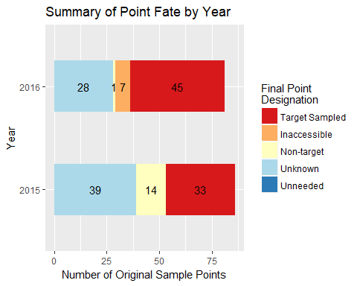

## Stratum Sampling Info

The initial designs considered for this report used stratification as a way to spread sampling effort across the study area. The extent to which estimates calculated from monitoring data reflect conditions across the study area depends on whether or not the strata were adequately sampled. It is not uncommon for some sample sites to be not visited for various reasons (e.g., inaccessibility, time ran out). This is typically not a problem as long as: 1) the missed points do not account for a majority of the selected sample points and 2) the points that were not sampled were missed at random (i.e, there was no pattern to which points were missed and which were sampled). The table below summarizes the total calculated area and estimated sampling area by design stratum for the **study area**. Separate strata sampling proportions are calculated for each reporting unit, but looking at the study area overall gives a good rough estimation of whether or not there were issues with how the sample data represents the different strata. If there are strata with very low sampled proportions, this may affect the ability to draw inferences beyond the sample data in these strata, and should be more thoroughly evaluated.

Design Stratum

# Design Points

# Sampled Points

Prop. Design Points Sampled

Estimated Stratum Area (ha)

Stratum Area Sampled

Calculated Point Weight (ha/pt)

Basin_Sagebrush_Cool_Moist

13

9

0.69

7492.63

5187.20

576.36

Big_Sagebrush_Cool_Moist

18

10

0.56

62328.47

34626.93

3462.69

Big_Sagebrush_Warm_Dry

33

12

0.36

164495.67

59816.61

4984.72

Black_Sagebrush

13

9

0.69

17180.00

11893.85

1321.54

Low_Sagebrush_Cool_Moist

37

20

0.54

204141.18

110346.58

5517.33

Low_Sagebrush_Warm_Dry

13

7

0.54

10305.80

5549.28

792.75

Meadow_Dry

4

2

0.50

631.14

315.57

157.79

Salt_Desert_Mix

22

7

0.32

85976.33

27356.10

3908.01

Unknown_&_Aspen

14

2

0.14

36810.18

5258.60

2629.30

# Goals, Monitoring Objectives, Benchmarks, and Results Summary

This table summarizes the results of this report. It contains broad goals as well as monitoring objectives and whether they were achieved based on available monitoring data for the area of interest. Monitoring objectives include key indicators, benchmarks that define desired values of the indicators, and the proportion of the landscape required to meet benchmarks. Together, this information can be used by BLM land managers to determine whether goals are being achieved and to recommend changes in management, if needed.

## Results Summary

### Objectives Summary: Met

Managment Question

Indicator

Objective Met?

Reporting Unit

Land Health Standard: Biotic Integrity

Invasive Annual Grass Cover (%, any hit)

Met

Dickshooter Creek

Land Health Standard: Biotic Integrity

Invasive Annual Grass Cover (%, any hit)

Met

Lower Battle Creek

Land Health Standard: Watershed

Overall Soil Stability Rating

Met

Marys Creek

Land Health Standard: Watershed

Overall Soil Stability Rating

Met

Marys Creek

Land Health Standard: Biotic Integrity

Invasive Annual Grass Cover (%, any hit)

Met

McDonald Creek-Bruneau River

Land Health Standard: Biotic Integrity

Invasive Annual Grass Cover (%, any hit)

Met

Pole Creek

Land Health Standard: Biotic Integrity

Invasive Annual Grass Cover (%, any hit)

Met

Ross Slough-Owyhee River

Land Health Standard: Native Plants

Average Non-invasive Perennial Grass Height (cm)

Met

Ross Slough-Owyhee River

Land Health Standard: Native Plants

Average Non-invasive Perennial Grass Height (cm)

Met

Ross Slough-Owyhee River

Land Health Standard: Watershed

Overall Soil Stability Rating

Met

Ross Slough-Owyhee River

Land Health Standard: Watershed

Overall Soil Stability Rating

Met

Ross Slough-Owyhee River

Land Health Standard: Wildlife

Average Non-invasive Perennial Grass Height (cm)

Met

Ross Slough-Owyhee River

Land Health Standard: Wildlife

Average Non-invasive Perennial Grass Height (cm)

Met

Ross Slough-Owyhee River

GRSG Habitat Objectives

Sagebrush Cover (%, any hit)

Met

Shoofly Creek

Land Health Standard: Biotic Integrity

Invasive Annual Grass Cover (%, any hit)

Met

Upper Battle Creek

Land Health Standard: Native Plants

Average Non-invasive Perennial Grass Height (cm)

Met

Upper Battle Creek

Land Health Standard: Native Plants

Average Non-invasive Perennial Grass Height (cm)

Met

Upper Battle Creek

Land Health Standard: Wildlife

Average Non-invasive Perennial Grass Height (cm)

Met

Upper Battle Creek

Land Health Standard: Wildlife

Average Non-invasive Perennial Grass Height (cm)

Met

Upper Battle Creek

Land Health Standard: Biotic Integrity

Invasive Annual Grass Cover (%, any hit)

Met

Upper Blue Creek

Land Health Standard: Native Plants

Average Non-invasive Perennial Grass Height (cm)

Met

Yatahoney Creek-Owyhee River

Land Health Standard: Native Plants

Average Non-invasive Perennial Grass Height (cm)

Met

Yatahoney Creek-Owyhee River

Land Health Standard: Wildlife

Average Non-invasive Perennial Grass Height (cm)

Met

Yatahoney Creek-Owyhee River

Land Health Standard: Wildlife

Average Non-invasive Perennial Grass Height (cm)

Met

Yatahoney Creek-Owyhee River

### Objectives Summary: Not Met

Managment Question

Indicator

Objective Met?

Reporting Unit

GRSG Habitat Objectives

Sagebrush Cover (%, any hit)

Not Met

Bruneau Field Office

Land Health Standard: Biotic Integrity

Invasive Annual Grass Cover (%, any hit)

Not Met

Bruneau Field Office

Land Health Standard: Native Plants

Average Non-invasive Perennial Grass Height (cm)

Not Met

Bruneau Field Office

Land Health Standard: Native Plants

Average Non-invasive Perennial Grass Height (cm)

Not Met

Bruneau Field Office

Land Health Standard: Watershed

Overall Soil Stability Rating

Not Met

Bruneau Field Office

Land Health Standard: Watershed

Overall Soil Stability Rating

Not Met

Bruneau Field Office

Land Health Standard: Wildlife

Average Non-invasive Perennial Grass Height (cm)

Not Met

Bruneau Field Office

Land Health Standard: Wildlife

Average Non-invasive Perennial Grass Height (cm)

Not Met

Bruneau Field Office

Land Health Standard: Biotic Integrity

Invasive Annual Grass Cover (%, any hit)

Not Met

Big Jacks Creek

Land Health Standard: Biotic Integrity

Invasive Annual Grass Cover (%, any hit)

Not Met

Birch Creek-Snake River

Land Health Standard: Watershed

Overall Soil Stability Rating

Not Met

Bruneau Valley-Bruneau River

Land Health Standard: Watershed

Overall Soil Stability Rating

Not Met

Bruneau Valley-Bruneau River

Land Health Standard: Native Plants

Average Non-invasive Perennial Grass Height (cm)

Not Met

Jacks Creek

Land Health Standard: Native Plants

Average Non-invasive Perennial Grass Height (cm)

Not Met

Jacks Creek

Land Health Standard: Wildlife

Average Non-invasive Perennial Grass Height (cm)

Not Met

Jacks Creek

Land Health Standard: Wildlife

Average Non-invasive Perennial Grass Height (cm)

Not Met

Jacks Creek

Land Health Standard: Biotic Integrity

Invasive Annual Grass Cover (%, any hit)

Not Met

Little Jacks Creek

Land Health Standard: Native Plants

Average Non-invasive Perennial Grass Height (cm)

Not Met

Little Jacks Creek

Land Health Standard: Native Plants

Average Non-invasive Perennial Grass Height (cm)

Not Met

Little Jacks Creek

Land Health Standard: Watershed

Overall Soil Stability Rating

Not Met

Little Jacks Creek

Land Health Standard: Watershed

Overall Soil Stability Rating

Not Met

Little Jacks Creek

Land Health Standard: Wildlife

Average Non-invasive Perennial Grass Height (cm)

Not Met

Little Jacks Creek

Land Health Standard: Wildlife

Average Non-invasive Perennial Grass Height (cm)

Not Met

Little Jacks Creek

Land Health Standard: Native Plants

Average Non-invasive Perennial Grass Height (cm)

Not Met

Lower Sheep Creek

Land Health Standard: Native Plants

Average Non-invasive Perennial Grass Height (cm)

Not Met

Lower Sheep Creek

Land Health Standard: Wildlife

Average Non-invasive Perennial Grass Height (cm)

Not Met

Lower Sheep Creek

Land Health Standard: Wildlife

Average Non-invasive Perennial Grass Height (cm)

Not Met

Lower Sheep Creek

Land Health Standard: Native Plants

Average Non-invasive Perennial Grass Height (cm)

Not Met

McDonald Creek-Bruneau River

Land Health Standard: Native Plants

Average Non-invasive Perennial Grass Height (cm)

Not Met

McDonald Creek-Bruneau River

Land Health Standard: Wildlife

Average Non-invasive Perennial Grass Height (cm)

Not Met

McDonald Creek-Bruneau River

Land Health Standard: Wildlife

Average Non-invasive Perennial Grass Height (cm)

Not Met

McDonald Creek-Bruneau River

GRSG Habitat Objectives

Sagebrush Cover (%, any hit)

Not Met

Middle Blue Creek

Land Health Standard: Native Plants

Average Non-invasive Perennial Grass Height (cm)

Not Met

Middle Blue Creek

Land Health Standard: Native Plants

Average Non-invasive Perennial Grass Height (cm)

Not Met

Middle Blue Creek

Land Health Standard: Watershed

Overall Soil Stability Rating

Not Met

Middle Blue Creek

Land Health Standard: Watershed

Overall Soil Stability Rating

Not Met

Middle Blue Creek

Land Health Standard: Wildlife

Average Non-invasive Perennial Grass Height (cm)

Not Met

Middle Blue Creek

Land Health Standard: Wildlife

Average Non-invasive Perennial Grass Height (cm)

Not Met

Middle Blue Creek

Land Health Standard: Native Plants

Average Non-invasive Perennial Grass Height (cm)

Not Met

Miller Water-Bruneau River

Land Health Standard: Native Plants

Average Non-invasive Perennial Grass Height (cm)

Not Met

Miller Water-Bruneau River

Land Health Standard: Wildlife

Average Non-invasive Perennial Grass Height (cm)

Not Met

Miller Water-Bruneau River

Land Health Standard: Wildlife

Average Non-invasive Perennial Grass Height (cm)

Not Met

Miller Water-Bruneau River

Land Health Standard: Biotic Integrity

Invasive Annual Grass Cover (%, any hit)

Not Met

Shoofly Creek

Land Health Standard: Native Plants

Average Non-invasive Perennial Grass Height (cm)

Not Met

Shoofly Creek

Land Health Standard: Native Plants

Average Non-invasive Perennial Grass Height (cm)

Not Met

Shoofly Creek

Land Health Standard: Wildlife

Average Non-invasive Perennial Grass Height (cm)

Not Met

Shoofly Creek

Land Health Standard: Wildlife

Average Non-invasive Perennial Grass Height (cm)

Not Met

Shoofly Creek

Land Health Standard: Watershed

Overall Soil Stability Rating

Not Met

Upper Blue Creek

Land Health Standard: Watershed

Overall Soil Stability Rating

Not Met

Upper Blue Creek

### Objectives Summary: Inconclusive

Managment Question

Indicator

Objective Met?

Reporting Unit

GRSG Habitat Objectives

Sagebrush Cover (%, any hit)

Inconclusive

Big Jacks Creek

Land Health Standard: Native Plants

Average Non-invasive Perennial Grass Height (cm)

Inconclusive

Big Jacks Creek

Land Health Standard: Native Plants

Average Non-invasive Perennial Grass Height (cm)

Inconclusive

Big Jacks Creek

Land Health Standard: Watershed

Overall Soil Stability Rating

Inconclusive

Big Jacks Creek

Land Health Standard: Watershed

Overall Soil Stability Rating

Inconclusive

Big Jacks Creek

Land Health Standard: Wildlife

Average Non-invasive Perennial Grass Height (cm)

Inconclusive

Big Jacks Creek

Land Health Standard: Wildlife

Average Non-invasive Perennial Grass Height (cm)

Inconclusive

Big Jacks Creek

Land Health Standard: Native Plants

Average Non-invasive Perennial Grass Height (cm)

Inconclusive

Birch Creek-Snake River

Land Health Standard: Native Plants

Average Non-invasive Perennial Grass Height (cm)

Inconclusive

Birch Creek-Snake River

Land Health Standard: Watershed

Overall Soil Stability Rating

Inconclusive

Birch Creek-Snake River

Land Health Standard: Watershed

Overall Soil Stability Rating

Inconclusive

Birch Creek-Snake River

Land Health Standard: Wildlife

Average Non-invasive Perennial Grass Height (cm)

Inconclusive

Birch Creek-Snake River

Land Health Standard: Wildlife

Average Non-invasive Perennial Grass Height (cm)

Inconclusive

Birch Creek-Snake River

GRSG Habitat Objectives

Sagebrush Cover (%, any hit)

Inconclusive

Dickshooter Creek

Land Health Standard: Native Plants

Average Non-invasive Perennial Grass Height (cm)

Inconclusive

Dickshooter Creek

Land Health Standard: Native Plants

Average Non-invasive Perennial Grass Height (cm)

Inconclusive

Dickshooter Creek

Land Health Standard: Wildlife

Average Non-invasive Perennial Grass Height (cm)

Inconclusive

Dickshooter Creek

Land Health Standard: Wildlife

Average Non-invasive Perennial Grass Height (cm)

Inconclusive

Dickshooter Creek

Land Health Standard: Watershed

Overall Soil Stability Rating

Inconclusive

Jacks Creek

Land Health Standard: Watershed

Overall Soil Stability Rating

Inconclusive

Jacks Creek

Land Health Standard: Native Plants

Average Non-invasive Perennial Grass Height (cm)

Inconclusive

Lower Battle Creek

Land Health Standard: Native Plants

Average Non-invasive Perennial Grass Height (cm)

Inconclusive

Lower Battle Creek

Land Health Standard: Wildlife

Average Non-invasive Perennial Grass Height (cm)

Inconclusive

Lower Battle Creek

Land Health Standard: Wildlife

Average Non-invasive Perennial Grass Height (cm)

Inconclusive

Lower Battle Creek

GRSG Habitat Objectives

Sagebrush Cover (%, any hit)

Inconclusive

Lower Sheep Creek

Land Health Standard: Biotic Integrity

Invasive Annual Grass Cover (%, any hit)

Inconclusive

Lower Sheep Creek

Land Health Standard: Watershed

Overall Soil Stability Rating

Inconclusive

Lower Sheep Creek

Land Health Standard: Watershed

Overall Soil Stability Rating

Inconclusive

Lower Sheep Creek

Land Health Standard: Biotic Integrity

Invasive Annual Grass Cover (%, any hit)

Inconclusive

Marys Creek

Land Health Standard: Native Plants

Average Non-invasive Perennial Grass Height (cm)

Inconclusive

Marys Creek

Land Health Standard: Native Plants

Average Non-invasive Perennial Grass Height (cm)

Inconclusive

Marys Creek

Land Health Standard: Wildlife

Average Non-invasive Perennial Grass Height (cm)

Inconclusive

Marys Creek

Land Health Standard: Wildlife

Average Non-invasive Perennial Grass Height (cm)

Inconclusive

Marys Creek

Land Health Standard: Watershed

Overall Soil Stability Rating

Inconclusive

McDonald Creek-Bruneau River

Land Health Standard: Watershed

Overall Soil Stability Rating

Inconclusive

McDonald Creek-Bruneau River

Land Health Standard: Biotic Integrity

Invasive Annual Grass Cover (%, any hit)

Inconclusive

Middle Blue Creek

GRSG Habitat Objectives

Sagebrush Cover (%, any hit)

Inconclusive

Miller Water-Bruneau River

Land Health Standard: Biotic Integrity

Invasive Annual Grass Cover (%, any hit)

Inconclusive

Miller Water-Bruneau River

Land Health Standard: Watershed

Overall Soil Stability Rating

Inconclusive

Miller Water-Bruneau River

Land Health Standard: Watershed

Overall Soil Stability Rating

Inconclusive

Miller Water-Bruneau River

Land Health Standard: Native Plants

Average Non-invasive Perennial Grass Height (cm)

Inconclusive

Pole Creek

Land Health Standard: Native Plants

Average Non-invasive Perennial Grass Height (cm)

Inconclusive

Pole Creek

Land Health Standard: Watershed

Overall Soil Stability Rating

Inconclusive

Pole Creek

Land Health Standard: Watershed

Overall Soil Stability Rating

Inconclusive

Pole Creek

Land Health Standard: Wildlife

Average Non-invasive Perennial Grass Height (cm)

Inconclusive

Pole Creek

Land Health Standard: Wildlife

Average Non-invasive Perennial Grass Height (cm)

Inconclusive

Pole Creek

GRSG Habitat Objectives

Sagebrush Cover (%, any hit)

Inconclusive

Upper Battle Creek

Land Health Standard: Watershed

Overall Soil Stability Rating

Inconclusive

Upper Battle Creek

Land Health Standard: Watershed

Overall Soil Stability Rating

Inconclusive

Upper Battle Creek

Land Health Standard: Watershed

Overall Soil Stability Rating

Inconclusive

Upper Sheep Creek

Land Health Standard: Watershed

Overall Soil Stability Rating

Inconclusive

Upper Sheep Creek

GRSG Habitat Objectives

Sagebrush Cover (%, any hit)

Inconclusive

Yatahoney Creek-Owyhee River

## Goals, Objectives, Results and Benchmarks by Reporting Unit

### Reporting Unit Level: Bruneau Field Office

Management Question

Indicator

Category

Required Percent

n

Estimated Percent

Lower CI

Upper CI

Objective Met?

GRSG Habitat Objectives

Sagebrush Cover (%, any hit)

Meeting

>= 80 %

14

21.48

10.85

32.11

Not Met

GRSG Habitat Objectives

Sagebrush Cover (%, any hit)

Not Meeting

41

78.52

67.89

89.15

Land Health Standard: Biotic Integrity

Invasive Annual Grass Cover (%, any hit)

Meeting

>= 90 %

43

57.47

47.91

67.03

Not Met

Land Health Standard: Biotic Integrity

Invasive Annual Grass Cover (%, any hit)

Not Meeting

35

42.53

32.97

52.09

Land Health Standard: Hydrologic Function

Between-Canopy Herbaceous and Woody Litter (%)

Meeting

>= 90 %

Land Health Standard: Hydrologic Function

Between-Canopy Herbaceous and Woody Litter (%)

Not Meeting

Land Health Standard: Native Plants

Average Non-invasive Perennial Grass Height (cm)

Meeting

>= 80 %

33

38.33

27.63

49.02

Not Met

Land Health Standard: Native Plants

Average Non-invasive Perennial Grass Height (cm)

Meeting

>= 80 %

33

38.33

27.63

49.02

Not Met

Land Health Standard: Native Plants

Average Non-invasive Perennial Grass Height (cm)

Not Meeting

41

61.67

50.98

72.37

Land Health Standard: Native Plants

Average Non-invasive Perennial Grass Height (cm)

Not Meeting

41

61.67

50.98

72.37

Land Health Standard: Soils

Bare Soil (%)

Meeting

>= 90 %

Land Health Standard: Soils

Bare Soil (%)

Not Meeting

Land Health Standard: Watershed

Overall Soil Stability Rating

Meeting

>= 90 %

38

56.17

45.04

67.30

Not Met

Land Health Standard: Watershed

Overall Soil Stability Rating

Meeting

>= 90 %

38

56.17

45.04

67.30

Not Met

Land Health Standard: Watershed

Overall Soil Stability Rating

Not Meeting

36

43.83

32.70

54.96

Land Health Standard: Watershed

Overall Soil Stability Rating

Not Meeting

36

43.83

32.70

54.96

Land Health Standard: Wildlife

Average Non-invasive Perennial Grass Height (cm)

Meeting

>= 80 %

33

38.33

27.63

49.02

Not Met

Land Health Standard: Wildlife

Average Non-invasive Perennial Grass Height (cm)

Meeting

>= 80 %

33

38.33

27.63

49.02

Not Met

Land Health Standard: Wildlife

Average Non-invasive Perennial Grass Height (cm)

Not Meeting

41

61.67

50.98

72.37

Land Health Standard: Wildlife

Average Non-invasive Perennial Grass Height (cm)

Not Meeting

41

61.67

50.98

72.37

### Reporting Unit Level: Big Jacks Creek

Management Question

Indicator

Category

Required Percent

n

Estimated Percent

Lower CI

Upper CI

Objective Met?

GRSG Habitat Objectives

Sagebrush Cover (%, any hit)

Meeting

>= 80 %

2

49.98

0.00

100.00

Inconclusive

GRSG Habitat Objectives

Sagebrush Cover (%, any hit)

Not Meeting

2

50.02

0.00

100.00

Land Health Standard: Biotic Integrity

Invasive Annual Grass Cover (%, any hit)

Meeting

>= 90 %

2

0.09

0.00

0.27

Not Met

Land Health Standard: Biotic Integrity

Invasive Annual Grass Cover (%, any hit)

Not Meeting

3

99.91

99.73

100.00

Land Health Standard: Hydrologic Function

Between-Canopy Herbaceous and Woody Litter (%)

Meeting

>= 90 %

Land Health Standard: Hydrologic Function

Between-Canopy Herbaceous and Woody Litter (%)

Not Meeting

Land Health Standard: Native Plants

Average Non-invasive Perennial Grass Height (cm)

Meeting

>= 80 %

3

44.45

0.61

88.29

Inconclusive

Land Health Standard: Native Plants

Average Non-invasive Perennial Grass Height (cm)

Meeting

>= 80 %

3

44.45

0.61

88.29

Inconclusive

Land Health Standard: Native Plants

Average Non-invasive Perennial Grass Height (cm)

Not Meeting

2

55.55

11.71

99.39

Land Health Standard: Native Plants

Average Non-invasive Perennial Grass Height (cm)

Not Meeting

2

55.55

11.71

99.39

Land Health Standard: Soils

Bare Soil (%)

Meeting

>= 90 %

Land Health Standard: Soils

Bare Soil (%)

Not Meeting

Land Health Standard: Watershed

Overall Soil Stability Rating

Meeting

>= 90 %

3

77.78

38.13

100.00

Inconclusive

Land Health Standard: Watershed

Overall Soil Stability Rating

Meeting

>= 90 %

3

77.78

38.13

100.00

Inconclusive

Land Health Standard: Watershed

Overall Soil Stability Rating

Not Meeting

1

22.22

0.00

61.87

Land Health Standard: Watershed

Overall Soil Stability Rating

Not Meeting

1

22.22

0.00

61.87

Land Health Standard: Wildlife

Average Non-invasive Perennial Grass Height (cm)

Meeting

>= 80 %

3

44.45

0.61

88.29

Inconclusive

Land Health Standard: Wildlife

Average Non-invasive Perennial Grass Height (cm)

Meeting

>= 80 %

3

44.45

0.61

88.29

Inconclusive

Land Health Standard: Wildlife

Average Non-invasive Perennial Grass Height (cm)

Not Meeting

2

55.55

11.71

99.39

Land Health Standard: Wildlife

Average Non-invasive Perennial Grass Height (cm)

Not Meeting

2

55.55

11.71

99.39

### Reporting Unit Level: Birch Creek-Snake River

Management Question

Indicator

Category

Required Percent

n

Estimated Percent

Lower CI

Upper CI

Objective Met?

GRSG Habitat Objectives

Sagebrush Cover (%, any hit)

Meeting

>= 80 %

GRSG Habitat Objectives

Sagebrush Cover (%, any hit)

Not Meeting

Land Health Standard: Biotic Integrity

Invasive Annual Grass Cover (%, any hit)

Meeting

>= 90 %

2

30.54

0.00

61.39

Not Met

Land Health Standard: Biotic Integrity

Invasive Annual Grass Cover (%, any hit)

Not Meeting

4

69.46

38.61

100.00

Land Health Standard: Hydrologic Function

Between-Canopy Herbaceous and Woody Litter (%)

Meeting

>= 90 %

Land Health Standard: Hydrologic Function

Between-Canopy Herbaceous and Woody Litter (%)

Not Meeting

Land Health Standard: Native Plants

Average Non-invasive Perennial Grass Height (cm)

Meeting

>= 80 %

2

49.94

0.00

99.88

Inconclusive

Land Health Standard: Native Plants

Average Non-invasive Perennial Grass Height (cm)

Meeting

>= 80 %

2

49.94

0.00

99.88

Inconclusive

Land Health Standard: Native Plants

Average Non-invasive Perennial Grass Height (cm)

Not Meeting

2

50.06

0.12

100.00

Land Health Standard: Native Plants

Average Non-invasive Perennial Grass Height (cm)

Not Meeting

2

50.06

0.12

100.00

Land Health Standard: Soils

Bare Soil (%)

Meeting

>= 90 %

Land Health Standard: Soils

Bare Soil (%)

Not Meeting

Land Health Standard: Watershed

Overall Soil Stability Rating

Meeting

>= 90 %

3

92.70

77.40

100.00

Inconclusive

Land Health Standard: Watershed

Overall Soil Stability Rating

Meeting

>= 90 %

3

92.70

77.40

100.00

Inconclusive

Land Health Standard: Watershed

Overall Soil Stability Rating

Not Meeting

1

7.30

0.00

22.60

Land Health Standard: Watershed

Overall Soil Stability Rating

Not Meeting

1

7.30

0.00

22.60

Land Health Standard: Wildlife

Average Non-invasive Perennial Grass Height (cm)

Meeting

>= 80 %

2

49.94

0.00

99.88

Inconclusive

Land Health Standard: Wildlife

Average Non-invasive Perennial Grass Height (cm)

Meeting

>= 80 %

2

49.94

0.00

99.88

Inconclusive

Land Health Standard: Wildlife

Average Non-invasive Perennial Grass Height (cm)

Not Meeting

2

50.06

0.12

100.00

Land Health Standard: Wildlife

Average Non-invasive Perennial Grass Height (cm)

Not Meeting

2

50.06

0.12

100.00

### Reporting Unit Level: Bruneau Valley-Bruneau River

Management Question

Indicator

Category

Required Percent

n

Estimated Percent

Lower CI

Upper CI

Objective Met?

GRSG Habitat Objectives

Sagebrush Cover (%, any hit)

Meeting

>= 80 %

GRSG Habitat Objectives

Sagebrush Cover (%, any hit)

Not Meeting

Land Health Standard: Biotic Integrity

Invasive Annual Grass Cover (%, any hit)

Meeting

>= 90 %

Land Health Standard: Biotic Integrity

Invasive Annual Grass Cover (%, any hit)

Not Meeting

3

100.00

100.00

100.00

Land Health Standard: Hydrologic Function

Between-Canopy Herbaceous and Woody Litter (%)

Meeting

>= 90 %

Land Health Standard: Hydrologic Function

Between-Canopy Herbaceous and Woody Litter (%)

Not Meeting

Land Health Standard: Native Plants

Average Non-invasive Perennial Grass Height (cm)

Meeting

>= 80 %

Land Health Standard: Native Plants

Average Non-invasive Perennial Grass Height (cm)

Not Meeting

2

100.00

100.00

100.00

Land Health Standard: Native Plants

Average Non-invasive Perennial Grass Height (cm)

Not Meeting

2

100.00

100.00

100.00

Land Health Standard: Soils

Bare Soil (%)

Meeting

>= 90 %

Land Health Standard: Soils

Bare Soil (%)

Not Meeting

Land Health Standard: Watershed

Overall Soil Stability Rating

Meeting

>= 90 %

2

1.46

0.00

5.69

Not Met

Land Health Standard: Watershed

Overall Soil Stability Rating

Meeting

>= 90 %

2

1.46

0.00

5.69

Not Met

Land Health Standard: Watershed

Overall Soil Stability Rating

Not Meeting

1

98.54

94.31

100.00

Land Health Standard: Watershed

Overall Soil Stability Rating

Not Meeting

1

98.54

94.31

100.00

Land Health Standard: Wildlife

Average Non-invasive Perennial Grass Height (cm)

Meeting

>= 80 %

Land Health Standard: Wildlife

Average Non-invasive Perennial Grass Height (cm)

Not Meeting

2

100.00

100.00

100.00

Land Health Standard: Wildlife

Average Non-invasive Perennial Grass Height (cm)

Not Meeting

2

100.00

100.00

100.00

### Reporting Unit Level: Dickshooter Creek

Management Question

Indicator

Category

Required Percent

n

Estimated Percent

Lower CI

Upper CI

Objective Met?

GRSG Habitat Objectives

Sagebrush Cover (%, any hit)

Meeting

>= 80 %

1

40.76

0.00

100.00

Inconclusive

GRSG Habitat Objectives

Sagebrush Cover (%, any hit)

Not Meeting

1

59.24

0.00

100.00

Land Health Standard: Biotic Integrity

Invasive Annual Grass Cover (%, any hit)

Meeting

>= 90 %

2

100.00

100.00

100.00

Met

Land Health Standard: Biotic Integrity

Invasive Annual Grass Cover (%, any hit)

Not Meeting

Land Health Standard: Hydrologic Function

Between-Canopy Herbaceous and Woody Litter (%)

Meeting

>= 90 %

Land Health Standard: Hydrologic Function

Between-Canopy Herbaceous and Woody Litter (%)

Not Meeting

Land Health Standard: Native Plants

Average Non-invasive Perennial Grass Height (cm)

Meeting

>= 80 %

1

59.24

0.00

100.00

Inconclusive

Land Health Standard: Native Plants

Average Non-invasive Perennial Grass Height (cm)

Meeting

>= 80 %

1

59.24

0.00

100.00

Inconclusive

Land Health Standard: Native Plants

Average Non-invasive Perennial Grass Height (cm)

Not Meeting

1

40.76

0.00

100.00

Land Health Standard: Native Plants

Average Non-invasive Perennial Grass Height (cm)

Not Meeting

1

40.76

0.00

100.00

Land Health Standard: Soils

Bare Soil (%)

Meeting

>= 90 %

Land Health Standard: Soils

Bare Soil (%)

Not Meeting

Land Health Standard: Watershed

Overall Soil Stability Rating

Meeting

>= 90 %

Land Health Standard: Watershed

Overall Soil Stability Rating

Not Meeting

2

100.00

100.00

100.00

Land Health Standard: Watershed

Overall Soil Stability Rating

Not Meeting

2

100.00

100.00

100.00

Land Health Standard: Wildlife

Average Non-invasive Perennial Grass Height (cm)

Meeting

>= 80 %

1

59.24

0.00

100.00

Inconclusive

Land Health Standard: Wildlife

Average Non-invasive Perennial Grass Height (cm)

Meeting

>= 80 %

1

59.24

0.00

100.00

Inconclusive

Land Health Standard: Wildlife

Average Non-invasive Perennial Grass Height (cm)

Not Meeting

1

40.76

0.00

100.00

Land Health Standard: Wildlife

Average Non-invasive Perennial Grass Height (cm)

Not Meeting

1

40.76

0.00

100.00

### Reporting Unit Level: Jacks Creek

Management Question

Indicator

Category

Required Percent

n

Estimated Percent

Lower CI

Upper CI

Objective Met?

GRSG Habitat Objectives

Sagebrush Cover (%, any hit)

Meeting

>= 80 %

GRSG Habitat Objectives

Sagebrush Cover (%, any hit)

Not Meeting

Land Health Standard: Biotic Integrity

Invasive Annual Grass Cover (%, any hit)

Meeting

>= 90 %

Land Health Standard: Biotic Integrity

Invasive Annual Grass Cover (%, any hit)

Not Meeting

4

100.00

100.00

100.00

Land Health Standard: Hydrologic Function

Between-Canopy Herbaceous and Woody Litter (%)

Meeting

>= 90 %

Land Health Standard: Hydrologic Function

Between-Canopy Herbaceous and Woody Litter (%)

Not Meeting

Land Health Standard: Native Plants

Average Non-invasive Perennial Grass Height (cm)

Meeting

>= 80 %

1

15.99

0.00

47.51

Not Met

Land Health Standard: Native Plants

Average Non-invasive Perennial Grass Height (cm)

Meeting

>= 80 %

1

15.99

0.00

47.51

Not Met

Land Health Standard: Native Plants

Average Non-invasive Perennial Grass Height (cm)

Not Meeting

3

84.01

52.49

100.00

Land Health Standard: Native Plants

Average Non-invasive Perennial Grass Height (cm)

Not Meeting

3

84.01

52.49

100.00

Land Health Standard: Soils

Bare Soil (%)

Meeting

>= 90 %

Land Health Standard: Soils

Bare Soil (%)

Not Meeting

Land Health Standard: Watershed

Overall Soil Stability Rating

Meeting

>= 90 %

1

52.03

1.11

100.00

Inconclusive

Land Health Standard: Watershed

Overall Soil Stability Rating

Meeting

>= 90 %

1

52.03

1.11

100.00

Inconclusive

Land Health Standard: Watershed

Overall Soil Stability Rating

Not Meeting

3

47.97

0.00

98.89

Land Health Standard: Watershed

Overall Soil Stability Rating

Not Meeting

3

47.97

0.00

98.89

Land Health Standard: Wildlife

Average Non-invasive Perennial Grass Height (cm)

Meeting

>= 80 %

1

15.99

0.00

47.51

Not Met

Land Health Standard: Wildlife

Average Non-invasive Perennial Grass Height (cm)

Meeting

>= 80 %

1

15.99

0.00

47.51

Not Met

Land Health Standard: Wildlife

Average Non-invasive Perennial Grass Height (cm)

Not Meeting

3

84.01

52.49

100.00

Land Health Standard: Wildlife

Average Non-invasive Perennial Grass Height (cm)

Not Meeting

3

84.01

52.49

100.00

### Reporting Unit Level: Little Jacks Creek

Management Question

Indicator

Category

Required Percent

n

Estimated Percent

Lower CI

Upper CI

Objective Met?

GRSG Habitat Objectives

Sagebrush Cover (%, any hit)

Meeting

>= 80 %

GRSG Habitat Objectives

Sagebrush Cover (%, any hit)

Not Meeting

4

100.00

100.00

100.00

Land Health Standard: Biotic Integrity

Invasive Annual Grass Cover (%, any hit)

Meeting

>= 90 %

4

2.27

0.00

6.16

Not Met

Land Health Standard: Biotic Integrity

Invasive Annual Grass Cover (%, any hit)

Not Meeting

2

97.73

93.84

100.00

Land Health Standard: Hydrologic Function

Between-Canopy Herbaceous and Woody Litter (%)

Meeting

>= 90 %

Land Health Standard: Hydrologic Function

Between-Canopy Herbaceous and Woody Litter (%)

Not Meeting

Land Health Standard: Native Plants

Average Non-invasive Perennial Grass Height (cm)

Meeting

>= 80 %

2

23.09

0.00

66.21

Not Met

Land Health Standard: Native Plants

Average Non-invasive Perennial Grass Height (cm)

Meeting

>= 80 %

2

23.09

0.00

66.21

Not Met

Land Health Standard: Native Plants

Average Non-invasive Perennial Grass Height (cm)

Not Meeting

4

76.91

33.79

100.00

Land Health Standard: Native Plants

Average Non-invasive Perennial Grass Height (cm)

Not Meeting

4

76.91

33.79

100.00

Land Health Standard: Soils

Bare Soil (%)

Meeting

>= 90 %

Land Health Standard: Soils

Bare Soil (%)

Not Meeting

Land Health Standard: Watershed

Overall Soil Stability Rating

Meeting

>= 90 %

2

1.43

0.00

4.27

Not Met

Land Health Standard: Watershed

Overall Soil Stability Rating

Meeting

>= 90 %

2

1.43

0.00

4.27

Not Met

Land Health Standard: Watershed

Overall Soil Stability Rating

Not Meeting

4

98.57

95.73

100.00

Land Health Standard: Watershed

Overall Soil Stability Rating

Not Meeting

4

98.57

95.73

100.00

Land Health Standard: Wildlife

Average Non-invasive Perennial Grass Height (cm)

Meeting

>= 80 %

2

23.09

0.00

66.21

Not Met

Land Health Standard: Wildlife

Average Non-invasive Perennial Grass Height (cm)

Meeting

>= 80 %

2

23.09

0.00

66.21

Not Met

Land Health Standard: Wildlife

Average Non-invasive Perennial Grass Height (cm)

Not Meeting

4

76.91

33.79

100.00

Land Health Standard: Wildlife

Average Non-invasive Perennial Grass Height (cm)

Not Meeting

4

76.91

33.79

100.00

### Reporting Unit Level: Lower Battle Creek

Management Question

Indicator

Category

Required Percent

n

Estimated Percent

Lower CI

Upper CI

Objective Met?

GRSG Habitat Objectives

Sagebrush Cover (%, any hit)

Meeting

>= 80 %

GRSG Habitat Objectives

Sagebrush Cover (%, any hit)

Not Meeting

2

100.00

100.00

100.00

Land Health Standard: Biotic Integrity

Invasive Annual Grass Cover (%, any hit)

Meeting

>= 90 %

2

100.00

100.00

100.00

Met

Land Health Standard: Biotic Integrity

Invasive Annual Grass Cover (%, any hit)

Not Meeting

Land Health Standard: Hydrologic Function

Between-Canopy Herbaceous and Woody Litter (%)

Meeting

>= 90 %

Land Health Standard: Hydrologic Function

Between-Canopy Herbaceous and Woody Litter (%)

Not Meeting

Land Health Standard: Native Plants

Average Non-invasive Perennial Grass Height (cm)

Meeting

>= 80 %

1

80.45

18.80

100.00

Inconclusive

Land Health Standard: Native Plants

Average Non-invasive Perennial Grass Height (cm)

Meeting

>= 80 %

1

80.45

18.80

100.00

Inconclusive

Land Health Standard: Native Plants

Average Non-invasive Perennial Grass Height (cm)

Not Meeting

1

19.55

0.00

81.20

Land Health Standard: Native Plants

Average Non-invasive Perennial Grass Height (cm)

Not Meeting

1

19.55

0.00

81.20

Land Health Standard: Soils

Bare Soil (%)

Meeting

>= 90 %

Land Health Standard: Soils

Bare Soil (%)

Not Meeting

Land Health Standard: Watershed

Overall Soil Stability Rating

Meeting

>= 90 %

Land Health Standard: Watershed

Overall Soil Stability Rating

Not Meeting

2

100.00

100.00

100.00

Land Health Standard: Watershed

Overall Soil Stability Rating

Not Meeting

2

100.00

100.00

100.00

Land Health Standard: Wildlife

Average Non-invasive Perennial Grass Height (cm)

Meeting

>= 80 %

1

80.45

18.80

100.00

Inconclusive

Land Health Standard: Wildlife

Average Non-invasive Perennial Grass Height (cm)

Meeting

>= 80 %

1

80.45

18.80

100.00

Inconclusive

Land Health Standard: Wildlife

Average Non-invasive Perennial Grass Height (cm)

Not Meeting

1

19.55

0.00

81.20

Land Health Standard: Wildlife

Average Non-invasive Perennial Grass Height (cm)

Not Meeting

1

19.55

0.00

81.20

### Reporting Unit Level: Lower Sheep Creek

Management Question

Indicator

Category

Required Percent

n

Estimated Percent

Lower CI

Upper CI

Objective Met?

GRSG Habitat Objectives

Sagebrush Cover (%, any hit)

Meeting

>= 80 %

1

27.22

0.00

100.00

Inconclusive

GRSG Habitat Objectives

Sagebrush Cover (%, any hit)

Not Meeting

1

72.78

0.00

100.00

Land Health Standard: Biotic Integrity

Invasive Annual Grass Cover (%, any hit)

Meeting

>= 90 %

2

51.48

6.27

96.70

Inconclusive

Land Health Standard: Biotic Integrity

Invasive Annual Grass Cover (%, any hit)

Not Meeting

2

48.52

3.30

93.73

Land Health Standard: Hydrologic Function

Between-Canopy Herbaceous and Woody Litter (%)

Meeting

>= 90 %

Land Health Standard: Hydrologic Function

Between-Canopy Herbaceous and Woody Litter (%)

Not Meeting

Land Health Standard: Native Plants

Average Non-invasive Perennial Grass Height (cm)

Meeting

>= 80 %

1

30.50

0.00

75.06

Not Met

Land Health Standard: Native Plants

Average Non-invasive Perennial Grass Height (cm)

Meeting

>= 80 %

1

30.50

0.00

75.06

Not Met

Land Health Standard: Native Plants

Average Non-invasive Perennial Grass Height (cm)

Not Meeting

3

69.50

24.94

100.00

Land Health Standard: Native Plants

Average Non-invasive Perennial Grass Height (cm)

Not Meeting

3

69.50

24.94

100.00

Land Health Standard: Soils

Bare Soil (%)

Meeting

>= 90 %

Land Health Standard: Soils

Bare Soil (%)

Not Meeting

Land Health Standard: Watershed

Overall Soil Stability Rating

Meeting

>= 90 %

2

58.09

11.16

100.00

Inconclusive

Land Health Standard: Watershed

Overall Soil Stability Rating

Meeting

>= 90 %

2

58.09

11.16

100.00

Inconclusive

Land Health Standard: Watershed

Overall Soil Stability Rating

Not Meeting

2

41.91

0.00

88.84

Land Health Standard: Watershed

Overall Soil Stability Rating

Not Meeting

2

41.91

0.00

88.84

Land Health Standard: Wildlife

Average Non-invasive Perennial Grass Height (cm)

Meeting

>= 80 %

1

30.50

0.00

75.06

Not Met

Land Health Standard: Wildlife

Average Non-invasive Perennial Grass Height (cm)

Meeting

>= 80 %

1

30.50

0.00

75.06

Not Met

Land Health Standard: Wildlife

Average Non-invasive Perennial Grass Height (cm)

Not Meeting

3

69.50

24.94

100.00

Land Health Standard: Wildlife

Average Non-invasive Perennial Grass Height (cm)

Not Meeting

3

69.50

24.94

100.00

### Reporting Unit Level: Marys Creek

Management Question

Indicator

Category

Required Percent

n

Estimated Percent

Lower CI

Upper CI

Objective Met?

GRSG Habitat Objectives

Sagebrush Cover (%, any hit)

Meeting

>= 80 %

GRSG Habitat Objectives

Sagebrush Cover (%, any hit)

Not Meeting

Land Health Standard: Biotic Integrity

Invasive Annual Grass Cover (%, any hit)

Meeting

>= 90 %

1

51.69

0.00

100.00

Inconclusive

Land Health Standard: Biotic Integrity

Invasive Annual Grass Cover (%, any hit)

Not Meeting

1

48.31

0.00

100.00

Land Health Standard: Hydrologic Function

Between-Canopy Herbaceous and Woody Litter (%)

Meeting

>= 90 %

Land Health Standard: Hydrologic Function

Between-Canopy Herbaceous and Woody Litter (%)

Not Meeting

Land Health Standard: Native Plants

Average Non-invasive Perennial Grass Height (cm)

Meeting

>= 80 %

1

51.69

0.00

100.00

Inconclusive

Land Health Standard: Native Plants

Average Non-invasive Perennial Grass Height (cm)

Meeting

>= 80 %

1

51.69

0.00

100.00

Inconclusive

Land Health Standard: Native Plants

Average Non-invasive Perennial Grass Height (cm)

Not Meeting

1

48.31

0.00

100.00

Land Health Standard: Native Plants

Average Non-invasive Perennial Grass Height (cm)

Not Meeting

1

48.31

0.00

100.00

Land Health Standard: Soils

Bare Soil (%)

Meeting

>= 90 %

Land Health Standard: Soils

Bare Soil (%)

Not Meeting

Land Health Standard: Watershed

Overall Soil Stability Rating

Meeting

>= 90 %

2

100.00

100.00

100.00

Met

Land Health Standard: Watershed

Overall Soil Stability Rating

Meeting

>= 90 %

2

100.00

100.00

100.00

Met

Land Health Standard: Watershed

Overall Soil Stability Rating

Not Meeting

Land Health Standard: Wildlife

Average Non-invasive Perennial Grass Height (cm)

Meeting

>= 80 %

1

51.69

0.00

100.00

Inconclusive

Land Health Standard: Wildlife

Average Non-invasive Perennial Grass Height (cm)

Meeting

>= 80 %

1

51.69

0.00

100.00

Inconclusive

Land Health Standard: Wildlife

Average Non-invasive Perennial Grass Height (cm)

Not Meeting

1

48.31

0.00

100.00

Land Health Standard: Wildlife

Average Non-invasive Perennial Grass Height (cm)

Not Meeting

1

48.31

0.00

100.00

### Reporting Unit Level: McDonald Creek-Bruneau River

Management Question

Indicator

Category

Required Percent

n

Estimated Percent

Lower CI

Upper CI

Objective Met?

GRSG Habitat Objectives

Sagebrush Cover (%, any hit)

Meeting

>= 80 %

GRSG Habitat Objectives

Sagebrush Cover (%, any hit)

Not Meeting

2

100.00

100.00

100.00

Land Health Standard: Biotic Integrity

Invasive Annual Grass Cover (%, any hit)

Meeting

>= 90 %

2

100.00

100.00

100.00

Met

Land Health Standard: Biotic Integrity

Invasive Annual Grass Cover (%, any hit)

Not Meeting

Land Health Standard: Hydrologic Function

Between-Canopy Herbaceous and Woody Litter (%)

Meeting

>= 90 %

Land Health Standard: Hydrologic Function

Between-Canopy Herbaceous and Woody Litter (%)

Not Meeting

Land Health Standard: Native Plants

Average Non-invasive Perennial Grass Height (cm)

Meeting

>= 80 %

1

3.52

0.00

16.83

Not Met

Land Health Standard: Native Plants

Average Non-invasive Perennial Grass Height (cm)

Meeting

>= 80 %

1

3.52

0.00

16.83

Not Met

Land Health Standard: Native Plants

Average Non-invasive Perennial Grass Height (cm)

Not Meeting

1

96.48

83.17

100.00

Land Health Standard: Native Plants

Average Non-invasive Perennial Grass Height (cm)

Not Meeting

1

96.48

83.17

100.00

Land Health Standard: Soils

Bare Soil (%)

Meeting

>= 90 %

Land Health Standard: Soils

Bare Soil (%)

Not Meeting

Land Health Standard: Watershed

Overall Soil Stability Rating

Meeting

>= 90 %

1

96.48

83.17

100.00

Inconclusive

Land Health Standard: Watershed

Overall Soil Stability Rating

Meeting

>= 90 %

1

96.48

83.17

100.00

Inconclusive

Land Health Standard: Watershed

Overall Soil Stability Rating

Not Meeting

1

3.52

0.00

16.83

Land Health Standard: Watershed

Overall Soil Stability Rating

Not Meeting

1

3.52

0.00

16.83

Land Health Standard: Wildlife

Average Non-invasive Perennial Grass Height (cm)

Meeting

>= 80 %

1

3.52

0.00

16.83

Not Met

Land Health Standard: Wildlife

Average Non-invasive Perennial Grass Height (cm)

Meeting

>= 80 %

1

3.52

0.00

16.83

Not Met

Land Health Standard: Wildlife

Average Non-invasive Perennial Grass Height (cm)

Not Meeting

1

96.48

83.17

100.00

Land Health Standard: Wildlife

Average Non-invasive Perennial Grass Height (cm)

Not Meeting

1

96.48

83.17

100.00

### Reporting Unit Level: Middle Blue Creek

Management Question

Indicator

Category

Required Percent

n

Estimated Percent

Lower CI

Upper CI

Objective Met?

GRSG Habitat Objectives

Sagebrush Cover (%, any hit)

Meeting

>= 80 %

1

3.16

0.00

9.72

Not Met

GRSG Habitat Objectives

Sagebrush Cover (%, any hit)

Not Meeting

5

96.84

90.28

100.00

Land Health Standard: Biotic Integrity

Invasive Annual Grass Cover (%, any hit)

Meeting

>= 90 %

4

77.47

44.60

100.00

Inconclusive

Land Health Standard: Biotic Integrity

Invasive Annual Grass Cover (%, any hit)

Not Meeting

2

22.53

0.00

55.40

Land Health Standard: Hydrologic Function

Between-Canopy Herbaceous and Woody Litter (%)

Meeting

>= 90 %

Land Health Standard: Hydrologic Function

Between-Canopy Herbaceous and Woody Litter (%)

Not Meeting

Land Health Standard: Native Plants

Average Non-invasive Perennial Grass Height (cm)

Meeting

>= 80 %

1

3.16

0.00

9.72

Not Met

Land Health Standard: Native Plants

Average Non-invasive Perennial Grass Height (cm)

Meeting

>= 80 %

1

3.16

0.00

9.72

Not Met

Land Health Standard: Native Plants

Average Non-invasive Perennial Grass Height (cm)

Not Meeting

5

96.84

90.28

100.00

Land Health Standard: Native Plants

Average Non-invasive Perennial Grass Height (cm)

Not Meeting

5

96.84

90.28

100.00

Land Health Standard: Soils

Bare Soil (%)

Meeting

>= 90 %

Land Health Standard: Soils

Bare Soil (%)

Not Meeting

Land Health Standard: Watershed

Overall Soil Stability Rating

Meeting

>= 90 %

1

3.16

0.00

9.72

Not Met

Land Health Standard: Watershed

Overall Soil Stability Rating

Meeting

>= 90 %

1

3.16

0.00

9.72

Not Met

Land Health Standard: Watershed

Overall Soil Stability Rating

Not Meeting

5

96.84

90.28

100.00

Land Health Standard: Watershed

Overall Soil Stability Rating

Not Meeting

5

96.84

90.28

100.00

Land Health Standard: Wildlife

Average Non-invasive Perennial Grass Height (cm)

Meeting

>= 80 %

1

3.16

0.00

9.72

Not Met

Land Health Standard: Wildlife

Average Non-invasive Perennial Grass Height (cm)

Meeting

>= 80 %

1

3.16

0.00

9.72

Not Met

Land Health Standard: Wildlife

Average Non-invasive Perennial Grass Height (cm)

Not Meeting

5

96.84

90.28

100.00

Land Health Standard: Wildlife

Average Non-invasive Perennial Grass Height (cm)

Not Meeting

5

96.84

90.28

100.00

### Reporting Unit Level: Miller Water-Bruneau River

Management Question

Indicator

Category

Required Percent

n

Estimated Percent

Lower CI

Upper CI

Objective Met?

GRSG Habitat Objectives

Sagebrush Cover (%, any hit)

Meeting

>= 80 %

1

76.49

6.00

100.00

Inconclusive

GRSG Habitat Objectives

Sagebrush Cover (%, any hit)

Not Meeting

1

23.51

0.00

94.00

Land Health Standard: Biotic Integrity

Invasive Annual Grass Cover (%, any hit)

Meeting

>= 90 %

1

38.24

0.00

91.23

Inconclusive

Land Health Standard: Biotic Integrity

Invasive Annual Grass Cover (%, any hit)

Not Meeting

3

61.76

8.77

100.00

Land Health Standard: Hydrologic Function

Between-Canopy Herbaceous and Woody Litter (%)

Meeting

>= 90 %

Land Health Standard: Hydrologic Function

Between-Canopy Herbaceous and Woody Litter (%)

Not Meeting

Land Health Standard: Native Plants

Average Non-invasive Perennial Grass Height (cm)

Meeting

>= 80 %

1

11.76

0.00

35.64

Not Met

Land Health Standard: Native Plants

Average Non-invasive Perennial Grass Height (cm)

Meeting

>= 80 %

1

11.76

0.00

35.64

Not Met

Land Health Standard: Native Plants

Average Non-invasive Perennial Grass Height (cm)

Not Meeting

3

88.24

64.36

100.00

Land Health Standard: Native Plants

Average Non-invasive Perennial Grass Height (cm)

Not Meeting

3

88.24

64.36

100.00

Land Health Standard: Soils

Bare Soil (%)

Meeting

>= 90 %

Land Health Standard: Soils

Bare Soil (%)

Not Meeting

Land Health Standard: Watershed

Overall Soil Stability Rating

Meeting

>= 90 %

3

88.24

64.36

100.00

Inconclusive

Land Health Standard: Watershed

Overall Soil Stability Rating

Meeting

>= 90 %

3

88.24

64.36

100.00

Inconclusive

Land Health Standard: Watershed

Overall Soil Stability Rating

Not Meeting

1

11.76

0.00

35.64

Land Health Standard: Watershed

Overall Soil Stability Rating

Not Meeting

1

11.76

0.00

35.64

Land Health Standard: Wildlife

Average Non-invasive Perennial Grass Height (cm)

Meeting

>= 80 %

1

11.76

0.00

35.64

Not Met

Land Health Standard: Wildlife

Average Non-invasive Perennial Grass Height (cm)

Meeting

>= 80 %

1

11.76

0.00

35.64

Not Met

Land Health Standard: Wildlife

Average Non-invasive Perennial Grass Height (cm)

Not Meeting

3

88.24

64.36

100.00

Land Health Standard: Wildlife

Average Non-invasive Perennial Grass Height (cm)

Not Meeting

3

88.24

64.36

100.00

### Reporting Unit Level: Pole Creek

Management Question

Indicator

Category

Required Percent

n

Estimated Percent

Lower CI

Upper CI

Objective Met?

GRSG Habitat Objectives

Sagebrush Cover (%, any hit)

Meeting

>= 80 %

GRSG Habitat Objectives

Sagebrush Cover (%, any hit)

Not Meeting

5

100.00

100.00

100.00

Land Health Standard: Biotic Integrity

Invasive Annual Grass Cover (%, any hit)

Meeting

>= 90 %

5

100.00

100.00

100.00

Met

Land Health Standard: Biotic Integrity

Invasive Annual Grass Cover (%, any hit)

Not Meeting

Land Health Standard: Hydrologic Function

Between-Canopy Herbaceous and Woody Litter (%)

Meeting

>= 90 %

Land Health Standard: Hydrologic Function

Between-Canopy Herbaceous and Woody Litter (%)

Not Meeting

Land Health Standard: Native Plants

Average Non-invasive Perennial Grass Height (cm)

Meeting

>= 80 %

4

86.72

59.34

100.00

Inconclusive

Land Health Standard: Native Plants

Average Non-invasive Perennial Grass Height (cm)

Meeting

>= 80 %

4

86.72

59.34

100.00

Inconclusive

Land Health Standard: Native Plants

Average Non-invasive Perennial Grass Height (cm)

Not Meeting

1

13.28

0.00

40.66

Land Health Standard: Native Plants

Average Non-invasive Perennial Grass Height (cm)

Not Meeting

1

13.28

0.00

40.66

Land Health Standard: Soils

Bare Soil (%)

Meeting

>= 90 %

Land Health Standard: Soils

Bare Soil (%)

Not Meeting

Land Health Standard: Watershed

Overall Soil Stability Rating

Meeting

>= 90 %

3

83.09

51.97

100.00

Inconclusive

Land Health Standard: Watershed

Overall Soil Stability Rating

Meeting

>= 90 %

3

83.09

51.97

100.00

Inconclusive

Land Health Standard: Watershed

Overall Soil Stability Rating

Not Meeting

2

16.91

0.00

48.03

Land Health Standard: Watershed

Overall Soil Stability Rating

Not Meeting

2

16.91

0.00

48.03

Land Health Standard: Wildlife

Average Non-invasive Perennial Grass Height (cm)

Meeting

>= 80 %

4

86.72

59.34

100.00

Inconclusive

Land Health Standard: Wildlife

Average Non-invasive Perennial Grass Height (cm)

Meeting

>= 80 %

4

86.72

59.34

100.00

Inconclusive

Land Health Standard: Wildlife

Average Non-invasive Perennial Grass Height (cm)

Not Meeting

1

13.28

0.00

40.66

Land Health Standard: Wildlife

Average Non-invasive Perennial Grass Height (cm)

Not Meeting

1

13.28

0.00

40.66

### Reporting Unit Level: Ross Slough-Owyhee River

Management Question

Indicator

Category

Required Percent

n

Estimated Percent

Lower CI

Upper CI

Objective Met?

GRSG Habitat Objectives

Sagebrush Cover (%, any hit)

Meeting

>= 80 %

GRSG Habitat Objectives

Sagebrush Cover (%, any hit)

Not Meeting

2

100.00

100.00

100.00

Land Health Standard: Biotic Integrity

Invasive Annual Grass Cover (%, any hit)

Meeting

>= 90 %

2

100.00

100.00

100.00

Met

Land Health Standard: Biotic Integrity

Invasive Annual Grass Cover (%, any hit)

Not Meeting

Land Health Standard: Hydrologic Function

Between-Canopy Herbaceous and Woody Litter (%)

Meeting

>= 90 %

Land Health Standard: Hydrologic Function

Between-Canopy Herbaceous and Woody Litter (%)

Not Meeting

Land Health Standard: Native Plants

Average Non-invasive Perennial Grass Height (cm)

Meeting

>= 80 %

2

100.00

100.00

100.00

Met

Land Health Standard: Native Plants

Average Non-invasive Perennial Grass Height (cm)

Meeting

>= 80 %

2

100.00

100.00

100.00

Met

Land Health Standard: Native Plants

Average Non-invasive Perennial Grass Height (cm)

Not Meeting

Land Health Standard: Soils

Bare Soil (%)

Meeting

>= 90 %

Land Health Standard: Soils

Bare Soil (%)

Not Meeting

Land Health Standard: Watershed

Overall Soil Stability Rating

Meeting

>= 90 %

2

100.00

100.00

100.00

Met

Land Health Standard: Watershed

Overall Soil Stability Rating

Meeting

>= 90 %

2

100.00

100.00

100.00

Met

Land Health Standard: Watershed

Overall Soil Stability Rating

Not Meeting

Land Health Standard: Wildlife

Average Non-invasive Perennial Grass Height (cm)

Meeting

>= 80 %

2

100.00

100.00

100.00

Met

Land Health Standard: Wildlife

Average Non-invasive Perennial Grass Height (cm)

Meeting

>= 80 %

2

100.00

100.00

100.00

Met

Land Health Standard: Wildlife

Average Non-invasive Perennial Grass Height (cm)

Not Meeting

### Reporting Unit Level: Shoofly Creek

Management Question

Indicator

Category

Required Percent

n

Estimated Percent

Lower CI

Upper CI

Objective Met?

GRSG Habitat Objectives

Sagebrush Cover (%, any hit)

Meeting

>= 80 %

1

99.93

99.64

100.00

Met

GRSG Habitat Objectives

Sagebrush Cover (%, any hit)

Not Meeting

1

0.07

0.00

0.36

Land Health Standard: Biotic Integrity

Invasive Annual Grass Cover (%, any hit)

Meeting

>= 90 %

1

0.07

0.00

0.36

Not Met

Land Health Standard: Biotic Integrity

Invasive Annual Grass Cover (%, any hit)

Not Meeting

1

99.93

99.64

100.00

Land Health Standard: Hydrologic Function

Between-Canopy Herbaceous and Woody Litter (%)

Meeting

>= 90 %

Land Health Standard: Hydrologic Function

Between-Canopy Herbaceous and Woody Litter (%)

Not Meeting

Land Health Standard: Native Plants

Average Non-invasive Perennial Grass Height (cm)

Meeting

>= 80 %

1

0.07

0.00

0.36

Not Met

Land Health Standard: Native Plants

Average Non-invasive Perennial Grass Height (cm)

Meeting

>= 80 %

1

0.07

0.00

0.36

Not Met

Land Health Standard: Native Plants

Average Non-invasive Perennial Grass Height (cm)

Not Meeting

1

99.93

99.64

100.00

Land Health Standard: Native Plants

Average Non-invasive Perennial Grass Height (cm)

Not Meeting

1

99.93

99.64

100.00

Land Health Standard: Soils

Bare Soil (%)

Meeting

>= 90 %

Land Health Standard: Soils

Bare Soil (%)

Not Meeting

Land Health Standard: Watershed

Overall Soil Stability Rating

Meeting

>= 90 %

Land Health Standard: Watershed

Overall Soil Stability Rating

Not Meeting

2

100.00

100.00

100.00

Land Health Standard: Watershed

Overall Soil Stability Rating

Not Meeting

2

100.00

100.00

100.00

Land Health Standard: Wildlife

Average Non-invasive Perennial Grass Height (cm)

Meeting

>= 80 %

1

0.07

0.00

0.36

Not Met

Land Health Standard: Wildlife

Average Non-invasive Perennial Grass Height (cm)

Meeting

>= 80 %

1

0.07

0.00

0.36

Not Met

Land Health Standard: Wildlife

Average Non-invasive Perennial Grass Height (cm)

Not Meeting

1

99.93

99.64

100.00

Land Health Standard: Wildlife

Average Non-invasive Perennial Grass Height (cm)

Not Meeting

1

99.93

99.64

100.00

### Reporting Unit Level: Upper Battle Creek

Management Question

Indicator

Category

Required Percent

n

Estimated Percent

Lower CI

Upper CI

Objective Met?

GRSG Habitat Objectives

Sagebrush Cover (%, any hit)

Meeting

>= 80 %

1

67.20

0.00

100.00

Inconclusive

GRSG Habitat Objectives

Sagebrush Cover (%, any hit)

Not Meeting

1

32.80

0.00

100.00

Land Health Standard: Biotic Integrity

Invasive Annual Grass Cover (%, any hit)

Meeting

>= 90 %

2

100.00

100.00

100.00

Met

Land Health Standard: Biotic Integrity

Invasive Annual Grass Cover (%, any hit)

Not Meeting

Land Health Standard: Hydrologic Function

Between-Canopy Herbaceous and Woody Litter (%)

Meeting

>= 90 %

Land Health Standard: Hydrologic Function

Between-Canopy Herbaceous and Woody Litter (%)

Not Meeting

Land Health Standard: Native Plants

Average Non-invasive Perennial Grass Height (cm)

Meeting

>= 80 %

2

100.00

100.00

100.00

Met

Land Health Standard: Native Plants

Average Non-invasive Perennial Grass Height (cm)

Meeting

>= 80 %

2

100.00

100.00

100.00

Met

Land Health Standard: Native Plants

Average Non-invasive Perennial Grass Height (cm)

Not Meeting

Land Health Standard: Soils

Bare Soil (%)

Meeting

>= 90 %

Land Health Standard: Soils

Bare Soil (%)

Not Meeting

Land Health Standard: Watershed

Overall Soil Stability Rating

Meeting

>= 90 %

1

32.80

0.00

100.00

Inconclusive

Land Health Standard: Watershed

Overall Soil Stability Rating

Meeting

>= 90 %

1

32.80

0.00

100.00

Inconclusive

Land Health Standard: Watershed

Overall Soil Stability Rating

Not Meeting

1

67.20

0.00

100.00

Land Health Standard: Watershed

Overall Soil Stability Rating

Not Meeting

1

67.20

0.00

100.00

Land Health Standard: Wildlife

Average Non-invasive Perennial Grass Height (cm)

Meeting

>= 80 %

2

100.00

100.00

100.00

Met

Land Health Standard: Wildlife

Average Non-invasive Perennial Grass Height (cm)

Meeting

>= 80 %

2

100.00

100.00

100.00

Met

Land Health Standard: Wildlife

Average Non-invasive Perennial Grass Height (cm)

Not Meeting

### Reporting Unit Level: Upper Blue Creek

Management Question

Indicator

Category

Required Percent

n

Estimated Percent

Lower CI

Upper CI

Objective Met?

GRSG Habitat Objectives

Sagebrush Cover (%, any hit)

Meeting

>= 80 %

GRSG Habitat Objectives

Sagebrush Cover (%, any hit)

Not Meeting

2

100.00

100.00

100.00

Land Health Standard: Biotic Integrity

Invasive Annual Grass Cover (%, any hit)

Meeting

>= 90 %

2

100.00

100.00

100.00

Met

Land Health Standard: Biotic Integrity

Invasive Annual Grass Cover (%, any hit)

Not Meeting

Land Health Standard: Hydrologic Function

Between-Canopy Herbaceous and Woody Litter (%)

Meeting

>= 90 %

Land Health Standard: Hydrologic Function

Between-Canopy Herbaceous and Woody Litter (%)

Not Meeting

Land Health Standard: Native Plants

Average Non-invasive Perennial Grass Height (cm)

Meeting

>= 80 %

Land Health Standard: Native Plants

Average Non-invasive Perennial Grass Height (cm)

Not Meeting

2

100.00

100.00

100.00

Land Health Standard: Native Plants

Average Non-invasive Perennial Grass Height (cm)

Not Meeting

2

100.00

100.00

100.00

Land Health Standard: Soils

Bare Soil (%)

Meeting

>= 90 %

Land Health Standard: Soils

Bare Soil (%)

Not Meeting

Land Health Standard: Watershed

Overall Soil Stability Rating

Meeting

>= 90 %

1

0.78

0.00

3.81

Not Met

Land Health Standard: Watershed

Overall Soil Stability Rating

Meeting

>= 90 %

1

0.78

0.00

3.81

Not Met

Land Health Standard: Watershed

Overall Soil Stability Rating

Not Meeting

1

99.22

96.19

100.00

Land Health Standard: Watershed

Overall Soil Stability Rating

Not Meeting

1

99.22

96.19

100.00

Land Health Standard: Wildlife

Average Non-invasive Perennial Grass Height (cm)

Meeting

>= 80 %

Land Health Standard: Wildlife

Average Non-invasive Perennial Grass Height (cm)

Not Meeting

2

100.00

100.00

100.00

Land Health Standard: Wildlife

Average Non-invasive Perennial Grass Height (cm)

Not Meeting

2

100.00

100.00

100.00

### Reporting Unit Level: Upper Sheep Creek

Management Question

Indicator

Category

Required Percent

n

Estimated Percent

Lower CI

Upper CI

Objective Met?

GRSG Habitat Objectives

Sagebrush Cover (%, any hit)

Meeting

>= 80 %

GRSG Habitat Objectives

Sagebrush Cover (%, any hit)

Not Meeting

Land Health Standard: Biotic Integrity

Invasive Annual Grass Cover (%, any hit)

Meeting

>= 90 %

Land Health Standard: Biotic Integrity

Invasive Annual Grass Cover (%, any hit)

Not Meeting

2

100.00

100.00

100.00

Land Health Standard: Hydrologic Function

Between-Canopy Herbaceous and Woody Litter (%)

Meeting

>= 90 %

Land Health Standard: Hydrologic Function

Between-Canopy Herbaceous and Woody Litter (%)

Not Meeting

Land Health Standard: Native Plants

Average Non-invasive Perennial Grass Height (cm)

Meeting

>= 80 %

Land Health Standard: Native Plants

Average Non-invasive Perennial Grass Height (cm)

Not Meeting

2

100.00

100.00

100.00

Land Health Standard: Native Plants

Average Non-invasive Perennial Grass Height (cm)

Not Meeting

2

100.00

100.00

100.00

Land Health Standard: Soils

Bare Soil (%)

Meeting

>= 90 %

Land Health Standard: Soils

Bare Soil (%)

Not Meeting

Land Health Standard: Watershed

Overall Soil Stability Rating

Meeting

>= 90 %

1

83.35

28.96

100.00

Inconclusive

Land Health Standard: Watershed

Overall Soil Stability Rating

Meeting

>= 90 %

1

83.35

28.96

100.00

Inconclusive

Land Health Standard: Watershed

Overall Soil Stability Rating

Not Meeting

1

16.65

0.00

71.04

Land Health Standard: Watershed

Overall Soil Stability Rating

Not Meeting

1

16.65

0.00

71.04

Land Health Standard: Wildlife

Average Non-invasive Perennial Grass Height (cm)

Meeting

>= 80 %

Land Health Standard: Wildlife

Average Non-invasive Perennial Grass Height (cm)

Not Meeting

2

100.00

100.00

100.00

Land Health Standard: Wildlife

Average Non-invasive Perennial Grass Height (cm)

Not Meeting

2

100.00

100.00

100.00

### Reporting Unit Level: Yatahoney Creek-Owyhee River

Management Question

Indicator

Category

Required Percent

n

Estimated Percent

Lower CI

Upper CI

Objective Met?

GRSG Habitat Objectives

Sagebrush Cover (%, any hit)

Meeting

>= 80 %

1

50.00

0.00

100.00

Inconclusive

GRSG Habitat Objectives

Sagebrush Cover (%, any hit)

Not Meeting

1

50.00

0.00

100.00

Land Health Standard: Biotic Integrity

Invasive Annual Grass Cover (%, any hit)

Meeting

>= 90 %

Land Health Standard: Biotic Integrity

Invasive Annual Grass Cover (%, any hit)

Not Meeting

2

100.00

100.00

100.00

Land Health Standard: Hydrologic Function

Between-Canopy Herbaceous and Woody Litter (%)

Meeting

>= 90 %

Land Health Standard: Hydrologic Function

Between-Canopy Herbaceous and Woody Litter (%)

Not Meeting

Land Health Standard: Native Plants

Average Non-invasive Perennial Grass Height (cm)

Meeting

>= 80 %

2

100.00

100.00

100.00

Met

Land Health Standard: Native Plants

Average Non-invasive Perennial Grass Height (cm)

Meeting

>= 80 %

2

100.00

100.00

100.00

Met

Land Health Standard: Native Plants

Average Non-invasive Perennial Grass Height (cm)

Not Meeting

Land Health Standard: Soils

Bare Soil (%)

Meeting

>= 90 %

Land Health Standard: Soils

Bare Soil (%)

Not Meeting

Land Health Standard: Watershed

Overall Soil Stability Rating

Meeting

>= 90 %

Land Health Standard: Watershed

Overall Soil Stability Rating

Not Meeting

Land Health Standard: Wildlife

Average Non-invasive Perennial Grass Height (cm)

Meeting

>= 80 %

2

100.00

100.00

100.00

Met

Land Health Standard: Wildlife

Average Non-invasive Perennial Grass Height (cm)

Meeting

>= 80 %

2

100.00

100.00

100.00

Met

Land Health Standard: Wildlife

Average Non-invasive Perennial Grass Height (cm)

Not Meeting

### Benchmarks

|  |  |  |  |  |  |
| --- | --- | --- | --- | --- | --- |
| Management Question | Indicator | Benchmark Source | Evaluation Stratum | Category | Evaluation Benchmark |
| GRSG Habitat Objectives | Sagebrush Cover (%, any hit) | Policy - HAF | In GRSG PHMA | Meeting | 15<= SagebrushCover_AH <=25 |
| GRSG Habitat Objectives | Sagebrush Cover (%, any hit) | Policy - HAF | In GRSG PHMA | Not Meeting | 0<= SagebrushCover_AH <15 |
| GRSG Habitat Objectives | Sagebrush Cover (%, any hit) | Policy - HAF | In GRSG PHMA | Not Meeting | 25< SagebrushCover_AH <=100 |
| Land Health Standard: Biotic Integrity | Invasive Annual Grass Cover (%, any hit) | Ecological Site Descriptions | Study Area | Meeting | 0<= InvAnnGrassCover_AH <=10 |
| Land Health Standard: Biotic Integrity | Invasive Annual Grass Cover (%, any hit) | Ecological Site Descriptions | Study Area | Not Meeting | 10< InvAnnGrassCover_AH <=100 |
| Land Health Standard: Hydrologic Function | Between-Canopy Herbaceous and Woody Litter (%) | Ecological Site Descriptions | Big Sage Warm Dry | Meeting | 10<= TotalLitterCover_FH <=25 |
| Land Health Standard: Hydrologic Function | Between-Canopy Herbaceous and Woody Litter (%) | Ecological Site Descriptions | Dry Meadow | Meeting | 35<= TotalLitterCover_FH <=50 |
| Land Health Standard: Hydrologic Function | Between-Canopy Herbaceous and Woody Litter (%) | Ecological Site Descriptions | Low Sage Cool Moist | Meeting | 20<= TotalLitterCover_FH <=40 |
| Land Health Standard: Hydrologic Function | Between-Canopy Herbaceous and Woody Litter (%) | Ecological Site Descriptions | Big Sage Cool Moist | Meeting | 20<= TotalLitterCover_FH <=45 |
| Land Health Standard: Hydrologic Function | Between-Canopy Herbaceous and Woody Litter (%) | Ecological Site Descriptions | Salt Desert Mix | Meeting | 5<= TotalLitterCover_FH <=25 |
| Land Health Standard: Hydrologic Function | Between-Canopy Herbaceous and Woody Litter (%) | Ecological Site Descriptions | Unknown/Aspen | Meeting | 5<= TotalLitterCover_FH <=35 |
| Land Health Standard: Hydrologic Function | Between-Canopy Herbaceous and Woody Litter (%) | Ecological Site Descriptions | Black Sage | Meeting | 5<= TotalLitterCover_FH <=25 |
| Land Health Standard: Hydrologic Function | Between-Canopy Herbaceous and Woody Litter (%) | Ecological Site Descriptions | Low Sage Warm Dry | Meeting | 5<= TotalLitterCover_FH <=25 |
| Land Health Standard: Hydrologic Function | Between-Canopy Herbaceous and Woody Litter (%) | Ecological Site Descriptions | Basin Sage Cool Moist | Meeting | 10<= TotalLitterCover_FH <=25 |
| Land Health Standard: Hydrologic Function | Between-Canopy Herbaceous and Woody Litter (%) | Ecological Site Descriptions | Basin Sage Cool Moist | Not Meeting | 0<= TotalLitterCover_FH <10 |
| Land Health Standard: Hydrologic Function | Between-Canopy Herbaceous and Woody Litter (%) | Ecological Site Descriptions | Black Sage | Not Meeting | 0<= TotalLitterCover_FH <5 |
| Land Health Standard: Hydrologic Function | Between-Canopy Herbaceous and Woody Litter (%) | Ecological Site Descriptions | Black Sage | Not Meeting | 25< TotalLitterCover_FH <=100 |
| Land Health Standard: Hydrologic Function | Between-Canopy Herbaceous and Woody Litter (%) | Ecological Site Descriptions | Big Sage Warm Dry | Not Meeting | 0<= TotalLitterCover_FH <10 |
| Land Health Standard: Hydrologic Function | Between-Canopy Herbaceous and Woody Litter (%) | Ecological Site Descriptions | Basin Sage Cool Moist | Not Meeting | 25< TotalLitterCover_FH <=100 |
| Land Health Standard: Hydrologic Function | Between-Canopy Herbaceous and Woody Litter (%) | Ecological Site Descriptions | Big Sage Cool Moist | Not Meeting | 0<= TotalLitterCover_FH <20 |
| Land Health Standard: Hydrologic Function | Between-Canopy Herbaceous and Woody Litter (%) | Ecological Site Descriptions | Big Sage Cool Moist | Not Meeting | 45< TotalLitterCover_FH <=100 |
| Land Health Standard: Hydrologic Function | Between-Canopy Herbaceous and Woody Litter (%) | Ecological Site Descriptions | Low Sage Warm Dry | Not Meeting | 25< TotalLitterCover_FH <=100 |
| Land Health Standard: Hydrologic Function | Between-Canopy Herbaceous and Woody Litter (%) | Ecological Site Descriptions | Salt Desert Mix | Not Meeting | 0<= TotalLitterCover_FH <5 |
| Land Health Standard: Hydrologic Function | Between-Canopy Herbaceous and Woody Litter (%) | Ecological Site Descriptions | Salt Desert Mix | Not Meeting | 25< TotalLitterCover_FH <=100 |
| Land Health Standard: Hydrologic Function | Between-Canopy Herbaceous and Woody Litter (%) | Ecological Site Descriptions | Dry Meadow | Not Meeting | 0<= TotalLitterCover_FH <35 |
| Land Health Standard: Hydrologic Function | Between-Canopy Herbaceous and Woody Litter (%) | Ecological Site Descriptions | Dry Meadow | Not Meeting | 50< TotalLitterCover_FH <=100 |
| Land Health Standard: Hydrologic Function | Between-Canopy Herbaceous and Woody Litter (%) | Ecological Site Descriptions | Big Sage Warm Dry | Not Meeting | 25< TotalLitterCover_FH <=100 |
| Land Health Standard: Hydrologic Function | Between-Canopy Herbaceous and Woody Litter (%) | Ecological Site Descriptions | Low Sage Cool Moist | Not Meeting | 0<= TotalLitterCover_FH <20 |
| Land Health Standard: Hydrologic Function | Between-Canopy Herbaceous and Woody Litter (%) | Ecological Site Descriptions | Unknown/Aspen | Not Meeting | 0<= TotalLitterCover_FH <5 |
| Land Health Standard: Hydrologic Function | Between-Canopy Herbaceous and Woody Litter (%) | Ecological Site Descriptions | Unknown/Aspen | Not Meeting | 35< TotalLitterCover_FH <=100 |
| Land Health Standard: Hydrologic Function | Between-Canopy Herbaceous and Woody Litter (%) | Ecological Site Descriptions | Low Sage Cool Moist | Not Meeting | 40< TotalLitterCover_FH <=100 |
| Land Health Standard: Hydrologic Function | Between-Canopy Herbaceous and Woody Litter (%) | Ecological Site Descriptions | Low Sage Warm Dry | Not Meeting | 0<= TotalLitterCover_FH <5 |
| Land Health Standard: Native Plants | Average Non-invasive Perennial Grass Height (cm) | Policy - HAF | In GRSG PHMA | Meeting | 17.8<= NonInvPerenGrassHgt_Avg <=500 |
| Land Health Standard: Native Plants | Average Non-invasive Perennial Grass Height (cm) | Policy - HAF | Outside GRSG PHMA | Meeting | 17.8<= NonInvPerenGrassHgt_Avg <=500 |
| Land Health Standard: Native Plants | Non-invasive Perennial Grass Cover (%, any hit) | Policy - HAF | Mesic Sites in PHMA | Meeting | 15<= NonInvPerenGrassCover_AH <=100 |
| Land Health Standard: Native Plants | Non-invasive Perennial Grass Cover (%, any hit) | Policy - HAF | Arid Sites outside PHMA | Meeting | 10<= NonInvPerenGrassCover_AH <=100 |
| Land Health Standard: Native Plants | Non-invasive Perennial Grass Cover (%, any hit) | Policy - HAF | Mesic Sites outside PHMA | Meeting | 15<= NonInvPerenGrassCover_AH <=100 |
| Land Health Standard: Native Plants | Non-invasive Perennial Grass Cover (%, any hit) | Policy - HAF | Arid Sites in PHMA | Meeting | 10<= NonInvPerenGrassCover_AH <=100 |
| Land Health Standard: Native Plants | Average Non-invasive Perennial Grass Height (cm) | Policy - HAF | In GRSG PHMA | Not Meeting | 0<= NonInvPerenGrassHgt_Avg <17.8 |
| Land Health Standard: Native Plants | Average Non-invasive Perennial Grass Height (cm) | Policy - HAF | Outside GRSG PHMA | Not Meeting | 0<= NonInvPerenGrassHgt_Avg <17.8 |
| Land Health Standard: Native Plants | Non-invasive Perennial Grass Cover (%, any hit) | Policy - HAF | Mesic Sites in PHMA | Not Meeting | 0<= NonInvPerenGrassCover_AH <15 |
| Land Health Standard: Native Plants | Non-invasive Perennial Grass Cover (%, any hit) | Policy - HAF | Arid Sites outside PHMA | Not Meeting | 0<= NonInvPerenGrassCover_AH <10 |
| Land Health Standard: Native Plants | Non-invasive Perennial Grass Cover (%, any hit) | Policy - HAF | Mesic Sites outside PHMA | Not Meeting | 0<= NonInvPerenGrassCover_AH <15 |
| Land Health Standard: Native Plants | Non-invasive Perennial Grass Cover (%, any hit) | Policy - HAF | Arid Sites in PHMA | Not Meeting | 0<= NonInvPerenGrassCover_AH <10 |
| Land Health Standard: Soils | Bare Soil (%) | Ecological Site Descriptions | Basin Sage Cool Moist | Meeting | 0<= BareSoilCover_FH <35 |
| Land Health Standard: Soils | Bare Soil (%) | Ecological Site Descriptions | Big Sage Cool Moist | Meeting | 0<= BareSoilCover_FH <35 |
| Land Health Standard: Soils | Bare Soil (%) | Ecological Site Descriptions | Big Sage Warm Dry | Meeting | 0<= BareSoilCover_FH <45 |
| Land Health Standard: Soils | Bare Soil (%) | Ecological Site Descriptions | Low Sage Cool Moist | Meeting | 0<= BareSoilCover_FH <45 |
| Land Health Standard: Soils | Bare Soil (%) | Ecological Site Descriptions | Low Sage Warm Dry | Meeting | 0<= BareSoilCover_FH <45 |
| Land Health Standard: Soils | Bare Soil (%) | Ecological Site Descriptions | Black Sage | Meeting | 0<= BareSoilCover_FH <25 |
| Land Health Standard: Soils | Bare Soil (%) | Ecological Site Descriptions | Dry Meadow | Meeting | 0<= BareSoilCover_FH <25 |
| Land Health Standard: Soils | Bare Soil (%) | Ecological Site Descriptions | Salt Desert Mix | Meeting | 0<= BareSoilCover_FH <50 |
| Land Health Standard: Soils | Bare Soil (%) | Ecological Site Descriptions | Unknown/Aspen | Meeting | 0<= BareSoilCover_FH <30 |
| Land Health Standard: Soils | Overall Soil Stability Rating | Ecological Site Descriptions | Loamy Soils | Meeting | 4<= SoilStability_All <=6 |
| Land Health Standard: Soils | Overall Soil Stability Rating | Ecological Site Descriptions | Sandy Soils | Meeting | 2<= SoilStability_All <=6 |
| Land Health Standard: Soils | Percent in Gaps > 200 cm | Ecological Site Descriptions | Study Area | Meeting | 0<= GapPct_200_plus <=10 |
| Land Health Standard: Soils | Percent in Gaps 101-200 cm | Ecological Site Descriptions | Study Area | Meeting | 0<= GapPct_101_200 <=10 |
| Land Health Standard: Soils | Percent in Gaps 51-100 cm | Ecological Site Descriptions | Study Area | Meeting | 0<= GapPct_51_100 <=10 |
| Land Health Standard: Soils | Bare Soil (%) | Ecological Site Descriptions | Dry Meadow | Not Meeting | 25<= BareSoilCover_FH <=100 |
| Land Health Standard: Soils | Bare Soil (%) | Ecological Site Descriptions | Salt Desert Mix | Not Meeting | 50<= BareSoilCover_FH <=100 |
| Land Health Standard: Soils | Bare Soil (%) | Ecological Site Descriptions | Black Sage | Not Meeting | 25<= BareSoilCover_FH <=100 |
| Land Health Standard: Soils | Bare Soil (%) | Ecological Site Descriptions | Unknown/Aspen | Not Meeting | 30<= BareSoilCover_FH <=100 |
| Land Health Standard: Soils | Bare Soil (%) | Ecological Site Descriptions | Basin Sage Cool Moist | Not Meeting | 35<= BareSoilCover_FH <=100 |
| Land Health Standard: Soils | Bare Soil (%) | Ecological Site Descriptions | Big Sage Cool Moist | Not Meeting | 35<= BareSoilCover_FH <=100 |
| Land Health Standard: Soils | Bare Soil (%) | Ecological Site Descriptions | Low Sage Warm Dry | Not Meeting | 45<= BareSoilCover_FH <=100 |
| Land Health Standard: Soils | Bare Soil (%) | Ecological Site Descriptions | Big Sage Warm Dry | Not Meeting | 45<= BareSoilCover_FH <=100 |
| Land Health Standard: Soils | Bare Soil (%) | Ecological Site Descriptions | Low Sage Cool Moist | Not Meeting | 45<= BareSoilCover_FH <=100 |
| Land Health Standard: Soils | Overall Soil Stability Rating | Ecological Site Descriptions | Loamy Soils | Not Meeting | 0<= SoilStability_All <4 |
| Land Health Standard: Soils | Overall Soil Stability Rating | Ecological Site Descriptions | Sandy Soils | Not Meeting | 0<= SoilStability_All <2 |
| Land Health Standard: Soils | Percent in Gaps > 200 cm | Ecological Site Descriptions | Study Area | Not Meeting | 10< GapPct_200_plus <=100 |
| Land Health Standard: Soils | Percent in Gaps 101-200 cm | Ecological Site Descriptions | Study Area | Not Meeting | 10< GapPct_101_200 <=100 |
| Land Health Standard: Soils | Percent in Gaps 51-100 cm | Ecological Site Descriptions | Study Area | Not Meeting | 10< GapPct_51_100 <=100 |
| Land Health Standard: Watershed | Overall Soil Stability Rating | Ecological Site Descriptions | Sandy Soils | Meeting | 2<= SoilStability_All <=6 |
| Land Health Standard: Watershed | Overall Soil Stability Rating | Ecological Site Descriptions | Loamy Soils | Meeting | 4<= SoilStability_All <=6 |
| Land Health Standard: Watershed | Percent in Gaps > 200 cm | Ecological Site Descriptions | Study Area | Meeting | 0<= GapPct_200_plus <=10 |
| Land Health Standard: Watershed | Percent in Gaps 101-200 cm | Ecological Site Descriptions | Study Area | Meeting | 0<= GapPct_101_200 <=10 |
| Land Health Standard: Watershed | Percent in Gaps 51-100 cm | Ecological Site Descriptions | Study Area | Meeting | 0<= GapPct_51_100 <=10 |
| Land Health Standard: Watershed | Overall Soil Stability Rating | Ecological Site Descriptions | Sandy Soils | Not Meeting | 0<= SoilStability_All <2 |
| Land Health Standard: Watershed | Overall Soil Stability Rating | Ecological Site Descriptions | Loamy Soils | Not Meeting | 0<= SoilStability_All <4 |
| Land Health Standard: Watershed | Percent in Gaps > 200 cm | Ecological Site Descriptions | Study Area | Not Meeting | 10< GapPct_200_plus <=100 |
| Land Health Standard: Watershed | Percent in Gaps 101-200 cm | Ecological Site Descriptions | Study Area | Not Meeting | 10< GapPct_101_200 <=100 |
| Land Health Standard: Watershed | Percent in Gaps 51-100 cm | Ecological Site Descriptions | Study Area | Not Meeting | 10< GapPct_51_100 <=100 |
| Land Health Standard: Wildlife | Average Non-invasive Perennial Grass Height (cm) | Policy - HAF | In GRSG PHMA | Meeting | 17.8<= NonInvPerenGrassHgt_Avg <=500 |
| Land Health Standard: Wildlife | Average Non-invasive Perennial Grass Height (cm) | Policy - HAF | Outside GRSG PHMA | Meeting | 17.8<= NonInvPerenGrassHgt_Avg <=500 |
| Land Health Standard: Wildlife | Average Sagebrush Height (cm) | Policy - HAF | Arid Sites in PHMA | Meeting | 30<= SagebrushHgt_Avg <=80 |
| Land Health Standard: Wildlife | Average Sagebrush Height (cm) | Policy - HAF | Mesic Sites in PHMA | Meeting | 40<= SagebrushHgt_Avg <=80 |
| Land Health Standard: Wildlife | Non-invasive Perennial Grass Cover (%, any hit) | Policy - HAF | Arid Sites in PHMA | Meeting | 10<= NonInvPerenGrassCover_AH <=100 |
| Land Health Standard: Wildlife | Non-invasive Perennial Grass Cover (%, any hit) | Policy - HAF | Mesic Sites in PHMA | Meeting | 15<= NonInvPerenGrassCover_AH <=100 |
| Land Health Standard: Wildlife | Non-invasive Perennial Grass Cover (%, any hit) | Policy - HAF | Arid Sites outside PHMA | Meeting | 10<= NonInvPerenGrassCover_AH <=100 |
| Land Health Standard: Wildlife | Non-invasive Perennial Grass Cover (%, any hit) | Policy - HAF | Mesic Sites outside PHMA | Meeting | 15<= NonInvPerenGrassCover_AH <=100 |
| Land Health Standard: Wildlife | Average Non-invasive Perennial Grass Height (cm) | Policy - HAF | In GRSG PHMA | Not Meeting | 0<= NonInvPerenGrassHgt_Avg <17.8 |
| Land Health Standard: Wildlife | Average Non-invasive Perennial Grass Height (cm) | Policy - HAF | Outside GRSG PHMA | Not Meeting | 0<= NonInvPerenGrassHgt_Avg <17.8 |
| Land Health Standard: Wildlife | Average Sagebrush Height (cm) | Policy - HAF | Arid Sites in PHMA | Not Meeting | 0<= SagebrushHgt_Avg <=30 |
| Land Health Standard: Wildlife | Average Sagebrush Height (cm) | Policy - HAF | Arid Sites in PHMA | Not Meeting | 80< SagebrushHgt_Avg <=100 |
| Land Health Standard: Wildlife | Average Sagebrush Height (cm) | Policy - HAF | Mesic Sites in PHMA | Not Meeting | 0<= SagebrushHgt_Avg <40 |
| Land Health Standard: Wildlife | Average Sagebrush Height (cm) | Policy - HAF | Mesic Sites in PHMA | Not Meeting | 80< SagebrushHgt_Avg <=100 |
| Land Health Standard: Wildlife | Non-invasive Perennial Grass Cover (%, any hit) | Policy - HAF | Arid Sites in PHMA | Not Meeting | 0<= NonInvPerenGrassCover_AH <10 |
| Land Health Standard: Wildlife | Non-invasive Perennial Grass Cover (%, any hit) | Policy - HAF | Mesic Sites in PHMA | Not Meeting | 0<= NonInvPerenGrassCover_AH <15 |
| Land Health Standard: Wildlife | Non-invasive Perennial Grass Cover (%, any hit) | Policy - HAF | Arid Sites outside PHMA | Not Meeting | 0<= NonInvPerenGrassCover_AH <10 |
| Land Health Standard: Wildlife | Non-invasive Perennial Grass Cover (%, any hit) | Policy - HAF | Mesic Sites outside PHMA | Not Meeting | 0<= NonInvPerenGrassCover_AH <15 |

# Indicator Estimates by Reporting Unit for Monitoring Objectives

This section identifies the condition of each indicator for each area of interest or reporting unit. Condition refers to the proportion of land or water resources that is achieving desired values known as benchmarks. This section provides further detail about each row of the table in the previous section and can be used as supporting information for the conclusions drawn from that table. Specifically, for each indicator, the following are reported:

* Graph of proportion of the area achieving desired conditions (benchmarks) relative to the required proportion in the monitoring objective
* Table showing the proportion of the area achieving desired conditions (benchmarks) as well as the indicator, benchmark, and required proportion of the landscape
* Map of the reporting unit relative to the sample frame
* Map(s) of spatial distribution of indicator from USGS grass/shrub, or Landfire.

## Results by Reporting Unit

### Study Area : Bruneau Field Office

#### Management Question: Land Health Standard: Watershed

#### Indicator: Percent in Gaps 101-200 cm

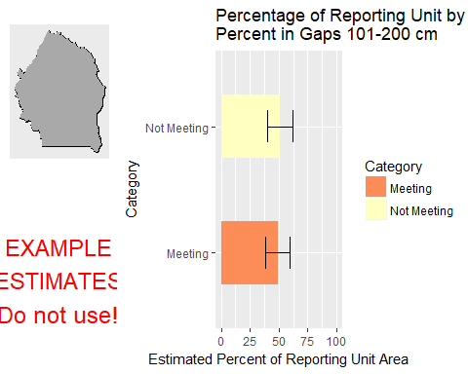

This graph shows the estimated percentage of the reporting unit in different categories for the specified indicator. 80% confidence intervals around those estimates are provided as error bars. The yellow bar denotes the landscape criterion, or point at which an objective is deemed to be met or not met as defined in the Sample Design Worksheet.

#### Results Table

|  |  |  |  |  |  |
| --- | --- | --- | --- | --- | --- |
| Category | # Points | % Area Estimate | Std. Error | Lower 80% CI | Upper 80% CI |
| Meeting | 45 | 48.97 | 5.503 | 38.18 | 59.76 |
| Not Meeting | 33 | 51.03 | 5.503 | 40.24 | 61.82 |

This table gives the analysis results for the specified indicator and reporting unit, and contains the data used to create the graph above.

#### Indicator: Percent in Gaps > 200 cm

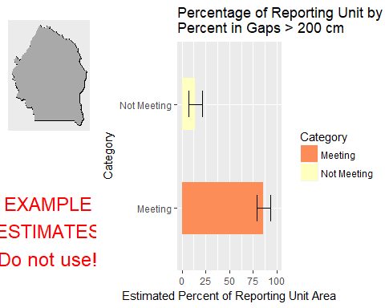

This graph shows the estimated percentage of the reporting unit in different categories for the specified indicator. 80% confidence intervals around those estimates are provided as error bars. The yellow bar denotes the landscape criterion, or point at which an objective is deemed to be met or not met as defined in the Sample Design Worksheet.

#### Results Table

|  |  |  |  |  |  |
| --- | --- | --- | --- | --- | --- |
| Category | # Points | % Area Estimate | Std. Error | Lower 80% CI | Upper 80% CI |
| Meeting | 66 | 85.85 | 3.521 | 78.95 | 92.75 |
| Not Meeting | 12 | 14.15 | 3.521 | 7.251 | 21.05 |

This table gives the analysis results for the specified indicator and reporting unit, and contains the data used to create the graph above.

#### Indicator: Percent in Gaps 51-100 cm

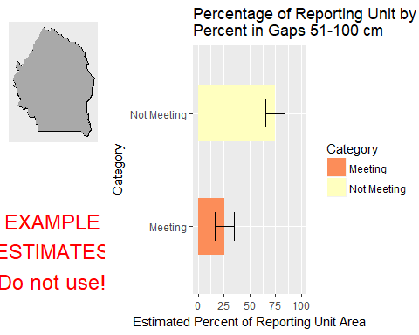

This graph shows the estimated percentage of the reporting unit in different categories for the specified indicator. 80% confidence intervals around those estimates are provided as error bars. The yellow bar denotes the landscape criterion, or point at which an objective is deemed to be met or not met as defined in the Sample Design Worksheet.

#### Results Table

|  |  |  |  |  |  |
| --- | --- | --- | --- | --- | --- |
| Category | # Points | % Area Estimate | Std. Error | Lower 80% CI | Upper 80% CI |
| Meeting | 21 | 25.72 | 4.726 | 16.46 | 34.98 |
| Not Meeting | 57 | 74.28 | 4.726 | 65.02 | 83.54 |

This table gives the analysis results for the specified indicator and reporting unit, and contains the data used to create the graph above.

#### Indicator: Overall Soil Stability Rating

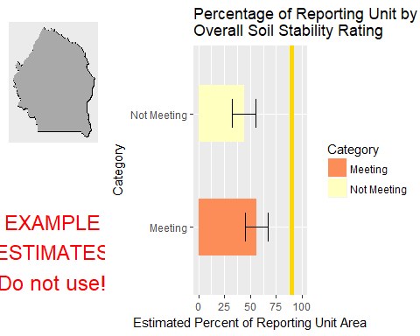

This graph shows the estimated percentage of the reporting unit in different categories for the specified indicator. 80% confidence intervals around those estimates are provided as error bars. The yellow bar denotes the landscape criterion, or point at which an objective is deemed to be met or not met as defined in the Sample Design Worksheet.

#### Results Table

|  |  |  |  |  |  |
| --- | --- | --- | --- | --- | --- |
| Category | # Points | % Area Estimate | Std. Error | Lower 80% CI | Upper 80% CI |
| Meeting | 38 | 56.17 | 5.676 | 45.04 | 67.3 |
| Not Meeting | 36 | 43.83 | 5.676 | 32.7 | 54.96 |

This table gives the analysis results for the specified indicator and reporting unit, and contains the data used to create the graph above.

#### Management Question: Land Health Standard: Soils

#### Indicator: Percent in Gaps 101-200 cm



This graph shows the estimated percentage of the reporting unit in different categories for the specified indicator. 80% confidence intervals around those estimates are provided as error bars. The yellow bar denotes the landscape criterion, or point at which an objective is deemed to be met or not met as defined in the Sample Design Worksheet.

#### Results Table

|  |  |  |  |  |  |
| --- | --- | --- | --- | --- | --- |
| Category | # Points | % Area Estimate | Std. Error | Lower 80% CI | Upper 80% CI |
| Meeting | 45 | 48.97 | 5.503 | 38.18 | 59.76 |
| Not Meeting | 33 | 51.03 | 5.503 | 40.24 | 61.82 |

This table gives the analysis results for the specified indicator and reporting unit, and contains the data used to create the graph above.

#### Indicator: Percent in Gaps > 200 cm



This graph shows the estimated percentage of the reporting unit in different categories for the specified indicator. 80% confidence intervals around those estimates are provided as error bars. The yellow bar denotes the landscape criterion, or point at which an objective is deemed to be met or not met as defined in the Sample Design Worksheet.

#### Results Table

|  |  |  |  |  |  |
| --- | --- | --- | --- | --- | --- |
| Category | # Points | % Area Estimate | Std. Error | Lower 80% CI | Upper 80% CI |
| Meeting | 66 | 85.85 | 3.521 | 78.95 | 92.75 |
| Not Meeting | 12 | 14.15 | 3.521 | 7.251 | 21.05 |

This table gives the analysis results for the specified indicator and reporting unit, and contains the data used to create the graph above.

#### Indicator: Percent in Gaps 51-100 cm



This graph shows the estimated percentage of the reporting unit in different categories for the specified indicator. 80% confidence intervals around those estimates are provided as error bars. The yellow bar denotes the landscape criterion, or point at which an objective is deemed to be met or not met as defined in the Sample Design Worksheet.

#### Results Table

|  |  |  |  |  |  |
| --- | --- | --- | --- | --- | --- |
| Category | # Points | % Area Estimate | Std. Error | Lower 80% CI | Upper 80% CI |
| Meeting | 21 | 25.72 | 4.726 | 16.46 | 34.98 |
| Not Meeting | 57 | 74.28 | 4.726 | 65.02 | 83.54 |

This table gives the analysis results for the specified indicator and reporting unit, and contains the data used to create the graph above.

#### Indicator: Overall Soil Stability Rating



This graph shows the estimated percentage of the reporting unit in different categories for the specified indicator. 80% confidence intervals around those estimates are provided as error bars. The yellow bar denotes the landscape criterion, or point at which an objective is deemed to be met or not met as defined in the Sample Design Worksheet.

#### Results Table

|  |  |  |  |  |  |
| --- | --- | --- | --- | --- | --- |
| Category | # Points | % Area Estimate | Std. Error | Lower 80% CI | Upper 80% CI |
| Meeting | 38 | 56.17 | 5.676 | 45.04 | 67.3 |
| Not Meeting | 36 | 43.83 | 5.676 | 32.7 | 54.96 |

This table gives the analysis results for the specified indicator and reporting unit, and contains the data used to create the graph above.

#### Management Question: Land Health Standard: Biotic Integrity

#### Indicator: Invasive Annual Grass Cover (%, any hit)

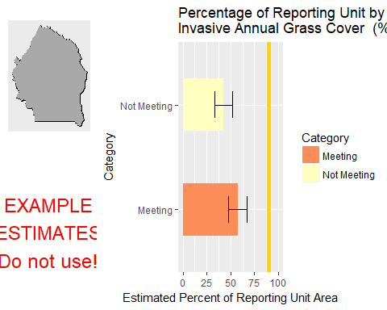

This graph shows the estimated percentage of the reporting unit in different categories for the specified indicator. 80% confidence intervals around those estimates are provided as error bars. The yellow bar denotes the landscape criterion, or point at which an objective is deemed to be met or not met as defined in the Sample Design Worksheet.

#### Results Table

|  |  |  |  |  |  |
| --- | --- | --- | --- | --- | --- |
| Category | # Points | % Area Estimate | Std. Error | Lower 80% CI | Upper 80% CI |
| Meeting | 43 | 57.47 | 4.878 | 47.91 | 67.03 |
| Not Meeting | 35 | 42.53 | 4.878 | 32.97 | 52.09 |

This table gives the analysis results for the specified indicator and reporting unit, and contains the data used to create the graph above.

#### Management Question: GRSG Habitat Objectives

#### Indicator: Sagebrush Cover (%, any hit)

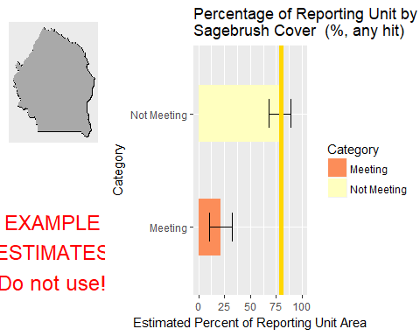

This graph shows the estimated percentage of the reporting unit in different categories for the specified indicator. 80% confidence intervals around those estimates are provided as error bars. The yellow bar denotes the landscape criterion, or point at which an objective is deemed to be met or not met as defined in the Sample Design Worksheet.

#### Results Table

|  |  |  |  |  |  |
| --- | --- | --- | --- | --- | --- |
| Category | # Points | % Area Estimate | Std. Error | Lower 80% CI | Upper 80% CI |
| Meeting | 14 | 21.48 | 5.423 | 10.85 | 32.11 |
| Not Meeting | 41 | 78.52 | 5.423 | 67.89 | 89.15 |

This table gives the analysis results for the specified indicator and reporting unit, and contains the data used to create the graph above.

#### Management Question: Land Health Standard: Native Plants

#### Indicator: Non-invasive Perennial Grass Cover (%, any hit)

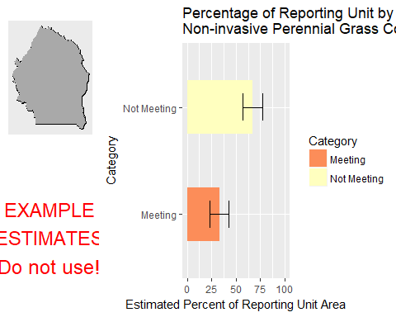

This graph shows the estimated percentage of the reporting unit in different categories for the specified indicator. 80% confidence intervals around those estimates are provided as error bars. The yellow bar denotes the landscape criterion, or point at which an objective is deemed to be met or not met as defined in the Sample Design Worksheet.

#### Results Table

|  |  |  |  |  |  |
| --- | --- | --- | --- | --- | --- |
| Category | # Points | % Area Estimate | Std. Error | Lower 80% CI | Upper 80% CI |
| Meeting | 28 | 33.1 | 5.023 | 23.25 | 42.94 |
| Not Meeting | 47 | 66.9 | 5.023 | 57.06 | 76.75 |

This table gives the analysis results for the specified indicator and reporting unit, and contains the data used to create the graph above.

#### Indicator: Average Non-invasive Perennial Grass Height (cm)

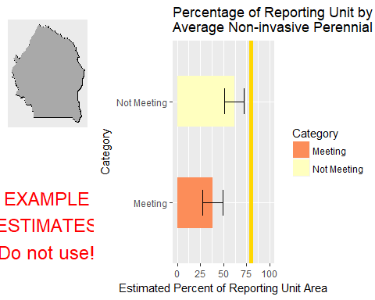

This graph shows the estimated percentage of the reporting unit in different categories for the specified indicator. 80% confidence intervals around those estimates are provided as error bars. The yellow bar denotes the landscape criterion, or point at which an objective is deemed to be met or not met as defined in the Sample Design Worksheet.

#### Results Table

|  |  |  |  |  |  |
| --- | --- | --- | --- | --- | --- |
| Category | # Points | % Area Estimate | Std. Error | Lower 80% CI | Upper 80% CI |
| Meeting | 33 | 38.33 | 5.455 | 27.63 | 49.02 |
| Not Meeting | 41 | 61.67 | 5.455 | 50.98 | 72.37 |

This table gives the analysis results for the specified indicator and reporting unit, and contains the data used to create the graph above.

#### Management Question: Land Health Standard: Wildlife

#### Indicator: Non-invasive Perennial Grass Cover (%, any hit)



This graph shows the estimated percentage of the reporting unit in different categories for the specified indicator. 80% confidence intervals around those estimates are provided as error bars. The yellow bar denotes the landscape criterion, or point at which an objective is deemed to be met or not met as defined in the Sample Design Worksheet.

#### Results Table

|  |  |  |  |  |  |
| --- | --- | --- | --- | --- | --- |
| Category | # Points | % Area Estimate | Std. Error | Lower 80% CI | Upper 80% CI |
| Meeting | 28 | 33.1 | 5.023 | 23.25 | 42.94 |
| Not Meeting | 47 | 66.9 | 5.023 | 57.06 | 76.75 |

This table gives the analysis results for the specified indicator and reporting unit, and contains the data used to create the graph above.

#### Indicator: Average Non-invasive Perennial Grass Height (cm)



This graph shows the estimated percentage of the reporting unit in different categories for the specified indicator. 80% confidence intervals around those estimates are provided as error bars. The yellow bar denotes the landscape criterion, or point at which an objective is deemed to be met or not met as defined in the Sample Design Worksheet.

#### Results Table

|  |  |  |  |  |  |
| --- | --- | --- | --- | --- | --- |
| Category | # Points | % Area Estimate | Std. Error | Lower 80% CI | Upper 80% CI |
| Meeting | 33 | 38.33 | 5.455 | 27.63 | 49.02 |
| Not Meeting | 41 | 61.67 | 5.455 | 50.98 | 72.37 |

This table gives the analysis results for the specified indicator and reporting unit, and contains the data used to create the graph above.

#### Indicator: Average Sagebrush Height (cm)

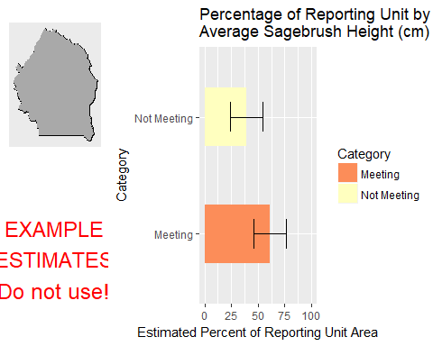

This graph shows the estimated percentage of the reporting unit in different categories for the specified indicator. 80% confidence intervals around those estimates are provided as error bars. The yellow bar denotes the landscape criterion, or point at which an objective is deemed to be met or not met as defined in the Sample Design Worksheet.

#### Results Table

|  |  |  |  |  |  |
| --- | --- | --- | --- | --- | --- |
| Category | # Points | % Area Estimate | Std. Error | Lower 80% CI | Upper 80% CI |
| Meeting | 31 | 60.85 | 7.764 | 45.63 | 76.06 |
| Not Meeting | 17 | 39.15 | 7.764 | 23.94 | 54.37 |

This table gives the analysis results for the specified indicator and reporting unit, and contains the data used to create the graph above.

### Watershed : Big Jacks Creek

#### Management Question: Land Health Standard: Wildlife

#### Indicator: Non-invasive Perennial Grass Cover (%, any hit)

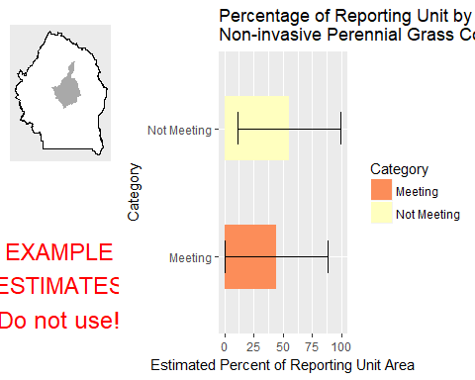

This graph shows the estimated percentage of the reporting unit in different categories for the specified indicator. 80% confidence intervals around those estimates are provided as error bars. The yellow bar denotes the landscape criterion, or point at which an objective is deemed to be met or not met as defined in the Sample Design Worksheet.

#### Results Table

|  |  |  |  |  |  |
| --- | --- | --- | --- | --- | --- |
| Category | # Points | % Area Estimate | Std. Error | Lower 80% CI | Upper 80% CI |
| Meeting | 3 | 44.45 | 22.37 | 0.6125 | 88.29 |
| Not Meeting | 2 | 55.55 | 22.37 | 11.71 | 99.39 |

This table gives the analysis results for the specified indicator and reporting unit, and contains the data used to create the graph above.

#### Indicator: Average Non-invasive Perennial Grass Height (cm)

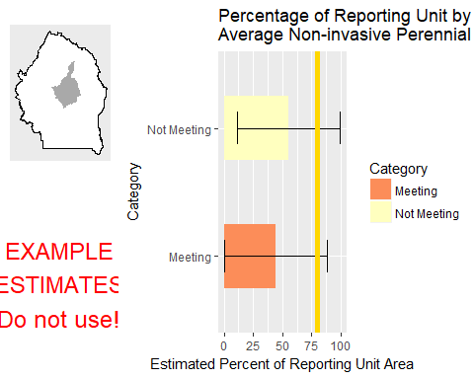

This graph shows the estimated percentage of the reporting unit in different categories for the specified indicator. 80% confidence intervals around those estimates are provided as error bars. The yellow bar denotes the landscape criterion, or point at which an objective is deemed to be met or not met as defined in the Sample Design Worksheet.

#### Results Table

|  |  |  |  |  |  |
| --- | --- | --- | --- | --- | --- |
| Category | # Points | % Area Estimate | Std. Error | Lower 80% CI | Upper 80% CI |
| Meeting | 3 | 44.45 | 22.37 | 0.6125 | 88.29 |
| Not Meeting | 2 | 55.55 | 22.37 | 11.71 | 99.39 |

This table gives the analysis results for the specified indicator and reporting unit, and contains the data used to create the graph above.

#### Indicator: Average Sagebrush Height (cm)

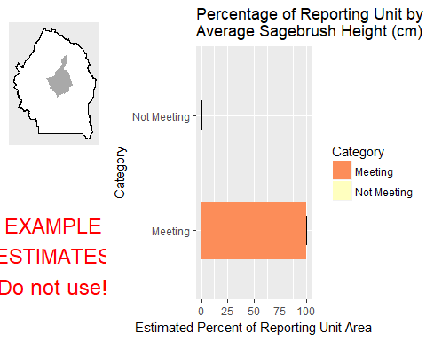

This graph shows the estimated percentage of the reporting unit in different categories for the specified indicator. 80% confidence intervals around those estimates are provided as error bars. The yellow bar denotes the landscape criterion, or point at which an objective is deemed to be met or not met as defined in the Sample Design Worksheet.

#### Results Table

|  |  |  |  |  |  |
| --- | --- | --- | --- | --- | --- |
| Category | # Points | % Area Estimate | Std. Error | Lower 80% CI | Upper 80% CI |
| Meeting | 3 | 99.87 | 0.1538 | 99.57 | 100 |
| Not Meeting | 1 | 0.1257 | 0.1538 | 0 | 0.4271 |

This table gives the analysis results for the specified indicator and reporting unit, and contains the data used to create the graph above.

#### Management Question: Land Health Standard: Watershed

#### Indicator: Percent in Gaps 101-200 cm

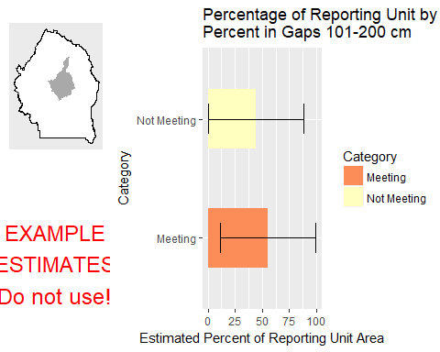

This graph shows the estimated percentage of the reporting unit in different categories for the specified indicator. 80% confidence intervals around those estimates are provided as error bars. The yellow bar denotes the landscape criterion, or point at which an objective is deemed to be met or not met as defined in the Sample Design Worksheet.

#### Results Table

|  |  |  |  |  |  |
| --- | --- | --- | --- | --- | --- |
| Category | # Points | % Area Estimate | Std. Error | Lower 80% CI | Upper 80% CI |
| Meeting | 1 | 55.49 | 22.38 | 11.63 | 99.35 |
| Not Meeting | 4 | 44.51 | 22.38 | 0.6459 | 88.37 |

This table gives the analysis results for the specified indicator and reporting unit, and contains the data used to create the graph above.

#### Indicator: Percent in Gaps > 200 cm

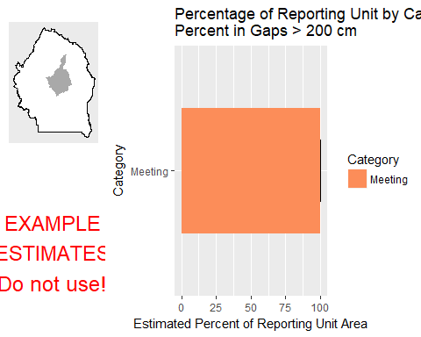

This graph shows the estimated percentage of the reporting unit in different categories for the specified indicator. 80% confidence intervals around those estimates are provided as error bars. The yellow bar denotes the landscape criterion, or point at which an objective is deemed to be met or not met as defined in the Sample Design Worksheet.

#### Results Table

|  |  |  |  |  |  |
| --- | --- | --- | --- | --- | --- |
| Category | # Points | % Area Estimate | Std. Error | Lower 80% CI | Upper 80% CI |
| Meeting | 5 | 100 | 0 | 100 | 100 |

This table gives the analysis results for the specified indicator and reporting unit, and contains the data used to create the graph above.

#### Indicator: Percent in Gaps 51-100 cm

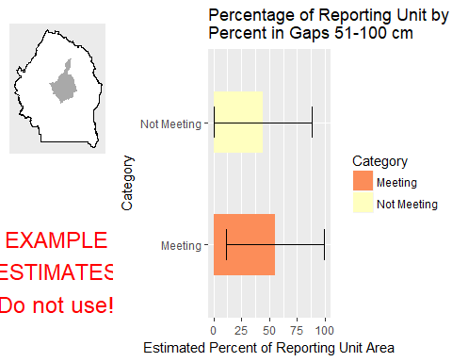

This graph shows the estimated percentage of the reporting unit in different categories for the specified indicator. 80% confidence intervals around those estimates are provided as error bars. The yellow bar denotes the landscape criterion, or point at which an objective is deemed to be met or not met as defined in the Sample Design Worksheet.

#### Results Table

|  |  |  |  |  |  |
| --- | --- | --- | --- | --- | --- |
| Category | # Points | % Area Estimate | Std. Error | Lower 80% CI | Upper 80% CI |
| Meeting | 1 | 55.49 | 22.38 | 11.63 | 99.35 |
| Not Meeting | 4 | 44.51 | 22.38 | 0.6459 | 88.37 |

This table gives the analysis results for the specified indicator and reporting unit, and contains the data used to create the graph above.

#### Indicator: Overall Soil Stability Rating

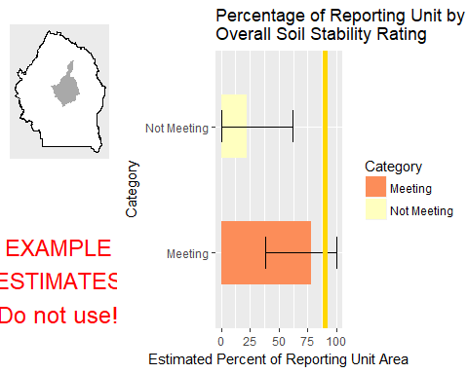

This graph shows the estimated percentage of the reporting unit in different categories for the specified indicator. 80% confidence intervals around those estimates are provided as error bars. The yellow bar denotes the landscape criterion, or point at which an objective is deemed to be met or not met as defined in the Sample Design Worksheet.

#### Results Table

|  |  |  |  |  |  |
| --- | --- | --- | --- | --- | --- |
| Category | # Points | % Area Estimate | Std. Error | Lower 80% CI | Upper 80% CI |
| Meeting | 3 | 77.78 | 20.23 | 38.13 | 100 |
| Not Meeting | 1 | 22.22 | 20.23 | 0 | 61.87 |

This table gives the analysis results for the specified indicator and reporting unit, and contains the data used to create the graph above.

#### Management Question: GRSG Habitat Objectives

#### Indicator: Sagebrush Cover (%, any hit)

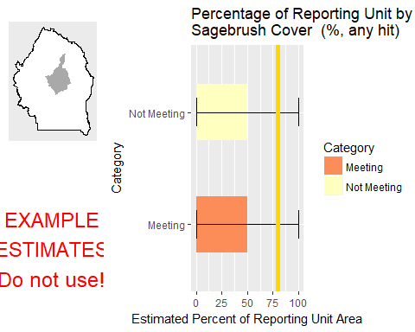

This graph shows the estimated percentage of the reporting unit in different categories for the specified indicator. 80% confidence intervals around those estimates are provided as error bars. The yellow bar denotes the landscape criterion, or point at which an objective is deemed to be met or not met as defined in the Sample Design Worksheet.

#### Results Table

|  |  |  |  |  |  |
| --- | --- | --- | --- | --- | --- |
| Category | # Points | % Area Estimate | Std. Error | Lower 80% CI | Upper 80% CI |
| Meeting | 2 | 49.98 | 33.92 | 0 | 100 |
| Not Meeting | 2 | 50.02 | 33.92 | 0 | 100 |

This table gives the analysis results for the specified indicator and reporting unit, and contains the data used to create the graph above.

#### Management Question: Land Health Standard: Soils

#### Indicator: Percent in Gaps 101-200 cm



This graph shows the estimated percentage of the reporting unit in different categories for the specified indicator. 80% confidence intervals around those estimates are provided as error bars. The yellow bar denotes the landscape criterion, or point at which an objective is deemed to be met or not met as defined in the Sample Design Worksheet.

#### Results Table

|  |  |  |  |  |  |
| --- | --- | --- | --- | --- | --- |
| Category | # Points | % Area Estimate | Std. Error | Lower 80% CI | Upper 80% CI |
| Meeting | 1 | 55.49 | 22.38 | 11.63 | 99.35 |
| Not Meeting | 4 | 44.51 | 22.38 | 0.6459 | 88.37 |

This table gives the analysis results for the specified indicator and reporting unit, and contains the data used to create the graph above.

#### Indicator: Percent in Gaps > 200 cm



This graph shows the estimated percentage of the reporting unit in different categories for the specified indicator. 80% confidence intervals around those estimates are provided as error bars. The yellow bar denotes the landscape criterion, or point at which an objective is deemed to be met or not met as defined in the Sample Design Worksheet.

#### Results Table

|  |  |  |  |  |  |
| --- | --- | --- | --- | --- | --- |
| Category | # Points | % Area Estimate | Std. Error | Lower 80% CI | Upper 80% CI |
| Meeting | 5 | 100 | 0 | 100 | 100 |

This table gives the analysis results for the specified indicator and reporting unit, and contains the data used to create the graph above.

#### Indicator: Percent in Gaps 51-100 cm



This graph shows the estimated percentage of the reporting unit in different categories for the specified indicator. 80% confidence intervals around those estimates are provided as error bars. The yellow bar denotes the landscape criterion, or point at which an objective is deemed to be met or not met as defined in the Sample Design Worksheet.

#### Results Table

|  |  |  |  |  |  |
| --- | --- | --- | --- | --- | --- |
| Category | # Points | % Area Estimate | Std. Error | Lower 80% CI | Upper 80% CI |
| Meeting | 1 | 55.49 | 22.38 | 11.63 | 99.35 |
| Not Meeting | 4 | 44.51 | 22.38 | 0.6459 | 88.37 |

This table gives the analysis results for the specified indicator and reporting unit, and contains the data used to create the graph above.

#### Indicator: Overall Soil Stability Rating



This graph shows the estimated percentage of the reporting unit in different categories for the specified indicator. 80% confidence intervals around those estimates are provided as error bars. The yellow bar denotes the landscape criterion, or point at which an objective is deemed to be met or not met as defined in the Sample Design Worksheet.

#### Results Table

|  |  |  |  |  |  |
| --- | --- | --- | --- | --- | --- |
| Category | # Points | % Area Estimate | Std. Error | Lower 80% CI | Upper 80% CI |
| Meeting | 3 | 77.78 | 20.23 | 38.13 | 100 |
| Not Meeting | 1 | 22.22 | 20.23 | 0 | 61.87 |

This table gives the analysis results for the specified indicator and reporting unit, and contains the data used to create the graph above.

#### Management Question: Land Health Standard: Biotic Integrity

#### Indicator: Invasive Annual Grass Cover (%, any hit)

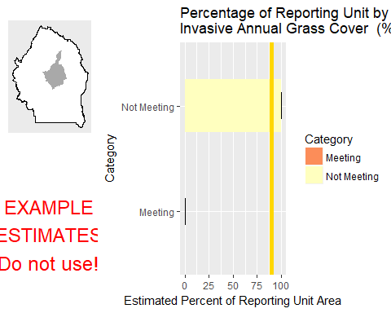

This graph shows the estimated percentage of the reporting unit in different categories for the specified indicator. 80% confidence intervals around those estimates are provided as error bars. The yellow bar denotes the landscape criterion, or point at which an objective is deemed to be met or not met as defined in the Sample Design Worksheet.

#### Results Table

|  |  |  |  |  |  |
| --- | --- | --- | --- | --- | --- |
| Category | # Points | % Area Estimate | Std. Error | Lower 80% CI | Upper 80% CI |
| Meeting | 2 | 0.09447 | 0.08995 | 0 | 0.2708 |
| Not Meeting | 3 | 99.91 | 0.08995 | 99.73 | 100 |

This table gives the analysis results for the specified indicator and reporting unit, and contains the data used to create the graph above.

#### Management Question: Land Health Standard: Native Plants

#### Indicator: Non-invasive Perennial Grass Cover (%, any hit)



This graph shows the estimated percentage of the reporting unit in different categories for the specified indicator. 80% confidence intervals around those estimates are provided as error bars. The yellow bar denotes the landscape criterion, or point at which an objective is deemed to be met or not met as defined in the Sample Design Worksheet.

#### Results Table

|  |  |  |  |  |  |
| --- | --- | --- | --- | --- | --- |
| Category | # Points | % Area Estimate | Std. Error | Lower 80% CI | Upper 80% CI |
| Meeting | 3 | 44.45 | 22.37 | 0.6125 | 88.29 |
| Not Meeting | 2 | 55.55 | 22.37 | 11.71 | 99.39 |

This table gives the analysis results for the specified indicator and reporting unit, and contains the data used to create the graph above.

#### Indicator: Average Non-invasive Perennial Grass Height (cm)



This graph shows the estimated percentage of the reporting unit in different categories for the specified indicator. 80% confidence intervals around those estimates are provided as error bars. The yellow bar denotes the landscape criterion, or point at which an objective is deemed to be met or not met as defined in the Sample Design Worksheet.

#### Results Table

|  |  |  |  |  |  |
| --- | --- | --- | --- | --- | --- |
| Category | # Points | % Area Estimate | Std. Error | Lower 80% CI | Upper 80% CI |
| Meeting | 3 | 44.45 | 22.37 | 0.6125 | 88.29 |
| Not Meeting | 2 | 55.55 | 22.37 | 11.71 | 99.39 |

This table gives the analysis results for the specified indicator and reporting unit, and contains the data used to create the graph above.

### Watershed : Birch Creek-Snake River

#### Management Question: Land Health Standard: Wildlife

#### Indicator: Non-invasive Perennial Grass Cover (%, any hit)

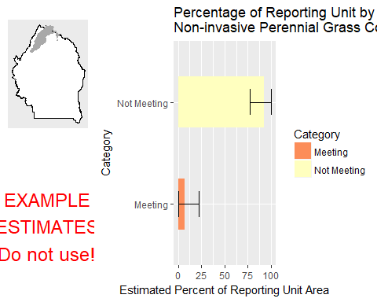

This graph shows the estimated percentage of the reporting unit in different categories for the specified indicator. 80% confidence intervals around those estimates are provided as error bars. The yellow bar denotes the landscape criterion, or point at which an objective is deemed to be met or not met as defined in the Sample Design Worksheet.

#### Results Table

|  |  |  |  |  |  |
| --- | --- | --- | --- | --- | --- |
| Category | # Points | % Area Estimate | Std. Error | Lower 80% CI | Upper 80% CI |
| Meeting | 1 | 7.3 | 7.804 | 0 | 22.6 |
| Not Meeting | 3 | 92.7 | 7.804 | 77.4 | 100 |

This table gives the analysis results for the specified indicator and reporting unit, and contains the data used to create the graph above.

#### Indicator: Average Non-invasive Perennial Grass Height (cm)

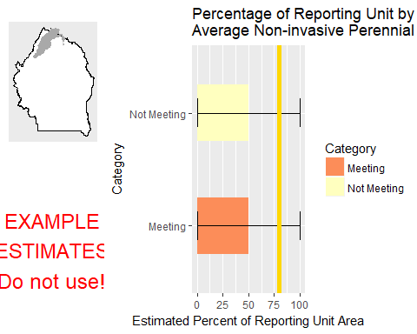

This graph shows the estimated percentage of the reporting unit in different categories for the specified indicator. 80% confidence intervals around those estimates are provided as error bars. The yellow bar denotes the landscape criterion, or point at which an objective is deemed to be met or not met as defined in the Sample Design Worksheet.

#### Results Table

|  |  |  |  |  |  |
| --- | --- | --- | --- | --- | --- |
| Category | # Points | % Area Estimate | Std. Error | Lower 80% CI | Upper 80% CI |
| Meeting | 2 | 49.94 | 25.48 | 0 | 99.88 |
| Not Meeting | 2 | 50.06 | 25.48 | 0.1204 | 100 |

This table gives the analysis results for the specified indicator and reporting unit, and contains the data used to create the graph above.

#### Management Question: Land Health Standard: Watershed

#### Indicator: Percent in Gaps 101-200 cm

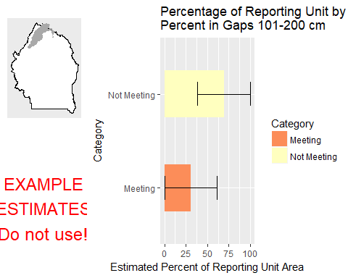

This graph shows the estimated percentage of the reporting unit in different categories for the specified indicator. 80% confidence intervals around those estimates are provided as error bars. The yellow bar denotes the landscape criterion, or point at which an objective is deemed to be met or not met as defined in the Sample Design Worksheet.

#### Results Table

|  |  |  |  |  |  |
| --- | --- | --- | --- | --- | --- |
| Category | # Points | % Area Estimate | Std. Error | Lower 80% CI | Upper 80% CI |
| Meeting | 2 | 30.54 | 15.74 | 0 | 61.39 |
| Not Meeting | 4 | 69.46 | 15.74 | 38.61 | 100 |

This table gives the analysis results for the specified indicator and reporting unit, and contains the data used to create the graph above.

#### Indicator: Percent in Gaps > 200 cm

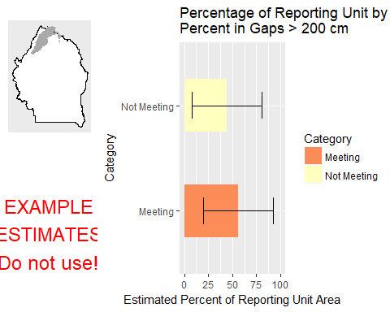

This graph shows the estimated percentage of the reporting unit in different categories for the specified indicator. 80% confidence intervals around those estimates are provided as error bars. The yellow bar denotes the landscape criterion, or point at which an objective is deemed to be met or not met as defined in the Sample Design Worksheet.

#### Results Table

|  |  |  |  |  |  |
| --- | --- | --- | --- | --- | --- |
| Category | # Points | % Area Estimate | Std. Error | Lower 80% CI | Upper 80% CI |
| Meeting | 3 | 55.93 | 18.47 | 19.73 | 92.13 |
| Not Meeting | 3 | 44.07 | 18.47 | 7.872 | 80.27 |

This table gives the analysis results for the specified indicator and reporting unit, and contains the data used to create the graph above.

#### Indicator: Percent in Gaps 51-100 cm

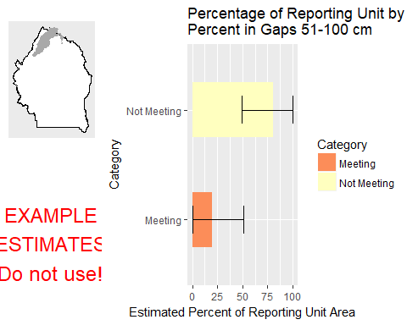

This graph shows the estimated percentage of the reporting unit in different categories for the specified indicator. 80% confidence intervals around those estimates are provided as error bars. The yellow bar denotes the landscape criterion, or point at which an objective is deemed to be met or not met as defined in the Sample Design Worksheet.

#### Results Table

|  |  |  |  |  |  |
| --- | --- | --- | --- | --- | --- |
| Category | # Points | % Area Estimate | Std. Error | Lower 80% CI | Upper 80% CI |
| Meeting | 1 | 19.5 | 15.99 | 0 | 50.84 |
| Not Meeting | 5 | 80.5 | 15.99 | 49.16 | 100 |

This table gives the analysis results for the specified indicator and reporting unit, and contains the data used to create the graph above.

#### Indicator: Overall Soil Stability Rating

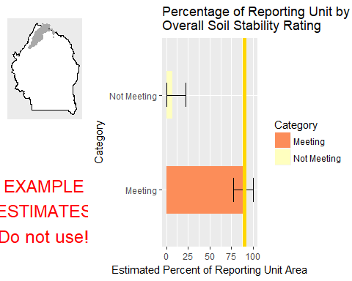

This graph shows the estimated percentage of the reporting unit in different categories for the specified indicator. 80% confidence intervals around those estimates are provided as error bars. The yellow bar denotes the landscape criterion, or point at which an objective is deemed to be met or not met as defined in the Sample Design Worksheet.

#### Results Table

|  |  |  |  |  |  |
| --- | --- | --- | --- | --- | --- |
| Category | # Points | % Area Estimate | Std. Error | Lower 80% CI | Upper 80% CI |
| Meeting | 3 | 92.7 | 7.804 | 77.4 | 100 |
| Not Meeting | 1 | 7.3 | 7.804 | 0 | 22.6 |

This table gives the analysis results for the specified indicator and reporting unit, and contains the data used to create the graph above.

#### Management Question: Land Health Standard: Soils

#### Indicator: Percent in Gaps 101-200 cm



This graph shows the estimated percentage of the reporting unit in different categories for the specified indicator. 80% confidence intervals around those estimates are provided as error bars. The yellow bar denotes the landscape criterion, or point at which an objective is deemed to be met or not met as defined in the Sample Design Worksheet.

#### Results Table

|  |  |  |  |  |  |
| --- | --- | --- | --- | --- | --- |
| Category | # Points | % Area Estimate | Std. Error | Lower 80% CI | Upper 80% CI |
| Meeting | 2 | 30.54 | 15.74 | 0 | 61.39 |
| Not Meeting | 4 | 69.46 | 15.74 | 38.61 | 100 |

This table gives the analysis results for the specified indicator and reporting unit, and contains the data used to create the graph above.

#### Indicator: Percent in Gaps > 200 cm



This graph shows the estimated percentage of the reporting unit in different categories for the specified indicator. 80% confidence intervals around those estimates are provided as error bars. The yellow bar denotes the landscape criterion, or point at which an objective is deemed to be met or not met as defined in the Sample Design Worksheet.

#### Results Table

|  |  |  |  |  |  |
| --- | --- | --- | --- | --- | --- |
| Category | # Points | % Area Estimate | Std. Error | Lower 80% CI | Upper 80% CI |
| Meeting | 3 | 55.93 | 18.47 | 19.73 | 92.13 |
| Not Meeting | 3 | 44.07 | 18.47 | 7.872 | 80.27 |

This table gives the analysis results for the specified indicator and reporting unit, and contains the data used to create the graph above.

#### Indicator: Percent in Gaps 51-100 cm



This graph shows the estimated percentage of the reporting unit in different categories for the specified indicator. 80% confidence intervals around those estimates are provided as error bars. The yellow bar denotes the landscape criterion, or point at which an objective is deemed to be met or not met as defined in the Sample Design Worksheet.

#### Results Table

|  |  |  |  |  |  |
| --- | --- | --- | --- | --- | --- |
| Category | # Points | % Area Estimate | Std. Error | Lower 80% CI | Upper 80% CI |
| Meeting | 1 | 19.5 | 15.99 | 0 | 50.84 |
| Not Meeting | 5 | 80.5 | 15.99 | 49.16 | 100 |

This table gives the analysis results for the specified indicator and reporting unit, and contains the data used to create the graph above.

#### Indicator: Overall Soil Stability Rating



This graph shows the estimated percentage of the reporting unit in different categories for the specified indicator. 80% confidence intervals around those estimates are provided as error bars. The yellow bar denotes the landscape criterion, or point at which an objective is deemed to be met or not met as defined in the Sample Design Worksheet.

#### Results Table

|  |  |  |  |  |  |
| --- | --- | --- | --- | --- | --- |
| Category | # Points | % Area Estimate | Std. Error | Lower 80% CI | Upper 80% CI |
| Meeting | 3 | 92.7 | 7.804 | 77.4 | 100 |
| Not Meeting | 1 | 7.3 | 7.804 | 0 | 22.6 |

This table gives the analysis results for the specified indicator and reporting unit, and contains the data used to create the graph above.

#### Management Question: Land Health Standard: Biotic Integrity

#### Indicator: Invasive Annual Grass Cover (%, any hit)

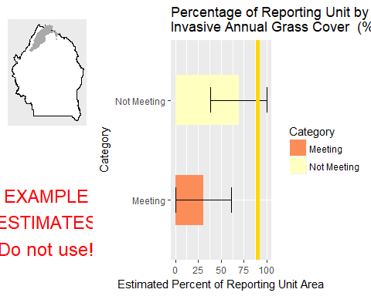

This graph shows the estimated percentage of the reporting unit in different categories for the specified indicator. 80% confidence intervals around those estimates are provided as error bars. The yellow bar denotes the landscape criterion, or point at which an objective is deemed to be met or not met as defined in the Sample Design Worksheet.

#### Results Table

|  |  |  |  |  |  |
| --- | --- | --- | --- | --- | --- |
| Category | # Points | % Area Estimate | Std. Error | Lower 80% CI | Upper 80% CI |
| Meeting | 2 | 30.54 | 15.74 | 0 | 61.39 |
| Not Meeting | 4 | 69.46 | 15.74 | 38.61 | 100 |

This table gives the analysis results for the specified indicator and reporting unit, and contains the data used to create the graph above.

#### Management Question: Land Health Standard: Native Plants

#### Indicator: Non-invasive Perennial Grass Cover (%, any hit)



This graph shows the estimated percentage of the reporting unit in different categories for the specified indicator. 80% confidence intervals around those estimates are provided as error bars. The yellow bar denotes the landscape criterion, or point at which an objective is deemed to be met or not met as defined in the Sample Design Worksheet.

#### Results Table

|  |  |  |  |  |  |
| --- | --- | --- | --- | --- | --- |
| Category | # Points | % Area Estimate | Std. Error | Lower 80% CI | Upper 80% CI |
| Meeting | 1 | 7.3 | 7.804 | 0 | 22.6 |
| Not Meeting | 3 | 92.7 | 7.804 | 77.4 | 100 |

This table gives the analysis results for the specified indicator and reporting unit, and contains the data used to create the graph above.

#### Indicator: Average Non-invasive Perennial Grass Height (cm)



This graph shows the estimated percentage of the reporting unit in different categories for the specified indicator. 80% confidence intervals around those estimates are provided as error bars. The yellow bar denotes the landscape criterion, or point at which an objective is deemed to be met or not met as defined in the Sample Design Worksheet.

#### Results Table

|  |  |  |  |  |  |
| --- | --- | --- | --- | --- | --- |
| Category | # Points | % Area Estimate | Std. Error | Lower 80% CI | Upper 80% CI |
| Meeting | 2 | 49.94 | 25.48 | 0 | 99.88 |
| Not Meeting | 2 | 50.06 | 25.48 | 0.1204 | 100 |

This table gives the analysis results for the specified indicator and reporting unit, and contains the data used to create the graph above.

### Watershed : Bruneau Valley-Bruneau River

#### Management Question: Land Health Standard: Wildlife

#### Indicator: Non-invasive Perennial Grass Cover (%, any hit)

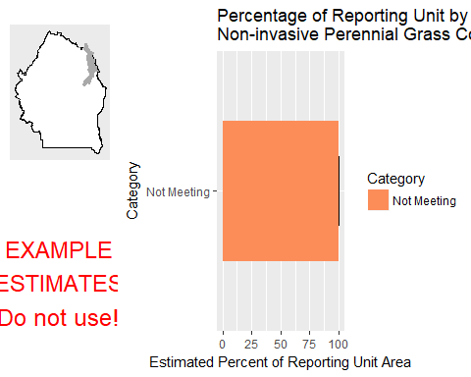

This graph shows the estimated percentage of the reporting unit in different categories for the specified indicator. 80% confidence intervals around those estimates are provided as error bars. The yellow bar denotes the landscape criterion, or point at which an objective is deemed to be met or not met as defined in the Sample Design Worksheet.

#### Results Table

|  |  |  |  |  |  |
| --- | --- | --- | --- | --- | --- |
| Category | # Points | % Area Estimate | Std. Error | Lower 80% CI | Upper 80% CI |
| Not Meeting | 3 | 100 | 0 | 100 | 100 |

This table gives the analysis results for the specified indicator and reporting unit, and contains the data used to create the graph above.

#### Indicator: Average Non-invasive Perennial Grass Height (cm)

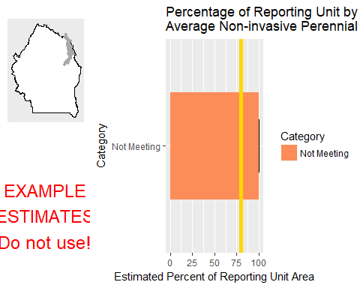

This graph shows the estimated percentage of the reporting unit in different categories for the specified indicator. 80% confidence intervals around those estimates are provided as error bars. The yellow bar denotes the landscape criterion, or point at which an objective is deemed to be met or not met as defined in the Sample Design Worksheet.

#### Results Table

|  |  |  |  |  |  |
| --- | --- | --- | --- | --- | --- |
| Category | # Points | % Area Estimate | Std. Error | Lower 80% CI | Upper 80% CI |
| Not Meeting | 2 | 100 | 0 | 100 | 100 |

This table gives the analysis results for the specified indicator and reporting unit, and contains the data used to create the graph above.

#### Management Question: Land Health Standard: Watershed

#### Indicator: Percent in Gaps 101-200 cm

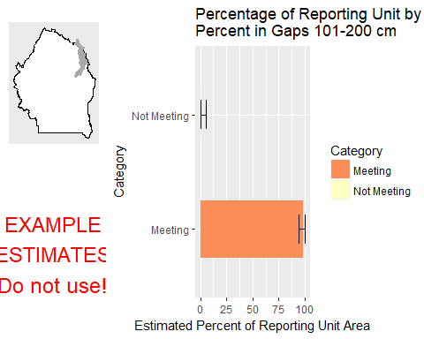

This graph shows the estimated percentage of the reporting unit in different categories for the specified indicator. 80% confidence intervals around those estimates are provided as error bars. The yellow bar denotes the landscape criterion, or point at which an objective is deemed to be met or not met as defined in the Sample Design Worksheet.

#### Results Table

|  |  |  |  |  |  |
| --- | --- | --- | --- | --- | --- |
| Category | # Points | % Area Estimate | Std. Error | Lower 80% CI | Upper 80% CI |
| Meeting | 1 | 98.54 | 2.159 | 94.31 | 100 |
| Not Meeting | 2 | 1.461 | 2.159 | 0 | 5.693 |

This table gives the analysis results for the specified indicator and reporting unit, and contains the data used to create the graph above.

#### Indicator: Percent in Gaps > 200 cm

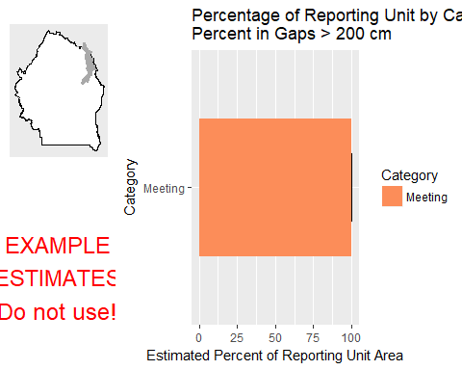

This graph shows the estimated percentage of the reporting unit in different categories for the specified indicator. 80% confidence intervals around those estimates are provided as error bars. The yellow bar denotes the landscape criterion, or point at which an objective is deemed to be met or not met as defined in the Sample Design Worksheet.

#### Results Table

|  |  |  |  |  |  |
| --- | --- | --- | --- | --- | --- |
| Category | # Points | % Area Estimate | Std. Error | Lower 80% CI | Upper 80% CI |
| Meeting | 3 | 100 | 0 | 100 | 100 |

This table gives the analysis results for the specified indicator and reporting unit, and contains the data used to create the graph above.

#### Indicator: Percent in Gaps 51-100 cm

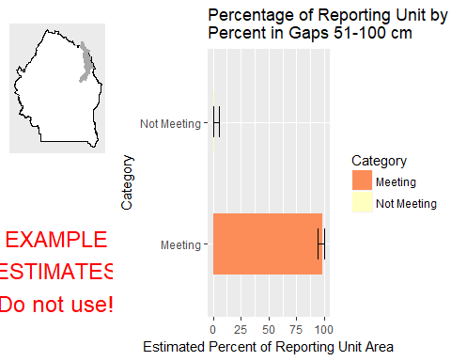

This graph shows the estimated percentage of the reporting unit in different categories for the specified indicator. 80% confidence intervals around those estimates are provided as error bars. The yellow bar denotes the landscape criterion, or point at which an objective is deemed to be met or not met as defined in the Sample Design Worksheet.

#### Results Table

|  |  |  |  |  |  |
| --- | --- | --- | --- | --- | --- |
| Category | # Points | % Area Estimate | Std. Error | Lower 80% CI | Upper 80% CI |
| Meeting | 1 | 98.54 | 2.159 | 94.31 | 100 |
| Not Meeting | 2 | 1.461 | 2.159 | 0 | 5.693 |

This table gives the analysis results for the specified indicator and reporting unit, and contains the data used to create the graph above.

#### Indicator: Overall Soil Stability Rating

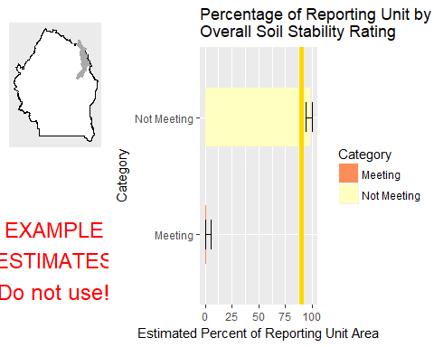

This graph shows the estimated percentage of the reporting unit in different categories for the specified indicator. 80% confidence intervals around those estimates are provided as error bars. The yellow bar denotes the landscape criterion, or point at which an objective is deemed to be met or not met as defined in the Sample Design Worksheet.

#### Results Table

|  |  |  |  |  |  |
| --- | --- | --- | --- | --- | --- |
| Category | # Points | % Area Estimate | Std. Error | Lower 80% CI | Upper 80% CI |
| Meeting | 2 | 1.461 | 2.159 | 0 | 5.693 |
| Not Meeting | 1 | 98.54 | 2.159 | 94.31 | 100 |

This table gives the analysis results for the specified indicator and reporting unit, and contains the data used to create the graph above.

#### Management Question: Land Health Standard: Soils

#### Indicator: Percent in Gaps 101-200 cm



This graph shows the estimated percentage of the reporting unit in different categories for the specified indicator. 80% confidence intervals around those estimates are provided as error bars. The yellow bar denotes the landscape criterion, or point at which an objective is deemed to be met or not met as defined in the Sample Design Worksheet.

#### Results Table

|  |  |  |  |  |  |
| --- | --- | --- | --- | --- | --- |
| Category | # Points | % Area Estimate | Std. Error | Lower 80% CI | Upper 80% CI |
| Meeting | 1 | 98.54 | 2.159 | 94.31 | 100 |
| Not Meeting | 2 | 1.461 | 2.159 | 0 | 5.693 |

This table gives the analysis results for the specified indicator and reporting unit, and contains the data used to create the graph above.

#### Indicator: Percent in Gaps > 200 cm



This graph shows the estimated percentage of the reporting unit in different categories for the specified indicator. 80% confidence intervals around those estimates are provided as error bars. The yellow bar denotes the landscape criterion, or point at which an objective is deemed to be met or not met as defined in the Sample Design Worksheet.

#### Results Table

|  |  |  |  |  |  |
| --- | --- | --- | --- | --- | --- |
| Category | # Points | % Area Estimate | Std. Error | Lower 80% CI | Upper 80% CI |
| Meeting | 3 | 100 | 0 | 100 | 100 |

This table gives the analysis results for the specified indicator and reporting unit, and contains the data used to create the graph above.

#### Indicator: Percent in Gaps 51-100 cm



This graph shows the estimated percentage of the reporting unit in different categories for the specified indicator. 80% confidence intervals around those estimates are provided as error bars. The yellow bar denotes the landscape criterion, or point at which an objective is deemed to be met or not met as defined in the Sample Design Worksheet.

#### Results Table

|  |  |  |  |  |  |
| --- | --- | --- | --- | --- | --- |
| Category | # Points | % Area Estimate | Std. Error | Lower 80% CI | Upper 80% CI |
| Meeting | 1 | 98.54 | 2.159 | 94.31 | 100 |
| Not Meeting | 2 | 1.461 | 2.159 | 0 | 5.693 |

This table gives the analysis results for the specified indicator and reporting unit, and contains the data used to create the graph above.

#### Indicator: Overall Soil Stability Rating



This graph shows the estimated percentage of the reporting unit in different categories for the specified indicator. 80% confidence intervals around those estimates are provided as error bars. The yellow bar denotes the landscape criterion, or point at which an objective is deemed to be met or not met as defined in the Sample Design Worksheet.

#### Results Table

|  |  |  |  |  |  |
| --- | --- | --- | --- | --- | --- |
| Category | # Points | % Area Estimate | Std. Error | Lower 80% CI | Upper 80% CI |
| Meeting | 2 | 1.461 | 2.159 | 0 | 5.693 |
| Not Meeting | 1 | 98.54 | 2.159 | 94.31 | 100 |

This table gives the analysis results for the specified indicator and reporting unit, and contains the data used to create the graph above.

#### Management Question: Land Health Standard: Biotic Integrity

#### Indicator: Invasive Annual Grass Cover (%, any hit)

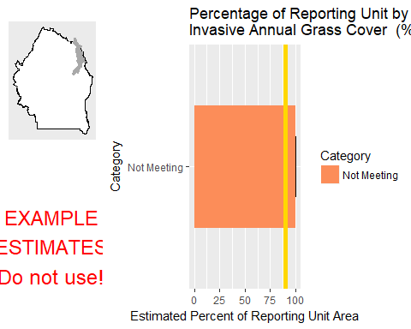

This graph shows the estimated percentage of the reporting unit in different categories for the specified indicator. 80% confidence intervals around those estimates are provided as error bars. The yellow bar denotes the landscape criterion, or point at which an objective is deemed to be met or not met as defined in the Sample Design Worksheet.

#### Results Table

|  |  |  |  |  |  |
| --- | --- | --- | --- | --- | --- |
| Category | # Points | % Area Estimate | Std. Error | Lower 80% CI | Upper 80% CI |
| Not Meeting | 3 | 100 | 0 | 100 | 100 |

This table gives the analysis results for the specified indicator and reporting unit, and contains the data used to create the graph above.

#### Management Question: Land Health Standard: Native Plants

#### Indicator: Non-invasive Perennial Grass Cover (%, any hit)



This graph shows the estimated percentage of the reporting unit in different categories for the specified indicator. 80% confidence intervals around those estimates are provided as error bars. The yellow bar denotes the landscape criterion, or point at which an objective is deemed to be met or not met as defined in the Sample Design Worksheet.

#### Results Table

|  |  |  |  |  |  |
| --- | --- | --- | --- | --- | --- |
| Category | # Points | % Area Estimate | Std. Error | Lower 80% CI | Upper 80% CI |
| Not Meeting | 3 | 100 | 0 | 100 | 100 |

This table gives the analysis results for the specified indicator and reporting unit, and contains the data used to create the graph above.

#### Indicator: Average Non-invasive Perennial Grass Height (cm)



This graph shows the estimated percentage of the reporting unit in different categories for the specified indicator. 80% confidence intervals around those estimates are provided as error bars. The yellow bar denotes the landscape criterion, or point at which an objective is deemed to be met or not met as defined in the Sample Design Worksheet.

#### Results Table

|  |  |  |  |  |  |
| --- | --- | --- | --- | --- | --- |
| Category | # Points | % Area Estimate | Std. Error | Lower 80% CI | Upper 80% CI |
| Not Meeting | 2 | 100 | 0 | 100 | 100 |

This table gives the analysis results for the specified indicator and reporting unit, and contains the data used to create the graph above.

### Watershed : Dickshooter Creek

#### Management Question: Land Health Standard: Wildlife

#### Indicator: Non-invasive Perennial Grass Cover (%, any hit)

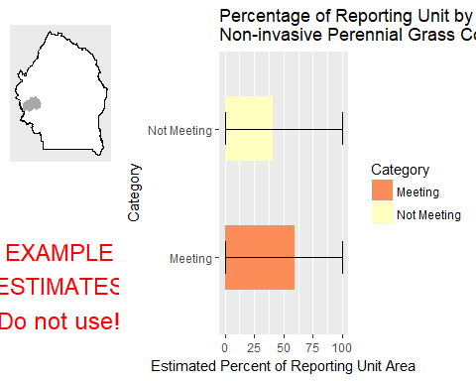

This graph shows the estimated percentage of the reporting unit in different categories for the specified indicator. 80% confidence intervals around those estimates are provided as error bars. The yellow bar denotes the landscape criterion, or point at which an objective is deemed to be met or not met as defined in the Sample Design Worksheet.

#### Results Table

|  |  |  |  |  |  |
| --- | --- | --- | --- | --- | --- |
| Category | # Points | % Area Estimate | Std. Error | Lower 80% CI | Upper 80% CI |
| Meeting | 1 | 59.24 | 48.29 | 0 | 100 |
| Not Meeting | 1 | 40.76 | 48.29 | 0 | 100 |

This table gives the analysis results for the specified indicator and reporting unit, and contains the data used to create the graph above.

#### Indicator: Average Non-invasive Perennial Grass Height (cm)

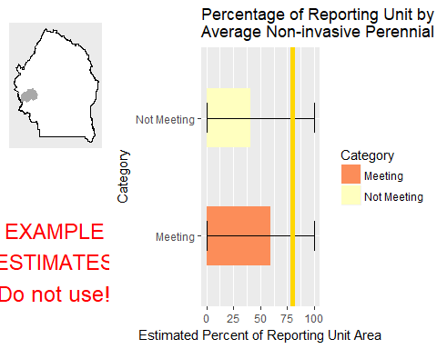

This graph shows the estimated percentage of the reporting unit in different categories for the specified indicator. 80% confidence intervals around those estimates are provided as error bars. The yellow bar denotes the landscape criterion, or point at which an objective is deemed to be met or not met as defined in the Sample Design Worksheet.

#### Results Table

|  |  |  |  |  |  |
| --- | --- | --- | --- | --- | --- |
| Category | # Points | % Area Estimate | Std. Error | Lower 80% CI | Upper 80% CI |
| Meeting | 1 | 59.24 | 48.29 | 0 | 100 |
| Not Meeting | 1 | 40.76 | 48.29 | 0 | 100 |

This table gives the analysis results for the specified indicator and reporting unit, and contains the data used to create the graph above.

#### Indicator: Average Sagebrush Height (cm)

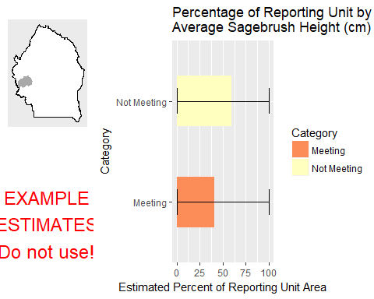

This graph shows the estimated percentage of the reporting unit in different categories for the specified indicator. 80% confidence intervals around those estimates are provided as error bars. The yellow bar denotes the landscape criterion, or point at which an objective is deemed to be met or not met as defined in the Sample Design Worksheet.

#### Results Table

|  |  |  |  |  |  |
| --- | --- | --- | --- | --- | --- |
| Category | # Points | % Area Estimate | Std. Error | Lower 80% CI | Upper 80% CI |
| Meeting | 1 | 40.76 | 48.29 | 0 | 100 |
| Not Meeting | 1 | 59.24 | 48.29 | 0 | 100 |

This table gives the analysis results for the specified indicator and reporting unit, and contains the data used to create the graph above.

#### Management Question: Land Health Standard: Watershed

#### Indicator: Percent in Gaps 101-200 cm

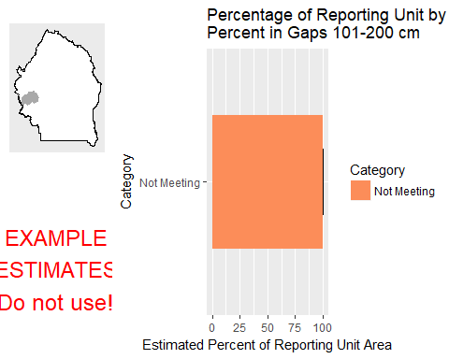

This graph shows the estimated percentage of the reporting unit in different categories for the specified indicator. 80% confidence intervals around those estimates are provided as error bars. The yellow bar denotes the landscape criterion, or point at which an objective is deemed to be met or not met as defined in the Sample Design Worksheet.

#### Results Table

|  |  |  |  |  |  |
| --- | --- | --- | --- | --- | --- |
| Category | # Points | % Area Estimate | Std. Error | Lower 80% CI | Upper 80% CI |
| Not Meeting | 2 | 100 | 0 | 100 | 100 |

This table gives the analysis results for the specified indicator and reporting unit, and contains the data used to create the graph above.

#### Indicator: Percent in Gaps > 200 cm

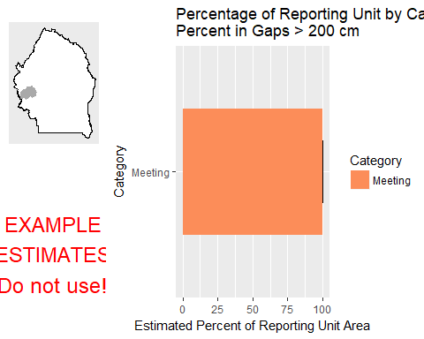

This graph shows the estimated percentage of the reporting unit in different categories for the specified indicator. 80% confidence intervals around those estimates are provided as error bars. The yellow bar denotes the landscape criterion, or point at which an objective is deemed to be met or not met as defined in the Sample Design Worksheet.

#### Results Table

|  |  |  |  |  |  |
| --- | --- | --- | --- | --- | --- |
| Category | # Points | % Area Estimate | Std. Error | Lower 80% CI | Upper 80% CI |
| Meeting | 2 | 100 | 0 | 100 | 100 |

This table gives the analysis results for the specified indicator and reporting unit, and contains the data used to create the graph above.

#### Indicator: Percent in Gaps 51-100 cm

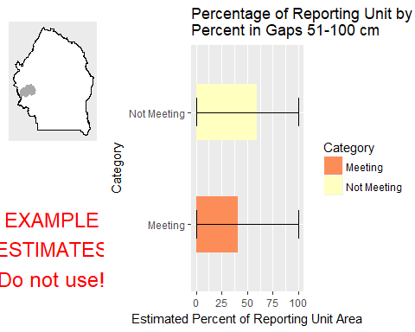

This graph shows the estimated percentage of the reporting unit in different categories for the specified indicator. 80% confidence intervals around those estimates are provided as error bars. The yellow bar denotes the landscape criterion, or point at which an objective is deemed to be met or not met as defined in the Sample Design Worksheet.

#### Results Table

|  |  |  |  |  |  |
| --- | --- | --- | --- | --- | --- |
| Category | # Points | % Area Estimate | Std. Error | Lower 80% CI | Upper 80% CI |
| Meeting | 1 | 40.76 | 48.29 | 0 | 100 |
| Not Meeting | 1 | 59.24 | 48.29 | 0 | 100 |

This table gives the analysis results for the specified indicator and reporting unit, and contains the data used to create the graph above.

#### Indicator: Overall Soil Stability Rating

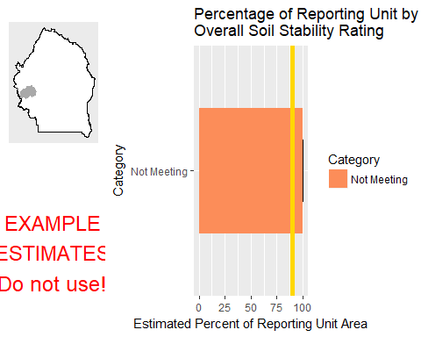

This graph shows the estimated percentage of the reporting unit in different categories for the specified indicator. 80% confidence intervals around those estimates are provided as error bars. The yellow bar denotes the landscape criterion, or point at which an objective is deemed to be met or not met as defined in the Sample Design Worksheet.

#### Results Table

|  |  |  |  |  |  |
| --- | --- | --- | --- | --- | --- |
| Category | # Points | % Area Estimate | Std. Error | Lower 80% CI | Upper 80% CI |
| Not Meeting | 2 | 100 | 0 | 100 | 100 |

This table gives the analysis results for the specified indicator and reporting unit, and contains the data used to create the graph above.

#### Management Question: GRSG Habitat Objectives

#### Indicator: Sagebrush Cover (%, any hit)

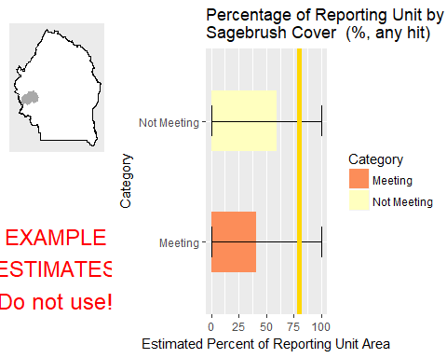

This graph shows the estimated percentage of the reporting unit in different categories for the specified indicator. 80% confidence intervals around those estimates are provided as error bars. The yellow bar denotes the landscape criterion, or point at which an objective is deemed to be met or not met as defined in the Sample Design Worksheet.

#### Results Table

|  |  |  |  |  |  |
| --- | --- | --- | --- | --- | --- |
| Category | # Points | % Area Estimate | Std. Error | Lower 80% CI | Upper 80% CI |
| Meeting | 1 | 40.76 | 48.29 | 0 | 100 |
| Not Meeting | 1 | 59.24 | 48.29 | 0 | 100 |

This table gives the analysis results for the specified indicator and reporting unit, and contains the data used to create the graph above.

#### Management Question: Land Health Standard: Soils

#### Indicator: Percent in Gaps 101-200 cm



This graph shows the estimated percentage of the reporting unit in different categories for the specified indicator. 80% confidence intervals around those estimates are provided as error bars. The yellow bar denotes the landscape criterion, or point at which an objective is deemed to be met or not met as defined in the Sample Design Worksheet.

#### Results Table

|  |  |  |  |  |  |
| --- | --- | --- | --- | --- | --- |
| Category | # Points | % Area Estimate | Std. Error | Lower 80% CI | Upper 80% CI |
| Not Meeting | 2 | 100 | 0 | 100 | 100 |

This table gives the analysis results for the specified indicator and reporting unit, and contains the data used to create the graph above.

#### Indicator: Percent in Gaps > 200 cm



This graph shows the estimated percentage of the reporting unit in different categories for the specified indicator. 80% confidence intervals around those estimates are provided as error bars. The yellow bar denotes the landscape criterion, or point at which an objective is deemed to be met or not met as defined in the Sample Design Worksheet.

#### Results Table

|  |  |  |  |  |  |
| --- | --- | --- | --- | --- | --- |
| Category | # Points | % Area Estimate | Std. Error | Lower 80% CI | Upper 80% CI |
| Meeting | 2 | 100 | 0 | 100 | 100 |

This table gives the analysis results for the specified indicator and reporting unit, and contains the data used to create the graph above.

#### Indicator: Percent in Gaps 51-100 cm



This graph shows the estimated percentage of the reporting unit in different categories for the specified indicator. 80% confidence intervals around those estimates are provided as error bars. The yellow bar denotes the landscape criterion, or point at which an objective is deemed to be met or not met as defined in the Sample Design Worksheet.

#### Results Table

|  |  |  |  |  |  |
| --- | --- | --- | --- | --- | --- |
| Category | # Points | % Area Estimate | Std. Error | Lower 80% CI | Upper 80% CI |
| Meeting | 1 | 40.76 | 48.29 | 0 | 100 |
| Not Meeting | 1 | 59.24 | 48.29 | 0 | 100 |

This table gives the analysis results for the specified indicator and reporting unit, and contains the data used to create the graph above.

#### Indicator: Overall Soil Stability Rating



This graph shows the estimated percentage of the reporting unit in different categories for the specified indicator. 80% confidence intervals around those estimates are provided as error bars. The yellow bar denotes the landscape criterion, or point at which an objective is deemed to be met or not met as defined in the Sample Design Worksheet.

#### Results Table

|  |  |  |  |  |  |
| --- | --- | --- | --- | --- | --- |
| Category | # Points | % Area Estimate | Std. Error | Lower 80% CI | Upper 80% CI |
| Not Meeting | 2 | 100 | 0 | 100 | 100 |

This table gives the analysis results for the specified indicator and reporting unit, and contains the data used to create the graph above.

#### Management Question: Land Health Standard: Biotic Integrity

#### Indicator: Invasive Annual Grass Cover (%, any hit)

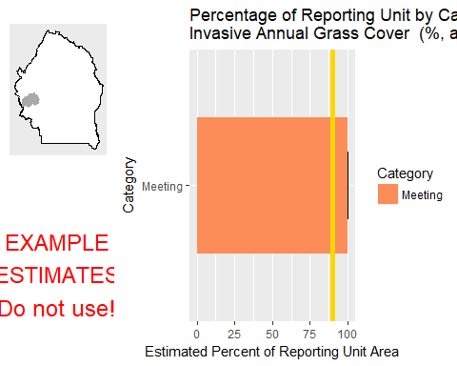

This graph shows the estimated percentage of the reporting unit in different categories for the specified indicator. 80% confidence intervals around those estimates are provided as error bars. The yellow bar denotes the landscape criterion, or point at which an objective is deemed to be met or not met as defined in the Sample Design Worksheet.

#### Results Table

|  |  |  |  |  |  |
| --- | --- | --- | --- | --- | --- |
| Category | # Points | % Area Estimate | Std. Error | Lower 80% CI | Upper 80% CI |
| Meeting | 2 | 100 | 0 | 100 | 100 |

This table gives the analysis results for the specified indicator and reporting unit, and contains the data used to create the graph above.

#### Management Question: Land Health Standard: Native Plants

#### Indicator: Non-invasive Perennial Grass Cover (%, any hit)



This graph shows the estimated percentage of the reporting unit in different categories for the specified indicator. 80% confidence intervals around those estimates are provided as error bars. The yellow bar denotes the landscape criterion, or point at which an objective is deemed to be met or not met as defined in the Sample Design Worksheet.

#### Results Table

|  |  |  |  |  |  |
| --- | --- | --- | --- | --- | --- |
| Category | # Points | % Area Estimate | Std. Error | Lower 80% CI | Upper 80% CI |
| Meeting | 1 | 59.24 | 48.29 | 0 | 100 |
| Not Meeting | 1 | 40.76 | 48.29 | 0 | 100 |

This table gives the analysis results for the specified indicator and reporting unit, and contains the data used to create the graph above.

#### Indicator: Average Non-invasive Perennial Grass Height (cm)



This graph shows the estimated percentage of the reporting unit in different categories for the specified indicator. 80% confidence intervals around those estimates are provided as error bars. The yellow bar denotes the landscape criterion, or point at which an objective is deemed to be met or not met as defined in the Sample Design Worksheet.

#### Results Table

|  |  |  |  |  |  |
| --- | --- | --- | --- | --- | --- |
| Category | # Points | % Area Estimate | Std. Error | Lower 80% CI | Upper 80% CI |
| Meeting | 1 | 59.24 | 48.29 | 0 | 100 |
| Not Meeting | 1 | 40.76 | 48.29 | 0 | 100 |

This table gives the analysis results for the specified indicator and reporting unit, and contains the data used to create the graph above.

### Watershed : Jacks Creek

#### Management Question: Land Health Standard: Wildlife

#### Indicator: Non-invasive Perennial Grass Cover (%, any hit)

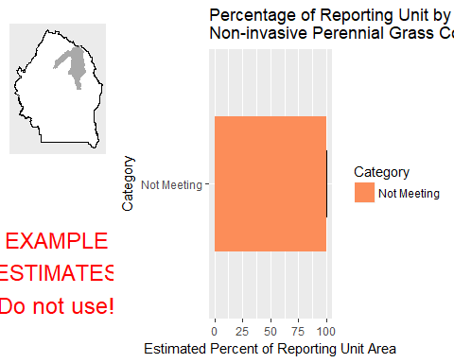

This graph shows the estimated percentage of the reporting unit in different categories for the specified indicator. 80% confidence intervals around those estimates are provided as error bars. The yellow bar denotes the landscape criterion, or point at which an objective is deemed to be met or not met as defined in the Sample Design Worksheet.

#### Results Table

|  |  |  |  |  |  |
| --- | --- | --- | --- | --- | --- |
| Category | # Points | % Area Estimate | Std. Error | Lower 80% CI | Upper 80% CI |
| Not Meeting | 4 | 100 | 0 | 100 | 100 |

This table gives the analysis results for the specified indicator and reporting unit, and contains the data used to create the graph above.

#### Indicator: Average Non-invasive Perennial Grass Height (cm)

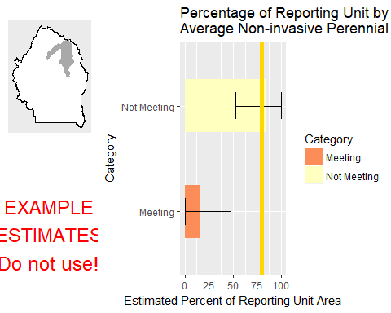

This graph shows the estimated percentage of the reporting unit in different categories for the specified indicator. 80% confidence intervals around those estimates are provided as error bars. The yellow bar denotes the landscape criterion, or point at which an objective is deemed to be met or not met as defined in the Sample Design Worksheet.

#### Results Table

|  |  |  |  |  |  |
| --- | --- | --- | --- | --- | --- |
| Category | # Points | % Area Estimate | Std. Error | Lower 80% CI | Upper 80% CI |
| Meeting | 1 | 15.99 | 16.08 | 0 | 47.51 |
| Not Meeting | 3 | 84.01 | 16.08 | 52.49 | 100 |

This table gives the analysis results for the specified indicator and reporting unit, and contains the data used to create the graph above.

#### Management Question: Land Health Standard: Watershed

#### Indicator: Percent in Gaps 101-200 cm

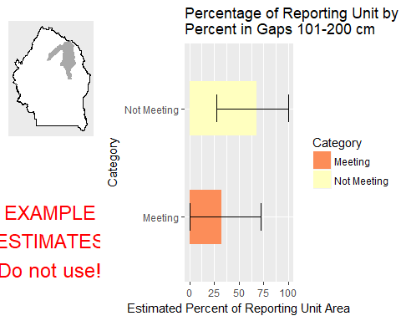

This graph shows the estimated percentage of the reporting unit in different categories for the specified indicator. 80% confidence intervals around those estimates are provided as error bars. The yellow bar denotes the landscape criterion, or point at which an objective is deemed to be met or not met as defined in the Sample Design Worksheet.

#### Results Table

|  |  |  |  |  |  |
| --- | --- | --- | --- | --- | --- |
| Category | # Points | % Area Estimate | Std. Error | Lower 80% CI | Upper 80% CI |
| Meeting | 2 | 31.98 | 20.6 | 0 | 72.36 |
| Not Meeting | 2 | 68.02 | 20.6 | 27.64 | 100 |

This table gives the analysis results for the specified indicator and reporting unit, and contains the data used to create the graph above.

#### Indicator: Percent in Gaps > 200 cm

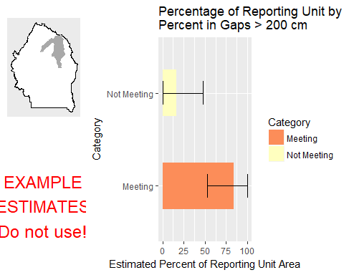

This graph shows the estimated percentage of the reporting unit in different categories for the specified indicator. 80% confidence intervals around those estimates are provided as error bars. The yellow bar denotes the landscape criterion, or point at which an objective is deemed to be met or not met as defined in the Sample Design Worksheet.

#### Results Table

|  |  |  |  |  |  |
| --- | --- | --- | --- | --- | --- |
| Category | # Points | % Area Estimate | Std. Error | Lower 80% CI | Upper 80% CI |
| Meeting | 3 | 84.01 | 16.08 | 52.49 | 100 |
| Not Meeting | 1 | 15.99 | 16.08 | 0 | 47.51 |

This table gives the analysis results for the specified indicator and reporting unit, and contains the data used to create the graph above.

#### Indicator: Percent in Gaps 51-100 cm

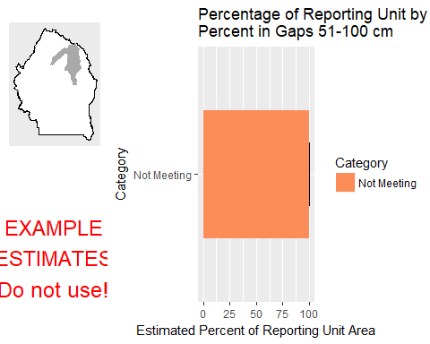

This graph shows the estimated percentage of the reporting unit in different categories for the specified indicator. 80% confidence intervals around those estimates are provided as error bars. The yellow bar denotes the landscape criterion, or point at which an objective is deemed to be met or not met as defined in the Sample Design Worksheet.

#### Results Table

|  |  |  |  |  |  |
| --- | --- | --- | --- | --- | --- |
| Category | # Points | % Area Estimate | Std. Error | Lower 80% CI | Upper 80% CI |
| Not Meeting | 4 | 100 | 0 | 100 | 100 |

This table gives the analysis results for the specified indicator and reporting unit, and contains the data used to create the graph above.

#### Indicator: Overall Soil Stability Rating

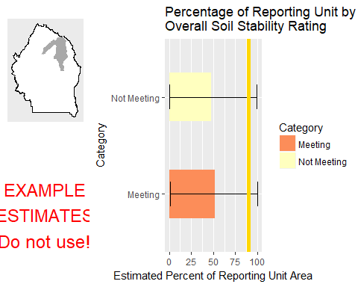

This graph shows the estimated percentage of the reporting unit in different categories for the specified indicator. 80% confidence intervals around those estimates are provided as error bars. The yellow bar denotes the landscape criterion, or point at which an objective is deemed to be met or not met as defined in the Sample Design Worksheet.

#### Results Table

|  |  |  |  |  |  |
| --- | --- | --- | --- | --- | --- |
| Category | # Points | % Area Estimate | Std. Error | Lower 80% CI | Upper 80% CI |
| Meeting | 1 | 52.03 | 25.98 | 1.107 | 100 |
| Not Meeting | 3 | 47.97 | 25.98 | 0 | 98.89 |

This table gives the analysis results for the specified indicator and reporting unit, and contains the data used to create the graph above.

#### Management Question: Land Health Standard: Soils

#### Indicator: Percent in Gaps 101-200 cm



This graph shows the estimated percentage of the reporting unit in different categories for the specified indicator. 80% confidence intervals around those estimates are provided as error bars. The yellow bar denotes the landscape criterion, or point at which an objective is deemed to be met or not met as defined in the Sample Design Worksheet.

#### Results Table

|  |  |  |  |  |  |
| --- | --- | --- | --- | --- | --- |
| Category | # Points | % Area Estimate | Std. Error | Lower 80% CI | Upper 80% CI |
| Meeting | 2 | 31.98 | 20.6 | 0 | 72.36 |
| Not Meeting | 2 | 68.02 | 20.6 | 27.64 | 100 |

This table gives the analysis results for the specified indicator and reporting unit, and contains the data used to create the graph above.

#### Indicator: Percent in Gaps > 200 cm



This graph shows the estimated percentage of the reporting unit in different categories for the specified indicator. 80% confidence intervals around those estimates are provided as error bars. The yellow bar denotes the landscape criterion, or point at which an objective is deemed to be met or not met as defined in the Sample Design Worksheet.

#### Results Table

|  |  |  |  |  |  |
| --- | --- | --- | --- | --- | --- |
| Category | # Points | % Area Estimate | Std. Error | Lower 80% CI | Upper 80% CI |
| Meeting | 3 | 84.01 | 16.08 | 52.49 | 100 |
| Not Meeting | 1 | 15.99 | 16.08 | 0 | 47.51 |

This table gives the analysis results for the specified indicator and reporting unit, and contains the data used to create the graph above.

#### Indicator: Percent in Gaps 51-100 cm



This graph shows the estimated percentage of the reporting unit in different categories for the specified indicator. 80% confidence intervals around those estimates are provided as error bars. The yellow bar denotes the landscape criterion, or point at which an objective is deemed to be met or not met as defined in the Sample Design Worksheet.

#### Results Table

|  |  |  |  |  |  |
| --- | --- | --- | --- | --- | --- |
| Category | # Points | % Area Estimate | Std. Error | Lower 80% CI | Upper 80% CI |
| Not Meeting | 4 | 100 | 0 | 100 | 100 |

This table gives the analysis results for the specified indicator and reporting unit, and contains the data used to create the graph above.

#### Indicator: Overall Soil Stability Rating



This graph shows the estimated percentage of the reporting unit in different categories for the specified indicator. 80% confidence intervals around those estimates are provided as error bars. The yellow bar denotes the landscape criterion, or point at which an objective is deemed to be met or not met as defined in the Sample Design Worksheet.

#### Results Table

|  |  |  |  |  |  |
| --- | --- | --- | --- | --- | --- |
| Category | # Points | % Area Estimate | Std. Error | Lower 80% CI | Upper 80% CI |
| Meeting | 1 | 52.03 | 25.98 | 1.107 | 100 |
| Not Meeting | 3 | 47.97 | 25.98 | 0 | 98.89 |

This table gives the analysis results for the specified indicator and reporting unit, and contains the data used to create the graph above.

#### Management Question: Land Health Standard: Biotic Integrity

#### Indicator: Invasive Annual Grass Cover (%, any hit)

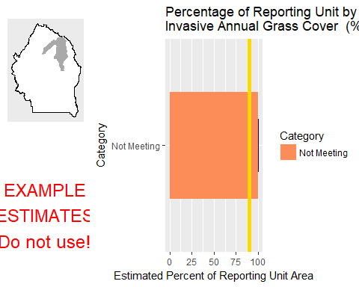

This graph shows the estimated percentage of the reporting unit in different categories for the specified indicator. 80% confidence intervals around those estimates are provided as error bars. The yellow bar denotes the landscape criterion, or point at which an objective is deemed to be met or not met as defined in the Sample Design Worksheet.

#### Results Table

|  |  |  |  |  |  |
| --- | --- | --- | --- | --- | --- |
| Category | # Points | % Area Estimate | Std. Error | Lower 80% CI | Upper 80% CI |
| Not Meeting | 4 | 100 | 0 | 100 | 100 |

This table gives the analysis results for the specified indicator and reporting unit, and contains the data used to create the graph above.

#### Management Question: Land Health Standard: Native Plants

#### Indicator: Non-invasive Perennial Grass Cover (%, any hit)



This graph shows the estimated percentage of the reporting unit in different categories for the specified indicator. 80% confidence intervals around those estimates are provided as error bars. The yellow bar denotes the landscape criterion, or point at which an objective is deemed to be met or not met as defined in the Sample Design Worksheet.

#### Results Table

|  |  |  |  |  |  |
| --- | --- | --- | --- | --- | --- |
| Category | # Points | % Area Estimate | Std. Error | Lower 80% CI | Upper 80% CI |
| Not Meeting | 4 | 100 | 0 | 100 | 100 |

This table gives the analysis results for the specified indicator and reporting unit, and contains the data used to create the graph above.

#### Indicator: Average Non-invasive Perennial Grass Height (cm)



This graph shows the estimated percentage of the reporting unit in different categories for the specified indicator. 80% confidence intervals around those estimates are provided as error bars. The yellow bar denotes the landscape criterion, or point at which an objective is deemed to be met or not met as defined in the Sample Design Worksheet.

#### Results Table

|  |  |  |  |  |  |
| --- | --- | --- | --- | --- | --- |
| Category | # Points | % Area Estimate | Std. Error | Lower 80% CI | Upper 80% CI |
| Meeting | 1 | 15.99 | 16.08 | 0 | 47.51 |
| Not Meeting | 3 | 84.01 | 16.08 | 52.49 | 100 |

This table gives the analysis results for the specified indicator and reporting unit, and contains the data used to create the graph above.

### Watershed : Little Jacks Creek

#### Management Question: Land Health Standard: Wildlife

#### Indicator: Non-invasive Perennial Grass Cover (%, any hit)

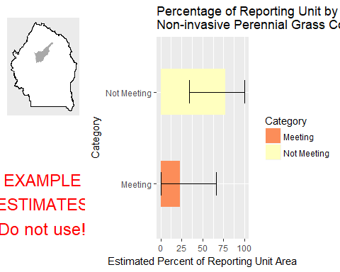

This graph shows the estimated percentage of the reporting unit in different categories for the specified indicator. 80% confidence intervals around those estimates are provided as error bars. The yellow bar denotes the landscape criterion, or point at which an objective is deemed to be met or not met as defined in the Sample Design Worksheet.

#### Results Table

|  |  |  |  |  |  |
| --- | --- | --- | --- | --- | --- |
| Category | # Points | % Area Estimate | Std. Error | Lower 80% CI | Upper 80% CI |
| Meeting | 2 | 23.09 | 22 | 0 | 66.21 |
| Not Meeting | 4 | 76.91 | 22 | 33.79 | 100 |

This table gives the analysis results for the specified indicator and reporting unit, and contains the data used to create the graph above.

#### Indicator: Average Non-invasive Perennial Grass Height (cm)

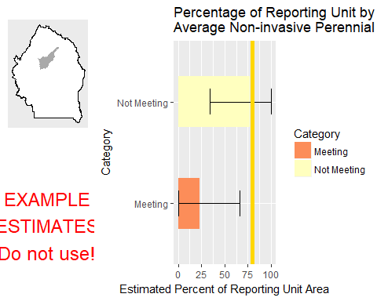

This graph shows the estimated percentage of the reporting unit in different categories for the specified indicator. 80% confidence intervals around those estimates are provided as error bars. The yellow bar denotes the landscape criterion, or point at which an objective is deemed to be met or not met as defined in the Sample Design Worksheet.

#### Results Table

|  |  |  |  |  |  |
| --- | --- | --- | --- | --- | --- |
| Category | # Points | % Area Estimate | Std. Error | Lower 80% CI | Upper 80% CI |
| Meeting | 2 | 23.09 | 22 | 0 | 66.21 |
| Not Meeting | 4 | 76.91 | 22 | 33.79 | 100 |

This table gives the analysis results for the specified indicator and reporting unit, and contains the data used to create the graph above.

#### Indicator: Average Sagebrush Height (cm)

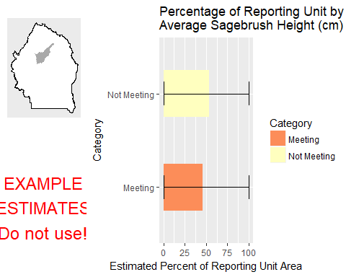

This graph shows the estimated percentage of the reporting unit in different categories for the specified indicator. 80% confidence intervals around those estimates are provided as error bars. The yellow bar denotes the landscape criterion, or point at which an objective is deemed to be met or not met as defined in the Sample Design Worksheet.

#### Results Table

|  |  |  |  |  |  |
| --- | --- | --- | --- | --- | --- |
| Category | # Points | % Area Estimate | Std. Error | Lower 80% CI | Upper 80% CI |
| Meeting | 1 | 46.23 | 40.38 | 0 | 100 |
| Not Meeting | 2 | 53.77 | 40.38 | 0 | 100 |

This table gives the analysis results for the specified indicator and reporting unit, and contains the data used to create the graph above.

#### Management Question: Land Health Standard: Watershed

#### Indicator: Percent in Gaps 101-200 cm

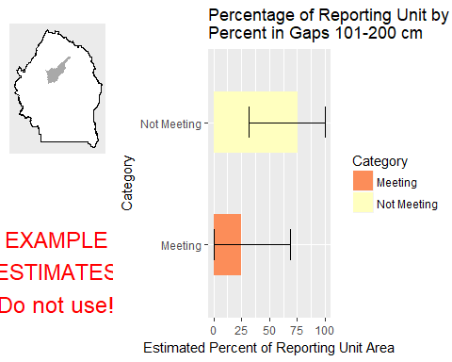

This graph shows the estimated percentage of the reporting unit in different categories for the specified indicator. 80% confidence intervals around those estimates are provided as error bars. The yellow bar denotes the landscape criterion, or point at which an objective is deemed to be met or not met as defined in the Sample Design Worksheet.

#### Results Table

|  |  |  |  |  |  |
| --- | --- | --- | --- | --- | --- |
| Category | # Points | % Area Estimate | Std. Error | Lower 80% CI | Upper 80% CI |
| Meeting | 4 | 24.53 | 22.55 | 0 | 68.72 |
| Not Meeting | 2 | 75.47 | 22.55 | 31.28 | 100 |

This table gives the analysis results for the specified indicator and reporting unit, and contains the data used to create the graph above.

#### Indicator: Percent in Gaps > 200 cm

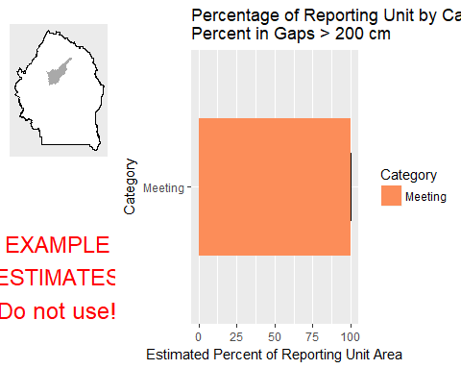

This graph shows the estimated percentage of the reporting unit in different categories for the specified indicator. 80% confidence intervals around those estimates are provided as error bars. The yellow bar denotes the landscape criterion, or point at which an objective is deemed to be met or not met as defined in the Sample Design Worksheet.

#### Results Table

|  |  |  |  |  |  |
| --- | --- | --- | --- | --- | --- |
| Category | # Points | % Area Estimate | Std. Error | Lower 80% CI | Upper 80% CI |
| Meeting | 6 | 100 | 0 | 100 | 100 |

This table gives the analysis results for the specified indicator and reporting unit, and contains the data used to create the graph above.

#### Indicator: Percent in Gaps 51-100 cm

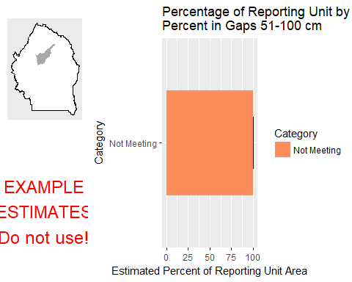

This graph shows the estimated percentage of the reporting unit in different categories for the specified indicator. 80% confidence intervals around those estimates are provided as error bars. The yellow bar denotes the landscape criterion, or point at which an objective is deemed to be met or not met as defined in the Sample Design Worksheet.

#### Results Table

|  |  |  |  |  |  |
| --- | --- | --- | --- | --- | --- |
| Category | # Points | % Area Estimate | Std. Error | Lower 80% CI | Upper 80% CI |
| Not Meeting | 6 | 100 | 0 | 100 | 100 |

This table gives the analysis results for the specified indicator and reporting unit, and contains the data used to create the graph above.

#### Indicator: Overall Soil Stability Rating

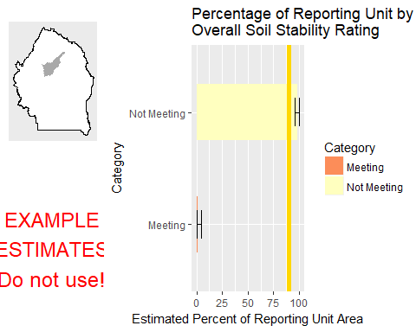

This graph shows the estimated percentage of the reporting unit in different categories for the specified indicator. 80% confidence intervals around those estimates are provided as error bars. The yellow bar denotes the landscape criterion, or point at which an objective is deemed to be met or not met as defined in the Sample Design Worksheet.

#### Results Table

|  |  |  |  |  |  |
| --- | --- | --- | --- | --- | --- |
| Category | # Points | % Area Estimate | Std. Error | Lower 80% CI | Upper 80% CI |
| Meeting | 2 | 1.433 | 1.447 | 0 | 4.269 |
| Not Meeting | 4 | 98.57 | 1.447 | 95.73 | 100 |

This table gives the analysis results for the specified indicator and reporting unit, and contains the data used to create the graph above.

#### Management Question: GRSG Habitat Objectives

#### Indicator: Sagebrush Cover (%, any hit)

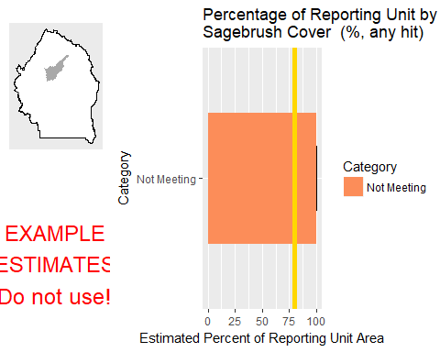

This graph shows the estimated percentage of the reporting unit in different categories for the specified indicator. 80% confidence intervals around those estimates are provided as error bars. The yellow bar denotes the landscape criterion, or point at which an objective is deemed to be met or not met as defined in the Sample Design Worksheet.

#### Results Table

|  |  |  |  |  |  |
| --- | --- | --- | --- | --- | --- |
| Category | # Points | % Area Estimate | Std. Error | Lower 80% CI | Upper 80% CI |
| Not Meeting | 4 | 100 | 0 | 100 | 100 |

This table gives the analysis results for the specified indicator and reporting unit, and contains the data used to create the graph above.

#### Management Question: Land Health Standard: Soils

#### Indicator: Percent in Gaps 101-200 cm



This graph shows the estimated percentage of the reporting unit in different categories for the specified indicator. 80% confidence intervals around those estimates are provided as error bars. The yellow bar denotes the landscape criterion, or point at which an objective is deemed to be met or not met as defined in the Sample Design Worksheet.

#### Results Table

|  |  |  |  |  |  |
| --- | --- | --- | --- | --- | --- |
| Category | # Points | % Area Estimate | Std. Error | Lower 80% CI | Upper 80% CI |
| Meeting | 4 | 24.53 | 22.55 | 0 | 68.72 |
| Not Meeting | 2 | 75.47 | 22.55 | 31.28 | 100 |

This table gives the analysis results for the specified indicator and reporting unit, and contains the data used to create the graph above.

#### Indicator: Percent in Gaps > 200 cm



This graph shows the estimated percentage of the reporting unit in different categories for the specified indicator. 80% confidence intervals around those estimates are provided as error bars. The yellow bar denotes the landscape criterion, or point at which an objective is deemed to be met or not met as defined in the Sample Design Worksheet.

#### Results Table

|  |  |  |  |  |  |
| --- | --- | --- | --- | --- | --- |
| Category | # Points | % Area Estimate | Std. Error | Lower 80% CI | Upper 80% CI |
| Meeting | 6 | 100 | 0 | 100 | 100 |

This table gives the analysis results for the specified indicator and reporting unit, and contains the data used to create the graph above.

#### Indicator: Percent in Gaps 51-100 cm



This graph shows the estimated percentage of the reporting unit in different categories for the specified indicator. 80% confidence intervals around those estimates are provided as error bars. The yellow bar denotes the landscape criterion, or point at which an objective is deemed to be met or not met as defined in the Sample Design Worksheet.

#### Results Table

|  |  |  |  |  |  |
| --- | --- | --- | --- | --- | --- |
| Category | # Points | % Area Estimate | Std. Error | Lower 80% CI | Upper 80% CI |
| Not Meeting | 6 | 100 | 0 | 100 | 100 |

This table gives the analysis results for the specified indicator and reporting unit, and contains the data used to create the graph above.

#### Indicator: Overall Soil Stability Rating



This graph shows the estimated percentage of the reporting unit in different categories for the specified indicator. 80% confidence intervals around those estimates are provided as error bars. The yellow bar denotes the landscape criterion, or point at which an objective is deemed to be met or not met as defined in the Sample Design Worksheet.

#### Results Table

|  |  |  |  |  |  |
| --- | --- | --- | --- | --- | --- |
| Category | # Points | % Area Estimate | Std. Error | Lower 80% CI | Upper 80% CI |
| Meeting | 2 | 1.433 | 1.447 | 0 | 4.269 |
| Not Meeting | 4 | 98.57 | 1.447 | 95.73 | 100 |

This table gives the analysis results for the specified indicator and reporting unit, and contains the data used to create the graph above.

#### Management Question: Land Health Standard: Biotic Integrity

#### Indicator: Invasive Annual Grass Cover (%, any hit)

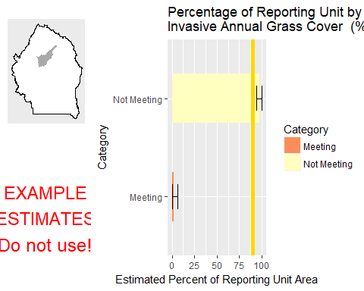

This graph shows the estimated percentage of the reporting unit in different categories for the specified indicator. 80% confidence intervals around those estimates are provided as error bars. The yellow bar denotes the landscape criterion, or point at which an objective is deemed to be met or not met as defined in the Sample Design Worksheet.

#### Results Table

|  |  |  |  |  |  |
| --- | --- | --- | --- | --- | --- |
| Category | # Points | % Area Estimate | Std. Error | Lower 80% CI | Upper 80% CI |
| Meeting | 4 | 2.266 | 1.988 | 0 | 6.163 |
| Not Meeting | 2 | 97.73 | 1.988 | 93.84 | 100 |

This table gives the analysis results for the specified indicator and reporting unit, and contains the data used to create the graph above.

#### Management Question: Land Health Standard: Native Plants

#### Indicator: Non-invasive Perennial Grass Cover (%, any hit)



This graph shows the estimated percentage of the reporting unit in different categories for the specified indicator. 80% confidence intervals around those estimates are provided as error bars. The yellow bar denotes the landscape criterion, or point at which an objective is deemed to be met or not met as defined in the Sample Design Worksheet.

#### Results Table

|  |  |  |  |  |  |
| --- | --- | --- | --- | --- | --- |
| Category | # Points | % Area Estimate | Std. Error | Lower 80% CI | Upper 80% CI |
| Meeting | 2 | 23.09 | 22 | 0 | 66.21 |
| Not Meeting | 4 | 76.91 | 22 | 33.79 | 100 |

This table gives the analysis results for the specified indicator and reporting unit, and contains the data used to create the graph above.

#### Indicator: Average Non-invasive Perennial Grass Height (cm)



This graph shows the estimated percentage of the reporting unit in different categories for the specified indicator. 80% confidence intervals around those estimates are provided as error bars. The yellow bar denotes the landscape criterion, or point at which an objective is deemed to be met or not met as defined in the Sample Design Worksheet.

#### Results Table

|  |  |  |  |  |  |
| --- | --- | --- | --- | --- | --- |
| Category | # Points | % Area Estimate | Std. Error | Lower 80% CI | Upper 80% CI |
| Meeting | 2 | 23.09 | 22 | 0 | 66.21 |
| Not Meeting | 4 | 76.91 | 22 | 33.79 | 100 |

This table gives the analysis results for the specified indicator and reporting unit, and contains the data used to create the graph above.

### Watershed : Lower Battle Creek

#### Management Question: Land Health Standard: Wildlife

#### Indicator: Non-invasive Perennial Grass Cover (%, any hit)

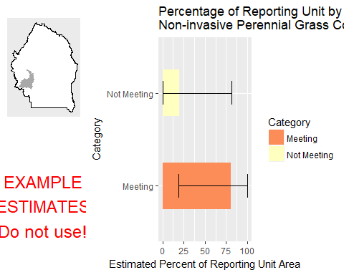

This graph shows the estimated percentage of the reporting unit in different categories for the specified indicator. 80% confidence intervals around those estimates are provided as error bars. The yellow bar denotes the landscape criterion, or point at which an objective is deemed to be met or not met as defined in the Sample Design Worksheet.

#### Results Table

|  |  |  |  |  |  |
| --- | --- | --- | --- | --- | --- |
| Category | # Points | % Area Estimate | Std. Error | Lower 80% CI | Upper 80% CI |
| Meeting | 1 | 80.45 | 31.45 | 18.8 | 100 |
| Not Meeting | 1 | 19.55 | 31.45 | 0 | 81.2 |

This table gives the analysis results for the specified indicator and reporting unit, and contains the data used to create the graph above.

#### Indicator: Average Non-invasive Perennial Grass Height (cm)

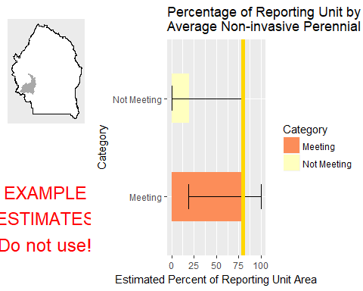

This graph shows the estimated percentage of the reporting unit in different categories for the specified indicator. 80% confidence intervals around those estimates are provided as error bars. The yellow bar denotes the landscape criterion, or point at which an objective is deemed to be met or not met as defined in the Sample Design Worksheet.

#### Results Table

|  |  |  |  |  |  |
| --- | --- | --- | --- | --- | --- |
| Category | # Points | % Area Estimate | Std. Error | Lower 80% CI | Upper 80% CI |
| Meeting | 1 | 80.45 | 31.45 | 18.8 | 100 |
| Not Meeting | 1 | 19.55 | 31.45 | 0 | 81.2 |

This table gives the analysis results for the specified indicator and reporting unit, and contains the data used to create the graph above.

#### Indicator: Average Sagebrush Height (cm)

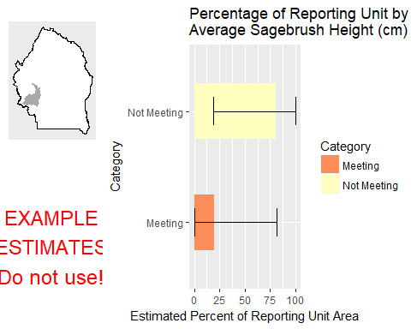

This graph shows the estimated percentage of the reporting unit in different categories for the specified indicator. 80% confidence intervals around those estimates are provided as error bars. The yellow bar denotes the landscape criterion, or point at which an objective is deemed to be met or not met as defined in the Sample Design Worksheet.

#### Results Table

|  |  |  |  |  |  |
| --- | --- | --- | --- | --- | --- |
| Category | # Points | % Area Estimate | Std. Error | Lower 80% CI | Upper 80% CI |
| Meeting | 1 | 19.55 | 31.45 | 0 | 81.2 |
| Not Meeting | 1 | 80.45 | 31.45 | 18.8 | 100 |

This table gives the analysis results for the specified indicator and reporting unit, and contains the data used to create the graph above.

#### Management Question: Land Health Standard: Watershed

#### Indicator: Percent in Gaps 101-200 cm

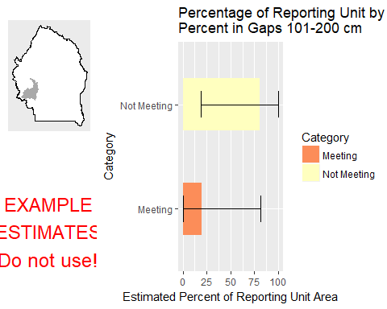

This graph shows the estimated percentage of the reporting unit in different categories for the specified indicator. 80% confidence intervals around those estimates are provided as error bars. The yellow bar denotes the landscape criterion, or point at which an objective is deemed to be met or not met as defined in the Sample Design Worksheet.

#### Results Table

|  |  |  |  |  |  |
| --- | --- | --- | --- | --- | --- |
| Category | # Points | % Area Estimate | Std. Error | Lower 80% CI | Upper 80% CI |
| Meeting | 1 | 19.55 | 31.45 | 0 | 81.2 |
| Not Meeting | 1 | 80.45 | 31.45 | 18.8 | 100 |

This table gives the analysis results for the specified indicator and reporting unit, and contains the data used to create the graph above.

#### Indicator: Percent in Gaps > 200 cm

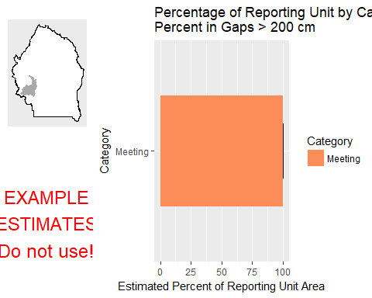

This graph shows the estimated percentage of the reporting unit in different categories for the specified indicator. 80% confidence intervals around those estimates are provided as error bars. The yellow bar denotes the landscape criterion, or point at which an objective is deemed to be met or not met as defined in the Sample Design Worksheet.

#### Results Table

|  |  |  |  |  |  |
| --- | --- | --- | --- | --- | --- |
| Category | # Points | % Area Estimate | Std. Error | Lower 80% CI | Upper 80% CI |
| Meeting | 2 | 100 | 0 | 100 | 100 |

This table gives the analysis results for the specified indicator and reporting unit, and contains the data used to create the graph above.

#### Indicator: Percent in Gaps 51-100 cm

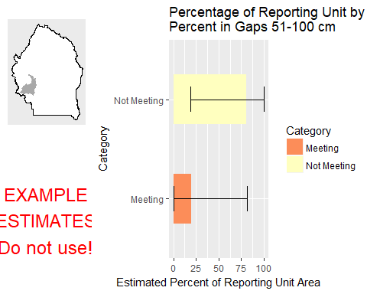

This graph shows the estimated percentage of the reporting unit in different categories for the specified indicator. 80% confidence intervals around those estimates are provided as error bars. The yellow bar denotes the landscape criterion, or point at which an objective is deemed to be met or not met as defined in the Sample Design Worksheet.

#### Results Table

|  |  |  |  |  |  |
| --- | --- | --- | --- | --- | --- |
| Category | # Points | % Area Estimate | Std. Error | Lower 80% CI | Upper 80% CI |
| Meeting | 1 | 19.55 | 31.45 | 0 | 81.2 |
| Not Meeting | 1 | 80.45 | 31.45 | 18.8 | 100 |

This table gives the analysis results for the specified indicator and reporting unit, and contains the data used to create the graph above.

#### Indicator: Overall Soil Stability Rating

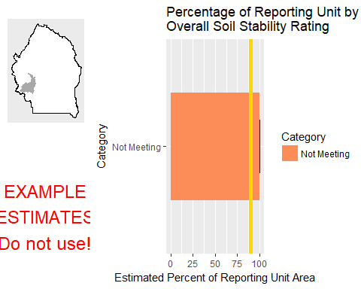

This graph shows the estimated percentage of the reporting unit in different categories for the specified indicator. 80% confidence intervals around those estimates are provided as error bars. The yellow bar denotes the landscape criterion, or point at which an objective is deemed to be met or not met as defined in the Sample Design Worksheet.

#### Results Table

|  |  |  |  |  |  |
| --- | --- | --- | --- | --- | --- |
| Category | # Points | % Area Estimate | Std. Error | Lower 80% CI | Upper 80% CI |
| Not Meeting | 2 | 100 | 0 | 100 | 100 |

This table gives the analysis results for the specified indicator and reporting unit, and contains the data used to create the graph above.

#### Management Question: GRSG Habitat Objectives

#### Indicator: Sagebrush Cover (%, any hit)

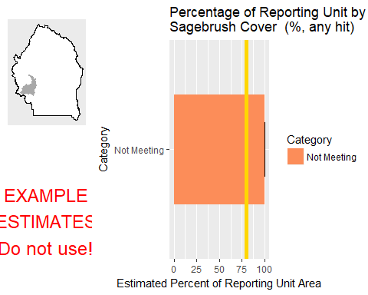

This graph shows the estimated percentage of the reporting unit in different categories for the specified indicator. 80% confidence intervals around those estimates are provided as error bars. The yellow bar denotes the landscape criterion, or point at which an objective is deemed to be met or not met as defined in the Sample Design Worksheet.

#### Results Table

|  |  |  |  |  |  |
| --- | --- | --- | --- | --- | --- |
| Category | # Points | % Area Estimate | Std. Error | Lower 80% CI | Upper 80% CI |
| Not Meeting | 2 | 100 | 0 | 100 | 100 |

This table gives the analysis results for the specified indicator and reporting unit, and contains the data used to create the graph above.

#### Management Question: Land Health Standard: Soils

#### Indicator: Percent in Gaps 101-200 cm



This graph shows the estimated percentage of the reporting unit in different categories for the specified indicator. 80% confidence intervals around those estimates are provided as error bars. The yellow bar denotes the landscape criterion, or point at which an objective is deemed to be met or not met as defined in the Sample Design Worksheet.

#### Results Table

|  |  |  |  |  |  |
| --- | --- | --- | --- | --- | --- |
| Category | # Points | % Area Estimate | Std. Error | Lower 80% CI | Upper 80% CI |
| Meeting | 1 | 19.55 | 31.45 | 0 | 81.2 |
| Not Meeting | 1 | 80.45 | 31.45 | 18.8 | 100 |

This table gives the analysis results for the specified indicator and reporting unit, and contains the data used to create the graph above.

#### Indicator: Percent in Gaps > 200 cm



This graph shows the estimated percentage of the reporting unit in different categories for the specified indicator. 80% confidence intervals around those estimates are provided as error bars. The yellow bar denotes the landscape criterion, or point at which an objective is deemed to be met or not met as defined in the Sample Design Worksheet.

#### Results Table

|  |  |  |  |  |  |
| --- | --- | --- | --- | --- | --- |
| Category | # Points | % Area Estimate | Std. Error | Lower 80% CI | Upper 80% CI |
| Meeting | 2 | 100 | 0 | 100 | 100 |

This table gives the analysis results for the specified indicator and reporting unit, and contains the data used to create the graph above.

#### Indicator: Percent in Gaps 51-100 cm



This graph shows the estimated percentage of the reporting unit in different categories for the specified indicator. 80% confidence intervals around those estimates are provided as error bars. The yellow bar denotes the landscape criterion, or point at which an objective is deemed to be met or not met as defined in the Sample Design Worksheet.

#### Results Table

|  |  |  |  |  |  |
| --- | --- | --- | --- | --- | --- |
| Category | # Points | % Area Estimate | Std. Error | Lower 80% CI | Upper 80% CI |
| Meeting | 1 | 19.55 | 31.45 | 0 | 81.2 |
| Not Meeting | 1 | 80.45 | 31.45 | 18.8 | 100 |

This table gives the analysis results for the specified indicator and reporting unit, and contains the data used to create the graph above.

#### Indicator: Overall Soil Stability Rating



This graph shows the estimated percentage of the reporting unit in different categories for the specified indicator. 80% confidence intervals around those estimates are provided as error bars. The yellow bar denotes the landscape criterion, or point at which an objective is deemed to be met or not met as defined in the Sample Design Worksheet.

#### Results Table

|  |  |  |  |  |  |
| --- | --- | --- | --- | --- | --- |
| Category | # Points | % Area Estimate | Std. Error | Lower 80% CI | Upper 80% CI |
| Not Meeting | 2 | 100 | 0 | 100 | 100 |

This table gives the analysis results for the specified indicator and reporting unit, and contains the data used to create the graph above.

#### Management Question: Land Health Standard: Biotic Integrity

#### Indicator: Invasive Annual Grass Cover (%, any hit)

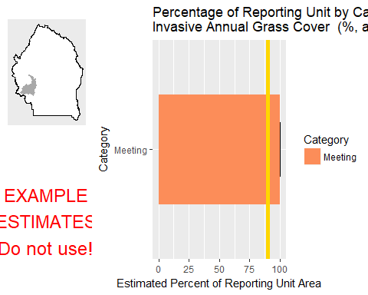

This graph shows the estimated percentage of the reporting unit in different categories for the specified indicator. 80% confidence intervals around those estimates are provided as error bars. The yellow bar denotes the landscape criterion, or point at which an objective is deemed to be met or not met as defined in the Sample Design Worksheet.

#### Results Table

|  |  |  |  |  |  |
| --- | --- | --- | --- | --- | --- |
| Category | # Points | % Area Estimate | Std. Error | Lower 80% CI | Upper 80% CI |
| Meeting | 2 | 100 | 0 | 100 | 100 |

This table gives the analysis results for the specified indicator and reporting unit, and contains the data used to create the graph above.

#### Management Question: Land Health Standard: Native Plants

#### Indicator: Non-invasive Perennial Grass Cover (%, any hit)



This graph shows the estimated percentage of the reporting unit in different categories for the specified indicator. 80% confidence intervals around those estimates are provided as error bars. The yellow bar denotes the landscape criterion, or point at which an objective is deemed to be met or not met as defined in the Sample Design Worksheet.

#### Results Table

|  |  |  |  |  |  |
| --- | --- | --- | --- | --- | --- |
| Category | # Points | % Area Estimate | Std. Error | Lower 80% CI | Upper 80% CI |
| Meeting | 1 | 80.45 | 31.45 | 18.8 | 100 |
| Not Meeting | 1 | 19.55 | 31.45 | 0 | 81.2 |

This table gives the analysis results for the specified indicator and reporting unit, and contains the data used to create the graph above.

#### Indicator: Average Non-invasive Perennial Grass Height (cm)



This graph shows the estimated percentage of the reporting unit in different categories for the specified indicator. 80% confidence intervals around those estimates are provided as error bars. The yellow bar denotes the landscape criterion, or point at which an objective is deemed to be met or not met as defined in the Sample Design Worksheet.

#### Results Table

|  |  |  |  |  |  |
| --- | --- | --- | --- | --- | --- |
| Category | # Points | % Area Estimate | Std. Error | Lower 80% CI | Upper 80% CI |
| Meeting | 1 | 80.45 | 31.45 | 18.8 | 100 |
| Not Meeting | 1 | 19.55 | 31.45 | 0 | 81.2 |

This table gives the analysis results for the specified indicator and reporting unit, and contains the data used to create the graph above.

### Watershed : Lower Sheep Creek

#### Management Question: Land Health Standard: Wildlife

#### Indicator: Non-invasive Perennial Grass Cover (%, any hit)

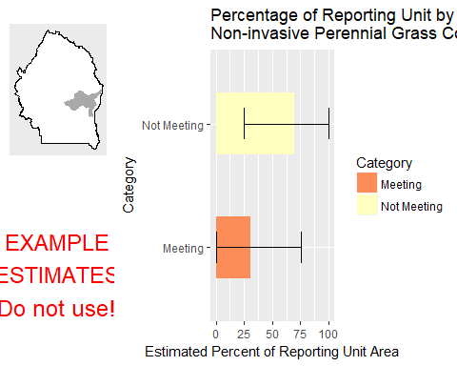

This graph shows the estimated percentage of the reporting unit in different categories for the specified indicator. 80% confidence intervals around those estimates are provided as error bars. The yellow bar denotes the landscape criterion, or point at which an objective is deemed to be met or not met as defined in the Sample Design Worksheet.

#### Results Table

|  |  |  |  |  |  |
| --- | --- | --- | --- | --- | --- |
| Category | # Points | % Area Estimate | Std. Error | Lower 80% CI | Upper 80% CI |
| Meeting | 1 | 30.5 | 22.74 | 0 | 75.06 |
| Not Meeting | 3 | 69.5 | 22.74 | 24.94 | 100 |

This table gives the analysis results for the specified indicator and reporting unit, and contains the data used to create the graph above.

#### Indicator: Average Non-invasive Perennial Grass Height (cm)

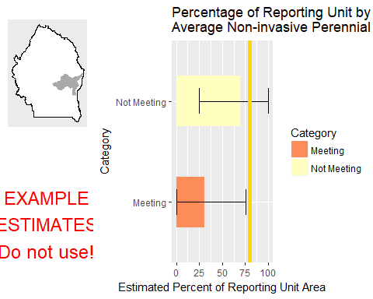

This graph shows the estimated percentage of the reporting unit in different categories for the specified indicator. 80% confidence intervals around those estimates are provided as error bars. The yellow bar denotes the landscape criterion, or point at which an objective is deemed to be met or not met as defined in the Sample Design Worksheet.

#### Results Table

|  |  |  |  |  |  |
| --- | --- | --- | --- | --- | --- |
| Category | # Points | % Area Estimate | Std. Error | Lower 80% CI | Upper 80% CI |
| Meeting | 1 | 30.5 | 22.74 | 0 | 75.06 |
| Not Meeting | 3 | 69.5 | 22.74 | 24.94 | 100 |

This table gives the analysis results for the specified indicator and reporting unit, and contains the data used to create the graph above.

#### Indicator: Average Sagebrush Height (cm)

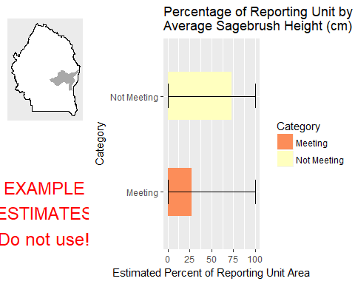

This graph shows the estimated percentage of the reporting unit in different categories for the specified indicator. 80% confidence intervals around those estimates are provided as error bars. The yellow bar denotes the landscape criterion, or point at which an objective is deemed to be met or not met as defined in the Sample Design Worksheet.

#### Results Table

|  |  |  |  |  |  |
| --- | --- | --- | --- | --- | --- |
| Category | # Points | % Area Estimate | Std. Error | Lower 80% CI | Upper 80% CI |
| Meeting | 1 | 27.22 | 39.62 | 0 | 100 |
| Not Meeting | 1 | 72.78 | 39.62 | 0 | 100 |

This table gives the analysis results for the specified indicator and reporting unit, and contains the data used to create the graph above.

#### Management Question: Land Health Standard: Watershed

#### Indicator: Percent in Gaps 101-200 cm

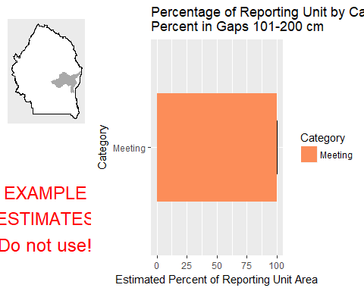

This graph shows the estimated percentage of the reporting unit in different categories for the specified indicator. 80% confidence intervals around those estimates are provided as error bars. The yellow bar denotes the landscape criterion, or point at which an objective is deemed to be met or not met as defined in the Sample Design Worksheet.

#### Results Table

|  |  |  |  |  |  |
| --- | --- | --- | --- | --- | --- |
| Category | # Points | % Area Estimate | Std. Error | Lower 80% CI | Upper 80% CI |
| Meeting | 4 | 100 | 0 | 100 | 100 |

This table gives the analysis results for the specified indicator and reporting unit, and contains the data used to create the graph above.

#### Indicator: Percent in Gaps > 200 cm

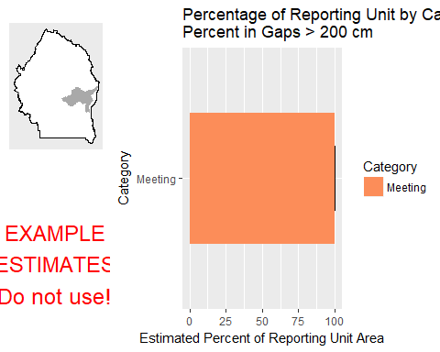

This graph shows the estimated percentage of the reporting unit in different categories for the specified indicator. 80% confidence intervals around those estimates are provided as error bars. The yellow bar denotes the landscape criterion, or point at which an objective is deemed to be met or not met as defined in the Sample Design Worksheet.

#### Results Table

|  |  |  |  |  |  |
| --- | --- | --- | --- | --- | --- |
| Category | # Points | % Area Estimate | Std. Error | Lower 80% CI | Upper 80% CI |
| Meeting | 4 | 100 | 0 | 100 | 100 |

This table gives the analysis results for the specified indicator and reporting unit, and contains the data used to create the graph above.

#### Indicator: Percent in Gaps 51-100 cm

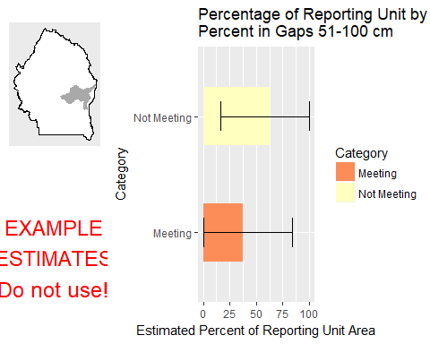

This graph shows the estimated percentage of the reporting unit in different categories for the specified indicator. 80% confidence intervals around those estimates are provided as error bars. The yellow bar denotes the landscape criterion, or point at which an objective is deemed to be met or not met as defined in the Sample Design Worksheet.

#### Results Table

|  |  |  |  |  |  |
| --- | --- | --- | --- | --- | --- |
| Category | # Points | % Area Estimate | Std. Error | Lower 80% CI | Upper 80% CI |
| Meeting | 1 | 37.11 | 23.95 | 0 | 84.06 |
| Not Meeting | 3 | 62.89 | 23.95 | 15.94 | 100 |

This table gives the analysis results for the specified indicator and reporting unit, and contains the data used to create the graph above.

#### Indicator: Overall Soil Stability Rating

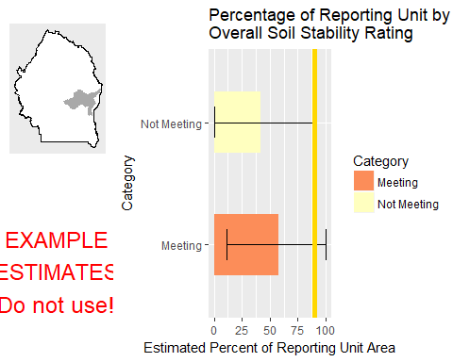

This graph shows the estimated percentage of the reporting unit in different categories for the specified indicator. 80% confidence intervals around those estimates are provided as error bars. The yellow bar denotes the landscape criterion, or point at which an objective is deemed to be met or not met as defined in the Sample Design Worksheet.

#### Results Table

|  |  |  |  |  |  |
| --- | --- | --- | --- | --- | --- |
| Category | # Points | % Area Estimate | Std. Error | Lower 80% CI | Upper 80% CI |
| Meeting | 2 | 58.09 | 23.95 | 11.16 | 100 |
| Not Meeting | 2 | 41.91 | 23.95 | 0 | 88.84 |

This table gives the analysis results for the specified indicator and reporting unit, and contains the data used to create the graph above.

#### Management Question: GRSG Habitat Objectives

#### Indicator: Sagebrush Cover (%, any hit)

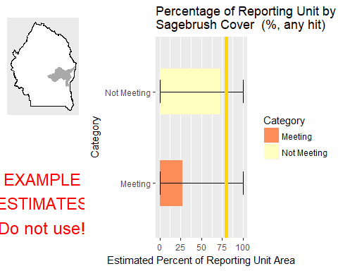

This graph shows the estimated percentage of the reporting unit in different categories for the specified indicator. 80% confidence intervals around those estimates are provided as error bars. The yellow bar denotes the landscape criterion, or point at which an objective is deemed to be met or not met as defined in the Sample Design Worksheet.

#### Results Table

|  |  |  |  |  |  |
| --- | --- | --- | --- | --- | --- |
| Category | # Points | % Area Estimate | Std. Error | Lower 80% CI | Upper 80% CI |
| Meeting | 1 | 27.22 | 39.62 | 0 | 100 |
| Not Meeting | 1 | 72.78 | 39.62 | 0 | 100 |

This table gives the analysis results for the specified indicator and reporting unit, and contains the data used to create the graph above.

#### Management Question: Land Health Standard: Soils

#### Indicator: Percent in Gaps 101-200 cm



This graph shows the estimated percentage of the reporting unit in different categories for the specified indicator. 80% confidence intervals around those estimates are provided as error bars. The yellow bar denotes the landscape criterion, or point at which an objective is deemed to be met or not met as defined in the Sample Design Worksheet.

#### Results Table

|  |  |  |  |  |  |
| --- | --- | --- | --- | --- | --- |
| Category | # Points | % Area Estimate | Std. Error | Lower 80% CI | Upper 80% CI |
| Meeting | 4 | 100 | 0 | 100 | 100 |

This table gives the analysis results for the specified indicator and reporting unit, and contains the data used to create the graph above.

#### Indicator: Percent in Gaps > 200 cm



This graph shows the estimated percentage of the reporting unit in different categories for the specified indicator. 80% confidence intervals around those estimates are provided as error bars. The yellow bar denotes the landscape criterion, or point at which an objective is deemed to be met or not met as defined in the Sample Design Worksheet.

#### Results Table

|  |  |  |  |  |  |
| --- | --- | --- | --- | --- | --- |
| Category | # Points | % Area Estimate | Std. Error | Lower 80% CI | Upper 80% CI |
| Meeting | 4 | 100 | 0 | 100 | 100 |

This table gives the analysis results for the specified indicator and reporting unit, and contains the data used to create the graph above.

#### Indicator: Percent in Gaps 51-100 cm



This graph shows the estimated percentage of the reporting unit in different categories for the specified indicator. 80% confidence intervals around those estimates are provided as error bars. The yellow bar denotes the landscape criterion, or point at which an objective is deemed to be met or not met as defined in the Sample Design Worksheet.

#### Results Table

|  |  |  |  |  |  |
| --- | --- | --- | --- | --- | --- |
| Category | # Points | % Area Estimate | Std. Error | Lower 80% CI | Upper 80% CI |
| Meeting | 1 | 37.11 | 23.95 | 0 | 84.06 |
| Not Meeting | 3 | 62.89 | 23.95 | 15.94 | 100 |

This table gives the analysis results for the specified indicator and reporting unit, and contains the data used to create the graph above.

#### Indicator: Overall Soil Stability Rating



This graph shows the estimated percentage of the reporting unit in different categories for the specified indicator. 80% confidence intervals around those estimates are provided as error bars. The yellow bar denotes the landscape criterion, or point at which an objective is deemed to be met or not met as defined in the Sample Design Worksheet.

#### Results Table

|  |  |  |  |  |  |
| --- | --- | --- | --- | --- | --- |
| Category | # Points | % Area Estimate | Std. Error | Lower 80% CI | Upper 80% CI |
| Meeting | 2 | 58.09 | 23.95 | 11.16 | 100 |
| Not Meeting | 2 | 41.91 | 23.95 | 0 | 88.84 |

This table gives the analysis results for the specified indicator and reporting unit, and contains the data used to create the graph above.

#### Management Question: Land Health Standard: Biotic Integrity

#### Indicator: Invasive Annual Grass Cover (%, any hit)

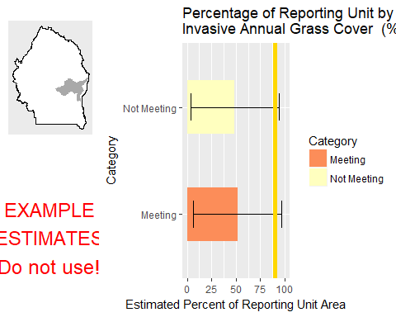

This graph shows the estimated percentage of the reporting unit in different categories for the specified indicator. 80% confidence intervals around those estimates are provided as error bars. The yellow bar denotes the landscape criterion, or point at which an objective is deemed to be met or not met as defined in the Sample Design Worksheet.

#### Results Table

|  |  |  |  |  |  |
| --- | --- | --- | --- | --- | --- |
| Category | # Points | % Area Estimate | Std. Error | Lower 80% CI | Upper 80% CI |
| Meeting | 2 | 51.48 | 23.07 | 6.27 | 96.7 |
| Not Meeting | 2 | 48.52 | 23.07 | 3.3 | 93.73 |

This table gives the analysis results for the specified indicator and reporting unit, and contains the data used to create the graph above.

#### Management Question: Land Health Standard: Native Plants

#### Indicator: Non-invasive Perennial Grass Cover (%, any hit)



This graph shows the estimated percentage of the reporting unit in different categories for the specified indicator. 80% confidence intervals around those estimates are provided as error bars. The yellow bar denotes the landscape criterion, or point at which an objective is deemed to be met or not met as defined in the Sample Design Worksheet.

#### Results Table

|  |  |  |  |  |  |
| --- | --- | --- | --- | --- | --- |
| Category | # Points | % Area Estimate | Std. Error | Lower 80% CI | Upper 80% CI |
| Meeting | 1 | 30.5 | 22.74 | 0 | 75.06 |
| Not Meeting | 3 | 69.5 | 22.74 | 24.94 | 100 |

This table gives the analysis results for the specified indicator and reporting unit, and contains the data used to create the graph above.

#### Indicator: Average Non-invasive Perennial Grass Height (cm)



This graph shows the estimated percentage of the reporting unit in different categories for the specified indicator. 80% confidence intervals around those estimates are provided as error bars. The yellow bar denotes the landscape criterion, or point at which an objective is deemed to be met or not met as defined in the Sample Design Worksheet.

#### Results Table

|  |  |  |  |  |  |
| --- | --- | --- | --- | --- | --- |
| Category | # Points | % Area Estimate | Std. Error | Lower 80% CI | Upper 80% CI |
| Meeting | 1 | 30.5 | 22.74 | 0 | 75.06 |
| Not Meeting | 3 | 69.5 | 22.74 | 24.94 | 100 |

This table gives the analysis results for the specified indicator and reporting unit, and contains the data used to create the graph above.

### Watershed : Marys Creek

#### Management Question: Land Health Standard: Wildlife

#### Indicator: Non-invasive Perennial Grass Cover (%, any hit)

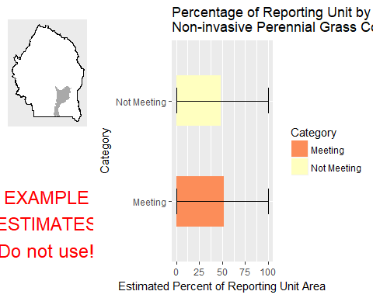

This graph shows the estimated percentage of the reporting unit in different categories for the specified indicator. 80% confidence intervals around those estimates are provided as error bars. The yellow bar denotes the landscape criterion, or point at which an objective is deemed to be met or not met as defined in the Sample Design Worksheet.

#### Results Table

|  |  |  |  |  |  |
| --- | --- | --- | --- | --- | --- |
| Category | # Points | % Area Estimate | Std. Error | Lower 80% CI | Upper 80% CI |
| Meeting | 1 | 51.69 | 49.94 | 0 | 100 |
| Not Meeting | 1 | 48.31 | 49.94 | 0 | 100 |

This table gives the analysis results for the specified indicator and reporting unit, and contains the data used to create the graph above.

#### Indicator: Average Non-invasive Perennial Grass Height (cm)

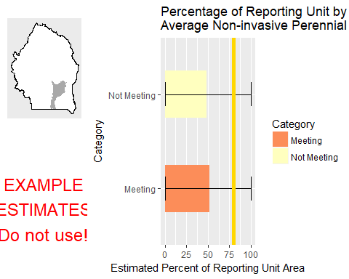

This graph shows the estimated percentage of the reporting unit in different categories for the specified indicator. 80% confidence intervals around those estimates are provided as error bars. The yellow bar denotes the landscape criterion, or point at which an objective is deemed to be met or not met as defined in the Sample Design Worksheet.

#### Results Table

|  |  |  |  |  |  |
| --- | --- | --- | --- | --- | --- |
| Category | # Points | % Area Estimate | Std. Error | Lower 80% CI | Upper 80% CI |
| Meeting | 1 | 51.69 | 49.94 | 0 | 100 |
| Not Meeting | 1 | 48.31 | 49.94 | 0 | 100 |

This table gives the analysis results for the specified indicator and reporting unit, and contains the data used to create the graph above.

#### Management Question: Land Health Standard: Watershed

#### Indicator: Percent in Gaps 101-200 cm

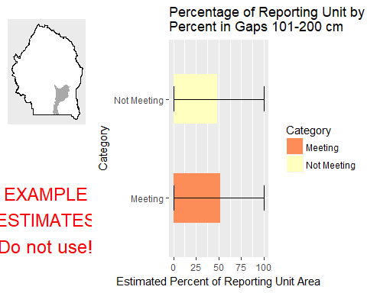

This graph shows the estimated percentage of the reporting unit in different categories for the specified indicator. 80% confidence intervals around those estimates are provided as error bars. The yellow bar denotes the landscape criterion, or point at which an objective is deemed to be met or not met as defined in the Sample Design Worksheet.

#### Results Table

|  |  |  |  |  |  |
| --- | --- | --- | --- | --- | --- |
| Category | # Points | % Area Estimate | Std. Error | Lower 80% CI | Upper 80% CI |
| Meeting | 1 | 51.69 | 49.94 | 0 | 100 |
| Not Meeting | 1 | 48.31 | 49.94 | 0 | 100 |

This table gives the analysis results for the specified indicator and reporting unit, and contains the data used to create the graph above.

#### Indicator: Percent in Gaps > 200 cm

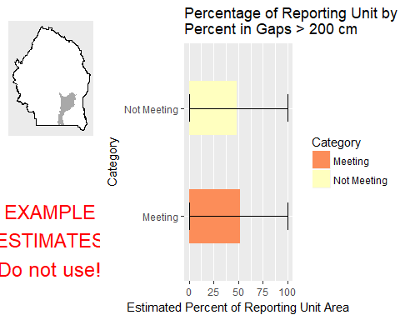

This graph shows the estimated percentage of the reporting unit in different categories for the specified indicator. 80% confidence intervals around those estimates are provided as error bars. The yellow bar denotes the landscape criterion, or point at which an objective is deemed to be met or not met as defined in the Sample Design Worksheet.

#### Results Table

|  |  |  |  |  |  |
| --- | --- | --- | --- | --- | --- |
| Category | # Points | % Area Estimate | Std. Error | Lower 80% CI | Upper 80% CI |
| Meeting | 1 | 51.69 | 49.94 | 0 | 100 |
| Not Meeting | 1 | 48.31 | 49.94 | 0 | 100 |

This table gives the analysis results for the specified indicator and reporting unit, and contains the data used to create the graph above.

#### Indicator: Percent in Gaps 51-100 cm

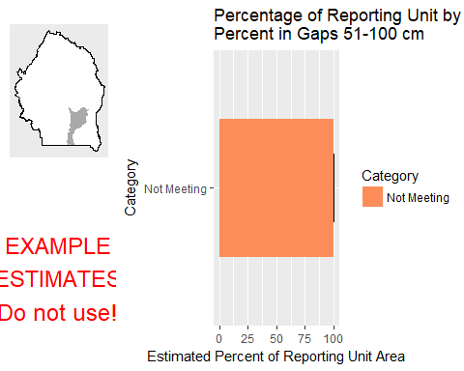

This graph shows the estimated percentage of the reporting unit in different categories for the specified indicator. 80% confidence intervals around those estimates are provided as error bars. The yellow bar denotes the landscape criterion, or point at which an objective is deemed to be met or not met as defined in the Sample Design Worksheet.

#### Results Table

|  |  |  |  |  |  |
| --- | --- | --- | --- | --- | --- |
| Category | # Points | % Area Estimate | Std. Error | Lower 80% CI | Upper 80% CI |
| Not Meeting | 2 | 100 | 0 | 100 | 100 |

This table gives the analysis results for the specified indicator and reporting unit, and contains the data used to create the graph above.

#### Indicator: Overall Soil Stability Rating

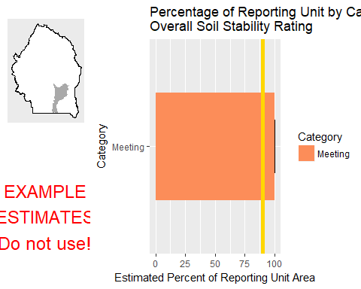

This graph shows the estimated percentage of the reporting unit in different categories for the specified indicator. 80% confidence intervals around those estimates are provided as error bars. The yellow bar denotes the landscape criterion, or point at which an objective is deemed to be met or not met as defined in the Sample Design Worksheet.

#### Results Table

|  |  |  |  |  |  |
| --- | --- | --- | --- | --- | --- |
| Category | # Points | % Area Estimate | Std. Error | Lower 80% CI | Upper 80% CI |
| Meeting | 2 | 100 | 0 | 100 | 100 |

This table gives the analysis results for the specified indicator and reporting unit, and contains the data used to create the graph above.

#### Management Question: Land Health Standard: Soils

#### Indicator: Percent in Gaps 101-200 cm



This graph shows the estimated percentage of the reporting unit in different categories for the specified indicator. 80% confidence intervals around those estimates are provided as error bars. The yellow bar denotes the landscape criterion, or point at which an objective is deemed to be met or not met as defined in the Sample Design Worksheet.

#### Results Table

|  |  |  |  |  |  |
| --- | --- | --- | --- | --- | --- |
| Category | # Points | % Area Estimate | Std. Error | Lower 80% CI | Upper 80% CI |
| Meeting | 1 | 51.69 | 49.94 | 0 | 100 |
| Not Meeting | 1 | 48.31 | 49.94 | 0 | 100 |

This table gives the analysis results for the specified indicator and reporting unit, and contains the data used to create the graph above.

#### Indicator: Percent in Gaps > 200 cm



This graph shows the estimated percentage of the reporting unit in different categories for the specified indicator. 80% confidence intervals around those estimates are provided as error bars. The yellow bar denotes the landscape criterion, or point at which an objective is deemed to be met or not met as defined in the Sample Design Worksheet.

#### Results Table

|  |  |  |  |  |  |
| --- | --- | --- | --- | --- | --- |
| Category | # Points | % Area Estimate | Std. Error | Lower 80% CI | Upper 80% CI |
| Meeting | 1 | 51.69 | 49.94 | 0 | 100 |
| Not Meeting | 1 | 48.31 | 49.94 | 0 | 100 |

This table gives the analysis results for the specified indicator and reporting unit, and contains the data used to create the graph above.

#### Indicator: Percent in Gaps 51-100 cm



This graph shows the estimated percentage of the reporting unit in different categories for the specified indicator. 80% confidence intervals around those estimates are provided as error bars. The yellow bar denotes the landscape criterion, or point at which an objective is deemed to be met or not met as defined in the Sample Design Worksheet.

#### Results Table

|  |  |  |  |  |  |
| --- | --- | --- | --- | --- | --- |
| Category | # Points | % Area Estimate | Std. Error | Lower 80% CI | Upper 80% CI |
| Not Meeting | 2 | 100 | 0 | 100 | 100 |

This table gives the analysis results for the specified indicator and reporting unit, and contains the data used to create the graph above.

#### Indicator: Overall Soil Stability Rating



This graph shows the estimated percentage of the reporting unit in different categories for the specified indicator. 80% confidence intervals around those estimates are provided as error bars. The yellow bar denotes the landscape criterion, or point at which an objective is deemed to be met or not met as defined in the Sample Design Worksheet.

#### Results Table

|  |  |  |  |  |  |
| --- | --- | --- | --- | --- | --- |
| Category | # Points | % Area Estimate | Std. Error | Lower 80% CI | Upper 80% CI |
| Meeting | 2 | 100 | 0 | 100 | 100 |

This table gives the analysis results for the specified indicator and reporting unit, and contains the data used to create the graph above.

#### Management Question: Land Health Standard: Biotic Integrity

#### Indicator: Invasive Annual Grass Cover (%, any hit)

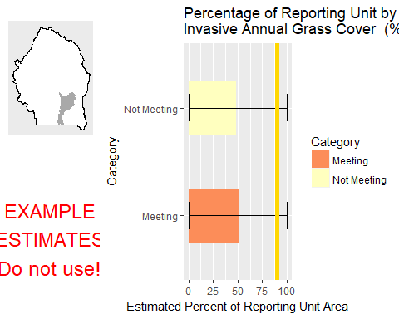

This graph shows the estimated percentage of the reporting unit in different categories for the specified indicator. 80% confidence intervals around those estimates are provided as error bars. The yellow bar denotes the landscape criterion, or point at which an objective is deemed to be met or not met as defined in the Sample Design Worksheet.

#### Results Table

|  |  |  |  |  |  |
| --- | --- | --- | --- | --- | --- |
| Category | # Points | % Area Estimate | Std. Error | Lower 80% CI | Upper 80% CI |
| Meeting | 1 | 51.69 | 49.94 | 0 | 100 |
| Not Meeting | 1 | 48.31 | 49.94 | 0 | 100 |

This table gives the analysis results for the specified indicator and reporting unit, and contains the data used to create the graph above.

#### Management Question: Land Health Standard: Native Plants

#### Indicator: Non-invasive Perennial Grass Cover (%, any hit)



This graph shows the estimated percentage of the reporting unit in different categories for the specified indicator. 80% confidence intervals around those estimates are provided as error bars. The yellow bar denotes the landscape criterion, or point at which an objective is deemed to be met or not met as defined in the Sample Design Worksheet.

#### Results Table

|  |  |  |  |  |  |
| --- | --- | --- | --- | --- | --- |
| Category | # Points | % Area Estimate | Std. Error | Lower 80% CI | Upper 80% CI |
| Meeting | 1 | 51.69 | 49.94 | 0 | 100 |
| Not Meeting | 1 | 48.31 | 49.94 | 0 | 100 |

This table gives the analysis results for the specified indicator and reporting unit, and contains the data used to create the graph above.

#### Indicator: Average Non-invasive Perennial Grass Height (cm)



This graph shows the estimated percentage of the reporting unit in different categories for the specified indicator. 80% confidence intervals around those estimates are provided as error bars. The yellow bar denotes the landscape criterion, or point at which an objective is deemed to be met or not met as defined in the Sample Design Worksheet.

#### Results Table

|  |  |  |  |  |  |
| --- | --- | --- | --- | --- | --- |
| Category | # Points | % Area Estimate | Std. Error | Lower 80% CI | Upper 80% CI |
| Meeting | 1 | 51.69 | 49.94 | 0 | 100 |
| Not Meeting | 1 | 48.31 | 49.94 | 0 | 100 |

This table gives the analysis results for the specified indicator and reporting unit, and contains the data used to create the graph above.

### Watershed : McDonald Creek-Bruneau River

#### Management Question: Land Health Standard: Wildlife

#### Indicator: Non-invasive Perennial Grass Cover (%, any hit)

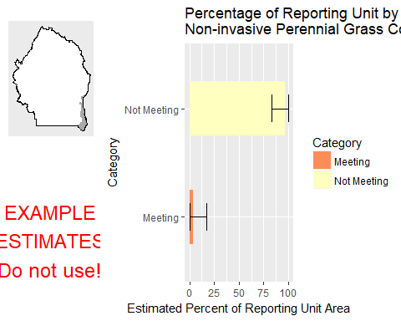

This graph shows the estimated percentage of the reporting unit in different categories for the specified indicator. 80% confidence intervals around those estimates are provided as error bars. The yellow bar denotes the landscape criterion, or point at which an objective is deemed to be met or not met as defined in the Sample Design Worksheet.

#### Results Table

|  |  |  |  |  |  |
| --- | --- | --- | --- | --- | --- |
| Category | # Points | % Area Estimate | Std. Error | Lower 80% CI | Upper 80% CI |
| Meeting | 1 | 3.519 | 6.79 | 0 | 16.83 |
| Not Meeting | 1 | 96.48 | 6.79 | 83.17 | 100 |

This table gives the analysis results for the specified indicator and reporting unit, and contains the data used to create the graph above.

#### Indicator: Average Non-invasive Perennial Grass Height (cm)

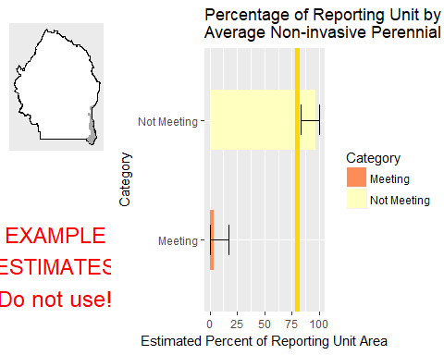

This graph shows the estimated percentage of the reporting unit in different categories for the specified indicator. 80% confidence intervals around those estimates are provided as error bars. The yellow bar denotes the landscape criterion, or point at which an objective is deemed to be met or not met as defined in the Sample Design Worksheet.

#### Results Table

|  |  |  |  |  |  |
| --- | --- | --- | --- | --- | --- |
| Category | # Points | % Area Estimate | Std. Error | Lower 80% CI | Upper 80% CI |
| Meeting | 1 | 3.519 | 6.79 | 0 | 16.83 |
| Not Meeting | 1 | 96.48 | 6.79 | 83.17 | 100 |

This table gives the analysis results for the specified indicator and reporting unit, and contains the data used to create the graph above.

#### Indicator: Average Sagebrush Height (cm)

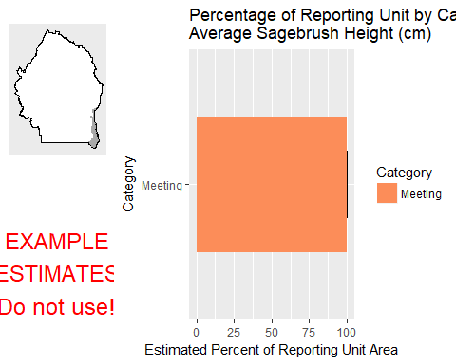

This graph shows the estimated percentage of the reporting unit in different categories for the specified indicator. 80% confidence intervals around those estimates are provided as error bars. The yellow bar denotes the landscape criterion, or point at which an objective is deemed to be met or not met as defined in the Sample Design Worksheet.

#### Results Table

|  |  |  |  |  |  |
| --- | --- | --- | --- | --- | --- |
| Category | # Points | % Area Estimate | Std. Error | Lower 80% CI | Upper 80% CI |
| Meeting | 2 | 100 | 0 | 100 | 100 |

This table gives the analysis results for the specified indicator and reporting unit, and contains the data used to create the graph above.

#### Management Question: Land Health Standard: Watershed

#### Indicator: Percent in Gaps 101-200 cm

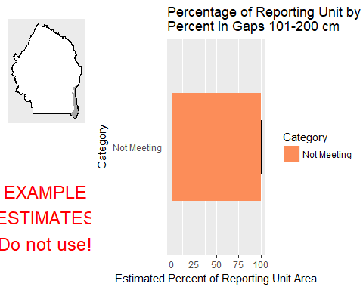

This graph shows the estimated percentage of the reporting unit in different categories for the specified indicator. 80% confidence intervals around those estimates are provided as error bars. The yellow bar denotes the landscape criterion, or point at which an objective is deemed to be met or not met as defined in the Sample Design Worksheet.

#### Results Table

|  |  |  |  |  |  |
| --- | --- | --- | --- | --- | --- |
| Category | # Points | % Area Estimate | Std. Error | Lower 80% CI | Upper 80% CI |
| Not Meeting | 2 | 100 | 0 | 100 | 100 |

This table gives the analysis results for the specified indicator and reporting unit, and contains the data used to create the graph above.

#### Indicator: Percent in Gaps > 200 cm

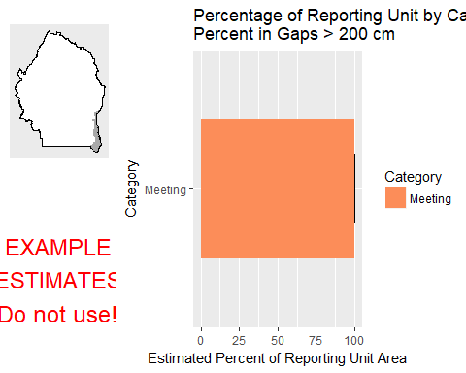

This graph shows the estimated percentage of the reporting unit in different categories for the specified indicator. 80% confidence intervals around those estimates are provided as error bars. The yellow bar denotes the landscape criterion, or point at which an objective is deemed to be met or not met as defined in the Sample Design Worksheet.

#### Results Table

|  |  |  |  |  |  |
| --- | --- | --- | --- | --- | --- |
| Category | # Points | % Area Estimate | Std. Error | Lower 80% CI | Upper 80% CI |
| Meeting | 2 | 100 | 0 | 100 | 100 |

This table gives the analysis results for the specified indicator and reporting unit, and contains the data used to create the graph above.

#### Indicator: Percent in Gaps 51-100 cm

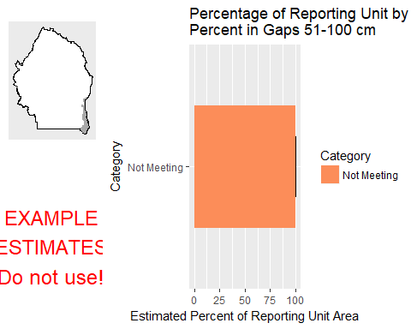

This graph shows the estimated percentage of the reporting unit in different categories for the specified indicator. 80% confidence intervals around those estimates are provided as error bars. The yellow bar denotes the landscape criterion, or point at which an objective is deemed to be met or not met as defined in the Sample Design Worksheet.

#### Results Table

|  |  |  |  |  |  |
| --- | --- | --- | --- | --- | --- |
| Category | # Points | % Area Estimate | Std. Error | Lower 80% CI | Upper 80% CI |
| Not Meeting | 2 | 100 | 0 | 100 | 100 |

This table gives the analysis results for the specified indicator and reporting unit, and contains the data used to create the graph above.

#### Indicator: Overall Soil Stability Rating

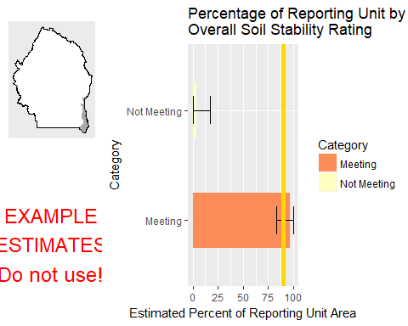

This graph shows the estimated percentage of the reporting unit in different categories for the specified indicator. 80% confidence intervals around those estimates are provided as error bars. The yellow bar denotes the landscape criterion, or point at which an objective is deemed to be met or not met as defined in the Sample Design Worksheet.

#### Results Table

|  |  |  |  |  |  |
| --- | --- | --- | --- | --- | --- |
| Category | # Points | % Area Estimate | Std. Error | Lower 80% CI | Upper 80% CI |
| Meeting | 1 | 96.48 | 6.79 | 83.17 | 100 |
| Not Meeting | 1 | 3.519 | 6.79 | 0 | 16.83 |

This table gives the analysis results for the specified indicator and reporting unit, and contains the data used to create the graph above.

#### Management Question: GRSG Habitat Objectives

#### Indicator: Sagebrush Cover (%, any hit)

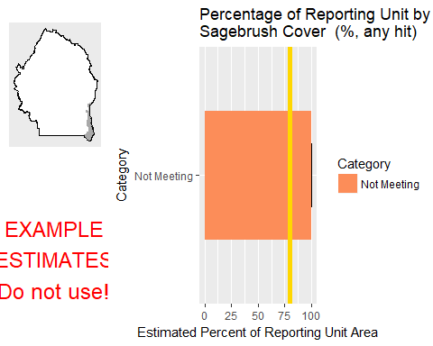

This graph shows the estimated percentage of the reporting unit in different categories for the specified indicator. 80% confidence intervals around those estimates are provided as error bars. The yellow bar denotes the landscape criterion, or point at which an objective is deemed to be met or not met as defined in the Sample Design Worksheet.

#### Results Table

|  |  |  |  |  |  |
| --- | --- | --- | --- | --- | --- |
| Category | # Points | % Area Estimate | Std. Error | Lower 80% CI | Upper 80% CI |
| Not Meeting | 2 | 100 | 0 | 100 | 100 |

This table gives the analysis results for the specified indicator and reporting unit, and contains the data used to create the graph above.

#### Management Question: Land Health Standard: Soils

#### Indicator: Percent in Gaps 101-200 cm



This graph shows the estimated percentage of the reporting unit in different categories for the specified indicator. 80% confidence intervals around those estimates are provided as error bars. The yellow bar denotes the landscape criterion, or point at which an objective is deemed to be met or not met as defined in the Sample Design Worksheet.

#### Results Table

|  |  |  |  |  |  |
| --- | --- | --- | --- | --- | --- |
| Category | # Points | % Area Estimate | Std. Error | Lower 80% CI | Upper 80% CI |
| Not Meeting | 2 | 100 | 0 | 100 | 100 |

This table gives the analysis results for the specified indicator and reporting unit, and contains the data used to create the graph above.

#### Indicator: Percent in Gaps > 200 cm



This graph shows the estimated percentage of the reporting unit in different categories for the specified indicator. 80% confidence intervals around those estimates are provided as error bars. The yellow bar denotes the landscape criterion, or point at which an objective is deemed to be met or not met as defined in the Sample Design Worksheet.

#### Results Table

|  |  |  |  |  |  |
| --- | --- | --- | --- | --- | --- |
| Category | # Points | % Area Estimate | Std. Error | Lower 80% CI | Upper 80% CI |
| Meeting | 2 | 100 | 0 | 100 | 100 |

This table gives the analysis results for the specified indicator and reporting unit, and contains the data used to create the graph above.

#### Indicator: Percent in Gaps 51-100 cm



This graph shows the estimated percentage of the reporting unit in different categories for the specified indicator. 80% confidence intervals around those estimates are provided as error bars. The yellow bar denotes the landscape criterion, or point at which an objective is deemed to be met or not met as defined in the Sample Design Worksheet.

#### Results Table

|  |  |  |  |  |  |
| --- | --- | --- | --- | --- | --- |
| Category | # Points | % Area Estimate | Std. Error | Lower 80% CI | Upper 80% CI |
| Not Meeting | 2 | 100 | 0 | 100 | 100 |

This table gives the analysis results for the specified indicator and reporting unit, and contains the data used to create the graph above.

#### Indicator: Overall Soil Stability Rating



This graph shows the estimated percentage of the reporting unit in different categories for the specified indicator. 80% confidence intervals around those estimates are provided as error bars. The yellow bar denotes the landscape criterion, or point at which an objective is deemed to be met or not met as defined in the Sample Design Worksheet.

#### Results Table

|  |  |  |  |  |  |
| --- | --- | --- | --- | --- | --- |
| Category | # Points | % Area Estimate | Std. Error | Lower 80% CI | Upper 80% CI |
| Meeting | 1 | 96.48 | 6.79 | 83.17 | 100 |
| Not Meeting | 1 | 3.519 | 6.79 | 0 | 16.83 |

This table gives the analysis results for the specified indicator and reporting unit, and contains the data used to create the graph above.

#### Management Question: Land Health Standard: Biotic Integrity

#### Indicator: Invasive Annual Grass Cover (%, any hit)

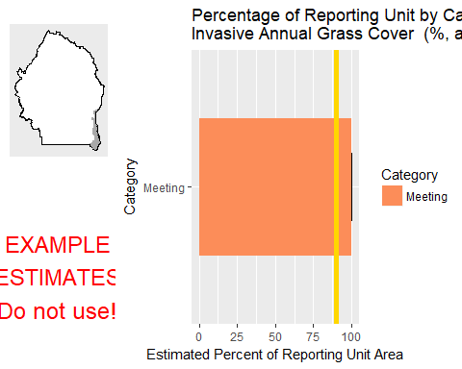

This graph shows the estimated percentage of the reporting unit in different categories for the specified indicator. 80% confidence intervals around those estimates are provided as error bars. The yellow bar denotes the landscape criterion, or point at which an objective is deemed to be met or not met as defined in the Sample Design Worksheet.

#### Results Table

|  |  |  |  |  |  |
| --- | --- | --- | --- | --- | --- |
| Category | # Points | % Area Estimate | Std. Error | Lower 80% CI | Upper 80% CI |
| Meeting | 2 | 100 | 0 | 100 | 100 |

This table gives the analysis results for the specified indicator and reporting unit, and contains the data used to create the graph above.

#### Management Question: Land Health Standard: Native Plants

#### Indicator: Non-invasive Perennial Grass Cover (%, any hit)



This graph shows the estimated percentage of the reporting unit in different categories for the specified indicator. 80% confidence intervals around those estimates are provided as error bars. The yellow bar denotes the landscape criterion, or point at which an objective is deemed to be met or not met as defined in the Sample Design Worksheet.

#### Results Table

|  |  |  |  |  |  |
| --- | --- | --- | --- | --- | --- |
| Category | # Points | % Area Estimate | Std. Error | Lower 80% CI | Upper 80% CI |
| Meeting | 1 | 3.519 | 6.79 | 0 | 16.83 |
| Not Meeting | 1 | 96.48 | 6.79 | 83.17 | 100 |

This table gives the analysis results for the specified indicator and reporting unit, and contains the data used to create the graph above.

#### Indicator: Average Non-invasive Perennial Grass Height (cm)



This graph shows the estimated percentage of the reporting unit in different categories for the specified indicator. 80% confidence intervals around those estimates are provided as error bars. The yellow bar denotes the landscape criterion, or point at which an objective is deemed to be met or not met as defined in the Sample Design Worksheet.

#### Results Table

|  |  |  |  |  |  |
| --- | --- | --- | --- | --- | --- |
| Category | # Points | % Area Estimate | Std. Error | Lower 80% CI | Upper 80% CI |
| Meeting | 1 | 3.519 | 6.79 | 0 | 16.83 |
| Not Meeting | 1 | 96.48 | 6.79 | 83.17 | 100 |

This table gives the analysis results for the specified indicator and reporting unit, and contains the data used to create the graph above.

### Watershed : Middle Blue Creek

#### Management Question: Land Health Standard: Wildlife

#### Indicator: Non-invasive Perennial Grass Cover (%, any hit)

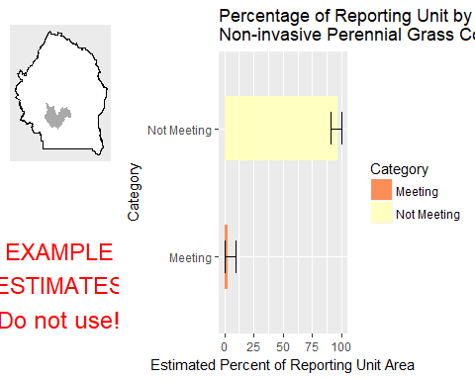

This graph shows the estimated percentage of the reporting unit in different categories for the specified indicator. 80% confidence intervals around those estimates are provided as error bars. The yellow bar denotes the landscape criterion, or point at which an objective is deemed to be met or not met as defined in the Sample Design Worksheet.

#### Results Table

|  |  |  |  |  |  |
| --- | --- | --- | --- | --- | --- |
| Category | # Points | % Area Estimate | Std. Error | Lower 80% CI | Upper 80% CI |
| Meeting | 1 | 3.159 | 3.348 | 0 | 9.722 |
| Not Meeting | 5 | 96.84 | 3.348 | 90.28 | 100 |

This table gives the analysis results for the specified indicator and reporting unit, and contains the data used to create the graph above.

#### Indicator: Average Non-invasive Perennial Grass Height (cm)

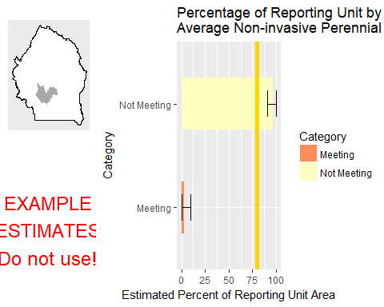

This graph shows the estimated percentage of the reporting unit in different categories for the specified indicator. 80% confidence intervals around those estimates are provided as error bars. The yellow bar denotes the landscape criterion, or point at which an objective is deemed to be met or not met as defined in the Sample Design Worksheet.

#### Results Table

|  |  |  |  |  |  |
| --- | --- | --- | --- | --- | --- |
| Category | # Points | % Area Estimate | Std. Error | Lower 80% CI | Upper 80% CI |
| Meeting | 1 | 3.159 | 3.348 | 0 | 9.722 |
| Not Meeting | 5 | 96.84 | 3.348 | 90.28 | 100 |

This table gives the analysis results for the specified indicator and reporting unit, and contains the data used to create the graph above.

#### Indicator: Average Sagebrush Height (cm)

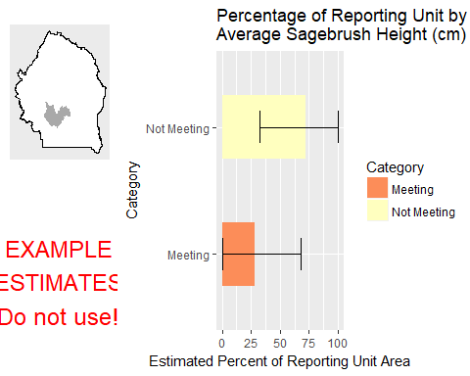

This graph shows the estimated percentage of the reporting unit in different categories for the specified indicator. 80% confidence intervals around those estimates are provided as error bars. The yellow bar denotes the landscape criterion, or point at which an objective is deemed to be met or not met as defined in the Sample Design Worksheet.

#### Results Table

|  |  |  |  |  |  |
| --- | --- | --- | --- | --- | --- |
| Category | # Points | % Area Estimate | Std. Error | Lower 80% CI | Upper 80% CI |
| Meeting | 2 | 27.94 | 20.22 | 0 | 67.57 |
| Not Meeting | 3 | 72.06 | 20.22 | 32.43 | 100 |

This table gives the analysis results for the specified indicator and reporting unit, and contains the data used to create the graph above.

#### Management Question: Land Health Standard: Watershed

#### Indicator: Percent in Gaps 101-200 cm

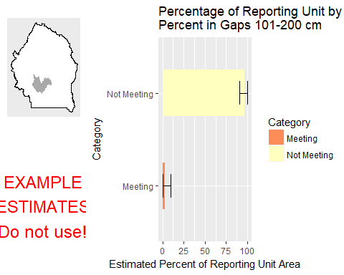

This graph shows the estimated percentage of the reporting unit in different categories for the specified indicator. 80% confidence intervals around those estimates are provided as error bars. The yellow bar denotes the landscape criterion, or point at which an objective is deemed to be met or not met as defined in the Sample Design Worksheet.

#### Results Table

|  |  |  |  |  |  |
| --- | --- | --- | --- | --- | --- |
| Category | # Points | % Area Estimate | Std. Error | Lower 80% CI | Upper 80% CI |
| Meeting | 1 | 3.159 | 3.348 | 0 | 9.722 |
| Not Meeting | 5 | 96.84 | 3.348 | 90.28 | 100 |

This table gives the analysis results for the specified indicator and reporting unit, and contains the data used to create the graph above.

#### Indicator: Percent in Gaps > 200 cm

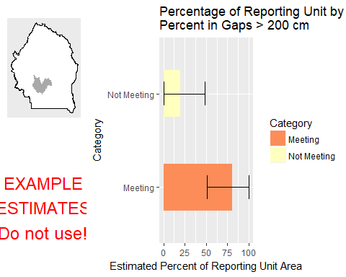

This graph shows the estimated percentage of the reporting unit in different categories for the specified indicator. 80% confidence intervals around those estimates are provided as error bars. The yellow bar denotes the landscape criterion, or point at which an objective is deemed to be met or not met as defined in the Sample Design Worksheet.

#### Results Table

|  |  |  |  |  |  |
| --- | --- | --- | --- | --- | --- |
| Category | # Points | % Area Estimate | Std. Error | Lower 80% CI | Upper 80% CI |
| Meeting | 5 | 80.63 | 15.03 | 51.18 | 100 |
| Not Meeting | 1 | 19.37 | 15.03 | 0 | 48.82 |

This table gives the analysis results for the specified indicator and reporting unit, and contains the data used to create the graph above.

#### Indicator: Percent in Gaps 51-100 cm

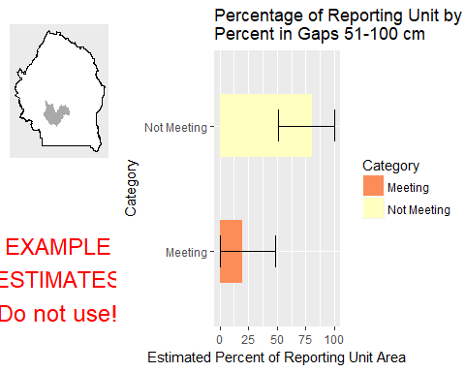

This graph shows the estimated percentage of the reporting unit in different categories for the specified indicator. 80% confidence intervals around those estimates are provided as error bars. The yellow bar denotes the landscape criterion, or point at which an objective is deemed to be met or not met as defined in the Sample Design Worksheet.

#### Results Table

|  |  |  |  |  |  |
| --- | --- | --- | --- | --- | --- |
| Category | # Points | % Area Estimate | Std. Error | Lower 80% CI | Upper 80% CI |
| Meeting | 1 | 19.37 | 15.03 | 0 | 48.82 |
| Not Meeting | 5 | 80.63 | 15.03 | 51.18 | 100 |

This table gives the analysis results for the specified indicator and reporting unit, and contains the data used to create the graph above.

#### Indicator: Overall Soil Stability Rating

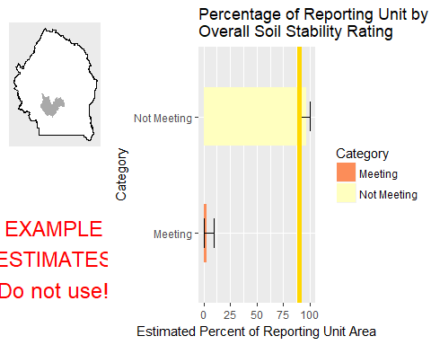

This graph shows the estimated percentage of the reporting unit in different categories for the specified indicator. 80% confidence intervals around those estimates are provided as error bars. The yellow bar denotes the landscape criterion, or point at which an objective is deemed to be met or not met as defined in the Sample Design Worksheet.

#### Results Table

|  |  |  |  |  |  |
| --- | --- | --- | --- | --- | --- |
| Category | # Points | % Area Estimate | Std. Error | Lower 80% CI | Upper 80% CI |
| Meeting | 1 | 3.159 | 3.348 | 0 | 9.722 |
| Not Meeting | 5 | 96.84 | 3.348 | 90.28 | 100 |

This table gives the analysis results for the specified indicator and reporting unit, and contains the data used to create the graph above.

#### Management Question: GRSG Habitat Objectives

#### Indicator: Sagebrush Cover (%, any hit)

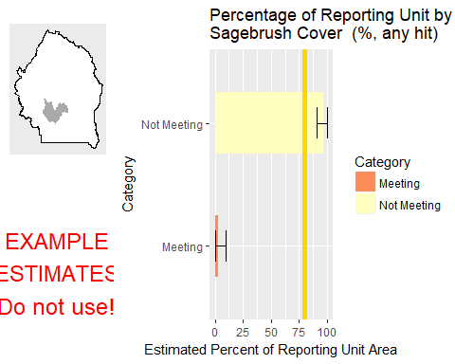

This graph shows the estimated percentage of the reporting unit in different categories for the specified indicator. 80% confidence intervals around those estimates are provided as error bars. The yellow bar denotes the landscape criterion, or point at which an objective is deemed to be met or not met as defined in the Sample Design Worksheet.

#### Results Table

|  |  |  |  |  |  |
| --- | --- | --- | --- | --- | --- |
| Category | # Points | % Area Estimate | Std. Error | Lower 80% CI | Upper 80% CI |
| Meeting | 1 | 3.159 | 3.348 | 0 | 9.722 |
| Not Meeting | 5 | 96.84 | 3.348 | 90.28 | 100 |

This table gives the analysis results for the specified indicator and reporting unit, and contains the data used to create the graph above.

#### Management Question: Land Health Standard: Soils

#### Indicator: Percent in Gaps 101-200 cm



This graph shows the estimated percentage of the reporting unit in different categories for the specified indicator. 80% confidence intervals around those estimates are provided as error bars. The yellow bar denotes the landscape criterion, or point at which an objective is deemed to be met or not met as defined in the Sample Design Worksheet.

#### Results Table

|  |  |  |  |  |  |
| --- | --- | --- | --- | --- | --- |
| Category | # Points | % Area Estimate | Std. Error | Lower 80% CI | Upper 80% CI |
| Meeting | 1 | 3.159 | 3.348 | 0 | 9.722 |
| Not Meeting | 5 | 96.84 | 3.348 | 90.28 | 100 |

This table gives the analysis results for the specified indicator and reporting unit, and contains the data used to create the graph above.

#### Indicator: Percent in Gaps > 200 cm



This graph shows the estimated percentage of the reporting unit in different categories for the specified indicator. 80% confidence intervals around those estimates are provided as error bars. The yellow bar denotes the landscape criterion, or point at which an objective is deemed to be met or not met as defined in the Sample Design Worksheet.

#### Results Table

|  |  |  |  |  |  |
| --- | --- | --- | --- | --- | --- |
| Category | # Points | % Area Estimate | Std. Error | Lower 80% CI | Upper 80% CI |
| Meeting | 5 | 80.63 | 15.03 | 51.18 | 100 |
| Not Meeting | 1 | 19.37 | 15.03 | 0 | 48.82 |

This table gives the analysis results for the specified indicator and reporting unit, and contains the data used to create the graph above.

#### Indicator: Percent in Gaps 51-100 cm



This graph shows the estimated percentage of the reporting unit in different categories for the specified indicator. 80% confidence intervals around those estimates are provided as error bars. The yellow bar denotes the landscape criterion, or point at which an objective is deemed to be met or not met as defined in the Sample Design Worksheet.

#### Results Table

|  |  |  |  |  |  |
| --- | --- | --- | --- | --- | --- |
| Category | # Points | % Area Estimate | Std. Error | Lower 80% CI | Upper 80% CI |
| Meeting | 1 | 19.37 | 15.03 | 0 | 48.82 |
| Not Meeting | 5 | 80.63 | 15.03 | 51.18 | 100 |

This table gives the analysis results for the specified indicator and reporting unit, and contains the data used to create the graph above.

#### Indicator: Overall Soil Stability Rating



This graph shows the estimated percentage of the reporting unit in different categories for the specified indicator. 80% confidence intervals around those estimates are provided as error bars. The yellow bar denotes the landscape criterion, or point at which an objective is deemed to be met or not met as defined in the Sample Design Worksheet.

#### Results Table

|  |  |  |  |  |  |
| --- | --- | --- | --- | --- | --- |
| Category | # Points | % Area Estimate | Std. Error | Lower 80% CI | Upper 80% CI |
| Meeting | 1 | 3.159 | 3.348 | 0 | 9.722 |
| Not Meeting | 5 | 96.84 | 3.348 | 90.28 | 100 |

This table gives the analysis results for the specified indicator and reporting unit, and contains the data used to create the graph above.

#### Management Question: Land Health Standard: Biotic Integrity

#### Indicator: Invasive Annual Grass Cover (%, any hit)

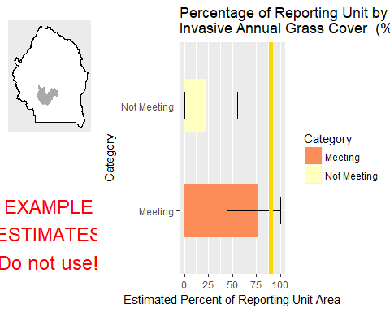

This graph shows the estimated percentage of the reporting unit in different categories for the specified indicator. 80% confidence intervals around those estimates are provided as error bars. The yellow bar denotes the landscape criterion, or point at which an objective is deemed to be met or not met as defined in the Sample Design Worksheet.

#### Results Table

|  |  |  |  |  |  |
| --- | --- | --- | --- | --- | --- |
| Category | # Points | % Area Estimate | Std. Error | Lower 80% CI | Upper 80% CI |
| Meeting | 4 | 77.47 | 16.77 | 44.6 | 100 |
| Not Meeting | 2 | 22.53 | 16.77 | 0 | 55.4 |

This table gives the analysis results for the specified indicator and reporting unit, and contains the data used to create the graph above.

#### Management Question: Land Health Standard: Native Plants

#### Indicator: Non-invasive Perennial Grass Cover (%, any hit)



This graph shows the estimated percentage of the reporting unit in different categories for the specified indicator. 80% confidence intervals around those estimates are provided as error bars. The yellow bar denotes the landscape criterion, or point at which an objective is deemed to be met or not met as defined in the Sample Design Worksheet.

#### Results Table

|  |  |  |  |  |  |
| --- | --- | --- | --- | --- | --- |
| Category | # Points | % Area Estimate | Std. Error | Lower 80% CI | Upper 80% CI |
| Meeting | 1 | 3.159 | 3.348 | 0 | 9.722 |
| Not Meeting | 5 | 96.84 | 3.348 | 90.28 | 100 |

This table gives the analysis results for the specified indicator and reporting unit, and contains the data used to create the graph above.

#### Indicator: Average Non-invasive Perennial Grass Height (cm)



This graph shows the estimated percentage of the reporting unit in different categories for the specified indicator. 80% confidence intervals around those estimates are provided as error bars. The yellow bar denotes the landscape criterion, or point at which an objective is deemed to be met or not met as defined in the Sample Design Worksheet.

#### Results Table

|  |  |  |  |  |  |
| --- | --- | --- | --- | --- | --- |
| Category | # Points | % Area Estimate | Std. Error | Lower 80% CI | Upper 80% CI |
| Meeting | 1 | 3.159 | 3.348 | 0 | 9.722 |
| Not Meeting | 5 | 96.84 | 3.348 | 90.28 | 100 |

This table gives the analysis results for the specified indicator and reporting unit, and contains the data used to create the graph above.

### Watershed : Miller Water-Bruneau River

#### Management Question: Land Health Standard: Wildlife

#### Indicator: Non-invasive Perennial Grass Cover (%, any hit)

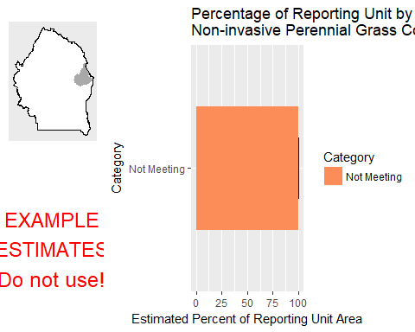

This graph shows the estimated percentage of the reporting unit in different categories for the specified indicator. 80% confidence intervals around those estimates are provided as error bars. The yellow bar denotes the landscape criterion, or point at which an objective is deemed to be met or not met as defined in the Sample Design Worksheet.

#### Results Table

|  |  |  |  |  |  |
| --- | --- | --- | --- | --- | --- |
| Category | # Points | % Area Estimate | Std. Error | Lower 80% CI | Upper 80% CI |
| Not Meeting | 4 | 100 | 0 | 100 | 100 |

This table gives the analysis results for the specified indicator and reporting unit, and contains the data used to create the graph above.

#### Indicator: Average Non-invasive Perennial Grass Height (cm)

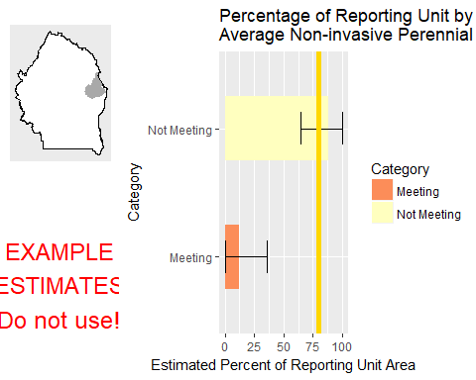

This graph shows the estimated percentage of the reporting unit in different categories for the specified indicator. 80% confidence intervals around those estimates are provided as error bars. The yellow bar denotes the landscape criterion, or point at which an objective is deemed to be met or not met as defined in the Sample Design Worksheet.

#### Results Table

|  |  |  |  |  |  |
| --- | --- | --- | --- | --- | --- |
| Category | # Points | % Area Estimate | Std. Error | Lower 80% CI | Upper 80% CI |
| Meeting | 1 | 11.76 | 12.19 | 0 | 35.64 |
| Not Meeting | 3 | 88.24 | 12.19 | 64.36 | 100 |

This table gives the analysis results for the specified indicator and reporting unit, and contains the data used to create the graph above.

#### Management Question: Land Health Standard: Watershed

#### Indicator: Percent in Gaps 101-200 cm

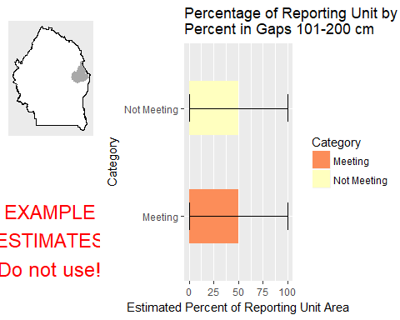

This graph shows the estimated percentage of the reporting unit in different categories for the specified indicator. 80% confidence intervals around those estimates are provided as error bars. The yellow bar denotes the landscape criterion, or point at which an objective is deemed to be met or not met as defined in the Sample Design Worksheet.

#### Results Table

|  |  |  |  |  |  |
| --- | --- | --- | --- | --- | --- |
| Category | # Points | % Area Estimate | Std. Error | Lower 80% CI | Upper 80% CI |
| Meeting | 2 | 50 | 27.01 | 0 | 100 |
| Not Meeting | 2 | 50 | 27.01 | 0 | 100 |

This table gives the analysis results for the specified indicator and reporting unit, and contains the data used to create the graph above.

#### Indicator: Percent in Gaps > 200 cm

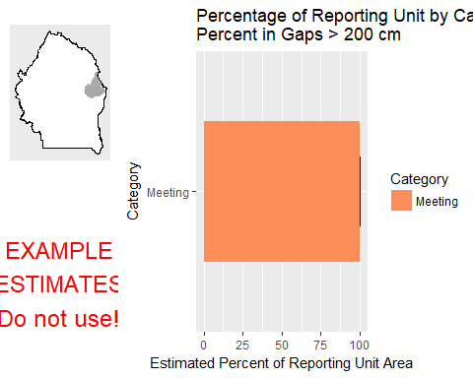

This graph shows the estimated percentage of the reporting unit in different categories for the specified indicator. 80% confidence intervals around those estimates are provided as error bars. The yellow bar denotes the landscape criterion, or point at which an objective is deemed to be met or not met as defined in the Sample Design Worksheet.

#### Results Table

|  |  |  |  |  |  |
| --- | --- | --- | --- | --- | --- |
| Category | # Points | % Area Estimate | Std. Error | Lower 80% CI | Upper 80% CI |
| Meeting | 4 | 100 | 0 | 100 | 100 |

This table gives the analysis results for the specified indicator and reporting unit, and contains the data used to create the graph above.

#### Indicator: Percent in Gaps 51-100 cm

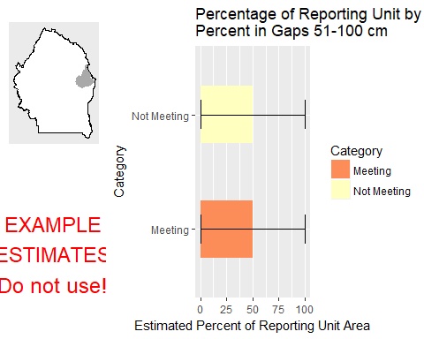

This graph shows the estimated percentage of the reporting unit in different categories for the specified indicator. 80% confidence intervals around those estimates are provided as error bars. The yellow bar denotes the landscape criterion, or point at which an objective is deemed to be met or not met as defined in the Sample Design Worksheet.

#### Results Table

|  |  |  |  |  |  |
| --- | --- | --- | --- | --- | --- |
| Category | # Points | % Area Estimate | Std. Error | Lower 80% CI | Upper 80% CI |
| Meeting | 2 | 50 | 27.01 | 0 | 100 |
| Not Meeting | 2 | 50 | 27.01 | 0 | 100 |

This table gives the analysis results for the specified indicator and reporting unit, and contains the data used to create the graph above.

#### Indicator: Overall Soil Stability Rating

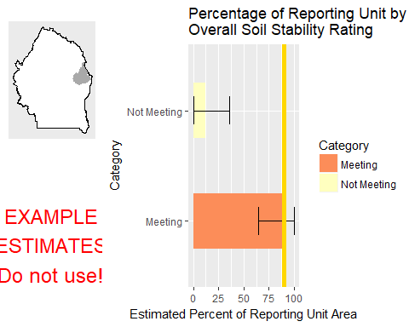

This graph shows the estimated percentage of the reporting unit in different categories for the specified indicator. 80% confidence intervals around those estimates are provided as error bars. The yellow bar denotes the landscape criterion, or point at which an objective is deemed to be met or not met as defined in the Sample Design Worksheet.

#### Results Table

|  |  |  |  |  |  |
| --- | --- | --- | --- | --- | --- |
| Category | # Points | % Area Estimate | Std. Error | Lower 80% CI | Upper 80% CI |
| Meeting | 3 | 88.24 | 12.19 | 64.36 | 100 |
| Not Meeting | 1 | 11.76 | 12.19 | 0 | 35.64 |

This table gives the analysis results for the specified indicator and reporting unit, and contains the data used to create the graph above.

#### Management Question: GRSG Habitat Objectives

#### Indicator: Sagebrush Cover (%, any hit)

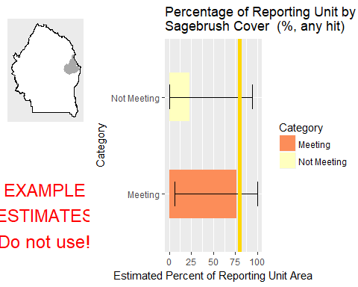

This graph shows the estimated percentage of the reporting unit in different categories for the specified indicator. 80% confidence intervals around those estimates are provided as error bars. The yellow bar denotes the landscape criterion, or point at which an objective is deemed to be met or not met as defined in the Sample Design Worksheet.

#### Results Table

|  |  |  |  |  |  |
| --- | --- | --- | --- | --- | --- |
| Category | # Points | % Area Estimate | Std. Error | Lower 80% CI | Upper 80% CI |
| Meeting | 1 | 76.49 | 35.97 | 5.998 | 100 |
| Not Meeting | 1 | 23.51 | 35.97 | 0 | 94 |

This table gives the analysis results for the specified indicator and reporting unit, and contains the data used to create the graph above.

#### Management Question: Land Health Standard: Soils

#### Indicator: Percent in Gaps 101-200 cm



This graph shows the estimated percentage of the reporting unit in different categories for the specified indicator. 80% confidence intervals around those estimates are provided as error bars. The yellow bar denotes the landscape criterion, or point at which an objective is deemed to be met or not met as defined in the Sample Design Worksheet.

#### Results Table

|  |  |  |  |  |  |
| --- | --- | --- | --- | --- | --- |
| Category | # Points | % Area Estimate | Std. Error | Lower 80% CI | Upper 80% CI |
| Meeting | 2 | 50 | 27.01 | 0 | 100 |
| Not Meeting | 2 | 50 | 27.01 | 0 | 100 |

This table gives the analysis results for the specified indicator and reporting unit, and contains the data used to create the graph above.

#### Indicator: Percent in Gaps > 200 cm



This graph shows the estimated percentage of the reporting unit in different categories for the specified indicator. 80% confidence intervals around those estimates are provided as error bars. The yellow bar denotes the landscape criterion, or point at which an objective is deemed to be met or not met as defined in the Sample Design Worksheet.

#### Results Table

|  |  |  |  |  |  |
| --- | --- | --- | --- | --- | --- |
| Category | # Points | % Area Estimate | Std. Error | Lower 80% CI | Upper 80% CI |
| Meeting | 4 | 100 | 0 | 100 | 100 |

This table gives the analysis results for the specified indicator and reporting unit, and contains the data used to create the graph above.

#### Indicator: Percent in Gaps 51-100 cm



This graph shows the estimated percentage of the reporting unit in different categories for the specified indicator. 80% confidence intervals around those estimates are provided as error bars. The yellow bar denotes the landscape criterion, or point at which an objective is deemed to be met or not met as defined in the Sample Design Worksheet.

#### Results Table

|  |  |  |  |  |  |
| --- | --- | --- | --- | --- | --- |
| Category | # Points | % Area Estimate | Std. Error | Lower 80% CI | Upper 80% CI |
| Meeting | 2 | 50 | 27.01 | 0 | 100 |
| Not Meeting | 2 | 50 | 27.01 | 0 | 100 |

This table gives the analysis results for the specified indicator and reporting unit, and contains the data used to create the graph above.

#### Indicator: Overall Soil Stability Rating



This graph shows the estimated percentage of the reporting unit in different categories for the specified indicator. 80% confidence intervals around those estimates are provided as error bars. The yellow bar denotes the landscape criterion, or point at which an objective is deemed to be met or not met as defined in the Sample Design Worksheet.

#### Results Table

|  |  |  |  |  |  |
| --- | --- | --- | --- | --- | --- |
| Category | # Points | % Area Estimate | Std. Error | Lower 80% CI | Upper 80% CI |
| Meeting | 3 | 88.24 | 12.19 | 64.36 | 100 |
| Not Meeting | 1 | 11.76 | 12.19 | 0 | 35.64 |

This table gives the analysis results for the specified indicator and reporting unit, and contains the data used to create the graph above.

#### Management Question: Land Health Standard: Biotic Integrity

#### Indicator: Invasive Annual Grass Cover (%, any hit)

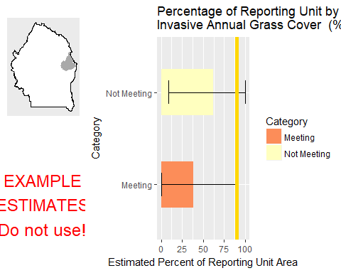

This graph shows the estimated percentage of the reporting unit in different categories for the specified indicator. 80% confidence intervals around those estimates are provided as error bars. The yellow bar denotes the landscape criterion, or point at which an objective is deemed to be met or not met as defined in the Sample Design Worksheet.

#### Results Table

|  |  |  |  |  |  |
| --- | --- | --- | --- | --- | --- |
| Category | # Points | % Area Estimate | Std. Error | Lower 80% CI | Upper 80% CI |
| Meeting | 1 | 38.24 | 27.04 | 0 | 91.23 |
| Not Meeting | 3 | 61.76 | 27.04 | 8.766 | 100 |

This table gives the analysis results for the specified indicator and reporting unit, and contains the data used to create the graph above.

#### Management Question: Land Health Standard: Native Plants

#### Indicator: Non-invasive Perennial Grass Cover (%, any hit)



This graph shows the estimated percentage of the reporting unit in different categories for the specified indicator. 80% confidence intervals around those estimates are provided as error bars. The yellow bar denotes the landscape criterion, or point at which an objective is deemed to be met or not met as defined in the Sample Design Worksheet.

#### Results Table

|  |  |  |  |  |  |
| --- | --- | --- | --- | --- | --- |
| Category | # Points | % Area Estimate | Std. Error | Lower 80% CI | Upper 80% CI |
| Not Meeting | 4 | 100 | 0 | 100 | 100 |

This table gives the analysis results for the specified indicator and reporting unit, and contains the data used to create the graph above.

#### Indicator: Average Non-invasive Perennial Grass Height (cm)



This graph shows the estimated percentage of the reporting unit in different categories for the specified indicator. 80% confidence intervals around those estimates are provided as error bars. The yellow bar denotes the landscape criterion, or point at which an objective is deemed to be met or not met as defined in the Sample Design Worksheet.

#### Results Table

|  |  |  |  |  |  |
| --- | --- | --- | --- | --- | --- |
| Category | # Points | % Area Estimate | Std. Error | Lower 80% CI | Upper 80% CI |
| Meeting | 1 | 11.76 | 12.19 | 0 | 35.64 |
| Not Meeting | 3 | 88.24 | 12.19 | 64.36 | 100 |

This table gives the analysis results for the specified indicator and reporting unit, and contains the data used to create the graph above.

### Watershed : Pole Creek

#### Management Question: Land Health Standard: Wildlife

#### Indicator: Non-invasive Perennial Grass Cover (%, any hit)

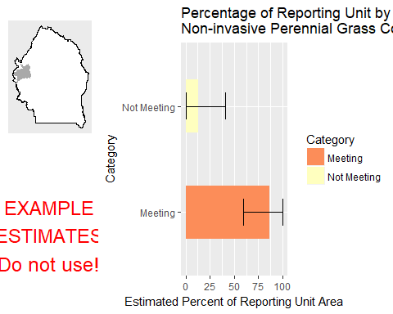

This graph shows the estimated percentage of the reporting unit in different categories for the specified indicator. 80% confidence intervals around those estimates are provided as error bars. The yellow bar denotes the landscape criterion, or point at which an objective is deemed to be met or not met as defined in the Sample Design Worksheet.

#### Results Table

|  |  |  |  |  |  |
| --- | --- | --- | --- | --- | --- |
| Category | # Points | % Area Estimate | Std. Error | Lower 80% CI | Upper 80% CI |
| Meeting | 4 | 86.72 | 13.97 | 59.34 | 100 |
| Not Meeting | 1 | 13.28 | 13.97 | 0 | 40.66 |

This table gives the analysis results for the specified indicator and reporting unit, and contains the data used to create the graph above.

#### Indicator: Average Non-invasive Perennial Grass Height (cm)

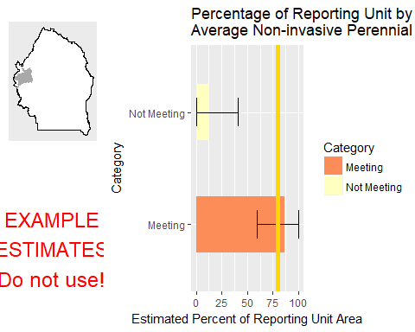

This graph shows the estimated percentage of the reporting unit in different categories for the specified indicator. 80% confidence intervals around those estimates are provided as error bars. The yellow bar denotes the landscape criterion, or point at which an objective is deemed to be met or not met as defined in the Sample Design Worksheet.

#### Results Table

|  |  |  |  |  |  |
| --- | --- | --- | --- | --- | --- |
| Category | # Points | % Area Estimate | Std. Error | Lower 80% CI | Upper 80% CI |
| Meeting | 4 | 86.72 | 13.97 | 59.34 | 100 |
| Not Meeting | 1 | 13.28 | 13.97 | 0 | 40.66 |

This table gives the analysis results for the specified indicator and reporting unit, and contains the data used to create the graph above.

#### Indicator: Average Sagebrush Height (cm)

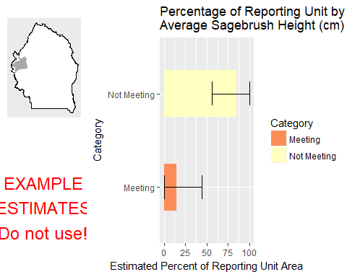

This graph shows the estimated percentage of the reporting unit in different categories for the specified indicator. 80% confidence intervals around those estimates are provided as error bars. The yellow bar denotes the landscape criterion, or point at which an objective is deemed to be met or not met as defined in the Sample Design Worksheet.

#### Results Table

|  |  |  |  |  |  |
| --- | --- | --- | --- | --- | --- |
| Category | # Points | % Area Estimate | Std. Error | Lower 80% CI | Upper 80% CI |
| Meeting | 3 | 14.96 | 14.82 | 0 | 44.01 |
| Not Meeting | 2 | 85.04 | 14.82 | 55.99 | 100 |

This table gives the analysis results for the specified indicator and reporting unit, and contains the data used to create the graph above.

#### Management Question: Land Health Standard: Watershed

#### Indicator: Percent in Gaps 101-200 cm

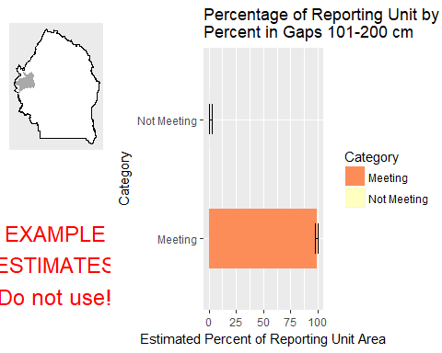

This graph shows the estimated percentage of the reporting unit in different categories for the specified indicator. 80% confidence intervals around those estimates are provided as error bars. The yellow bar denotes the landscape criterion, or point at which an objective is deemed to be met or not met as defined in the Sample Design Worksheet.

#### Results Table

|  |  |  |  |  |  |
| --- | --- | --- | --- | --- | --- |
| Category | # Points | % Area Estimate | Std. Error | Lower 80% CI | Upper 80% CI |
| Meeting | 4 | 99.16 | 1.068 | 97.07 | 100 |
| Not Meeting | 1 | 0.842 | 1.068 | 0 | 2.935 |

This table gives the analysis results for the specified indicator and reporting unit, and contains the data used to create the graph above.

#### Indicator: Percent in Gaps > 200 cm

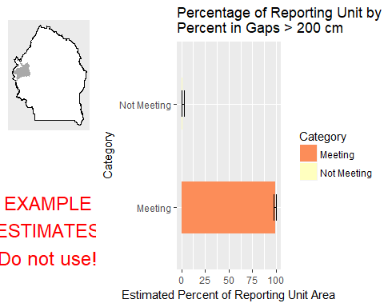

This graph shows the estimated percentage of the reporting unit in different categories for the specified indicator. 80% confidence intervals around those estimates are provided as error bars. The yellow bar denotes the landscape criterion, or point at which an objective is deemed to be met or not met as defined in the Sample Design Worksheet.

#### Results Table

|  |  |  |  |  |  |
| --- | --- | --- | --- | --- | --- |
| Category | # Points | % Area Estimate | Std. Error | Lower 80% CI | Upper 80% CI |
| Meeting | 4 | 99.16 | 1.068 | 97.07 | 100 |
| Not Meeting | 1 | 0.842 | 1.068 | 0 | 2.935 |

This table gives the analysis results for the specified indicator and reporting unit, and contains the data used to create the graph above.

#### Indicator: Percent in Gaps 51-100 cm

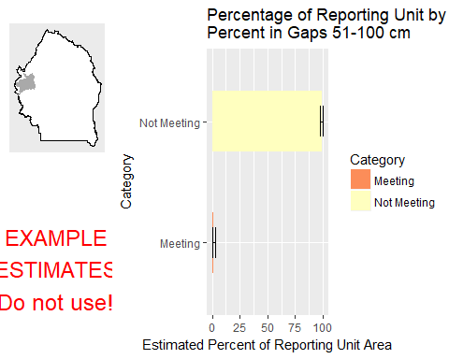

This graph shows the estimated percentage of the reporting unit in different categories for the specified indicator. 80% confidence intervals around those estimates are provided as error bars. The yellow bar denotes the landscape criterion, or point at which an objective is deemed to be met or not met as defined in the Sample Design Worksheet.

#### Results Table

|  |  |  |  |  |  |
| --- | --- | --- | --- | --- | --- |
| Category | # Points | % Area Estimate | Std. Error | Lower 80% CI | Upper 80% CI |
| Meeting | 1 | 0.842 | 1.079 | 0 | 2.956 |
| Not Meeting | 4 | 99.16 | 1.079 | 97.04 | 100 |

This table gives the analysis results for the specified indicator and reporting unit, and contains the data used to create the graph above.

#### Indicator: Overall Soil Stability Rating

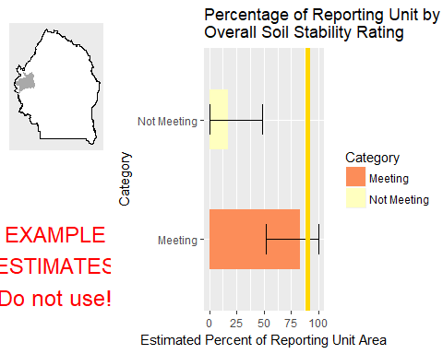

This graph shows the estimated percentage of the reporting unit in different categories for the specified indicator. 80% confidence intervals around those estimates are provided as error bars. The yellow bar denotes the landscape criterion, or point at which an objective is deemed to be met or not met as defined in the Sample Design Worksheet.

#### Results Table

|  |  |  |  |  |  |
| --- | --- | --- | --- | --- | --- |
| Category | # Points | % Area Estimate | Std. Error | Lower 80% CI | Upper 80% CI |
| Meeting | 3 | 83.09 | 15.88 | 51.97 | 100 |
| Not Meeting | 2 | 16.91 | 15.88 | 0 | 48.03 |

This table gives the analysis results for the specified indicator and reporting unit, and contains the data used to create the graph above.

#### Management Question: GRSG Habitat Objectives

#### Indicator: Sagebrush Cover (%, any hit)

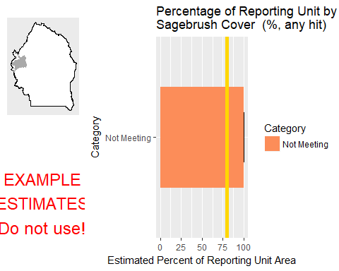

This graph shows the estimated percentage of the reporting unit in different categories for the specified indicator. 80% confidence intervals around those estimates are provided as error bars. The yellow bar denotes the landscape criterion, or point at which an objective is deemed to be met or not met as defined in the Sample Design Worksheet.

#### Results Table

|  |  |  |  |  |  |
| --- | --- | --- | --- | --- | --- |
| Category | # Points | % Area Estimate | Std. Error | Lower 80% CI | Upper 80% CI |
| Not Meeting | 5 | 100 | 0 | 100 | 100 |

This table gives the analysis results for the specified indicator and reporting unit, and contains the data used to create the graph above.

#### Management Question: Land Health Standard: Soils

#### Indicator: Percent in Gaps 101-200 cm



This graph shows the estimated percentage of the reporting unit in different categories for the specified indicator. 80% confidence intervals around those estimates are provided as error bars. The yellow bar denotes the landscape criterion, or point at which an objective is deemed to be met or not met as defined in the Sample Design Worksheet.

#### Results Table

|  |  |  |  |  |  |
| --- | --- | --- | --- | --- | --- |
| Category | # Points | % Area Estimate | Std. Error | Lower 80% CI | Upper 80% CI |
| Meeting | 4 | 99.16 | 1.068 | 97.07 | 100 |
| Not Meeting | 1 | 0.842 | 1.068 | 0 | 2.935 |

This table gives the analysis results for the specified indicator and reporting unit, and contains the data used to create the graph above.

#### Indicator: Percent in Gaps > 200 cm



This graph shows the estimated percentage of the reporting unit in different categories for the specified indicator. 80% confidence intervals around those estimates are provided as error bars. The yellow bar denotes the landscape criterion, or point at which an objective is deemed to be met or not met as defined in the Sample Design Worksheet.

#### Results Table

|  |  |  |  |  |  |
| --- | --- | --- | --- | --- | --- |
| Category | # Points | % Area Estimate | Std. Error | Lower 80% CI | Upper 80% CI |
| Meeting | 4 | 99.16 | 1.068 | 97.07 | 100 |
| Not Meeting | 1 | 0.842 | 1.068 | 0 | 2.935 |

This table gives the analysis results for the specified indicator and reporting unit, and contains the data used to create the graph above.

#### Indicator: Percent in Gaps 51-100 cm



This graph shows the estimated percentage of the reporting unit in different categories for the specified indicator. 80% confidence intervals around those estimates are provided as error bars. The yellow bar denotes the landscape criterion, or point at which an objective is deemed to be met or not met as defined in the Sample Design Worksheet.

#### Results Table

|  |  |  |  |  |  |
| --- | --- | --- | --- | --- | --- |
| Category | # Points | % Area Estimate | Std. Error | Lower 80% CI | Upper 80% CI |
| Meeting | 1 | 0.842 | 1.079 | 0 | 2.956 |
| Not Meeting | 4 | 99.16 | 1.079 | 97.04 | 100 |

This table gives the analysis results for the specified indicator and reporting unit, and contains the data used to create the graph above.

#### Indicator: Overall Soil Stability Rating



This graph shows the estimated percentage of the reporting unit in different categories for the specified indicator. 80% confidence intervals around those estimates are provided as error bars. The yellow bar denotes the landscape criterion, or point at which an objective is deemed to be met or not met as defined in the Sample Design Worksheet.

#### Results Table

|  |  |  |  |  |  |
| --- | --- | --- | --- | --- | --- |
| Category | # Points | % Area Estimate | Std. Error | Lower 80% CI | Upper 80% CI |
| Meeting | 3 | 83.09 | 15.88 | 51.97 | 100 |
| Not Meeting | 2 | 16.91 | 15.88 | 0 | 48.03 |

This table gives the analysis results for the specified indicator and reporting unit, and contains the data used to create the graph above.

#### Management Question: Land Health Standard: Biotic Integrity

#### Indicator: Invasive Annual Grass Cover (%, any hit)

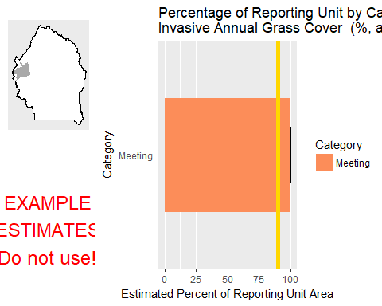

This graph shows the estimated percentage of the reporting unit in different categories for the specified indicator. 80% confidence intervals around those estimates are provided as error bars. The yellow bar denotes the landscape criterion, or point at which an objective is deemed to be met or not met as defined in the Sample Design Worksheet.

#### Results Table

|  |  |  |  |  |  |
| --- | --- | --- | --- | --- | --- |
| Category | # Points | % Area Estimate | Std. Error | Lower 80% CI | Upper 80% CI |
| Meeting | 5 | 100 | 0 | 100 | 100 |

This table gives the analysis results for the specified indicator and reporting unit, and contains the data used to create the graph above.

#### Management Question: Land Health Standard: Native Plants

#### Indicator: Non-invasive Perennial Grass Cover (%, any hit)



This graph shows the estimated percentage of the reporting unit in different categories for the specified indicator. 80% confidence intervals around those estimates are provided as error bars. The yellow bar denotes the landscape criterion, or point at which an objective is deemed to be met or not met as defined in the Sample Design Worksheet.

#### Results Table

|  |  |  |  |  |  |
| --- | --- | --- | --- | --- | --- |
| Category | # Points | % Area Estimate | Std. Error | Lower 80% CI | Upper 80% CI |
| Meeting | 4 | 86.72 | 13.97 | 59.34 | 100 |
| Not Meeting | 1 | 13.28 | 13.97 | 0 | 40.66 |

This table gives the analysis results for the specified indicator and reporting unit, and contains the data used to create the graph above.

#### Indicator: Average Non-invasive Perennial Grass Height (cm)



This graph shows the estimated percentage of the reporting unit in different categories for the specified indicator. 80% confidence intervals around those estimates are provided as error bars. The yellow bar denotes the landscape criterion, or point at which an objective is deemed to be met or not met as defined in the Sample Design Worksheet.

#### Results Table

|  |  |  |  |  |  |
| --- | --- | --- | --- | --- | --- |
| Category | # Points | % Area Estimate | Std. Error | Lower 80% CI | Upper 80% CI |
| Meeting | 4 | 86.72 | 13.97 | 59.34 | 100 |
| Not Meeting | 1 | 13.28 | 13.97 | 0 | 40.66 |

This table gives the analysis results for the specified indicator and reporting unit, and contains the data used to create the graph above.

### Watershed : Ross Slough-Owyhee River

#### Management Question: Land Health Standard: Wildlife

#### Indicator: Non-invasive Perennial Grass Cover (%, any hit)

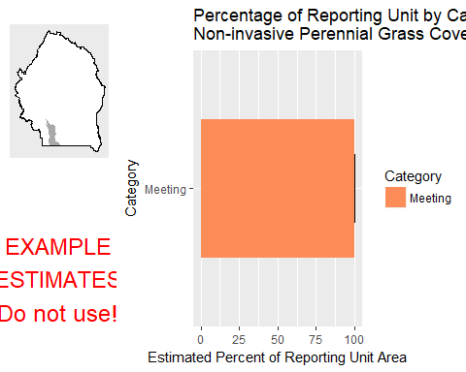

This graph shows the estimated percentage of the reporting unit in different categories for the specified indicator. 80% confidence intervals around those estimates are provided as error bars. The yellow bar denotes the landscape criterion, or point at which an objective is deemed to be met or not met as defined in the Sample Design Worksheet.

#### Results Table

|  |  |  |  |  |  |
| --- | --- | --- | --- | --- | --- |
| Category | # Points | % Area Estimate | Std. Error | Lower 80% CI | Upper 80% CI |
| Meeting | 2 | 100 | 0 | 100 | 100 |

This table gives the analysis results for the specified indicator and reporting unit, and contains the data used to create the graph above.

#### Indicator: Average Non-invasive Perennial Grass Height (cm)

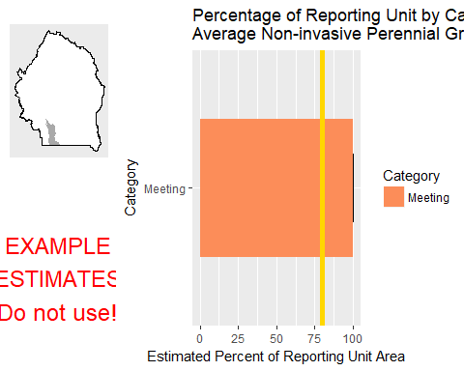

This graph shows the estimated percentage of the reporting unit in different categories for the specified indicator. 80% confidence intervals around those estimates are provided as error bars. The yellow bar denotes the landscape criterion, or point at which an objective is deemed to be met or not met as defined in the Sample Design Worksheet.

#### Results Table

|  |  |  |  |  |  |
| --- | --- | --- | --- | --- | --- |
| Category | # Points | % Area Estimate | Std. Error | Lower 80% CI | Upper 80% CI |
| Meeting | 2 | 100 | 0 | 100 | 100 |

This table gives the analysis results for the specified indicator and reporting unit, and contains the data used to create the graph above.

#### Indicator: Average Sagebrush Height (cm)

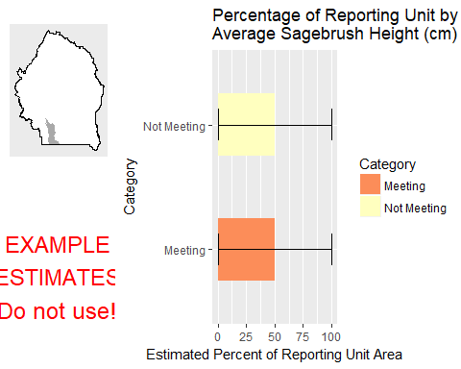

This graph shows the estimated percentage of the reporting unit in different categories for the specified indicator. 80% confidence intervals around those estimates are provided as error bars. The yellow bar denotes the landscape criterion, or point at which an objective is deemed to be met or not met as defined in the Sample Design Worksheet.

#### Results Table

|  |  |  |  |  |  |
| --- | --- | --- | --- | --- | --- |
| Category | # Points | % Area Estimate | Std. Error | Lower 80% CI | Upper 80% CI |
| Meeting | 1 | 50 | 50 | 0 | 100 |
| Not Meeting | 1 | 50 | 50 | 0 | 100 |

This table gives the analysis results for the specified indicator and reporting unit, and contains the data used to create the graph above.

#### Management Question: Land Health Standard: Watershed

#### Indicator: Percent in Gaps 101-200 cm

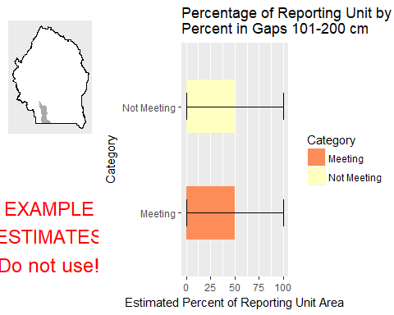

This graph shows the estimated percentage of the reporting unit in different categories for the specified indicator. 80% confidence intervals around those estimates are provided as error bars. The yellow bar denotes the landscape criterion, or point at which an objective is deemed to be met or not met as defined in the Sample Design Worksheet.

#### Results Table

|  |  |  |  |  |  |
| --- | --- | --- | --- | --- | --- |
| Category | # Points | % Area Estimate | Std. Error | Lower 80% CI | Upper 80% CI |
| Meeting | 1 | 50 | 50 | 0 | 100 |
| Not Meeting | 1 | 50 | 50 | 0 | 100 |

This table gives the analysis results for the specified indicator and reporting unit, and contains the data used to create the graph above.

#### Indicator: Percent in Gaps > 200 cm

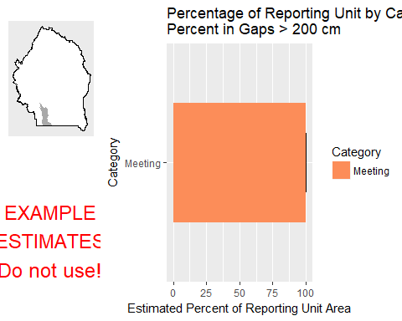

This graph shows the estimated percentage of the reporting unit in different categories for the specified indicator. 80% confidence intervals around those estimates are provided as error bars. The yellow bar denotes the landscape criterion, or point at which an objective is deemed to be met or not met as defined in the Sample Design Worksheet.

#### Results Table

|  |  |  |  |  |  |
| --- | --- | --- | --- | --- | --- |
| Category | # Points | % Area Estimate | Std. Error | Lower 80% CI | Upper 80% CI |
| Meeting | 2 | 100 | 0 | 100 | 100 |

This table gives the analysis results for the specified indicator and reporting unit, and contains the data used to create the graph above.

#### Indicator: Percent in Gaps 51-100 cm

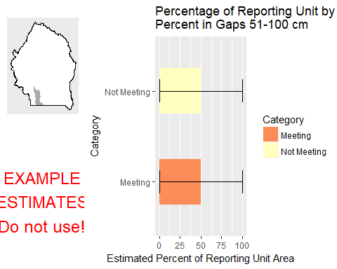

This graph shows the estimated percentage of the reporting unit in different categories for the specified indicator. 80% confidence intervals around those estimates are provided as error bars. The yellow bar denotes the landscape criterion, or point at which an objective is deemed to be met or not met as defined in the Sample Design Worksheet.

#### Results Table

|  |  |  |  |  |  |
| --- | --- | --- | --- | --- | --- |
| Category | # Points | % Area Estimate | Std. Error | Lower 80% CI | Upper 80% CI |
| Meeting | 1 | 50 | 50 | 0 | 100 |
| Not Meeting | 1 | 50 | 50 | 0 | 100 |

This table gives the analysis results for the specified indicator and reporting unit, and contains the data used to create the graph above.

#### Indicator: Overall Soil Stability Rating

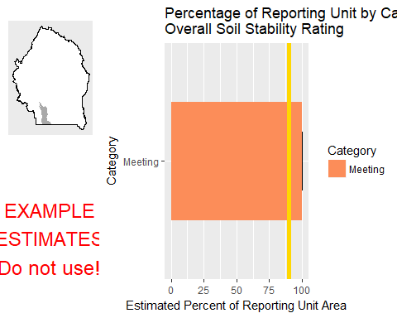

This graph shows the estimated percentage of the reporting unit in different categories for the specified indicator. 80% confidence intervals around those estimates are provided as error bars. The yellow bar denotes the landscape criterion, or point at which an objective is deemed to be met or not met as defined in the Sample Design Worksheet.

#### Results Table

|  |  |  |  |  |  |
| --- | --- | --- | --- | --- | --- |
| Category | # Points | % Area Estimate | Std. Error | Lower 80% CI | Upper 80% CI |
| Meeting | 2 | 100 | 0 | 100 | 100 |

This table gives the analysis results for the specified indicator and reporting unit, and contains the data used to create the graph above.

#### Management Question: GRSG Habitat Objectives

#### Indicator: Sagebrush Cover (%, any hit)

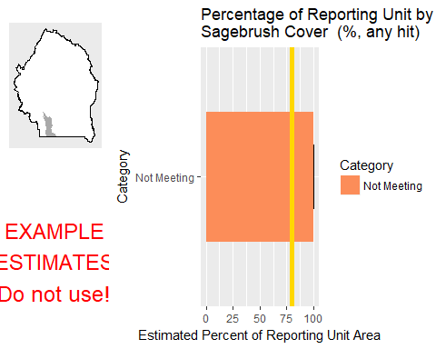

This graph shows the estimated percentage of the reporting unit in different categories for the specified indicator. 80% confidence intervals around those estimates are provided as error bars. The yellow bar denotes the landscape criterion, or point at which an objective is deemed to be met or not met as defined in the Sample Design Worksheet.

#### Results Table

|  |  |  |  |  |  |
| --- | --- | --- | --- | --- | --- |
| Category | # Points | % Area Estimate | Std. Error | Lower 80% CI | Upper 80% CI |
| Not Meeting | 2 | 100 | 0 | 100 | 100 |

This table gives the analysis results for the specified indicator and reporting unit, and contains the data used to create the graph above.

#### Management Question: Land Health Standard: Soils

#### Indicator: Percent in Gaps 101-200 cm



This graph shows the estimated percentage of the reporting unit in different categories for the specified indicator. 80% confidence intervals around those estimates are provided as error bars. The yellow bar denotes the landscape criterion, or point at which an objective is deemed to be met or not met as defined in the Sample Design Worksheet.

#### Results Table

|  |  |  |  |  |  |
| --- | --- | --- | --- | --- | --- |
| Category | # Points | % Area Estimate | Std. Error | Lower 80% CI | Upper 80% CI |
| Meeting | 1 | 50 | 50 | 0 | 100 |
| Not Meeting | 1 | 50 | 50 | 0 | 100 |

This table gives the analysis results for the specified indicator and reporting unit, and contains the data used to create the graph above.

#### Indicator: Percent in Gaps > 200 cm



This graph shows the estimated percentage of the reporting unit in different categories for the specified indicator. 80% confidence intervals around those estimates are provided as error bars. The yellow bar denotes the landscape criterion, or point at which an objective is deemed to be met or not met as defined in the Sample Design Worksheet.

#### Results Table

|  |  |  |  |  |  |
| --- | --- | --- | --- | --- | --- |
| Category | # Points | % Area Estimate | Std. Error | Lower 80% CI | Upper 80% CI |
| Meeting | 2 | 100 | 0 | 100 | 100 |

This table gives the analysis results for the specified indicator and reporting unit, and contains the data used to create the graph above.

#### Indicator: Percent in Gaps 51-100 cm



This graph shows the estimated percentage of the reporting unit in different categories for the specified indicator. 80% confidence intervals around those estimates are provided as error bars. The yellow bar denotes the landscape criterion, or point at which an objective is deemed to be met or not met as defined in the Sample Design Worksheet.

#### Results Table

|  |  |  |  |  |  |
| --- | --- | --- | --- | --- | --- |
| Category | # Points | % Area Estimate | Std. Error | Lower 80% CI | Upper 80% CI |
| Meeting | 1 | 50 | 50 | 0 | 100 |
| Not Meeting | 1 | 50 | 50 | 0 | 100 |

This table gives the analysis results for the specified indicator and reporting unit, and contains the data used to create the graph above.

#### Indicator: Overall Soil Stability Rating



This graph shows the estimated percentage of the reporting unit in different categories for the specified indicator. 80% confidence intervals around those estimates are provided as error bars. The yellow bar denotes the landscape criterion, or point at which an objective is deemed to be met or not met as defined in the Sample Design Worksheet.

#### Results Table

|  |  |  |  |  |  |
| --- | --- | --- | --- | --- | --- |
| Category | # Points | % Area Estimate | Std. Error | Lower 80% CI | Upper 80% CI |
| Meeting | 2 | 100 | 0 | 100 | 100 |

This table gives the analysis results for the specified indicator and reporting unit, and contains the data used to create the graph above.

#### Management Question: Land Health Standard: Biotic Integrity

#### Indicator: Invasive Annual Grass Cover (%, any hit)

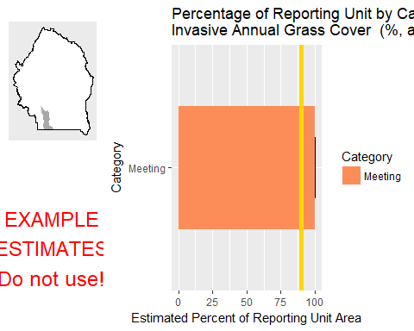

This graph shows the estimated percentage of the reporting unit in different categories for the specified indicator. 80% confidence intervals around those estimates are provided as error bars. The yellow bar denotes the landscape criterion, or point at which an objective is deemed to be met or not met as defined in the Sample Design Worksheet.

#### Results Table

|  |  |  |  |  |  |
| --- | --- | --- | --- | --- | --- |
| Category | # Points | % Area Estimate | Std. Error | Lower 80% CI | Upper 80% CI |
| Meeting | 2 | 100 | 0 | 100 | 100 |

This table gives the analysis results for the specified indicator and reporting unit, and contains the data used to create the graph above.

#### Management Question: Land Health Standard: Native Plants

#### Indicator: Non-invasive Perennial Grass Cover (%, any hit)



This graph shows the estimated percentage of the reporting unit in different categories for the specified indicator. 80% confidence intervals around those estimates are provided as error bars. The yellow bar denotes the landscape criterion, or point at which an objective is deemed to be met or not met as defined in the Sample Design Worksheet.

#### Results Table

|  |  |  |  |  |  |
| --- | --- | --- | --- | --- | --- |
| Category | # Points | % Area Estimate | Std. Error | Lower 80% CI | Upper 80% CI |
| Meeting | 2 | 100 | 0 | 100 | 100 |

This table gives the analysis results for the specified indicator and reporting unit, and contains the data used to create the graph above.

#### Indicator: Average Non-invasive Perennial Grass Height (cm)



This graph shows the estimated percentage of the reporting unit in different categories for the specified indicator. 80% confidence intervals around those estimates are provided as error bars. The yellow bar denotes the landscape criterion, or point at which an objective is deemed to be met or not met as defined in the Sample Design Worksheet.

#### Results Table

|  |  |  |  |  |  |
| --- | --- | --- | --- | --- | --- |
| Category | # Points | % Area Estimate | Std. Error | Lower 80% CI | Upper 80% CI |
| Meeting | 2 | 100 | 0 | 100 | 100 |

This table gives the analysis results for the specified indicator and reporting unit, and contains the data used to create the graph above.

### Watershed : Shoofly Creek

#### Management Question: Land Health Standard: Wildlife

#### Indicator: Non-invasive Perennial Grass Cover (%, any hit)

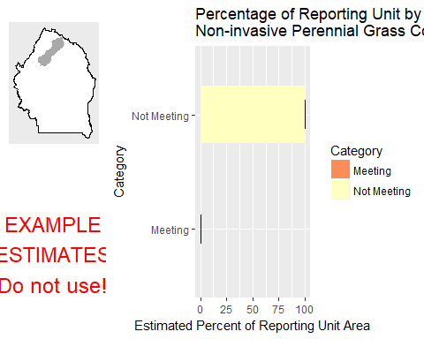

This graph shows the estimated percentage of the reporting unit in different categories for the specified indicator. 80% confidence intervals around those estimates are provided as error bars. The yellow bar denotes the landscape criterion, or point at which an objective is deemed to be met or not met as defined in the Sample Design Worksheet.

#### Results Table

|  |  |  |  |  |  |
| --- | --- | --- | --- | --- | --- |
| Category | # Points | % Area Estimate | Std. Error | Lower 80% CI | Upper 80% CI |
| Meeting | 1 | 0.07277 | 0.1454 | 0 | 0.3578 |
| Not Meeting | 1 | 99.93 | 0.1454 | 99.64 | 100 |

This table gives the analysis results for the specified indicator and reporting unit, and contains the data used to create the graph above.

#### Indicator: Average Non-invasive Perennial Grass Height (cm)

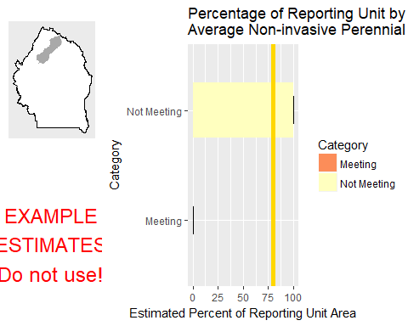

This graph shows the estimated percentage of the reporting unit in different categories for the specified indicator. 80% confidence intervals around those estimates are provided as error bars. The yellow bar denotes the landscape criterion, or point at which an objective is deemed to be met or not met as defined in the Sample Design Worksheet.

#### Results Table

|  |  |  |  |  |  |
| --- | --- | --- | --- | --- | --- |
| Category | # Points | % Area Estimate | Std. Error | Lower 80% CI | Upper 80% CI |
| Meeting | 1 | 0.07277 | 0.1454 | 0 | 0.3578 |
| Not Meeting | 1 | 99.93 | 0.1454 | 99.64 | 100 |

This table gives the analysis results for the specified indicator and reporting unit, and contains the data used to create the graph above.

#### Indicator: Average Sagebrush Height (cm)

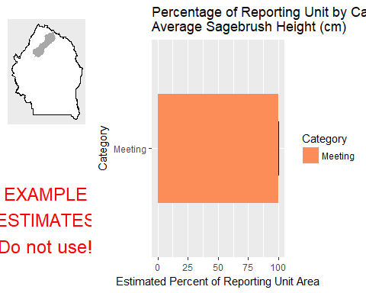

This graph shows the estimated percentage of the reporting unit in different categories for the specified indicator. 80% confidence intervals around those estimates are provided as error bars. The yellow bar denotes the landscape criterion, or point at which an objective is deemed to be met or not met as defined in the Sample Design Worksheet.

#### Results Table

|  |  |  |  |  |  |
| --- | --- | --- | --- | --- | --- |
| Category | # Points | % Area Estimate | Std. Error | Lower 80% CI | Upper 80% CI |
| Meeting | 2 | 100 | 0 | 100 | 100 |

This table gives the analysis results for the specified indicator and reporting unit, and contains the data used to create the graph above.

#### Management Question: Land Health Standard: Watershed

#### Indicator: Percent in Gaps 101-200 cm

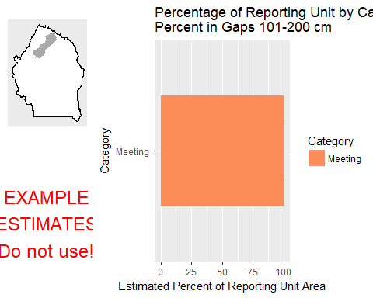

This graph shows the estimated percentage of the reporting unit in different categories for the specified indicator. 80% confidence intervals around those estimates are provided as error bars. The yellow bar denotes the landscape criterion, or point at which an objective is deemed to be met or not met as defined in the Sample Design Worksheet.

#### Results Table

|  |  |  |  |  |  |
| --- | --- | --- | --- | --- | --- |
| Category | # Points | % Area Estimate | Std. Error | Lower 80% CI | Upper 80% CI |
| Meeting | 2 | 100 | 0 | 100 | 100 |

This table gives the analysis results for the specified indicator and reporting unit, and contains the data used to create the graph above.

#### Indicator: Percent in Gaps > 200 cm

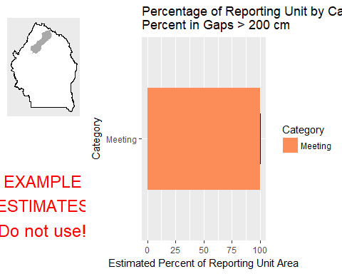

This graph shows the estimated percentage of the reporting unit in different categories for the specified indicator. 80% confidence intervals around those estimates are provided as error bars. The yellow bar denotes the landscape criterion, or point at which an objective is deemed to be met or not met as defined in the Sample Design Worksheet.

#### Results Table

|  |  |  |  |  |  |
| --- | --- | --- | --- | --- | --- |
| Category | # Points | % Area Estimate | Std. Error | Lower 80% CI | Upper 80% CI |
| Meeting | 2 | 100 | 0 | 100 | 100 |

This table gives the analysis results for the specified indicator and reporting unit, and contains the data used to create the graph above.

#### Indicator: Percent in Gaps 51-100 cm

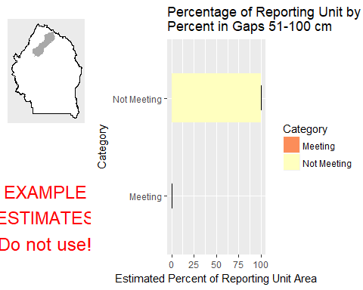

This graph shows the estimated percentage of the reporting unit in different categories for the specified indicator. 80% confidence intervals around those estimates are provided as error bars. The yellow bar denotes the landscape criterion, or point at which an objective is deemed to be met or not met as defined in the Sample Design Worksheet.

#### Results Table

|  |  |  |  |  |  |
| --- | --- | --- | --- | --- | --- |
| Category | # Points | % Area Estimate | Std. Error | Lower 80% CI | Upper 80% CI |
| Meeting | 1 | 0.07277 | 0.1454 | 0 | 0.3578 |
| Not Meeting | 1 | 99.93 | 0.1454 | 99.64 | 100 |

This table gives the analysis results for the specified indicator and reporting unit, and contains the data used to create the graph above.

#### Indicator: Overall Soil Stability Rating

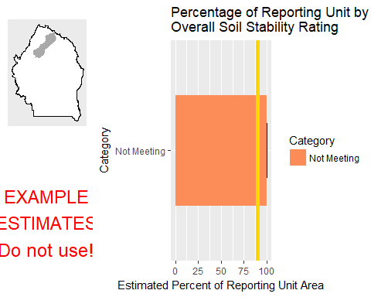

This graph shows the estimated percentage of the reporting unit in different categories for the specified indicator. 80% confidence intervals around those estimates are provided as error bars. The yellow bar denotes the landscape criterion, or point at which an objective is deemed to be met or not met as defined in the Sample Design Worksheet.

#### Results Table

|  |  |  |  |  |  |
| --- | --- | --- | --- | --- | --- |
| Category | # Points | % Area Estimate | Std. Error | Lower 80% CI | Upper 80% CI |
| Not Meeting | 2 | 100 | 0 | 100 | 100 |

This table gives the analysis results for the specified indicator and reporting unit, and contains the data used to create the graph above.

#### Management Question: GRSG Habitat Objectives

#### Indicator: Sagebrush Cover (%, any hit)

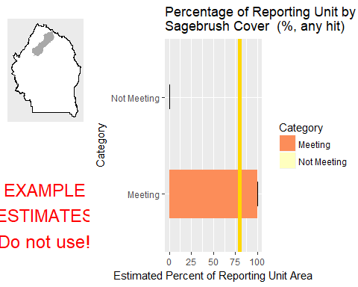

This graph shows the estimated percentage of the reporting unit in different categories for the specified indicator. 80% confidence intervals around those estimates are provided as error bars. The yellow bar denotes the landscape criterion, or point at which an objective is deemed to be met or not met as defined in the Sample Design Worksheet.

#### Results Table

|  |  |  |  |  |  |
| --- | --- | --- | --- | --- | --- |
| Category | # Points | % Area Estimate | Std. Error | Lower 80% CI | Upper 80% CI |
| Meeting | 1 | 99.93 | 0.1454 | 99.64 | 100 |
| Not Meeting | 1 | 0.07277 | 0.1454 | 0 | 0.3578 |

This table gives the analysis results for the specified indicator and reporting unit, and contains the data used to create the graph above.

#### Management Question: Land Health Standard: Soils

#### Indicator: Percent in Gaps 101-200 cm



This graph shows the estimated percentage of the reporting unit in different categories for the specified indicator. 80% confidence intervals around those estimates are provided as error bars. The yellow bar denotes the landscape criterion, or point at which an objective is deemed to be met or not met as defined in the Sample Design Worksheet.

#### Results Table

|  |  |  |  |  |  |
| --- | --- | --- | --- | --- | --- |
| Category | # Points | % Area Estimate | Std. Error | Lower 80% CI | Upper 80% CI |
| Meeting | 2 | 100 | 0 | 100 | 100 |

This table gives the analysis results for the specified indicator and reporting unit, and contains the data used to create the graph above.

#### Indicator: Percent in Gaps > 200 cm



This graph shows the estimated percentage of the reporting unit in different categories for the specified indicator. 80% confidence intervals around those estimates are provided as error bars. The yellow bar denotes the landscape criterion, or point at which an objective is deemed to be met or not met as defined in the Sample Design Worksheet.

#### Results Table

|  |  |  |  |  |  |
| --- | --- | --- | --- | --- | --- |
| Category | # Points | % Area Estimate | Std. Error | Lower 80% CI | Upper 80% CI |
| Meeting | 2 | 100 | 0 | 100 | 100 |

This table gives the analysis results for the specified indicator and reporting unit, and contains the data used to create the graph above.

#### Indicator: Percent in Gaps 51-100 cm



This graph shows the estimated percentage of the reporting unit in different categories for the specified indicator. 80% confidence intervals around those estimates are provided as error bars. The yellow bar denotes the landscape criterion, or point at which an objective is deemed to be met or not met as defined in the Sample Design Worksheet.

#### Results Table

|  |  |  |  |  |  |
| --- | --- | --- | --- | --- | --- |
| Category | # Points | % Area Estimate | Std. Error | Lower 80% CI | Upper 80% CI |
| Meeting | 1 | 0.07277 | 0.1454 | 0 | 0.3578 |
| Not Meeting | 1 | 99.93 | 0.1454 | 99.64 | 100 |

This table gives the analysis results for the specified indicator and reporting unit, and contains the data used to create the graph above.

#### Indicator: Overall Soil Stability Rating



This graph shows the estimated percentage of the reporting unit in different categories for the specified indicator. 80% confidence intervals around those estimates are provided as error bars. The yellow bar denotes the landscape criterion, or point at which an objective is deemed to be met or not met as defined in the Sample Design Worksheet.

#### Results Table

|  |  |  |  |  |  |
| --- | --- | --- | --- | --- | --- |
| Category | # Points | % Area Estimate | Std. Error | Lower 80% CI | Upper 80% CI |
| Not Meeting | 2 | 100 | 0 | 100 | 100 |

This table gives the analysis results for the specified indicator and reporting unit, and contains the data used to create the graph above.

#### Management Question: Land Health Standard: Biotic Integrity

#### Indicator: Invasive Annual Grass Cover (%, any hit)

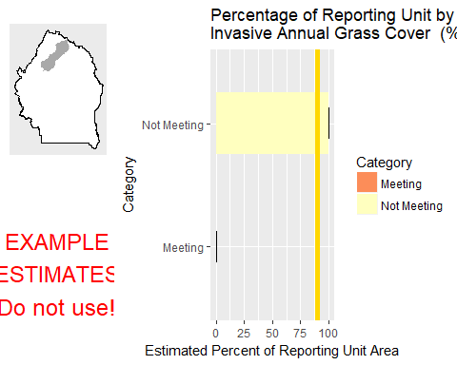

This graph shows the estimated percentage of the reporting unit in different categories for the specified indicator. 80% confidence intervals around those estimates are provided as error bars. The yellow bar denotes the landscape criterion, or point at which an objective is deemed to be met or not met as defined in the Sample Design Worksheet.

#### Results Table

|  |  |  |  |  |  |
| --- | --- | --- | --- | --- | --- |
| Category | # Points | % Area Estimate | Std. Error | Lower 80% CI | Upper 80% CI |
| Meeting | 1 | 0.07277 | 0.1454 | 0 | 0.3578 |
| Not Meeting | 1 | 99.93 | 0.1454 | 99.64 | 100 |

This table gives the analysis results for the specified indicator and reporting unit, and contains the data used to create the graph above.

#### Management Question: Land Health Standard: Native Plants

#### Indicator: Non-invasive Perennial Grass Cover (%, any hit)



This graph shows the estimated percentage of the reporting unit in different categories for the specified indicator. 80% confidence intervals around those estimates are provided as error bars. The yellow bar denotes the landscape criterion, or point at which an objective is deemed to be met or not met as defined in the Sample Design Worksheet.

#### Results Table

|  |  |  |  |  |  |
| --- | --- | --- | --- | --- | --- |
| Category | # Points | % Area Estimate | Std. Error | Lower 80% CI | Upper 80% CI |
| Meeting | 1 | 0.07277 | 0.1454 | 0 | 0.3578 |
| Not Meeting | 1 | 99.93 | 0.1454 | 99.64 | 100 |

This table gives the analysis results for the specified indicator and reporting unit, and contains the data used to create the graph above.

#### Indicator: Average Non-invasive Perennial Grass Height (cm)



This graph shows the estimated percentage of the reporting unit in different categories for the specified indicator. 80% confidence intervals around those estimates are provided as error bars. The yellow bar denotes the landscape criterion, or point at which an objective is deemed to be met or not met as defined in the Sample Design Worksheet.

#### Results Table

|  |  |  |  |  |  |
| --- | --- | --- | --- | --- | --- |
| Category | # Points | % Area Estimate | Std. Error | Lower 80% CI | Upper 80% CI |
| Meeting | 1 | 0.07277 | 0.1454 | 0 | 0.3578 |
| Not Meeting | 1 | 99.93 | 0.1454 | 99.64 | 100 |

This table gives the analysis results for the specified indicator and reporting unit, and contains the data used to create the graph above.

### Watershed : Upper Battle Creek

#### Management Question: Land Health Standard: Wildlife

#### Indicator: Non-invasive Perennial Grass Cover (%, any hit)

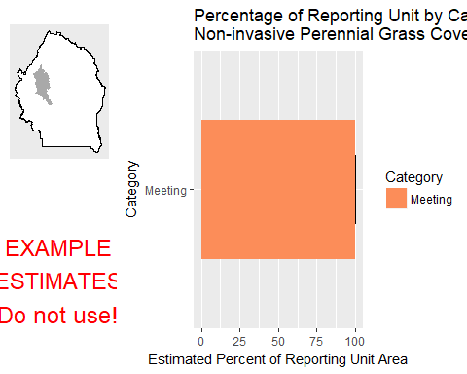

This graph shows the estimated percentage of the reporting unit in different categories for the specified indicator. 80% confidence intervals around those estimates are provided as error bars. The yellow bar denotes the landscape criterion, or point at which an objective is deemed to be met or not met as defined in the Sample Design Worksheet.

#### Results Table

|  |  |  |  |  |  |
| --- | --- | --- | --- | --- | --- |
| Category | # Points | % Area Estimate | Std. Error | Lower 80% CI | Upper 80% CI |
| Meeting | 2 | 100 | 0 | 100 | 100 |

This table gives the analysis results for the specified indicator and reporting unit, and contains the data used to create the graph above.

#### Indicator: Average Non-invasive Perennial Grass Height (cm)

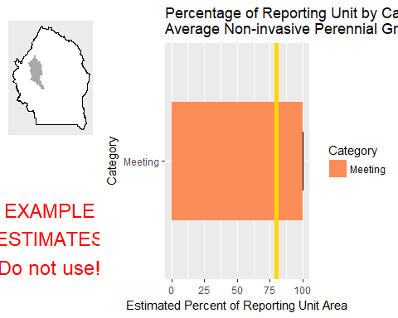

This graph shows the estimated percentage of the reporting unit in different categories for the specified indicator. 80% confidence intervals around those estimates are provided as error bars. The yellow bar denotes the landscape criterion, or point at which an objective is deemed to be met or not met as defined in the Sample Design Worksheet.

#### Results Table

|  |  |  |  |  |  |
| --- | --- | --- | --- | --- | --- |
| Category | # Points | % Area Estimate | Std. Error | Lower 80% CI | Upper 80% CI |
| Meeting | 2 | 100 | 0 | 100 | 100 |

This table gives the analysis results for the specified indicator and reporting unit, and contains the data used to create the graph above.

#### Indicator: Average Sagebrush Height (cm)

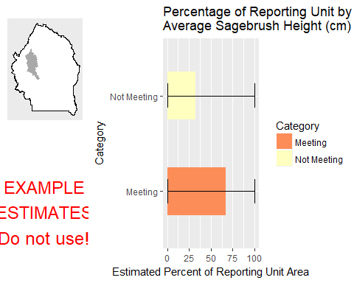

This graph shows the estimated percentage of the reporting unit in different categories for the specified indicator. 80% confidence intervals around those estimates are provided as error bars. The yellow bar denotes the landscape criterion, or point at which an objective is deemed to be met or not met as defined in the Sample Design Worksheet.

#### Results Table

|  |  |  |  |  |  |
| --- | --- | --- | --- | --- | --- |
| Category | # Points | % Area Estimate | Std. Error | Lower 80% CI | Upper 80% CI |
| Meeting | 1 | 67.2 | 44.08 | 0 | 100 |
| Not Meeting | 1 | 32.8 | 44.08 | 0 | 100 |

This table gives the analysis results for the specified indicator and reporting unit, and contains the data used to create the graph above.

#### Management Question: Land Health Standard: Watershed

#### Indicator: Percent in Gaps 101-200 cm

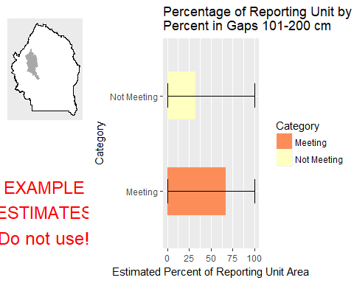

This graph shows the estimated percentage of the reporting unit in different categories for the specified indicator. 80% confidence intervals around those estimates are provided as error bars. The yellow bar denotes the landscape criterion, or point at which an objective is deemed to be met or not met as defined in the Sample Design Worksheet.

#### Results Table

|  |  |  |  |  |  |
| --- | --- | --- | --- | --- | --- |
| Category | # Points | % Area Estimate | Std. Error | Lower 80% CI | Upper 80% CI |
| Meeting | 1 | 67.2 | 44.08 | 0 | 100 |
| Not Meeting | 1 | 32.8 | 44.08 | 0 | 100 |

This table gives the analysis results for the specified indicator and reporting unit, and contains the data used to create the graph above.

#### Indicator: Percent in Gaps > 200 cm

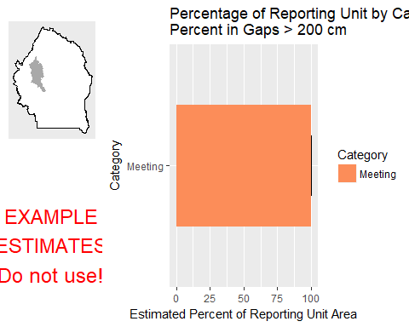

This graph shows the estimated percentage of the reporting unit in different categories for the specified indicator. 80% confidence intervals around those estimates are provided as error bars. The yellow bar denotes the landscape criterion, or point at which an objective is deemed to be met or not met as defined in the Sample Design Worksheet.

#### Results Table

|  |  |  |  |  |  |
| --- | --- | --- | --- | --- | --- |
| Category | # Points | % Area Estimate | Std. Error | Lower 80% CI | Upper 80% CI |
| Meeting | 2 | 100 | 0 | 100 | 100 |

This table gives the analysis results for the specified indicator and reporting unit, and contains the data used to create the graph above.

#### Indicator: Percent in Gaps 51-100 cm

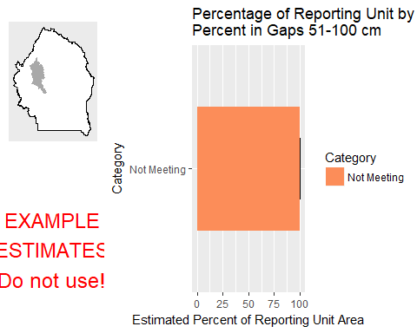

This graph shows the estimated percentage of the reporting unit in different categories for the specified indicator. 80% confidence intervals around those estimates are provided as error bars. The yellow bar denotes the landscape criterion, or point at which an objective is deemed to be met or not met as defined in the Sample Design Worksheet.

#### Results Table

|  |  |  |  |  |  |
| --- | --- | --- | --- | --- | --- |
| Category | # Points | % Area Estimate | Std. Error | Lower 80% CI | Upper 80% CI |
| Not Meeting | 2 | 100 | 0 | 100 | 100 |

This table gives the analysis results for the specified indicator and reporting unit, and contains the data used to create the graph above.

#### Indicator: Overall Soil Stability Rating

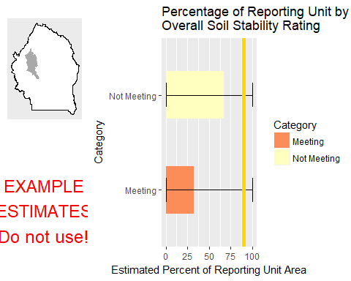

This graph shows the estimated percentage of the reporting unit in different categories for the specified indicator. 80% confidence intervals around those estimates are provided as error bars. The yellow bar denotes the landscape criterion, or point at which an objective is deemed to be met or not met as defined in the Sample Design Worksheet.

#### Results Table

|  |  |  |  |  |  |
| --- | --- | --- | --- | --- | --- |
| Category | # Points | % Area Estimate | Std. Error | Lower 80% CI | Upper 80% CI |
| Meeting | 1 | 32.8 | 44.08 | 0 | 100 |
| Not Meeting | 1 | 67.2 | 44.08 | 0 | 100 |

This table gives the analysis results for the specified indicator and reporting unit, and contains the data used to create the graph above.

#### Management Question: GRSG Habitat Objectives

#### Indicator: Sagebrush Cover (%, any hit)

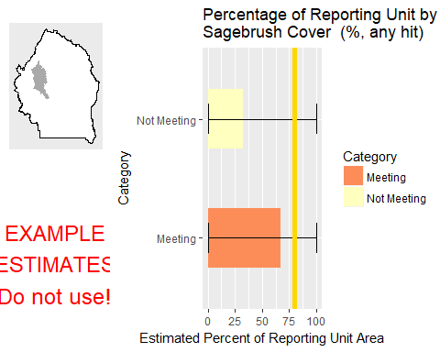

This graph shows the estimated percentage of the reporting unit in different categories for the specified indicator. 80% confidence intervals around those estimates are provided as error bars. The yellow bar denotes the landscape criterion, or point at which an objective is deemed to be met or not met as defined in the Sample Design Worksheet.

#### Results Table

|  |  |  |  |  |  |
| --- | --- | --- | --- | --- | --- |
| Category | # Points | % Area Estimate | Std. Error | Lower 80% CI | Upper 80% CI |
| Meeting | 1 | 67.2 | 44.08 | 0 | 100 |
| Not Meeting | 1 | 32.8 | 44.08 | 0 | 100 |

This table gives the analysis results for the specified indicator and reporting unit, and contains the data used to create the graph above.

#### Management Question: Land Health Standard: Soils

#### Indicator: Percent in Gaps 101-200 cm



This graph shows the estimated percentage of the reporting unit in different categories for the specified indicator. 80% confidence intervals around those estimates are provided as error bars. The yellow bar denotes the landscape criterion, or point at which an objective is deemed to be met or not met as defined in the Sample Design Worksheet.

#### Results Table

|  |  |  |  |  |  |
| --- | --- | --- | --- | --- | --- |
| Category | # Points | % Area Estimate | Std. Error | Lower 80% CI | Upper 80% CI |
| Meeting | 1 | 67.2 | 44.08 | 0 | 100 |
| Not Meeting | 1 | 32.8 | 44.08 | 0 | 100 |

This table gives the analysis results for the specified indicator and reporting unit, and contains the data used to create the graph above.

#### Indicator: Percent in Gaps > 200 cm



This graph shows the estimated percentage of the reporting unit in different categories for the specified indicator. 80% confidence intervals around those estimates are provided as error bars. The yellow bar denotes the landscape criterion, or point at which an objective is deemed to be met or not met as defined in the Sample Design Worksheet.

#### Results Table

|  |  |  |  |  |  |
| --- | --- | --- | --- | --- | --- |
| Category | # Points | % Area Estimate | Std. Error | Lower 80% CI | Upper 80% CI |
| Meeting | 2 | 100 | 0 | 100 | 100 |

This table gives the analysis results for the specified indicator and reporting unit, and contains the data used to create the graph above.

#### Indicator: Percent in Gaps 51-100 cm



This graph shows the estimated percentage of the reporting unit in different categories for the specified indicator. 80% confidence intervals around those estimates are provided as error bars. The yellow bar denotes the landscape criterion, or point at which an objective is deemed to be met or not met as defined in the Sample Design Worksheet.

#### Results Table

|  |  |  |  |  |  |
| --- | --- | --- | --- | --- | --- |
| Category | # Points | % Area Estimate | Std. Error | Lower 80% CI | Upper 80% CI |
| Not Meeting | 2 | 100 | 0 | 100 | 100 |

This table gives the analysis results for the specified indicator and reporting unit, and contains the data used to create the graph above.

#### Indicator: Overall Soil Stability Rating



This graph shows the estimated percentage of the reporting unit in different categories for the specified indicator. 80% confidence intervals around those estimates are provided as error bars. The yellow bar denotes the landscape criterion, or point at which an objective is deemed to be met or not met as defined in the Sample Design Worksheet.

#### Results Table

|  |  |  |  |  |  |
| --- | --- | --- | --- | --- | --- |
| Category | # Points | % Area Estimate | Std. Error | Lower 80% CI | Upper 80% CI |
| Meeting | 1 | 32.8 | 44.08 | 0 | 100 |
| Not Meeting | 1 | 67.2 | 44.08 | 0 | 100 |

This table gives the analysis results for the specified indicator and reporting unit, and contains the data used to create the graph above.

#### Management Question: Land Health Standard: Biotic Integrity

#### Indicator: Invasive Annual Grass Cover (%, any hit)

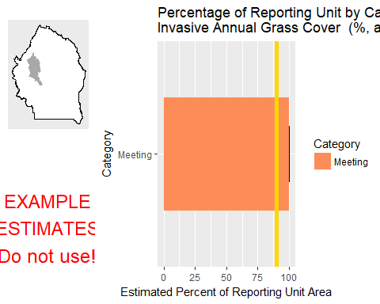

This graph shows the estimated percentage of the reporting unit in different categories for the specified indicator. 80% confidence intervals around those estimates are provided as error bars. The yellow bar denotes the landscape criterion, or point at which an objective is deemed to be met or not met as defined in the Sample Design Worksheet.

#### Results Table

|  |  |  |  |  |  |
| --- | --- | --- | --- | --- | --- |
| Category | # Points | % Area Estimate | Std. Error | Lower 80% CI | Upper 80% CI |
| Meeting | 2 | 100 | 0 | 100 | 100 |

This table gives the analysis results for the specified indicator and reporting unit, and contains the data used to create the graph above.

#### Management Question: Land Health Standard: Native Plants

#### Indicator: Non-invasive Perennial Grass Cover (%, any hit)



This graph shows the estimated percentage of the reporting unit in different categories for the specified indicator. 80% confidence intervals around those estimates are provided as error bars. The yellow bar denotes the landscape criterion, or point at which an objective is deemed to be met or not met as defined in the Sample Design Worksheet.

#### Results Table

|  |  |  |  |  |  |
| --- | --- | --- | --- | --- | --- |
| Category | # Points | % Area Estimate | Std. Error | Lower 80% CI | Upper 80% CI |
| Meeting | 2 | 100 | 0 | 100 | 100 |

This table gives the analysis results for the specified indicator and reporting unit, and contains the data used to create the graph above.

#### Indicator: Average Non-invasive Perennial Grass Height (cm)



This graph shows the estimated percentage of the reporting unit in different categories for the specified indicator. 80% confidence intervals around those estimates are provided as error bars. The yellow bar denotes the landscape criterion, or point at which an objective is deemed to be met or not met as defined in the Sample Design Worksheet.

#### Results Table

|  |  |  |  |  |  |
| --- | --- | --- | --- | --- | --- |
| Category | # Points | % Area Estimate | Std. Error | Lower 80% CI | Upper 80% CI |
| Meeting | 2 | 100 | 0 | 100 | 100 |

This table gives the analysis results for the specified indicator and reporting unit, and contains the data used to create the graph above.

### Watershed : Upper Blue Creek

#### Management Question: Land Health Standard: Wildlife

#### Indicator: Non-invasive Perennial Grass Cover (%, any hit)

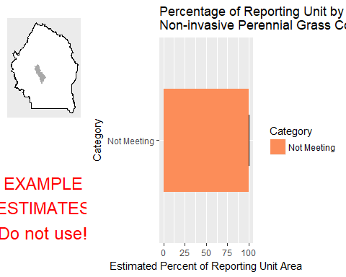

This graph shows the estimated percentage of the reporting unit in different categories for the specified indicator. 80% confidence intervals around those estimates are provided as error bars. The yellow bar denotes the landscape criterion, or point at which an objective is deemed to be met or not met as defined in the Sample Design Worksheet.

#### Results Table

|  |  |  |  |  |  |
| --- | --- | --- | --- | --- | --- |
| Category | # Points | % Area Estimate | Std. Error | Lower 80% CI | Upper 80% CI |
| Not Meeting | 2 | 100 | 0 | 100 | 100 |

This table gives the analysis results for the specified indicator and reporting unit, and contains the data used to create the graph above.

#### Indicator: Average Non-invasive Perennial Grass Height (cm)

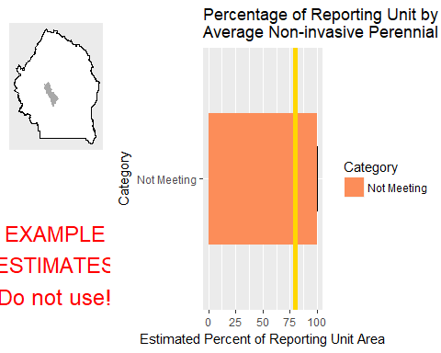

This graph shows the estimated percentage of the reporting unit in different categories for the specified indicator. 80% confidence intervals around those estimates are provided as error bars. The yellow bar denotes the landscape criterion, or point at which an objective is deemed to be met or not met as defined in the Sample Design Worksheet.

#### Results Table

|  |  |  |  |  |  |
| --- | --- | --- | --- | --- | --- |
| Category | # Points | % Area Estimate | Std. Error | Lower 80% CI | Upper 80% CI |
| Not Meeting | 2 | 100 | 0 | 100 | 100 |

This table gives the analysis results for the specified indicator and reporting unit, and contains the data used to create the graph above.

#### Management Question: Land Health Standard: Watershed

#### Indicator: Percent in Gaps 101-200 cm

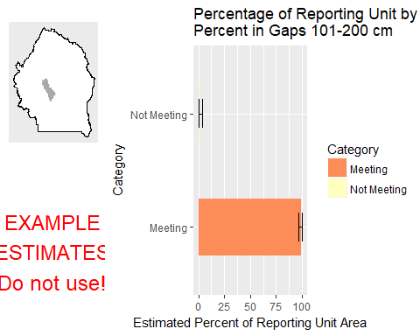

This graph shows the estimated percentage of the reporting unit in different categories for the specified indicator. 80% confidence intervals around those estimates are provided as error bars. The yellow bar denotes the landscape criterion, or point at which an objective is deemed to be met or not met as defined in the Sample Design Worksheet.

#### Results Table

|  |  |  |  |  |  |
| --- | --- | --- | --- | --- | --- |
| Category | # Points | % Area Estimate | Std. Error | Lower 80% CI | Upper 80% CI |
| Meeting | 1 | 99.22 | 1.547 | 96.19 | 100 |
| Not Meeting | 1 | 0.7793 | 1.547 | 0 | 3.811 |

This table gives the analysis results for the specified indicator and reporting unit, and contains the data used to create the graph above.

#### Indicator: Percent in Gaps > 200 cm

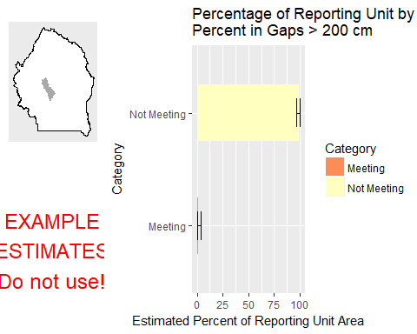

This graph shows the estimated percentage of the reporting unit in different categories for the specified indicator. 80% confidence intervals around those estimates are provided as error bars. The yellow bar denotes the landscape criterion, or point at which an objective is deemed to be met or not met as defined in the Sample Design Worksheet.

#### Results Table

|  |  |  |  |  |  |
| --- | --- | --- | --- | --- | --- |
| Category | # Points | % Area Estimate | Std. Error | Lower 80% CI | Upper 80% CI |
| Meeting | 1 | 0.7793 | 1.547 | 0 | 3.811 |
| Not Meeting | 1 | 99.22 | 1.547 | 96.19 | 100 |

This table gives the analysis results for the specified indicator and reporting unit, and contains the data used to create the graph above.

#### Indicator: Percent in Gaps 51-100 cm

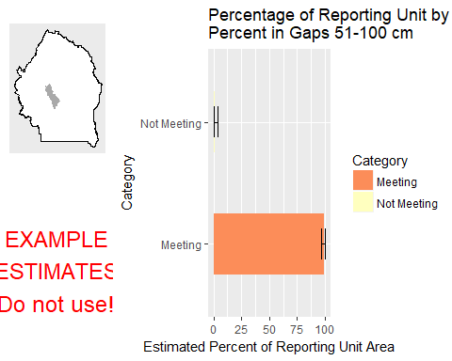

This graph shows the estimated percentage of the reporting unit in different categories for the specified indicator. 80% confidence intervals around those estimates are provided as error bars. The yellow bar denotes the landscape criterion, or point at which an objective is deemed to be met or not met as defined in the Sample Design Worksheet.

#### Results Table

|  |  |  |  |  |  |
| --- | --- | --- | --- | --- | --- |
| Category | # Points | % Area Estimate | Std. Error | Lower 80% CI | Upper 80% CI |
| Meeting | 1 | 99.22 | 1.547 | 96.19 | 100 |
| Not Meeting | 1 | 0.7793 | 1.547 | 0 | 3.811 |

This table gives the analysis results for the specified indicator and reporting unit, and contains the data used to create the graph above.

#### Indicator: Overall Soil Stability Rating

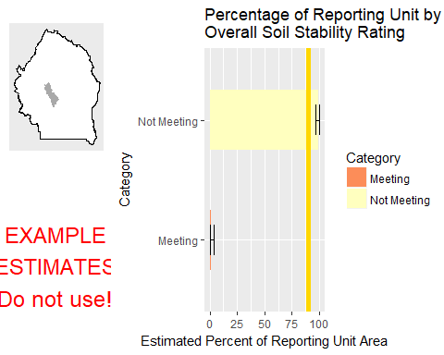

This graph shows the estimated percentage of the reporting unit in different categories for the specified indicator. 80% confidence intervals around those estimates are provided as error bars. The yellow bar denotes the landscape criterion, or point at which an objective is deemed to be met or not met as defined in the Sample Design Worksheet.

#### Results Table

|  |  |  |  |  |  |
| --- | --- | --- | --- | --- | --- |
| Category | # Points | % Area Estimate | Std. Error | Lower 80% CI | Upper 80% CI |
| Meeting | 1 | 0.7793 | 1.547 | 0 | 3.811 |
| Not Meeting | 1 | 99.22 | 1.547 | 96.19 | 100 |

This table gives the analysis results for the specified indicator and reporting unit, and contains the data used to create the graph above.

#### Management Question: GRSG Habitat Objectives

#### Indicator: Sagebrush Cover (%, any hit)

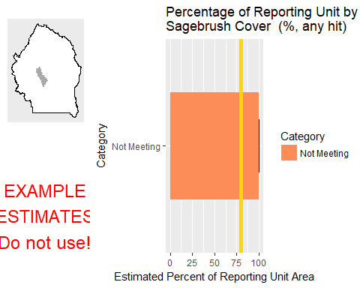

This graph shows the estimated percentage of the reporting unit in different categories for the specified indicator. 80% confidence intervals around those estimates are provided as error bars. The yellow bar denotes the landscape criterion, or point at which an objective is deemed to be met or not met as defined in the Sample Design Worksheet.

#### Results Table

|  |  |  |  |  |  |
| --- | --- | --- | --- | --- | --- |
| Category | # Points | % Area Estimate | Std. Error | Lower 80% CI | Upper 80% CI |
| Not Meeting | 2 | 100 | 0 | 100 | 100 |

This table gives the analysis results for the specified indicator and reporting unit, and contains the data used to create the graph above.

#### Management Question: Land Health Standard: Soils

#### Indicator: Percent in Gaps 101-200 cm



This graph shows the estimated percentage of the reporting unit in different categories for the specified indicator. 80% confidence intervals around those estimates are provided as error bars. The yellow bar denotes the landscape criterion, or point at which an objective is deemed to be met or not met as defined in the Sample Design Worksheet.

#### Results Table

|  |  |  |  |  |  |
| --- | --- | --- | --- | --- | --- |
| Category | # Points | % Area Estimate | Std. Error | Lower 80% CI | Upper 80% CI |
| Meeting | 1 | 99.22 | 1.547 | 96.19 | 100 |
| Not Meeting | 1 | 0.7793 | 1.547 | 0 | 3.811 |

This table gives the analysis results for the specified indicator and reporting unit, and contains the data used to create the graph above.

#### Indicator: Percent in Gaps > 200 cm



This graph shows the estimated percentage of the reporting unit in different categories for the specified indicator. 80% confidence intervals around those estimates are provided as error bars. The yellow bar denotes the landscape criterion, or point at which an objective is deemed to be met or not met as defined in the Sample Design Worksheet.

#### Results Table

|  |  |  |  |  |  |
| --- | --- | --- | --- | --- | --- |
| Category | # Points | % Area Estimate | Std. Error | Lower 80% CI | Upper 80% CI |
| Meeting | 1 | 0.7793 | 1.547 | 0 | 3.811 |
| Not Meeting | 1 | 99.22 | 1.547 | 96.19 | 100 |

This table gives the analysis results for the specified indicator and reporting unit, and contains the data used to create the graph above.

#### Indicator: Percent in Gaps 51-100 cm



This graph shows the estimated percentage of the reporting unit in different categories for the specified indicator. 80% confidence intervals around those estimates are provided as error bars. The yellow bar denotes the landscape criterion, or point at which an objective is deemed to be met or not met as defined in the Sample Design Worksheet.

#### Results Table

|  |  |  |  |  |  |
| --- | --- | --- | --- | --- | --- |
| Category | # Points | % Area Estimate | Std. Error | Lower 80% CI | Upper 80% CI |
| Meeting | 1 | 99.22 | 1.547 | 96.19 | 100 |
| Not Meeting | 1 | 0.7793 | 1.547 | 0 | 3.811 |

This table gives the analysis results for the specified indicator and reporting unit, and contains the data used to create the graph above.

#### Indicator: Overall Soil Stability Rating



This graph shows the estimated percentage of the reporting unit in different categories for the specified indicator. 80% confidence intervals around those estimates are provided as error bars. The yellow bar denotes the landscape criterion, or point at which an objective is deemed to be met or not met as defined in the Sample Design Worksheet.

#### Results Table

|  |  |  |  |  |  |
| --- | --- | --- | --- | --- | --- |
| Category | # Points | % Area Estimate | Std. Error | Lower 80% CI | Upper 80% CI |
| Meeting | 1 | 0.7793 | 1.547 | 0 | 3.811 |
| Not Meeting | 1 | 99.22 | 1.547 | 96.19 | 100 |

This table gives the analysis results for the specified indicator and reporting unit, and contains the data used to create the graph above.

#### Management Question: Land Health Standard: Biotic Integrity

#### Indicator: Invasive Annual Grass Cover (%, any hit)

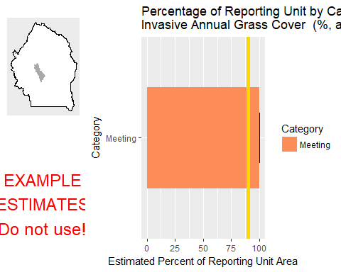

This graph shows the estimated percentage of the reporting unit in different categories for the specified indicator. 80% confidence intervals around those estimates are provided as error bars. The yellow bar denotes the landscape criterion, or point at which an objective is deemed to be met or not met as defined in the Sample Design Worksheet.

#### Results Table

|  |  |  |  |  |  |
| --- | --- | --- | --- | --- | --- |
| Category | # Points | % Area Estimate | Std. Error | Lower 80% CI | Upper 80% CI |
| Meeting | 2 | 100 | 0 | 100 | 100 |

This table gives the analysis results for the specified indicator and reporting unit, and contains the data used to create the graph above.

#### Management Question: Land Health Standard: Native Plants

#### Indicator: Non-invasive Perennial Grass Cover (%, any hit)



This graph shows the estimated percentage of the reporting unit in different categories for the specified indicator. 80% confidence intervals around those estimates are provided as error bars. The yellow bar denotes the landscape criterion, or point at which an objective is deemed to be met or not met as defined in the Sample Design Worksheet.

#### Results Table

|  |  |  |  |  |  |
| --- | --- | --- | --- | --- | --- |
| Category | # Points | % Area Estimate | Std. Error | Lower 80% CI | Upper 80% CI |
| Not Meeting | 2 | 100 | 0 | 100 | 100 |

This table gives the analysis results for the specified indicator and reporting unit, and contains the data used to create the graph above.

#### Indicator: Average Non-invasive Perennial Grass Height (cm)



This graph shows the estimated percentage of the reporting unit in different categories for the specified indicator. 80% confidence intervals around those estimates are provided as error bars. The yellow bar denotes the landscape criterion, or point at which an objective is deemed to be met or not met as defined in the Sample Design Worksheet.

#### Results Table

|  |  |  |  |  |  |
| --- | --- | --- | --- | --- | --- |
| Category | # Points | % Area Estimate | Std. Error | Lower 80% CI | Upper 80% CI |
| Not Meeting | 2 | 100 | 0 | 100 | 100 |

This table gives the analysis results for the specified indicator and reporting unit, and contains the data used to create the graph above.

### Watershed : Upper Sheep Creek

#### Management Question: Land Health Standard: Wildlife

#### Indicator: Non-invasive Perennial Grass Cover (%, any hit)

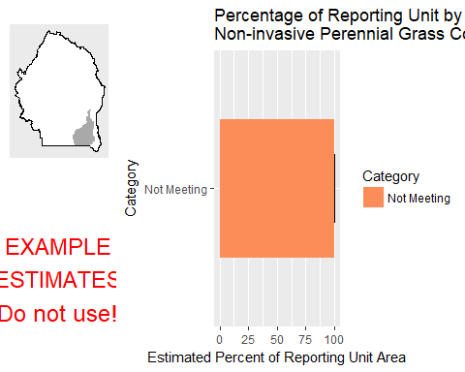

This graph shows the estimated percentage of the reporting unit in different categories for the specified indicator. 80% confidence intervals around those estimates are provided as error bars. The yellow bar denotes the landscape criterion, or point at which an objective is deemed to be met or not met as defined in the Sample Design Worksheet.

#### Results Table

|  |  |  |  |  |  |
| --- | --- | --- | --- | --- | --- |
| Category | # Points | % Area Estimate | Std. Error | Lower 80% CI | Upper 80% CI |
| Not Meeting | 2 | 100 | 0 | 100 | 100 |

This table gives the analysis results for the specified indicator and reporting unit, and contains the data used to create the graph above.

#### Indicator: Average Non-invasive Perennial Grass Height (cm)

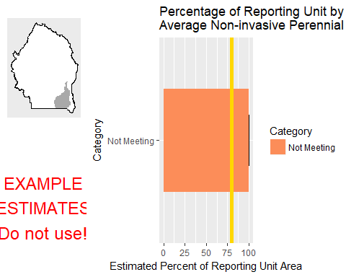

This graph shows the estimated percentage of the reporting unit in different categories for the specified indicator. 80% confidence intervals around those estimates are provided as error bars. The yellow bar denotes the landscape criterion, or point at which an objective is deemed to be met or not met as defined in the Sample Design Worksheet.

#### Results Table

|  |  |  |  |  |  |
| --- | --- | --- | --- | --- | --- |
| Category | # Points | % Area Estimate | Std. Error | Lower 80% CI | Upper 80% CI |
| Not Meeting | 2 | 100 | 0 | 100 | 100 |

This table gives the analysis results for the specified indicator and reporting unit, and contains the data used to create the graph above.

#### Management Question: Land Health Standard: Watershed

#### Indicator: Percent in Gaps 101-200 cm

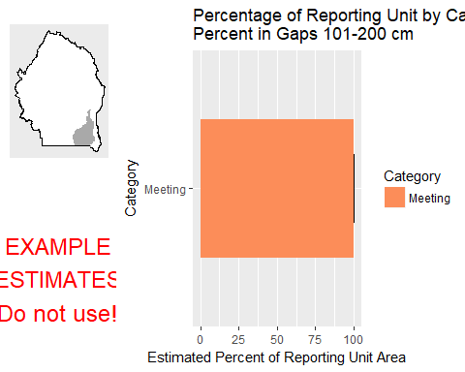

This graph shows the estimated percentage of the reporting unit in different categories for the specified indicator. 80% confidence intervals around those estimates are provided as error bars. The yellow bar denotes the landscape criterion, or point at which an objective is deemed to be met or not met as defined in the Sample Design Worksheet.

#### Results Table

|  |  |  |  |  |  |
| --- | --- | --- | --- | --- | --- |
| Category | # Points | % Area Estimate | Std. Error | Lower 80% CI | Upper 80% CI |
| Meeting | 2 | 100 | 0 | 100 | 100 |

This table gives the analysis results for the specified indicator and reporting unit, and contains the data used to create the graph above.

#### Indicator: Percent in Gaps > 200 cm

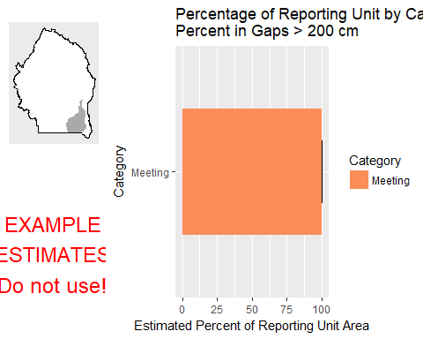

This graph shows the estimated percentage of the reporting unit in different categories for the specified indicator. 80% confidence intervals around those estimates are provided as error bars. The yellow bar denotes the landscape criterion, or point at which an objective is deemed to be met or not met as defined in the Sample Design Worksheet.

#### Results Table

|  |  |  |  |  |  |
| --- | --- | --- | --- | --- | --- |
| Category | # Points | % Area Estimate | Std. Error | Lower 80% CI | Upper 80% CI |
| Meeting | 2 | 100 | 0 | 100 | 100 |

This table gives the analysis results for the specified indicator and reporting unit, and contains the data used to create the graph above.

#### Indicator: Percent in Gaps 51-100 cm

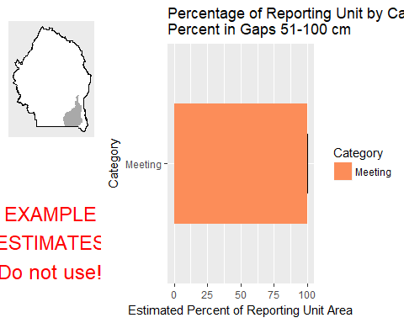

This graph shows the estimated percentage of the reporting unit in different categories for the specified indicator. 80% confidence intervals around those estimates are provided as error bars. The yellow bar denotes the landscape criterion, or point at which an objective is deemed to be met or not met as defined in the Sample Design Worksheet.

#### Results Table

|  |  |  |  |  |  |
| --- | --- | --- | --- | --- | --- |
| Category | # Points | % Area Estimate | Std. Error | Lower 80% CI | Upper 80% CI |
| Meeting | 2 | 100 | 0 | 100 | 100 |

This table gives the analysis results for the specified indicator and reporting unit, and contains the data used to create the graph above.

#### Indicator: Overall Soil Stability Rating

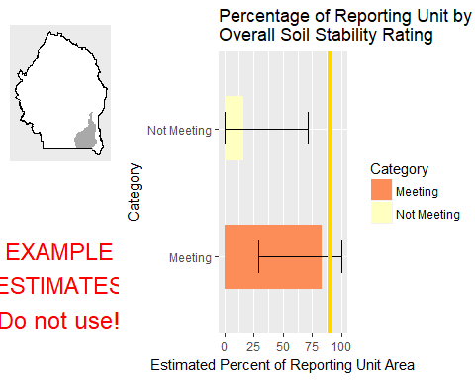

This graph shows the estimated percentage of the reporting unit in different categories for the specified indicator. 80% confidence intervals around those estimates are provided as error bars. The yellow bar denotes the landscape criterion, or point at which an objective is deemed to be met or not met as defined in the Sample Design Worksheet.

#### Results Table

|  |  |  |  |  |  |
| --- | --- | --- | --- | --- | --- |
| Category | # Points | % Area Estimate | Std. Error | Lower 80% CI | Upper 80% CI |
| Meeting | 1 | 83.35 | 27.75 | 28.96 | 100 |
| Not Meeting | 1 | 16.65 | 27.75 | 0 | 71.04 |

This table gives the analysis results for the specified indicator and reporting unit, and contains the data used to create the graph above.

#### Management Question: Land Health Standard: Soils

#### Indicator: Percent in Gaps 101-200 cm



This graph shows the estimated percentage of the reporting unit in different categories for the specified indicator. 80% confidence intervals around those estimates are provided as error bars. The yellow bar denotes the landscape criterion, or point at which an objective is deemed to be met or not met as defined in the Sample Design Worksheet.

#### Results Table

|  |  |  |  |  |  |
| --- | --- | --- | --- | --- | --- |
| Category | # Points | % Area Estimate | Std. Error | Lower 80% CI | Upper 80% CI |
| Meeting | 2 | 100 | 0 | 100 | 100 |

This table gives the analysis results for the specified indicator and reporting unit, and contains the data used to create the graph above.

#### Indicator: Percent in Gaps > 200 cm



This graph shows the estimated percentage of the reporting unit in different categories for the specified indicator. 80% confidence intervals around those estimates are provided as error bars. The yellow bar denotes the landscape criterion, or point at which an objective is deemed to be met or not met as defined in the Sample Design Worksheet.

#### Results Table

|  |  |  |  |  |  |
| --- | --- | --- | --- | --- | --- |
| Category | # Points | % Area Estimate | Std. Error | Lower 80% CI | Upper 80% CI |
| Meeting | 2 | 100 | 0 | 100 | 100 |

This table gives the analysis results for the specified indicator and reporting unit, and contains the data used to create the graph above.

#### Indicator: Percent in Gaps 51-100 cm



This graph shows the estimated percentage of the reporting unit in different categories for the specified indicator. 80% confidence intervals around those estimates are provided as error bars. The yellow bar denotes the landscape criterion, or point at which an objective is deemed to be met or not met as defined in the Sample Design Worksheet.

#### Results Table

|  |  |  |  |  |  |
| --- | --- | --- | --- | --- | --- |
| Category | # Points | % Area Estimate | Std. Error | Lower 80% CI | Upper 80% CI |
| Meeting | 2 | 100 | 0 | 100 | 100 |

This table gives the analysis results for the specified indicator and reporting unit, and contains the data used to create the graph above.

#### Indicator: Overall Soil Stability Rating



This graph shows the estimated percentage of the reporting unit in different categories for the specified indicator. 80% confidence intervals around those estimates are provided as error bars. The yellow bar denotes the landscape criterion, or point at which an objective is deemed to be met or not met as defined in the Sample Design Worksheet.

#### Results Table

|  |  |  |  |  |  |
| --- | --- | --- | --- | --- | --- |
| Category | # Points | % Area Estimate | Std. Error | Lower 80% CI | Upper 80% CI |
| Meeting | 1 | 83.35 | 27.75 | 28.96 | 100 |
| Not Meeting | 1 | 16.65 | 27.75 | 0 | 71.04 |

This table gives the analysis results for the specified indicator and reporting unit, and contains the data used to create the graph above.

#### Management Question: Land Health Standard: Biotic Integrity

#### Indicator: Invasive Annual Grass Cover (%, any hit)

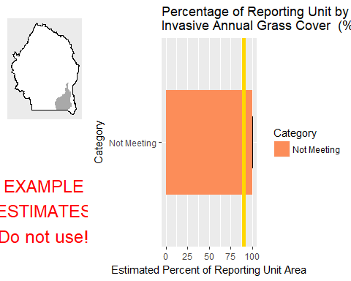

This graph shows the estimated percentage of the reporting unit in different categories for the specified indicator. 80% confidence intervals around those estimates are provided as error bars. The yellow bar denotes the landscape criterion, or point at which an objective is deemed to be met or not met as defined in the Sample Design Worksheet.

#### Results Table

|  |  |  |  |  |  |
| --- | --- | --- | --- | --- | --- |
| Category | # Points | % Area Estimate | Std. Error | Lower 80% CI | Upper 80% CI |
| Not Meeting | 2 | 100 | 0 | 100 | 100 |

This table gives the analysis results for the specified indicator and reporting unit, and contains the data used to create the graph above.

#### Management Question: Land Health Standard: Native Plants

#### Indicator: Non-invasive Perennial Grass Cover (%, any hit)



This graph shows the estimated percentage of the reporting unit in different categories for the specified indicator. 80% confidence intervals around those estimates are provided as error bars. The yellow bar denotes the landscape criterion, or point at which an objective is deemed to be met or not met as defined in the Sample Design Worksheet.

#### Results Table

|  |  |  |  |  |  |
| --- | --- | --- | --- | --- | --- |
| Category | # Points | % Area Estimate | Std. Error | Lower 80% CI | Upper 80% CI |
| Not Meeting | 2 | 100 | 0 | 100 | 100 |

This table gives the analysis results for the specified indicator and reporting unit, and contains the data used to create the graph above.

#### Indicator: Average Non-invasive Perennial Grass Height (cm)



This graph shows the estimated percentage of the reporting unit in different categories for the specified indicator. 80% confidence intervals around those estimates are provided as error bars. The yellow bar denotes the landscape criterion, or point at which an objective is deemed to be met or not met as defined in the Sample Design Worksheet.

#### Results Table

|  |  |  |  |  |  |
| --- | --- | --- | --- | --- | --- |
| Category | # Points | % Area Estimate | Std. Error | Lower 80% CI | Upper 80% CI |
| Not Meeting | 2 | 100 | 0 | 100 | 100 |

This table gives the analysis results for the specified indicator and reporting unit, and contains the data used to create the graph above.

### Watershed : Yatahoney Creek-Owyhee River

#### Management Question: Land Health Standard: Wildlife

#### Indicator: Average Non-invasive Perennial Grass Height (cm)

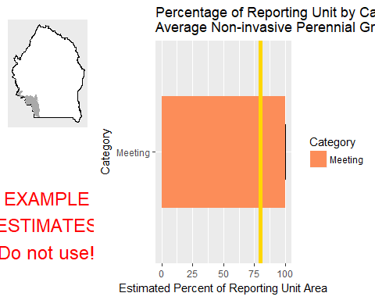

This graph shows the estimated percentage of the reporting unit in different categories for the specified indicator. 80% confidence intervals around those estimates are provided as error bars. The yellow bar denotes the landscape criterion, or point at which an objective is deemed to be met or not met as defined in the Sample Design Worksheet.

#### Results Table

|  |  |  |  |  |  |
| --- | --- | --- | --- | --- | --- |
| Category | # Points | % Area Estimate | Std. Error | Lower 80% CI | Upper 80% CI |
| Meeting | 2 | 100 | 0 | 100 | 100 |

This table gives the analysis results for the specified indicator and reporting unit, and contains the data used to create the graph above.

#### Management Question: Land Health Standard: Watershed

#### Indicator: Percent in Gaps 101-200 cm

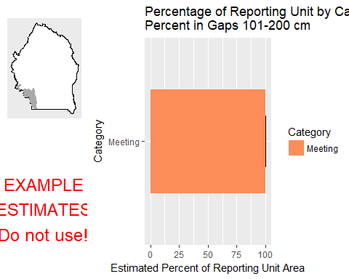

This graph shows the estimated percentage of the reporting unit in different categories for the specified indicator. 80% confidence intervals around those estimates are provided as error bars. The yellow bar denotes the landscape criterion, or point at which an objective is deemed to be met or not met as defined in the Sample Design Worksheet.

#### Results Table

|  |  |  |  |  |  |
| --- | --- | --- | --- | --- | --- |
| Category | # Points | % Area Estimate | Std. Error | Lower 80% CI | Upper 80% CI |
| Meeting | 2 | 100 | 0 | 100 | 100 |

This table gives the analysis results for the specified indicator and reporting unit, and contains the data used to create the graph above.

#### Indicator: Percent in Gaps > 200 cm

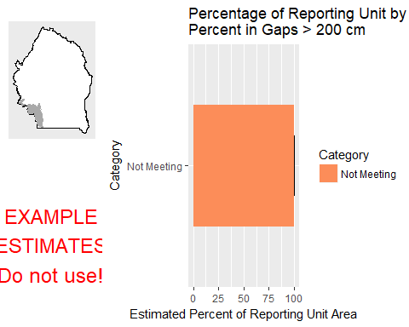

This graph shows the estimated percentage of the reporting unit in different categories for the specified indicator. 80% confidence intervals around those estimates are provided as error bars. The yellow bar denotes the landscape criterion, or point at which an objective is deemed to be met or not met as defined in the Sample Design Worksheet.

#### Results Table

|  |  |  |  |  |  |
| --- | --- | --- | --- | --- | --- |
| Category | # Points | % Area Estimate | Std. Error | Lower 80% CI | Upper 80% CI |
| Not Meeting | 2 | 100 | 0 | 100 | 100 |

This table gives the analysis results for the specified indicator and reporting unit, and contains the data used to create the graph above.

#### Indicator: Percent in Gaps 51-100 cm

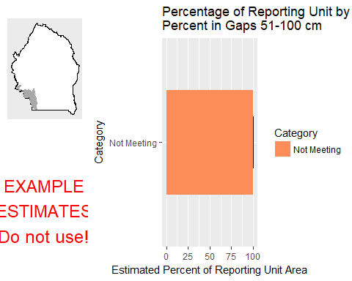

This graph shows the estimated percentage of the reporting unit in different categories for the specified indicator. 80% confidence intervals around those estimates are provided as error bars. The yellow bar denotes the landscape criterion, or point at which an objective is deemed to be met or not met as defined in the Sample Design Worksheet.

#### Results Table

|  |  |  |  |  |  |
| --- | --- | --- | --- | --- | --- |
| Category | # Points | % Area Estimate | Std. Error | Lower 80% CI | Upper 80% CI |
| Not Meeting | 2 | 100 | 0 | 100 | 100 |

This table gives the analysis results for the specified indicator and reporting unit, and contains the data used to create the graph above.

#### Management Question: GRSG Habitat Objectives

#### Indicator: Sagebrush Cover (%, any hit)

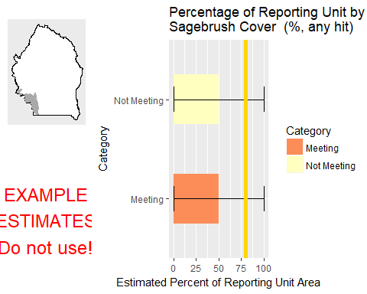

This graph shows the estimated percentage of the reporting unit in different categories for the specified indicator. 80% confidence intervals around those estimates are provided as error bars. The yellow bar denotes the landscape criterion, or point at which an objective is deemed to be met or not met as defined in the Sample Design Worksheet.

#### Results Table

|  |  |  |  |  |  |
| --- | --- | --- | --- | --- | --- |
| Category | # Points | % Area Estimate | Std. Error | Lower 80% CI | Upper 80% CI |
| Meeting | 1 | 50 | 50 | 0 | 100 |
| Not Meeting | 1 | 50 | 50 | 0 | 100 |

This table gives the analysis results for the specified indicator and reporting unit, and contains the data used to create the graph above.

#### Management Question: Land Health Standard: Soils

#### Indicator: Percent in Gaps 101-200 cm



This graph shows the estimated percentage of the reporting unit in different categories for the specified indicator. 80% confidence intervals around those estimates are provided as error bars. The yellow bar denotes the landscape criterion, or point at which an objective is deemed to be met or not met as defined in the Sample Design Worksheet.

#### Results Table

|  |  |  |  |  |  |
| --- | --- | --- | --- | --- | --- |
| Category | # Points | % Area Estimate | Std. Error | Lower 80% CI | Upper 80% CI |
| Meeting | 2 | 100 | 0 | 100 | 100 |

This table gives the analysis results for the specified indicator and reporting unit, and contains the data used to create the graph above.

#### Indicator: Percent in Gaps > 200 cm



This graph shows the estimated percentage of the reporting unit in different categories for the specified indicator. 80% confidence intervals around those estimates are provided as error bars. The yellow bar denotes the landscape criterion, or point at which an objective is deemed to be met or not met as defined in the Sample Design Worksheet.

#### Results Table

|  |  |  |  |  |  |
| --- | --- | --- | --- | --- | --- |
| Category | # Points | % Area Estimate | Std. Error | Lower 80% CI | Upper 80% CI |
| Not Meeting | 2 | 100 | 0 | 100 | 100 |

This table gives the analysis results for the specified indicator and reporting unit, and contains the data used to create the graph above.

#### Indicator: Percent in Gaps 51-100 cm



This graph shows the estimated percentage of the reporting unit in different categories for the specified indicator. 80% confidence intervals around those estimates are provided as error bars. The yellow bar denotes the landscape criterion, or point at which an objective is deemed to be met or not met as defined in the Sample Design Worksheet.

#### Results Table

|  |  |  |  |  |  |
| --- | --- | --- | --- | --- | --- |
| Category | # Points | % Area Estimate | Std. Error | Lower 80% CI | Upper 80% CI |
| Not Meeting | 2 | 100 | 0 | 100 | 100 |

This table gives the analysis results for the specified indicator and reporting unit, and contains the data used to create the graph above.

#### Management Question: Land Health Standard: Biotic Integrity

#### Indicator: Invasive Annual Grass Cover (%, any hit)

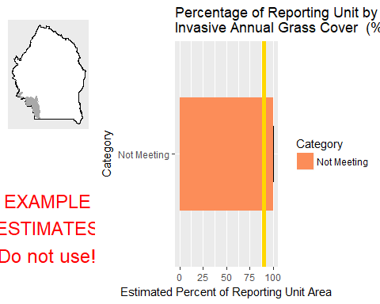

This graph shows the estimated percentage of the reporting unit in different categories for the specified indicator. 80% confidence intervals around those estimates are provided as error bars. The yellow bar denotes the landscape criterion, or point at which an objective is deemed to be met or not met as defined in the Sample Design Worksheet.

#### Results Table

|  |  |  |  |  |  |
| --- | --- | --- | --- | --- | --- |
| Category | # Points | % Area Estimate | Std. Error | Lower 80% CI | Upper 80% CI |
| Not Meeting | 2 | 100 | 0 | 100 | 100 |

This table gives the analysis results for the specified indicator and reporting unit, and contains the data used to create the graph above.

#### Management Question: Land Health Standard: Native Plants

#### Indicator: Average Non-invasive Perennial Grass Height (cm)



This graph shows the estimated percentage of the reporting unit in different categories for the specified indicator. 80% confidence intervals around those estimates are provided as error bars. The yellow bar denotes the landscape criterion, or point at which an objective is deemed to be met or not met as defined in the Sample Design Worksheet.

#### Results Table

|  |  |  |  |  |  |
| --- | --- | --- | --- | --- | --- |
| Category | # Points | % Area Estimate | Std. Error | Lower 80% CI | Upper 80% CI |
| Meeting | 2 | 100 | 0 | 100 | 100 |

This table gives the analysis results for the specified indicator and reporting unit, and contains the data used to create the graph above.

# Spatial Distribution of Core Indicators

These maps depict spatial representation of a selection of AIM indicators that were developed using remote sensing. **These maps are provided for reference only.** To maintain performance of the report document and keep file sizes small, the map products displayed here have been resampled from their native resolution (30m) to a scale of 120m resolution. For detailed analyses or for higher-quality maps, download the products from their source.

# Appendices

* [Summary of methods for data collection](http://aim.landscapetoolbox.org/analysis-reporting/reporting/report-appendices/)
* [Sample design information](http://aim.landscapetoolbox.org/analysis-reporting/reporting/report-appendices/)
* [Analysis methods](http://aim.landscapetoolbox.org/analysis-reporting/reporting/report-appendices/)
* Report Inputs
  + Raw data from TerrADat (?? Point to Data Explorer workbook?)
  + Sample design geodatabase
  + Project planning workbook
  + Reporting units spatial data
  + Remote-sensing datasets