DIMA Quality Control Report

29 November, 2016

Table of Contents

It is important to understand the quality of monitoring data in order to be able to successfully use it to support management decision making. This report is a **Quality Control** assessment of data contained in a DIMA database. The purpose of this report is to identify statistical patterns that exist in core monitoring data (LPI, Vegetation Height, Canopy Gap, Soil Stability, Species Inventory) and to flag data values that are outside of what is expected (i.e., potential errors or extreme events). This report consists of the following sections:

1. DIMA Data Summary
2. Crew Variability Checks
3. Missing Data Checks
4. Suspect Value Checks
5. Temporal Variability in Indicators

# DIMA Data Summary

### Report parameters and options

* DIMA Database: WRFO_2011-2014_DIMA3.1.mdb
* Site: all
* Year: 2014

## Data Summary:

Total number of plots sampled: 50

### Temporal Sampling Window

Knowing when during the year that monitoring data were collected is helpful for evaluating whether or not monitoring data are appropriate or useful for a specific purpose, especially with indicators that are sensitive to phenological stage or time of year when they are collected.

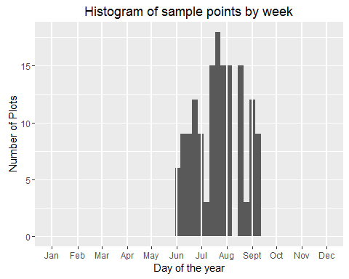

### Sample Locations Map

The map below is drawn from latitude/longitude coordinates contained in the DIMA plots table. This is a useful, fast check if there are gross errors in the plot coordinates that were recorded in DIMA (e.g., Are the plots in the right general place? Are there some plots that are way out of position relative to the others?).

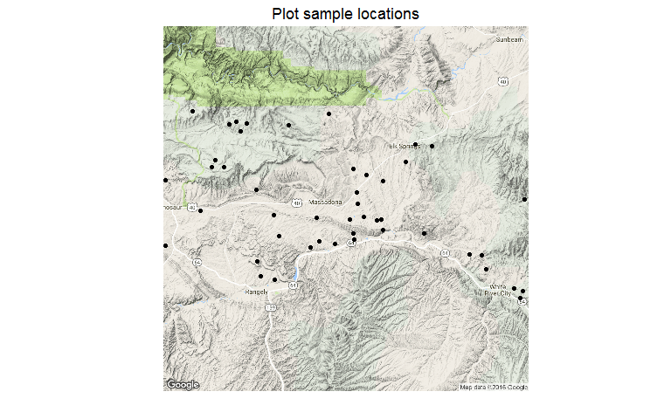

# Observer data summary

Number of plots on which each crew member was an observer.

|  |  |  |  |  |
| --- | --- | --- | --- | --- |
| Observer | Canopy Gap | LPI | Soil Stability | Species Richness |
| Emma Stewart | 47 | 46 | 44 | 46 |
| Stephen White | 46 | 46 | 2 | 3 |
| Tim Rogers | 3 | 3 | 4 | 1 |

## Within-crew Variability by Indicator

For data quality, it is important that all members of a field crew observe and record characteristics and attributes of a site in the same manner. Following a method's protocol is a central part of this, but there can also be differences between crew members in how things like litter or canopy gaps are identified and recorded. Training and calibration are designed to maximize the consistency in data recording among crew members.

One way to look at within-crew variability in aggregate is to plot the range of values for an indicator by observer for a large set of plots. This gives an idea of, on average, how each observer stacks up against the other observers in that crew. Large deviations from the rest of the crew can indicate a crew member that is either not well trained or not calibrated to the rest of the crew. Equivalence tests evaluate the null hypothesis that two crew members are, on average, within a specified equivalence region to each other (i.e., if results are, on average, within a specified amount to each other, we conclude that they're equivalent). The equivalence region for these tests is set to 20% of the overall indicator mean. A low p-value for the significance test indicates that there may be a significant difference in average indicator values between two observers. Equivalence test results should be evaluated alongside the indicator's boxplot.

Just because an observer's average results are not statistically equivalent to other observers does not necessarily mean that one observer is wrong - other factors may be at play. For example, it could be that the observer was recording more often for sites of a certain type (e.g., low-productivity sites) and their average results reflect this. Extreme departures from equivalence, though, should be followed up by examination of an observer's data forms to identify what might be causing the issue.

### Within Crew Equivalence for LPI Indicators

Observer equivalence tests by LPI indicator.

|  |  |  |  |  |  |  |
| --- | --- | --- | --- | --- | --- | --- |
| Indicator | Comparisons | Estimates | Std.Err | Eval.Criterion | t.statistic | p.value |
| pctCanopy | Stephen White - Emma Stewart | 5.5591 | 3.3930 | 14.3726 | -2.5976 | 0.9948 |
| pctBare | Stephen White - Emma Stewart | -2.3129 | 2.1589 | 2.4959 | -2.2274 | 0.9863 |
| pctBasal | Stephen White - Emma Stewart | -0.4545 | 1.4517 | 1.9589 | -1.6625 | 0.9507 |
| pctCheckedPlants | Stephen White - Emma Stewart | -0.7703 | 0.8319 | 1.1034 | -2.2523 | 0.9871 |
| pctLitterTotal | Stephen White - Emma Stewart | -0.7871 | 3.3731 | 10.2438 | -3.2703 | 0.9993 |
| pctLitterUnder | Stephen White - Emma Stewart | 2.0508 | 3.5590 | 8.6904 | -1.8656 | 0.9679 |

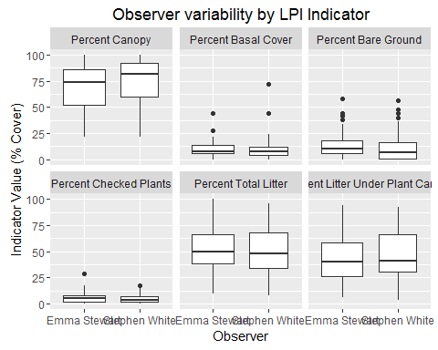

### Within Crew Equivalence for Vegetation Height Indicators

Observer equivalence tests for Vegetation Height indicators.

|  |  |  |  |  |  |  |
| --- | --- | --- | --- | --- | --- | --- |
| Indicator | Comparisons | Estimates | Std.Err | Eval.Criterion | t.statistic | p.value |
| Woody Height | Stephen White - Emma Stewart | -10.7351 | 35.4819 | 21.8916 | -0.9195 | 0.8203 |
| Herbaceous Height | Stephen White - Emma Stewart | 2.2782 | 1.8756 | 6.4629 | -2.2311 | 0.9864 |

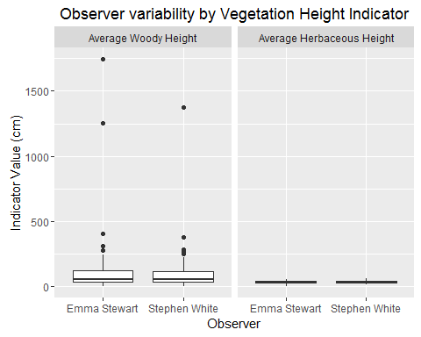

### Within Crew Equivalence for Canopy Gap Indicators

Observer equivalence tests for Canopy Gap indicators.

|  |  |  |  |  |  |  |
| --- | --- | --- | --- | --- | --- | --- |
| Indicator | Comparisons | Estimates | Std.Err | Eval.Criterion | t.statistic | p.value |
| pctCanCat1 | Stephen White - Emma Stewart | -0.0990 | 0.9748 | 1.4974 | -1.6377 | 0.9482 |
| pctCanCat2 | Stephen White - Emma Stewart | -1.9579 | 1.5137 | 2.1165 | -2.6916 | 0.9960 |
| pctCanCat3 | Stephen White - Emma Stewart | -4.8600 | 1.7821 | 2.0445 | -3.8745 | 0.9999 |
| pctCanCat4 | Stephen White - Emma Stewart | -2.7730 | 3.0269 | 2.2321 | -1.6535 | 0.9498 |

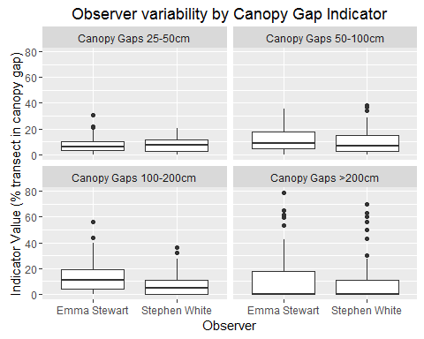

### Within Crew Equivalence for Soil Stability Indicators

Observer equivalence tests for Soil Stability Indicators

|  |  |  |  |  |  |  |
| --- | --- | --- | --- | --- | --- | --- |
| Indicator | Comparisons | Estimates | Std.Err | Eval.Criterion | t.statistic | p.value |
| AllAvgSurf | Tim Rogers - Emma Stewart | -1.1700 | 0.4402 | 0.9228 | -4.7542 | 1.0000 |
| ProAvgSurf | Tim Rogers - Emma Stewart | -1.1700 | 0.4402 | 0.9887 | -4.9038 | 1.0000 |
| NCAvgSurf | Tim Rogers - Emma Stewart | -0.8100 | 0.6581 | 0.8194 | -2.4759 | 0.9915 |
| PctSurf6 | Tim Rogers - Emma Stewart | -0.3089 | 0.1221 | 0.1039 | -3.3812 | 0.9993 |

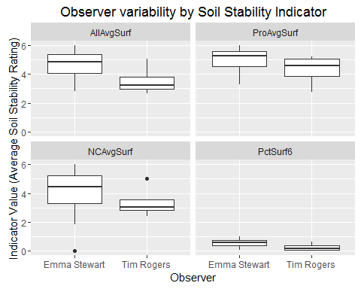

# Missing Value Checks

Queries/results of plots that have missing information

### Plot Information Completeness

Plot characterization information is important for describing the general setting where monitoring data were collected and provide valuable covariate information for analyses. Below is a quick check of how many plots are missing valid values for a set of plot attributes. To find specifically which plots are missing these plot attribute values, check the tblPlots table.

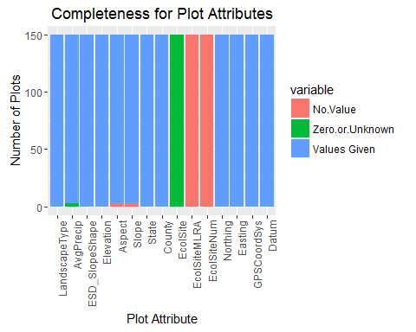

# Data Consistency Checks

Data consistency checks consist of graphs and or statistical analyses of plot and transect-level indicators to flag possible errant data values. It is important to note that results of the data consistency checks do not necessarily mean that the data are wrong, but that it falls outside of what is expected for an indicator. The appropriate steps to take for data that are flagged in a data consistency check is to go back to the original DIMA forms or paper data sheets, field notes, and plot photos to see if something was possibly recorded incorrectly or if there is another explanation for the values.

## LPI Values Checks

### Prevalence of unknown plant codes, "retired" plant codes, and codes not in the PLANTS database

The graph below shows what proportion of the species recorded on a plot were valid plant codes, valid unknown codes, "retired" plant codes, or codes that were not in the PLANTS database. 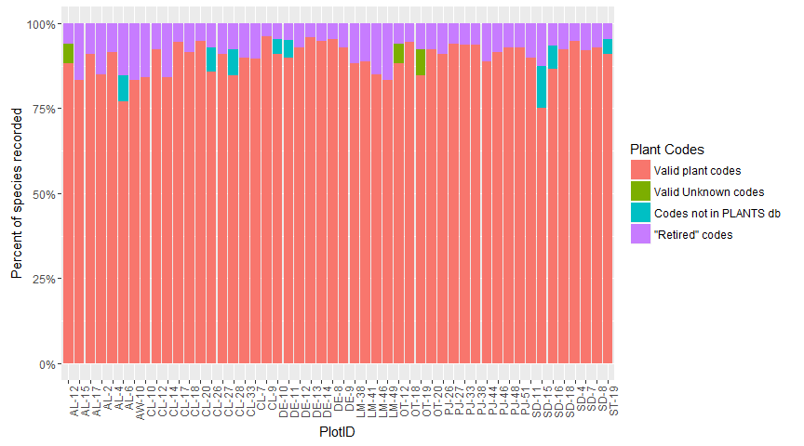

### Check LPI Species Codes

#### Species codes that are not currently valid codes in the PLANTS database

The following plant codes were not found as current codes in the PLANTS database, but were found as a synonym of a current code. The current code and species information is also presented. Please verify that this is the species that was intended before changing any plant codes!

|  |  |  |  |
| --- | --- | --- | --- |
| Code in DIMA | Current PLANTS Code | Scientific Name | Common Name |
| AGSP | PSSPS | Agropyron spicatum Pursh |  |
| ASGL3 | EUGL19 | Aster glaucodes S.F. Blake |  |
| BERE | MARE11 | Berberis repens Lindl. |  |
| BRJA | BRAR5 | Bromus japonicus Thunb. |  |
| ERCO24 | ARCOC4 | Eremogone congesta (Nutt.) Ikonn. |  |
| HIJA | PLJA | Hilaria jamesii (Torr.) Benth. |  |
| LARE | LAOCO | Lappula redowskii auct. non (Hornem.) Greene |  |
| POAG | POPRP2 | Poa agassizensis B. Boivin & D. LÃ¶ve |  |
| RATE | CETE5 | Ranunculus testiculatus Crantz |  |
| STCO3 | ACNED | Stipa columbiana auct. non Macoun |  |

#### Species codes not recognized by the PLANTS database

The following plant codes are not recognized as either a legitimate/current plant code in the USDA PLANTS Database, a synonym of a current code, or an AIM unknown plant code.

|  |  |
| --- | --- |
| PlotID | Code not in PLANTS list |
| CL-26 | AAFF |
| CL-28 | PPGG |
| AL-6 | UUFF |
| ST-19 | AAFF |
| DE-10 | AAFF |
| DE-11 | AAFF |
| SD-15 | CRYPTAA |
| SD-16 | ERIOGAA |

### Vegetation Height Checks

The plots shown in the graphs below were flagged as having vegetation heights considered to be outliers (i.e., more than 1.5 times the inner quartile range of all heights measured on the plot). Extreme values for vegetation height do not necessarily mean that an error has occurred, but height values for these plots should be double-checked to ensure accuracy. If a suspicious height value or an error is identified, please make note of it in the QC tracking worksheet.

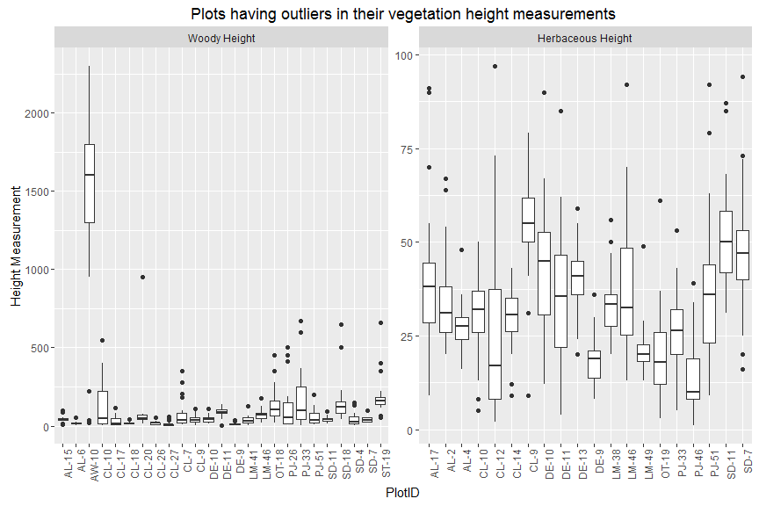

## Canopy Gap Values Check

The total amount of canopy gaps recorded on an AIM plot should correlate well to the plot's LPI estimates of bare ground and non-plant ground cover (e.g., rocks, litter) not under a plant canopy. Extreme differences between these two measures may indicate that there is a problem with the canopy gap estimates for the plot.

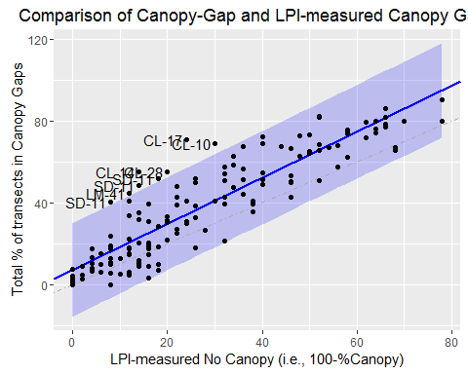

Estimates of total amount of "no canopy" along transects based on Canopy Gap and LPI should be a close reflection of each other. The blue shaded region in the graph is the 95% prediction interval for a regression between the LPI and canopy gap measures of "no canopy." Labeled points are extreme values (outside the 95% prediction interval) and should be more closely examined to determine if they represent errors. Points above the blue-shaded region have a significantly larger estimate of "no canopy" than was recorded in LPI. Those points below the blue-shaded region have significantly lower estimates of "no canopy" from Gap than was recorded in LPI.

## Plot species inventory data

The following plots have species codes listed in their species inventory that are not in the DIMA master species table (tblSpecies) list. This is uncommon, but can happen if you override the DIMA check for a species not being in the table when entering data and then fail to enter the species afterward.

## All plant codes in the species inventory are in the DIMA Species Table. Check above for plant codes not in the USDA PLANTS database master list.

### Comparison of number of species in species inventory to number from LPI.

The graph below plots number of species recorded in a plot's LPI forms by the number of species recorded in the plot-level species inventory. The number of species in the plot inventory should always be greater than or equal to the number of species encountered in LPI. If it is not (i.e., plots below the dashed 1:1 line), then this signifies an error in the plot species inventory and should be noted in the data QC worksheet.

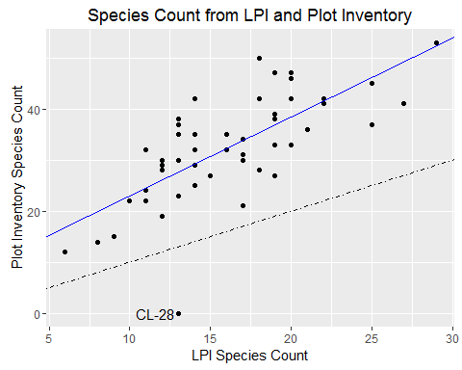

## Temporal Stability of Indicators

Examining the variability of indicators by day across the sampling period can be a useful tool for understanding if there are significant trends due to changes in phenology. For example, values for certain indicators (e.g., forb cover) are believed to be sensitive to when in the field season they are measured. The graphs below look at how DIMA's standard, pre-calculated indicators for each of the core methods over the course of the year. A 2nd-order polynomial trend line is fit to the data to help highlight if there is an overall seasonal pattern to the indicator values. Be sure to interpret the trend line in the light of the amount, spread, and pattern of the underlying points (i.e., plot data).

While this analysis can be valuable for understanding factors that might be influencing monitoring data, the results below should be interpreted with caution - i.e., it is easy to over-interpret these graphs. Many different factors may contribute to a pattern of indicator values by time. For instance, if monitoring plots are visited in such an order that low-productivity sites are visited early in the year and higher-productivity sites visited later, this will manifest as a trend of increaing cover and species diversity with time. In this case, the pattern is a reflection of hitch planning and logistics, and not necessarily due to sampling sites at non-optimal times. Conversely, if data from many different ecosystem types are included in this analysis, then patterns in indicators (e.g., a peak in cover corresponding to peak growing season) may be obscured by data from other systems. Use your knowledge of the data to select plots to include in the analyses and to interpret visible patterns.

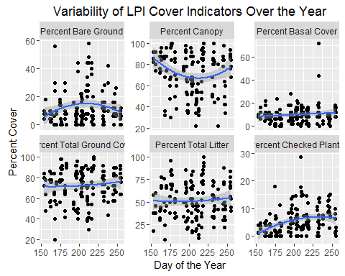

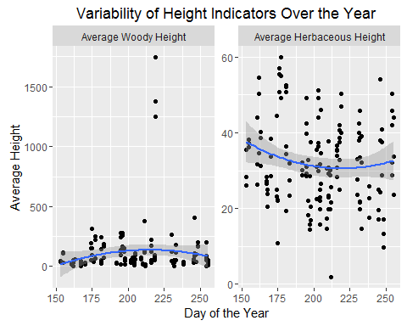

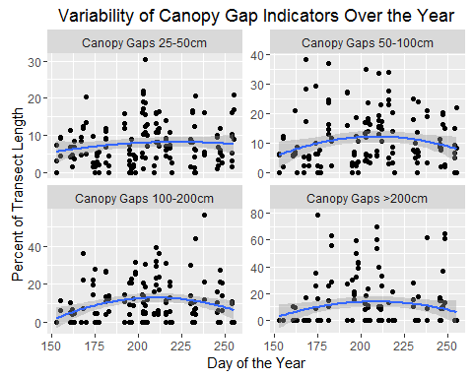

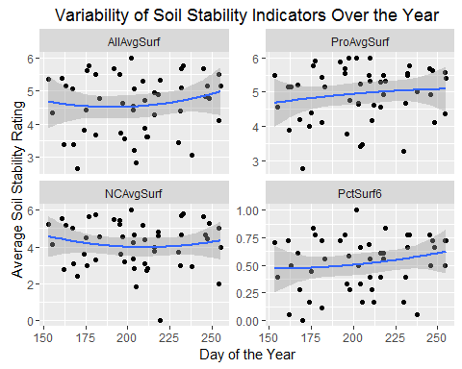

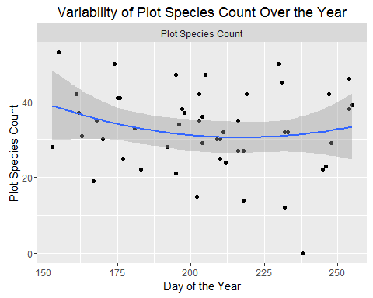

# Implications

Fill out a data quality workbook that summarizes the significant findings from this QC report and identifies any missing data and/or suspect or abberant plot indicator values.