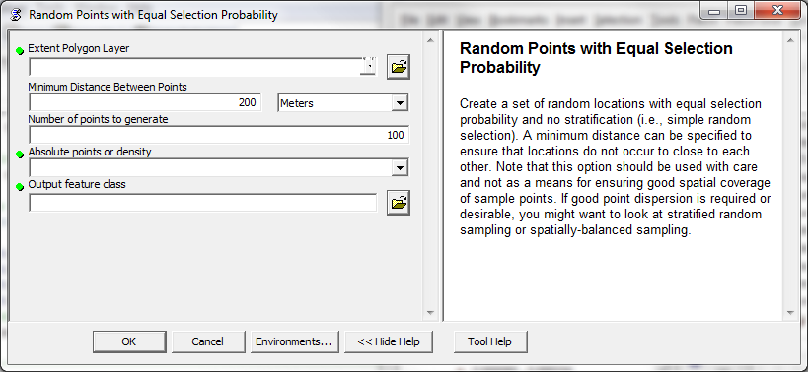

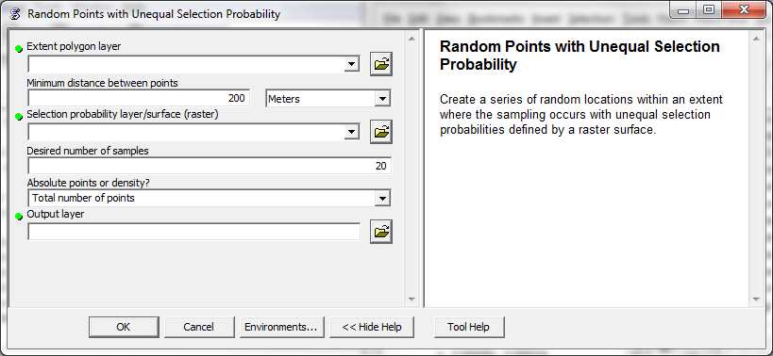

* Summary:
  + For more information on the different sample design options and how to use these tools, visit the following URL in the Landscape Toolbox Wiki:
  + <http://abstracts.rangelandmethods.org/doku.php/general_design_topics:home>
  + Rangeland Methods Guide - Sample Design Considerations and Tools
* Extent Layer:
  + A polygon feature layer that defines the extent within which you want to create random features. If the extent polygon layer consists of multiple polygons, they will be dissolved (merged) before generating the points, and the points will be distributed through the outside-most boundary of all polygons. If you want to generate random points within polygons of a shapefile, try stratified random sampling.
* Feature set of sample units
  + A polygon feature set that defines the sampling units from which the random selection is to be made.
* Minimum distance between points:
  + The minimum distance that is acceptable between random locations. This option is used to keep points from being too close to each other. For example, if sampling plots are circular with a 50m radius, then the minimum distance might be set at 100m so that there is no chance that plots could overlap.
  + Special consideration should be given to the value assigned to this parameter. As illustrated above, the maximum dimension of the plot is recommended as the value for this parameter. When sampling, an assumption is that the entire area for a sample location is measured. If the separation distance corresponds to the plot size, then this assumption is met, but if the separation distance is much larger than the plot size, then only a portion of the effective sample area is being measured (effectively taking a sample of a sample). Thus while large separation distances can produce simple random selections that appear to have good (i.e., relatively even) spatial distribution, this is misleading and other methods (e.g., stratified random or spatially balanced) should be used to generate sample locations with good spatial dispersion.
* Selection probability layer/surface
  + Raster layer that defines the probability of any area being selected for sampling. This raster layer must be numeric, but does not need to be expressed as probabilities (i.e., values from 0 to 1 that all sum to 1). A selection probability layer can be created so that likelihood of selecting a location varies by things like environmental variability or logistical constraints (e.g., slope and/or distance to roads). Varying selection probability by some variable that is strongly correlated with what you're sampling can result in greater sampling efficiency. Varying selection probability without respect to variability in the variable being sampled can result in a loss of sampling efficiency.
* Desired number of samples
  + How many random locations should be generated. This number can be specified in absolute terms (e.g., "I want X points") or as a density (e.g., "I want X points per acre", or "I want 1 point per X acres"). The sample design tool will check to make sure that the desired number of points will fit in the extent polygon given the minimum separation distance specified above.
* Absolute points or density?
  + For the number of samples specified above, what are the units? This number can be specified in absolute terms (e.g., "I want X points") or as a density (e.g., "I want X points per acre", or "I want 1 point per X acres"). The sample design tool will check to make sure that the desired number of points will fit in the extent polygon given the minimum separation distance specified above.
* Output feature class
  + Name and location of the output feature class that will contain the random sampling locations.

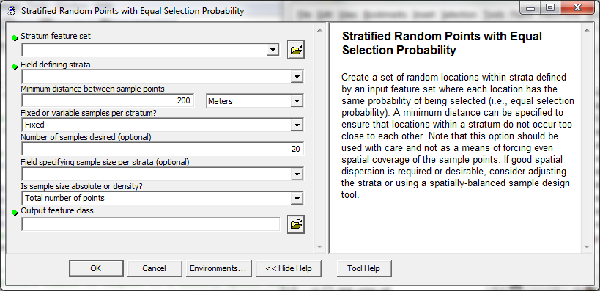

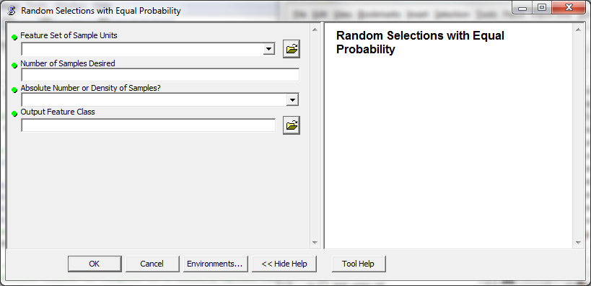

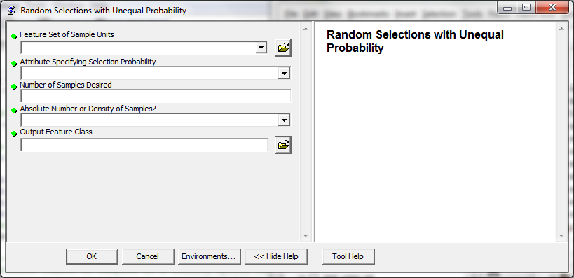

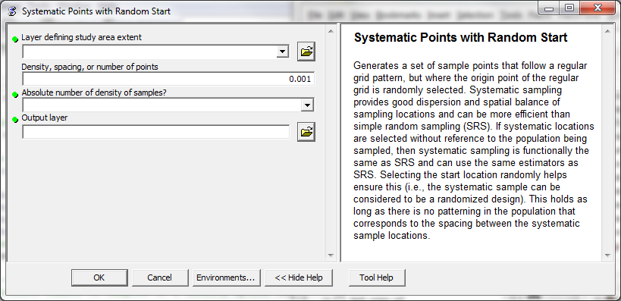

**Spatially-balanced sampling without stratification**

Create s set of random locations that are spatially balanced in nature (i.e., they have a good dispersion across the sampling area). This spatially balanced tool is a modification (and simplification) of the reversed randomized quadrant-recursive raster (RRQRR) tool developed by Theobald and Norman (2006). Unequal selection probabilities (i.e., sampling weights) and existing sample locations can be included in the spatially-balanced sampling. This tool requires a Spatial Analyst license to run.