Module 4 Assignment
Title: Design Secure Network - Diagram and Writeup
Johnna Auman – 9/7/2025

Introduction:

This network is designed to accommodate both in office and remotely connected workers. Security is in place for any and all connections to prevent corruption of the network, connected devices, as well as data and overall integrity of the infrastructure. Some employees will be set up to work remotely using secure VPN connections from their home office or other remote locations. This ensures the security of the network prior to allowing any connections therefore preventing breaches before they have an opportunity to do any damage.

Depending on the purpose of everyone, they will access one of two separate connections that will host separate data and have restrictions in place based on pre-set administrative rights to that data. All users and access will be initiated and maintained by the Security Team that will manage the entire network. This team will also create a Disaster Recovery Plan and have additional hardware and software to seamlessly re-connect the network should a disaster occur. The initial network diagram below shows the existing configuration which will also allow for expansion and changes in the future as needed.

Daily responsibilities for the Security Team will include monitoring and testing all access points to the network as well as looking for any suspicious connections, software updates, downloads, employee access requests, unauthorized access to data, consistent and ongoing updates to security systems and protocols, and Disaster Recovery Protocols. Any suspected data or network breaches will be dealt with immediately and steps laid out in their Standard Security Operations Procedures that all employees will be required to be familiar with and confirm they have reviewed and agreed with these procedures.

Firewalls in place on connections from both inside and outside the network will be constantly monitored and updated as new or potential issues arise. Within the firewalls there will be robust preventative measures to track and stop breaches before they happen. If there is a breach, there will be an SOP for handling that breach and the network will be locked down as much as needed to confine the issue and be able to eliminate it.

Wireless connectivity will require a secure, approved, VPN connection using only the VPN software authorized by the Security Team. The Security Team will configure all VPN connections and will allow or block as they are monitoring the network. Direct employee access to any database will be restricted to those with the highest level of access allowed. For example, for any personnel information, the Security Team as well as approved members of the Human Resources Department will be the only ones with access. Local access to data will be set up on a need to access basis based on the employee’s role.

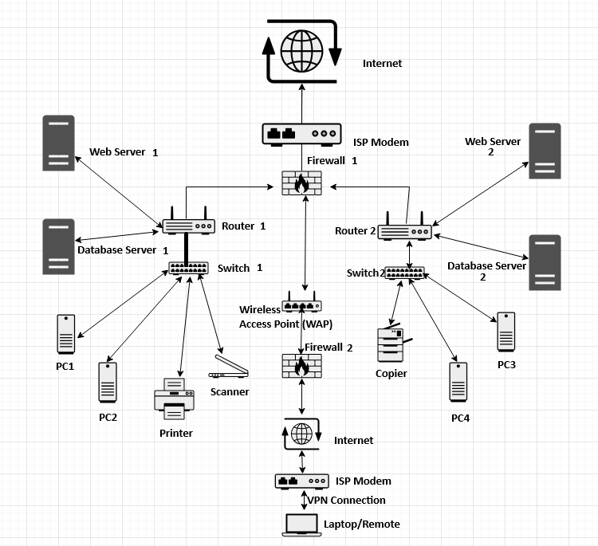
- Please note that traffic from Firewalls to Routers are both coming and going on only a secured connection whether inside or outside of the network.
Over time the network will be constantly reviewed and updated as needed by the Security Team based on business needs, security threats, employee information, hardware and software updates and upgrades. Consistent and ongoing documentation of all changes and reasons for updates will be made available and tracked with detailed descriptions of all changes within the network.

