MODULE 6 PROJECT:
Cloud Security, IAM, and Incident Response

Johnna Auman
johnnakauman@gmail.com
11/30/2025

Executive Summary:
This report summarizes a comprehensive security initiative focused on strengthening our Identity and Access Management (IAM), implementing proactive access controls, and formalizing our incident response capabilities. The project was driven by the need to mitigate risks identified in our existing identity posture and to enhance our resilience against modern cyber threats.
- IAM Findings and Fixes
A review of our identity governance revealed over-permissioned users and excessive administrative role assignments, creating a significant attack surface. To remediate this, we executed a privilege access review, correcting group memberships to align with the principle of least privilege. Furthermore, guest user access settings were tightened to prevent unauthorized external sharing, substantially reducing the risk of credential misuse and lateral movement by an attacker.
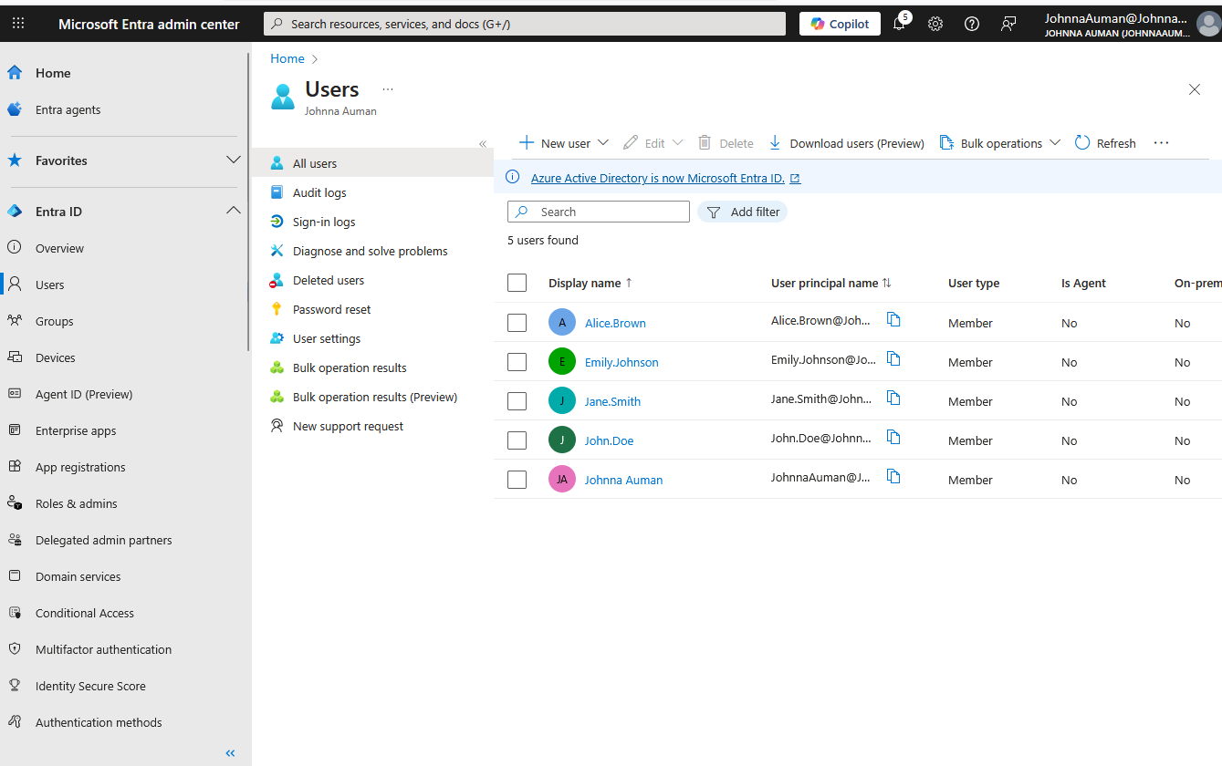
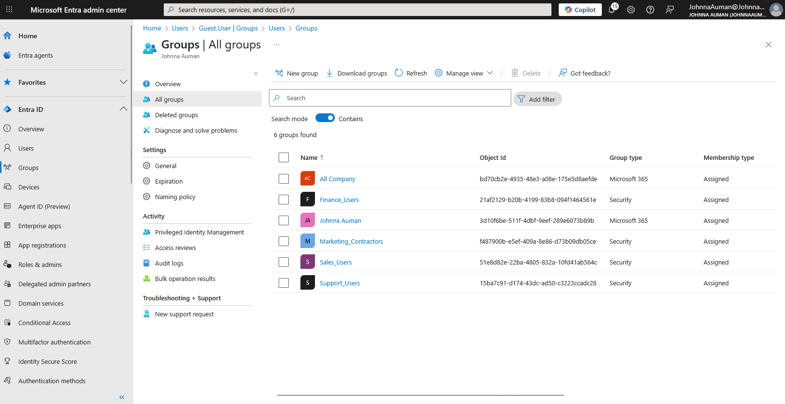
- Implemented Conditional Access
To proactively protect identities, we deployed a set of Conditional Access policies in Microsoft Entra ID. These policies enforce security requirements based on user, device, and location risk. Key implementations include requiring Multi-Factor Authentication (MFA) for all administrative and access to critical applications, blocking legacy authentication protocols, and restricting access from non-compliant or high-risk locations. Successful testing confirms that MFA is now actively enforced, adding a critical layer of defense against credential theft.
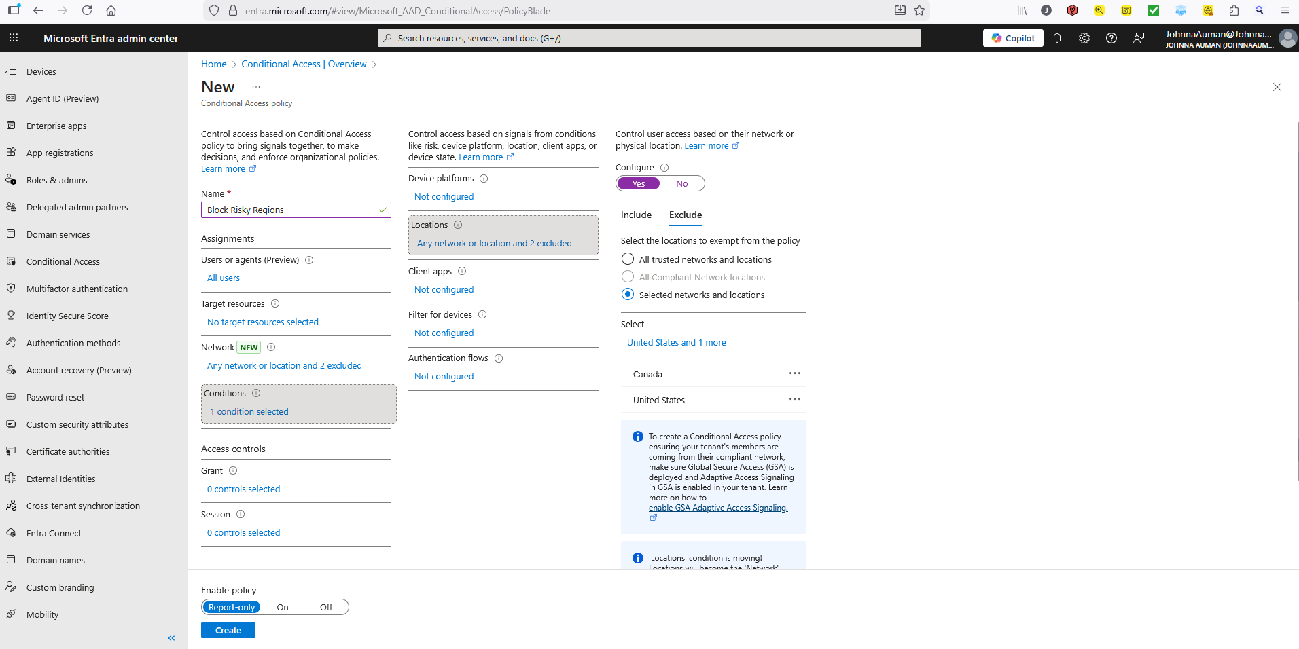
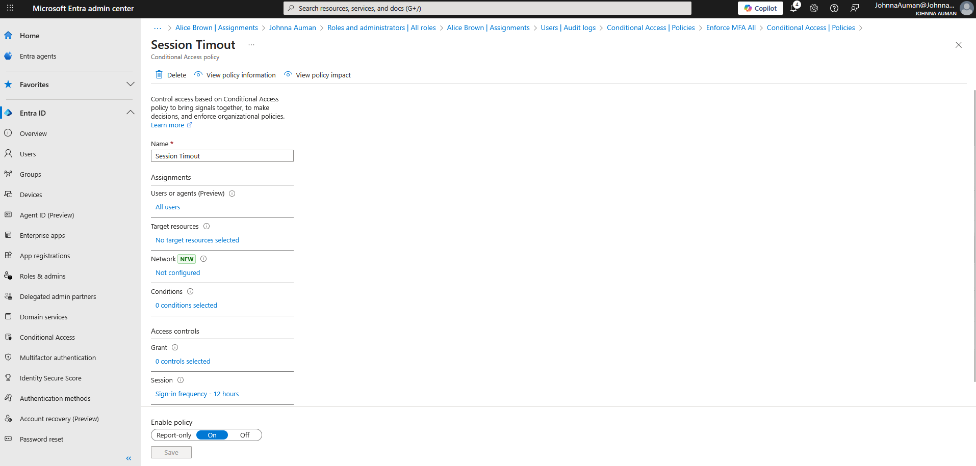
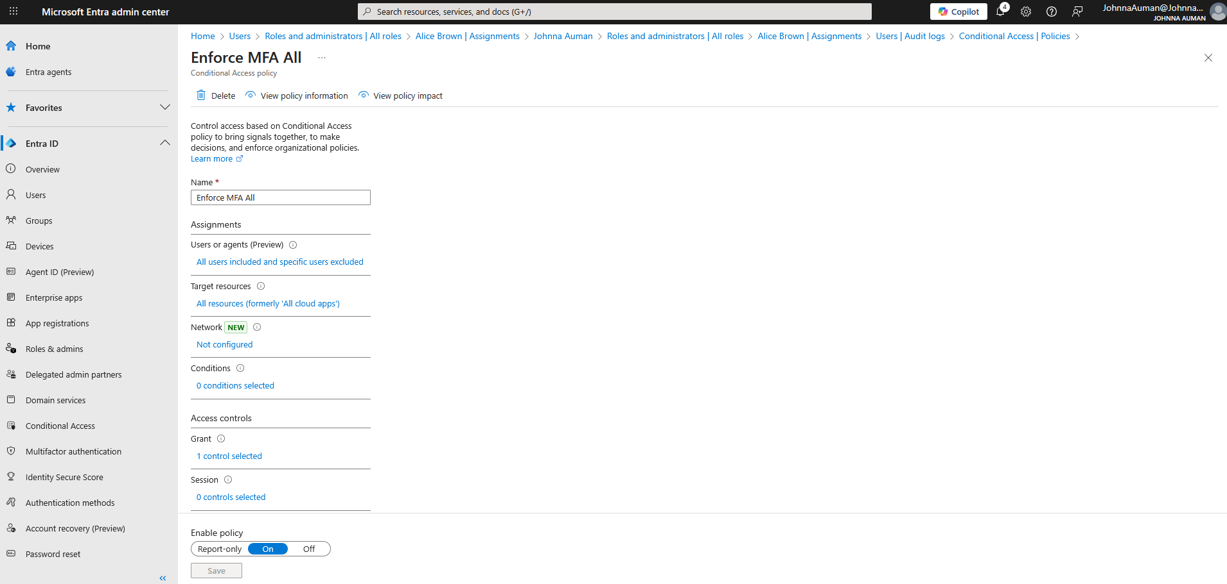
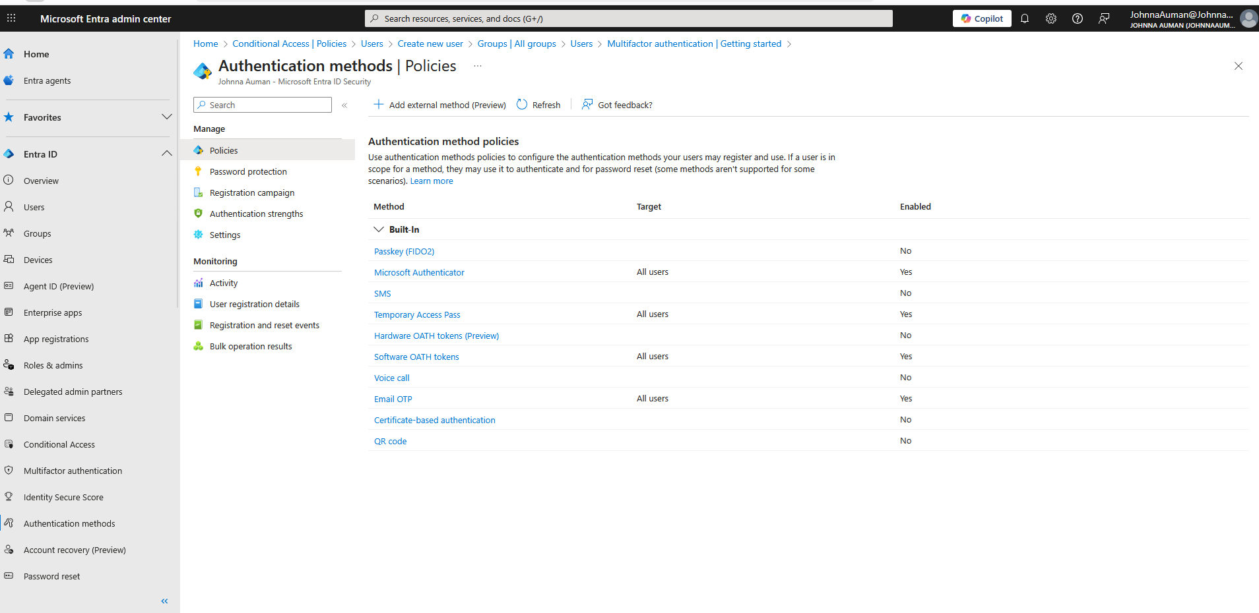

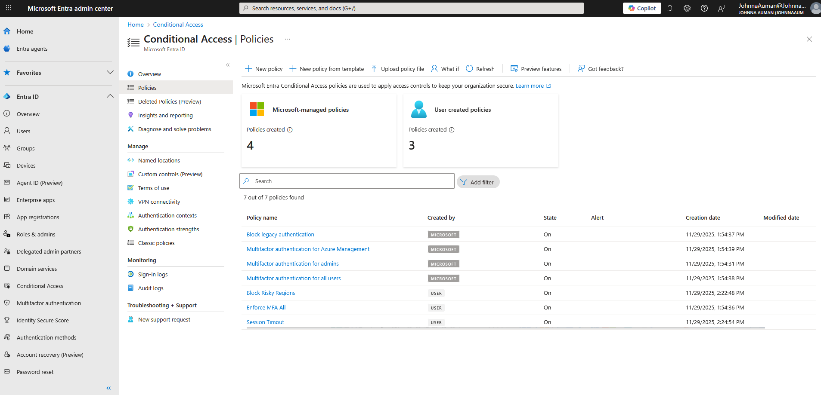
- IRP Playbook Development
A formal Incident Response Plan (IRP) playbook was developed, structured around the NIST 800-61 framework (Preparation, Detection & Analysis, Containment, Eradication & Recovery, and Post-Incident Activity). This playbook provides clear, actionable procedures for the security team. It is supported by integrated monitoring and logging from Microsoft Defender and Entra ID, ensuring we can rapidly detect, investigate, and respond to security events.

- Incident Documentation and Validation
The effectiveness of these new controls was validated through the documentation of a recent email-based threat. Log evidence and email quarantine screenshots demonstrate the system's ability to automatically detect and neutralize malicious messages, preventing them from reaching end-users. This incident underscores the practical value of the implemented security layers.

PHASES SUMMARY:
Phase 1: Preparation
Key Activities & Documentation:
- Incident Response Policy and Plan: Establishing a formal, written plan approved by management that defines what constitutes an incident, the team's authority, and the overall response strategy.
- Incident Response Team (IRT): Forming a CSIRT (Computer Security Incident Response Team) with defined roles, responsibilities, and contact lists.
- Hardening & Protection: Securing networks, systems, and applications through configuration management, patching, and security controls.
- Tools & Resources: Equipping the team with the necessary tools (e.g., forensic software, analyzers, secure communication channels) and adequate capacity for logging and evidence storage.
- Training & Awareness: Conducting regular tabletop exercises and simulations for the IRT and general security awareness training for all staff.
Phase 2: Detection & Analysis
Key Activities & Documentation:
- Incident Detection: Using alerts from IDS/IPS, SIEM systems, antivirus software, user reports, and threat intelligence feeds to identify potential incidents.
- Analysis & Triage: Correlating data from multiple sources to validate the incident, distinguish it from false positives, and prioritize its severity.
- Incident Documentation: Creating an Incident Record from the moment of detection. This log should include timelines, actions taken, and all findings.
- Forensic Evidence Collection: Preserving evidence (e.g., memory dumps, disk images, logs) in a forensically sound manner for analysis and potential legal action.
- Incident Notification: Determining who needs to be informed (e.g., management, legal counsel, public affairs, law enforcement) based on the incident classification.
Phase 3: Containment, Eradication, & Recovery
Key Activities & Documentation:
- Containment Strategy: Choosing a containment approach (short-term vs. long-term). Short-term may be immediate isolation, while long-term involves more permanent measures without disrupting business.
  - Example: Disconnecting a system from the network, blocking a malicious IP address, disabling compromised accounts.
- Eradication: Removing the root cause of the incident.
  - Example: Deleting malware, disabling breached user accounts, patching vulnerabilities, and identifying all affected hosts.
- Recovery: Restoring systems and services to normal operation securely.
  - Example: Restoring systems from clean backups, rebuilding systems from scratch, re-enabling services after verification, and continuous monitoring to ensure the threat does not return.
Phase 4: Post-Incident Activity
This phase focuses on learning from the incident to improve future response efforts.
Key Activities & Documentation:
- Lessons Learned Meeting: Holding a meeting with all key stakeholders soon after the incident to review:
  - What happened?
  - How well did the team respond?
  - What went wrong?
  - What can be improved?
- Incident Report: Creating a formal After-Action Report that details the incident's timeline, impact, root cause, response actions, and lessons learned.
- Evidence Retention: Securely storing all evidence and documentation related to the incident for the required retention period.
- Plan & Procedure Updates: Using the lessons learned to update the Incident Response Plan, security policies, and procedures to prevent a recurrence.

The Post-Incident Activity phase feeds directly back into the Preparation phase, creating a cycle of continuous improvement. An incident is never just an endpoint; it's an opportunity to become more resilient.

SCREENSHOTS:

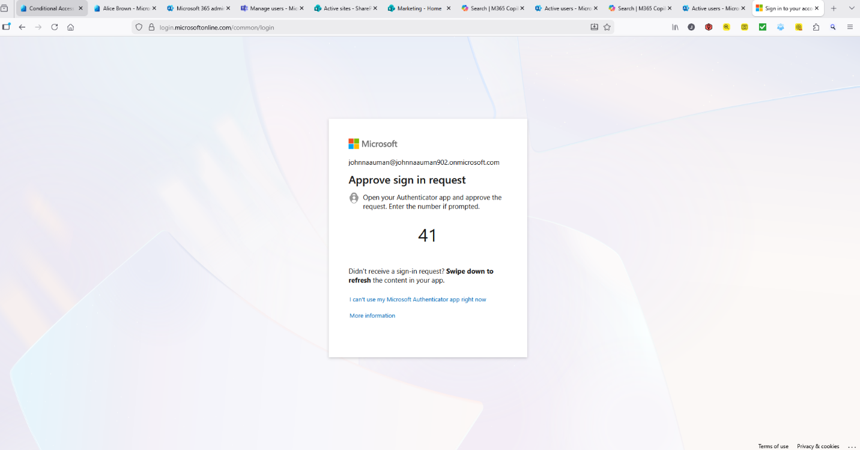
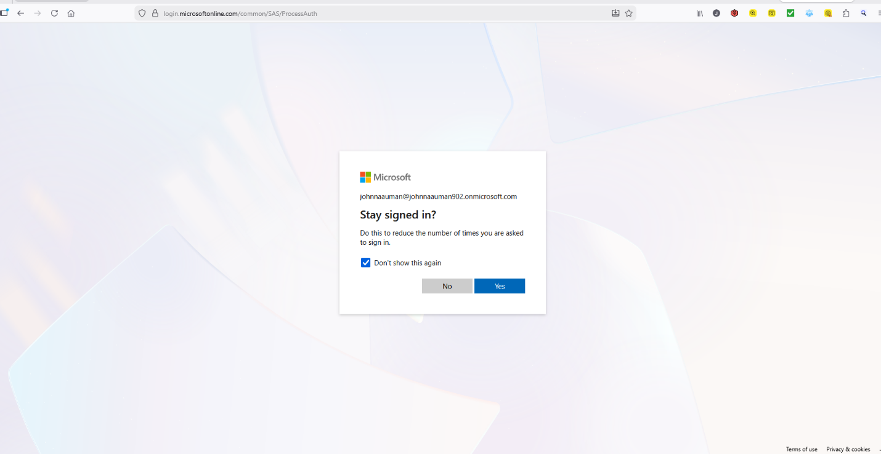

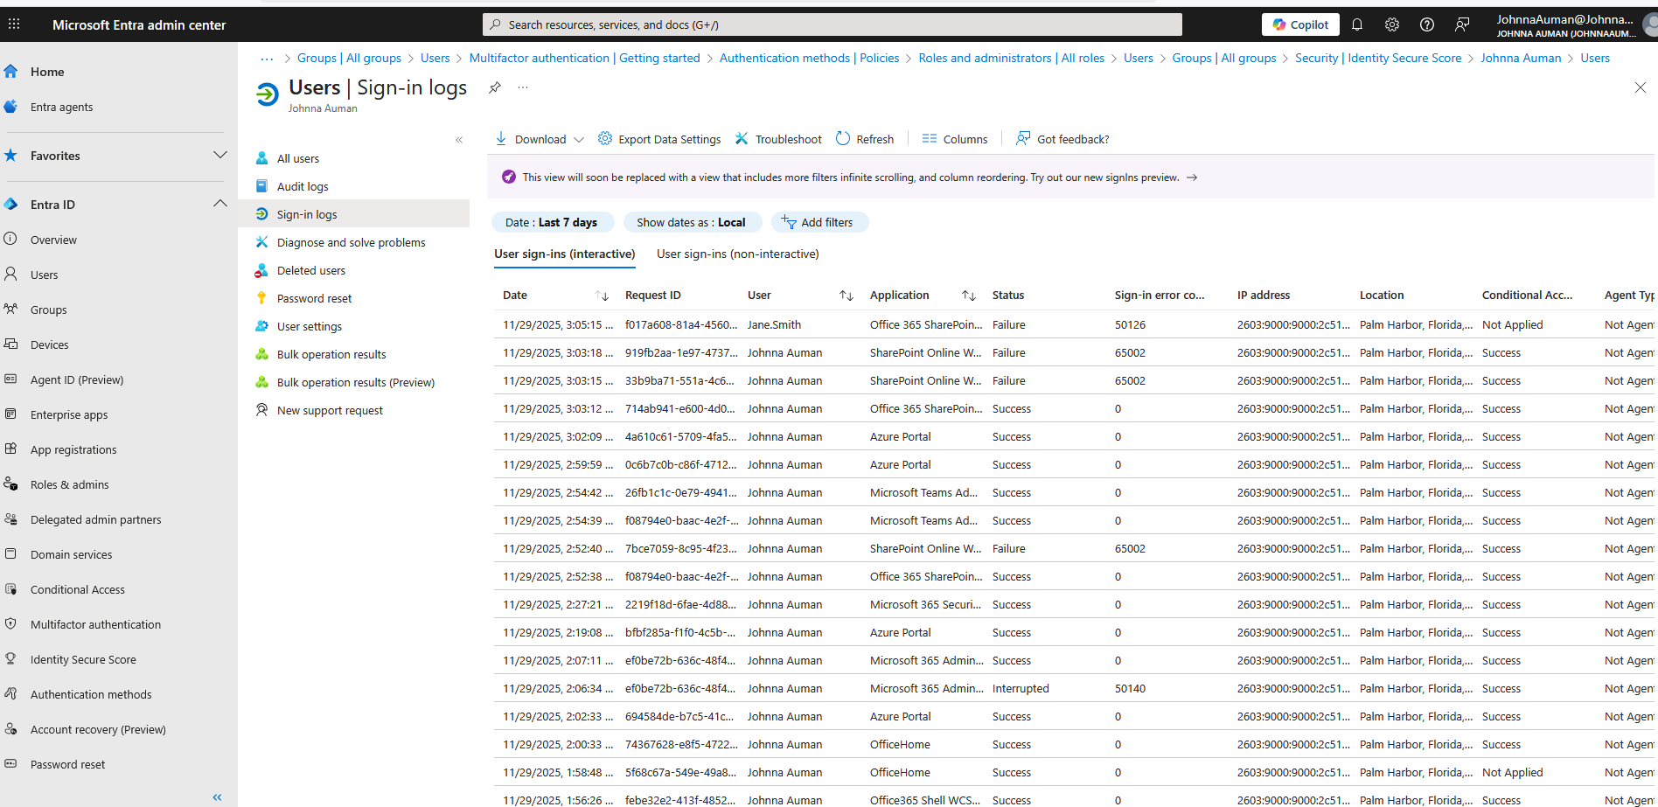

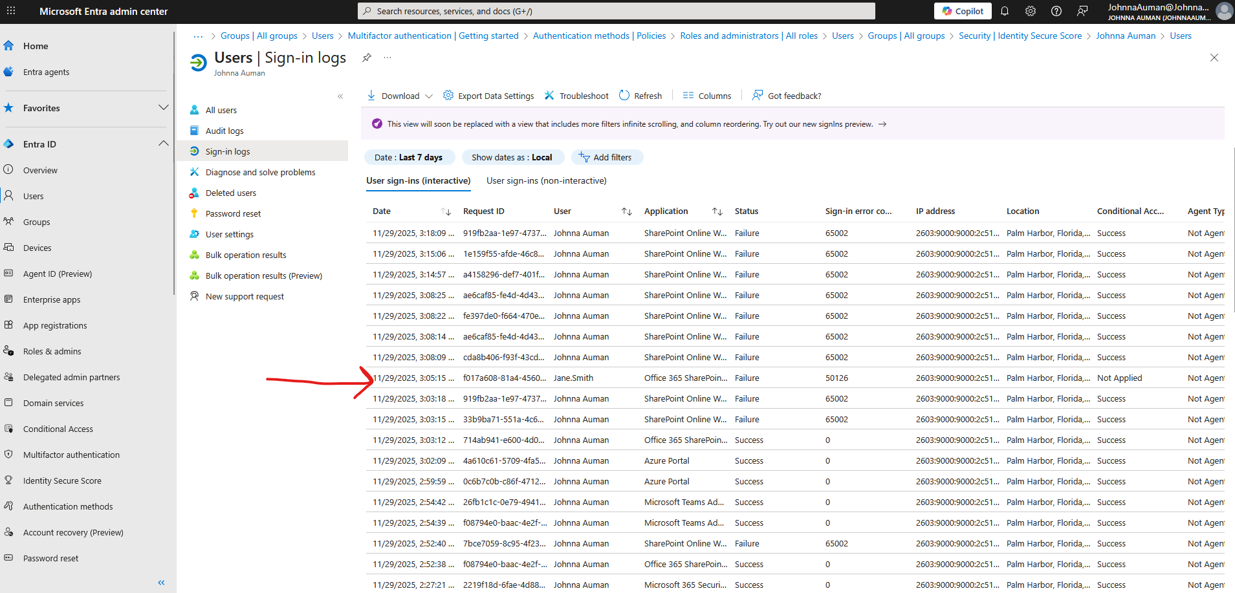

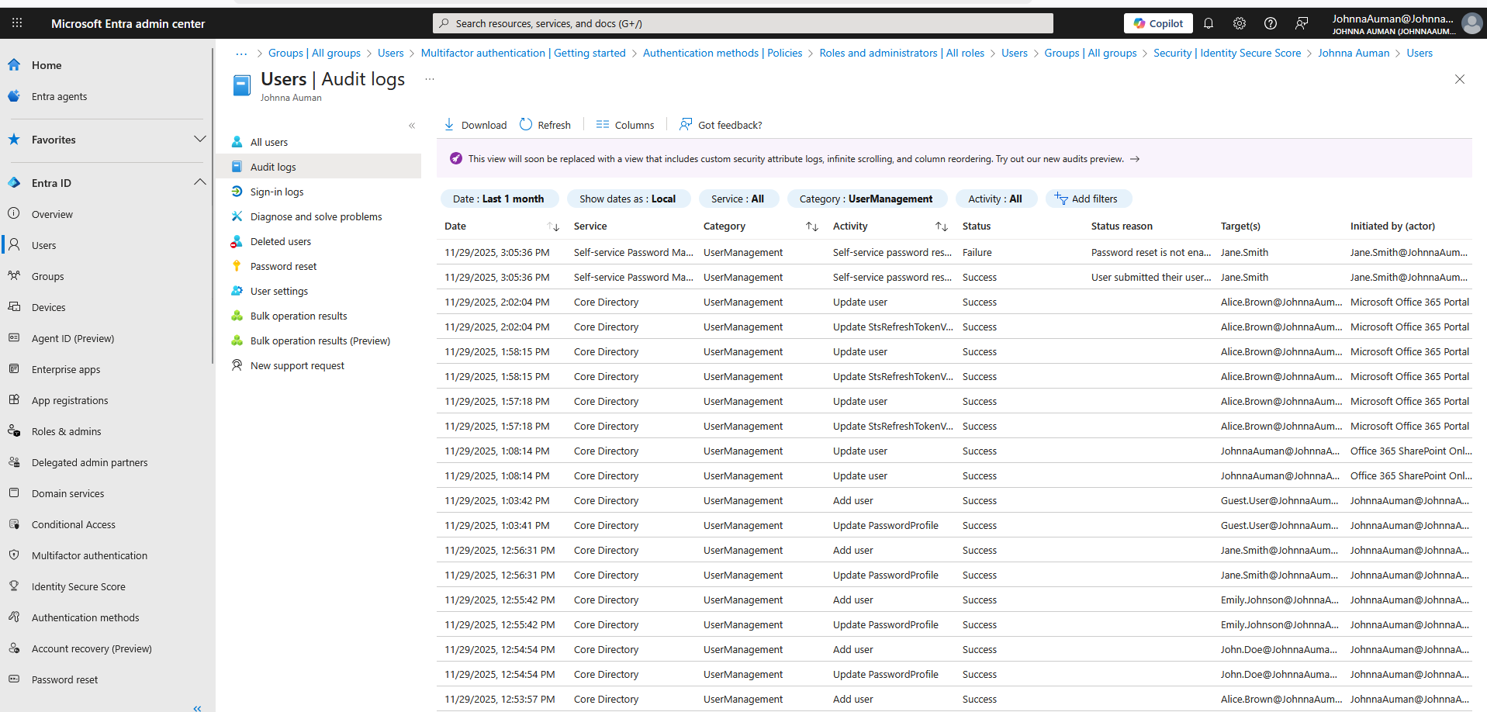
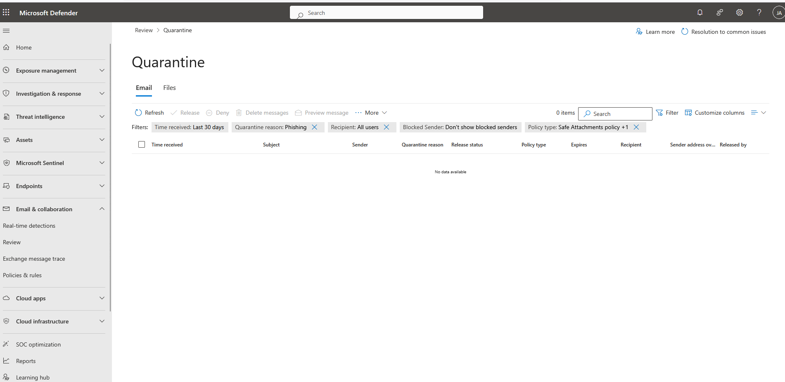

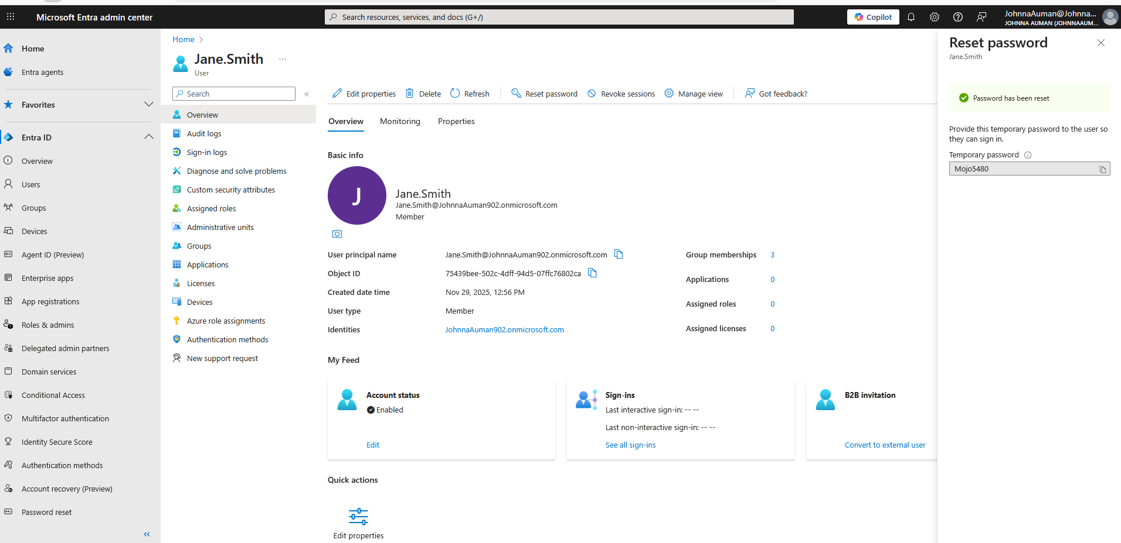
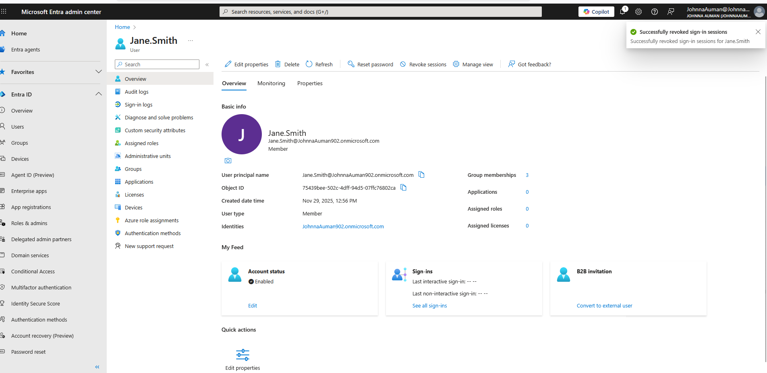

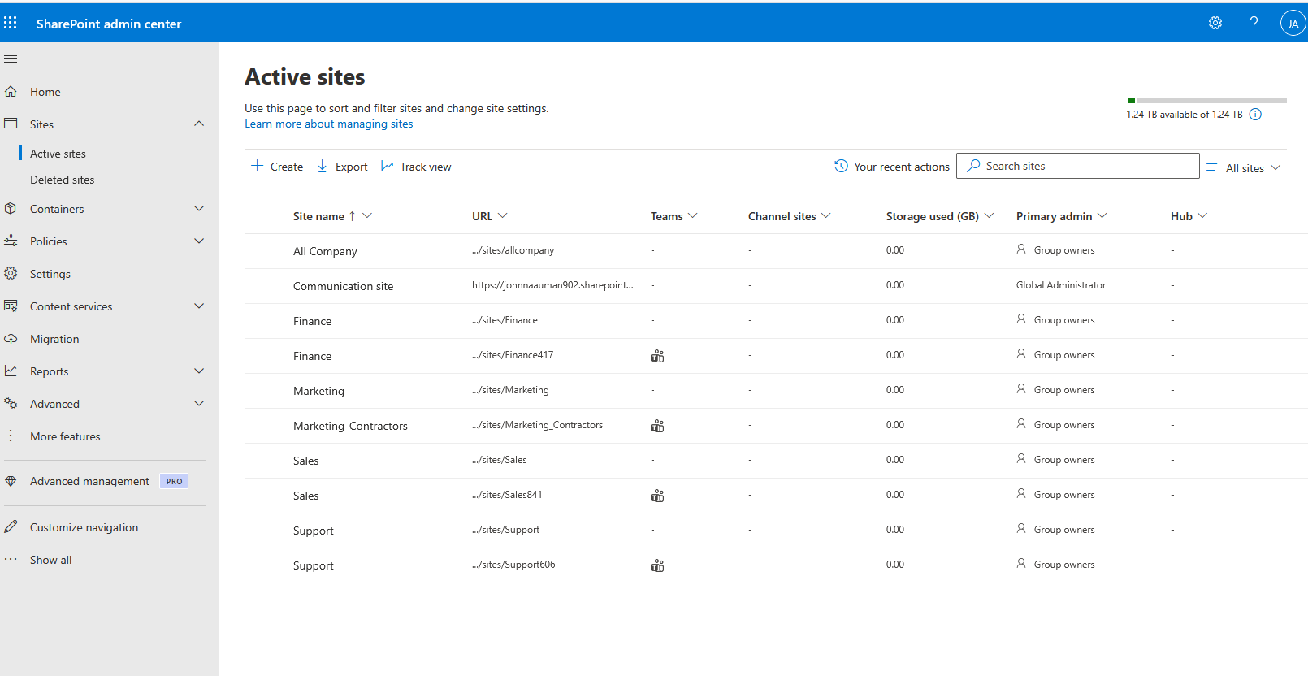

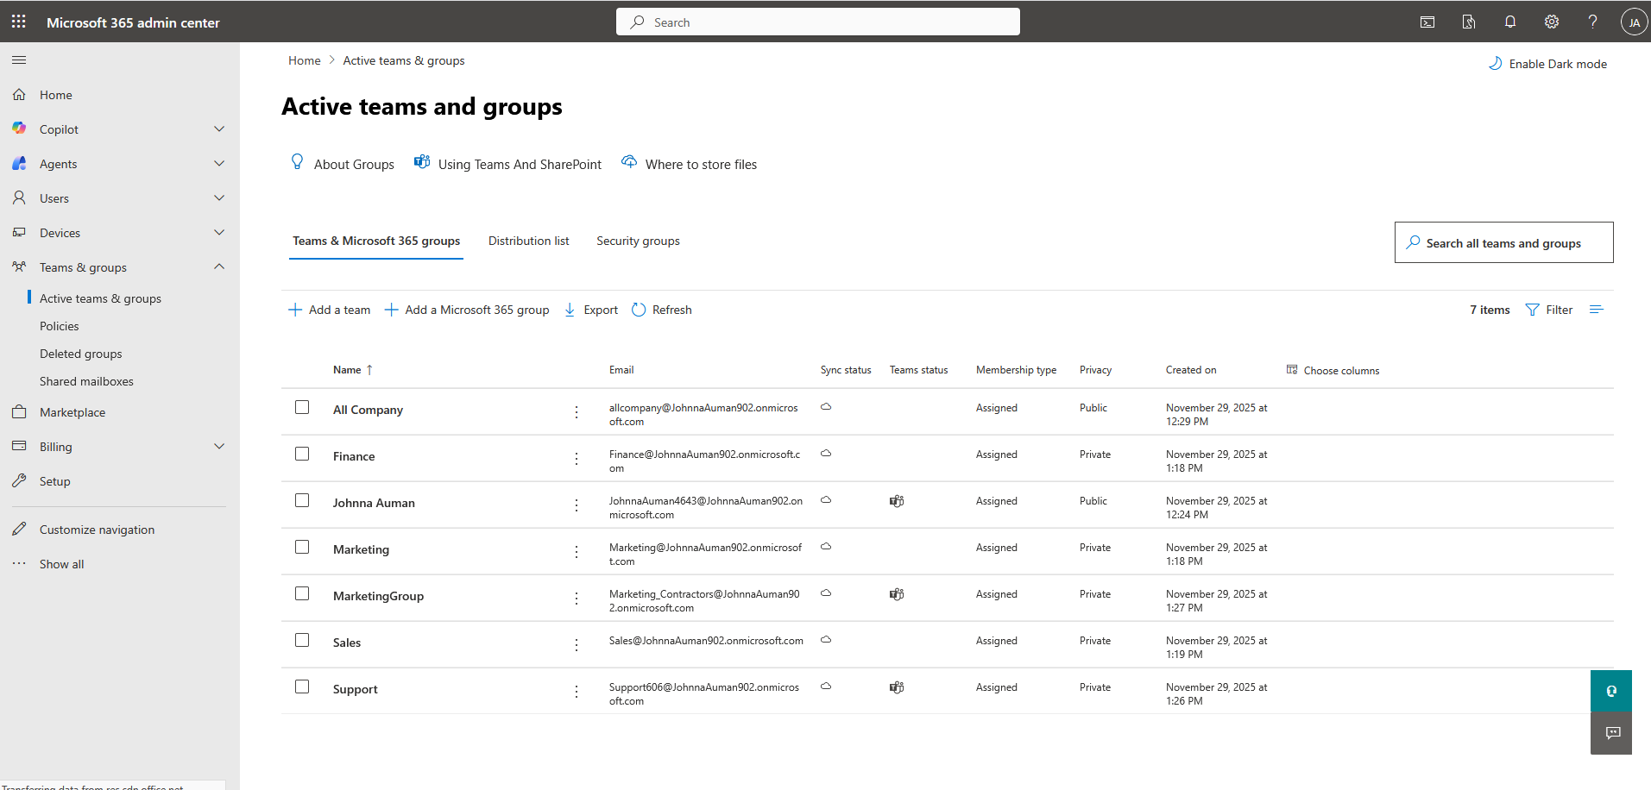

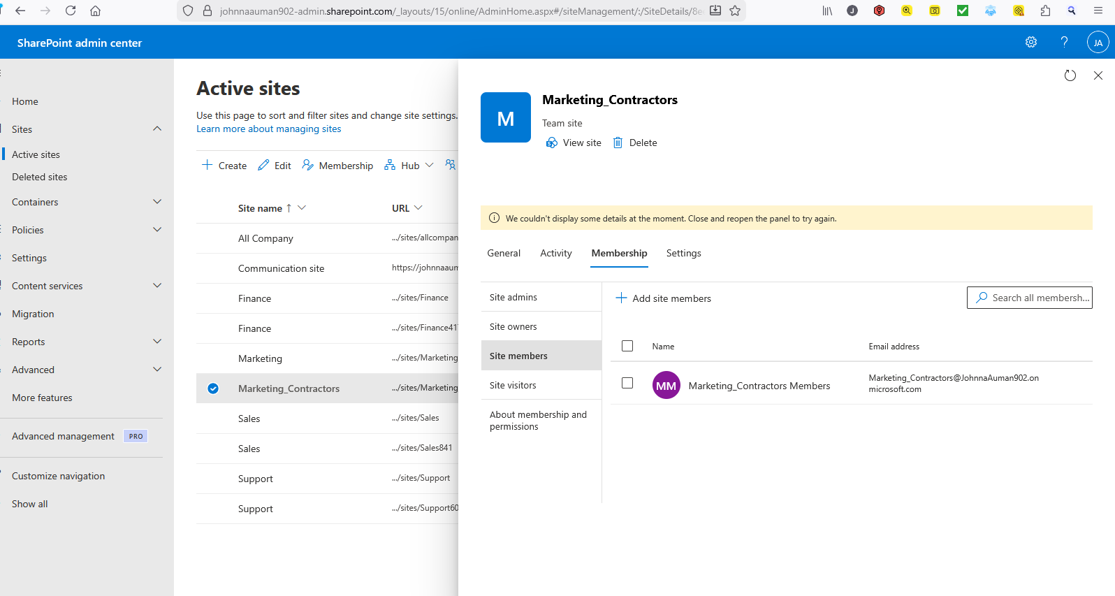

Key Lessons Learned
This initiative yielded critical insights:
- IAM Role Risks: Proactive management of user roles and permissions is fundamental to security; over-privileged accounts are a primary target for attackers.
- Conditional Access Benefits: Conditional Access policies act as a dynamic, context-aware gatekeeper, significantly reducing the risk of account compromise, even if a password is stolen.
- IRP Preparation Value: Having a tested and documented IRP is invaluable. It transforms a potential crisis into a managed process, minimizing downtime and impact during a security incident.

In conclusion, these measures have collectively elevated our security posture from reactive to proactive, better protecting our data, users, and assets from evolving threats now and in the future.

