Teacher (**TeacherID**, Name, Phone, dob, gender, Email, Address(address, city, postcode))

Groups(**gid**, gname, year, teacherID)

Student (**StudentID**, Name, Phone, dob, gender, Email, Address, gid)

Class(**ClassID**,ClassSize ,ClassName, TeacherID, gid)

Subject(**SubjectID**, SubjectName, **gid**)

class

group

subject

1

M

1

M

1

1

M

1

1

1

Student

Teacher

use school

create table teacher

(

teacherid int identity primary key,

tname varchar(30) not null,

dob date,

gender varchar(9),

phone varchar(15) not null,

email varchar(max) not null,

address1 varchar(25),

city varchar(35),

postcode varchar(10),

country varchar(25)

)

use school

insert into teacher(tname, email, phone, dob, gender, address1, city, country, postcode)

values('Alberto', 'alberto@justit.co.uk','0044 20852554','1985-05-16', 'male', '12 Tower Hill', 'London', 'UK', 'E1 2JK'),

('Jimmy Rajkumar', 'jimmy@justit.co.uk','0044 77852554','1988-11-22', 'male', '25 Tower Hill', 'London', 'UK', 'E1 2JK');

use school

create table groups

(gid int identity primary key,

gname varchar(15) not null,

gyear varchar(20),

teacherid int foreign key references teacher(teacherid)

)

OR

use school

create table groups

(gid int identity primary key,

gname varchar(15) not null,

gyear varchar(20),

teacherid int not null,

foreign key (teacherid) references teacher(teacherid)

);

**Problem**: to delete groups table. The reason was FK constraint from Teacher table, though there was no data in groups table.

**Solution**: Keys folder 🡪 deleted FK_groups_teacher… (then we could drop the groups table. )

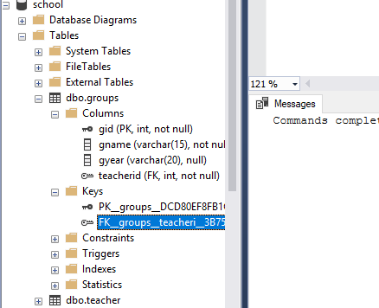

**Referential Integrity Constraints**

use school

insert into groups(gname, gyear, teacherid)

values('Year 3', '2018/19',1);

select tname, phone, email, gname, gyear

from groups, teacher

where groups.teacherid = teacher.teacherid;

2 Tables Database in MVC framework

create table suppliers

(sid int identity primary key,

company varchar(30) not null,

address1 varchar(40),

city varchar(30),

postcode varchar(10),

phone varchar(15) not null,

email varchar(max) not null,

contactperson varchar(35) not null

)

create table products

(

pid int identity primary key,

name varchar(40),

description1 varchar(max),

type1 varchar(20),

price float,

quantity int,

sid int foreign key references suppliers(sid))

insert into suppliers(company, address1, city, postcode, phone, email, contactperson)

values('Big Milk', '12 high street', 'London', 'Ha1 2JJ', '+4425200255', 'big@abc.com', 'Jonny')

insert into products(name, description1, type1, price, quantity, sid)

values('Milk 6 pts', 'Multi vitamin milk', 'Grocery', 1.99, 70, 1);