Predicting the Optimal Location of a Craft Brewery

Joel Blakeney

2/8/2020

- Introduction

  - Business Problem
In the city of Austin, Tx, there are been an increase in craft breweries over the last 15 years, but especially in the last few years. A craft brewery is a small, local brewery started and run by only a handful of people. From a wide variety of jobs and backgrounds, people have decided to change their jobs and decide to open a craft brewery. The craft breweries seem to open in specific clusters around town. It would be interesting to examine the demographics of the city in the locations where there are a lot of craft breweries and what effect, if any do the surroundings of the craft brewery justify the location. I wanted to explore the reasons for opening a craft brewery.

  - Audience
The obvious audience is anyone who has an interest in opening a craft brewery or is interested in how a brewery works. This data will also be beneficial to anyone else considering opening their own business or a similar entrepreneurial enterprise.

- Data Acquisition and Cleaning

  - Data Sources

Data was obtained from two websites: http://www.city-data.com/zipmaps/Austin-Texas.html and https://www.loopnet.com/texas/austin_warehouses-for-sale/ .
The first website is a list of zip codes in Austin, TX and associated data with each zip code: Population, Cost of Living, and Median_Income. While I thought this might be the bulk of my data analysis, the data was difficult to correlate to the craft brewery data. To supplement the economic zip code data, the number of wharehouses currently up for sale/lease per zip code was obtained from the second website. All the data was scraped using Beautiful Soup with the LXML parser. The craft brewery data was obtained by using FourSquare API. The latitude and longitude of Austin, TX was used as the search location and the search term “brewery” was used with the location varied until the optimal results were returned.

  - Data Collection and Cleaning
I would like to first acknowledge an unintentional misstep in the selection of the project. The idea was to identify the list of craft breweries and their location in Austin, Tx. Using the location, collect relevant data that would correlate why the craft brewery was opened in that particular location. I began scraping relevant data and then converted to a Pandas dataframe. The scraping and data wrangling to longer than expected. When I finally began my FourSquare API, only 30 breweries were listed on FourSquare. After I finally cleaned all the data, it dawned on me that the brewery information in nowhere near relevant for a data science project. By this point, I was over halfway done and I decided the project would still retain some relevance even with a small dataset.
The zip code data was scraped using Beautiful Soup and then combined into a Pandas Dataframe. The FourSquare API was used to collect the craft breweries located in Austin, TX. The zip code was included in the API results, but were located in nested list. I had to write a function to extract the zip code from the list. During the extraction, one brewery was not described via a Zip Code and was discarded. The two dataframes were merged with Zip Codes as the index.
In comparison to the FourSquare city guide website, searching for “brewery” in Austin, TX yields almost 70 results. The FourSquare API yielded only 31 results for “brewery”. Other similar terms were searched – such as “Brewpub”, but that specific result returned 3 terms with some of the listed items not craft breweries. I did not include the results due to the small sample size.

The initial first set of features were zip code data – Population, Cost of Living, and Median_Income. The brewery count per zip code was added as well as the count of available wharehouses for lease per zip code.

A Folium map of Austin, Tx shows the location of the selected craft breweries(blue circles):
Figure 1 Folium map of Austin, Tx with craft brewery locations as blue circles

- Methodology

  - Initial Data Exploration
A seaborn pairplot was performed to give a high level view of each feature’s correlation with each other feature and is shown below. The features compared are the Zip Codes, Brewery count per zip code, Cost of Living per zip code, Population per zip code and Median_Income of the zip code. The overview given by the pairplot indicates there might not be any strong correlations. In order to get a more definitive viewpoint, each feature was evaluated independently with respect to the brewery count per zip code.

Figure 2 Seaborn Pair plot of feature in original dataframe

  - Brewery count vs Zip Code Population
The brewery count per zip code is now evaluated versus the population of the zip codes. The results are shown in figure 3. The count of breweries are pretty evenly distributed are zip codes of all levels of population. However, the highest counts of breweries are located in some of the most populated zip codes. However, this only a quantity of two and don’t represent a strong correlation throughout the whole data set. Additionally, less than 10% of the zip codes have populations greater than 50,000.

Figure 3 Scatterplot of the Austin, TX population per Zip code and the craft brewery count per zip code

  - Brewery Count vs Cost of Living per Zip Code

The counts of breweries were plotted against Cost of Living per Zip Code feature. Breweries are located evenly in the middle of the Cost of Living data set. The Cost of Living has a maximum of 130 and a minimum of 80. It is rather difficult to open a new business in the most expensive area of town. Also, the least expensive area of town might not be readily accessible and might not get many retail customers. The distribution of breweries across the middle third of the Cost of Living data set is relatively flat.

Figure 4 Scatter plot of the Austin, TX Cost of Living index per zip code and the craft brewery count per zip code

  - Brewery Count vs. Wharehouse Count per Zip Code

Since the distribution of breweries were not heavily influenced by residential characteristics of zip codes, the count of wharehouse by Zip Code was added to the data set for comparison. A brewery is not typically going to be included in a residential development of a large neighborhood. Breweries will be located in a wharehouse or some other commercial development. The count of breweries are compared to the count of wharehouses is figure 5. The distribution has a relatively linear relationship. This is also evidenced in the next figure which shows the number of breweries compared to the same number of wharehouses in the appropriate zip code. Therefore, it seems that the number of breweries in a respective zip code is determined by the amount of available real estate in that zip code.

Figure 5 Scatter plot of Austin, Tx brewery count per zip code versus wharehouse count per zip code

Figure 6 Stacked bar chart of availalbe wharehouse count(red) and craft brewery count(blue) per zip code

The wharehouse locations(in green) are plotted along with the craft brewery locations(in blue).
Figure 7 Folium map of Austin, TX show the location of craft breweries(blue) and availabe wharehouse zip codes(green)

- Machine Learning Modeling

I applied a linear regression model to the data set. The y values are the wharehouse count and the brewery count, Cost of Living, Median_Income and Population are used to generate a test set. As mentioned previously, the lack of volume of data, strongly indicates that the data set will be difficult to predict accurately. The error for the linear regression model is as follows:

 | Mean Absolute Error | Mean squared error | Root Mean squared error
 | 5.860 | 51.377 | 7.168

A scatter plot of the predicted values is shown below. The large errors in the model are obvious and can be attributed to the limited data to train the model.

Figure 8 Scatter plot of test vs predicte values of linear regression model.

The linear regression model is trained and tested with just the wharehouse count and the brewery count. The scatter plot reveals a more linear relationship. This is also shown when comparing the error between the models.

Figure 9 Scatter plot of predicted vs test values of linear regression model. Here the only x value considered is the craft brewery count by zip code.

 | Mean Absolute Error | Mean squared error | Root Mean squared error
All Features | 5.860 | 51.377 | 7.168
Wharehouse count only | 3.263 | 21.52 | 4.639

The goal of the project is to evaluate which new Zip Code would be the best place to start up a craft brewery. Using the results of the Y test set, the dataframe set of zip codes with no brewery currently located in it was evaluated. Since there is a linear relationship between the brewery count and the wharehouse count, we search the dataframe for the largest number of wharehouse counts. This results in two zip codes – 78728 & 78744. The two new zip codes are annotated with black circle markers and the breweries are in blue and the wharehouses in green. The black marker representing zip code 78744 completely coincides with an available wharehouse.

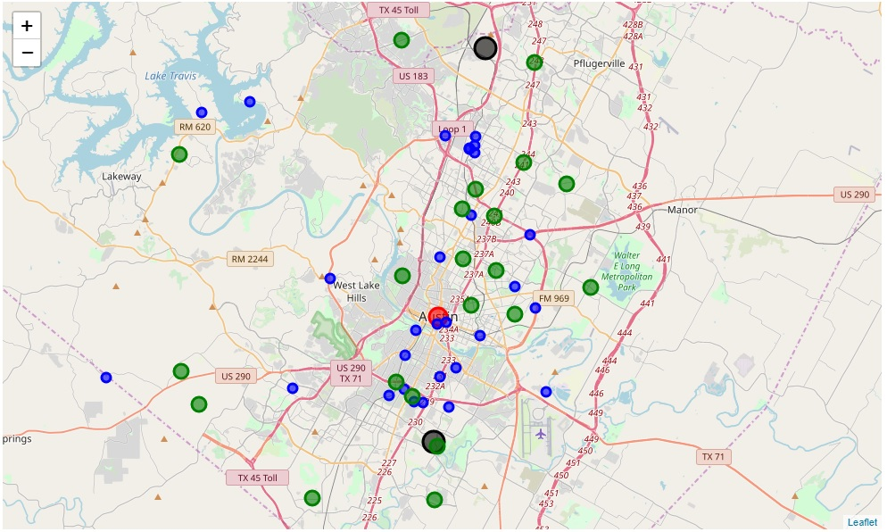
Figure 10 Folium map showing zip codes with a craft brewery(blue), an available wharehouse(green) and the best location to open a craft brewery(black).

Conclusion:
It is not clear that local city demographics have a strong influence on where to open a craft brewery. The factors of zip code population, Cost of Living & Median_Income had little to no correlation with opening a craft brewery in that zip code. The dataset with the highest correlation of craft brewery counts per zip code was the counts of available wharehouses in the corresponding zip code. As observed in the first map, some of the craft breweries were located in downtown Austin and some where completely outside the city. Essentially, if you can find a spot to fit your vision, then go for it.

Future Work:
Obviously, it would have been more beneficial to have compared a larger number of craft breweries. This would have enabled a much more thorough statistical analysis and opened further opportunities to explore the learning algorithms. Also, a much more thorough comparison of venues surrounding the craft brewery might shed some additional information. For instance, a Foursquare comparison of common venues around each craft brewery could be established. Also, establishing a common frame to compare at the time when each brewery was opened. A brewery might have opened 10 years ago in an unpopulated zip code, but now the zip code is modestly populated and wealthy. These data would give a clearer picture as to the reasons for why craft breweries open where they do.

