Product Design
Team | s361-01c French Toast Mafia

Architectural Model
This diagram represents the major subsystems of the product. Initially focus on the domain layer and its components before decomposing the user interface component. Note that a common interface allows both the GUI and a Command Line Interface to access the domain model in the same manner without regard to the type of presentation technique.
Presentation Layer
Product Graphical User Interface (GUI)
Development Testing Interface (Test Driver)
Domain Model
Domain Layer
Data
Domain Model Interface

Components and Functions

Vending Machine | State:  Machine ID  Row Count  Column Count  Depth of Shelf  Shelf Count (rows * columns)  List of Item Varieties  Profit Balance (money in machine)  Customer Balance  Online Status  Restocker Report (from manager)  Restocker Feedback (from restocker)  Behavior:  Change Machine Balance (internal, for Select Item)  Select Item (for customer)  Remove Item (internal, for Select Item or Restocker's checklist)  Discontinue Item (internal)  Add Item Quantity (internal, for Restocker's checklist)  List Available Items (for customer display and manager view)
Vending System | State:  List of Machines  List of Item Varieties  Startup Time  List of Managers  List of Restockers  Behavior:  Add Machine (for manager)  Initialize Item List (for testing)  Add Statistic Data Point  Add/Remove Manager  Add/Remove Restocker  Add Restocking Data Point  Check if machine exists
Customer (Model) | State:  Selected Machine  Vending System (that contains the machine)  Behavior:  Login (chooses machine)  Logout  Insert Money  Check Balance  Request Refund  Check Items in machine  Buy/Select Item
Restocker (Model) | State:  User Name  Password  Current Machine  Vending System  Behavior:  View Report  See Instruction List  Execute Instruction
Manager (Model) | State:  Username  Password  Manager Login List  Current Machine (changes upon mahcine selection)  Vending System  Behavior:  Login  Add Machine  Delete Machine  Add Restocker Report  View Machine Data  Add/Remove Manager Profile  Add/Remove Restocker Profile  Get Statistics
Data Point | (A usage data point for purchase statistics)  State:  Item Name  Item ID  Date of purchase  Machine ID (what machine was the purchase from)  Item index (shelf location in machine the item was purchased from)  Behavior:  Getters
Restocker Point | (A data point for the restocker behavior when he restocks the machine)  State:  Name of instruction  Instruction (the instruction that was checked off)  Date (when the instruction was checked off on)  Behavior:  Getters
Item | (Contains info of a collection of all of the goods in a particular shelf)  State:  Name (name of the type of item: Eg) “Mountain Goo”)  Item ID (identification for the item, can be lot info, etc, or shelf location)  Current Number (quantity of items in the shelf)  Cost  Expiration List (list of exp dates that correspond with item positions in the shelf)  Behavior:  Getters  Setters  Clear Expiration Dates  Check for Expiredness  Add To Front of Exp List
Statistics | (collection of data points and methods to extract info from those data points)  State:  List of Data Points (customer usage)  List of Restocker Data Points  Behavior:  Add Data Point  Add Restock Point  Display Data  Display Restock Data
Customer GUI | State:  Frame  Item Display  Selection/Purchase Button  Refund Button  Exit Button  Insert Money Button (0.25; 1.00; 5.00)  Machine ID Display Label  Balance Display  Message Box  Behavior:  Initialize Window  Initialize Buttons  Refresh Item list  Refresh Balance  Close Window
Restocker GUI | State:  Restocker Model  Frame  Instruction List  Task-completed Button (used to select the task being worked on)  Feedback Text Field (used to convey feedback from restocker)  Add Feedback Button (records whats entered in the Feedback field)  View Older Feedback Button  Logout Button  Behavior:  Inform of completed task  Select Task from List  Send Feedback Note
Manager GUI | State:  Manager Model  (Main)  Add/Delete Machine Buttons  Upload Restocker Report  View Machine Data Button  Add/Delete Manager Button  Add/Delete Restocker Button  View Statistics Button  Logout Button  (Add/Remove Machine subpane)  Machine Data initialization text fields  (View Machine Data)  View Inventory Button  View Expired Items Button  View Restocker Feedback Notes Button  (Add Manager) & (Add Restocker)  New UserName Field  New Password Field  Create Button  Exit Button  (Delete Manager) & (Delete Restocker)  Username Field  Delete Button  Exit Button  Behavior:  Functionality to perform the operations for the buttons listed above
Restock Launcher  (Chooses Machine  For restocker user) | State:  Frame  Machine List (for selection)  Log in Button  Log out Button  Behavior:  Choose Machine  Log into selected machine  Quit before logging into machine
Customer Launcher  (Chooses Machine for customer user) | State:  Frame  Machine List (for selection)  Login Button  Exit Button  Behavior:  Choose Machine  Log into selection machine  Quit before logging into machine
Central Launcher  (Solves concurrency issues, but inconveniently bundles all users into one executable) | State:  Frame  Customer Launch Button  Restocker Launch Button  Manager Launch Button  Exit Button  Behavior:  Launch each user window.

Class Diagram(s)
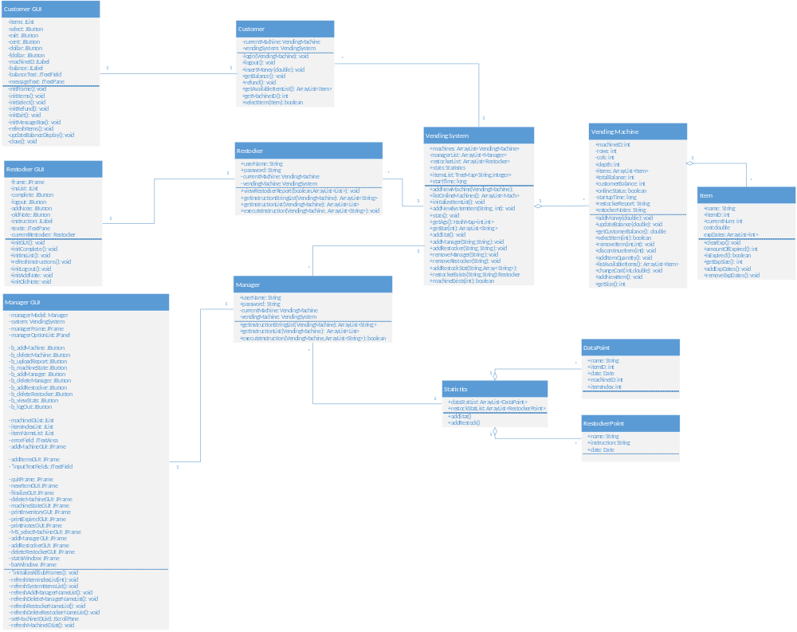

Sequence Diagram(s)

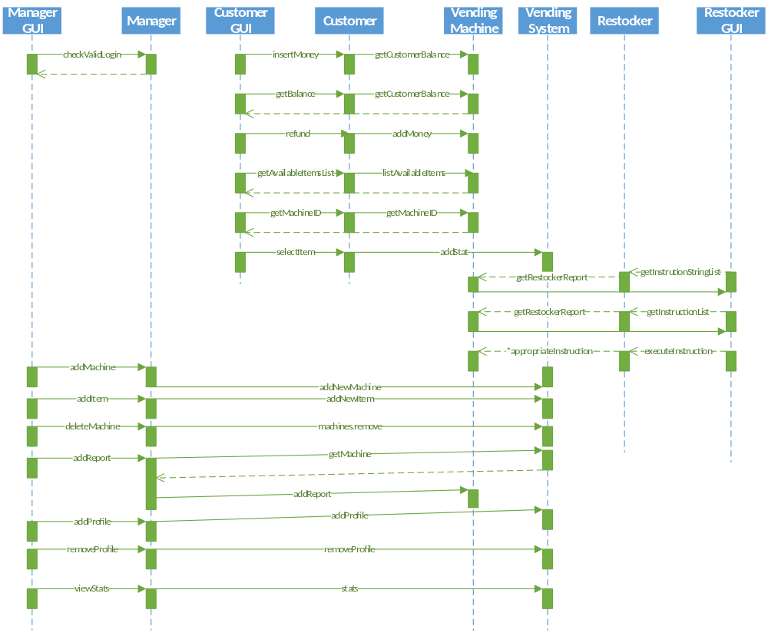

Design Rationale
Our first thought was to have the vending machine control all data that would pertain to a single machine (ex, items in that machine, size, etc.) The items inside would all be checked by the vending machine, and functionality for buying items from a machine will be included in the machine itself. The users would use getters and setters to change the state of the machine.
There will be a vending machine system to contain all inter-machine data and a list of machines themselves. This will be the entry point to initially grab a machine to perform actions onto.
At first we were going to include a system for managing the data but we have since realized that this is not practical and we are going to use generic text files. The vending machine will have the ability to receive a report from corporate, and the report will be stored internally in the machine.
We are planning to have the restocker complete restocking items one by one on a list and then we will clear them as they are completed.
We have decided to use a central launcher .jar file to launch any customer, restocker, or manager user. This solves any concurrency issues regarding the saved/serializable .ser file that the system data is saved in.
We cannot have the system be a member of each main method, because then we have separate instances of the system so they do not change the same data. To solve this issue we are going to change our plan to using one .jar file for all three users. We are going to create a Main class that will call all three user class when appropriate, make the system a member of this class, and pass it to each instance of the user classes. This will make sure they all change the same system.
We have added a few more classes to our design. We now need a Statistics, DataPoint, and RestockPoint classes to keep track of our data for the manager reports.

