**Name : Barathkumar J K**

**Assignment 1**

**GIT**

1. `git init` (Initialize a new git repository in local machine to particular directory)

`ls -la` (Listing the hidden files to see whether .git is created )

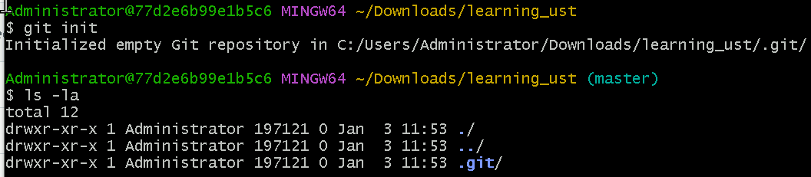

1. Created new repository in github as `**ustgit_learning`**

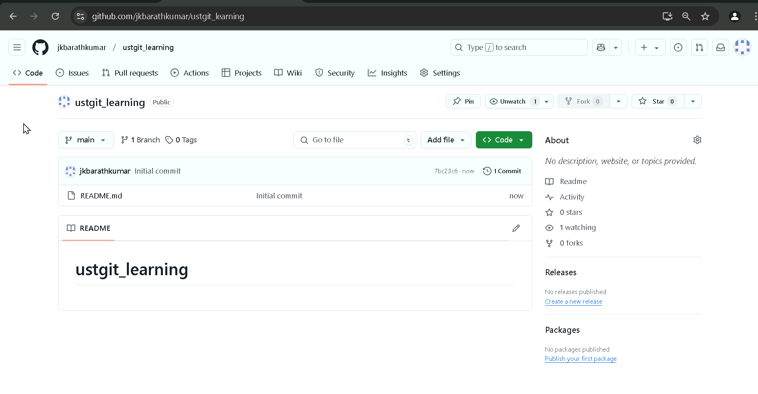

1. Setup the remote URL



To verify the remote URL is added check in `git config –list`

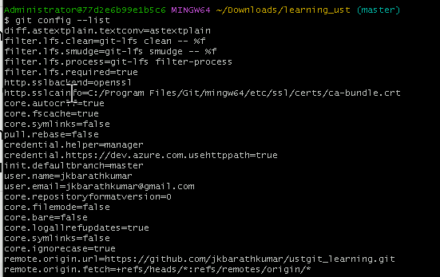

1. Setup username and email



To verify username and email is configured `git config –list`

1. Pull the files from that remote repository `git pull origin main`

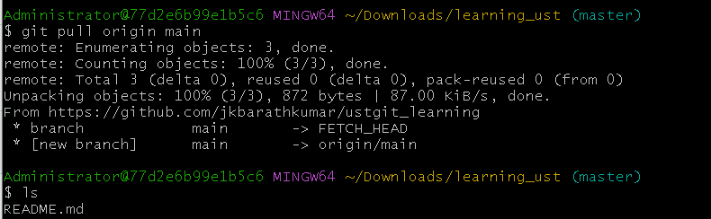

1. Create New file

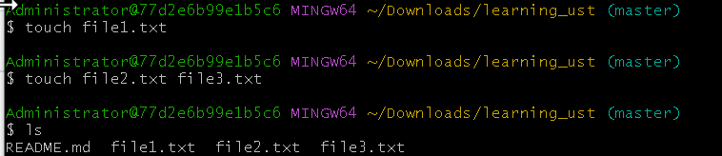

1. Add the files to staging area `git add .`



1. Git commit with message. `git commit -m “New files added” `

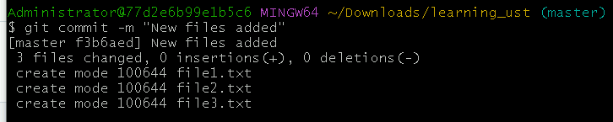

1. Before pushing to github check which branch currently you are. `git branch`



Renaming the branch master to main because when we given git init it will be in default master but in ui github website it will be main default so that we must change the branch name master to main `git branch -m master main`

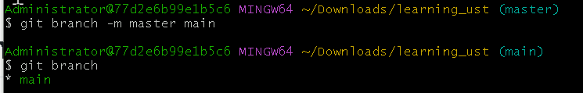

1. Now push the changes to repo from staging area `git push origin main`

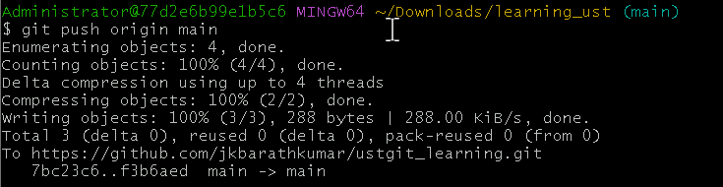

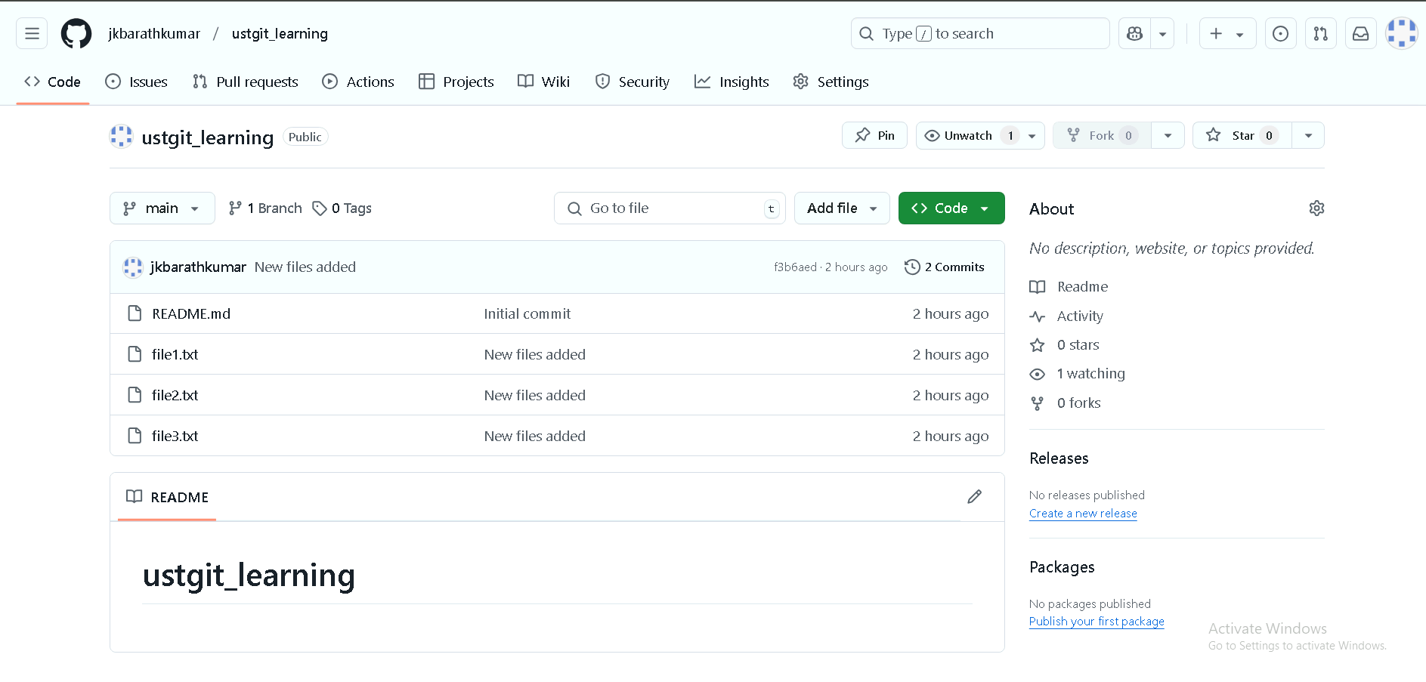

Summary

1. Git init (Initialize a new git repository in local machine)
2. Git pull (Pulls the latest changes from the remote repository to your local machine)
3. Git add . (Moves the changes we made to the staging area (preparing them to be committed)
4. Git commit -m “files added” (Commits the changes from the staging area to the local repository with a descriptive message)
5. Git push origin main (Pushes the committed changes from your local repository to the main branch of the remote GitHub repository)
6. Status and logs

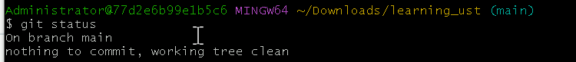

`git status` is used to see changes, staged files, untracked files.

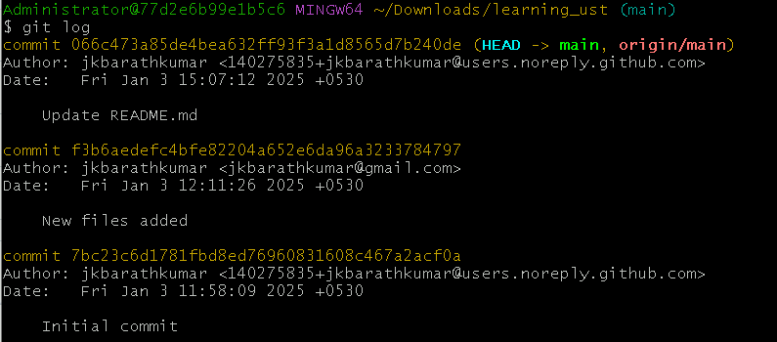

`git log` Displays commit history with details.

Branches

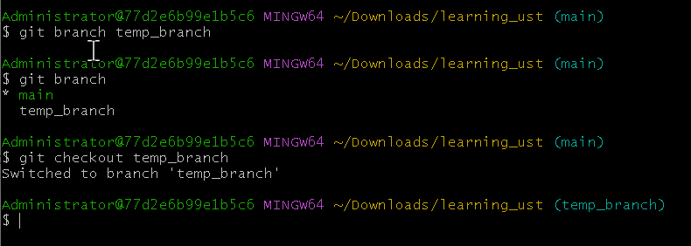

1. `git branch temp_branch` creating new temp_branch.
2. `git branch` is used to view all the branches.
3. `git checkout temp_branch` switching to temp_branch from current branch.

