**Name : Barathkumar J K**

**Project 2**

**Git project**

Step 1: Coded

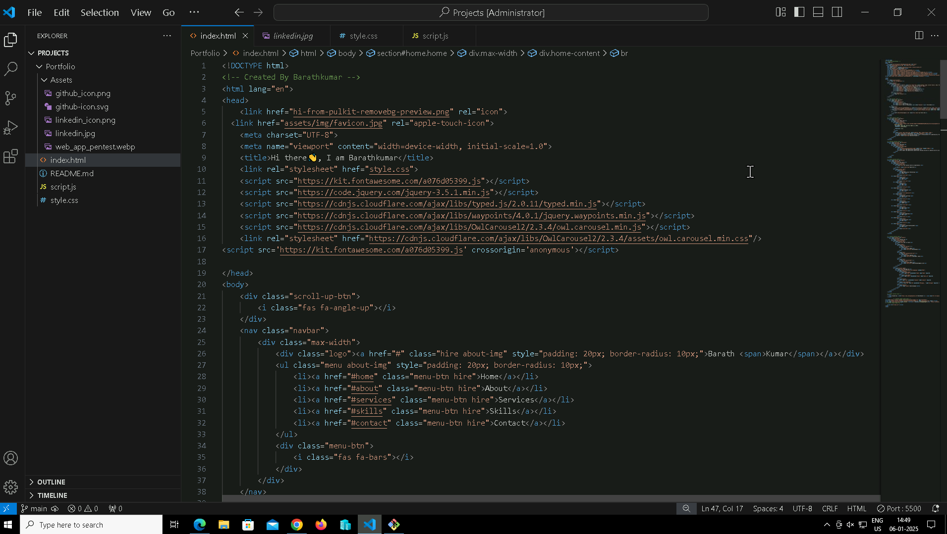

Step 3: Created a new repository with jkbarathkumar.github.io

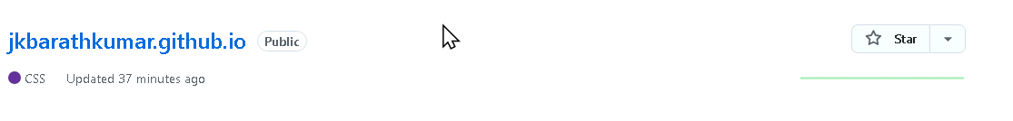

Step 4: Initialize a new git repository in local machine using **`git init`**

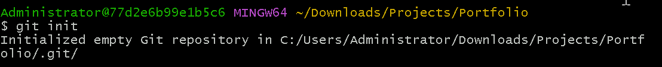

Step 5: Setup the remote URL



Step 6: Pull the files from github **`git pull origin main`**

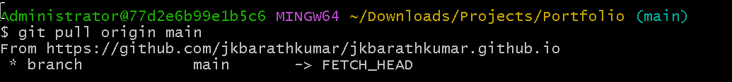

Step 7: Add all the files to staging area **`git add .`**



Step 8: Commit

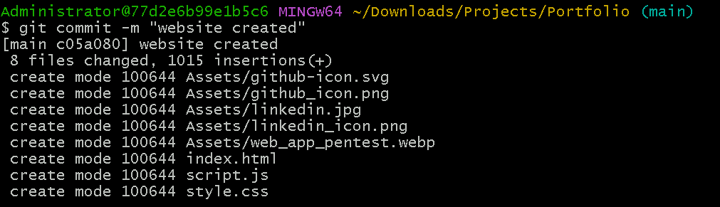

Step 9: Push the changes to github **`git push origin main`**

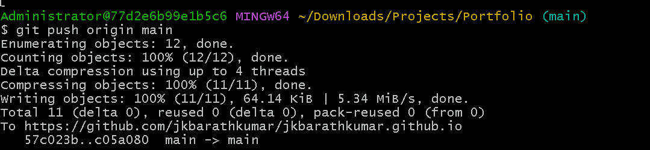

Step 10: Code pushed to github

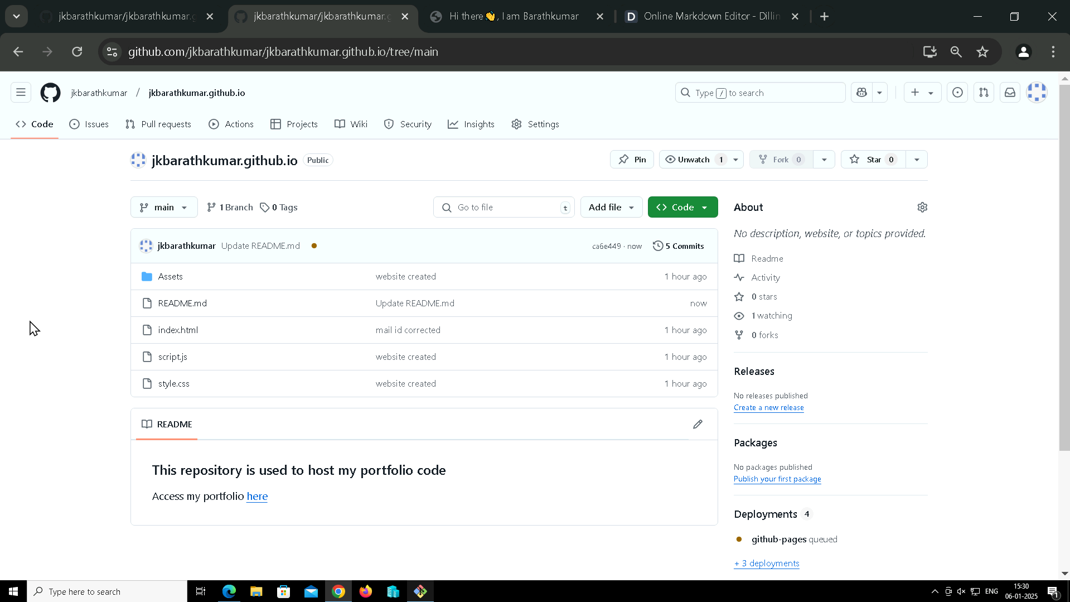

Step 11: Make changes in code

Step 12: Again added the changes, committed and pushed to github

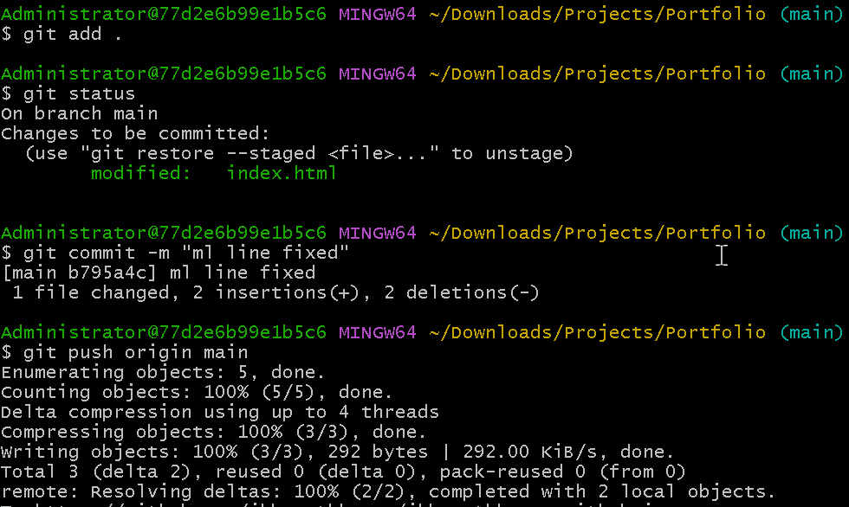

Step 13: Now the website pushed to github and hosted on github

