**Name : Barathkumar J K**

**Project : 1**

**TO-DO List App (Frontend)**

Step 1: Coded index.html, app.js

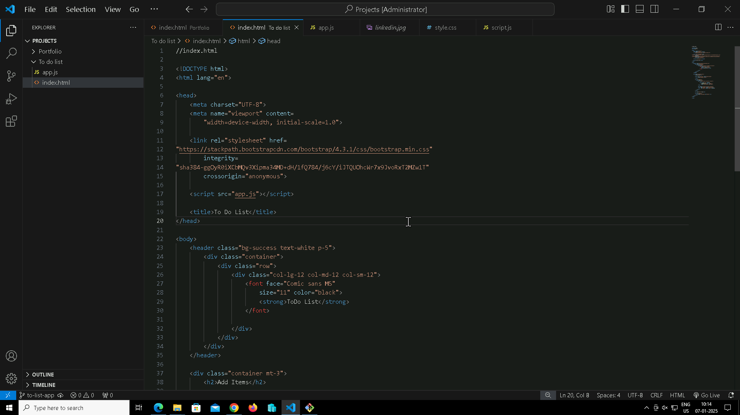

**Step 2: In**itialize git repository and add remote URL.



**Step 3:** Add files, commit, and pushed to github.

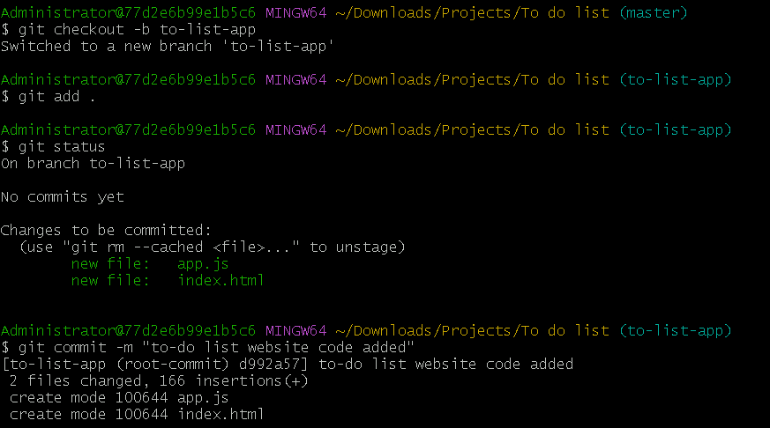

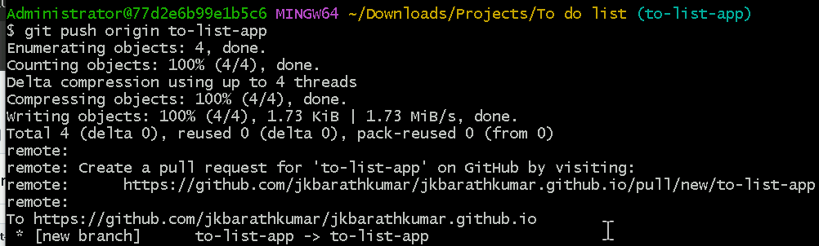

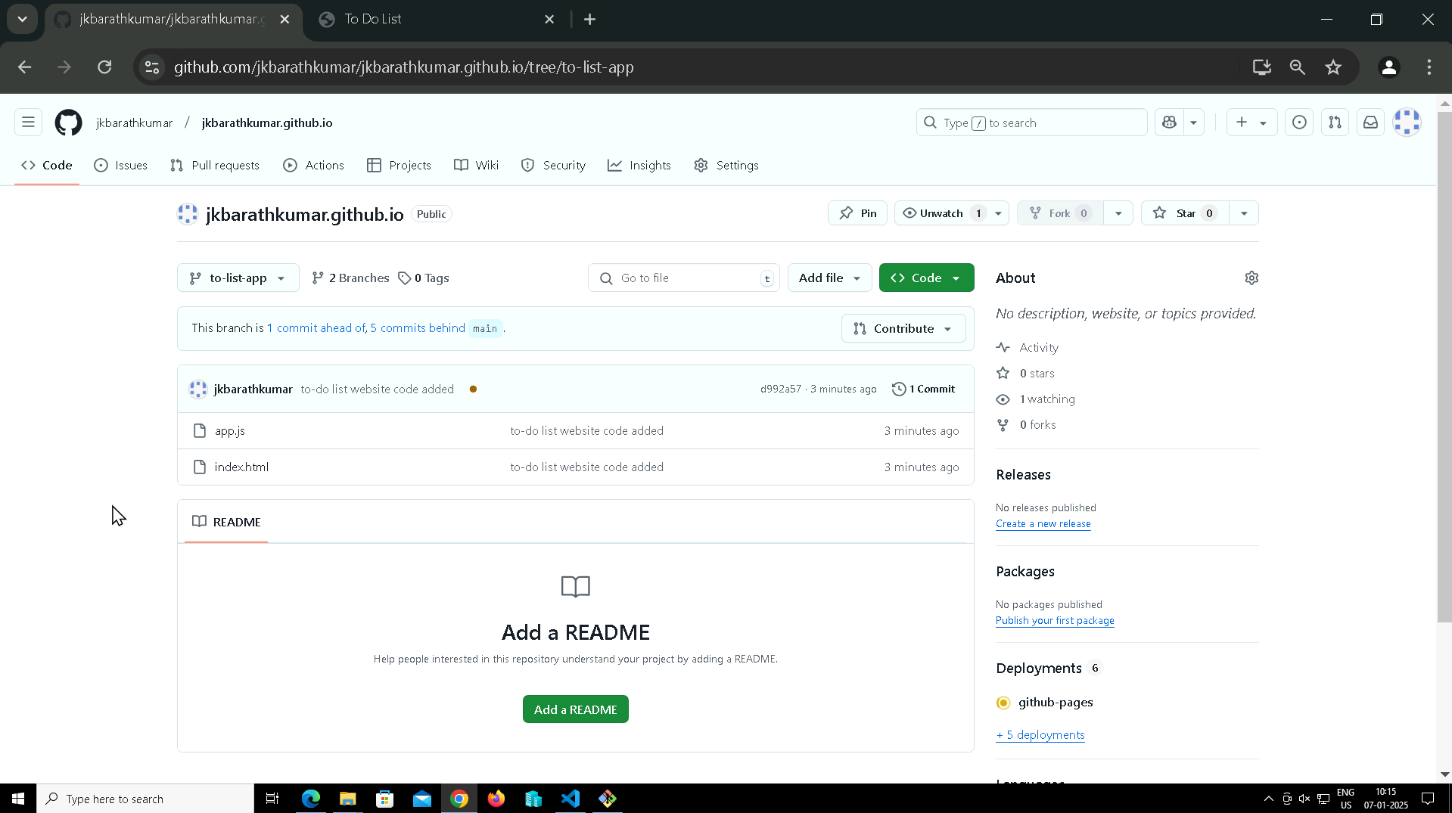

**Step 4:** Open the link to check it is correctly working

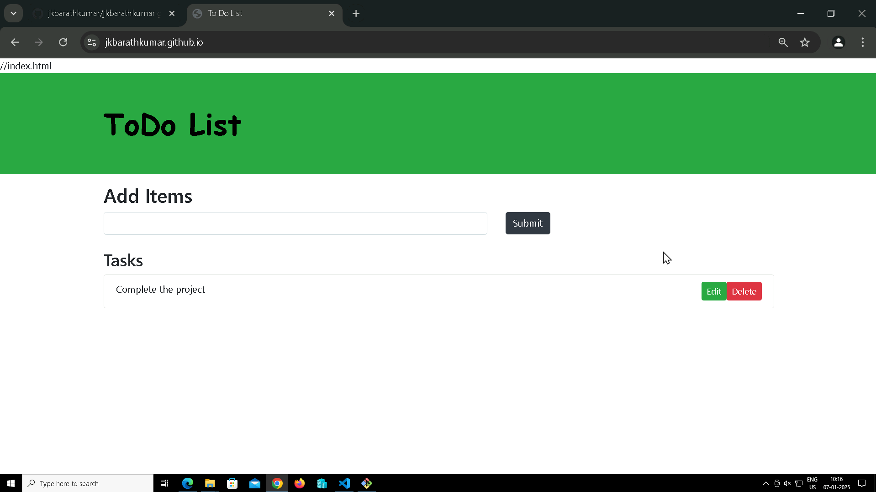

**Step 5:** New Branch for new Check box feature

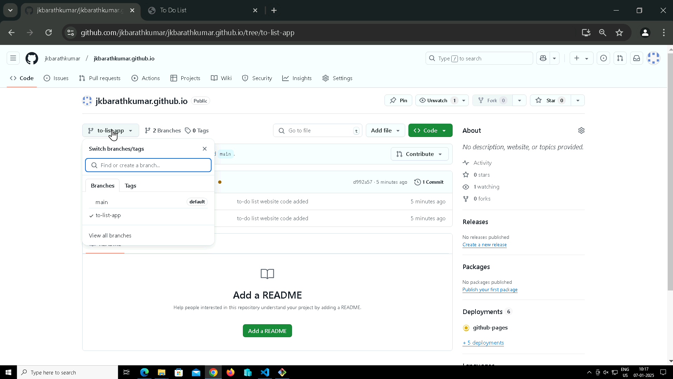

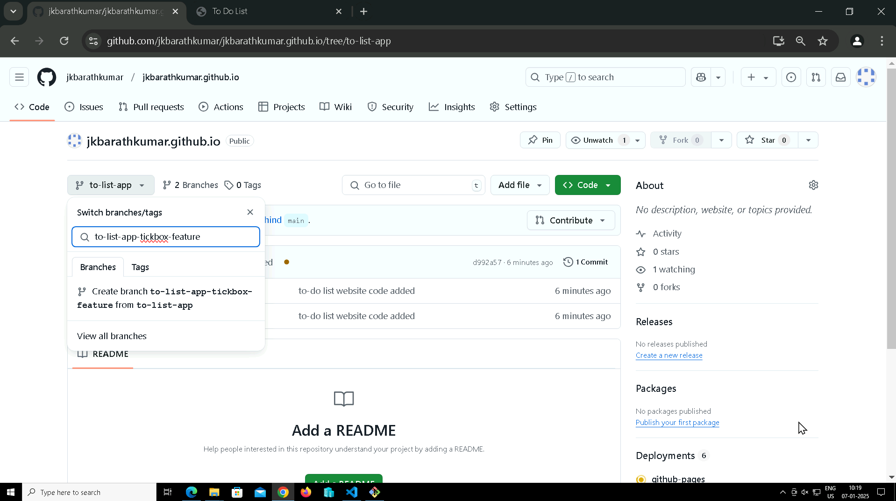

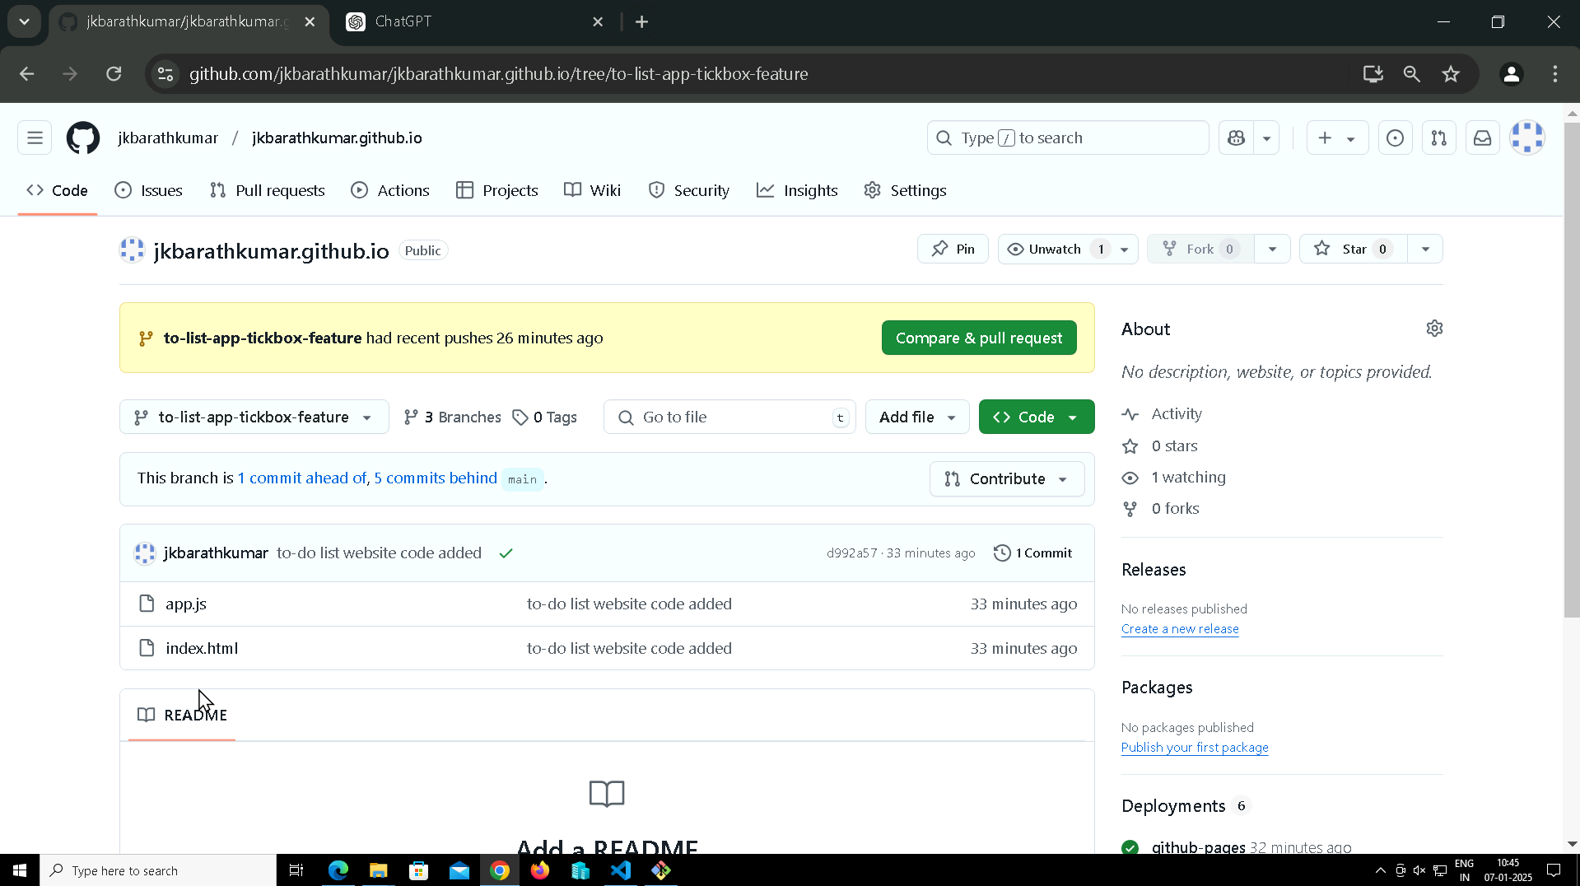

**Step 6:** Switch the branch to new feature branch and pull from github.

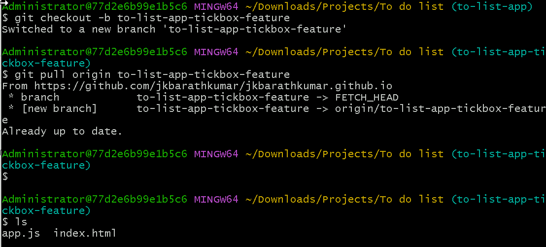

**Step 7:** Now make changes in files and add, commit and push it to to-list-app-tickbox-feature branch

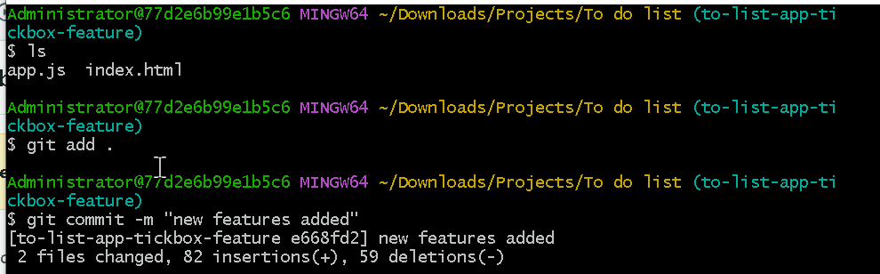

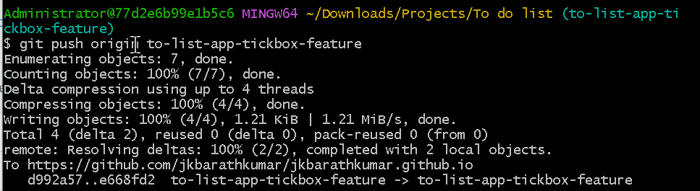

Step 8: Create pull request and merge pull request to main application.

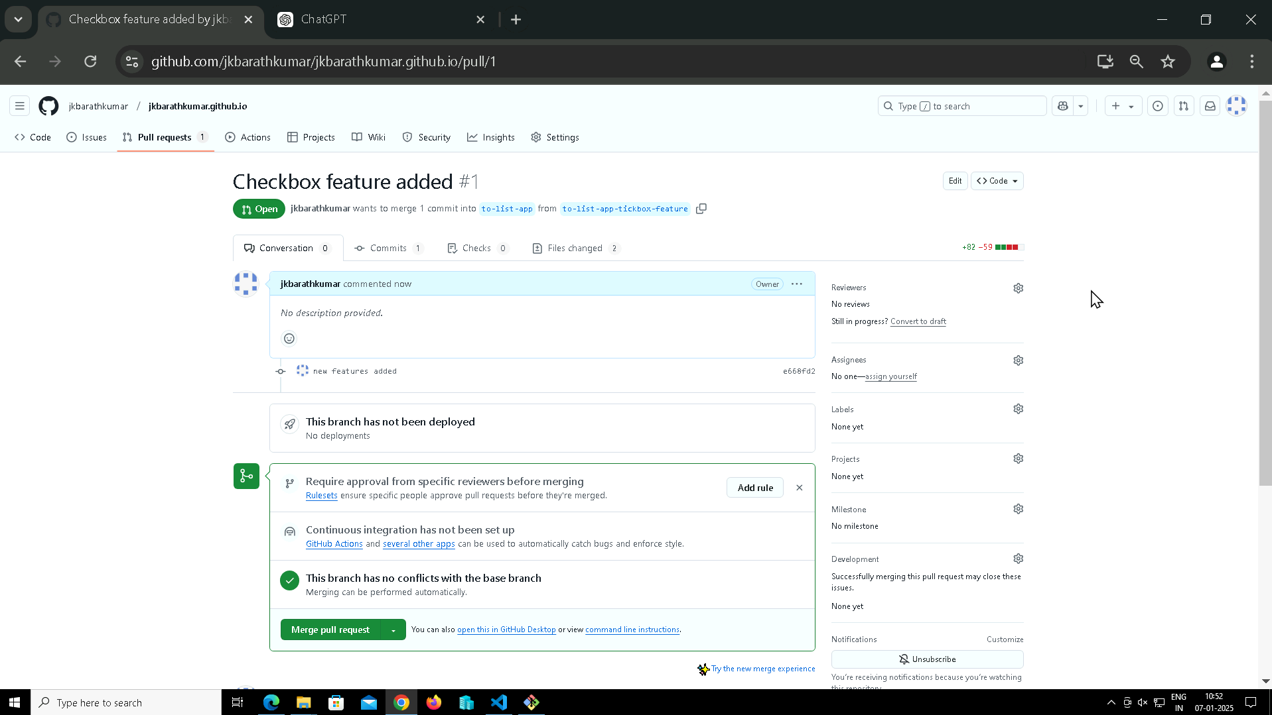

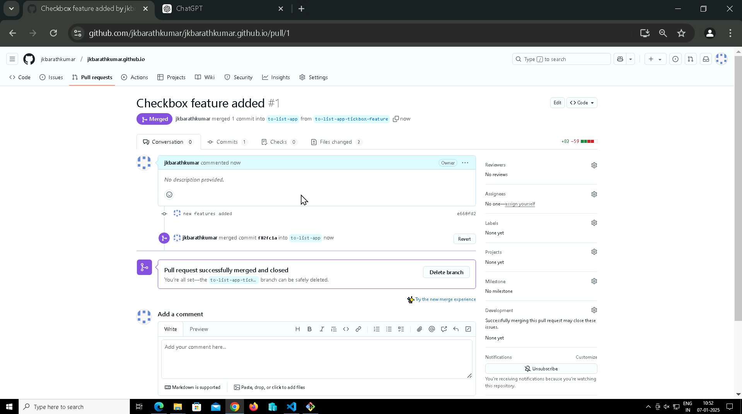

**Step 9:** Now it was merged to main to-do-application application and the subbranch is deleted.

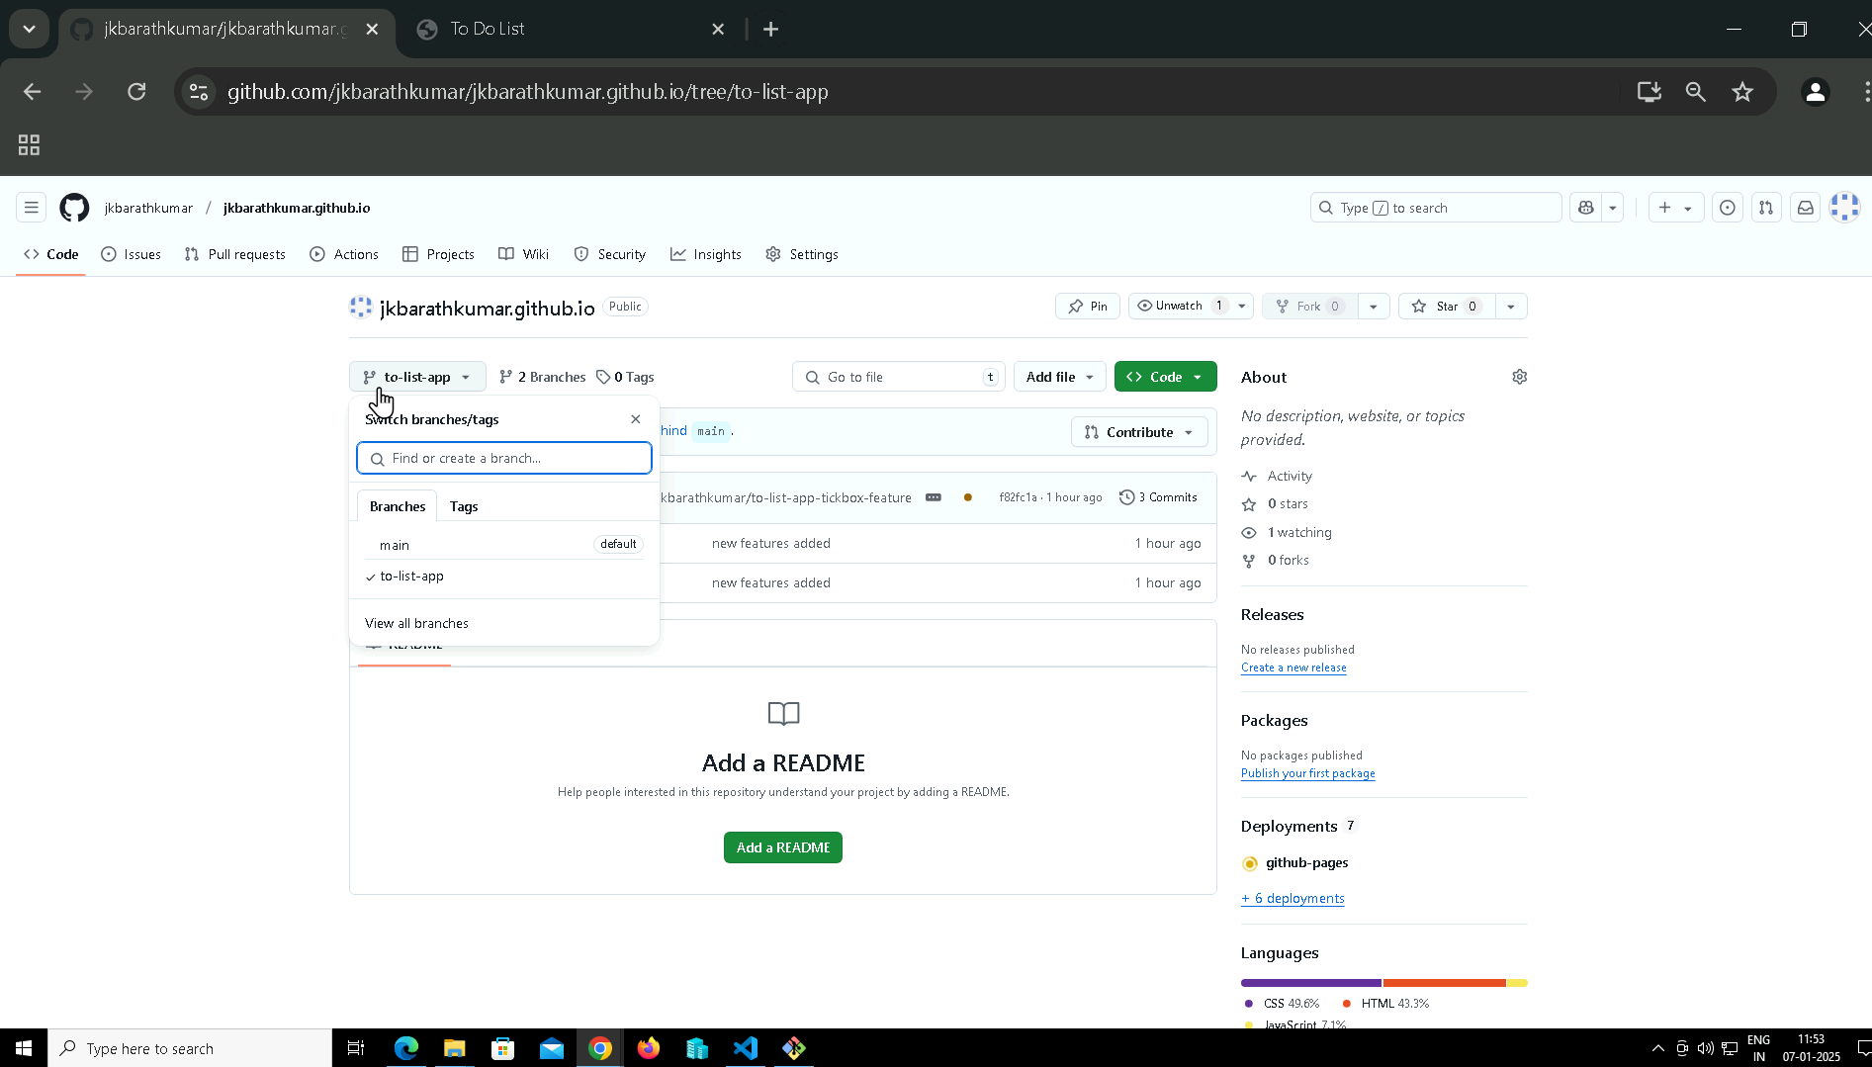

**Step 10:** Now open the website and the changes are there.

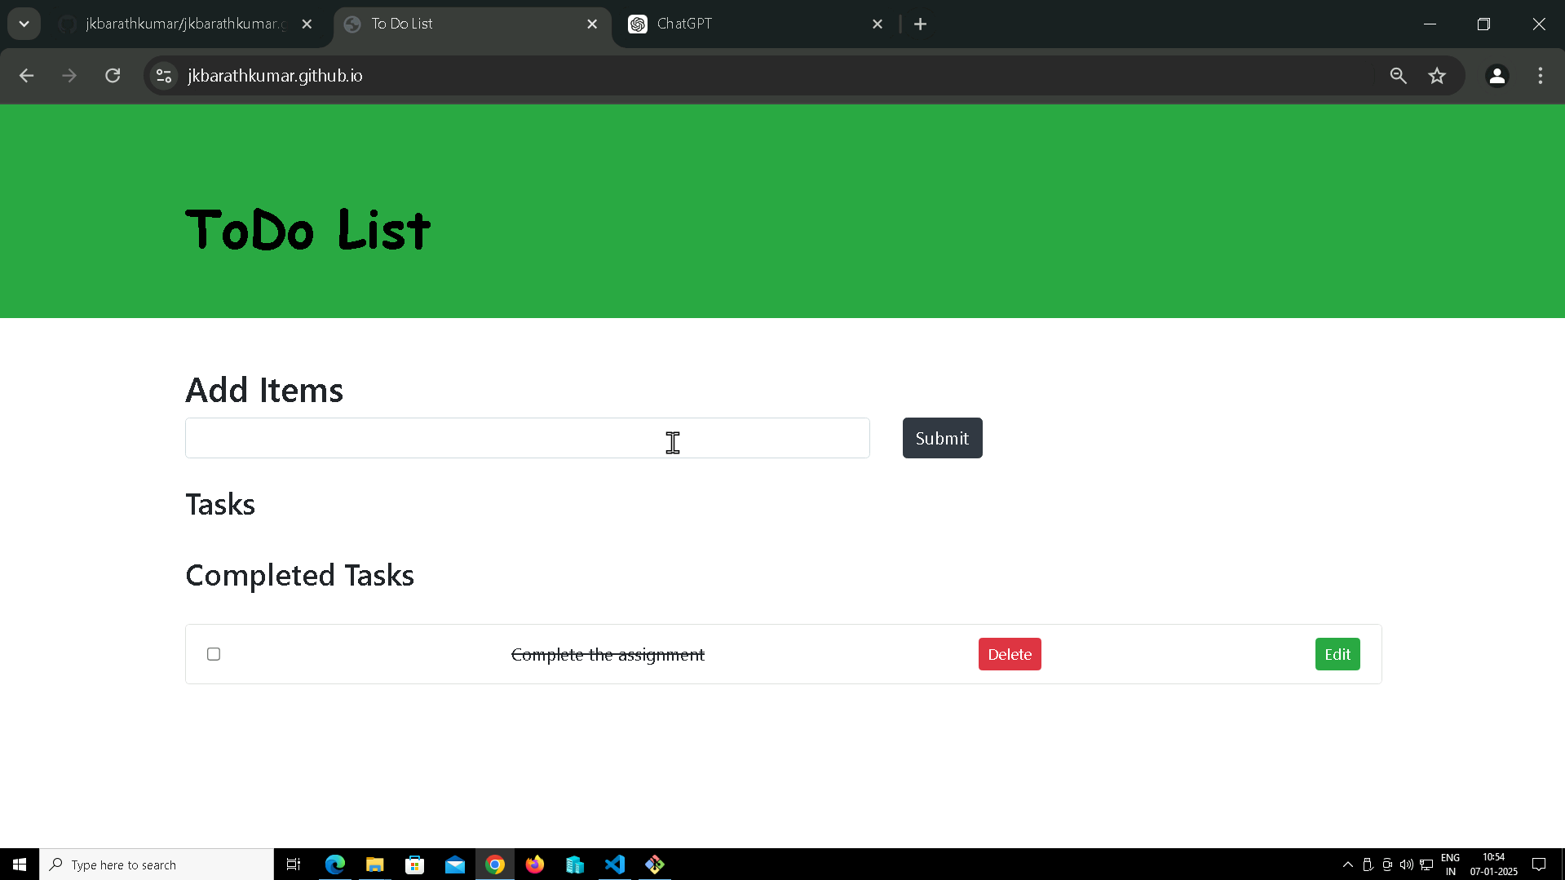

**Step 11:** Final output after merging other branches

