Correlation of Monthly Precipitation in the Marshall and Gilbert Islands

BY

CHLOE BRACIS1 AND JULIAN SACHS2

AbstRact
Monthly precipitation data exists for varying date ranges from weather stations located throughout the Marshall and Gilbert Islands. However, data generally doesn’t exist or exists in limited form for atolls that are sparsely populated and not of military significance. Since locations of scientific interest don’t necessarily coincide with weather station locations, this paper looks at how correlated the monthly precipitation data is among stations. Correlations of the remainder component after decomposing the time series were examined and correlations were found to be stronger for stations in close proximity, while stations located farther apart were uncorrelated. Thus, under certain conditions, a nearby station might be used as an approximate proxy for a location without monthly precipitation data.

Introduction

The climate of the last 2,000 years was punctuated by two prominent events: the Medieval Warm Period (MWP) from 800-1300 CE and the Little Ice Age (LIA) from 1400-1850 CE.(REF) The impact of, and evidence for these events derives almost exclusively from the middle latitudes of the Northern Hemisphere continents, largely from tree rings and mountain glaciers. Remarkably little attention has been given to the tropical climate of the last two millennia and its potential impact on the middle and high latitudes even though massive fluxes of latent heat, moisture, and momentum originate there. Indeed, theory and models suggest that tropical Pacific precipitation anomalies can cause global climate changes.(REFs) Tropical Pacific climate records that are removed from monsoonal and continental influences, span the last two millennia, and have decadal or better resolution are virtually non-existent. One of the authors, Julian Sachs, aims to circumvent these issues and produce a robust, decadally-resolved history of rainfall changes associated with movements of the Intertropical Convergence Zone (ITCZ) during the last 2,000 years by measuring the hydrogen isotopic composition of lipid biomarkers in rapidly accumulating sediments from 16 lakes and lagoons on 13 tropical Pacific islands located between 2°S and 10°N across the Pacific Ocean. He believes his molecular-isotopic indicators of rainfall applied in these multiple archives across the meridional and zonal extent of ITCZ-related convection and cloudiness, and the arid zones to the north and south, are the best way to improve our understanding of tropical convection patterns through time. It will also provide critical data for validating and improving the models used to predict the response of tropical and extratropical rainfall and drought to increasing greenhouse gas forcing.
In addition to the sediment cores recovered from Palau, Christmas Island, Washington Island, San Cristobal Island in the Galapagos, and the lagoon on Clipperton Atoll, we propose to core lakes and lagoons on 8 islands in the Marshall and Gilbert Islands in 2009. As part of the planning for the coring expedition to the Marshall and Gilbert Islands, we compiled monthly precipitation data. Ideally, we would have a long enough time series for one or more of the target islands in order to be able to overlap the precipitation data obtained from the sediment cores with meteorological records. This would be an important confirmation of the precipitation record obtained from the sediment cores, but because there isn't data available for every coring site, one question of interest is how correlated the stations are with each other. If nearby stations are strongly correlated, then nearby stations could be used as a proxy for some coring locations. This paper attempts to provide some insight to that question.
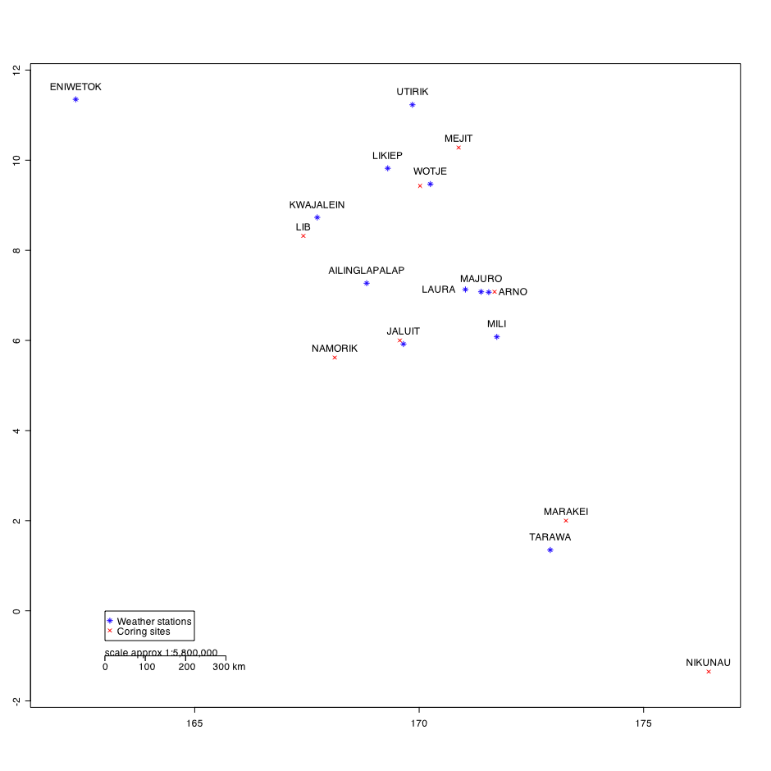
Figure 1. Map showing locations of proposed coring sites as well as weather stations where monthly precipitation data is available.

Data Sources
We obtained monthly precipitation data in inches from NOAA. The following table summarizes the data used in this report. Incidentally, DS3500 data for Tarawa from 1987 – 1998 was available but was not used because it was a much shorter times series and many of the values were marked as suspect.

Station | Latitude | Longitude | Data available | Format
Ailinglapalap | 7.27 | 168.83 | 1985 – 2006 | DS3220
Arno | 7.07 | 171.55 | 1991 – 2006 | DS3220
Eniwetok WSO | 11.35 | 162.35 | 1952 – 1978 | DS3220
Jabor * | 5.92 | 169.65 | 1956 – 1962 | DS3220
Jaluit * | 5.92 | 169.65 | 1985 – 2005 | DS3220
Kwajalein Missle Ran | 8.73 | 167.73 | 1952 – 2007 | DS3220
Laura | 7.13 | 171.03 | 1990 – 2006 | DS3220
Likiep | 9.82 | 169.30 | 1962 – 1964 | DS3220
Majuro WBAS AP | 7.08 | 171.38 | 1954 – 2007 | DS3220
Mili | 6.08 | 171.73 | 1985 – 2006 | DS3220
Tarawa | 1.35 | 172.92 | 1926 – 1998 | GSNMON
Utirik | 11.23 | 169.85 | 1985 – 2006 | DS3220
Wotje | 9.47 | 170.25 | 1985 – 2006 | DS3220
* Jabor is a location on Jaluit Atoll, and the stations have the same coordinates though there is a 23 year gap between them. The data for Jabor and Jaluit was combined and is listed as Jaluit for the remainder of this report.

Overview
The following two pages show plots giving an overview of the data. Figure 2 shows all the data, giving an idea of the scope and amount of data for each station. Figure 3 is a box plot showing the means, where the box shows the interquartile and the whiskers extend one and a half times the range of the interquartile. The widths of the boxes show the relative amounts of data available per station. Note that in these and other plots, the stations are ordered by latitude north to south along the rainfall gradient (dry – wet – dry) of the ITCZ.

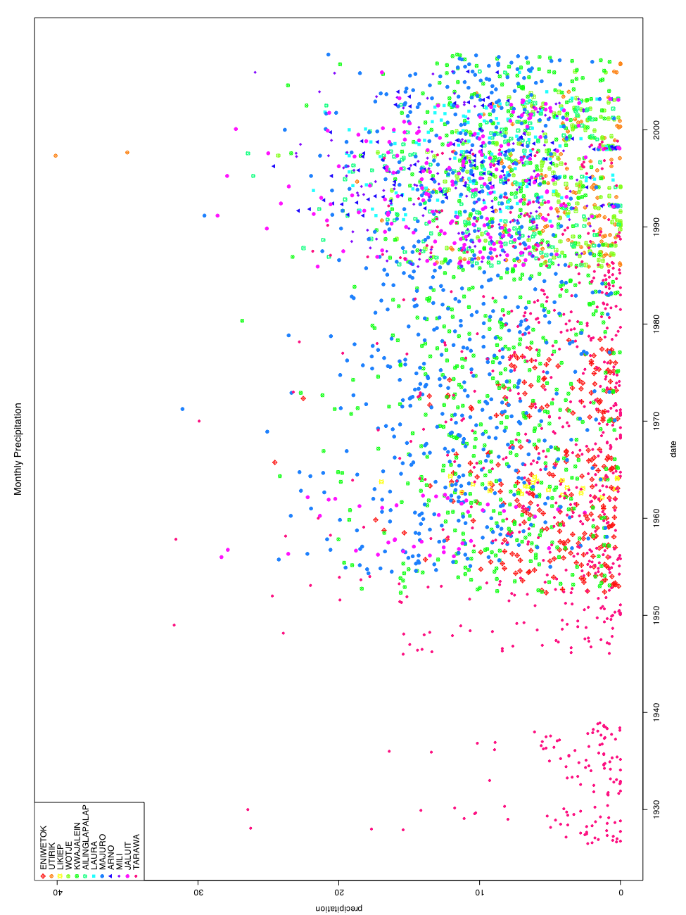

Figure 2. Raw data for all stations.
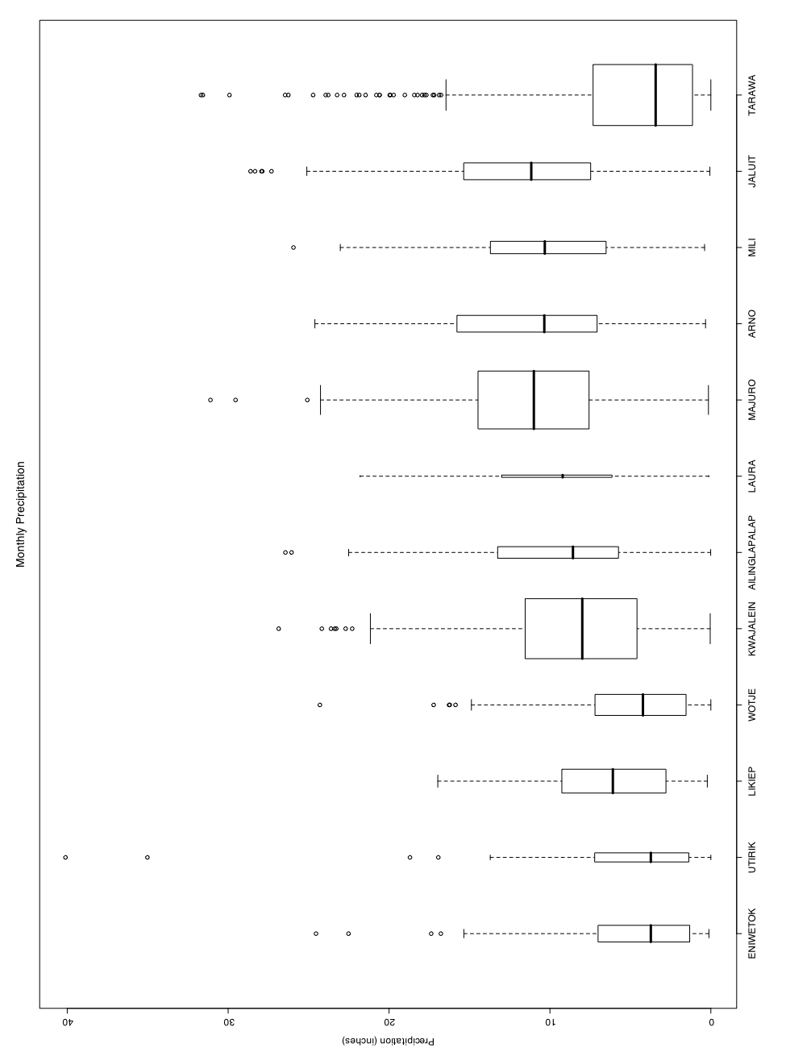

Figure 3. Box plot of monthly precipitation by station.

Methods
The monthly precipitation data was modeled with the classical decomposition model [REF]:
X_{t} = m_{t} + s_{t} + Y_{t}
where X_{t} is the data value at time t, m_{t} is the trend component (a function of t), s_{t} is the seasonal component (a function of the period of the data, which is a year in this case), and Y_{t} is the remainder component, which should be stationary, meaning … .
The challenge with this monthly precipitation data is that there are many missing values throughout the time series, including occasionally entire missing years. The data sets for Kwajalein and Majuro are the most complete, with just a few missing values at the beginning and end of the series. The Tarawa time series is the longest, stretching from 1926 to 1998, though it does have significant gaps and missing values, as the longest contiguous piece is only 11 years. The difficulty is that many, if not most, methods of time series analysis rely on a contiguous time series without missing values. To get around this problem, we chose to detrend the data by choosing a constant trend—the average monthly rainfall. To deseasonalize the data, we averaged each month's rainfall and subtracted the constant trend. This is very similar to how the seasonal component is estimated in other methods (see, for example, decompose() in R) but has the advantage of using the complete data set rather than just the contiguous portion. The disadvantage is that because the trend is assumed to be constant, some amount of annual trend is still present in the remainder (i.e. rainy years vs. dry years). So the mean and seasonal components are estimated as the following:
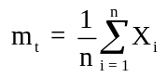
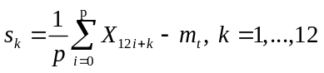
The following table summarizes the seasonal and trend estimates for each island, as well as showing the data range of the data, and the number of actual observations (Obs column) and missing observations (NAs column). For stations where it was possible, the chart contains the results from the R function stl() for the largest contiguous subset of the data. The function decomposes a time series into seasonal, trend, and remainder components using loess (a smoothing technique). Keep in mind that these are often very small time spans and hence not as reliable. There is considerable agreement between both methods for large, complete time series such as Kwajalein and Majuro. In this table, 'stl' refers to this type of decomposition, while 'all' refers to the method using all the data described in the preceding paragraph.

Type | Station | Data Range | Obs | NAs | Trend | Jan | Feb | Mar | Apr | May | Jun | Jul | Aug | Sep | Oct | Nov | Dec
all | Eniwetok | Jan 1952 – Dec 1978 | 264 | 60 | 4.62 | -3.28 | -3.69 | -2.90 | -1.46 | 0.60 | -0.62 | 2.33 | 2.53 | 2.78 | 5.09 | 1.64 | -1.60
stl | Eniwetok | Jan 1953 – Jun 1967 | 174 | 0 | varies | -3.57 | -3.88 | -2.98 | -2.32 | 0.24 | -0.87 | 2.23 | 2.12 | 2.46 | 5.93 | 1.94 | -1.30
all | Utirik | Jan 1985 – Dec 2006 | 137 | 127 | 5.06 | -2.33 | -3.65 | -1.51 | -2.56 | 1.78 | -0.89 | 0.18 | 1.83 | 7.04 | 1.36 | 1.92 | -2.29
all | Likiep | Jan 1962 – Dec 1964 | 25 | 11 | 6.12 | -5.26 | -4.68 | -4.36 | 0.22 | 3.29 | 1.93 | 2.62 | -0.10 | 2.62 | 5.95 | 1.47 | -1.51
all | Wotje | Jan 1985 – Dec 2006 | 187 | 77 | 5.07 | -2.55 | -3.35 | -2.27 | -0.97 | 0.55 | 0.31 | -0.53 | 0.08 | 2.74 | 4.18 | 3.19 | 0.06
stl | Wotje | Dec 1985 – Oct 1988 | 35 | 0 | varies | -3.16 | -3.97 | -3.76 | -2.52 | 0.83 | 2.69 | -3.17 | -0.57 | 1.91 | 7.84 | 3.26 | 0.62
all | Kwajalein | Jan 1952 – Dec 2007 | 665 | 7 | 8.32 | -4.07 | -5.17 | -4.18 | -1.13 | 0.89 | 0.82 | 1.74 | 2.18 | 2.69 | 3.65 | 2.62 | -0.22
stl | Kwajalein | Oct 1966 – Oct 2007 | 493 | 0 | varies | -3.66 | -4.88 | -4.30 | -0.86 | 0.35 | 0.53 | 1.95 | 2.35 | 2.95 | 3.66 | 2.07 | -0.16
all | Ailinglapalap | Jan 1985 – Dec 2006 | 184 | 80 | 9.33 | -2.98 | -4.17 | -3.23 | -0.94 | 2.49 | 0.59 | 2.43 | 1.27 | 1.49 | 1.67 | 2.87 | 0.53
stl | Ailinglapalap | Jan 1989 – May 1991 | 29 | 0 | varies | -3.83 | -5.44 | -1.52 | -3.96 | 4.31 | 1.87 | 2.57 | -0.45 | 2.98 | 4.45 | 2.03 | -3.00
all | Laura | Jan 1990 – Dec 2006 | 128 | 76 | 9.50 | -1.27 | -3.81 | -2.85 | -1.08 | 1.46 | -0.62 | 2.38 | 0.72 | 1.52 | 3.11 | 1.71 | -0.63
stl | Laura | Dec 1996 – May 1999 | 30 | 0 | varies | -6.27 | -5.30 | -3.72 | -1.99 | 0.33 | -0.63 | 1.96 | 7.99 | 2.07 | 5.45 | -0.23 | 0.34
all | Majuro | Jan 1954 – Dec 2007 | 641 | 7 | 11.05 | -2.84 | -3.96 | -2.76 | -0.23 | 0.21 | 0.43 | 1.25 | 0.53 | 1.45 | 3.28 | 2.09 | 0.41
stl | Majuro | Jul 1954 – Oct 2007 | 640 | 0 | varies | -2.80 | -3.93 | -2.72 | -0.19 | 0.12 | 0.48 | 1.24 | 0.53 | 1.45 | 3.29 | 2.10 | 0.43
all | Arno | Jan 1991 – Dec 2006 | 101 | 91 | 11.06 | -2.70 | -3.76 | -3.29 | 2.00 | 1.26 | 0.67 | -0.22 | -1.16 | 1.90 | 1.66 | 3.23 | 1.28
all | Mili | Jan 1985 – Dec 2006 | 185 | 79 | 10.41 | -1.55 | -2.96 | -2.17 | 0.55 | 1.49 | -0.42 | 2.52 | -0.05 | 1.38 | -0.29 | -0.52 | 1.95
stl | Mili | Jul 1995 – Feb 1998 | 32 | 0 | varies | -2.86 | 0.07 | -5.39 | 7.72 | 4.44 | -2.74 | -3.71 | 2.23 | 2.79 | -1.12 | -0.90 | -0.53
all | Jaluit * | Jan 1956 – Dec 2005 | 233 | 367 | 11.66 | 0.72 | -3.50 | -0.84 | 1.45 | 1.17 | 0.07 | 1.16 | -0.53 | 0.37 | 0.62 | 0.37 | -0.43
stl | Jaluit | Dec 1996 – May 1999 | 30 | 0 | varies | -3.08 | -4.29 | -5.65 | -2.20 | 0.24 | 1.29 | -1.81 | 8.12 | 2.70 | 2.77 | 0.95 | 0.96
all | Tarawa | Jan 1926 – Dec 1998 | 676 | 200 | 5.19 | 3.79 | 1.11 | 1.28 | -0.35 | -0.89 | -1.00 | -0.42 | -0.86 | -1.40 | -2.20 | -1.13 | 2.04
stl | Tarawa | Sep 1953 – Nov 1964 | 135 | 0 | varies | 2.58 | 1.15 | 1.43 | -0.54 | -1.30 | -1.91 | -0.8 | -0.84 | -0.37 | -2.20 | 0.88 | 1.92

* JALUIT includes data from Jaluit (1985 – 2005) and Jabor (1956 – 1962) stations.

Figure 4 shows each station's seasonal component, again with the stations ordered north to south. The top chart shows our decomposition of the seasonal component using all the data, while the bottom chart shows the stl decomposition using the largest contiguous subset. There were three stations (Utirik, Likiep, and Arno) that did not have a large enough contiguous section, and hence are missing from the bottom chart. The stl seasonal component is much more variable, and does not conform as well to known seasonal rainfall patterns. The top chart is more consistent, with the various stations having a similar seasonal component. Tarawa exhibits a bit of a different pattern, though it is significantly farther south than any other station and also farther from the mean ITCZ location of 7°N than any other station.
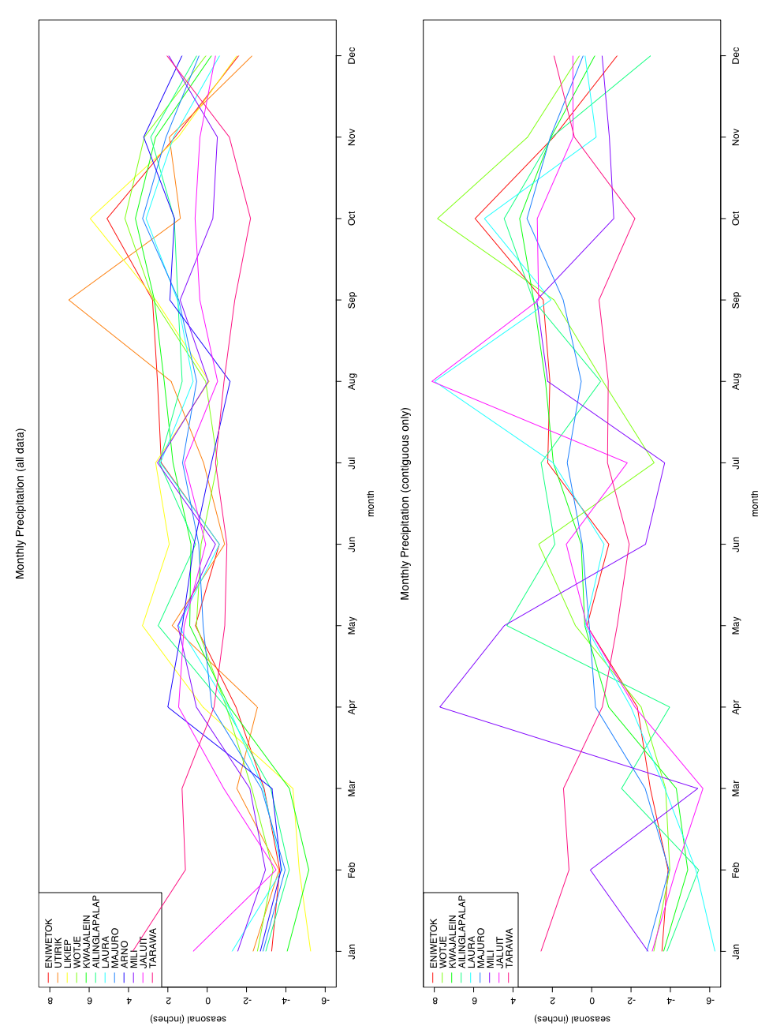

Figure 4. Comparisons of monthly mean when calculated using all data versus contiguous data only.

Correlations
The remainder component is what is left after subtracting the trend and seasonal components from the time series. The cross-correlations of the remainder between each pair of stations was examined, and the charts can be found in the appendix. Looking at the cross-correlations, and especially the autocorrelations (each station with itself), there is still an evident trend in the remainder. However, for the most part, the strongest cross-correlations are at a lag of 0, showing that at a monthly time scale, another station’s previous month's precipitation is not a strong influence on the current month. There are a few exceptions, such as Eniwetok with Jaluit; Utirik with Ailinglapalap, Laura, Arno, and Mili; Likiep with Majuro; and Tarawa with Laura, Arno, and Jaluit. Looking at the correlation at lag 0, it is clear that the strongest correlations ( > 0.5) are a function of proximity, but not a function of distance from the ITCZ. For example, Tarawa isn't correlated with any other station, except for slightly negatively with Majuro. This is expected, because the trend component was removed, which accounted for whether a station tended to be wet or dry. The correlation as a function of proximity does come through with the strong correlations between Utirik and Wotje as well as between Likiep and Kwajalein. Interestingly, there are strong correlations among Kwajalein, Ailinglapalap, Laura, Majuro, and Arno, but while the four more southern stations are also correlated with Mili and Jaluit, Kwajalein isn't. The following table summarizes the cross-correlations at lag 0, while the Appendix contains the complete cross-correlations.

 | Eniwetok | Utirik | Likiep | Wotje | Kwajalein | Ailinglapalap | Laura | Majuro | Arno | Mili | Jaluit | Tarawa
Eniwetok | 1 | NA | 0.21 | NA | 0.37 | NA | NA | 0.21 | NA | NA | -0.05 | -0.01
Utirik | NA | 1 | NA | 0.59 | 0.29 | 0.11 | 0.07 | 0.22 | -0.15 | 0.15 | 0.07 | 0.08
Likiep | 0.21 | NA | 1 | NA | 0.65 | NA | NA | 0.34 | NA | NA | NA | 0.05
Wotje | NA | 0.59 | NA | 1 | 0.4 | 0.35 | 0.28 | 0.27 | 0.17 | 0.29 | 0.13 | -0.18
Kwajalein | 0.37 | 0.29 | 0.65 | 0.4 | 1 | 0.54 | 0.47 | 0.47 | 0.45 | 0.28 | 0.28 | -0.02
Ailinglapalap | NA | 0.11 | NA | 0.35 | 0.54 | 1 | 0.46 | 0.47 | 0.64 | 0.44 | 0.44 | 0.08
Laura | NA | 0.07 | NA | 0.28 | 0.47 | 0.46 | 1 | 0.62 | 0.53 | 0.43 | 0.50 | -0.05
Majuro | 0.21 | 0.22 | 0.34 | 0.27 | 0.47 | 0.47 | 0.62 | 1 | 0.66 | 0.49 | 0.53 | -0.16
Arno | NA | -0.15 | NA | 0.17 | 0.45 | 0.64 | 0.53 | 0.66 | 1 | 0.47 | 0.57 | -0.01
Mili | NA | 0.15 | NA | 0.29 | 0.28 | 0.44 | 0.43 | 0.49 | 0.47 | 1 | 0.54 | -0.11
Jaluit | -0.05 | 0.07 | NA | 0.13 | 0.28 | 0.44 | 0.50 | 0.53 | 0.57 | 0.54 | 1 | -0.08
Tarawa | -0.01 | 0.08 | 0.05 | -0.18 | -0.02 | 0.08 | -0.05 | -0.16 | -0.01 | -0.11 | -0.08 | 1

The p-values for the correlations are shown below for H₀: ρ = 0 vs H₁: ρ != 0:
 | Eniwetok | Utirik | Likiep | Wotje | Kwajalein | Ailinglapalap | Laura | Majuro | Arno | Mili | Jaluit | Tarawa
Eniwetok |  | NA | 3.07E-01 | NA | 4.74E-10 | NA | NA | 1.16E-03 | NA | NA | 7.40E-01 | 8.76E-01
Utirik | NA |  | NA | 5.28E-13 | 6.54E-04 | 2.47E-01 | 5.53E-01 | 9.43E-03 | 2.58E-01 | 9.98E-02 | 4.58E-01 | 5.38E-01
Likiep | 3.07E-01 | NA |  | NA | 4.87E-04 | NA | NA | 9.78E-02 | NA | NA | NA | 8.20E-01
Wotje | NA | 5.28E-13 | NA |  | 1.33E-08 | 2.76E-06 | 2.07E-03 | 1.49E-04 | 1.04E-01 | 1.57E-04 | 8.49E-02 | 9.65E-02
Kwajalein | 4.74E-10 | 6.54E-04 | 4.87E-04 | 1.33E-08 |  | 3.33E-15 | 2.05E-08 | 0.00E+00 | 2.81E-06 | 1.05E-04 | 1.12E-05 | 6.87E-01
Ailinglapalap | NA | 2.47E-01 | NA | 2.76E-06 | 3.33E-15 |  | 2.16E-07 | 1.13E-11 | 1.75E-11 | 3.59E-09 | 1.79E-09 | 4.44E-01
Laura | NA | 5.53E-01 | NA | 2.07E-03 | 2.05E-08 | 2.16E-07 |  | 4.00E-15 | 2.39E-07 | 4.08E-06 | 5.64E-09 | 7.78E-01
Majuro | 1.16E-03 | 9.43E-03 | 9.78E-02 | 1.49E-04 | 0.00E+00 | 1.13E-11 | 4.00E-15 |  | 4.55E-14 | 2.04E-12 | 0.00E+00 | 5.32E-04
Arno | NA | 2.58E-01 | NA | 1.04E-01 | 2.81E-06 | 1.75E-11 | 2.39E-07 | 4.55E-14 |  | 2.08E-06 | 2.14E-09 | 9.43E-01
Mili | NA | 9.98E-02 | NA | 1.57E-04 | 1.05E-04 | 3.59E-09 | 4.08E-06 | 2.04E-12 | 2.08E-06 |  | 5.15E-14 | 3.13E-01
Jaluit | 7.40E-01 | 4.58E-01 | NA | 8.49E-02 | 1.12E-05 | 1.79E-09 | 5.64E-09 | 0.00E+00 | 2.14E-09 | 5.15E-14 |  | 3.44E-01
Tarawa | 8.76E-01 | 5.38E-01 | 8.20E-01 | 9.65E-02 | 6.87E-01 | 4.44E-01 | 7.78E-01 | 5.32E-04 | 9.43E-01 | 3.13E-01 | 3.44E-01

References
Brockwell, P. J. and R. A. Davis
1996. Introduction to Time Series and Forecasting. New York, NY: Springer. 420 pp.
Shumway, R. H. and D. S. Stoffer
2000. Time Series Analysis and Its Applications. New York, NY: Springer. 549 pp.

Appendix
The following pages show the cross-correlations of the remainder between each pair of stations. Each page shows the correlation of a station with every other station, including itself. Thus, each pair of stations is listed twice—on different pages—and the correlations are the same, just with the order of leading and trailing reversed. The correlations range from -1 to 1, with a value of 1 for the autocorrelation of a time series at lag 0. The time scale for the lag is in years, with a value shown for each month. The dashed blue lines show whether a correlation is significant at the 95% level.

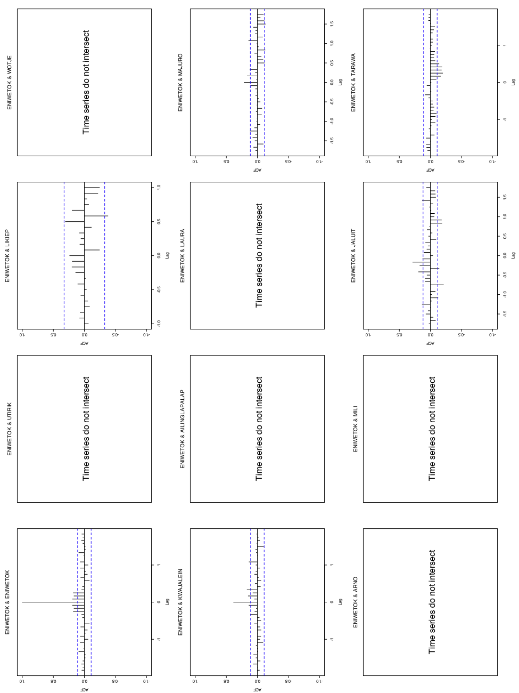
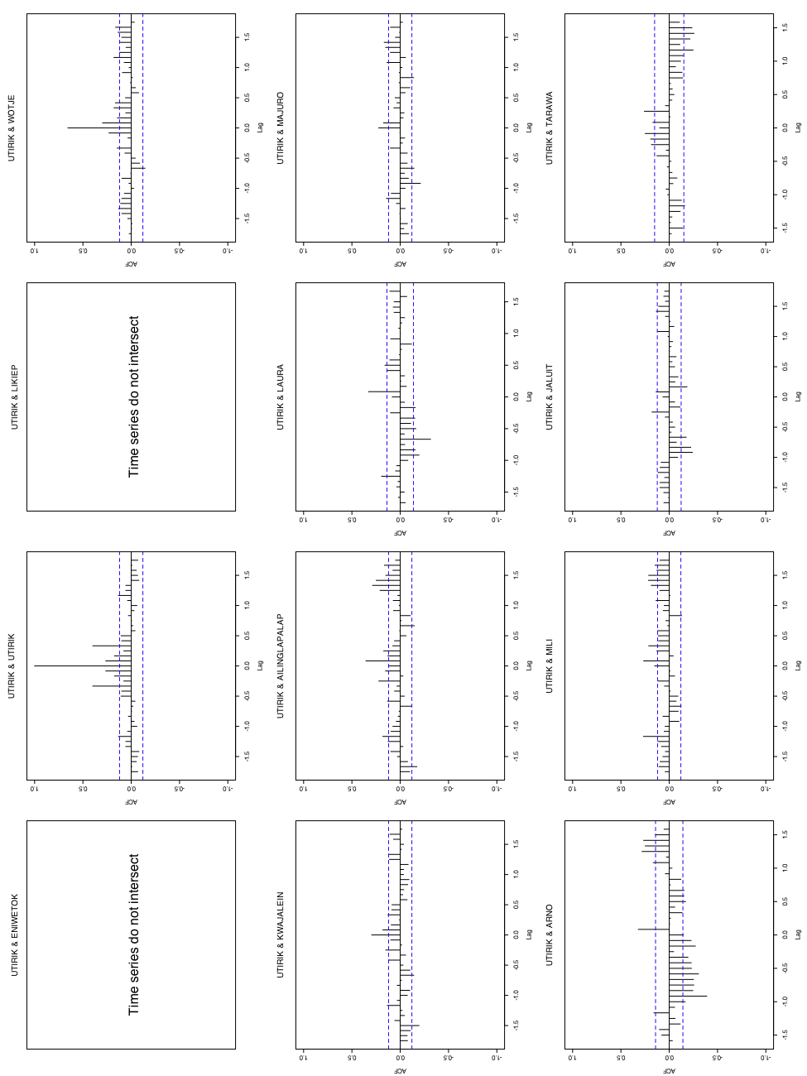
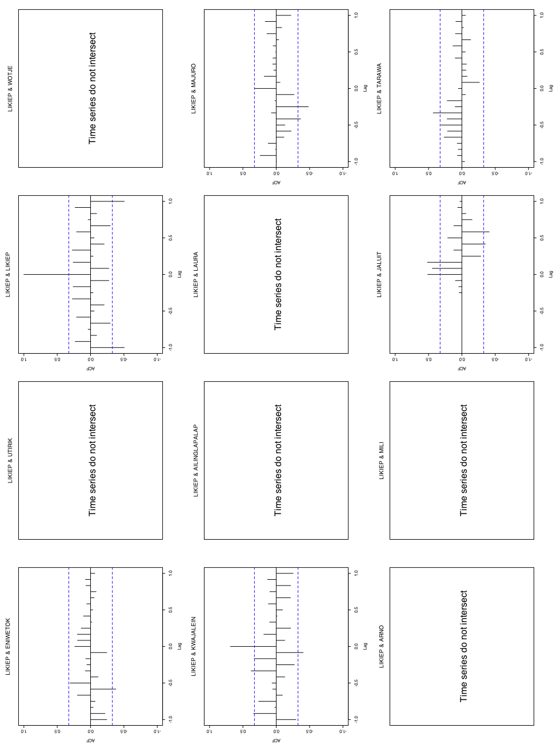
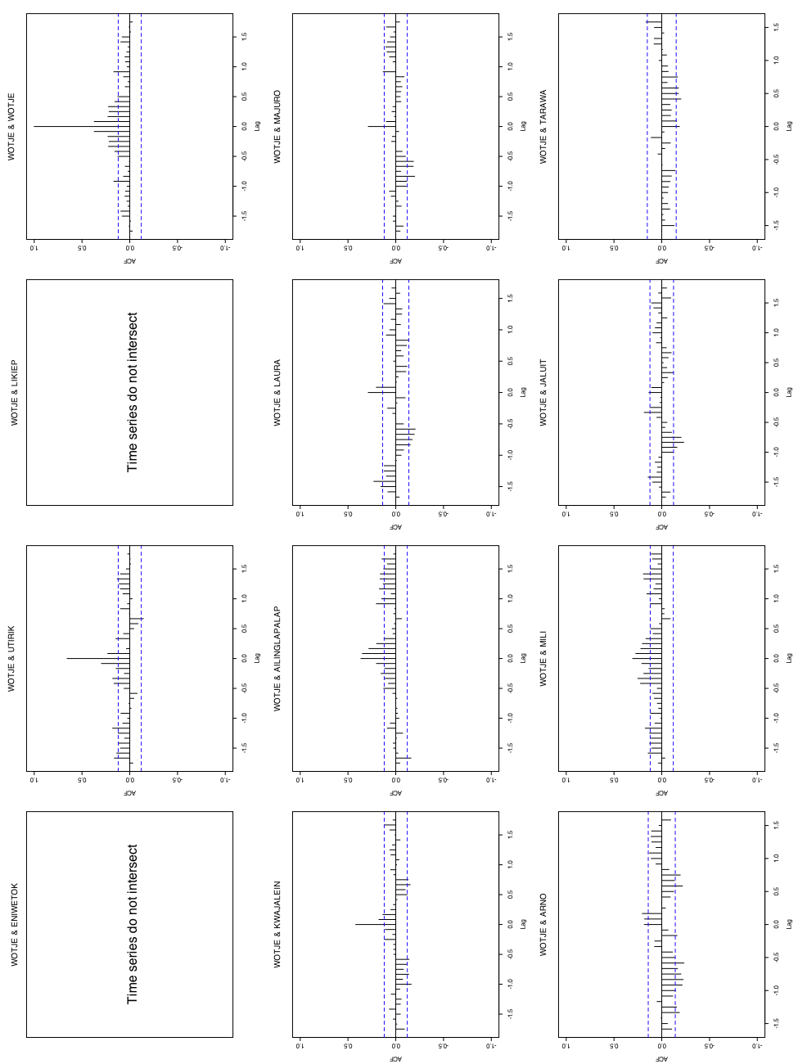
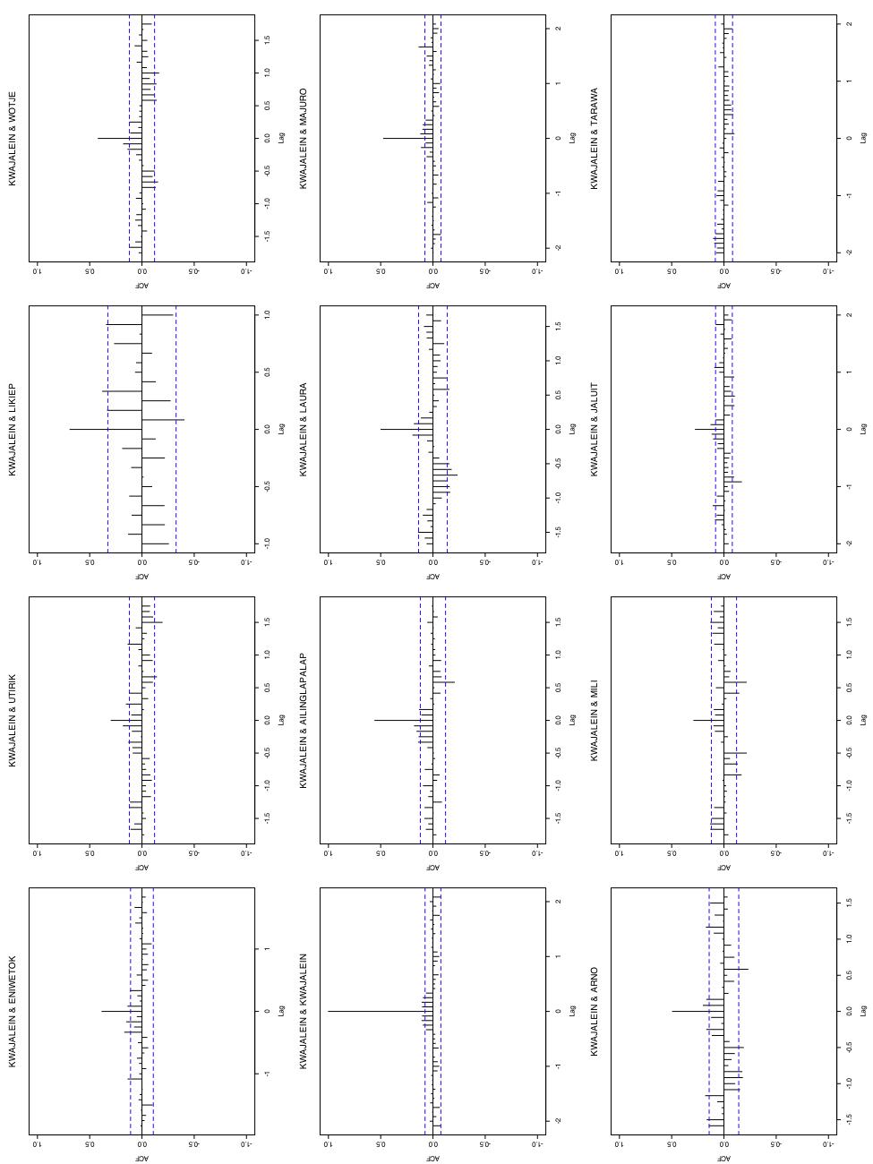
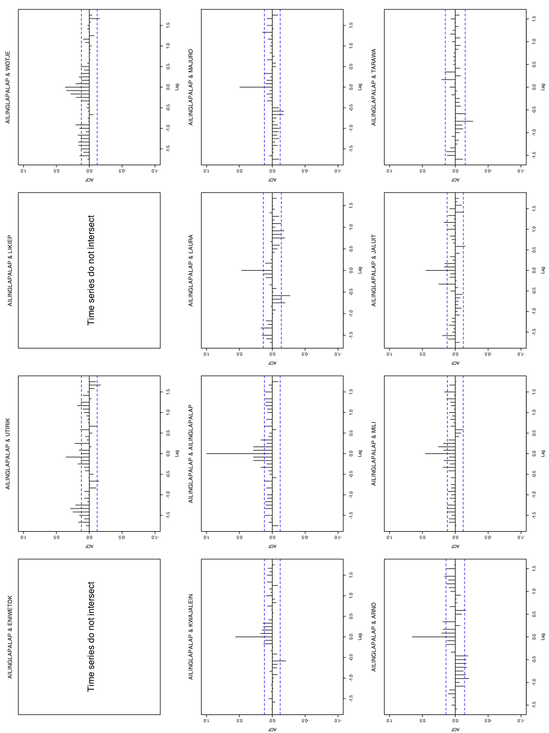
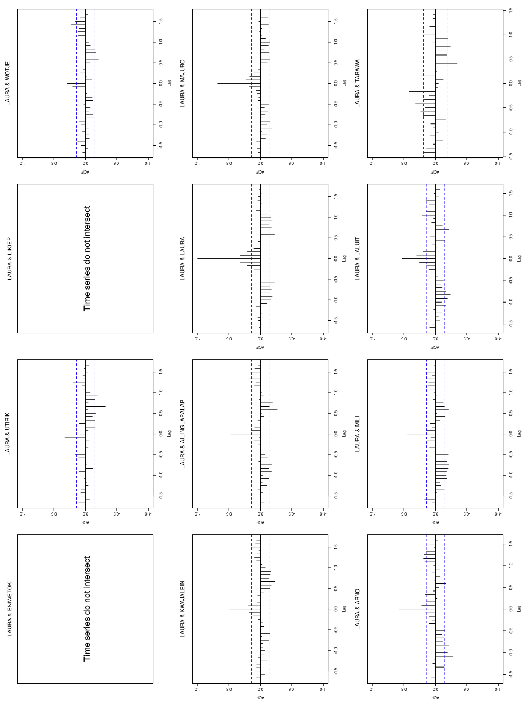
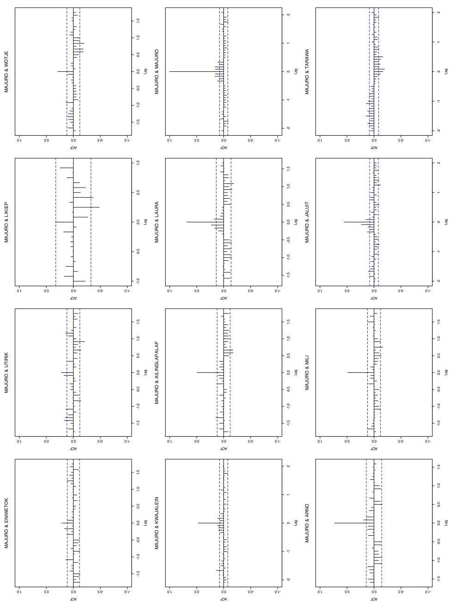
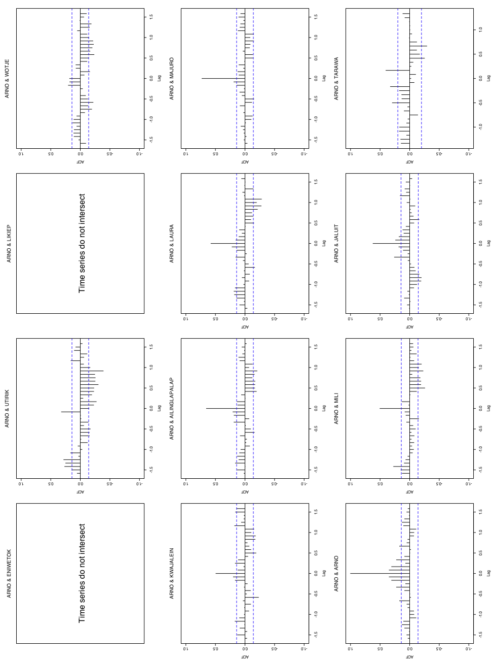
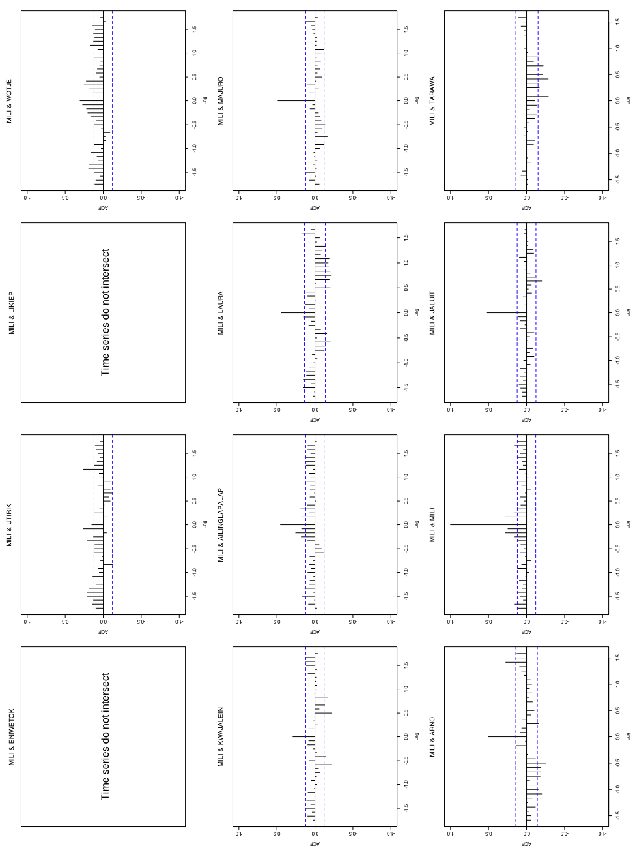
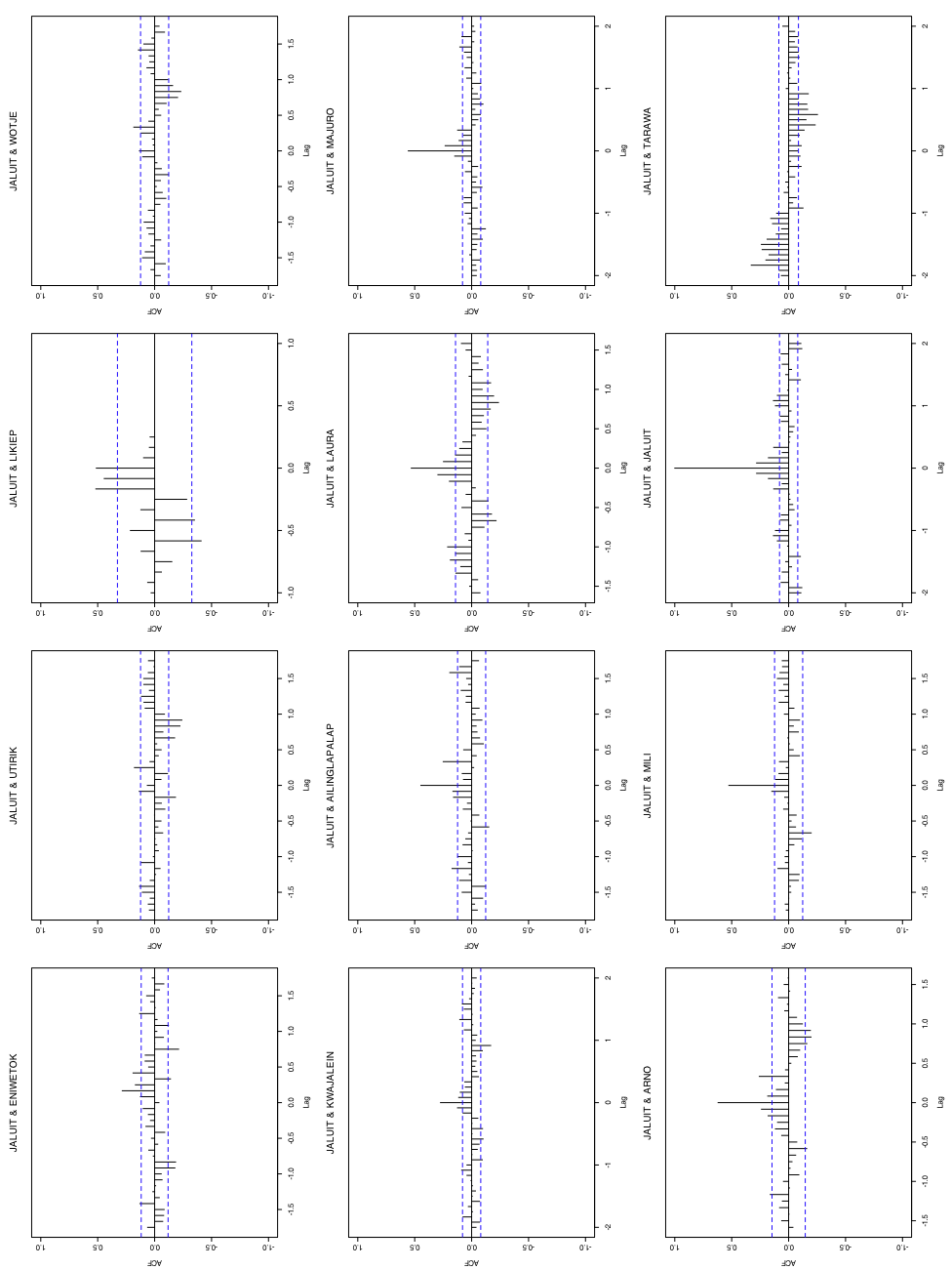
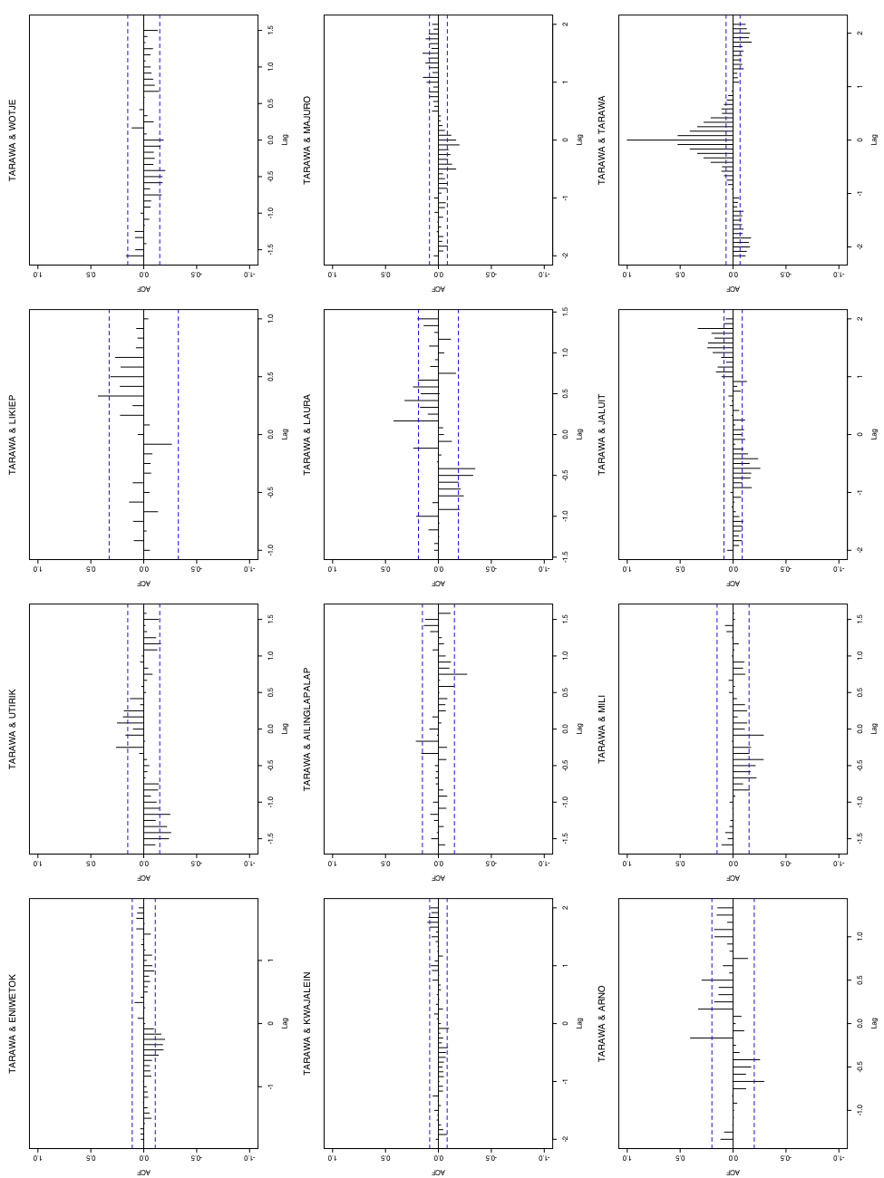

1 Quantitative Ecology and Resource Management, University of Washington, Box 352182, Seattle, WA 98195; email: cbracis@u.washington.edu
2 School of Oceanography, University of Washington, Box 355351, Seattle, WA 98195

