Git = **DISTRIBUTED** version control system. Any person has access to that folder.

Cloud system >> github, gitcloud

Git >> version control software

Github and gitlab >> cloud repository >> you upload your info to this hosting service >> they ALL use git

Git init >> NO WHERE in subfolder don’t type GIT again >> only top directory

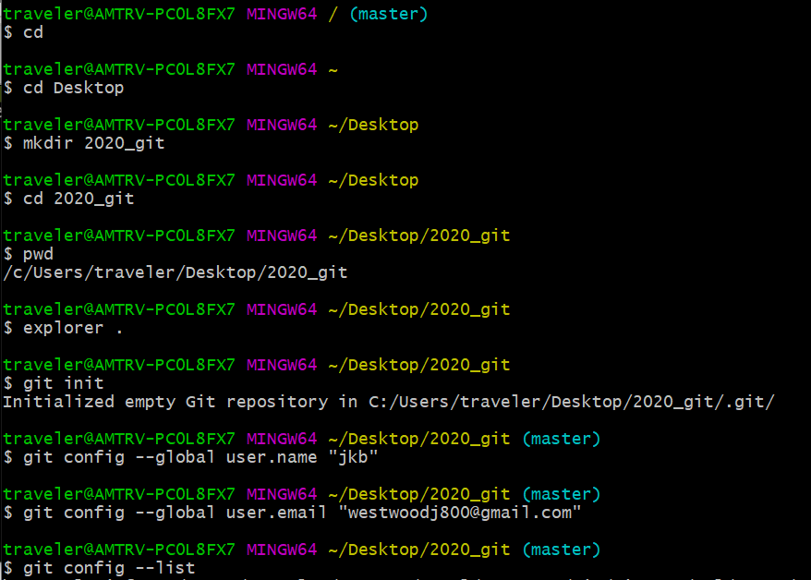

Master to main >> deal with branches

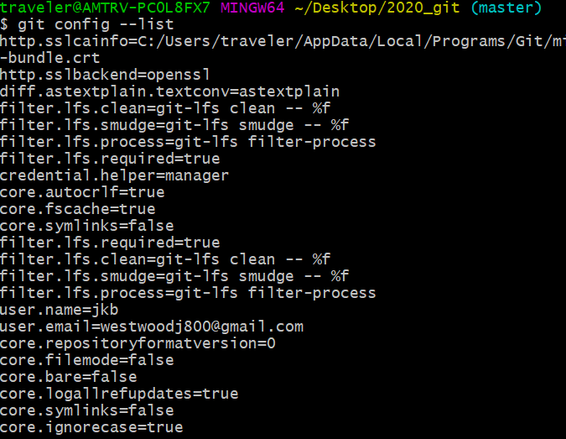

SHOW HIDDEN files and you will see git

Need to add and then commit

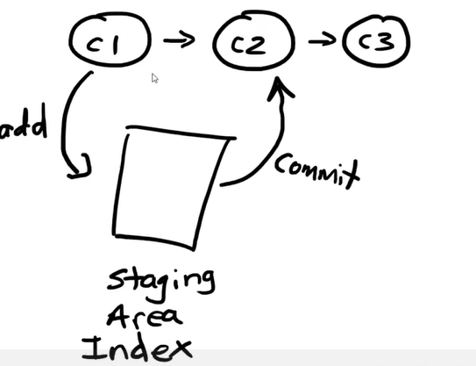

What is branch master >> Refers to all of the commits (CAN ALSO be CALLED MAIN)

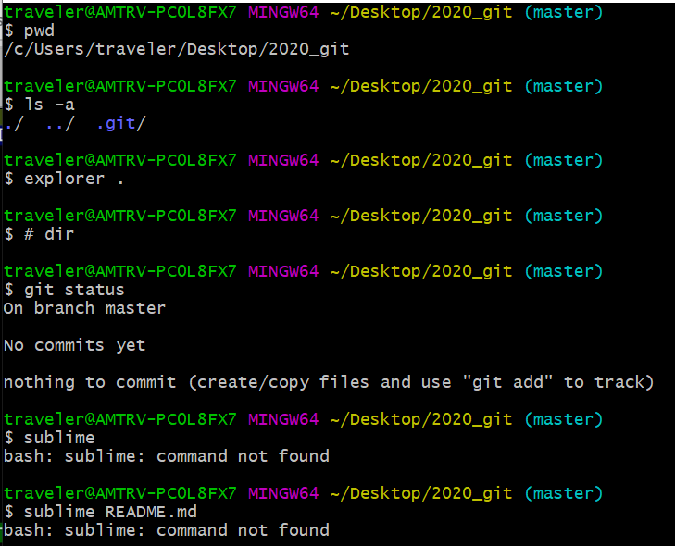  
  
README >> create a file and save in fir repository >> OUTSIDE THE .git repository

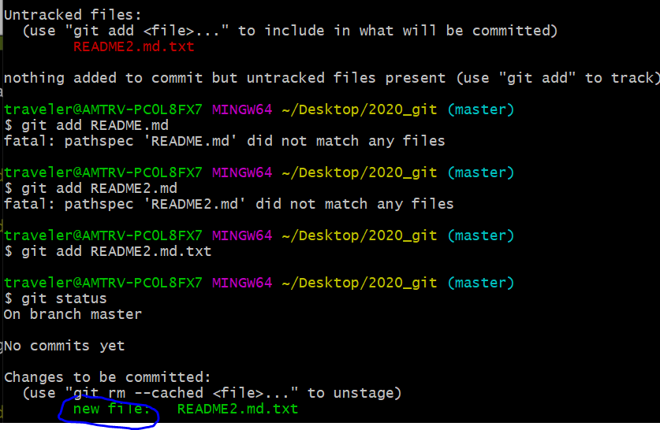

Git comit

This is what you get >> file

VIM EDITOR COMMANDS >> press ESC to get to COMMAND mode

I for INSERT MODE >> vim README2.md.txt >> to get to your file

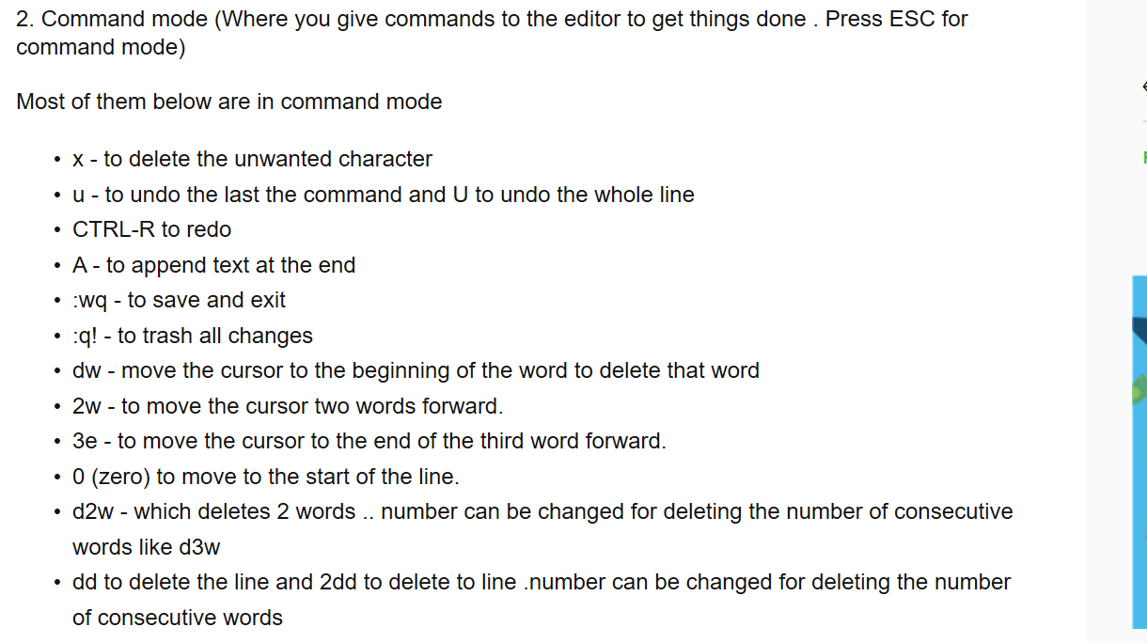  
  
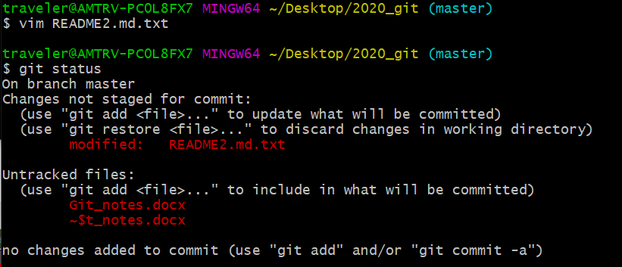  
  
git commit >> -m >> just add one line >> go into editor to get multilines comments

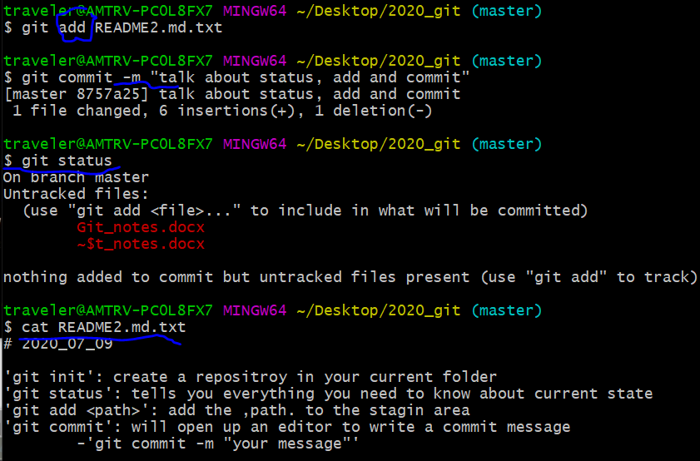  
  
history of different STATES of file

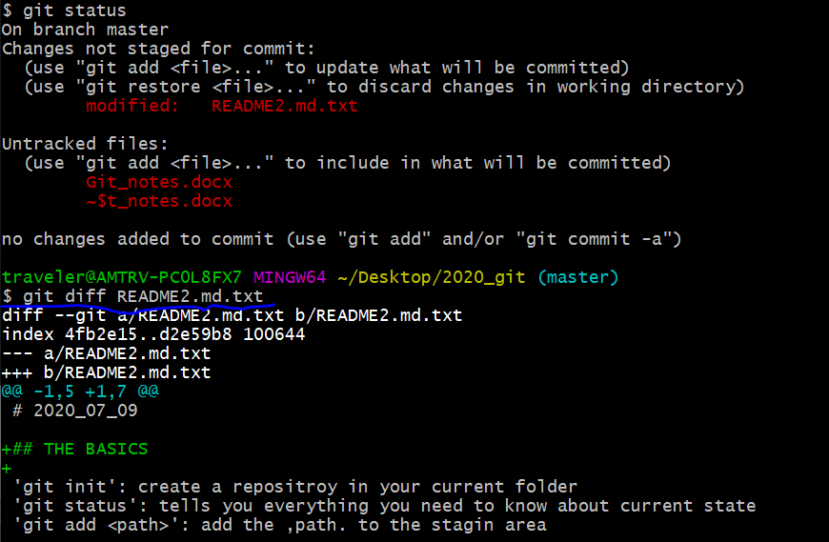  
  
green++ >> this is where the new items where changed to exiting file that has YET to be commited

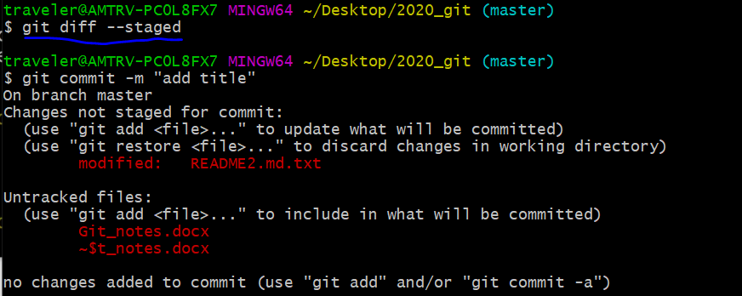

HEAD >> tells you exactly where you are looking in the branch

You can move HEAD around to see the history  
  
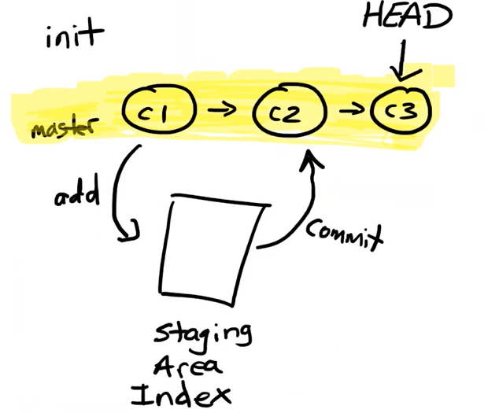

Config information is tagged with what they did

REVERSE chronological order

HEAD is where you are the latest stage in the master   
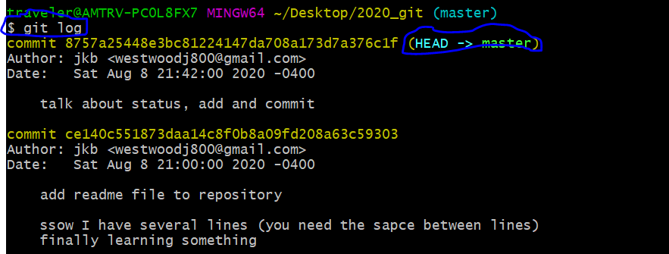

Git diff HEAD~1 >>> go back 1 version comparison

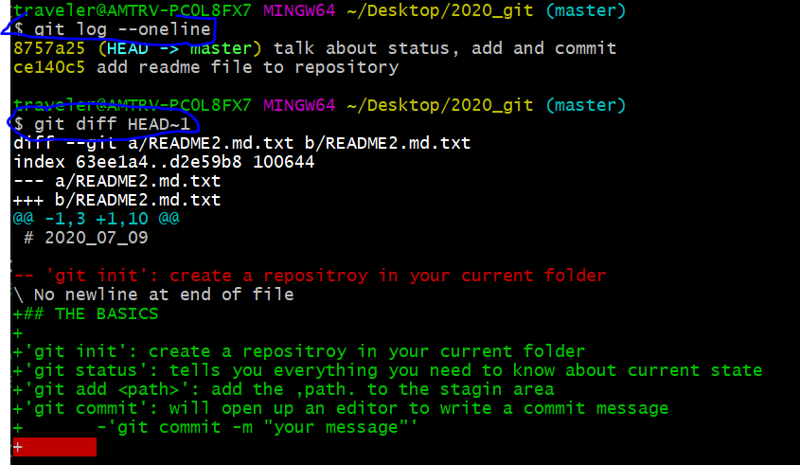  
  
  
can also go back via FILE   
  
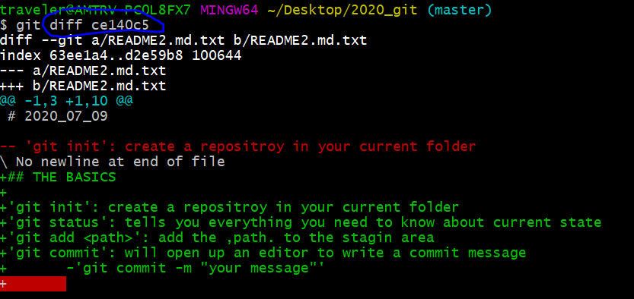

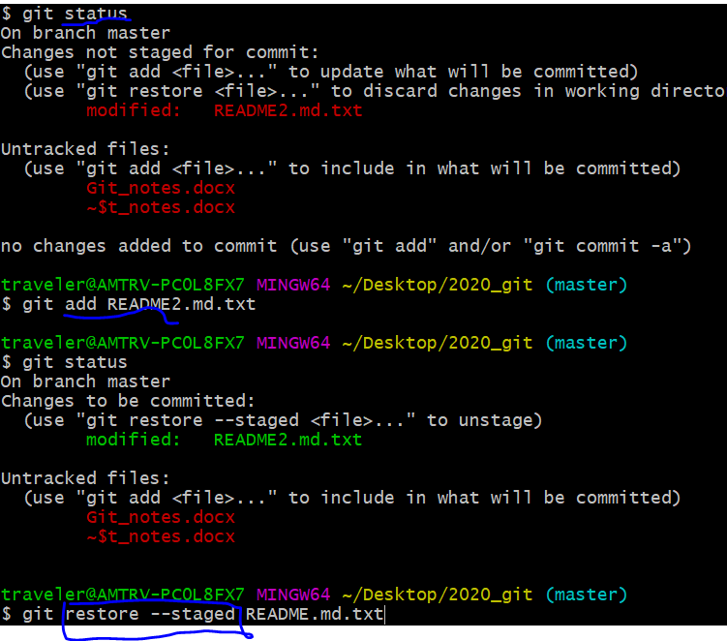

TO Get file back from a couple of files ago >> MOVE HEAD BACK

Checkout >> switch or restore

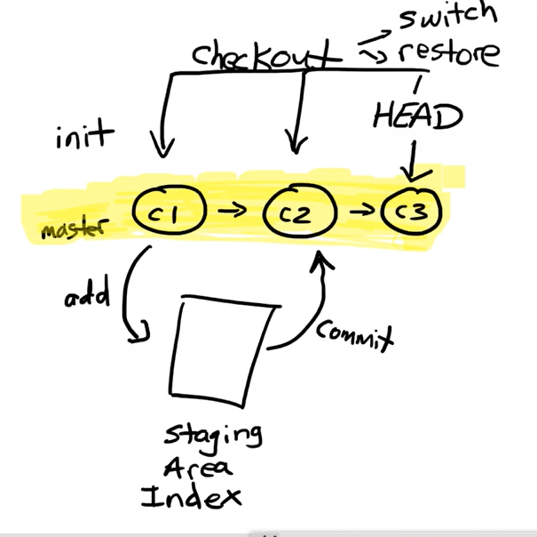

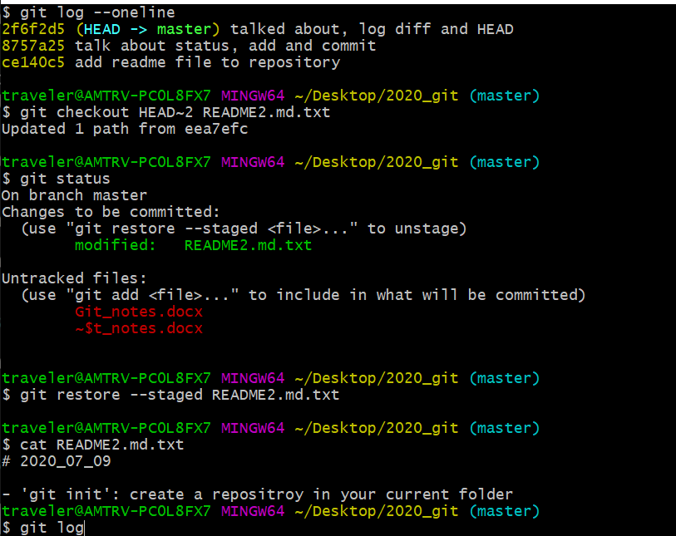

GIT DETACHED HEAD

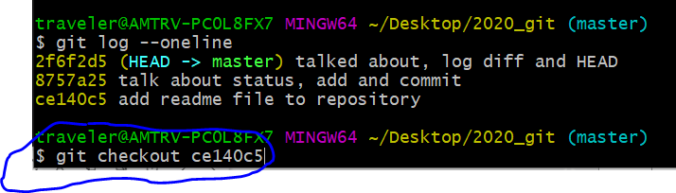

Run code from PREVIOUS state

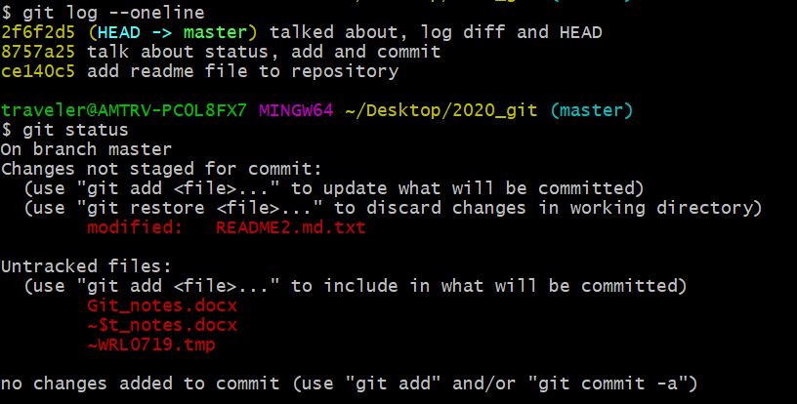

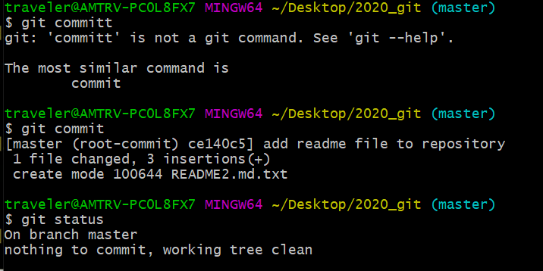  
  
working tree clean >> git has all saved changes

History >> gives you history of all commands that you typed

Git log >>>

GIT CHECKOUT >> MOVE THE HEAD AROUND

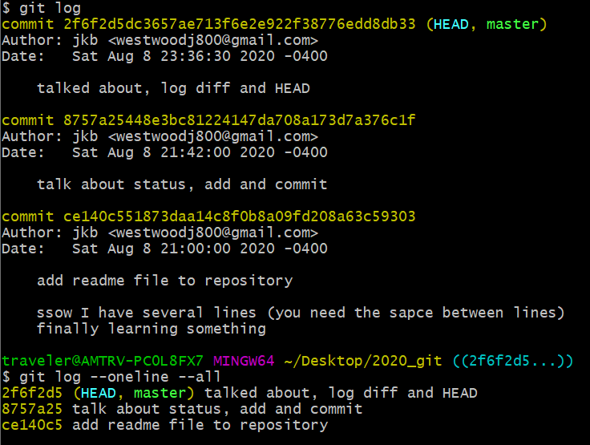

Git reset –hard >>> PERMENANTLY DELETE prior work (files lost for good)