RSAM Automation Framework Implementation Guide - QTP

1. Purpose of the Document 3
2. Framework Implementation in QTP 3
3. RSAM Automation Framework Architecture 3
4. Test Settings for Hybrid Framework Scripting 4
4.1. Run Settings 5
4.2. Resources Settings 6
4.3. Environment Tab Settings 7
4.4. Managing Object Repository 8
5. Building RSAM Automation Test Suites 9
6. Test Results 10
7. References 11

Purpose of the Document
This document provides the overview of the pre-requisites and settings required to implement the Hybrid Framework for RSAM Automation using HP Quick Test Professional.

Framework Implementation in QTP
The Hybrid Framework provides the adeptness of bringing together one or more frameworks required to achieve automation on RSAM. The following are the frameworks that this implementation model would make use of,
  - Modular Framework
  - Library Framework
  - Keyword Driven
  - Data Driven
The objective of implementing the Hybrid model of framework is to make use of the complete scope provided by the tool to achieve effective automation and ease in maintenance of the scripts.

RSAM Automation Framework Architecture

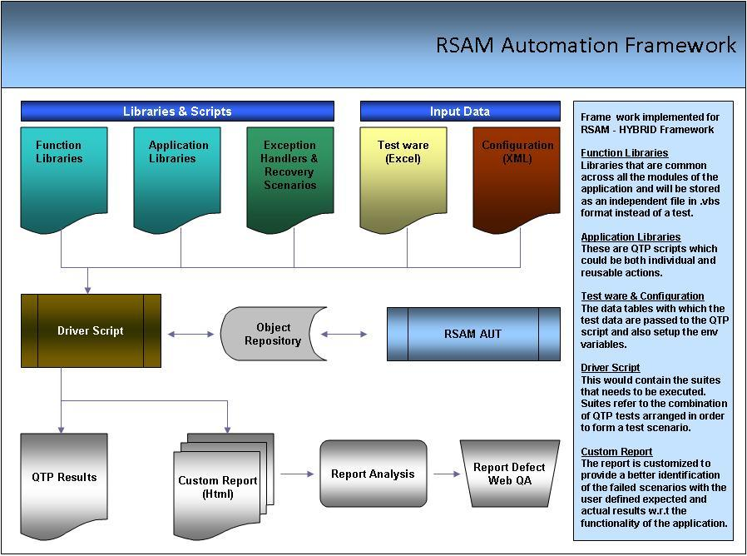

Test Settings for Hybrid Framework Scripting
In the Hybrid approach the entire script is developed with keywords and descriptions. The script is developed in the expert view of the QTP that is then called by the main driver script, which then uses the function library and object repository to execute the complete script.

The QTP Settings.vbs file can be used to easily perform the test settings that are needed before proceeding with the Scripting. This file associates the Function libraries, recovery scenarios, Environment Variables and the Object Repository files that are needed for a script.

The QTP Settings file needs to be customized before usage. Edit the .vbs file in notepad and make the necessary changes (mentioned below) in the ‘Input Data’ section of the file.
- Function Libraries – Specify the path where the Framework Files, Common Functions and the User Defined Functions are stored.
- Recovery Scenario File - Specify the path of the file where the Recovery scenarios are placed.
- Recovery Scenarios Name - Specify the names of the Recovery scenarios that need to be associated to the test script.
- Environment File - Specify the path of the xml file for the Global Environment Variables.
- Object Repository files - Specify the path of the Object Repository.

Open the test script in QTP for which the settings are needed and double click on the QTP Settings.vbs file. This file will perform the preferred settings automatically.
If there are multiple items of libraries, object repositories or global variables file, they can be specified as an array separated by ‘,’
Set the Flag envi_flag, recover_flag, repos_flag, library_flag to "Yes" if the corresponding files need to be associated to test, Else set it to "no"

Below is the Sample QTP Settings
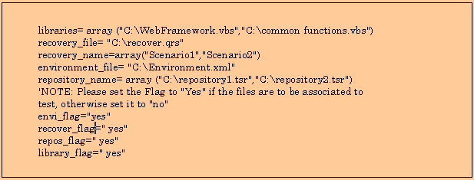
There should be just one Recovery file which holds all the Recovery scenarios. Multiple Recovery files cannot be used.
There should be no unsaved tests currently open in QTP. The test script for which the test settings need to be done should be open in QTP.

Run Settings

In the Run tab of the Test Settings dialog,
- The Run on all rows radio button will be selected depending on the need basis.
- The Disable Smart Identification during the run session check box will be checked.
- The Object Synchronization timeout value will be set as 20 seconds.

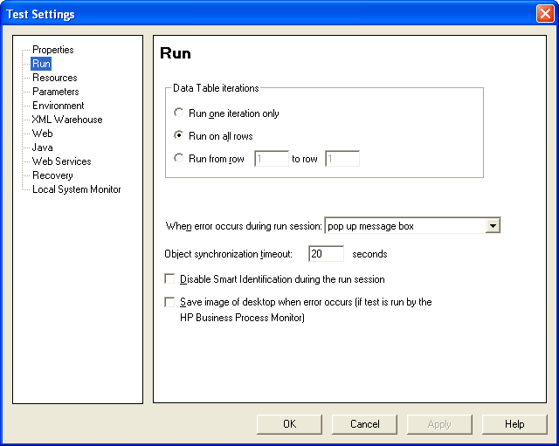

Resources Settings

After the run settings are completed, the QTP Settings file associates the framework with the test script. Here, the path and the names of the framework files need to be specified in the QTP Settings file. The framework will be taken from the location specified and associated with the test as shown below.
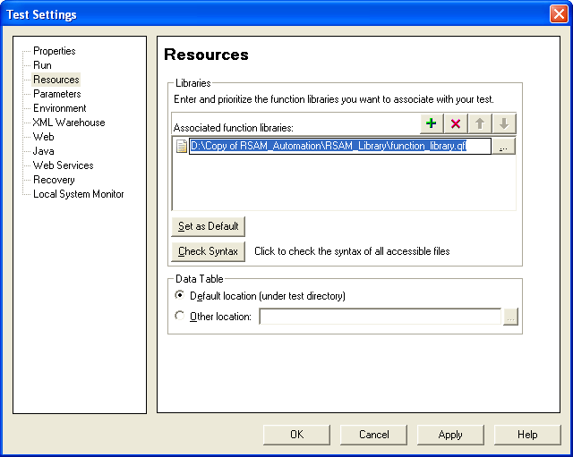

NOTE: The User defined functions file should be associated with the test only if needed by the test script.

Environment Tab Settings

QTP can insert a value from the environment variable list, which is a list of variables and corresponding values that can be accessed from the test. Throughout the test run, the value of an environment variable remains the same, regardless of the number of iterations, unless the value of the variable is changed programmatically in the script.

Associating the user-defined Environment Variables file with the test is also handled by the QTP Settings file. The Environment Variables file with an .xml file type will be taken from the path specified in the QTP Settings file and associated with the test.

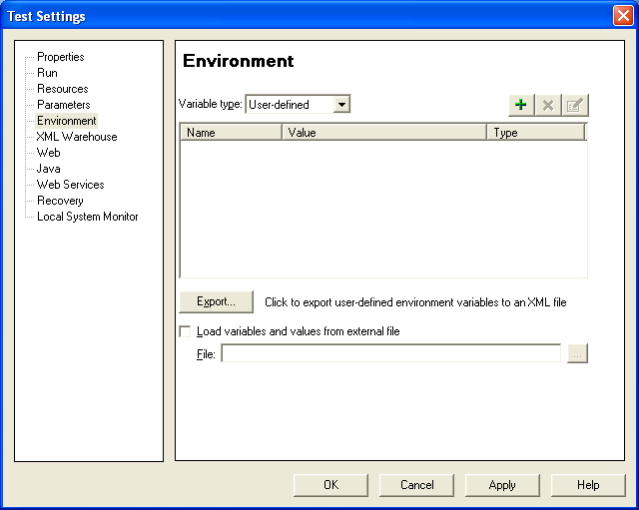

Managing Object Repository

After the test settings are completed, the QTP Settings file continues to associate the specified shared object repositories with the test. The objects from the shared repository will be uploaded and made available for the tests.
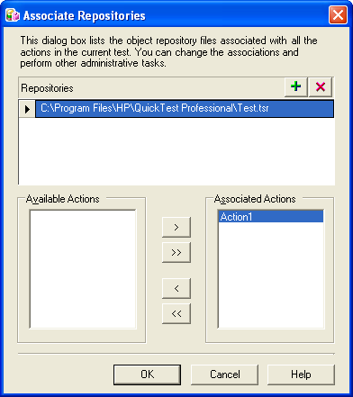

Building RSAM Automation Test Suites
The call to the individual tests needs to be specified in the Expert view. This will in turn call the corresponding actions and perform the tests on the application by associating the repository and the function library.

The purpose of building a suite is to achieve the desired work flow and scenario for testing with the minimal and effective use of the reusable components.

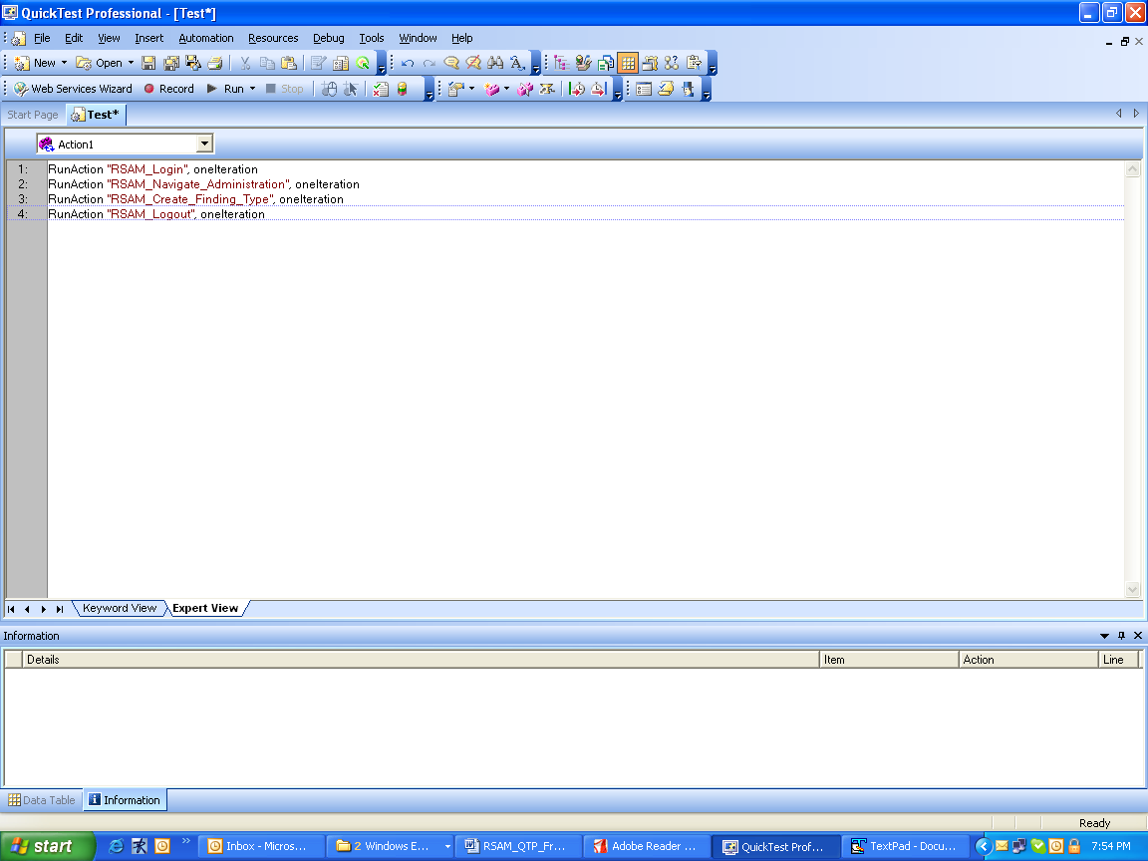

Test Results
The results file for the RSAM Automation framework is customized and will be in the HTML format.

This customization is created in order to facilitate the business with understandable error messages and to fasten the process of result analysis. This result file would be business friendly and cannot be modified. The failed steps would be highlighted in Red color.

Each execution will create a html file with date and time stamp appended to it. Also the step details would be associated with the time it ran.

Please find below the snap shot of the custom report.

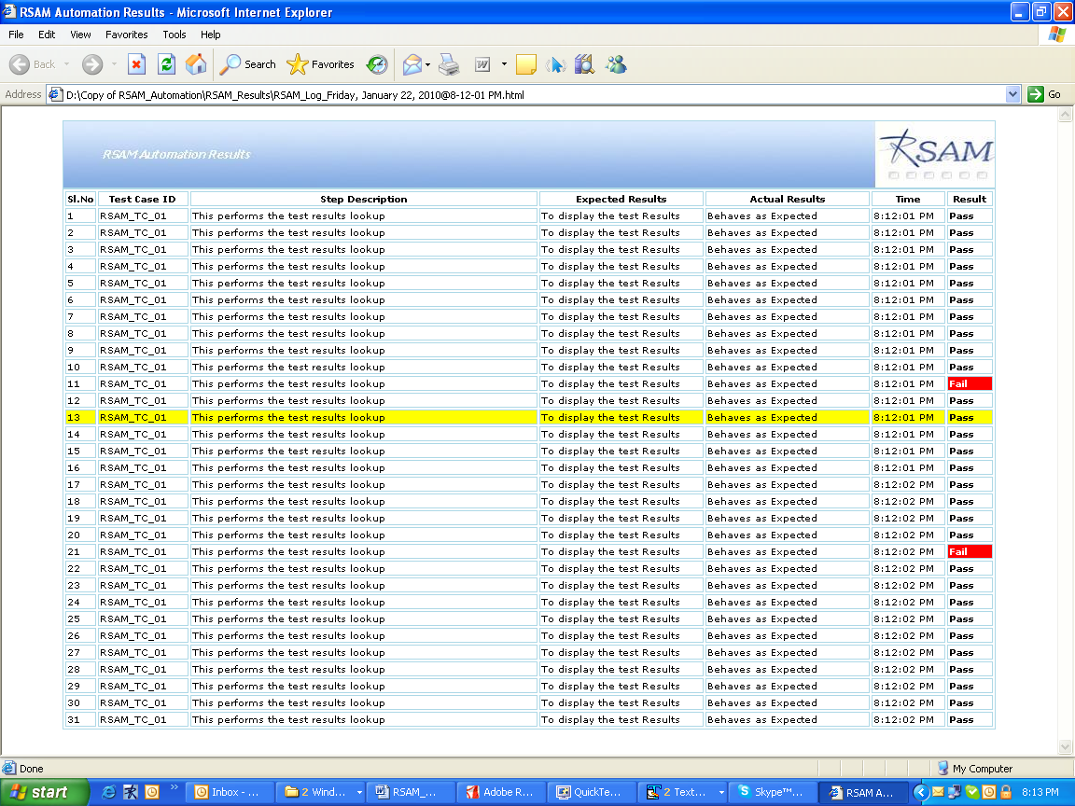

References
HP Quick Test Professional documentation

