TODAY - 19 February, 2010

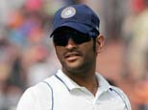

Dhoni praises bowlers
Dhoni credited his bowlers for the victory against SA in the second Test, lauding their 'huge effort' in the absence of Zaheer Khan. More
- Bhajji thanks Anil-bhai for his tips
- Smith gives full credit to India

