Angular module:

Module in Angular refers to a place where you can group the components, directives, pipes, and services, which are related to the application.

Angular components overview
Components are the main building blocks for Angular applications. Each component consists of:
- An HTML template that declares what renders on the page
- A TypeScript class that defines behavior
- A CSS selector that defines how the component is used in a template

Binding:

In an Angular template, a binding creates a live connection between a part of the UI created from a template (a DOM element, directive, or component) and the model (the component instance to which the template belongs).
Examples of binding include:
- text interpolations
- property binding
- event binding
- two-way binding
Property binding
Property binding in Angular helps you set values for properties of HTML elements or directives. Use property binding to do things such as toggle button features, set paths programmatically, and share values between components.

Binding to a property
To bind to an element's property, enclose it in square brackets, [], which identifies the property as a target property.
A target property is the DOM property to which you want to assign a value.
To assign a value to a target property for the image element's src property, type the following code:
<img alt="item" [src]="itemImageUrl">

colspan and colSpan
A common point of confusion is between the attribute, colspan, and the property, colSpan. Notice that these two names differ by only a single letter.
To use property binding using colSpan, type the following:
<!-- Notice the colSpan property is camel case -->
<tr><td [colSpan]="1 + 1">Three-Four</td></tr>
<!-- Bind button disabled state to `isUnchanged` property -->
<button type="button" [disabled]="isUnchanged">Disabled Button</button>

To set a property of a directive, type the following:
<p [ngClass]="classes">[ngClass] binding to the classes property making this blue</p>

To set the model property of a custom component for parent and child components to communicate with each other, type the following:

<app-item-detail [childItem]="parentItem"></app-item-detail>
---------------------------------------------------------------------------------------------------------------------------------

Attribute binding
Attribute binding in Angular helps you set values for attributes directly. With attribute binding, you can improve accessibility, style your application dynamically, and manage multiple CSS classes or styles simultaneously.

Binding to colspan
Another common use case for attribute binding is with the colspan attribute in tables. Binding to the colspan attribute helps you to keep your tables programmatically dynamic. Depending on the amount of data that your application populates a table with, the number of columns that a row spans could change.
To use attribute binding with the <td> attribute colspan
- Specify the colspan attribute by using the following syntax: [attr.colspan].
- Set [attr.colspan] equal to an expression.
In the following example, you bind the colspan attribute to the expression 1 + 1.
<!-- expression calculates colspan=2 -->
<tr><td [attr.colspan]="1 + 1">One-Two</td></tr>
Class and style binding
Use class and style bindings to add and remove CSS class names from an element's class attribute and to set styles dynamically.
The following table summarizes class binding syntax.
BINDING TYPE | SYNTAX | INPUT TYPE | EXAMPLE INPUT VALUES
Single class binding | [class.sale]="onSale" | boolean | undefined | null | true, false
Multi-class binding | [class]="classExpression" | string | "my-class-1 my-class-2 my-class-3"
Multi-class binding | [class]="classExpression" | Record<string, boolean | undefined | null> | {foo: true, bar: false}
Multi-class binding | [class]="classExpression" | Array<string> | ['foo', 'bar']

Binding to a single style
To create a single style binding, use the prefix style followed by a dot and the name of the CSS style.
For example, to set the width style, type the following: [style.width]="width"
The following table summarizes style binding syntax.
BINDING TYPE | SYNTAX | INPUT TYPE | EXAMPLE INPUT VALUES
Single style binding | [style.width]="width" | string | undefined | null | "100px"
Single style binding with units | [style.width.px]="width" | number | undefined | null | 100
Multi-style binding | [style]="styleExpression" | string | "width: 100px; height: 100px"
Multi-style binding | [style]="styleExpression" | Record<string, string | undefined | null> | {width: '100px', height: '100px'}

Event binding
Event binding lets you listen for and respond to user actions such as keystrokes, mouse movements, clicks, and touches.

Binding to events
To bind to an event you use the Angular event binding syntax. This syntax consists of a target event name within parentheses to the left of an equal sign, and a quoted template statement to the right.
Create the following example; the target event name is click and the template statement is onSave().
<button (click)="onSave()">Save</button>
Two-way binding -- ngModel
Two-way binding gives components in your application a way to share data. Use two-way binding to listen for events and update values simultaneously between parent and child components.
Two-way binding combines property binding with event binding:
BINDINGS | DETAILS
Property binding | Sets a specific element property.
Event binding | Listens for an element change event.

Adding two-way data binding
Angular's two-way binding syntax is a combination of square brackets and parentheses, [()]. The [()] syntax combines the brackets of property binding, [], with the parentheses of event binding, (), as follows.
<app-sizer [(size)]="fontSizePx"></app-sizer>
Visit this link for more: https://angular.io/guide/two-way-binding
Component interaction:
Visit for more: https://angular.io/guide/component-interaction

Component interaction when there is no relationship between them:
https://medium.com/mobiosolutions/angular-communicating-between-components-with-observable-827180e43eb5

Pass data from parent to child with input binding
export class HeroChildComponent {
@Input() hero!: Hero;
@Input('master') masterName = '';
}
The second @Input aliases the child component property name masterName as 'master'.
hero-parent.component.ts
import { Component } from '@angular/core';

import { HEROES } from './hero';

@Component({
selector: 'app-hero-parent',
template: `
<h2>{{master}} controls {{heroes.length}} heroes</h2>

<app-hero-child
*ngFor="let hero of heroes"
[hero]="hero"
[master]="master">
</app-hero-child>
`
})
export class HeroParentComponent {
heroes = HEROES;
master = 'Master';
}

Intercept input property changes with a setter
Use an input property setter to intercept and act upon a value from the parent.
The setter of the name input property in the child NameChildComponent trims the whitespace from a name and replaces an empty value with default text.
import { Component, Input } from '@angular/core';

@Component({
selector: 'app-name-child',
template: '<h3>"{{name}}"</h3>'
})
export class NameChildComponent {
@Input()
get name(): string { return this._name; }
set name(name: string) {
this._name = (name && name.trim()) || '<no name set>';
}
private _name = '';
}
Here's the NameParentComponent demonstrating name variations including a name with all spaces:
import { Component } from '@angular/core';

@Component({
selector: 'app-name-parent',
template: `
<h2>Master controls {{names.length}} names</h2>

<app-name-child *ngFor="let name of names" [name]="name"></app-name-child>
`
})
export class NameParentComponent {
// Displays 'Dr. IQ', '<no name set>', 'Bombasto'
names = ['Dr. IQ', ' ', ' Bombasto '];
}

Intercept input property changes with ngOnChanges()
Detect and act upon changes to input property values with the ngOnChanges() method of the OnChanges lifecycle hook interface.
The VersionParentComponent supplies the minor and major values and binds buttons to methods that change them.
import { Component } from '@angular/core';

@Component({
selector: 'app-version-parent',
template: `
<h2>Source code version</h2>
<button type="button" (click)="newMinor()">New minor version</button>
<button type="button" (click)="newMajor()">New major version</button>
<app-version-child [major]="major" [minor]="minor"></app-version-child>
`
})
export class VersionParentComponent {
major = 1;
minor = 23;

newMinor() {
this.minor++;
}

newMajor() {
this.major++;
this.minor = 0;
}
}

This VersionChildComponent detects changes to the major and minor input properties and composes a log message reporting these changes:
import { Component, Input, OnChanges, SimpleChanges } from '@angular/core';

@Component({
selector: 'app-version-child',
template: `
<h3>Version {{major}}.{{minor}}</h3>
<h4>Change log:</h4>
<ul>
<li *ngFor="let change of changeLog">{{change}}</li>
</ul>
`
})
export class VersionChildComponent implements OnChanges {
@Input() major = 0;
@Input() minor = 0;
changeLog: string[] = [];

ngOnChanges(changes: SimpleChanges) {
const log: string[] = [];
for (const propName in changes) {
const changedProp = changes[propName];
const to = JSON.stringify(changedProp.currentValue);
if (changedProp.isFirstChange()) {
log.push(`Initial value of ${propName} set to ${to}`);
} else {
const from = JSON.stringify(changedProp.previousValue);
log.push(`${propName} changed from ${from} to ${to}`);
}
}
this.changeLog.push(log.join(', '));
}
}

Parent listens for child event (child to parent)
The child component exposes an EventEmitter property with which it emits events when something happens. The parent binds to that event property and reacts to those events.
The child's EventEmitter property is an output property, typically adorned with an @Output() decorator as seen in this VoterComponent:

import { Component, EventEmitter, Input, Output } from '@angular/core';

@Component({

selector: 'app-voter',

template: `

<h4>{{name}}</h4>

<button type="button" (click)="vote(true)" [disabled]="didVote">Agree</button>

<button type="button" (click)="vote(false)" [disabled]="didVote">Disagree</button>

`

})

export class VoterComponent {

@Input() name = '';

@Output() voted = new EventEmitter<boolean>();

didVote = false;

vote(agreed: boolean) {

this.voted.emit(agreed);

this.didVote = true;

}

}
Clicking a button triggers emission of a true or false, the boolean payload.
The parent VoteTakerComponent binds an event handler called onVoted() that responds to the child event payload $event and updates a counter.
import { Component } from '@angular/core';

@Component({
selector: 'app-vote-taker',
template: `
<h2>Should mankind colonize the Universe?</h2>
<h3>Agree: {{agreed}}, Disagree: {{disagreed}}</h3>

<app-voter
*ngFor="let voter of voters"
[name]="voter"
(voted)="onVoted($event)">
</app-voter>
`
})
export class VoteTakerComponent {
agreed = 0;
disagreed = 0;
voters = ['Dr. IQ', 'Celeritas', 'Bombasto'];

onVoted(agreed: boolean) {
if (agreed) {
this.agreed++;
} else {
this.disagreed++;
}
}
}

Parent calls an @ViewChild() – to access childs property
The local variable approach is straightforward. But it is limited because the parent-child wiring must be done entirely within the parent template. The parent component itself has no access to the child.
You can't use the local variable technique if the parent component's class relies on the child component's class. The parent-child relationship of the components is not established within each component's respective class with the local variable technique. Because the class instances are not connected to one another, the parent class cannot access the child class properties and methods.
When the parent component class requires that kind of access, inject the child component into the parent as a ViewChild.
Here is the parent, CountdownViewChildParentComponent:
import { AfterViewInit, ViewChild } from '@angular/core';
import { Component } from '@angular/core';
import { CountdownTimerComponent } from './countdown-timer.component';

@Component({
selector: 'app-countdown-parent-vc',
template: `
<h3>Countdown to Liftoff (via ViewChild)</h3>
<button type="button" (click)="start()">Start</button>
<button type="button" (click)="stop()">Stop</button>
<div class="seconds">{{ seconds() }}</div>
<app-countdown-timer></app-countdown-timer>
`,
styleUrls: ['../assets/demo.css']
})
export class CountdownViewChildParentComponent implements AfterViewInit {

@ViewChild(CountdownTimerComponent)
private timerComponent!: CountdownTimerComponent;

seconds() { return 0; }

ngAfterViewInit() {
// Redefine `seconds()` to get from the `CountdownTimerComponent.seconds` ...
// but wait a tick first to avoid one-time devMode
// unidirectional-data-flow-violation error
setTimeout(() => this.seconds = () => this.timerComponent.seconds, 0);
}

start() { this.timerComponent.start(); }
stop() { this.timerComponent.stop(); }
}
It takes a bit more work to get the child view into the parent component class.
First, you have to import references to the ViewChild decorator and the AfterViewInit lifecycle hook.
Next, inject the child CountdownTimerComponent into the private timerComponent property using the @ViewChild property decoration.

Parent and children communicate using a service (using observable and subjects)
https://medium.com/mobiosolutions/angular-communicating-between-components-with-observable-827180e43eb5

-----------------------------------------------------------------------------------------------------------------------------------------

Component Lifecycle
A component instance has a lifecycle that starts when Angular instantiates the component class and renders the component view along with its child views. The lifecycle continues with change detection, as Angular checks to see when data-bound properties change, and updates both the view and the component instance as needed. The lifecycle ends when Angular destroys the component instance and removes its rendered template from the DOM. Directives have a similar lifecycle, as Angular creates, updates, and destroys instances in the course of execution.

Lifecycle event sequence
After your application instantiates a component or directive by calling its constructor, Angular calls the hook methods you have implemented at the appropriate point in the lifecycle of that instance.
Angular executes hook methods in the following sequence. Use them to perform the following kinds of operations.
HOOK METHOD | PURPOSE | TIMING
ngOnChanges() | Respond when Angular sets or resets data-bound input properties. The method receives a SimpleChanges object of current and previous property values.  NOTE:  This happens frequently, so any operation you perform here impacts performance significantly.  See details in Using change detection hooks in this document. | Called before ngOnInit() (if the component has bound inputs) and whenever one or more data-bound input properties change.  NOTE:  If your component has no inputs or you use it without providing any inputs, the framework will not call ngOnChanges().
ngOnInit() | Initialize the directive or component after Angular first displays the data-bound properties and sets the directive or component's input properties. See details in Initializing a component or directive in this document. | Called once, after the first ngOnChanges(). ngOnInit() is still called even when ngOnChanges() is not (which is the case when there are no template-bound inputs).
ngDoCheck() | Detect and act upon changes that Angular can't or won't detect on its own. See details and example in Defining custom change detection in this document. | Called immediately after ngOnChanges() on every change detection run, and immediately after ngOnInit() on the first run.  Triggers even there is a click we do !!
ngAfterContentInit() | Respond after Angular projects external content into the component's view, or into the view that a directive is in.  See details and example in Responding to changes in content in this document. | Called once after the first ngDoCheck().
ngAfterContentChecked() | Respond after Angular checks the content projected into the directive or component.  See details and example in Responding to projected content changes in this document. | Called after ngAfterContentInit() and every subsequent ngDoCheck().
ngAfterViewInit() | Respond after Angular initializes the component's views and child views, or the view that contains the directive.  See details and example in Responding to view changes in this document. | Called once after the first ngAfterContentChecked().
ngAfterViewChecked() | Respond after Angular checks the component's views and child views, or the view that contains the directive. | Called after the ngAfterViewInit() and every subsequent ngAfterContentChecked().
ngOnDestroy() | Cleanup just before Angular destroys the directive or component. Unsubscribe Observables and detach event handlers to avoid memory leaks. See details in Cleaning up on instance destruction in this document. | Called immediately before Angular destroys the directive or component.

Important links:
https://angular.io/guide/lifecycle-hooks#afterview
https://angular.io/guide/lifecycle-hooks#aftercontent
https://medium.com/@mudit.manucha/actual-use-of-angular-lifecycle-hooks-d922680283c0
https://blog.logrocket.com/angular-lifecycle-hooks/

Introduction to services and dependency injection
Open this link: read tree-shaking also
https://angular.io/guide/architecture-services

Dependency injection (DI) is the part of the Angular framework that provides components with access to services and other resources. Angular provides the ability for you to inject a service into a component to give that component access to the service.
- The injector is the main mechanism. Angular creates an application-wide injector for you during the bootstrap process, and additional injectors as needed. You don't have to create injectors.
- An injector creates dependencies and maintains a container of dependency instances that it reuses, if possible.
- A provider is an object that tells an injector how to obtain or create a dependency
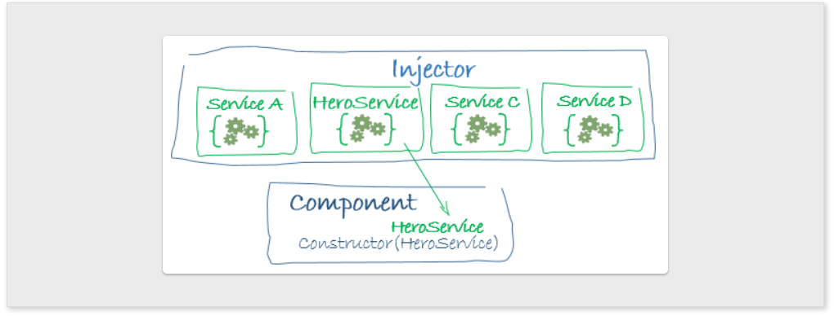

HTTP:
https://javascript.plainenglish.io/handle-errors-in-angular-with-httpclient-and-rxjs-34cf631e29a6
getSeedDataList(): Observable<any> {
const request = {
requestedData: [
{ value: 'Criteria' },
],
searchParameters: {
ruleTypeID: 7,
uniqueTypeID: '3',
},
};
return this.httpService.postDirect(PRICING_API(window['CONFIG']['apiEnv']) + 'seedData', request)
.pipe(map(this.mapSeedDataList)).pipe(catchError(this.errorHandler));
// .catch(this.errorHandler);
}

getSeedData() {
this.getSeedDataList().subscribe({next: response => {
if (response) {
this.seedData = response;
} else {
console.log('Error');
}
}, error: error => {
console.log('Error', error);
}});
}

What is observable, observer and subscribe ?
https://stackoverflow.com/questions/51520584/what-is-observable-observer-and-subscribe-in-angular
what is subject and its defferent types ?
https://www.learnrxjs.io/learn-rxjs/subjects

Difference between observable and subject:
https://stackoverflow.com/questions/47537934/what-is-the-difference-between-observable-and-a-subject-in-rxjs

Observables are unicast by design and Subjects are multicast by design.
If you look at the below example, each subscription receives the different values as observables developed as unicast by design.
import {Observable} from 'rxjs';

let obs = new Observable<any>(observer=>{
observer.next(Math.random());
})

obs.subscribe(res=>{
console.log('subscription a :', res); //subscription a :0.2859800202682865
});

obs.subscribe(res=>{
console.log('subscription b :', res); //subscription b :0.694302021731573
});
This could be weird if you are expecting the same values on both the subscription.
We can overcome this issue using Subjects. Subjects is similar to event-emitter and it does not invoke for each subscription. Consider the below example.
import {Subject} from 'rxjs';

let obs = new Subject();

obs.subscribe(res=>{
console.log('subscription a :', res); // subscription a : 0.91767565496093
});

obs.subscribe(res=>{
console.log('subscription b :', res);// subscription b : 0.91767565496093
});

obs.next(Math.random());
Both of the subscriptions got the same output value!

Routing and lazy loading:
https://angular.io/guide/router
ng g module admin –routing

Importing your new components

import { FirstComponent } from './first/first.component';
import { SecondComponent } from './second/second.component';

Defining a basic route
App.module.ts
imports: [ BrowserModule, AppRoutingModule // CLI adds AppRoutingModule to the AppModule's imports array ],

routing.ts file:
Import RouterModule and Routes into your routing module.
The Angular CLI performs this step automatically. The CLI also sets up a Routes array for your routes and configures the imports and exports arrays for @NgModule().

import { NgModule } from '@angular/core';
import { Routes, RouterModule } from '@angular/router'; // CLI imports router

const routes: Routes = []; // sets up routes constant where you define your routes

// configures NgModule imports and exports
@NgModule({
imports: [RouterModule.forRoot(routes)],
exports: [RouterModule]
})
export class AppRoutingModule { }

Define your routes in your Routes array.
Each route in this array is a JavaScript object that contains two properties. The first property, path, defines the URL path for the route. The second property, component, defines the component Angular should use for the corresponding path.

const routes: Routes = [ { path: 'first-component', component: FirstComponent }, { path: 'second-component', component: SecondComponent }, ];

Add your routes to your application.
Now that you have defined your routes, add them to your application. First, add links to the two components. Assign the anchor tag that you want to add the route to the routerLink attribute. Set the value of the attribute to the component to show when a user clicks on each link. Next, update your component template to include <router-outlet>. This element informs Angular to update the application view with the component for the selected route.

<h1>Angular Router App</h1>
<!-- This nav gives you links to click, which tells the router which route to use (defined in the routes constant in AppRoutingModule) -->
<nav>
<ul>
<li><a routerLink="/first-component" routerLinkActive="active" ariaCurrentWhenActive="page">First Component</a></li>
<li><a routerLink="/second-component" routerLinkActive="active" ariaCurrentWhenActive="page">Second Component</a></li>
</ul>
</nav>
<!-- The routed views render in the <router-outlet>-->
<router-outlet></router-outlet>

Route order
The order of routes is important because the Router uses a first-match wins strategy when matching routes, so more specific routes should be placed above less specific routes. List routes with a static path first, followed by an empty path route, which matches the default route. The wildcard route comes last because it matches every URL and the Router selects it only if no other routes match first.

Setting up wildcard routes
A well-functioning application should gracefully handle when users attempt to navigate to a part of your application that does not exist. To add this functionality to your application, you set up a wildcard route. The Angular router selects this route any time the requested URL doesn't match any router paths.
To set up a wildcard route, add the following code to your routes definition.
{ path: '**', component: <component-name> }

Setting up redirects
To set up a redirect, configure a route with the path you want to redirect from, the component you want to redirect to, and a pathMatch value that tells the router how to match the URL.
const routes: Routes = [
{ path: 'first-component', component: FirstComponent },
{ path: 'second-component', component: SecondComponent },
{ path: '', redirectTo: '/first-component', pathMatch: 'full' }, // redirect to `first-component`
{ path: '**', component: PageNotFoundComponent }, // Wildcard route for a 404 page
];

Nesting routes
As your application grows more complex, you might want to create routes that are relative to a component other than your root component. These types of nested routes are called child routes. This means you're adding a second <router-outlet> to your app, because it is in addition to the <router-outlet> in AppComponent.
In this example, there are two additional child components, child-a, and child-b. Here, FirstComponent has its own <nav> and a second <router-outlet> in addition to the one in AppComponent.
<h2>First Component</h2>

<nav>
<ul>
<li><a routerLink="child-a">Child A</a></li>
<li><a routerLink="child-b">Child B</a></li>
</ul>
</nav>

<router-outlet></router-outlet>

A child route is like any other route, in that it needs both a path and a component. The one difference is that you place child routes in a children array within the parent route.

const routes: Routes = [
{
path: 'first-component',
component: FirstComponent, // this is the component with the <router-outlet> in the template
children: [
{
path: 'child-a', // child route path
component: ChildAComponent, // child route component that the router renders
},
{
path: 'child-b',
component: ChildBComponent, // another child route component that the router renders
},
],
},
];

Using relative paths

Relative paths let you define paths that are relative to the current URL segment. The following example shows a relative route to another component, second-component. FirstComponent and SecondComponent are at the same level in the tree, however, the link to SecondComponent is situated within the FirstComponent, meaning that the router has to go up a level and then into the second directory to find the SecondComponent. Rather than writing out the whole path to get to SecondComponent, use the ../ notation to go up a level.
<h2>First Component</h2>

<nav>
<ul>
<li><a routerLink="../second-component">Relative Route to second component</a></li>
</ul>
</nav>
<router-outlet></router-outlet>

Accessing query parameters and fragments
Sometimes, a feature of your application requires accessing a part of a route, such as a query parameter or a fragment. The Tour of Heroes application at this stage in the tutorial uses a list view in which you can click on a hero to see details. The router uses an id to show the correct hero's details.
First, import the following members in the component you want to navigate from.
import { ActivatedRoute } from '@angular/router';
import { Observable } from 'rxjs';
import { switchMap } from 'rxjs/operators';

Next inject the activated route service:
constructor(private route: ActivatedRoute) {}
this.activatedRoute.params.subscribe(params => {
this.advtId = params['advtId'];
});

this.router.navigate(['/heroes', { id: heroId }]);

good document: https://www.pluralsight.com/guides/accessing-route-parameters-with-activatedroute-vs.-acitivatedroutesnapshot
if we have path like this: /first/:parameter. Avoid activatedroutersnapshot

Lazy loading
By default, NgModules are eagerly loaded. This means that as soon as the application loads, so do all the NgModules, whether they are immediately necessary or not. For large applications with lots of routes, consider lazy loading —a design pattern that loads NgModules as needed. Lazy loading helps keep initial bundle sizes smaller, which in turn helps decrease load times.

Lazy loading basics
To lazy load Angular modules, use loadChildren (instead of component) in your AppRoutingModule routes configuration as follows.
const routes: Routes = [
{
path: 'customers',
loadChildren: () => import('./customers/customers.module').then(m => m.CustomersModule)
},
{
path: 'orders',
loadChildren: () => import('./orders/orders.module').then(m => m.OrdersModule)
}
];

In the lazy-loaded module's routing module, add a route for the component.
const routes: Routes = [
{
path: '',
component: ItemsComponent
}
];

Set up the UI

<h1>
{{title}}
</h1>

<button type="button" routerLink="/customers">Customers</button>
<button type="button" routerLink="/orders">Orders</button>
<button type="button" routerLink="">Home</button>

<router-outlet></router-outlet>

forRoot() and forChild()
You might have noticed that the Angular CLI adds RouterModule.forRoot(routes) to the AppRoutingModule imports array. This lets Angular know that the AppRoutingModule is a routing module and forRoot() specifies that this is the root routing module. It configures all the routes you pass to it, gives you access to the router directives, and registers the Router service. Use forRoot() only once in the application, inside the AppRoutingModule.
The Angular CLI also adds RouterModule.forChild(routes) to feature routing modules. This way, Angular knows that the route list is only responsible for providing extra routes and is intended for feature modules. You can use forChild() in multiple modules.
The forRoot() method takes care of the global injector configuration for the Router. The forChild() method has no injector configuration. It uses directives such as RouterOutlet and RouterLink. For more information, see the forRoot() pattern section of the Singleton Services guide.

More to explore – What is preloading and Resolver ?
https://blog.bitsrc.io/preloading-strategies-boost-up-angular-app-loading-time-ffb19da63155
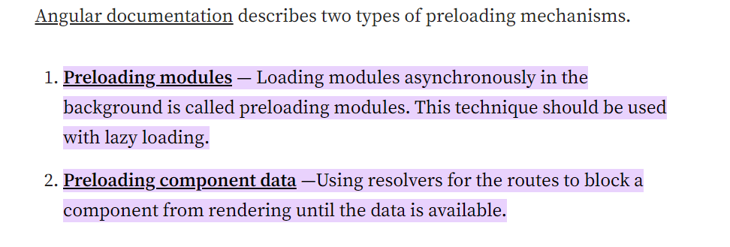

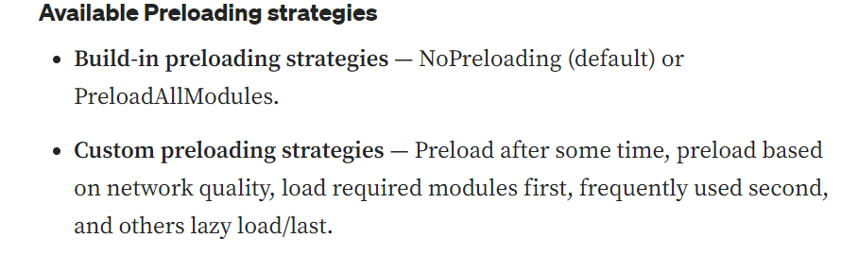
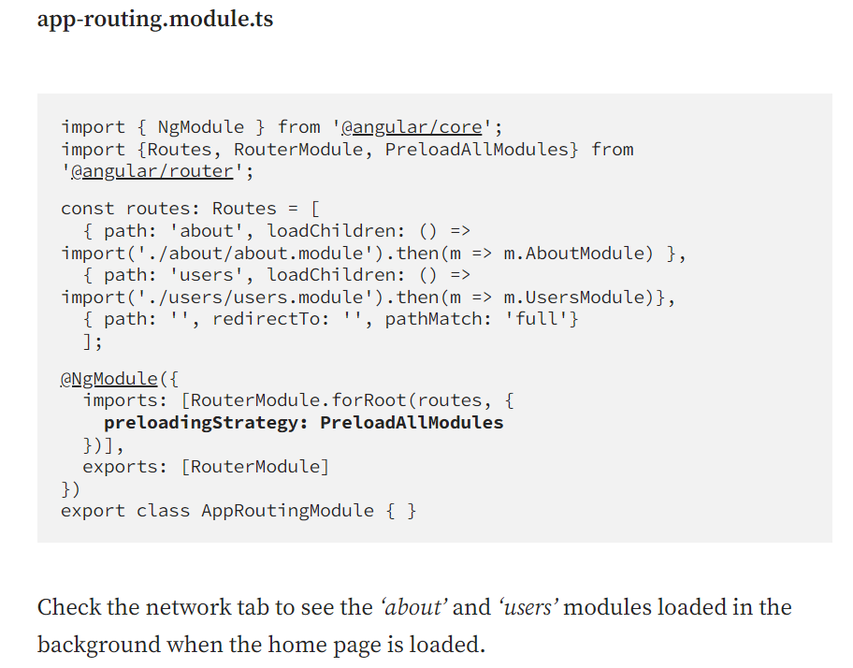
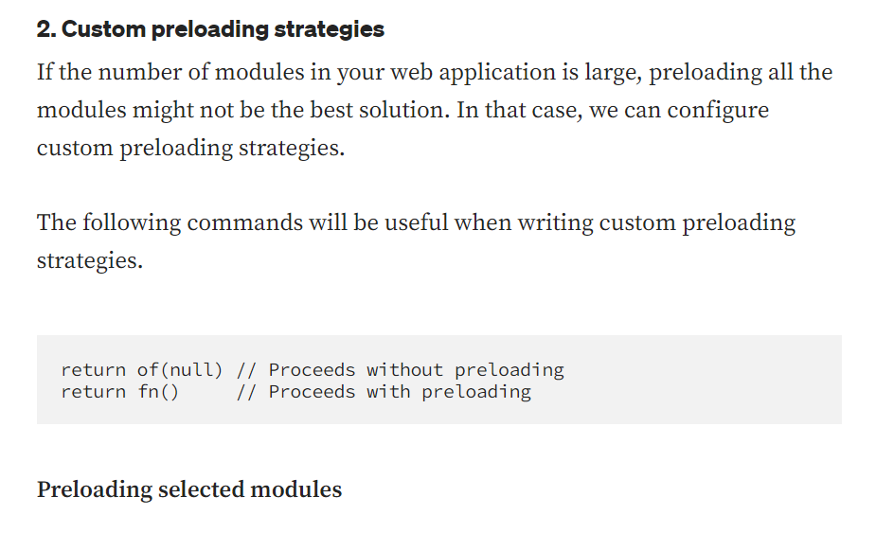
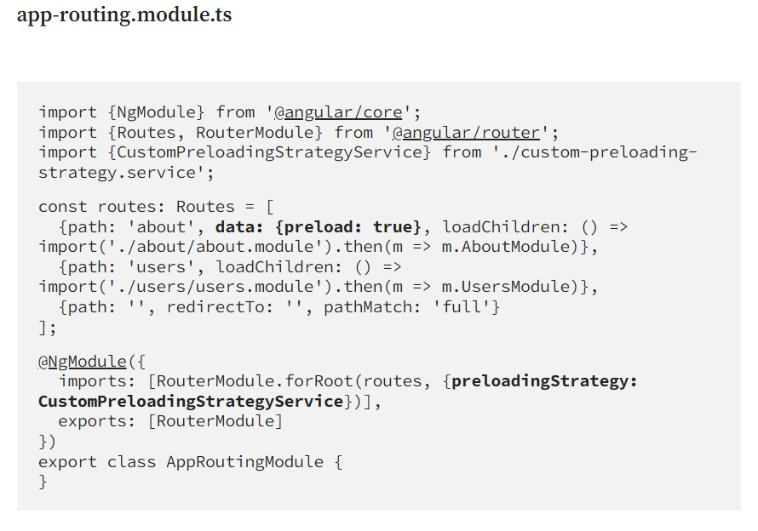
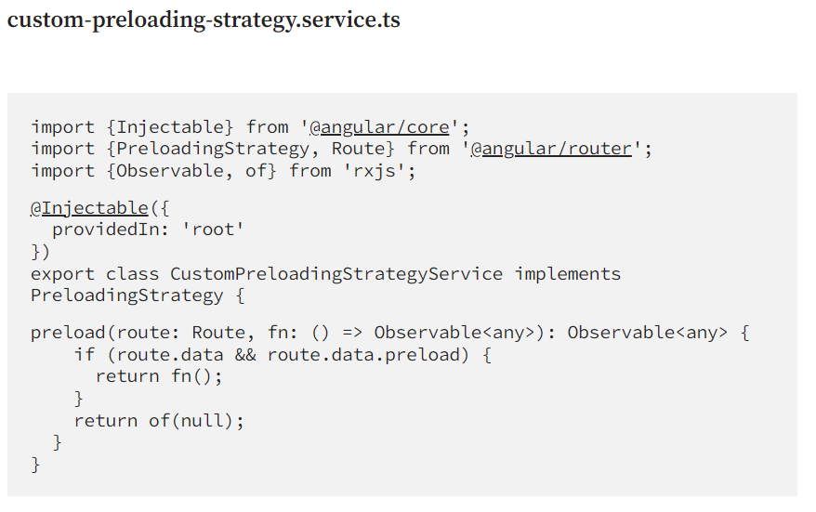

For resolver please check this:
https://medium.com/@redin.gaetan/angular-for-every-one-resolver-c900c8f7672a

Preventing unauthorized access

Use route guards to prevent users from navigating to parts of an application without authorization. The following route guards are available in Angular:
- canActivate
- canActivateChild

- canDeactivate : https://www.tektutorialshub.com/angular/angular-candeactivate-guard/

- canMatch: https://medium.com/ngconf/why-you-should-use-canmatch-in-your-routes-97fec434823d

- resolve
- canLoad: https://www.tektutorialshub.com/angular/angular-canload-guard-example/

Types of Forms in angular:

Choosing an approach
Reactive forms and template-driven forms process and manage form data differently. Each approach offers different advantages.
FORMS | DETAILS
Reactive forms | Provide direct, explicit access to the underlying form's object model. Compared to template-driven forms, they are more robust: they're more scalable, reusable, and testable. If forms are a key part of your application, or you're already using reactive patterns for building your application, use reactive forms.
Template-driven forms | Rely on directives in the template to create and manipulate the underlying object model. They are useful for adding a simple form to an app, such as an email list signup form. They're straightforward to add to an app, but they don't scale as well as reactive forms. If you have very basic form requirements and logic that can be managed solely in the template, template-driven forms could be a good fit.

Key differences

Form validation
Validation is an integral part of managing any set of forms. Whether you're checking for required fields or querying an external API for an existing username, Angular provides a set of built-in validators as well as the ability to create custom validators.
FORMS | DETAILS
Reactive forms | Define custom validators as functions that receive a control to validate
Template-driven forms | Tied to template directives, and must provide custom validator directives that wrap validation functions

https://angular.io/guide/form-validation

https://blog.angular-university.io/introduction-to-angular-2-forms-template-driven-vs-model-driven/

https://www.pluralsight.com/guides/difference-between-template-driven-and-reactive-forms-angular

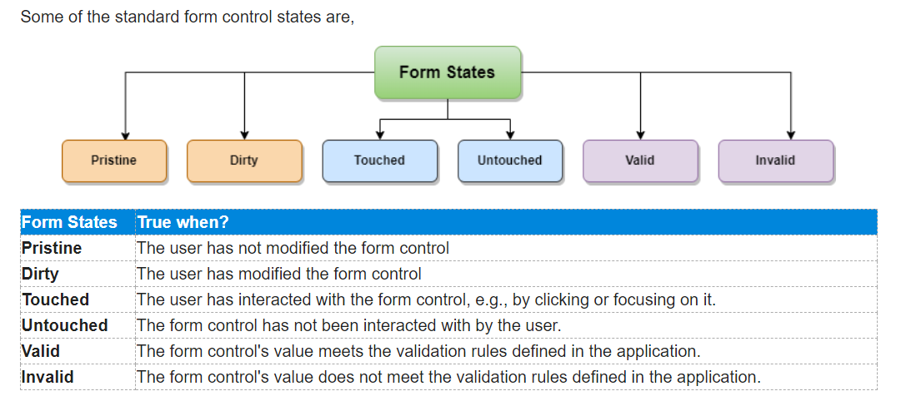

In reactive
<form [formGroup]="courseForm" (ngSubmit)="onSubmit()">
courseForm.get('courseName').valid && courseForm.get('courseName').touched

in template driven
<form (ngSubmit)="onSubmit(f)" #f="ngForm">

@ViewChild('f') courseForm: NgForm;
18
19 onSubmit(form: NgForm) {
20 console.log("Course Name is : " + form.value.courseName);
21 console.log("Course Desc is : " + form.value.courseDesc);
22 console.log("Course Amount is : " + form.value.courseAmount);
23 }
24
25 onClear() {
26 // Now that we have access to the form via the 'ViewChild', we can access the form and clear it.
27 this.courseForm.reset();
28 }

Custom validation:
https://www.digitalocean.com/community/tutorials/angular-custom-validation

Directives
Directives are classes that add additional behavior to elements in your Angular applications. Use Angular's built-in directives to manage forms, lists, styles, and what users see.
The different types of Angular directives are as follows:
DIRECTIVE TYPES | DETAILS
Components | Used with a template. This type of directive is the most common directive type.
Attribute directives | Change the appearance or behavior of an element, component, or another directive.
Structural directives | Change the DOM layout by adding and removing DOM elements.

Built-in attribute directives
Attribute directives listen to and modify the behavior of other HTML elements, attributes, properties, and components.
Many NgModules such as the RouterModule and the FormsModule define their own attribute directives. The most common attribute directives are as follows:
COMMON DIRECTIVES | DETAILS
NgClass | Adds and removes a set of CSS classes.
NgStyle | Adds and removes a set of HTML styles.
NgModel | Adds two-way data binding to an HTML form element.

ngClass:
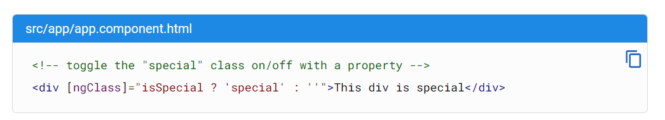
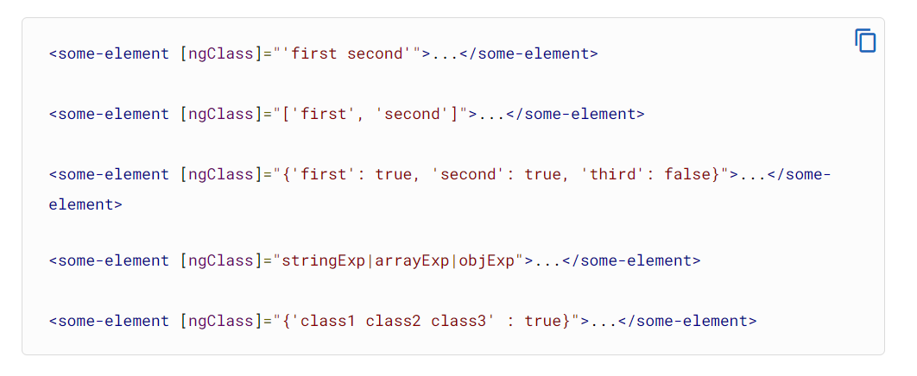

ngStyle:
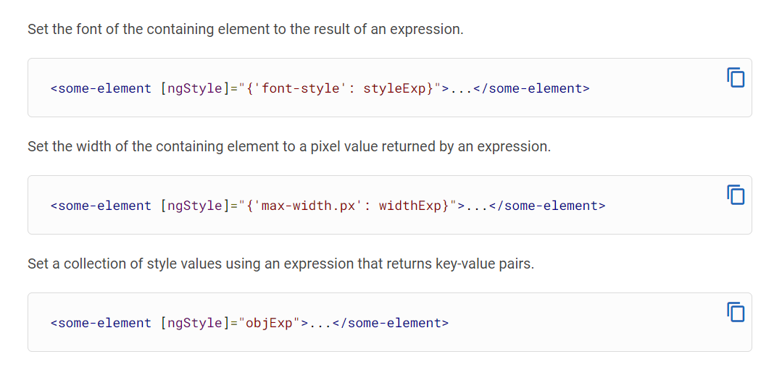

Built-in structural directives
tructural directives are responsible for HTML layout. They shape or reshape the DOM's structure, typically by adding, removing, and manipulating the host elements to which they are attached.
This section introduces the most common built-in structural directives:
COMMON BUILT-IN STRUCTURAL DIRECTIVES | DETAILS
NgIf | Conditionally creates or disposes of subviews from the template.
NgFor | Repeat a node for each item in a list.
NgSwitch | A set of directives that switch among alternative views.

Adding or removing an element with NgIf
Add or remove an element by applying an NgIf directive to a host element.
When NgIf is false, Angular removes an element and its descendants from the DOM. Angular then disposes of their components, which frees up memory and resources.

Listing items with NgFor
Use the NgFor directive to present a list of items.
- Define a block of HTML that determines how Angular renders a single item.
- To list your items, assign the shorthand let item of items to *ngFor.
<div *ngFor="let item of items">{{item.name}}</div>
The string "let item of items" instructs Angular to do the following:
- Store each item in the items array in the local item looping variable
- Make each item available to the templated HTML for each iteration
- Translate "let item of items" into an <ng-template> around the host element
- Repeat the <ng-template> for each item in the list

Getting the index of *ngFor
Get the index of *ngFor in a template input variable and use it in the template.
In the *ngFor, add a semicolon and let i=index to the shorthand. The following example gets the index in a variable named i and displays it with the item name.
<div *ngFor="let item of items; let i=index">{{i + 1}} - {{item.name}}</div>
The index property of the NgFor directive context returns the zero-based index of the item in each iteration.
Angular translates this instruction into an <ng-template> around the host element, then uses this template repeatedly to create a new set of elements and bindings for each item in the list. For more information about shorthand, see the Structural Directives guide.
l <ul>
<li *ngFor="let item of items; index as i; first as isFirst; last as isLast; even as isEven; odd as isOdd">
{{i}} - {{item}} - First: {{isFirst}}, Last: {{isLast}}, Even: {{isEven}}, Odd: {{isOdd}}
</li>
</ul>

Switching cases with NgSwitch
Like the JavaScript switch statement, NgSwitch displays one element from among several possible elements, based on a switch condition. Angular puts only the selected element into the DOM.
NgSwitch is a set of three directives:
NGSWITCH DIRECTIVES | DETAILS
NgSwitch | An attribute directive that changes the behavior of its companion directives.
NgSwitchCase | Structural directive that adds its element to the DOM when its bound value equals the switch value and removes its bound value when it doesn't equal the switch value.
NgSwitchDefault | Structural directive that adds its element to the DOM when there is no selected NgSwitchCase.

Building custom element directive
https://angular.io/guide/attribute-directives

https://www.syncfusion.com/blogs/post/building-custom-structural-and-attribute-directives-in-angular.aspx

Difference between ng-template, ng-container and ng-content
https://vibhas1892.medium.com/difference-between-ng-template-ng-container-and-ng-content-a1d264619655#:~:text=To%20sum%20up%2C%20ng%2Dcontent,your%20template%20or%20your%20code.

1) <ng-template></ng-template>
As the name suggests the <ng-template> is a template element that Angular uses with structural directives ( *ngIf, *ngFor, [ngSwitch], and custom directives). These template elements only work in the presence of structural directives, which help us to define a template that doesn’t render anything by itself, but conditionally renders them to the DOM. It helps us create dynamic templates that can be customized and configured.
<div>
Ng-template Content
<div *ngIf=”false else showNgTemplateContent”>
Shouldn't be displayed
</div>
</div>
<ng-template #showNgTemplateContent> Should be displayed
</ng-template>
In the above example, If the condition is false then we will show the text as “Shouldn't be displayed” else will show ng-template content as “Should be displayed”

2) <ng-container></ng-container>
ng-container is an extremely simple directive that allows you to group elements in a template that doesn’t interfere with styles or layout because Angular doesn’t put it in the DOM
This is helpful if you don’t want any extra div on DOM, you can simply use
ng-container. For eg: If there are two structural directives being called on one div as below:
<div *ngIf="details" *ngFor="let info of details">
{{ info.content }}
</div>
Attempting to compile this code will result in the following error:
Can't have multiple template bindings on one element. Use only one attribute prefixed with *
One workaround would be to separate the bindings as below:
<div *ngIf="details">
<div *ngFor="let info of details">
{{ info.content }}
</div>
</div>
Or we can use <ng-container> without adding any extra element to the DOM at runtime:
<ng-container *ngIf="details">
<div *ngFor="let info of details">
{{ info.content }}
</div>
</ng-container>

3) <ng-content></ng-content>
ng-content is used to project content into Angular components. You use the <ng-content></ng-content> tag as a placeholder for that dynamic content, then when the template is parsed Angular will replace that placeholder tag with your content.
For example, you have two components as parent and child component
and want to show some data in the child component from the parent component
In parent.component.html <app-child> selector is used to show data of the child component
<app-child>
<div> Child Component Details </div>
</app-child>
If you check on your browser <div>Child Component Details</div> inside
<app-child></app-child> would not be visible. What if we want to show this content? So this is where the ng-content directive comes into the picture. What we need to do is, just add “ng-content” inside the component template and it will find the content inside the directive tag and add it to that template at that particular place where we added the “ng-content” tag.
So instead of div, you do something similar with Angular components except you tell Angular where to display it in the parent template using ng-content.
In child.component.html:
<h1>Child Info</h1>
<ng-content></ng-content>
Now go to your browser again, and you are able to see this: <div>Child Component Details</div>
<ng-content> accepts a select attribute, which allows us to sort of name our slot, to be more specific, it allows us to define the selector of our slot. It means “Replace me only if the element has a card-body attribute”. Then, we change our app component view to include the card-body attribute.
For example: In child.component.html:
<h1>Child Info</h1>
<ng-content select="[input], [form-field]"></ng-content>
In parent.component.html:
<app-child>
<h1 input>Content1!</h3>
<h2 form-field>Content2!</h2>
<h3 input form-field>Content1 & Content2!</h1>
</app-child>
If you check your browser, all the heading tags will be visible from the child component with the help of <ng-content>.
To sum up, ng-content is used to display children in a template, ng-container is used as a non-rendered container to avoid having to add a span or a div, and ng-template allows you to group some content that is not rendered directly but can be used in other places of your template or your code.

JIT Vs AOT
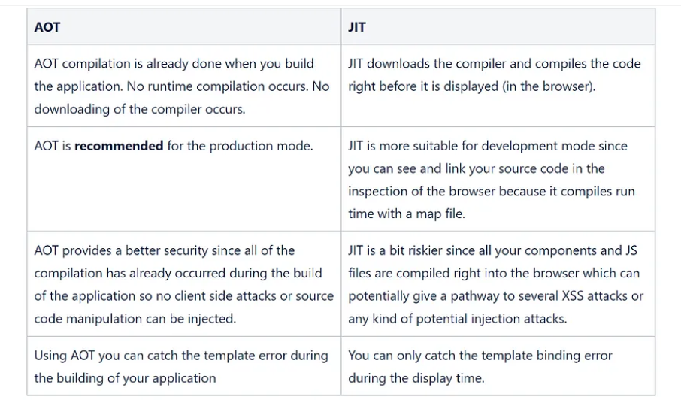

Difference between promise and observable
https://www.c-sharpcorner.com/article/observable-and-promise-in-angular/#:~:text=Observable%20can%20emit%20multiple%20values,will%20execute%20immediately%20on%20creation.

Change detection strategy in Angular
https://blogs.halodoc.io/understanding-angular-change-detection-strategy/

Why to use JWT token
https://medium.com/swlh/why-do-we-need-the-json-web-token-jwt-in-the-modern-web-8490a7284482
Difference between angularJs and angular 2+
https://www.interviewbit.com/blog/difference-between-angular-and-angularjs/

HTTP Interceptor
https://medium.com/@jaydeepvpatil225/http-interceptors-in-angular-6e9891ae0538

