1. Write a program in Java to find the Sum and the Average of the numbers input by the user.
2. Write a program to declare an integer array with the size of 10. Input values into the array and display the reverse order of the values.
3. Create a class called “Employee” which has 3 private variables (empID, empName, empDesignation) and create getters and setters for each field.

Include the following additional methods;

Write a display method to display the member variables

Include no parameter and parameterized Constructor

Write main method for the followings;

Create two objects for Mr.Abc and Ms.Xyz and set required values using setters and print them back on the console using getters.

Invoke No parameter and Parameterized Constructors and display the member variables values.

1. Create the following class with the given data and methods.

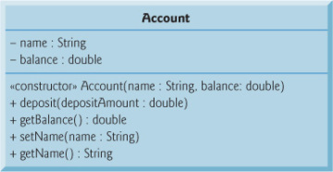

Create an object from the class and call the methods.