PROJECT AIM
My project investigates price volatility in relation to currency through the lens of everyday objects. It examines how fluctuations in economic systems quietly shape our emotional relationships with commodities we encounter daily. While public discourse often amplifies political conflict, this work redirects attention to the underlying economic structures that subtly organize our lived experience.
I use the banana as a central medium. As a mass-produced, globally distributed, and universally recognizable fruit, the banana embodies accessibility, affordability, and comfort. Yet it also carries deep entanglements with labor histories, trade systems, and capital flows. By deconstructing the banana into emotional layers — comfort, accessibility, feasibility, and fairness — I explore how economic volatility influences not only prices but also our sense of stability and attachment.
Historically, the banana has served as a powerful symbol in contemporary art.
- Andy Warhol used repetition and commodity imagery to expose mass production and consumer desire.
- Thomas Baumgärtel transformed the banana into a cultural marker and institutional critique.
- Natalia LL employed the banana in performative contexts that interrogated gender, consumption, and gaze.
Building on these precedents, my project repositions the banana not only as a symbol of consumerism but as a data-driven index of global currency fluctuation. By mapping average banana prices in cities such as Tokyo and New York City, I spatialize economic volatility into a perceptible, experiential form. The banana becomes a mediator between abstract financial systems and intimate human experience.
This project is deeply personal and subjective, informed by my lived experience across different economic and cultural contexts. Rather than engaging directly in political rhetoric, it asks a quieter but fundamental question:
How do economic systems shape our everyday emotional stability?
In a capitalistic society, I argue that understanding economic structures — accessibility, fairness, distribution, and fluctuation — is essential to reclaiming agency. By foregrounding the ordinary banana, the work reminds viewers that global finance is not distant or abstract; it is embedded in the most mundane aspects of daily life.

Essay I: The Banana and the Structure of Everyday Joy
The banana occupies a unique position in everyday life: it is ordinary, inexpensive, portable, and nutritionally sufficient. Unlike luxury goods, it does not signal status; unlike processed snacks, it does not require branding to justify its existence. Its presence in daily routines—breakfast tables, office desks, children’s lunchboxes—reveals a form of quiet stability embedded within mundane life.
The joy derived from a banana is subtle but structurally significant. It comes from ease: no preparation, no utensils, no transaction beyond a minimal exchange. The peel opens predictably, the sweetness is consistent, and the fruit is digestible across cultures. This predictability produces emotional reassurance. In societies defined by volatility—fluctuating currencies, unstable labor markets, and rising costs of living—the banana’s reliability becomes psychologically grounding.
This emotional attachment is not sentimental; it is infrastructural. The banana’s accessibility supports routines that give shape to daily life. When something is consistently within reach, it becomes part of one’s implicit sense of stability. Thus, the banana’s joy is less about flavor and more about continuity. It represents the promise that certain forms of comfort remain accessible within economic systems that otherwise generate uncertainty.

Essay II: Extrinsic Value and the Abstraction of Worth
The banana’s economic value is almost entirely extrinsic. Unlike precious metals or collectible goods, its worth does not derive from scarcity or symbolic prestige. Its price is determined by global supply chains, trade agreements, shipping logistics, currency exchange rates, agricultural inputs, and retail markups. The fruit itself remains materially identical regardless of the price assigned to it.
This reveals a fundamental characteristic of contemporary capitalism: value is detached from material essence. A banana in Tokyo and a banana in New York may differ in price not because of inherent difference but because of currency fluctuations and distribution infrastructures. Exchange value floats atop a stable physical object.
This abstraction produces a cognitive dissonance. We experience the banana sensorially—through taste, texture, smell—yet its market value is governed by financial systems invisible to the consumer. The distance between lived experience and economic determination illustrates how modern markets separate perception from valuation.
By examining the banana through currency volatility, one uncovers how economic systems shape emotional accessibility. When prices rise, the banana shifts from background stability to conscious expense. The object does not change; our relationship to it does. Extrinsic value quietly reorganizes emotional attachment.

Essay III: Mass Production and the Illusion of Natural Simplicity
The banana appears natural and uncomplicated, yet its accessibility depends on highly engineered processes. Industrial monoculture farming ensures uniform size, color, and ripening schedules. Controlled environments regulate transport. Global shipping networks move the fruit across oceans under precise temperature conditions. Ripening chambers synchronize availability with retail demand.
Mass production produces aesthetic simplicity by concealing complexity. The smooth yellow peel masks agricultural labor, land concentration, environmental strain, and supply chain coordination. Standardization is essential for affordability; without uniformity, the banana could not remain globally accessible.
This reveals a paradox: the more natural the banana appears, the more artificial its distribution system becomes. Contemporary markets rely on technological and logistical precision to sustain the illusion of effortless abundance. The banana’s presence in a supermarket is not accidental; it is the outcome of optimized economic structures.
Thus, the banana symbolizes the triumph of mass production in rendering global interdependence invisible. Accessibility is not spontaneous; it is constructed.

Essay IV: The Banana as Symbol of Contemporary Consumer Culture
Within contemporary art and popular imagery, the banana has repeatedly functioned as a symbol of consumerism and commodification. Its bright color, reproducible form, and cultural recognizability make it ideal for commentary on mass production and market desire. Artists such as Andy Warhol transformed everyday commodities into icons, exposing how repetition shapes consumer consciousness. Thomas Baumgärtel used the banana as a marker of institutional critique, while Natalia LL interrogated consumption and gaze through performative engagement with the fruit.
These artistic uses demonstrate that the banana’s power lies in its dual identity: it is both trivial and charged. As a symbol, it represents abundance, humor, sexuality, and commodity fetishism. In the contemporary market, it also reflects global trade systems historically linked to colonial expansion and corporate monopolies.
The banana’s symbolic capacity stems from its ordinariness. Because it is familiar, it can absorb layers of meaning. It becomes a mirror for consumer culture itself: colorful, accessible, widely circulated, and stripped of visible origins.
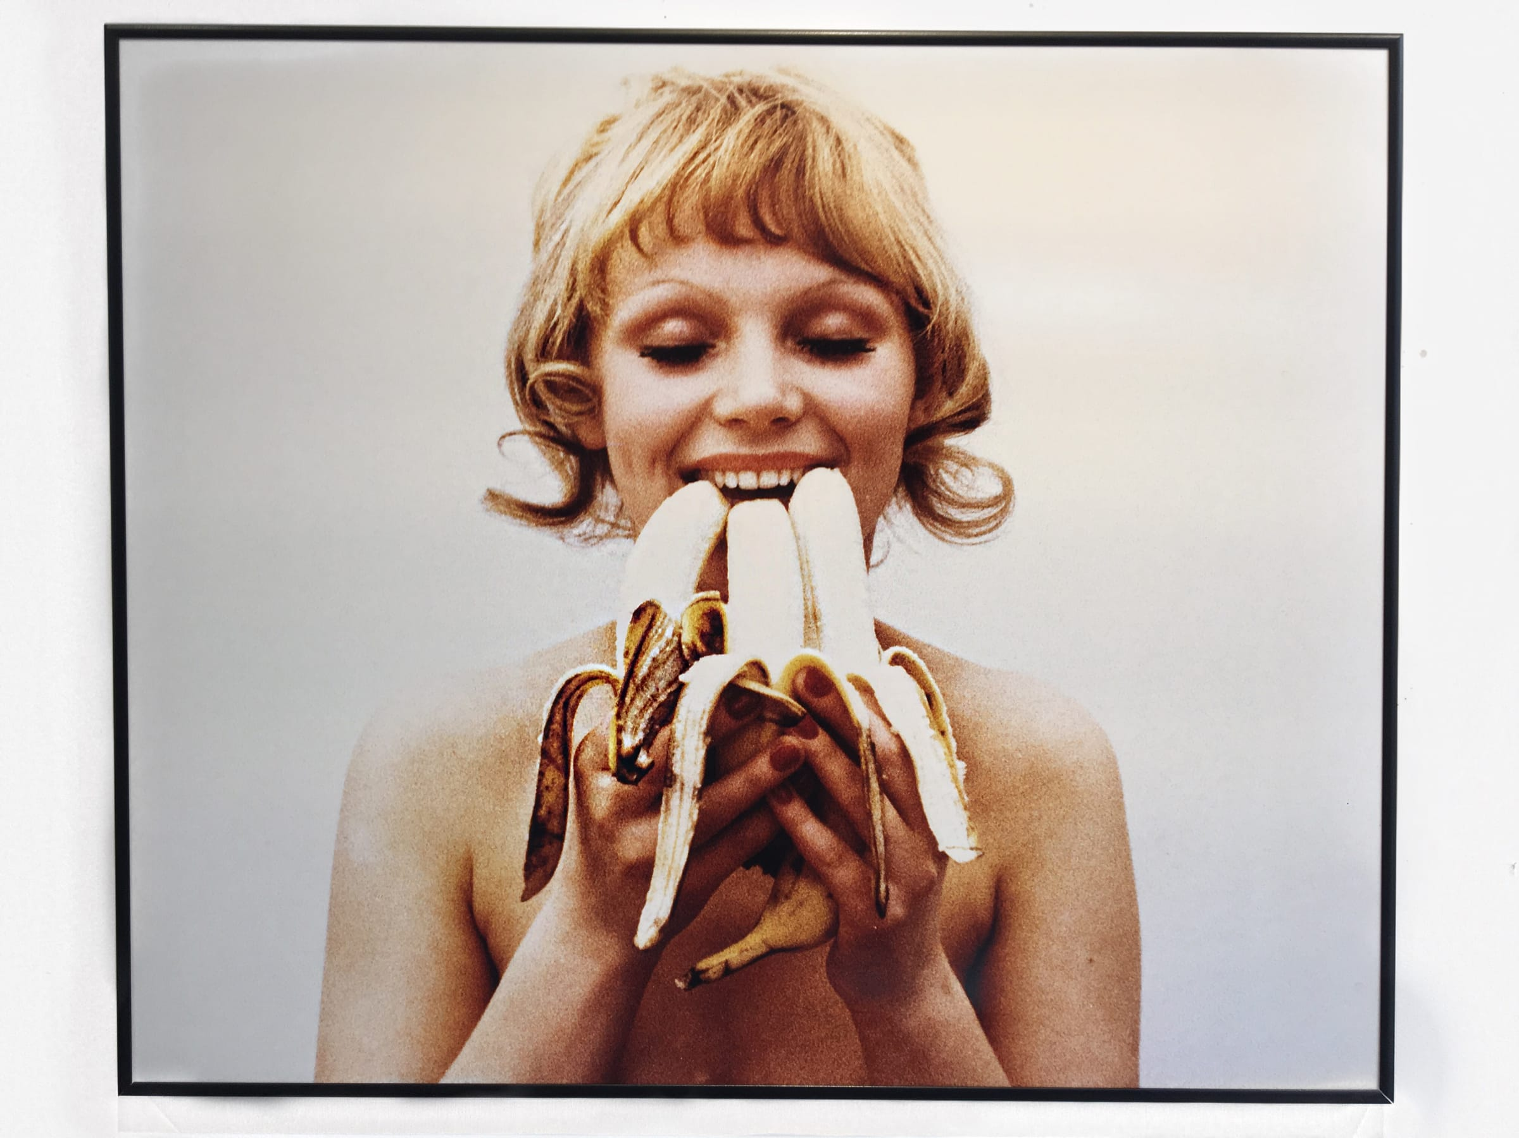

Essay V: Forgotten Layers and the Core Essence of Humanity
Beneath economic abstraction lies a fundamental human condition: the need for nourishment, comfort, and fairness. The banana satisfies hunger, but it also represents access. When an object is widely affordable, it embodies a sense of inclusion within economic systems. Accessibility becomes a form of dignity.
Contemporary economic systems often prioritize efficiency, growth, and profit over sensory awareness. Price becomes the dominant metric of value. In this framework, we forget the embodied dimensions of consumption (the tactile act of peeling, the smell released, the softness of texture. Sensory engagement is overshadowed by financial calculation.)
By deconstructing the banana into emotional layers: comfort, accessibility, feasibility, fairness - one uncovers the human foundation beneath consumer culture. The banana is not merely a commodity; it is a mediator between biological need and economic structure. Its stability fosters emotional security. Its fluctuation generates subtle anxiety.
To return attention to the banana is to re-center human experience within systems of exchange. It asks us to consider not only how markets function, but how they feel. The core essence of humanity: “care”, “nourishment”, “stability”, persists beneath layers of mass production and currency abstraction.
In this sense, the banana is both a symbol and index: a small, everyday object that reveals the intimate entanglement between economic systems and emotional life.
Essay 6: Commodity Fetishism and the Concealment of Relations - MARX POINTS
Marx’s concept of commodity fetishism describes how social relations between people appear as relations between things. The banana appears as an isolated object on a supermarket shelf, detached from the plantation labor, global shipping routes, and currency systems that made its presence possible.
The smooth yellow peel conceals labor conditions, climate vulnerability, and financial instruments that determine its price. Consumers encounter the banana as self-evident and natural, rather than as the endpoint of a vast global network. The commodity appears autonomous.
This fetishism is intensified by mass production. Uniformity erases traces of origin. The banana looks identical regardless of the labor regime or geopolitical context behind it. Its accessibility masks structural inequality.
Your project’s act of mapping banana prices across currencies disrupts fetishism. By reintroducing exchange rates into perception, you reveal the hidden relations embedded in the fruit. The banana ceases to be a neutral object and becomes an index of global interdependence.
In this way, emotional attachment is politicized not through rhetoric but through exposure of structure.

Essay 7: Simmel and the Abstraction of Value
In The Philosophy of Money, Georg Simmel argues that money abstracts qualitative differences into quantitative equivalence. Under monetary systems, diverse objects—bananas, books, rent, labor—become commensurable through price.
The banana’s sweetness, texture, and nourishment are reduced to a number. This number fluctuates according to exchange rates and market dynamics. Money thus distances us from direct sensory engagement; it mediates experience through abstraction.
The emotional comfort associated with accessibility becomes fragile in a monetary economy because accessibility is conditional. If currency shifts, affordability changes. What once felt stable can suddenly feel precarious.
Simmel suggests that modern life produces a “blasé attitude” as individuals adapt to constant valuation and revaluation. The banana, though mundane, reveals this condition. Its stable sensory qualities contrast with its unstable economic representation.
Your project re-materializes abstraction. By translating exchange rate volatility into spatial or sensory change, you reverse Simmel’s abstraction process. You make numerical fluctuation felt again.

Essay 8: Polanyi and the Disembedding of the Market
Karl Polanyi, in The Great Transformation, argues that modern capitalism “disembedded” markets from social relations. In pre-market societies, economic activity was integrated within social and moral systems. In market society, economic logic becomes autonomous and dominant.
The banana exemplifies this disembedding. Historically linked to colonial trade and corporate monopolies, banana production became organized around global market demands rather than local social needs. Land, labor, and food became “fictitious commodities”—treated as if they were purely market goods.
In contemporary urban life, the banana’s availability appears natural. Yet its price is shaped by financial systems distant from local communities. Economic logic overrides ecological and social embeddedness.
By examining banana price volatility across cities, your project investigates how global markets structure everyday accessibility. It does not argue against politics; rather, it exposes the economic ground upon which politics operates.
The banana becomes evidence that markets shape emotional life more quietly than political discourse.

Essay 10: Affect, Circulation, and the Emotional Infrastructure of Consumer Culture
Affect theorists such as Sara Ahmed and Brian Massumi argue that emotions circulate between bodies and objects. Objects accumulate affect through repetition and familiarity. The banana becomes associated with comfort not because of intrinsic symbolism, but because of repeated embodied encounters.
Emotion is infrastructural. It is built through consistency.
When an object remains affordable and accessible, it produces emotional security. When volatility disrupts accessibility, subtle anxiety emerges. The banana thus becomes part of what might be called an “emotional economy.”
Consumer culture depends on predictable circulation. Mass production ensures abundance; logistics ensure availability. This reliability sustains affective attachment. If accessibility is threatened, emotional equilibrium shifts.
The banana’s role in contemporary market society is therefore not trivial. It demonstrates how economic systems organize feeling. Comfort, fairness, and stability are not purely psychological states—they are conditioned by material accessibility.
To deconstruct the banana is to reveal how deeply economic infrastructures shape the core essence of humanity: nourishment, dignity, and security.

