Joshua Kelbley

Mod 6.2

11/19/2023

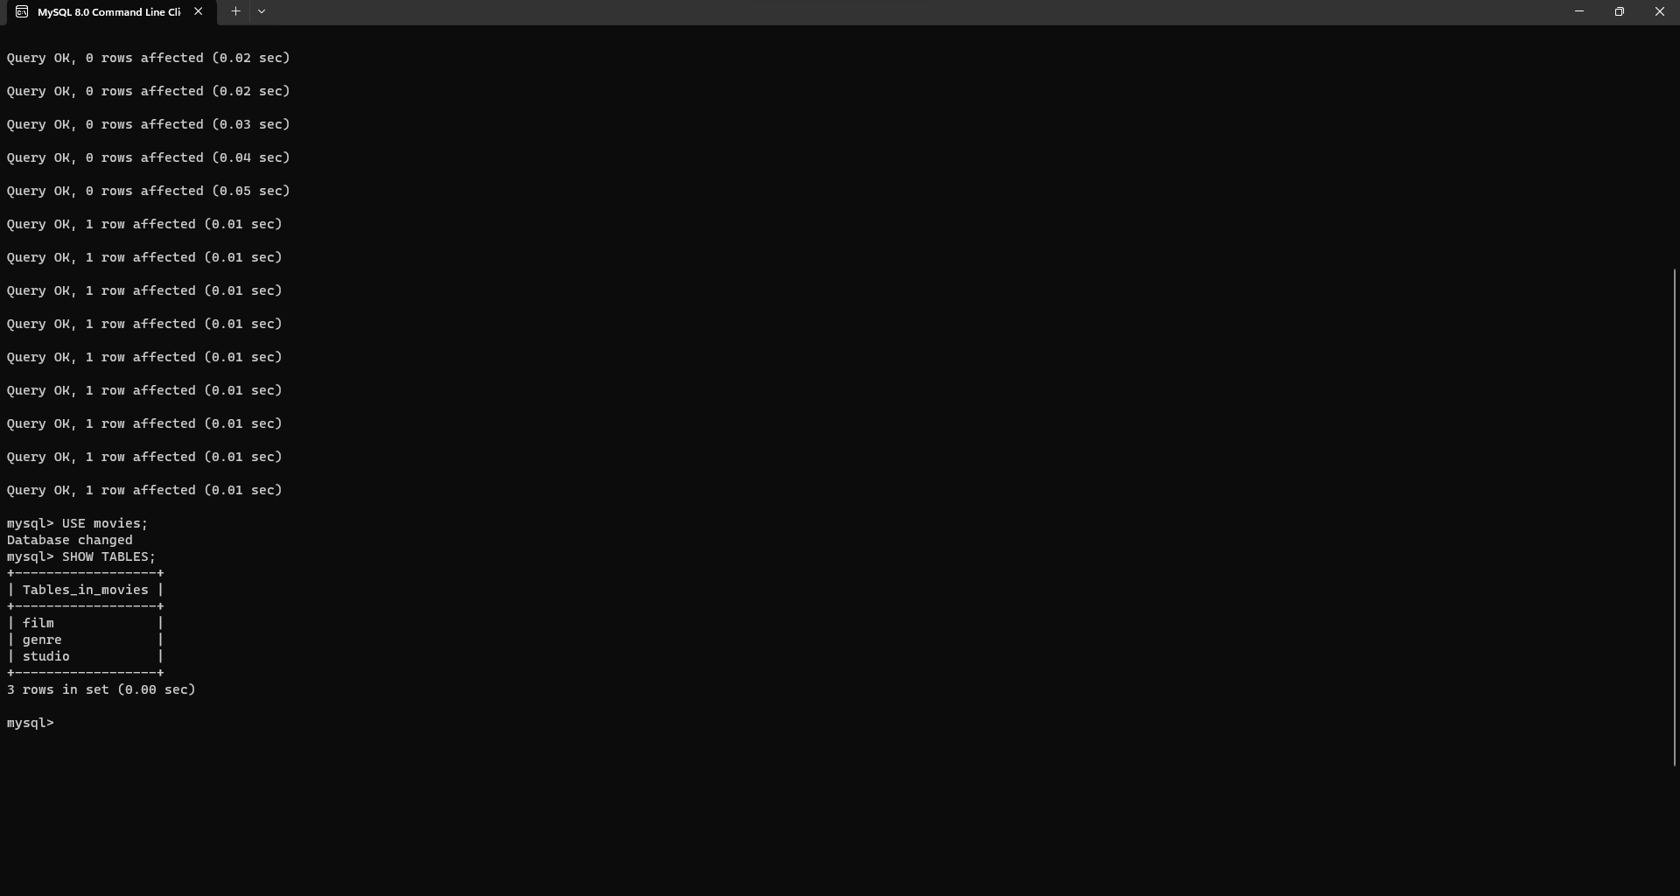

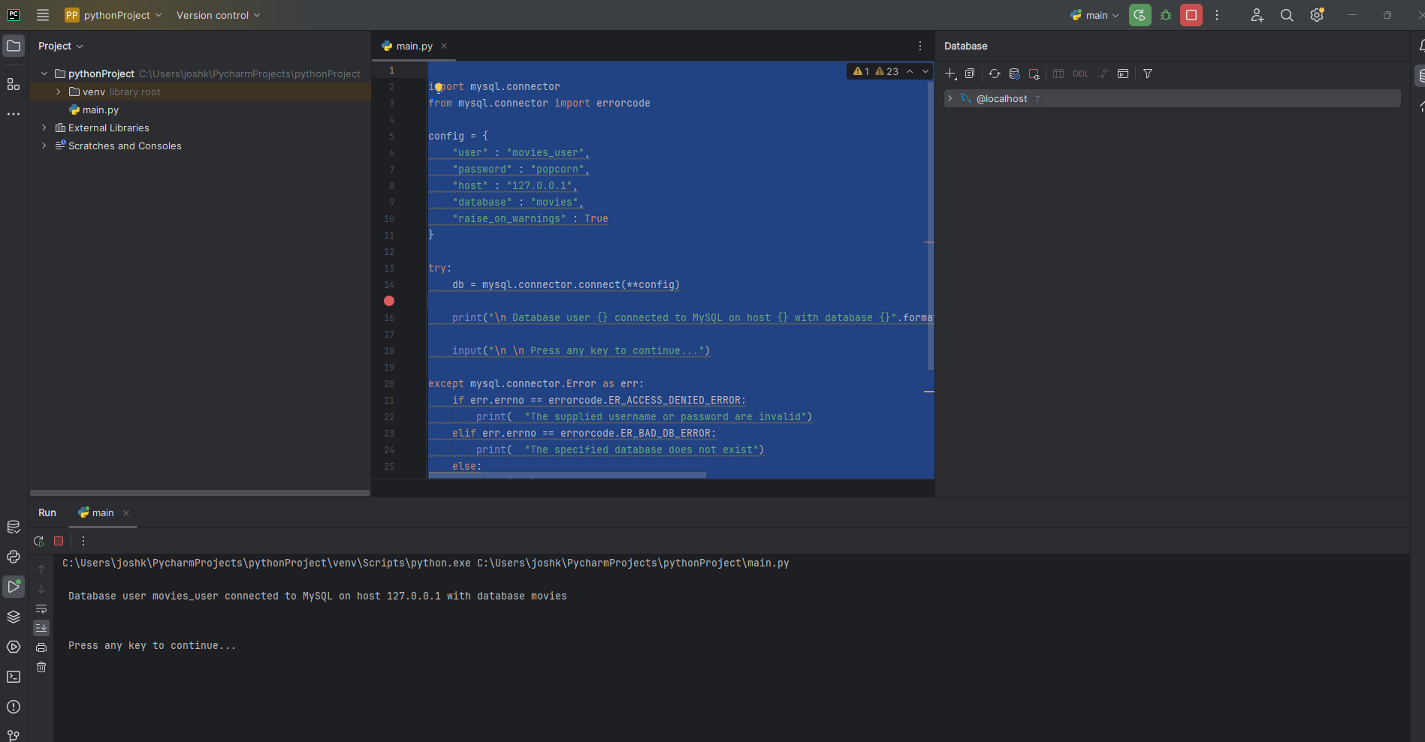

<https://github.com/jkelbley1/csd-310/tree/main/module_6>