**Project 1**

**<Connect Four>**

CIS-17A 43950

Name: Keller, Joseph

Date: 5/4/2015

**Summary**

Title: Connect Four

Opted for a game I was familiar with, and because honestly I had a really hard time thinking of "the perfect project." Also chose this because it is a fun game, and I can play it with my little brother.

Connect Four is a game where the objective is to, you guessed it, Connect Four pieces in a row! They can be connected vertically, horizontally, or diagonally. The game takes place between two players, as a race to see who can connect four the fastest. I only included a "dumb AI" to play against, as I was unsure how to implement a true AI.

I was sadly unable to implement some of the more advanced techniques we have learned in the class, but with how much trouble I had even getting what I had to work right, I would say at the very least I learned a ton by the completion of this project. It helped solidify my understanding of structures, pointers in structures, how to properly handle 2-dimentional arrays, and how to handle these in and out of multiple functions.

The project came out to a little over 300 lines of code, not counting the header files. I also utilized 14 functions and about 20 variables to get my program to do what I wanted it to accomplish. It isn't the most advanced program, or the best organized, but I feel this has been a vital step towards my understanding of how to create a C++ project.

**Flowchart**

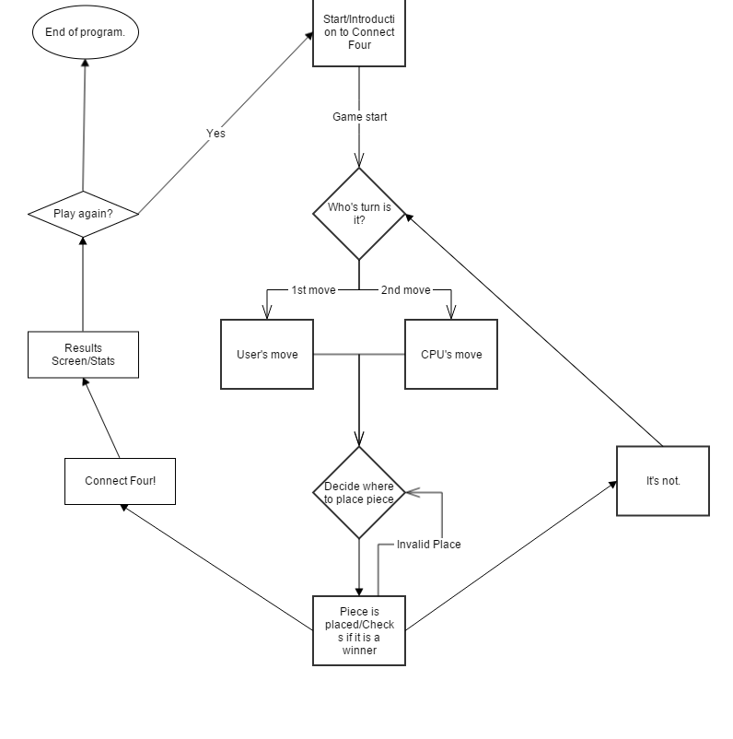

**Pseudocode**

*Introduce game*

*Allow player to choose whether to go first or second.*

*if player's turn*

*choose a column to play piece*

*checks to see if a piece can be placed there*

*else cpu's turn*

*rests a second to allow cpu to "think"*

*randomly places a legal piece*

*performs a vert/horizontal/diagonal check for a winner*

*checks to make sure the board isn't full*

*loops to the alternate player's turn until a end condition is met*

*if player gets a connect four, they win*

*if cpu gets a connect four, it wins*

*if the board is full, it's a draw*

*output results and asks if player would like to play again*