OCCUPANCY VERIFICATION LETTER
March 23, 2026
RE: Occupancy Verification — 1815 3rd St. SE, Canton, Ohio 44707
To Whom It May Concern:
This letter is provided solely for the purpose of verifying residential occupancy for utility service establishment. It does not constitute a lease agreement, rental agreement, or any other tenancy document, and confers no tenancy rights upon the occupant.
The undersigned property owner/authorized representative confirms that:
1. Name of Occupant(s): Joy A. Resendiz, Matthew Resendiz
2. Property Address: 1815 3rd St. SE, Canton, Ohio 44707
3. Parcel Number: 221015
4. Occupancy Status: Current physical occupant as of the date of this letter
5. Purpose of Letter: Utility service establishment only
This letter is not intended to create, renew, or extend any lease, rental agreement, or land contract, and shall not be construed as such. The property owner reserves all legal rights regarding the occupancy of the above-referenced property.
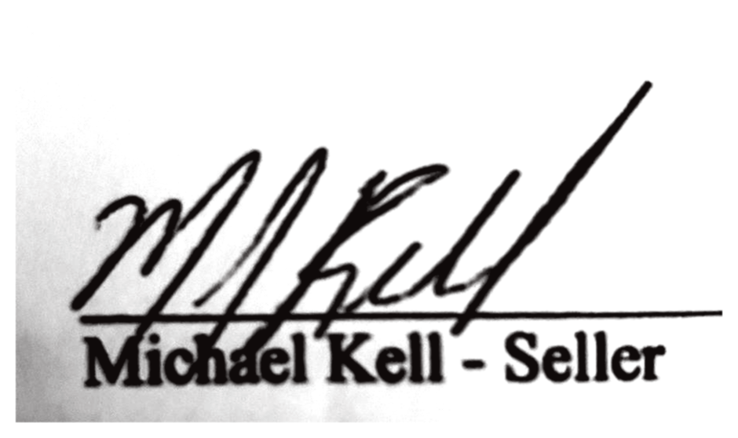
Sincerely,

Signature
Printed Name: Michael Kell
Title/Capacity: Property Owner
Address: 6521 Beverly Ave. NE, Canton, Ohio 44721

