Heavy: software for forward-modeling gravity change from MODFLOW output

Submitting to: Environmental Modeling and Software

Jeffrey R. Kennedya (corresponding author), Joshua Larsenb

aU.S. Geological Survey Arizona Water Science Center, 2255 N. Gemini Dr., Flagstaff, AZ 86001

bU.S. Geological Survey California Water Science Center, 6000 J Street, Sacramento, CA 95819

Highlights

* A MODFLOW post-processor for simulating gravity change
* Provides model predictions that can be compared to field measurements
* Generates storage-change maps for the model domain

*Review disclaimer*

This draft manuscript is distributed solely for purposes of scientific peer review. Its content is deliberative and predecisional, so it must not be disclosed or released by reviewers. Because the manuscript has not yet been approved for publication by the U.S. Geological Survey (USGS), it does not represent any official USGS finding or policy.

*Abstract*

Fortran software, named Heavy, was developed to simulate gravity change due to water-storage change in MODFLOW groundwater models. Heavy is compatible with MODFLOW-2005 and MODFLOW-NWT models using the layer-property flow or upstream weighting packages. All the necessary information for the gravity calculation—the geometry of the model cells, the storage coefficient, and head change—is present within the model files and no additional information is necessary. Gravity change is calculated at each time step, for each layer, at user specified locations or at a grid of hypothetical positions across the model. The model is validated using analytical gravity solutions and three example MODFLOW models are included for demonstration. Heavy leverages the input/output routines from MODFLOW and is orders of magnitude faster than previous efforts using interpreted languages such as Python or MATLAB. The objective of the software is to facilitate repeat microgravity field measurements for groundwater-flow model calibration.

*Keywords*: MODFLOW, hydrogeophysics, gravity, repeat microgravity

*Introduction*

Groundwater-flow model evaluation and calibration depends on comparing model output with observations of head, streamflow, and other observations (i.e., “history-matching”). One relatively new observation type, repeat microgravity, provides unique information about changes in groundwater storage by measuring the change in acceleration due to Earth’s gravity as groundwater (that is, water mass) is removed from or introduced into the gravity meter’s region of sensitivity. This region is generally large, extending to a radial distance about 10 times the distance between the gravity meter and the water table. In this way repeat microgravity provides spatially-averaged observations at a scale relevant to groundwater models with grid cells of hundreds of meters.

Nearly all groundwater modeling relies on head (groundwater level) observations, and several packages are available for extracting and viewing simulated head from models for the purpose of model evaluation and calibration (HYD, Hanson and Leake, 1999; OC, Harbaugh et al. 2000; HOB, Hill et al. 2000). In this paper we present a gravity observation package, similar to the head observation package (HOB), for the purpose of simulating gravity change at observation locations. In turn, simulated gravity change can be compared to repeat microgravity field measurements (observations) to calculate an objective function for model evaluation and calibration. Repeat microgravity is a natural fit for groundwater-model analysis because all of the information necessary for the gravity calculation (model geometry, head change, and storage properties) exists in the model itself with no additional parameters.

Several recent studies have demonstrated the value of repeat microgravity observations for groundwater-flow modeling and monitoring. These data can be used directly to map storage change (Carruth et al. 2018), to estimate specific yield (i.e., the relation between storage and groundwater-level change) at collocated monitoring wells (Pool and Eychaner, 1995), or to estimate model parameters through inversion (Kennedy et al. 2016, Kennedy et al., 2021a). Adoption of the repeat microgravity method is advancing with improvements in field methods (Kennedy et al., 2021b) and new quantum (Ménoret et al., 2018) and microelectronic (Carbone et al. 2020) sensors.

Gravity measurements can be standalone absolute-gravity measurements, or relative-gravity measurements between stations (Kennedy et al., 2021b). Often, relative- and absolute-gravity measurements are combined using least-squares network adjustment (Hwang et al., 2002). These surveys are typically carried out at discrete seasonal or annual intervals. Measurement precision of gravity change (i.e., between surveys) ranges from about 0.024 to 0.14 m of water, using the horizontal-infinite (Bouguer) slab approximation to convert acceleration to meters of water (41.9 µGal = 1 m of water; 1 µGal = 10 nm/s2). Alternatively, much more precise (< 1 µGal uncertainty) continuous (daily, hourly, or finer) data can be collected using superconducting or spring-based meters (Crossley, 2013). These deployments are less common, and typically require alternating-current (AC) power but can be especially useful where storage is rapidly changing, such as at artificial recharge facilities (Kennedy et al., 2014, Kennedy et al., 2016).

To facilitate the use of repeat microgravity field measurements for groundwater-flow model calibration, we present Fortran source code for a MODFLOW forward-gravity post-processor. Only one (optional) additional file is needed beyond the standard MODFLOW files, to specify observation locations. The software is made available as a compiled Windows executable, or the source is readily compiled for use on Linux and/or high-performance computing machines.

*Methods*

Forward-gravity modeling for MODFLOW calibration calculates the gravitational attraction of each model cell relative to each measurement location. Many different gravity analytical solutions exist for different mass geometry: rectangular prisms (Forsberg, 1984), point masses (Torge, 1989), spherical prisms (Uieda et al. 2016), wedge-shaped prisms, etc. Here, we build on the work of Leirião (2009), who presented a metric based on the dimensions of a rectangular model cell relative to the gravimeter position to determine the appropriate gravity formula:

(1)

Here, *r2* is the distance from the gravity meter to the prism center, and *dr2* = Δ*x2* + Δ*y2* + Δ*z*2 is a measure of the prism size (Figure 1). Leirãio (2009) recommended that for values of *f*2 less than 4, the prism formula, also known as the Forsberg (1984) be used:

**(d=r)** (2)

Where *γ* is the gravitational constant, *ρSy*is the cell density change (water density times specific yield), and *x1,2*, *y1,2*, *a*nd *z1,2* are the cartesian distances between the cell center and the gravity station. For large distances been the model cell and gravity station, the difference between the integration bounds in equation 2 can become small and the formula unstable. For values of *f2* greater than 81, Leirião (2009) recommends the point mass formula:

(3)

where is the average hydraulic head (for unconfined-layer cells) or cell midpoint (for confined-layer cells), is the change in head, and Li is the vertical distance between the microgravity instrument at location *i* and the hydraulic head elevation. For intermediate values of *f2* between 4 and 81, Leirião (2009) recommends an approximation of equation 2 (MacMillan 1958) for computational efficiency. In our testing, however, there was little performance benefit from using the MacMillan (1958) formula as compared to the more accurate prism formula and the latter was used for *f2* values less than 81.

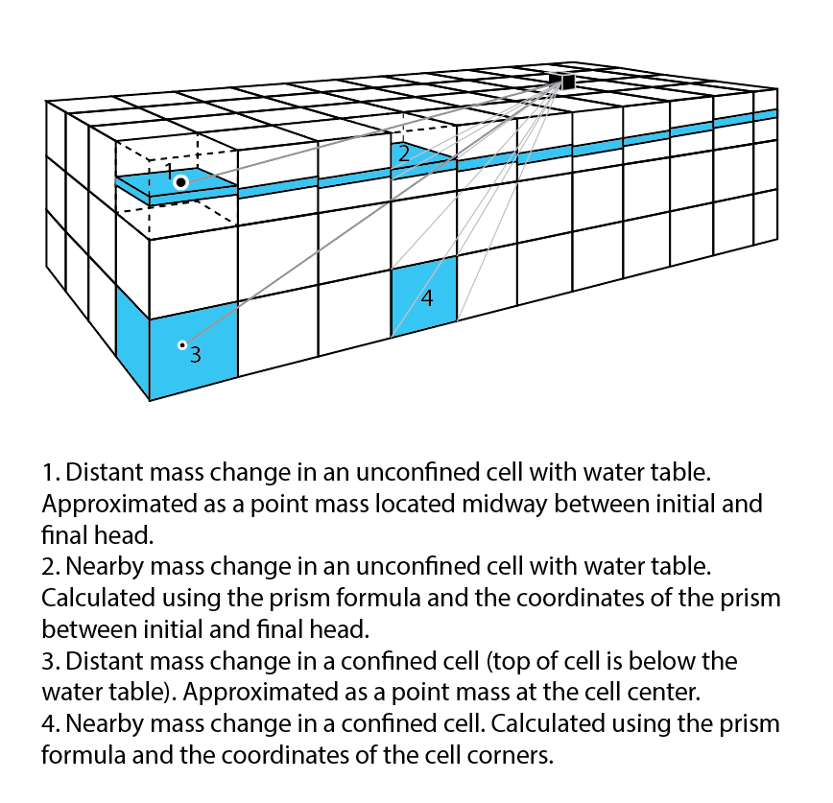

Figure 1: Conceptual diagram showing the geometry of MODFLOW cells relative to gravity stations

The forward gravity computation (equations 2 and 3) is carried out for each model cell in each layer, each gravity-meter position, and each time step. When using field data (i.e., a limited amount of data in sparse locations), computation time for most real-world groundwater models is on the order of seconds and is usually much faster than solving the groundwater-flow model. When generating gravity change over a grid of stations (using the “-g” command line option; Table 1) computation time can be much longer owing to the number of floating-point calculations that must be carried out (*m* model cells * *n* time steps * *i* gravity stations). However, this analysis is usually only carried out once or a few times for model screening, and not repeatedly as with parameter estimation.

Table 1: Description of optional command line arguments that can be supplied to Heavy

|  |  |
| --- | --- |
| Command-line option | Description |
| -g | Generates a grid of gravity stations for each cell in the model from user supplied grid spacing information |
| -l | Limits gravity calculations to the uppermost unconfined layer |
| -q | Perform Quality Assurance test calculations (Bouger slab and point mass) |
| -v | Prints version information |
| -t1 | Calculate gravity change relative to the end of time step 1. Default is to calculate relative to starting heads |

Two Python programs are included for visualization using Matplotlib (Figure 2). One program, g_animation.py outputs a time-series animation of simulated gravity change when the “-g” option is used to generate a grid of gravity stations. Data and station positions are read from files specified as command-line arguments. The second program, g_timeseries.py, creates a time series plot showing gravity change at all model cells.

Figure 2: Heavy output for MODFLOW models for A., the Rio Grande Valley near Albuquerque, NM (Myers and Friesz, 2019), B., the All American Canal in southeast California (Wildermuth and Kennedy, 2021), and C. the Truxton basin in northwest Arizona, a portion of a larger model (Knight, 2020).

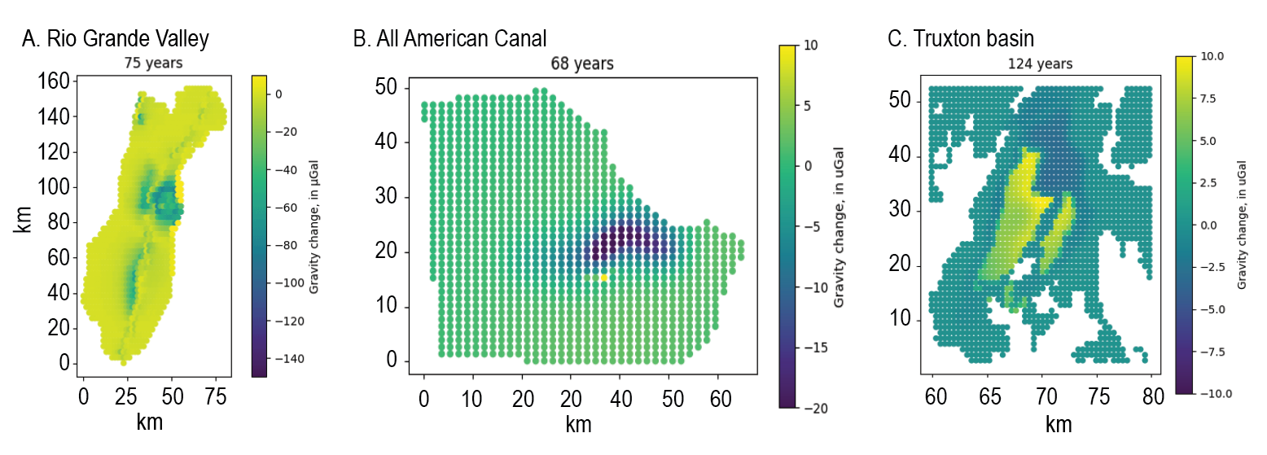

*Software description*

Heavy (software ref) is based on existing file input/output routines for MODFLOW (Harbaugh, 2005), which should ensure compatibility with model files and output from MODFLOW-2005 and MODFLOW-NWT executables provided by the U.S. Geological Survey. Heavy should also run with other models using compatible name files and head output (e.g., MODFLOW-OHWM; Boyce et al., 2020). A Microsoft Windows executable is provided in the project repository. The software can be compiled directly using gfortran or Intel compilers or with the pymake Python program (https://github.com/modflowpy/pymake). Performance of the compiled executable when using either the gfortran or Intel compilers was comparable when identical optimization flags were used.

Heavy reads model properties from the upstream weighting package (UPW) or layer property flow (LPF) package. The block centered flow package (BCF) is not supported, nor are packages simulating unsaturated-zone flow such as the UZF package (if included, UZF storage change is ignored). Like MODFLOW, Heavy reads model file names from a name (*.nam) file. This can be the same name file used for MODFLOW but must include a “HVY” file that specifies observation locations. Heavy is compatible with all methods for specifying model parameters, including zones and multiplier arrays. Heavy depends only on model geometry, head change, and storage properties; other properties such as hydraulic conductivity and initial head are ignored. Head change is read for all time steps present in the MODFLOW binary head file specified in the Heavy name file. Time steps must be specified in the output control file provided to MODFLOW.

When carrying out the gravity calculation for a given model cell, Heavy first determines if the cell is confined based on the head elevation relative to the top cell coordinate (Figure 1). If the head elevation is higher the cell is considered confined. In this case the cell geometry is defined by the model coordinates, and the density change is calculated from the head change and specific storage (expressed as storage capacity in MODFLOW) for that model cell. If the head elevation is within a cell, the cell is considered unconfined. In this case cell geometry for the purpose of the gravity calculation is defined by the beginning and ending head, assuming the cell drains or fills completely within the time step (Figure 1). Density change is calculated from the head change and specific yield.

Heavy accommodates models with multiple unconfined layers (Figure 3). The appropriate storage parameter (specific yield or specific storage) is selected based on the head elevation relative to the top of the cell. All layers below the uppermost unconfined cell are considered confined; layers above the uppermost unconfined cell are ignored. Because the cumulative gravity calculation is usually dominated by unconfined storage, by using the “-l” command line option (Table 1) the calculation can be limited to a single layer, thereby reducing computation time. By default, Heavy reports the change in gravitational attraction of each layer individually and the cumulative change.

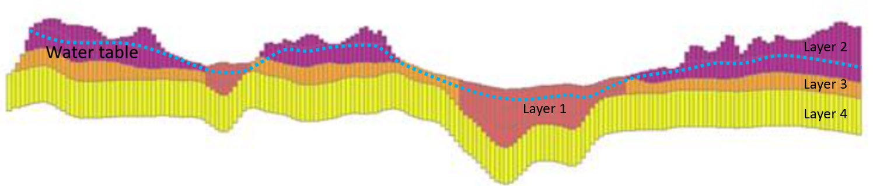

Figure 3: Model cross section of multilayer model (Knight, 2020), showing multiple (unconfined) convertible layers. In different parts of the model, the water table (and unconfined storage change) exists in layers 1, 2, and 3. For the gravity forward calculation, layer 2 must be treated as confined where overlain by layer 1, and unconfined elsewhere.

Gravity observation locations in the HVY file are specified in model coordinates. To facilitate rapid analysis without needing to specify observation locations, using the “-g” command line option Heavy can generate an evenly spaced grid of gravity stations across the model domain. In this case the observation locations in the HVY file are ignored. The z-coordinate of the gravity station is the elevation of the encompassing cell from the MODEL_TOP dataset. The user must verify MODEL_TOP represents the land surface. Additional command line options specify the number of observation locations in the x and y directions, and allow the user to specify locations over a subset of the model domain. See the User’s Guide for more information.

Several test cases are included with Heavy using the “-q” command line option (Table 1). Prism-formula (equation 2) solutions are compared to horizontal-infinite (“Bouguer”) slab approximations (single-prism and discretized into 10 x 10 m cells). Point-mass solutions are similarly compared to a Newton’s law solution. Three test models with MODFLOW input and head files are included: a single-layer MODFLOW-NWT model of the All American Canal used to demonstrate model calibration with repeat microgravity (Kennedy et al. 2021a, Wildermuth and Kennedy 2021), a 4-layer MODFLOW-NWT model from northwest Arizona demonstrating upstream weighting and unconfined storage in multiple layers (Knight, 2020), and a multilayer MODFLOW-2005 model for the Rio Grande Valley demonstrating layer property flow and complex use of zones and arrays (Meyers and Friesz, 2019). Output from these test cases is verified through a continuous integration test suite each time the source code is updated. For the single-layer All American Canal model, output is compared to validated gravity calculations present in the code repository.

Depth to water relative to model cell size is important to avoid “stair-stepping” in the gravity residual (Kennedy et al. 2021a). If this value (represented by equation 1) is too small, an artificial pattern is induced in the gravity forward calculation by the discretization of the MODFLOW model (Figure 4). At present the user must evaluate the significance of this effect for their model. A mitigating factor is that the repeat microgravity method depends only on the magnitude of gravity changes between time steps. Thus, a model that may produce a “stair-step” gravity field at each time step may also produce smoothly varying gravity profile over time at an individual station. Automatic head interpolation to avoid this effect is on the Heavy development roadmap.

Figure 4: Schematic diagram showing the “grid-effect” in the forward gravity calculation if depth to water is too shallow relative to the model cell size.

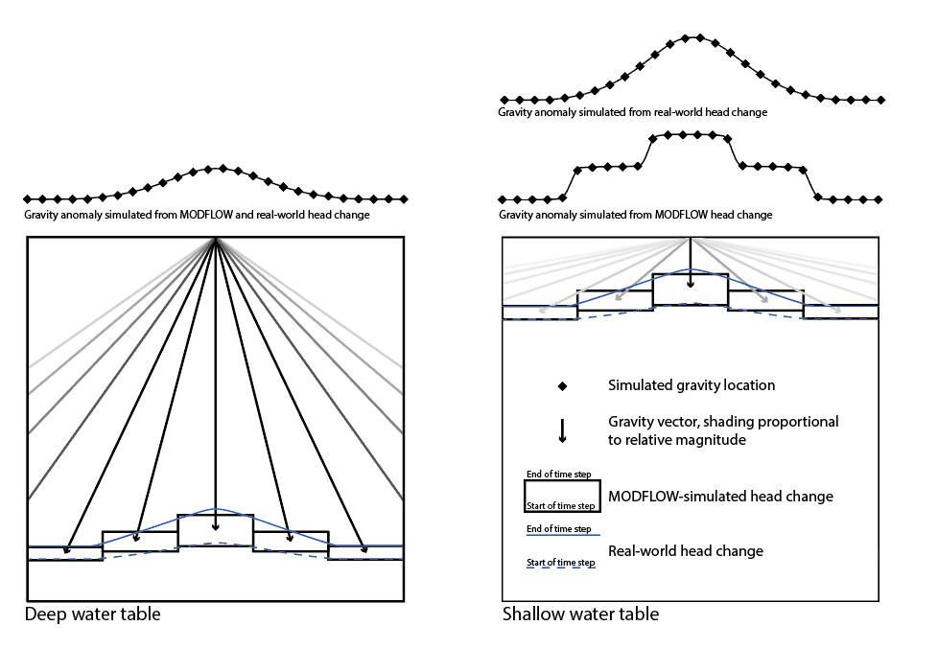

*Discussion and Conclusions*

Much progress has been made in recent decades to incorporate automated parameter estimation for groundwater models, reducing the need for expert local knowledge and trial-and-error parameter adjustments (Anderson et al. 2015). Repeat microgravity data is a natural candidate for model calibration because predicted values are obtained directly from the model, without requiring a petrophysical model to relate measurements to model-derived values. Gravity change is a direct measurement of storage change, a property of interest, rather than a surrogate property (e.g., electrical conductivity).

An alternative to predicting gravity change by forward modeling is to convert gravity change to 1-dimensional storage change using the infinite-slab (Bouguer) approximation. This approximation provides a direct relation between gravity change and storage change: 41.9 µGal = 1 m of water, regardless of depth to water or specific yield (porosity). For the All American Canal model, with significant mounding from recharge, the departure from the infinite-slab approximation was about 1 percent from the full 3-dimensional forward-modeled signal (Kennedy et al. 2021a). The disadvantage is that vertically integrated storage change across all model layers is not typically included in model output and must be calculated.

Many improvements are possible for Heavy. These include accommodating unstructured grids and triangular discretization made possible in MODFLOW 6. More detailed discretization leads to longer run times, but two solutions are possible. First, the gravity calculation is easily parallelized and multi-core PCs or high-performance computing can be applied. Second, for cells within the model that don’t change position (i.e., confined layers, but not unconfined layers, where the cell coordinates depend on head), the gravity effect of any one cell is simply *si,j,k*\*(mass change), where s*i,j,k* is a sensitivity that is calculated once for each gravimeter location/model cell pair and stored and reused for future time steps. Third, Heavy does not consider subsidence, but gravity measurements at the land surface are affected by changes in elevation caused by subsidence or uplift. This effect could be included for models that simulate subsidence caused by groundwater withdrawals. Finally, unsaturated zone storage is ignored in Heavy, but gravity measurements are affected by changes in by changes in storage in the unsaturated zone. Full integration into the MODFLOW source code could provide an avenue for these updates to be applied to Heavy.

Gravity-change maps (Figure 2) produced by Heavy represent a low-pass filtered view of model storage change, primarily in the uppermost unconfined aquifer. As such they may be useful for model evaluation apart from the comparison with gravity data. The power of such maps is that they show a quantity that can be measured at the land surface. Therefore, they can be used as a screening tool to determine where gravity data can be collected to verify or refute model assumptions.

*Software availability*

Heavy code and compiled executables are available at https://code.usgs.gov/sgp/heavy.

*Disclaimer*

Any use of trade, firm, or product names is for descriptive purposes only and does not imply endorsement by the U.S. Government.

*References*

Anderson, M.P., W.W. Woessner, Hunt, R.J., 2015. Applied Groundwater Modeling: Simulation of Flow and Advective Transport, 2nd ed. London, UK: Academic Press.

Boyce, S.E., Hanson, R.T., Ferguson, I., Schmid, W., Henson, W., Reimann, T., Mehl, S.M., Earll, M.M., 2020. One-Water Hydrologic Flow Model: A MODFLOW based conjunctive-use simulation software: U.S. Geological Survey Techniques and Methods 6–A60, 435 p., <https://doi.org/10.3133/tm6A60>

Carbone D., Antoni-Micollier L., Hammond G., de Zeeuw - van Dalfsen E., Rivalta E., Bonadonna C., Messina A., Lautier-Gaud J., Toland K., Koymans M., Anastasiou K., Bramsiepe S., Cannavò F., Contrafatto D., Frischknecht C., Greco F., Marocco G., Middlemiss R., Ménoret V., Noack A., Passarelli L., Paul D., Prasad A., Siligato G., Vermeulen P., 2020. The NEWTON-g Gravity Imager: Toward New Paradigms for Terrain Gravimetry: Frontiers in Earth Science 8, [https://doi.org/10.3389/feart.2020.573396](https://doi.org/10.3389/feart.2020.573396%20%20%20)

Carruth, R.L., Kahler, L.M., Conway, B.D., 2018. Groundwater-storage change and land-surface elevation change in Tucson Basin and Avra Valley, south-central Arizona—2003–2016: U.S. Geological Survey Scientific Investigations Report 2018–5154, 34 p., <https://doi.org/10.3133/sir20185154>.

Crossley, D., Hinderer, J., Riccardi, U., 2013. The measurement of surface gravity. Reports on Progress in Physics, 76(4), 046101. <https://doi.org/10.1088/0034-4885/76/4/046101>

Forsberg, R., 1984. A study of terrain reductions, density anomalies, and geophysical inversion methods in gravity field modelling. Ohio State University

Hanson, R.T., and Leake, S.A., 1999. Documentation for HYDMOD, a program for extracting and processing time-series data from the U.S. Geological Survey's modular three-dimensional finite-difference ground-water flow model: U.S. Geological Survey Open-File Report 98-564, 57 p. <https://doi.org/10.3133/ofr98564>

Harbaugh, A.W., Banta, E.R., Hill, M.C., McDonald, M.G., 2000. MODFLOW-2000, the U.S. Geological Survey modular ground-water model -- User guide to modularization concepts and the Ground-Water Flow Process: U.S. Geological Survey Open-File Report 00-92, 121 p. <https://doi.org/10.3133/ofr200092>

Harbaugh, A.W., 2005. MODFLOW-2005, the U.S. Geological Survey modular ground-water model -- the Ground-Water Flow Process: U.S. Geological Survey Techniques and Methods 6-A16.

Hill, M.C., Banta, E.R., Harbaugh, A.W., Anderman, E.R., 2000. MODFLOW-2000, the U.S. Geological Survey modular ground-water model -- User guide to the Observation, Sensitivity, and Parameter-Estimation Processes and three post-processing programs: U.S. Geological Survey Open-File Report 00-184, 210 p.

Hwang, C., Wang, C. G., Lee, L. H., 2002. Adjustment of relative gravity measurements using weighted and datum-free constraints. Computers and Geosciences, 28(9), 1005–1015. <https://doi.org/10.1016/S0098-3004(02)00005-5>

Kennedy, J. R., Ferré, T. P. A., Güntner, A., Abe, M., Creutzfeldt, B., 2014. Direct measurement of subsurface mass change using the variable baseline gravity gradient method. Geophysical Research Letters, 41(8), 2827–2834. <https://doi.org/10.1002/2014GL059673>.

Kennedy, J. R., Ferré, T. P. A., Creutzfeldt, B., 2016) Time-lapse gravity data for monitoring and modeling artificial recharge through a thick unsaturated zone. Water Resources Research, 52(9), 7244–7261. <https://doi.org/10.1002/2016WR018770>

Kennedy, J.R., Wildermuth, L., Knight, J.E., Larsen, J., 2021a. Improving groundwater model calibration with repeat microgravity measurements, Groundwater, <https://doi.org/10.1111/gwat.13167>

Kennedy, J.R., Pool, D.R., and Carruth, R.L., 2021b. Procedures for field data collection, processing, quality assurance and quality control, and archiving of relative- and absolute-gravity surveys: U.S. Geological Survey Techniques and Methods, book 2, chap. D4, 50 p., <https://doi.org/10.3133/tm2D4>.

Knight, J.E., 2020. MODFLOW-NWT groundwater model used for simulating potential future pumping scenarios and forecasting associated groundwater-level changes in the Truxton aquifer on the Hualapai Reservation and adjacent areas, Mohave County, Arizona, U.S. Geological Survey data release, <https://doi.org/10.5066/P9O2WGLS>

Leirião, S., He, X., Christiansen, L., Andersen, O. B., & Bauer-Gottwein, P., 2009. Calculation of the temporal gravity variation from spatially variable water storage change in soils and aquifers. Journal of Hydrology, 365(3–4), 302–309. <https://doi.org/10.1016/j.jhydrol.2008.11.040>

MacMillan, W.D., 1958. The Theory of Potential. Theoretical Mechanics, vol. 2. Dover, New York.

Ménoret, V., Vermeulen, P., Le Moigne, N. Bonvalot, S., Bouyer, P., Landragin, A., Desruelle, B., 2018. Gravity measurements below 10-9 g with a transportable absolute quantum gravimeter. Sci Rep 8, 12300. <https://doi.org/10.1038/s41598-018-30608-1>

Myers, N.C., Friesz, P.J., 2019. Hydrogeologic framework and delineation of transient areas contributing recharge and zones of contribution to selected wells in the upper Santa Fe Group aquifer, southeastern Albuquerque, New Mexico, 1900–2050: U.S. Geological Survey Scientific Investigations Report 2019–5052, 73 p., <https://doi.org/10.3133/sir20195052>.

Tsai, J.-P., T.-C.J. Yeh, C.-C. Cheng, Y. Zha, L.-C. Chang, C. Hwang, Y.-L. Wang, Hao, Y., 2017. Fusion of time-lapse gravity survey and hydraulic tomography for estimating spatially varying hydraulic conductivity and specific yield fields. Water Resources Research 53: 8554– 8571. <https://doi.org/10.1002/2017WR020459>

Torge, W., 1989. *Gravimetry*. De Gruyter.

Uieda, L., V. Barbosa, Braitenberg, C., 2016. Tesseroids: Forward-modeling gravitational fields in spherical coordinates, Geophysics, F41–F48, <https://doi.org/10.1190/geo2015-0204.1>.