ELECTRONIC GIANT

EG

2

1

31

Datasheet

High Power

MOS

、

IGBT

Gate Driver



201

7

©

屹晶微电子有限公司

版权所有

REV 1.0

版本变更记录

|  |  |  |
| --- | --- | --- |
| 版本号 | 日期 | 描述 |
| V1.0 | 2017年6月12日 | EG2131数据手册初稿 |
|  |  |  |
|  |  |  |

I

目录

1. 特性 1

2. 描述 1

3. 应用领域 1

4. 引脚 2

4.1 引脚定义 2

4.2 引脚描述 2

5. 结构框图 3

6. 典型应用电路 3

7. 电气特性 4

7.1 极限参数 4

7.2 典型参数 5

7.3 开关时间特性及死区时间波形图 6

8. 应用设计 7

8.1 Vcc端电源电压 7

8.2 输入逻辑信号要求和输出驱动器特性 7

8.3 自举电路 8

9. 封装尺寸 9

9.1 SO8封装尺寸 ............................................................................................................................................ 9 II

**EG2131** 芯片数据手册 **V1.0**

# 特性

* High-end suspension bootstrap power supply design, withstand voltage 300V
* Adapt to 5V, 3.3V input voltage
* Maximum frequency support 500KHz
* Low-end VCC undervoltage shutdown output
* Output current capability IO+/- 1A/1.5A
* Built-in dead zone control circuit
* Self-locking function, completely eliminate the output of the upper and lower tubes at the same time
* HIN input channel is active high, controlling high-end HO output
* LIN Input channel active low, controlling low-side LO output
* Less peripheral devices
* Static current is less than 5uA, ideal for battery applications
* Package form：SOP-8

# 描述

EG2131 is a cost-effective high-power MOS tube, IGBT tube gate drive dedicated chip, integrated logic signal input processing circuit, dead time control circuit, undervoltage shutdown circuit, blocking circuit, level shift circuit, pulse The filter circuit and the output drive circuit are dedicated to the drive circuit in the brushless motor controller.

The high-end operating voltage of the EG2131 can reach 300V, and the low-end Vcc has a wide supply voltage range of 11V to 20V, and the static power consumption is less than 5uA. The chip

It has a blocking function to prevent the output power tube from being turned on at the same time. The input channel HIN has a built-in 200K pull-down resistor. The LIN has built-in pull-up 5V high potential. When the input is floating, the upper and lower power MOS tubes are turned off, and the output current capability is IO+/- 1/1.5A in SOP8 package.

# 应用领域

* Mobile power high voltage fast charge switching power supply 
* Electric vehicle controller  Inverter pump controller
* Brushless motor driver
* 300V step-down switching power supply  High-voltage Class-D power amplifier

# 引脚

## 引脚定义

Vcc

GND

LO

VS

HO

E

G

2

1

3

1

1

2

3

4

5

6

7

8

H

IN

L

IN

V

B

图4-1. EG2131管脚定义

## 引脚描述

|  |  |  |  |
| --- | --- | --- | --- |
| Pin Number | Pin Name | **I/O** | Description |
| 1 | Vcc | Power | Chip working power input terminal, voltage range 11V-20V, external high frequency 0.1uF bypass capacitor can reduce high frequency noise at the input end of the chip |
| 2 | HIN | I | The logic input control signal is active high to control the turn-on and turn-off of the high-side power MOSFET  “0” is the power MOSFET that is turned off  "1" is the power MOS transistor |
| 3 | LIN | I | The logic input control signal is active low to control the turn-on and turn-off of the low-side power MOS transistor  "1" is the power MOS transistor off  “0” is the power MOS transistor |
| 4 | GND | GND | Chip ground. |
| 5 | LO | O | Output controls the conduction and cutoff of the low-side MOS power transistor |
| 6 | VS | O | High-end suspension ground |
| 7 | HO | O | Output control of the turn-on and turn-off of the high-end MOS power transistor |
| 8 | VB | Power | High-end suspension power supply |

# 结构框图

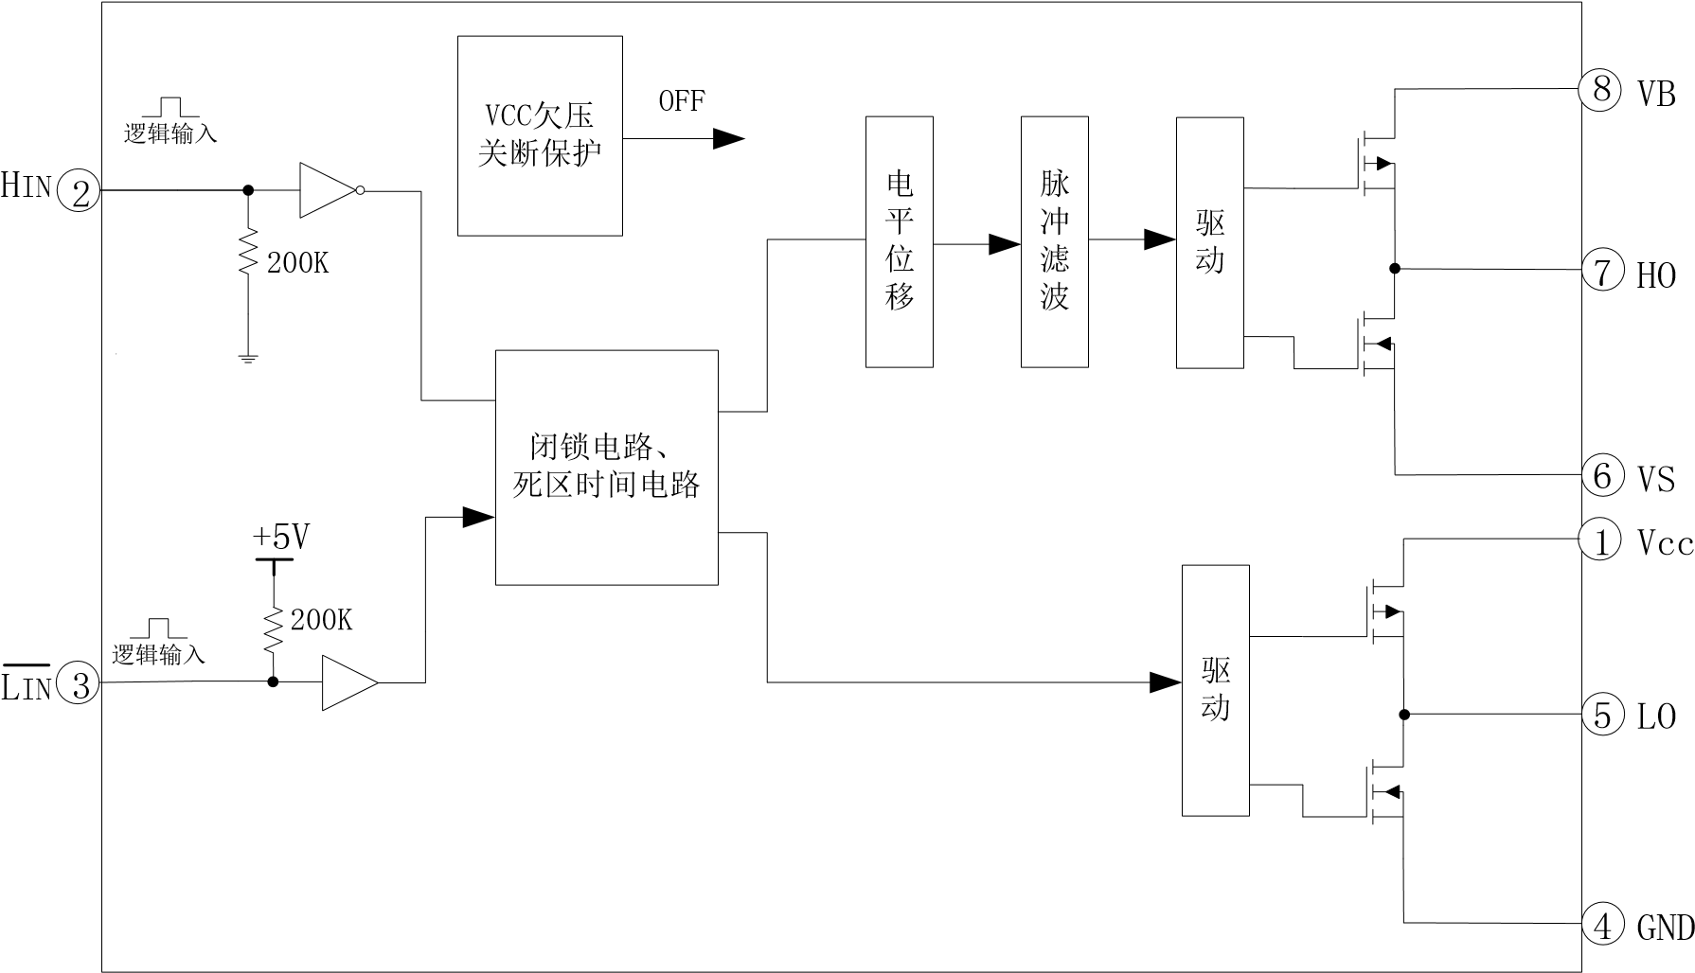

Driver

Driver

Pulse filtering

Level Shift

Blocking circuit dead time circuit

图5-1. EG2131内部电路图

# 典型应用电路

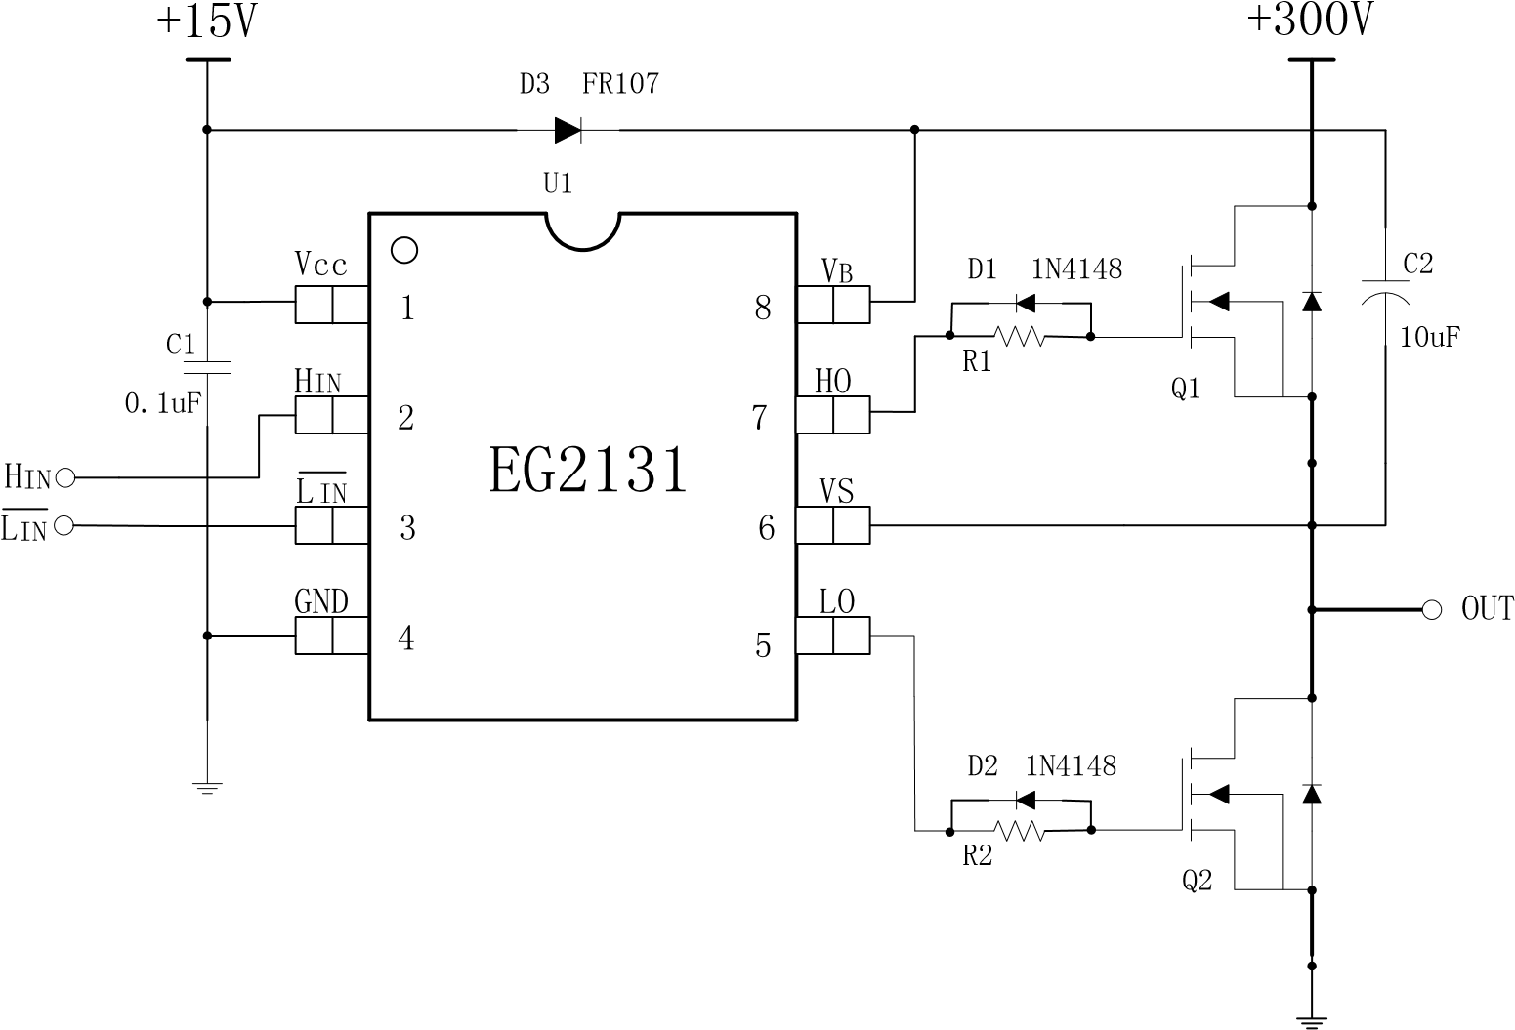

图6-1. Typical application circuit diagram of EG2131

# 电气特性

## 极限参数

无另外说明，在TA=25℃条件下

|  |  |  |  |  |  |
| --- | --- | --- | --- | --- | --- |
| 符号 | 参数名称 | 测试条件 | 最小 | 最大 | 单位 |
| VB | Bootstrap high-end VB power supply | - | -0.3 | 300 | V |
| VS | High-end suspension ground | - | VB-25 | VB+0.3 | V |
| HO | High-end output | - | VS-0.3 | VB+0.3 | V |
| LO | Low-end output | - | -0.3 | VCC+0.3 | V |
| VCC | Power supply | - | -0.3 | 25 | V |
| HIN | High channel logic signal input level | - | -0.3 | VCC+0.3 | V |
| ̅LIN̅̅̅̅ | Low channel logic signal input level | - | -0.3 | 6 | V |
| TA | Ambient temperature | - | -45 | 125 | ℃ |
| Tstr | Storage temperature | - | -55 | 150 | ℃ |
| TL | Welding temperature | T=10S | - | 300 | ℃ |

Note: Exceeding the listed limit parameters may cause permanent damage inside the chip. Long-term operation under extreme conditions may affect the reliability of the chip.

## 典型参数

Unless otherwise stated, under TA=25°C, Vcc=15V, load capacitance CL=10nF

|  |  |  |  |  |  |  |
| --- | --- | --- | --- | --- | --- | --- |
| Parameter Name | 符号 | 测试条件 | 最小 | 典型 | 最大 | 单位 |
| Power Supply | Vcc | - | 11 | 15 | 20 | V |
| Quiescent Current | Icc | 输入悬空，Vcc=12V | - | - | 30 | uA |
| Input logic signal high potential | Vin(H) | 所有输入控制信号 | 2.5 | - | - | V |
| Input logic signal low potential | Vin(L) | 所有输入控制信号 | -0.3 | 0 | 1.0 | V |
| Input logic signal high level current | Iin(H) | Vin=5V | - | - | 20 | uA |
| Input logic signal low level current | Iin(L) | Vin=0V | -20 | - | - | uA |
| VCC Power supply undervoltage shutdown | |  | | | | |
| Vcc 开启电压 | Vcc(on) | - | 9.6 | 10.3 | 11 | V |
| Vcc 关断电压 | Vcc（off） | - | 8.6 | 9.3 | 10 | V |
| 低端输出LO开关时间特性 | |  | | | | |
| 开延时 | Ton | 见图 7-1 | - | 410 | 500 | nS |
| 关延时 | Toff | 见图 7-1 | - | 150 | 300 | nS |
| 上升时间 | Tr | 见图 7-1 | - | 180 | 300 | nS |
| 下降时间 | Tf | 见图 7-1 | - | 70 | 150 | nS |
| 高端输出HO开关时间特性 | |  | | | | |
| 开延时 | Ton | 见图 7-2 | - | 400 | 500 | nS |
| 关延时 | Toff | 见图 7-2 | - | 150 | 400 | nS |
| 上升时间 | Tr | 见图 7-2 | - | 180 | 300 | nS |
| 下降时间 | Tf | 见图 7-2 | - | 70 | 150 | nS |
| Dead time characteristics | |  | | | | |
| 死区时间 DT | | 见图 7-3，  150 250 350 nS  无负载电容CL=0 | | | | |
| IO Output maximum drive capability | |  | | | | |
| IO 输出拉电流 | IO+ | Vo=0V,VIN=VIH  PW 10uS | 0.7 | 1 | - | A |
| IO 输出灌电流 | IO- | Vo=12V,VIN=VIL  PW 10uS | 1 | 1.5 | - | A |

## 开关时间特性及死区时间波形图

Ton

Tr

Toff

Tf

50

%

50

%

90

%

90

%

10

%

10

%

L

IN

LO

图

7

-

1

.

低端输出

LO

开关时间波形图

图

Ton

Tr

Toff

Tf

50

%

50

%

90

%

90

%

10

%

10

%

H

IN

HO

7

-

2

.

高端输出

HO

开关时间波形图

DT

50

%

50

%

LO

H

IN

LIN

90

%

90

%

10

%

10

%

HO

DT

图7-3. 死区时间波形图

# Application design

## Vcc terminal supply voltage

Considering that there is enough driving voltage to drive the N-channel power MOS transistor, it is recommended that the power supply Vcc operating voltage is typically 11V-20V; the ground of the EG2131 chip is grounded with the ground of the MCU.

## Input logic signal requirements and output driver characteristics

The main functions of EG2131 are logic signal input processing, dead time control, level shifting function, floating bootstrap power supply structure and upper and lower bridge totem pole output. The logic signal input has a high-level threshold of 2.5V or higher and a low-level threshold of 1.0V or less. The output current of the logic signal is required to be small, so that the MCU output logic signal can be directly connected to the input channel of the EG2131.

The high-side upper arm and low-side lower-arm output driver can sink up to 1.5A and the maximum output current can reach 1A. The high-end upper arm channel can withstand 300V and conduct conduction between the input logic signal and the output control signal. The delay is small, the low-side output turn-on conduction delay is 410nS, the turn-off conduction delay is 140nS, the high-side output turn-on conduction delay is 400nS, and the turn-off conduction delay is 150nS. The rise time of the low-side output turn-on is 180nS, the turn-off fall time is 100nS, the high-side output turn-on rise time is 180nS, and the turn-off fall time is 100nS.

The logic function diagram of input signal and output signal is shown in Figure 8-1：

1 1 1 1 1

|  |  |  |  |  |  |  |  |  |  |  |
| --- | --- | --- | --- | --- | --- | --- | --- | --- | --- | --- |
| 0 | 1 | 0 | 0 | 0 0 | | 1 | 0 | 1 | 0 | 0 |
| 0 | 0 | 0 | 1 | 1 | 0 |
| 1 | 0 | 1 | 1 | 0 |
| 0 | 0 | 0 | 0 | 0 | 0 |
| 0 | 0 | 0 |
| 1 | 1 | 0 | 1 | 0 | 0 | 0 | 1 |
|  |  |  |  |

HIN

LIN

HO

LO

图8-1. Input signal and output signal logic function diagram input signal and output signal logic truth table：

|  |  |  |  |
| --- | --- | --- | --- |
| 输入 | | 输出 | |
| 输入、输出逻辑 | | | |
| HIN（引脚4） | LIN̅̅̅̅̅（引脚3） | HO（引脚7） | LO（引脚5） |
| **0** | **0** | 0 | **1** |
| 0 | 1 | 0 | 0 |
| 1 | 0 | 0 | 0 |
| **1** | **1** | **1** | 0 |

From the truth table, the driver controls the output when the input logic signals HIN and LIN̅̅̅̅̅ are both "0" and non-simultaneously "1".

HO and LO are both "0" and the upper and lower power tubes are simultaneously turned off; when the input logic signals HIN and LIN are both "0", the driver control output HO is "0", the upper tube is turned off, and the LO is "1". The tube is turned on; when the input logic signals HIN, LIN̅̅̅̅̅ are both "1", the driver controls the output HO to

“1” upper tube is turned on, LO is “0”, the lower tube is turned off; the internal logic processor prevents the upper and lower power tubes of the controller output from being turned on at the same time, and has mutual blocking function.

## 自举电路

The EG2131 adopts the bootstrap suspension drive power supply structure to greatly simplify the design of the drive power supply. Only one power supply voltage VCC can be used to complete the high-end.

The driving of two power switching devices of the N-channel MOS transistor and the low-side N-channel MOS transistor brings great convenience to practical applications. The EG2131 can automatically perform the bootstrap boost function using an external bootstrap diode as shown in Figure 8-2 and a bootstrap capacitor, assuming that the lower tube is turned on and the upper tube is turned off.

The C bootstrap capacitor has been charged to a sufficient voltage (Vc=VCC). When the HO output is high and the upper tube is turned on and the lower tube is turned off, the voltage on the VC bootstrap capacitor will be equivalent to a voltage source as the internal driver VB and The power of the VS completes the driving of the high-side N-channel MOS transistor.

+

300

V

自举电容

VB

HO

VS

VCC

LO

FR

107

External bootstrap diode

8

7

6

5

1

2

3

+

15

V

L

IN

H

IN

VC

EG2131

图8-2. EG2131自举电路结构

# 封装尺寸

**9.1 SO8** 封装尺寸

