SORPTIVITY-BASED SERVICE LIFE PREDICTIONS FOR CONCRETE PAVEMENTS

Dale P. Bentz, Mark A. Ehlen, Chiara F. Ferraris, and Edward J. Garboczi
National Institute of Standards and Technology
100 Bureau Drive Stop 8621
Gaithersburg, MD 20899-8621 USA

ABSTRACT

The degradation of concrete pavements is often controlled by the transport of a deleterious species (chloride or sulfate ions, or water in the case of freeze/thaw) into the concrete. With this in mind, a three-year research project, funded by the Federal Highway Administration, has culminated in the development of sorptivity-based service life models for concrete pavements and bridge decks. To develop a service life model, one needs to identify and model the suspected degradation mechanism, develop laboratory tests to evaluate the critical material properties, and adequately characterize the exposure environment. For this project, degradation mechanisms for sulfate attack (ettringite-induced expansion) and freeze/thaw degradation (critical saturation of the air void system) have been postulated. To evaluate sorptivity, a laboratory-based testing protocol for conditioning and assessing the sorption properties of field concrete cores has been developed and submitted to ASTM committee C09 for standardization. To characterize the exposure environment, a one-dimensional finite difference computer model which utilizes typical meteorological year weather data supplied by the National Renewable Energy Laboratory has been developed to predict the concrete pavement surface temperature and time-of-wetness history for a wide variety of geographical locations throughout the United States. Finally, these methods and computational tools have been integrated into a computer software package, CONCLIFE, which provides sorptivity-based service life predictions.

NOMENCLATURE

t = time (s)
A = surface area (m²)
C_{E} = concentration of reacted sulfate as ettringite (mol/m³)
E = Young’s modulus (GPa)
I = sorption coefficient (m/s^{1/2})
I₀ = initial sorption (m)
W = mass gain (kg)
X_{spall} = spalling depth (m)
α = roughness factor for fracture path
β = linear strain caused by one mole of sulfate reacted (m³/mol)
η = dynamic viscosity (N-s/m²)
ρ = density (kg/m³)
γ_{f} = fracture surface energy of concrete (N/m)
σ = surface tension (N/m)
ν = Poisson’s ratio (e.g., 0.3)

INTRODUCTION

As with all concretes, those for pavements and bridge decks have undergone significant changes in their mixture proportions during the last decade. The use of pozzolans such as silica fume, fly ash, and slag is now commonplace, with many state DOTs progressing to ternary blends (cement, silica fume, and fly ash) to produce optimum-performing mixtures. Much of this paradigm shift in mixture design is due to increased interest in the durability of field concrete. No longer is 28 d compressive strength the lone criteria for concrete acceptance nor the benchmark by which different mixtures are compared. Instead, designers are targeting concrete mixtures that will perform adequately in the field for 50 years and more. With this change, obviously, the prediction of concrete service life is moving to the forefront of concrete research.

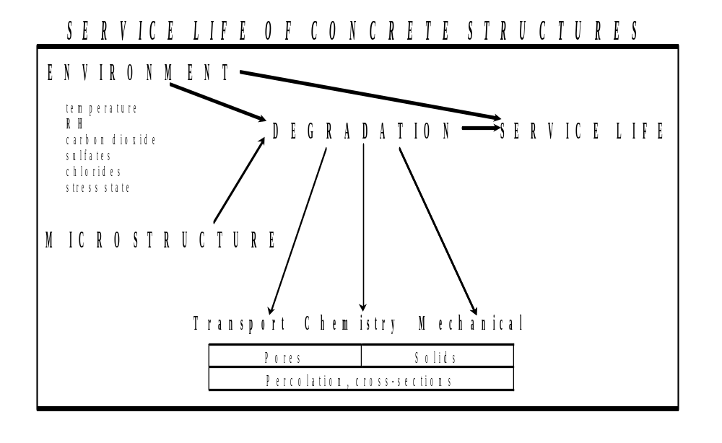
As outlined by Alexander and Ballim¹, durability studies require three main considerations: 1) complete and proper definition of the environment, 2) characterization of the material in the form of appropriate index values, and 3) test methods to ensure that the requisite index values have been met. The environment is important both in determining the loads (thermal, chemical, hygral, mechanical, etc.) placed on the structure and in defining the service limit state for the structure, as shown in the diagram in Figure 1. To proceed from durability to a prediction of service life, a degradation mechanism must be postulated and a quantitative degradation model that depends on measured material and environmental characteristics must be developed (Figure 1). The importance of the concrete microclimate^{4,12} can not be overemphasized; unfortunately, to date, very few quantitative results are available in this area. This paper presents a general methodology for developing service life models for concrete pavements by providing specific examples for the cases of sulfate attack and freeze/thaw degradation, both due to the sorption of deleterious materials.
Figure 1. Diagram illustrating relationships between material properties and the environment in determining degradation and service life of concrete structures.

EXPERIMENTAL

Materials

Cores of field concrete were obtained from the Rhode Island and Missouri Departments of Transportation during the summer 2000 construction season. The specimens received from the Rhode Island DOT were cores from small slabs (610 mm x 610 mm x 914 mm deep or 2 ft x 2 ft by 3 ft). The slabs were prepared by pumping the concrete into the molds. The slabs were then field cured and the cores were removed after 28 d. The cores were 368 mm (14.5 in) in length and 100 mm (4 in) in diameter. The specimens received from the Missouri DOT were cores from actual pavement slabs, not from separately cast specimens. These were taken from Route 65 in Benton County and from Route 13 in Henry County. The cores were either from the driving lane or the passing lane and were all from the northbound direction of the road. All specimens were received wrapped in plastic bags and were immediately stored in limewater upon reception by NIST until testing time. A 50 mm (2 in) slice was cut from each specimen for testing sorptivity. Precautions were taken to always use the top surface of the pavement. The compositions of the three concretes are given in Table 1.

Table 1: Compositions of the concretes
Materials | Rhode Island |  | Missouri Route 65 | Missouri Route 13
Cement [kg/m³] | 417 | 290 |  | 342
Water/Cement ratio | 0.39 | 0.36 |  | 0.35
Aggregates
Sand Type | Concrete | River sand |  | Class A sand
Amount [kg/m³] | 681 | 586 |  | 616
Coarse Aggregates | ¾ and pea stones | Limestone |  | Crushed Limestone
Amount [kg/m³] | 1054 | 1069 |  | 992
Admixtures type | Corrosion inhibitor | Air entrainer |  | None
Amounts [L/m³] | 15 | 73
Suppl. Cementitious Materials Type | None | Fly Ash |  | None
Amount [kg/m³] |  | 51

Sorptivity Testing

Water ingress into a non-saturated concrete structure is due to sorption, driven by the capillary forces⁶. If the water is on top of the concrete surface, gravity also will play a role in the water penetration. To measure the sorption coefficient of concrete, a new test proposed by NIST to ASTM for standardization was used. The method is similar to that recently published as a RILEM recommendation¹³. The principle of the method is that a concrete specimen has one surface in contact with water while the others are sealed. The proposed standard test allows either the top surface to be in contact (simulation of water on a pavement or bridge deck) or the bottom surface (substrate in contact with water). The first case is referred to as ponding sorption and the second as capillary sorption. As the most common case of water sorption in a pavement is ponding, all the tests for this paper were done using the ponding method.

The ponding sorption test consists of pre-conditioning the specimen by vacuum impregnation with water, followed by 3 d or 7 d in an environmental chamber with a controlled temperature and RH of 50 °C and 80 %, respectively. After this treatment, the specimen is placed in a closed container for 14 d and the RH is measured regularly. When the RH is constant, it signifies that the water in the specimen is evenly distributed throughout and that the specimen is in equilibrium with this measured RH. Several tests have indicated that the equilibrium RH is obtained in about 10 d. We selected 14 d to ensure that equilibrium was reached with all of the concretes. With this preconditioning regime, the specimen internal RH is typically about 60 %.

The concrete specimens were 50 mm (2 in) thick disks sliced from the received cores. The sides were covered with duct tape before the pre-conditioning. To measure the ponding sorption, some duct tape was used to form a pool as shown in Figure 2. A two-component epoxy caulk was used to seal the space between the tape and the concrete. Plastic wrap secured with a rubber band was used to seal the bottom surface.

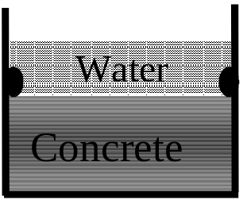

Figure 2: Schematic of ponding sorption test

The mass of the specimen was regularly measured after the water on the top was poured out and the top surface was patted dry. To determine the sorption coefficient, the mass gain divided by the surface area of the top surface is plotted versus the exposure time. The sorption coefficients are defined as shown in the following equation:

W/(ρA) = I √t + I₀

where all terms are defined in the Nomenclature section above and

I = early age sorption coefficient [m/s^{1/2}] if 1 min < t < 7 h
later age sorption coefficient [m/s^{1/2}] if t > 1 d
I₀ = initial sorption (m)
ρ = density of water (kg/m³)

Figure 3 shows these two slopes or sorption coefficients. Two slopes have been observed for the results obtained from a wide variety of concretes and mortars¹⁰. The later age sorption coefficient is usually attributed to other phenomena besides the capillary forces alone, such as filling of the larger pores and air voids.

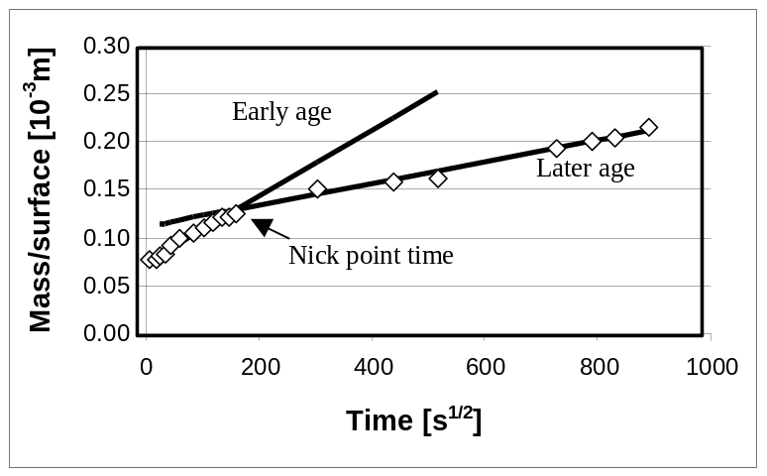

Figure 3: Calculation of the sorption coefficient

In the laboratory, sorptivity testing is generally performed at room temperature (25 ºC). In the modeling, these sorptivities are adjusted for the predicted concrete surface temperature based on the characteristics of water (surface tension, σ, and dynamic viscosity, η) as a function of temperature. Hall⁸ has indicated that sorptivity should generally scale as (σ/η)^{0.5}. Additionally, since the laboratory sorptivities are typically measured on concretes with an internal RH of about 60 %, the sorptivities are further adjusted for the RH of the environment prior to the wetting event, using linear interpolation and assuming a sorptivity of zero for fully saturated concrete (RH = 100 %).

Elastic Moduli Measurement

For the three field concretes, dynamic elastic moduli were measured based on the resonance frequency method as described in ASTM C 215². The mode used was longitudinal, i.e., the accelerometer was on the same axis as the driver. The values obtained, along with their measured standard deviations, are given in Table 2.

Table 2: Moduli of elasticity for the concretes
Rhode Island | Missouri Rt.65 |  | Missouri Rt. 13
Rhode Island | Driving lane | Passing Lane | Driving Lane | Passing lane
44 ± 1 GPa | 46 ± 0.3 GPa | 42 ± 0.2 GPa | 48 ± 0.3 GPa | 43 ± 0.2 GPa

COMPUTER MODELS

Surface Temperature and Time-of-Wetness Prediction

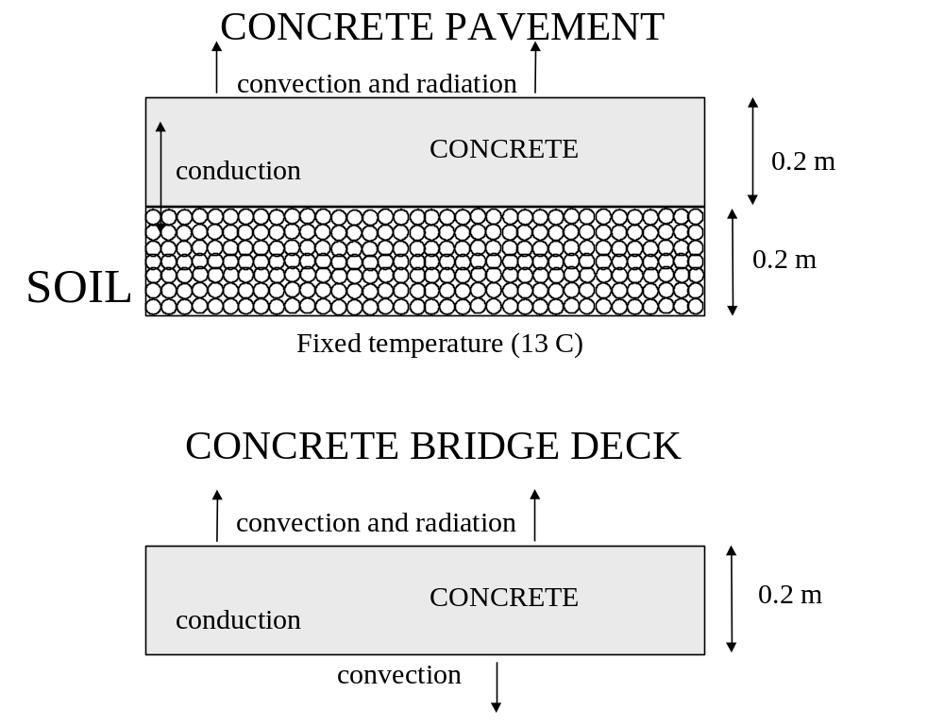
The basic one-dimensional model for heat transfer within a concrete pavement or bridge deck has been presented previously⁵. Figure 4 shows the basic concrete pavement and bridge deck configurations considered by the model, along with the relevant modes of heat transfer within the concrete and to/from its exposed surfaces. In the final version of the NIST CONCLIFE software, the user has the option of changing the dimensions or the fixed temperature at the bottom soil surface to better model a specific system of interest. The computer model considers heat transfer by conduction, convection, and radiation. For radiation to the sky, the sky temperature is estimated based on a series of equations first presented by Walton¹⁴. Default material properties for the concrete and soil layers¹¹ are provided in Table 3. In the final version of CONCLIFE, the user also has the option of altering these values if more specific information is available.

Figure 4. Basic configuration of one-dimensional heat transfer model for concrete pavements and bridge decks.

Table 3. Generic Material Properties for the Heat Transfer Model
Material | Heat Capacity  (J/(kg ºC)) | Thermal Conductivity  (W/(m ºC)) | Density  (kg/m³)
Concrete | 1000 | 1.5 | 2350
Soil | 800 | 0.3 | 1600

Environmental data for the heat transfer model is taken from the Typical Meteorological Year weather data files provided by the National Renewable Energy Laboratory⁹. These files provide typical weather data including ambient relative humidity, ambient temperature, cloud cover, dewpoint temperature, incident global horizontal solar radiation, precipitation events, and wind speed. Based on these environmental inputs and the concrete material properties, the computer model predicts the concrete surface temperature (see, Figure 5 for an example) and logs wetting and freezing events for the concrete surface. During the middle of a sunny day, the concrete surface temperature will rise above the ambient temperature due to the incoming solar radiation. Occasionally, on a clear night, the concrete surface temperature will fall below the ambient value, due to radiation emitted to the night sky. Wetting may be due to a precipitation event or condensation that occurs when the concrete surface temperature drops below the current dewpoint temperature. Each wetting event is characterized by a starting time, a concrete surface temperature, an external RH prior to wetting, and a duration. Each freezing event is characterized by a starting time, a minimum temperature achieved during freezing, and a duration. Figure 6 shows plots of the wetting events for concrete pavements in Kansas City, MO and Providence, RI. Clearly, the Rhode Island environment is wetter (total 776 h wet during the year, vs. 448 h for Kansas City). These wetting and freezing event files are then used in the concrete service life models to be described next.
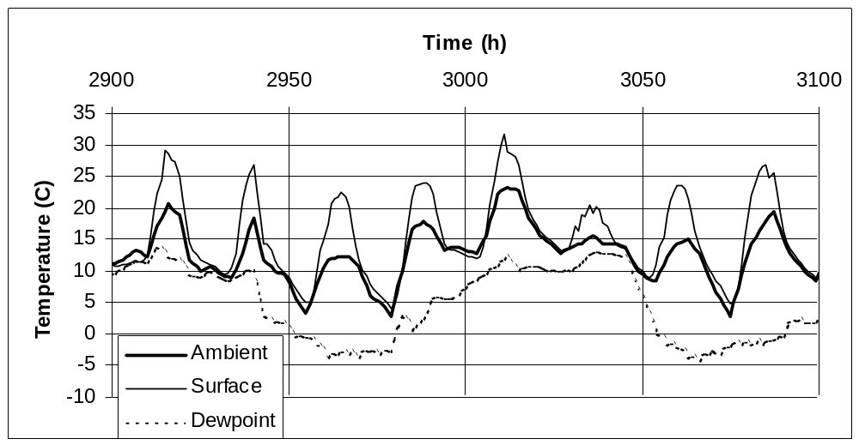Figure 5. Temperature predictions for a concrete pavement in Providence, Rhode Island in the spring. Time indicates cumulative hours from beginning of year.

Sulfate Attack

The service life model for sulfate attack is based on the model developed by Atkinson and Hearne³. While their development considered the main mode of sulfate ion transport into the concrete to be by diffusion, here we will develop a similar model for sulfate ions transported via sorption from the external environment. The basic equation developed by Atkinson and Hearne is³:

X_{spall} = (2αγ_{f} (1-ν))/(E(βC_{E})²)

where all terms are defined in the Nomenclature section above. The basic assumption of this model is that deleterious expansion and cracking is due to the formation of ettringite within the concrete. When the strain produced by the growing ettringite exceeds the fracture energy of the concrete, failure occurs, as a layer X_{spall} thick spalls from the concrete. For a sorptivity-based model, the buildup of ettringite is considered to be due to external sulfate ions penetrating into the concrete along with the sorbed external solution⁶. Thus, to use this model, the user must specify the concentration of sulfate ions in the external solution (e.g., rainwater or groundwater) and the sorption properties of the concrete. The basic screen within CONCLIFE for performing service life predictions in the case of sulfate attack is shown in Figure 7.
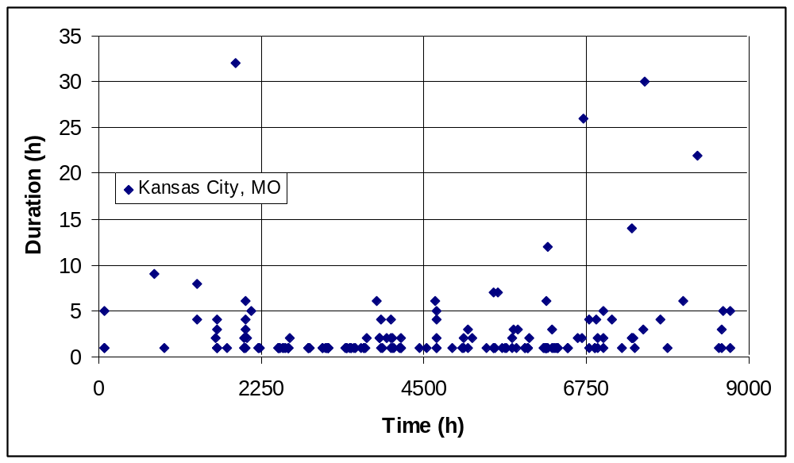
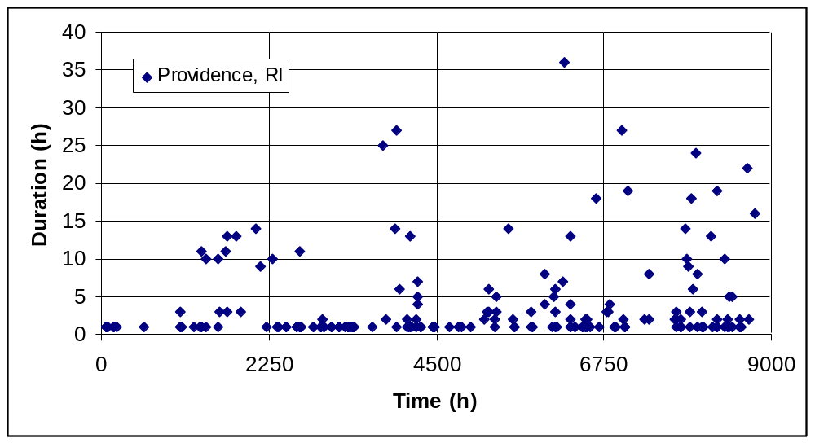Figure 6. Plots of wetting events in (top) Kansas City, MO and (bottom) Providence, RI, both for concrete pavements. Each diamond symbol indicates the duration of a wetting event occurring at a specific time during the year.

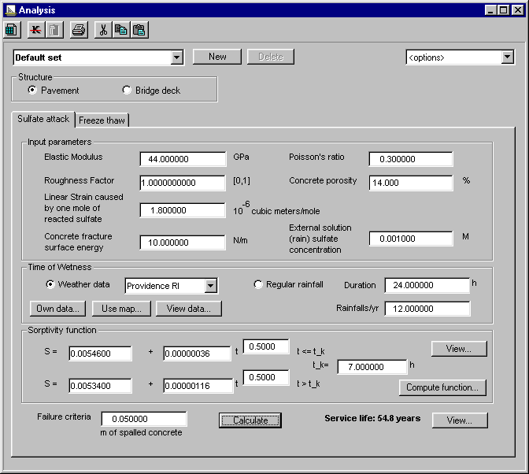

Figure 7. Basic screen for sulfate attack service life computation.

Freeze/Thaw Degradation

The service life model for freeze/thaw degradation is based on the critical air void saturation concept of Fagerlund⁷. The basic assumption is that the air voids in field concrete are slowly filled by liquid water during environmental exposure. This “filling” rate is assumed to be equivalent to the later age sorption coefficient discussed above. When a critical fraction of these air voids have become saturated (water-filled), the next freeze/thaw cycle will cause damage to the concrete. For the purposes of the model developed in this paper, failure is characterized by the time necessary to achieve the critical saturation. The subsequent cracking developed due to cyclic freezing and thawing is not considered. Critical parameters are the porosity and air void content of the concrete and its sorption characteristics. The basic screen within CONCLIFE for performing service life predictions in the case of freeze/thaw is shown in Figure 8.

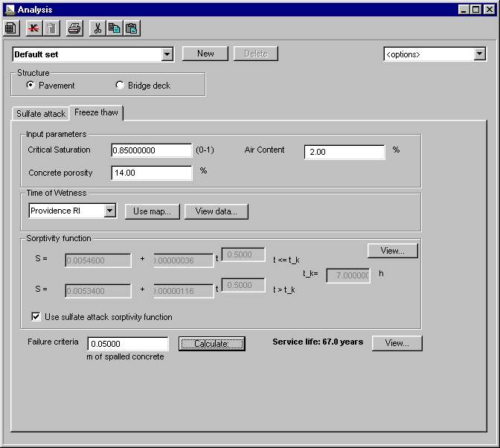

Figure 8. Basic screen for freeze/thaw service life computation.

RESULTS

Typical measured sorptivity values for the three concretes (following the 7 d of environmental chamber conditioning regime) are provided in Table 4. The concrete from Rhode Island is seen to exhibit a rapid initial sorption relative to the two concretes from Missouri (as evidenced by the values of I₀(early age)). After this initial absorption, the values of I(early age) for the three concretes are seen to be very similar (coefficient of variation between the samples of 13 %). The values of I(later age) exhibit a much higher variability between the three concretes (coefficient of variation of 60 %). The higher I₀(early age) value for the Rhode Island concrete would suggest that it would be more susceptible to sulfate attack by an external sulfate-containing solution. The higher I(later age) value obtained for the concrete from Rhode Island would suggest that it might be more susceptible to long-term sorption and deterioration due to freeze/thaw damage, once the air void system becomes critically saturated.

Table 4: Sorptivity properties for the concretes
Sorption Property | Rhode Island | Missouri Rte 65 Driving Lane | Missouri Rte 13 Driving Lane
I₀ (early age) (10⁻³ m) | 5.46 | 0.075 | 0.017
I (early age) (10⁻⁶ m/√s) | 0.36 | 0.42 | 0.47
Nick point time (h) | 7 | 7 | 6
I₀ (later age) (10⁻³ m) | 5.34 | 0.065 | 0.034
I (later age) (10⁻⁶ m/√s) | 1.16 | 0.51 | 0.39

The sorption properties presented above were utilized, along with the measured elastic moduli for the concretes and the appropriate weather files, to preliminarily predict the performance of the three concretes in their “home” environments under both degradation scenarios. For both degradation mechanisms, a failure criterion of 0.05 m of spalled concrete (a typical depth for reinforcement) was considered. Numerous additional assumptions had to be made to make these comparisons including the air content of the concretes (assumed to be a marginal air void system with only 2 % air), the sulfate concentration of the rainwater/condensation (0.001 mol/L), the concrete porosity (14 %, based on measurements on the Rhode Island cores), and the critical saturation of the air void system necessary to cause freeze/thaw damage (0.85). Using these values, the resultant service life predictions are provided in Table 5. The very low sorptivities of the Missouri concretes result in service life predictions that exceed 99 years (the maximum computed lifetime in the NIST CONCLIFE software). The higher I₀(early age) and I(later age) values for the Rhode Island concrete result in sulfate attack and freeze/thaw predicted service lives of about 55 years and 67 years, respectively.

The cumulative curve for spalling depth vs. time for the Rhode Island concrete for the case of freeze/thaw degradation is shown in Figure 9. While approximately 18 years are required for the first 5 mm of concrete to spall, successive spallings occur with a much higher frequency, as the air voids present in the successive layers have already been partially saturated during the exposure up to the previous spalling. While these analyses are quite preliminary in nature, they serve to illustrate the significant influence of concrete sorptivity on service life. Much effort remains to evaluate the reliability and accuracy of such predictions on field structures with known service lives.

Table 5: Predicted service lives for the concretes
Degradation mode | Rhode Island | Missouri Rte. 65 Driving Lane | Missouri Rte 13 Driving Lane
Sulfate attack | 54.8 years | > 99 years | > 99 years
Freeze/thaw | 67.0 years | > 99 years | > 99 years

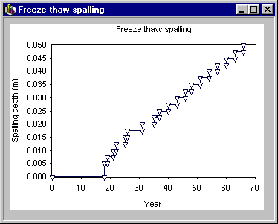
Figure 9. Spalling history (from CONCLIFE) for Rhode Island concrete for the case of freeze/thaw degradation.

CONCLUSIONS

Service life models for concrete pavement and bridge deck degradation due to the sorption of deleterious species have been developed for the cases of sulfate attack and freeze/thaw. Their development demonstrates the three-fold approach to the general problem of service life prediction: 1) characterization of the material’s appropriate mechanical and transport properties, 2) adequate characterization of the exposure environment, and 3) development of a quantitative relationship between transport properties and the degradation state of the material. In this paper, transport was characterized by a new test method for determining concrete sorptivity, the environment was characterized using a 1-D heat transfer model and typical meteorological year weather data files, and degradation was characterized by the successive spalling of layers from the exposed concrete surface. A few sample predictions were made to demonstrate the potential of the NIST CONCLIFE software, which should find application both to specific scenarios and to “what-if” type studies. Much work remains to validate these models for field use.

ACKNOWLEDGEMENTS

This study is being funded by the Federal Highway Administration. The assistance of the agreement officer’s technical representatives, Dr. Stephen Forster and Marcia Simon, is greatly appreciated. The assistance of John Winpigler (BFRL/NIST) in performing the sorptivity tests is gratefully acknowledged.

REFERENCES

- Alexander, M.A., and Ballim, Y., “Experiences with Durability Testing of Concrete: A Suggested Framework Incorporating Index Parameters and Results from Accelerated Durability Tests,” in Proceedings of the Third Canadian Symposium on Cement and Concrete, 248-263, 1993.
- ASTM C 215, “Standard Test Method for Fundamental Transverse, Longitudinal and Torsional Resonant Frequencies of Concrete Specimens”, ASTM C215 –97, Vol. 04.02, 1999.
- Atkinson, A., and Hearne, J.A., “Mechanistic Model for the Durability of Concrete Barriers Exposed to Sulphate-Bearing Groundwaters,” MRS Symposium Proceedings, Vol. 176, 149-156, 1990.
- Basheer, P.A.M., Chidiac, S.E., and Long, A.E., “Predictive Models for Deterioration of Concrete Structures,” Construction and Building Materials, Vol. 10 (1), 27-37, 1996.
- Bentz, D.P., “A Computer Model to Predict the Surface Temperature and Time-of-Wetness of Concrete Pavements and Bridge Decks,” NISTIR 6551, U.S. Department of Commerce, August 2000.
- Bentz, D.P., Clifton, J.R., Ferraris, C.F., and Garboczi, E.J., “Transport Properties and Durability of Concrete: Literature Review and Research Plan,” NISTIR 6395, U.S. Department of Commerce, September 1999.
- Fagerlund, G., “Modeling the Service Life of Concrete Exposed to Frost,” International Conference on Ion and Mass Transport in Cement-Based Materials, University of Toronto, October 1999.
- Hall, C., “Barrier Performance of Concrete: A Review of Fluid Transport Theory,” Materials and Structures, Vol. 27, 291-306, 1994.
- Marion, W., and Urban, K., “User’s Manual for TMY2s- Typical Meteorological Years,” National Renewable Energy Laboratory, June 1995.
- Martys N., and Ferraris C., “Capillary Transport in Mortars and Concrete,” Cement and Concrete Research, Vol. 27 (5), 747-760, 1997.
- McCullough, B.F., and Rasmussen, R.O., “Fast-Track Paving: Concrete Temperature Control and Traffic Opening Criteria for Bonded Concrete Overlays, Volume 1: Final Report,” FHWA-RD-98-167, Federal Highway Administration, 1999.
- Nilsson, L.O., “Interaction Between Microclimate and Concrete – A Prerequisite for Deterioration,” Construction and Building Materials, Vol. 10 (5), 301-308, 1996.
- “Recommendations of TC 116-PCD: Tests for Gas Permeability of Concrete C. Determination of the Capillary Absorption of Water of Hardened Concrete,” Materials and Structures, Vol. 32 (217), 178-179, 1999.
- Walton, G.N., “Thermal Analysis Research Program- Reference Manual,” NBSIR 83-2655, U.S. Department of Commerce, March 1983, Update 1985.

