- Name: Jacob Kupperman
- GitHub: https://github.com/jkfht/CS-449-Project
- Demonstration video: https://umsystem.hosted.panopto.com/Panopto/Pages/Viewer.aspx?id=603b3f96-022b-4d6c-8546-b4f1000cf64d
- Source Code Summary Table:
Source Code File Name | Production or Test? | # of lines of code
game_controller.py | Production | 72
game_gui.py | Production | 128
game_logic.py | Production | 156
gui_test_suite.py | Test | 80
logic_test_suite.py | Test | 202
Total |  | 638

- User Stories/Acceptance Criteria Testing
User Story ID & Name | AC ID | Class Name | Method Name | Status
1. Choose a board size | 1.1 | GameLogic | change_size | Done
1. Choose a board size | 1.2 | GameGUI | update_size | Done
1. Choose a board size | 1.3 | GameLogic | change_size | Done
1. Choose a board size | 1.4 | GameLogic | validate_board_parameters | Done
2. Choose a board type | 2.1 | GameLogic | change_board_type | Done
2. Choose a board type | 2.2 | GameGUI | update_board_type | Done
2. Choose a board type | 2.3 | GameLogic | change_board_type | Done
3. Start a new game of the chosen size and type | 3.1 | GameLogic | new_game | Done
4. Make a move in a game | 4.1 | GameLogic | make_move | Done
4. Make a move in a game | 4.2 | GameLogic | make_move, get_valid_moves | Done
4. Make a move in a game | 4.3 | GameLogic | make_move, get_valid_moves | Done
4. Make a move in a game | 4.4 | GameGUI | update_board | Done
5. Game is over | 5.1 | GameLogic | game_over | Done

Manual Testing: N/A

- Testing Tables:
User Story ID & Name | AC ID | Class Name of Test Code | Method Name of Test Code | Pass  /  Fail
1. Choose a board size | 1.1 | TestLogicBoardSize | test_1_1_board_size_regenerates | Pass
1. Choose a board size | 1.2 | TestGUIBoardSize | test_1_2_display_size_options | Pass
1. Choose a board size | 1.3 | TestLogicBoardSize | test_1_3_new_board_size_is_correct | Pass
1. Choose a board size | 1.4 | TestLogicBoardSize | test_1_4_invalid_board_size_rejected | Pass
2. Choose a board type | 2.1 | TestLogicBoardType | test_2_1_board_type_regenerates | Pass
2. Choose a board type | 2.2 | TestGUIBoardTypes | test_2_2_valid_move_updates_board_state | Pass
2. Choose a board type | 2.3 | TestLogicBoardType | test_2_3_new_board_type_is_correct | Pass
3. Start a new game of the chosen size and type | 3.1 | TestLogicFilledSpaces | test_3_1_board_filled_spaces_are_correct | Pass
4. Make a move in a game | 4.1 | TestLogicMoves | test_4_1_valid_moves_and_removes_jumped | Pass
4. Make a move in a game | 4.2 | TestLogicMoves | test_4_2_invalid_move_leaves_board_unchanged | Pass
4. Make a move in a game | 4.3 | TestLogicMoves | test_4_3_move_must_follow_board_type_rules | Pass
4. Make a move in a game | 4.4 | TestGUIMove | test_4_4_valid_move_updates_board_state | Pass
5. Game is over | 5.1 | TestLogicGameOver | test_5_1_game_over_detected | Pass

Manual Testing: N/A

- LLM Evidence:
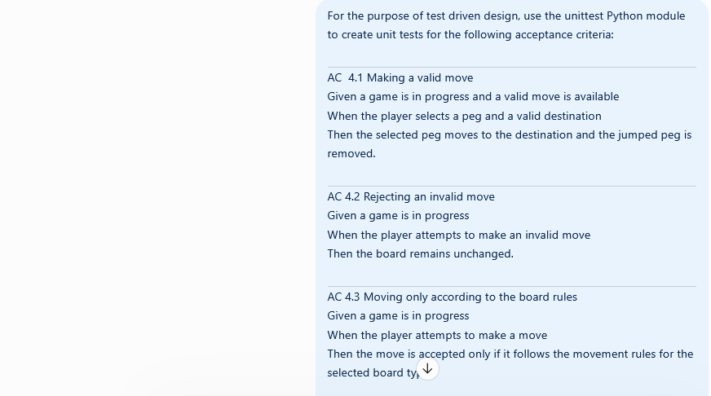
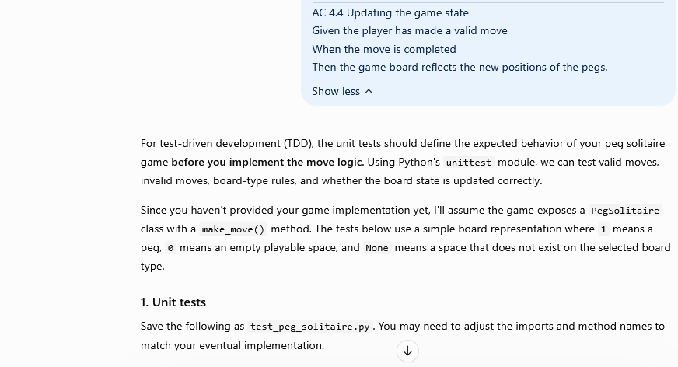
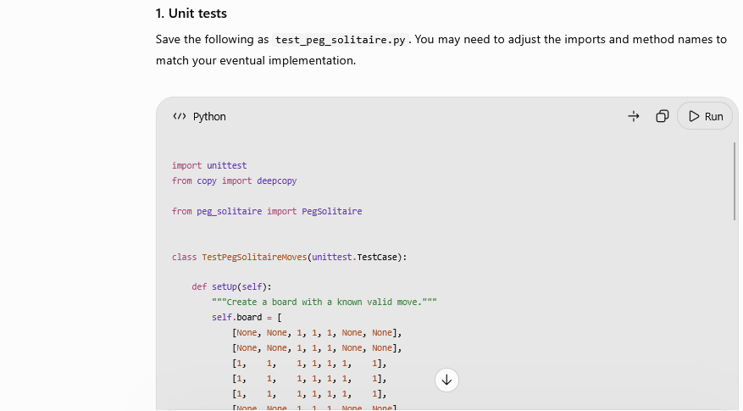
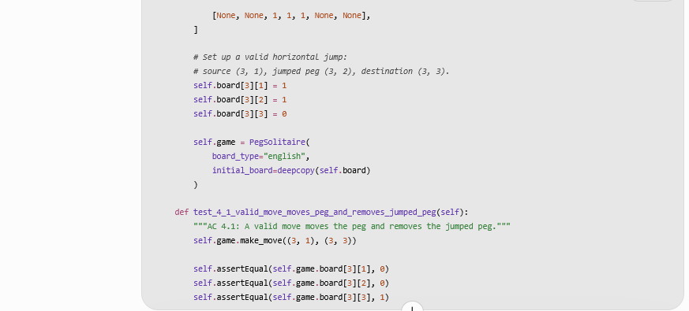
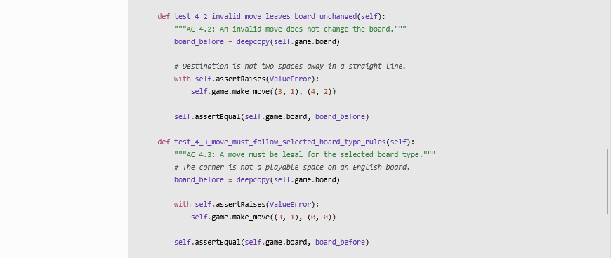
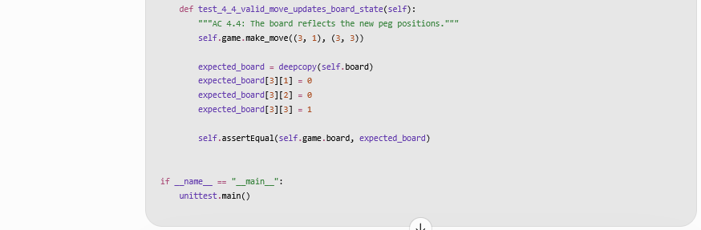
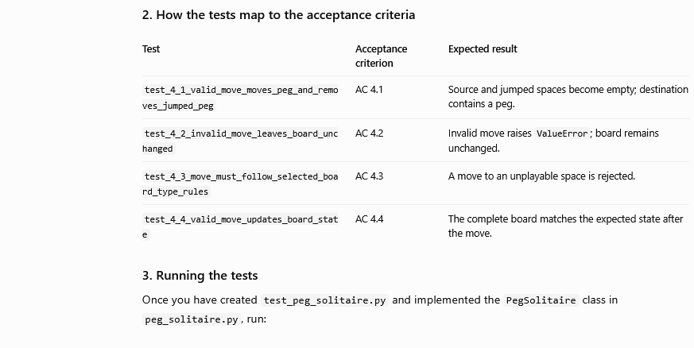
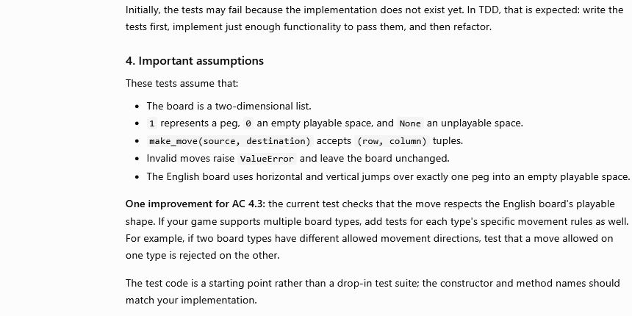

The LLM generated a generally acceptable structure for the tests, but significant adjustments had to be made to the tests to account for the specifics of implementation (logic/GUI/controller separation, dictionary representation of the board, etx). The LLM failed to understand the intention for AC 4.4 to be referring to the GUI’s board state and effectively duplicated the test for AC 4.1, which tested the game logic.

