Computer programming

Final Project

Report

I.E.S. San Vicente
San Vicente del Raspeig (Alicante)
2017/2018

Teachers:
José Ignacio Cabanes / Ignacio Iborra

Student:
Moiséx Encinas Picazo

1. Introduction
Project name
Bar POS

Made by
Moisés Encinas Picazo

Short description of the project
This is a tipical POS but only for using at bars and in restaurants, it will have 2 main screens, one with the tables and the other would be the classical POS interface.
I’ll do it with windows forms.

2. Functionality of the project
First of all a log in would be required to start using the program.
Then when you log in what you will see the tables screen.
When you click on a table the POS screen will appear.
The POS Screen will have the following stuffs:
- All the food and drink that can be bought
- A part which will show the list of items the table ordered
- Another part for the items to get paid
- Down the before part another telling the total to pay
- In the top you will see the actual worker, the actual register box and the table number

It will have the following functionalities:
- Save the items a table is buying and pay them separated
- Register the products the bar is selling, modify them, control their stock
- Save all the money won and all the things sold

3. Screen prototype
The POS screen will look like this:

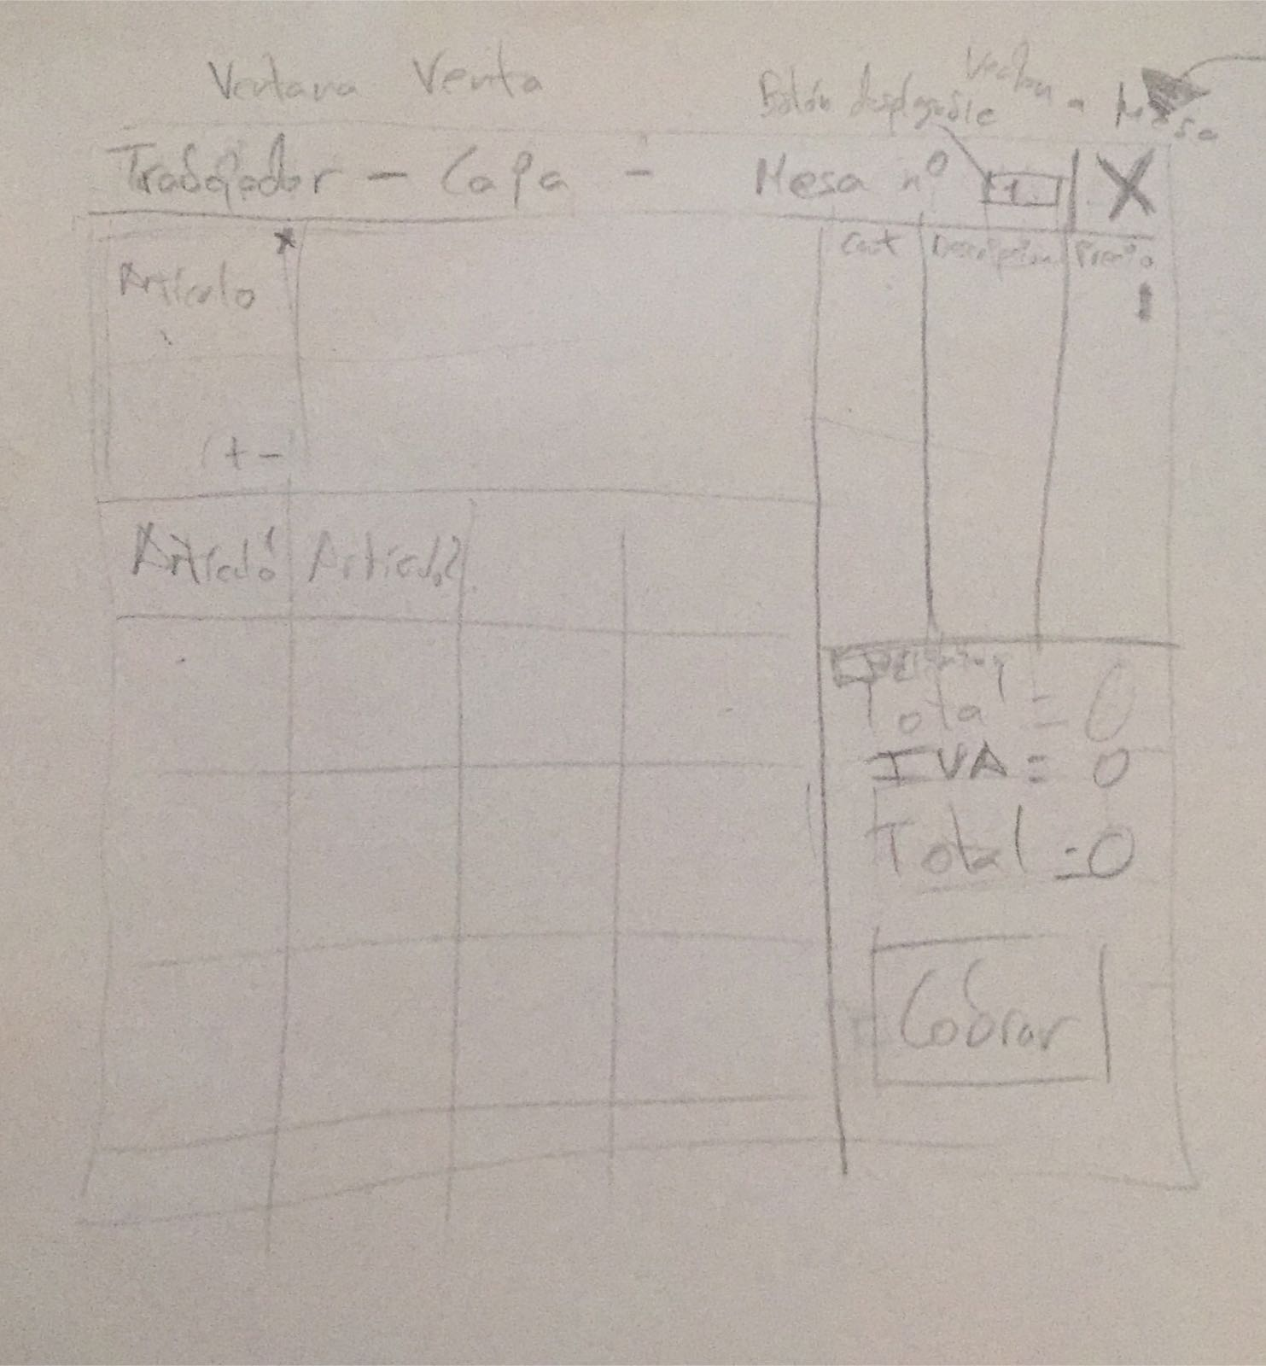

4.Analysis

4a. Requisites
Requisite | Date achieved
The program will allow the user to add products to a table and pay the products separately
The program will allow the user to click on a table and see the products that table order
The program will allow the boss to add users, delete them; introduce items, delete them, modify them.
The program will allow the boss to see the recorded bills and the money won
The program will allow the user to close it’s session and take the counts of the time he was in the register box

4c. Classes diagram

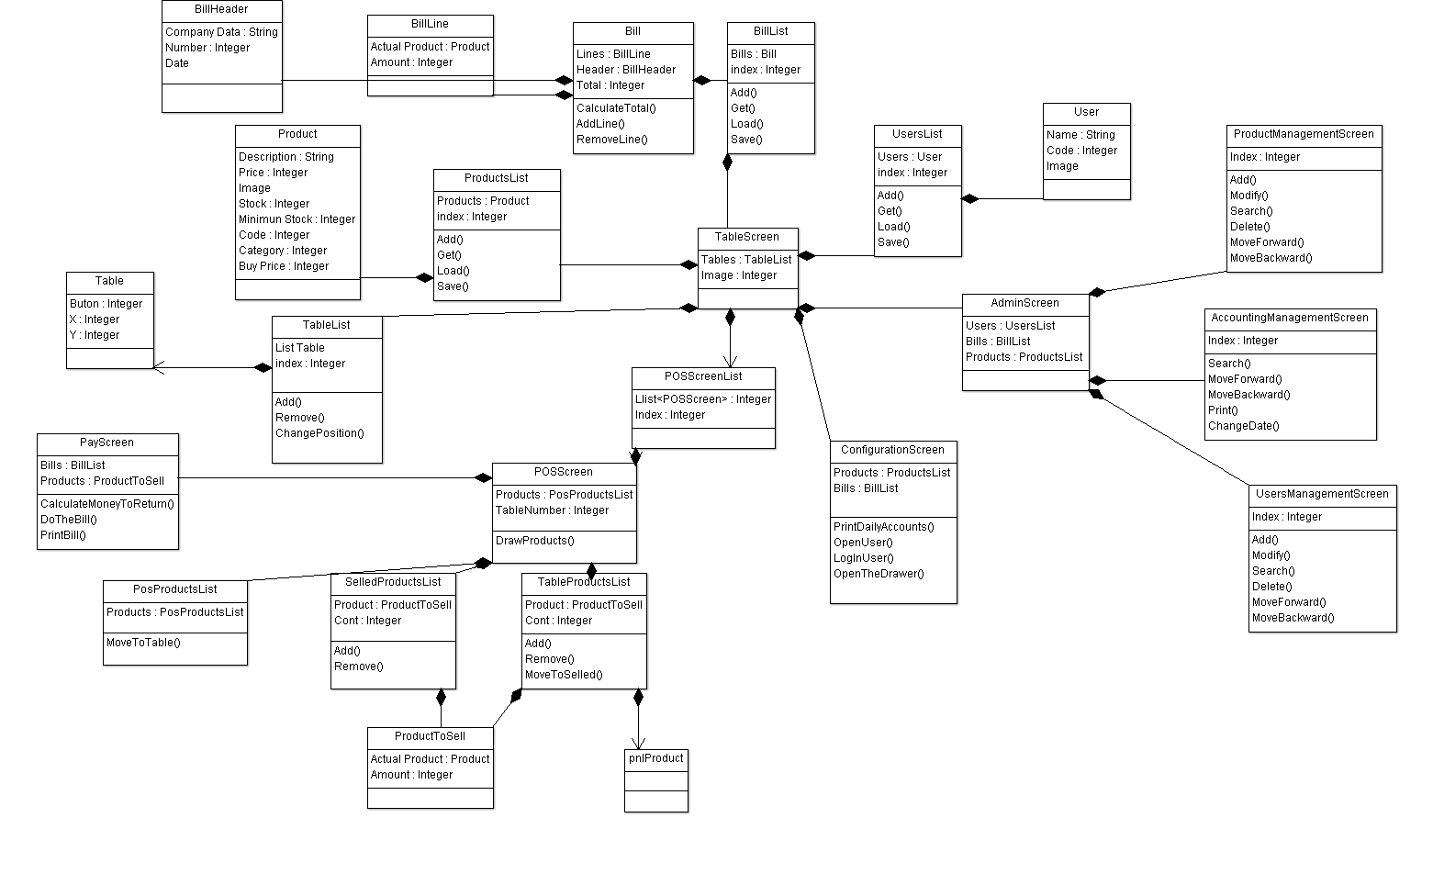

5. Initial planning and expected deliveries

5a. Expected deliveries
- Version 1: For the classes which controls the products, the bills, the users, the main screens, the POS screen added the basic skeleton
- Version 2:
Finishing configuration skeleton and admin skeleton which will contains the management of the product, accounting and users.
Open the POS and configuration screen from each button in the table screen and come back.
- Version 3: Show in the POS screen the actual table and change the table from the POS screen.
In the admin screen open the different management screens and come back.
In the POS screen click on the pay button and open the Pay screen and come back.
- Version 4: Do a help windows which will show a picture of the POS with instructions of how to use it and about windows, which will show the developer his email and the copyright
- Version 5: Load and save methods in order to share the products, users and the account between the client and server, also implemented the method to construct the bill(in order to print it), and the method to add products in the product managment
- Version 6: Product and accounting management (search, moveforward, moveBackward) implementation
- Version 7: accounting(Change date, print) and users management implementation
- Version 8: Log in, user change and close session, make the POS unacessible until the log in, show the actual user in the POS screen
- Version 9: Show product categories in the POS screen and inside them the products, move the products to the table products.
- Version 10: Show products in the table products, add and delete them
(the table products are the products which a table order but the products which are going to be paid are in the pay products, this is implemented for being able to pay separately)
- Version 11: Move the products from the table products to the pay products and show the total, and also be able to add or remove products from this list to the table products and show the pay products
- Version 12: In the pay screen, put the actual money, return the change, do the bill for the bills list, print the bill
I will print the bill with a method using the PrintDocument class
- Version 13: In the configuration screen print the daily accounts, this is used to see if the money in the box match with the money registered, (made for employees)
- Version 14: Change the table screen image, add buttons, remove buttons, move them
- Version 15: Send data to the server for saving the data

5b. Real deliveries
- Version 1 (May 14): As expected: Basic skeleton in almost all classes, also done the configuration skeleton
- Version 2 (May 15): As expected and also added some minor changes and some load, save methods completed, and some classes finished, also done the open and close for the payScreen
- Version 3 (May 16): As expected, also added some minor changes in some clases and now we start in the configuration screen and need to log in (just a simple click nothing seriously)
- Version 4 (May 17): Added the help button so that a help menu appears
on the screen with its different options that will be made later.
Created the help image and created the button to close the help window.
- Version 5 (May 18): As expected, also addeds methods to move forward backward in the productManagementScreen and the remove method
- Version 6 (May 21):
- Version 7 (May 22):
- Version 8 (May 23):
- Version 9 (May 24):
- Version 10 (May 25):
- Version 11 (May 28):
- Version 12 (May 29):
- Version 13 (May 30):
- Version 14 (May 31):
- Version 15 (May 1):

6. File formats

6a. Plain files format
The scores table is saved to a text file, which contains the name of a player in one line, and the corresponding score in the following line, and so on, to complete the 10 highest scores, as in this example:

John
125
Peter
116
…

7. Problems found and solutions
I preferred not to use the SDL library directly, which I found difficult to learn, so I have used the classes "Hardware", "GraphicsElement" and "Font" that we had used previously in class games (...)

Although in the level 3 (hard) I check the next three movements, sometimes the computer makes foolish moves, but always in the first column. I have not found where the bug is, but I think the problem may lie in this portion of code, in which I check each column versus the previous one: (...)

I noticed that if I take the game to another computer which has not the DotNet Framework installed in it, the program closes without any error or warning message (...)

(…)

8. Improvements or restrictions to the starting design
I have had time enough to include the effect of animation when the pieces fall (…)

I have not been able to implement (…) because of (…)

9. Screenshots of the final project
(…)

10. Source code of the final project
(…)

