1. **What do you expect for the single-ended S-parameters with NO gap?**
2. **What are the S-parameter features you will look for that describe the behavior of the interconnect? Which S-parameters will be most sensitive?**

**Note:** Answers for Q1 and Q2 are combined.

The model for no gap is as shown below:

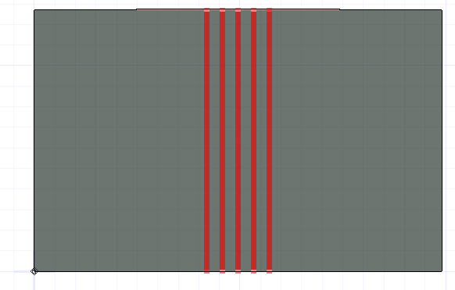

Its found through inspection that the upper ports are numbered as 1,3,5,7,9 and lower ports are 2,4,6,8,10 by observing their Return loss and Insertion loss graphs. This is a loosely coupled pair by default.

|  |  |
| --- | --- |
| **Parameter** | **Comments** |
| Return loss | The Characteristic Impedance of the Microstrip is 50 ohm as per IPC formulae (w=10 mil, h=6 mil, FR4, t=0.7 mil) and if Port Impedances at Tx and Rx are 50 ohm, then maximum amplitude of RETURN LOSS is expected to be a minimum (in order of -30 dB or -35 dB) as the network is almost matched. The first parallel resonant frequency dip happens at f = c/(sqrt(Dk)*2*len). In HFSS, the trace length is 12.7 mm or 0.5 in. So f= 6 GHz. From the snap below, RETURN LOSS max amplitude is around -30 dB showing the network is matched. The simulated value is 6.12 GHz as shown. As this is a lossy medium, RETURN LOSS keeps on increasing with frequency due to attenuation on INSERTION LOSS. All these are verified from the HFSS results shown below. The below snapshots support the arguments. Similar observations are made on S33, S55 and so on. As per below snap, Port Impedance on Port 1,3,5 are 50 ohm verifying that the network is matched. |
|  | |
| Insertion Loss | Insertion Loss signifies the signal content reaching Rx from Tx. Also, INSERTION LOSS starts with 0 dB at lower freq and should be ripple free until RETURN LOSS reaches -12 dB and above. At freq of 1 GHz, for a Df of 0.02, Dk of 4.4, len of 0.5 in, w of 14 mil, INSERTION LOSS = -(sqrt(f)/w+2.3*freq*sqrt(Dk)*Df*len). INSERTION LOSS = -0.07 dB. Figure of merit being 0.13 db/in/GHz. INSERTION LOSS should monotonically decrease with freq for a lossy attenuated channel. The simulated value is -0.08 dB. The simulated value of INSERTION LOSS @ 1GHz is -0.06 dB. Since the network with port termination is symmetrical, S12 = INSERTION LOSS. All these are verified from the HFSS results shown below. The simulated value of INSERTION LOSS @1 GHz is -0.08 dB. As RETURN LOSS never reaches above -13 dB, INSERTION LOSS will be ripple free in the assigned frequency range. The below snapshots support all the above explained points. |
|  | |
| NEXT | S31 is a measure of NEXT in a Transmission line. NEXT is maximum in a tightly coupled line and minimum in a loosely coupled line. NEXT is a function of spacing and Dielectric thickness only and independent of frequency/ rise time and length (above saturation length). Since the considered pair is loosely coupled, NEXT is expected to be quite low in amplitude. Here, Port 1 and Port 3 are active and victim ports respectively. If Dielectric thickness is kept constant, then as spacing between active and victim lines. So, amplitude of S51 is lesser than amplitude of S31, amplitude of S71 is lesser than amplitude of S51 and so on. The below snapshots support all the above explained points. As expected, since matched Microstrip set is loosely coupled, NEXT should be quite lesser than RETURN LOSS which is accurate from the snapshot below. |
|  | |
| FEXT | S41 is a measure of FEXT in a set of Transmission lines. S41 is a function of rise time / frreq and transmission line length. As freq increases, INSERTION LOSS decreases. Hence, the energy lost in INSERTION LOSS is found as an increase in S41 with increase in freq. In other words, as Rise time decreases, freq increases. Hence FEXT or S41 increases in amplitude. The same is observed in the snaps below. The same argument applies to all other interconnects. |
|  | |

The most sensitive S parameters considering Port 1 as port of interest are RETURN LOSS, INSERTION LOSS, S31, S41. The same trend applies to all other ports.

1. **What do you think will be the impact from the gap?**

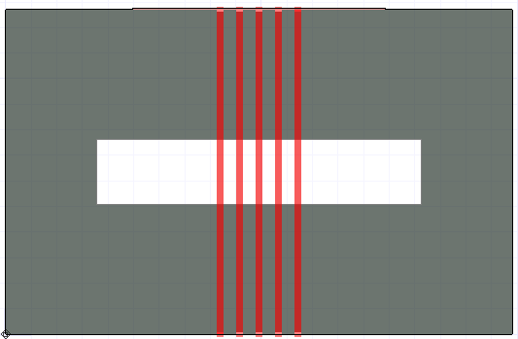

**The 3 main consequences of gap in Return path are:**

1. **Impedance mismatch** as the apparent dielectric thickness changes leading to Reflections
2. **Crosstalk** increasesas thefields from the trace should travel more distance to reach the return path and hence spreads spatially leading to inducing noise on adjacent lines
3. **Ground bounce** increasesas fields should travel a longer path to reach the return thereby increasing the total inductance along the return path affecting adjacent lines
4. **How do you expect each impact to scale with the gap length along the trace length and the gap width, across their length?**
5. **Compare each relevant S-parameter with and without the gap to confirm your expectation.**

|  |  |
| --- | --- |
| **Parameter varied** | **Comments** |
| Discontinuity height (Gap height) | Gap height is one of the variables contributing to Impedance mismatch. Whenever there is a gap in Return path, the return signal should travel along the conductive edge of the return plane for the signal to flow in the signal layer. Hence, the total inductance in the return path increases, leading to ground bounce. Also, as the fringe field should travel a longer distance to return, interference with adjacent traces leads to Crosstalk. With increase in Gap height along the length of trace, the Impedance mismatch increases. So, the amplitude of RETURN LOSS increases when compared to that of a line with no gap. Also, the first destructive interference (parallel resonance) dip in RETURN LOSS increases since the discontinuity length is lesser in a return path with gap than a return path with no gap. Also, there is a high chance that RETURN LOSS crosses -10 dB with a return path gap which leads to formation of ripples in INSERTION LOSS. As seen from the RETURN LOSS plot below, first parallel resonant freq for a no gap is at 6.59 GHz, which corresponds to a discontinuity of l = c/(sqrt(Dk)*2*f)= 0.5 in; which matches well with the Microstrip length in the model. When a gap with a width of 500 mil and height (discontinuity length) of 50 mil is introduced, RETURN LOSS amplitude increases indicating huge Impedance mismatch and decrease in discontinuity length where first frequency dip occurs at f= c/(sqrt(Dk)*2*l) = 45 GHz as shown. As per the Insertion loss plot, for a no gap condition, Insertion loss is linearly decreasing. As the Return loss increases above -12 dB, ripples are found. For a no gap plot, Insertion loss= -(sqrt(f)/w+2.3*freq*sqrt(Dk)*Df*len). INSERTION LOSS = -0.07 dB. Since, the field lines should expand now to reach the return path, fringe field interference occurs which increases NEXT. As seen from the NEXT plot in second row, NEXT increased for a Microstrip with return path discontinuity than that with no gap. As distance between active and victim lines increase, NEXT reduces in amplitude which is expected and seen in the second-row images. FEXT is a function of rise time, freq and length. Any return path gap leads to mutual inductance which increases FEXT. As distance between active and victim lines increase, FEXT effect decreases. The same is observed in third row images. |
|  | |
| Discontinuity width (Gapwidth) | Gap width is one of the variables contributing to Impedance mismatch. Whenever there is a gap in Return path, the return signal should travel along the conductive edge of the return plane for the signal to flow in the signal layer. Hence, the total inductance in the return path increases, leading to ground bounce. Also, as the fringe field should travel a longer distance to return, interference with adjacent traces leads to Crosstalk. With increase in Gap width along the length of trace, the Impedance mismatch increases as traces need to travel a longer distance in the Return path. So, the amplitude of RETURN LOSS increases when compared to that of a line with no gap. Also, the first destructive interference (parallel resonance) dip in RETURN LOSS increases since the discontinuity length is lesser in a return path with gap than a return path with no gap. Also, there is a high chance that RETURN LOSS crosses -10 dB with a return path gap which leads to formation of ripples in INSERTION LOSS. As seen from the RETURN LOSS plot below, first parallel resonant freq for a no gap is at 6.59 GHz, which corresponds to a discontinuity of l = c/(sqrt(Dk)*2*f)= 0.5 in; which matches well with the Microstrip length in the model. When a gap with a width of 250 mil and height (discontinuity length) of 100 mil is introduced, RETURN LOSS amplitude increases indicating huge Impedance mismatch and decrease in discontinuity length where first frequency dip occurs at f= c/(sqrt(Dk)*2*l) = 45 GHz as shown. As per the Insertion loss plot, for a no gap condition, Insertion loss is linearly decreasing. As the Return loss increases above -12 dB, ripples are found. For a no gap plot, Insertion loss= -(sqrt(f)/w+2.3*freq*sqrt(Dk)*Df*len). INSERTION LOSS = -0.07 dB. Since, the field lines should expand now to reach the return path, fringe field interference occurs which increases NEXT. Also, the signals on Microstrip with no return path at their bottom, should travel additional distance along the length of the path. As seen from the NEXT plot in second row, NEXT increased for a Microstrip with return path discontinuity than that with no gap. As distance between active and victim lines increase, NEXT reduces in amplitude which is expected and seen in the second-row images. FEXT is a function of rise time, freq and length. Any return path gap leads to mutual inductance which increases FEXT. As distance between active and victim lines increase, FEXT effect decreases. The same is observed in third row images. |
|  | |

**Conclusions:**

1. If confused about port allocation, refer the S parameter plots of different ports to get an idea. A linear drop starting from 0dB corresponds to Insertion Loss and a periodic log plot corresponds to Return loss.
2. As distance from active line increases, NEXT on victim decreases
3. Return path discontinuity leads to Impedance Mismatch, Crosstalk and Ground bounce
4. If the discontinuity is small, then there not much impact on Impedance of the Transmission line.
5. Never route any signal preferably high speed signal on Return path gap as it affects the performance of the signal.