**Goal:** The goal of this lab is to get a hands-on experience to inspect and verify the factors that affect the Near End Crosstalk and far End Crosstalk in a Microstrip and Stripline and tabulate their respective advantages and disadvantages. Tool used is Hyperlynx.

**Plan:** The plan is to theoretically anticipate the features of both the Transmission Lines and verify the same through simulation. The same needs to be verified in Hyperlynx.

1. **Select the TDR driver. Build two edges coupled 50 Ohm stripline, 10 inches long. Build two edge coupled 50 Ohm Microstrip, 10 inches long.**

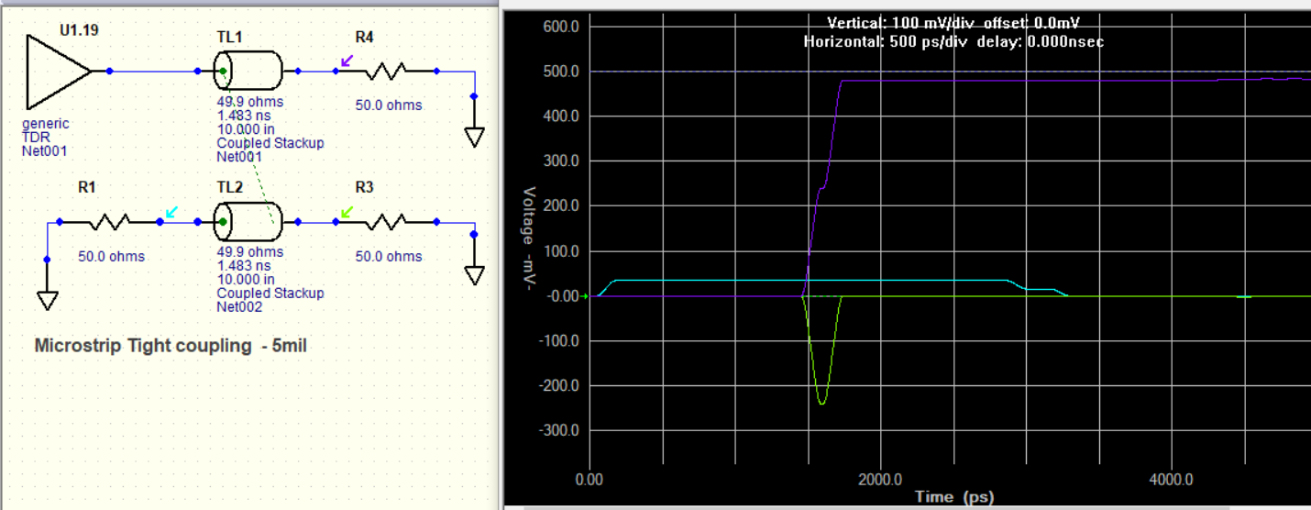 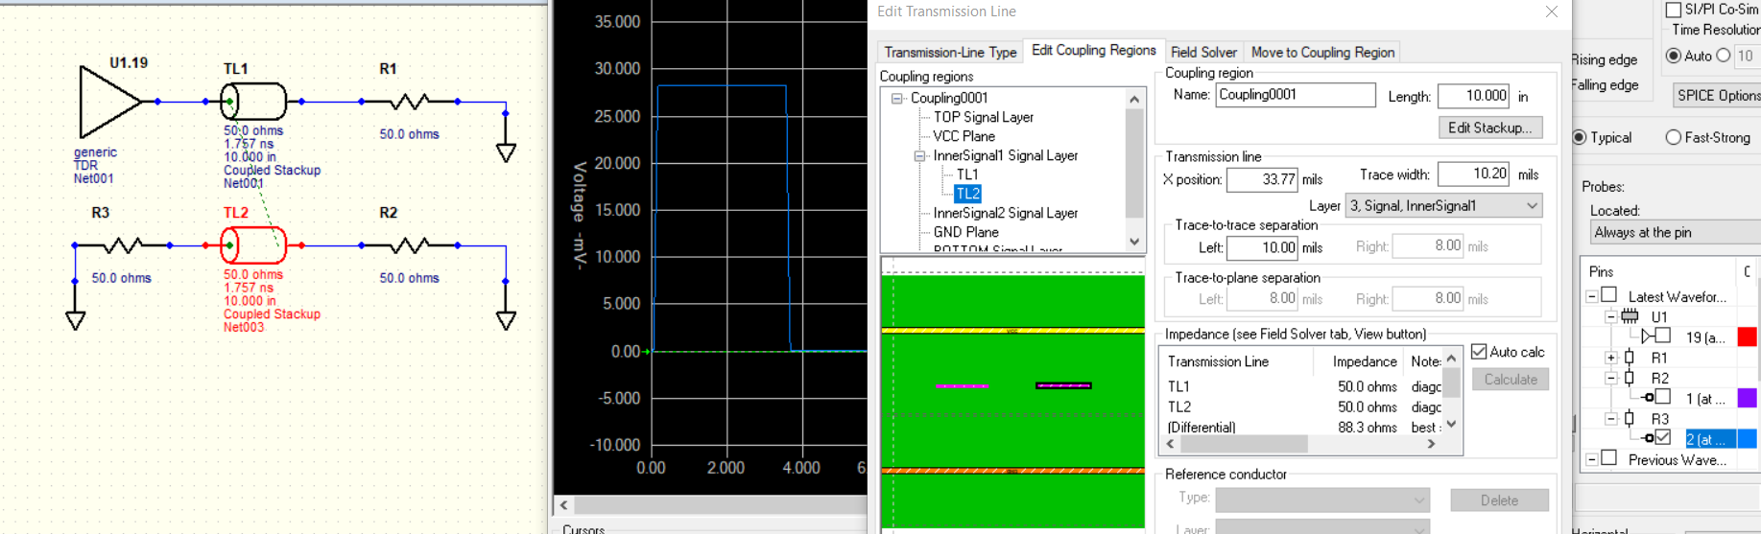

1. **Explore the near and far end cross talk and how the length and cross section affects the amount of near and far end cross talk.**

**For Microstrip:**

|  |  |  |
| --- | --- | --- |
| **Parameter varied** | **Affected? (Yes/No)** | **Comments** |
| Length | Yes, both NEXT and FEXT | In general, the duration of Near End Cross Talk **(NEXT)** at victim line is equal to the round-trip time. This can be verified in the figure above where the Microstrip delay is **1.5 ns** and NEXT duration is **3ns** est... The duration of Far End Cross Talk **(FEXT)** is equal to the rise time of active line signal. This can be verified in the figure above where the rise time of active line signal is **60ps** equal to FEXT duration. For uncoupled microstrip, the empirical relation could be developed considering the coupling length and Rise time of the Drive signal is **FEXT (mV) = Len(in)/Rise time (ns) +/- 5%.** This goes well with the theory as FEXT increases with coupling length and decreases with Rise time. The NEXT and FEXT voltages are found to be minimum in uncoupling condition and are maximum in tight coupling. This is because as the separation between Active and victim lines is increased, the fringe field interference between those lines decreases. The empirical relation developed goes well with other random variations in separation **keeping voltage driver Z0 and length constant.** **As per the first-row figures below, for uncoupled pair for length of 10 in, Rise time of 60 ps for TDR driver of Unloaded Voltage 1V, FEXT = Len / Rise time = 10 in/0.06 ns = 166 mV. The simulation value is 174mV which goes well with empirical formula. FEXT co-efficient FU=FEXT/VSignal = 0.174V/1V=17.4%.** NEXT is found to be 10 mV. **NEXT co-efficient NU=NEXT/VSignal = 0.01V/1V=1%.** For loose Coupling, the empirical relation could be developed considering the coupling length and Rise time of the Drive signal is **FEXT (mV) = 1.5*Len(in)/Rise time (ns) +/- 10%. As per the second-row figures below, for loose coupling for length of 10 in, FEXT = 1.5*Len / Rise time = 1.5*10 in/0.06 ns = 250 mV. The simulation value is 222mV which goes well with empirical formula. FEXT co-efficient FL=FEXT/VSignal = 0.222V/1V=22.4%.** NEXT is found to be 16.87 mV. **NEXT co-efficient NL=NEXT/VSignal = 0.016V/1V=1.7%.** For tight Coupling, the empirical relation could be developed considering the coupling length and Rise time of the Drive signal is **FEXT (mV) = 1.5*Len(in)/Rise time (ns) +/- 10%. As per the third-row figures below, for tight coupling for length of 10 in, FEXT = 1.5*Len / Rise time = 1.5*10 in/0.06 ns = 250 mV. The simulation value is 240mV which goes well with empirical formula. FEXT co-efficient FT=FEXT/VSignal = 0.24V/1V=24%.** NEXT is found to be 34 mV. **NEXT co-efficient NT=NEXT/VSignal = 0.034V/1V=3.4%.** The obtained value goes well with the graph of NEXT vs (spacing/width) graph where **difference in NEXT between loosely and tightly coupled Microstrip is 50% as we got 16.87 mV and 34 mV respectively.** Also, the NEXT in an uncoupled situation is less **than 1/3rd (1%)** than that of a tightly coupled case **(3.4%)** that goes well with the graph. |
| C:\Users\nagar\AppData\Local\Microsoft\Windows\INetCache\Content.Word\mlinuncouplingnext.jpg      The obtained Empirical formula is verified as follows for Dielectric Thickness of 5 mil. It is to be noted that the empirical formula drawn **deviates a lot for higher lengths like 12 in and above.**  **Tight Coupling Loose Coupling**   |  |  |  |  |  |  |  | | --- | --- | --- | --- | --- | --- | --- | | **Len (in)** | **Simulated FEXT (mV)** | **FEXT=2*len(in)/RT(ns)** |  | **Len (in)** | **Simulated FEXT (mV)** | **FEXT=2*len(in)/RT(ns)** | | **5** | **176.8** | **166.6666667** |  | **10** | **221.9** | **250** | | **6** | **202** | **200** |  | **11** | **231.5** | **275** | | **7** | **221** | **233.3333333** |  | **12** | **237.9** | **300** | | **8** | **234** | **266.6666667** |  | **13** | **241.1** | **325** | | **9** | **240** | **300** |  | **14** | **241.5** | **350** |   However, there is an additional constraint on length of Microstrip couple that controls the saturation amplitude and duration of NEXT; its **called Saturation Length Lsat nearly = RT*v*0.5. For** material with Dk=4, Lsat is nearly=RT*3. So, for TDR , Lsat = 0.06ns * 3 in/ns is nearly 0.18 in. This goes well with the simulation below considering tight coupling. Until a coupling length of 0.4 in, the NEXT amplitude and duration linearly increases; thereafter amplitude saturates and duration increases. **This holds good for loose coupling and uncoupled pairs too.** | | |
| Trace Spacing | Yes, both NEXT and FEXT | In theory, as the separation between the active and victim lines increases, the inductive and capacitive coupling reduce between them as the fringe field interference decreases. Hence the NEXT and FEXT also reduce when all other factors except separation are constant. As per simulation below, NEXT from Uncoupling to tighly coupled conditions increases from 5 mV to 34 mV. NEXT from Uncoupling to tightly coupled conditions increases from 5 mV to 34 mV. |
|  | | |

|  |  |  |
| --- | --- | --- |
| Dielectric Constant | Yes, FEXT | In theory, as the Dielectric constant is decreased, Capacitance per unit length decreases. Hence, the net capacitive coupling between Active and victim lines decreases with no change in Inductive coupling between the same. So, the amplitude of FEXT decreases and vice versa. The downside is the Z0 of the line increases due to this. NEXT is almost not affected by this change as NEXT amplitude mainly depends on the kind of coupling (loose, tight or uncoupled) , dielectric thickness and the coupling length. This is supported by the simulation. For a Microstrip couple with a Dk of 4, the FEXT is around 240 mV. For half of Dk, although the Z0 impedance increases by 35%, FEXT is reduced to 160 mV. However, NEXT is almost a constant. |
|  | | |
| Dielectric thickness | Yes, NEXT | In theory, as the Dielectric thickness is increased, the fringe field interference between Active and victim lines increase. So, the amplitude of NEXT decreases. The downside is the Z0 of the line increases due to this. FEXT is almost not affected by this change as FEXT amplitude mainly depends on the kind of coupling (loose, tight or uncoupled) and the coupling length. This is supported by the simulation. For a Microstrip couple with a dielectric thickness of 10 mil, the NEXT is around 70.5 mV. For half of dielectric thickness, although the Z0 impedance increases by 40%, NEXT is reduced to half. However, FEXT is almost a constant. |
|  | | |
| Adding a Guard Trace | Yes, NEXT and FEXT | In theory, adding a Guard trace with absorb the Capacitive and Inductive coupling from the active line and ensure minimum or no coupling happens to victim line; if placed between them. The same is in simulation below. |
|  | | |

Some other ways to control FEXT include:

1. Use a driver with a longer Rise time as longer rise time decreases both dV/dt and dI/dt which reduces the extent of Inductive and Capacitive Coupling; thus reducing FEXT
2. As seen from above examples, reduce Zo
3. Use Stripline which nullifies FEXT

**For Stripline:**

|  |  |  |
| --- | --- | --- |
| **Parameter varied** | **Affected? (Yes/No)** | **Comments** |
| Length | Yes, both NEXT and FEXT | In general, the duration of Near End Cross Talk **(NEXT)** at victim line is equal to the round-trip time. This can be verified in the figure above on 1st page right side 1st figure where the Stripline couple delay is **1.75 ns** and NEXT duration is **3.5ns** est... Since the Relative capacitive coupling is almost equal to Relative inductive coupling in a stripline, FEXT is almost zero (-0.35 mV). NEXT voltage is found to be minimum in uncoupling condition and are maximum in tight coupling. This is because as the separation between Active and victim lines is increased, the fringe field interference between those lines decreases. In uncoupled mode, NEXT is found to be 15 mV. **NEXT co-efficient NU=NEXT/VSignal = 0.051V/1V=1.5%.** For loose Coupling, NEXT is found to be 28 mV. **NEXT co-efficient NL=NEXT/VSignal = 0.028V/1V=2.8%.** For tight Coupling, NEXT is found to be 55 mV. **NEXT co-efficient NT=NEXT/VSignal = 0.055V/1V=5.4%.** The obtained value goes well with the graph of NEXT vs (spacing/width) graph where **difference in NEXT between loosely and tightly coupled stripline is 50% as we got 28 mV and 55 mV respectively.** Also, the NEXT in an uncoupled situation is less **than 1/3rd (1.5%)** than that of a tightly coupled case **(5.5%)** that goes well with the graph. |
| |  | | --- | | C:\Users\nagar\AppData\Local\Microsoft\Windows\INetCache\Content.Word\Striptracespacinguncoupled.jpg C:\Users\nagar\AppData\Local\Microsoft\Windows\INetCache\Content.Word\Striptracespacingloosecoupled.jpg C:\Users\nagar\AppData\Local\Microsoft\Windows\INetCache\Content.Word\Striptracespacingtightcoupled.jpg  However, there is an additional constraint on length of stripline couple that controls the saturation amplitude and duration of NEXT; its **called Saturation Length Lsat nearly = RT*v*0.5. For** material with Dk=4, Lsat is nearly=RT*3. So, for TDR , Lsat = 0.06ns * 3 in/ns is nearly 0.18 in. This goes well with the simulation below considering tight coupling. Until a coupling length of 0.4 in, the NEXT amplitude and duration linearly increases; thereafter amplitude saturates and duration increases. **This holds good for loose coupling and uncoupled pairs too.** | | | |
|  | | |
| Adding a Guard Trace | Yes, NEXT and FEXT | In theory, adding a Guard trace with absorb the Capacitive and Inductive coupling from the active line and ensure minimum or no coupling happens to victim line; if placed between them. The same is in simulation below. |
|  | | |

1. **In the edge coupled microstrip, what will happen to the near end cross talk when the far end is left open?**

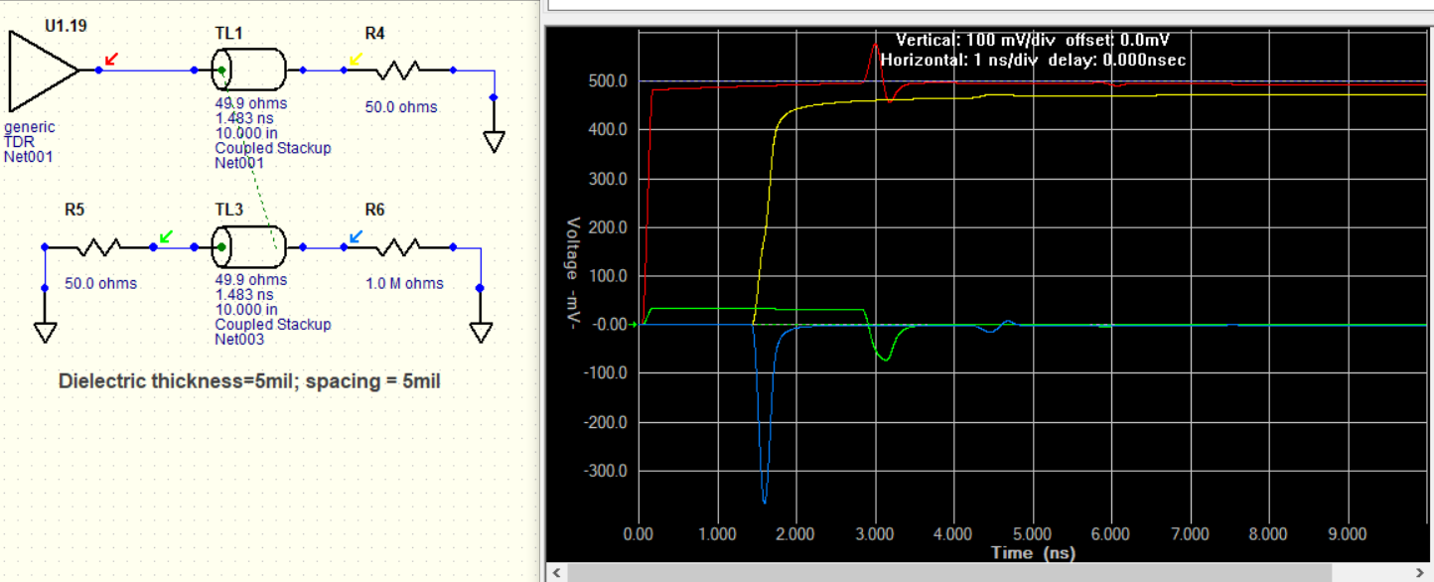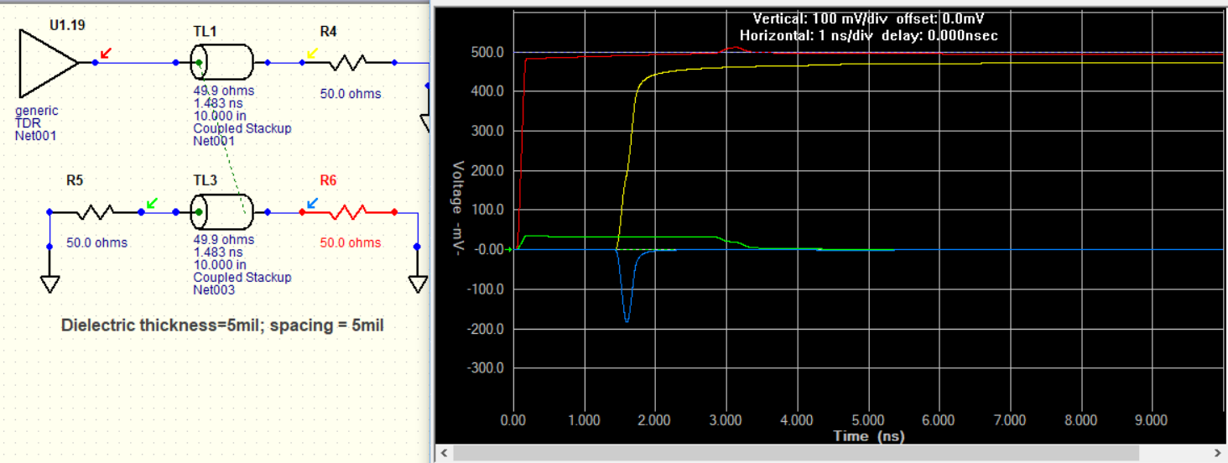

When the far end of the victim is open, the induced crosstalk on the victim propagates on both the directions. When encountered an open, it reflects after one-time delay. This creates a crosstalk in backward direction (towards input) apart from the forward direction. Hence, the FEXT almost becomes twice due to FEXT in both directions. At near end, due to reflections due to unmatched termination, a small fraction of Crosstalk which is now FEXT due to the reflected signal from open appears one-time delay later i.e third time delay. As per the figure above, the FEXT with 50 ohm and open terminations are 180 mV and 350 mV i.e. increasing in amplitude by 2. Also, the NEXT during the first two-time delays is constant in amplitude as expected. With the reflection from the open (R6), R5 is now the far end. So, at the third-time delay, R5 becomes far end. Hence, a FEXT should be observed. As per the above, R5 sees a FEXT at third time delay, with an amplitude of 80 mV as expected.

**Conclusions / Lessons Learnt:**

1. Always look to derive a thumb rule / estimation for Crosstalk wrt variation of Transmission Line features if possible
2. Critical / high speed signal routing through Stripline recommended to mitigate FEXT
3. NEXT amplitude can be controlled only by increasing the spacing of traces and the duration can be controlled by decreasing the coupling length; NEXT is independent of Rise Time of Driver
4. FEXT can be controlled by routing the signal through stripline, decreasing Z0, increasing the rise time of signal and decreasing coupling length
5. Any variation related to Z0 should be treated carefully as Z0 will change for all signals in that particular signal layer