**Goal:** The goal of this lab is to get a hands-on experience to analyse how parameters affect the various impedance features of a Differential pair of a Microstrip and Stripline. Tool used is Hyperlynx.

**Plan:** The plan is to theoretically anticipate the various impedance features theoretically and apply the same to 2D Field Solver.

**Design a tightly coupled 100 Ohm microstrip differential pair, with 5 mil wide trace. Adjust the dielectric thickness**

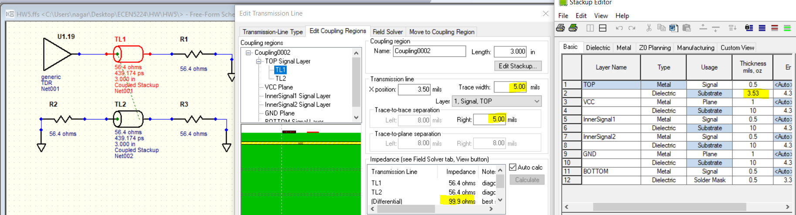

|  |  |  |  |
| --- | --- | --- | --- |
| **Coupling** | **Trace width (mil)** | **Zsingle(ohm)** | **Comment** |
| Tight | 5 | 56.4 | As per the above figure, Single ended impedance Zsingle=56.4 ohm nearly equal to half of Differential Impedance (Zdiff) of 100 ohms. Also, Odd mode impedance (Zodd) is theoretically half of Zdiff, its observed that Zodd = 50 ohm. By theory, Common mode impedance (Zcomm) is defined as impedance between the two lines when the line pair is driven with common mode signal. Even mode Impedance (Zeven) is defined by the impedance of a single transmission line when the pair is driven by a common mode signal. So, Zdiff=2Zodd and Zcomm=0.5*Zeven. Since, the **fringe lines** across the Differential pair is greater than Common signal pair, displacement current across the Differential pair is greater than Common signal pair. Hence, **Zeven>Zodd,** but definitely lesser than Zdiff which can be verified by the below figure. However, loss is greater in tight coupling compared to other coupling as width is narrower; advantages being low cost and high interconnect density. |
|  | | | |

**Now make the pair loosely coupled. What line width is needed to make it 100 Ohms.**

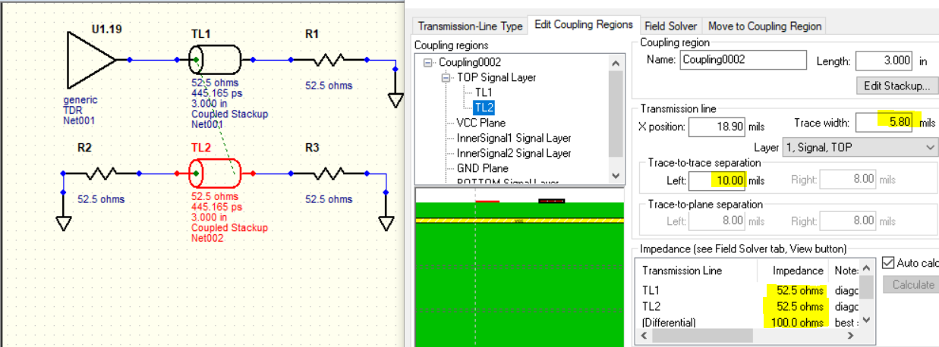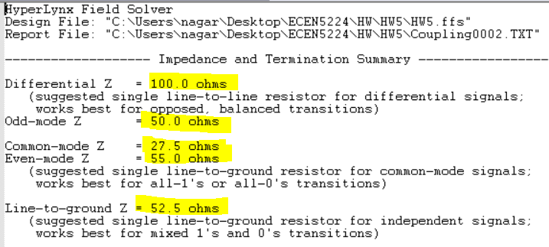

|  |  |  |  |
| --- | --- | --- | --- |
| **Coupling** | **Trace width (mil)** | **Zsingle (ohm)** | **Comment** |
| Loose | 5.8 | 52.5 | If the separation is blindly increased from the above condition (tight coupling), Zdiff would be more than 100 ohms. So, to compensate, trace is made wider. As per the above figure, Single ended impedance Zsingle=52.5 ohm nearly equal to half of Differential Impedance (Zdiff) of 100 ohms. Due to increase in trace width, Zsingle is lesser than the corresponding value in tight coupling. Since spacing is increased, Zeven decreases as the common mode fringe field interference decreases (hence, displacement current increases); so does Zcomm. Zodd is theoretically half of Zdiff, its observed that Zodd = 50 ohm. Also, **Zeven>Zodd,** but definitely lesser than Zdiff which can be verified by the figure. All the above discussed ideas are valid from above figures. |

**Now make it uncoupled. What line width is needed to make it 100 Ohms**

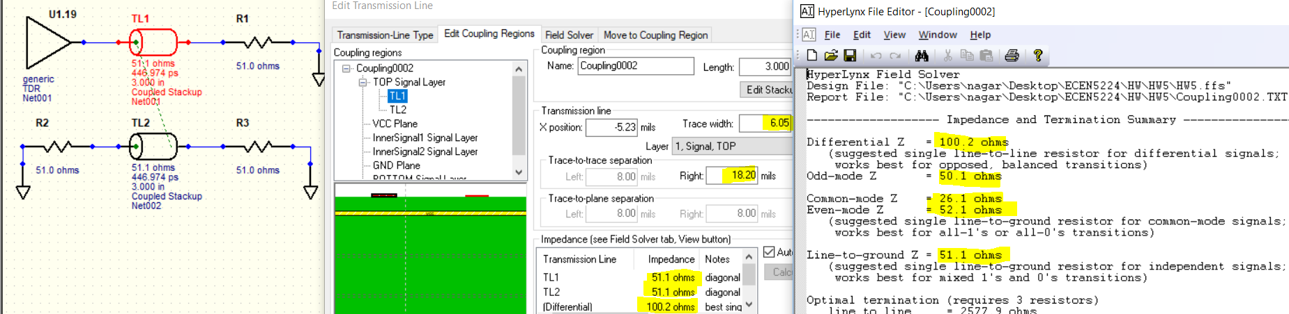

|  |  |  |  |
| --- | --- | --- | --- |
| **Coupling** | **Trace width (mil)** | **Zsingle (ohm)** | **Comment** |
| Uncoupled | 6.05 | 51 | If the separation is blindly increased from the above condition (tight coupling), Zdiff would be more than 100 ohms. So, to compensate, trace is made wider. As per the above figure, Single ended impedance Zsingle=51 ohm nearly equal to half of Differential Impedance (Zdiff) of 100 ohms. Due to increase in trace width, Zsingle is lesser than the corresponding value in loose coupling. Since spacing is increased, Zeven decreases as the common mode fringe field interference decresases (hence, displacement current increases); so does Zcomm. Zodd is theoretically half of Zdiff, its observed that Zodd = 50 ohm. Also, **Zeven>Zodd,** but definitely lesser than Zdiff which can be verified by the figure. All the above discussed ideas are valid from above figures. |

**Repeat for stripline diff pairs.**

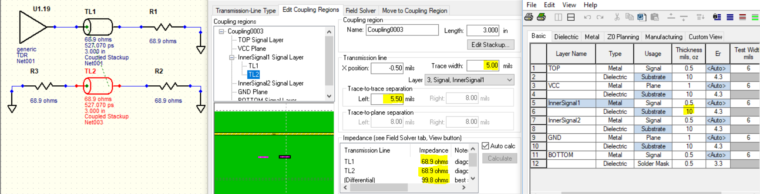

|  |  |  |  |
| --- | --- | --- | --- |
| **Coupling** | **Trace width (mil)** | **Zsingle(ohm)** | **Comment** |
| Tight | 5 | 68.9 | As per the above figure, Single ended impedance Zsingle=68.9. Also, Odd mode impedance (Zodd) is theoretically half of Zdiff, its observed that Zodd = 50 ohm. By theory, Common mode impedance (Zcomm) is defined as impedance between the two lines when the line pair is driven with common mode signal. Even mode Impedance (Zeven) is defined by the impedance of a single transmission line when the pair is driven by a common mode signal. So, Zdiff=2Zodd and Zcomm=0.5*Zeven. Since, the **fringe lines** across the Differential pair is greater than Common signal pair, displacement current across the Differential pair is greater than Common signal pair. Hence, **Zeven>Zodd,** but definitely lesser than Zdiff which can be verified by the below figure. However, loss is greater in tight coupling compared to other coupling as width is narrower; advantages being low cost and high interconnect density. It can be observed that Dielectric thickness for target Differential Impedance in Stripline is more than that of a Microstrip. |
|  | | | |

**Loose Coupling:**

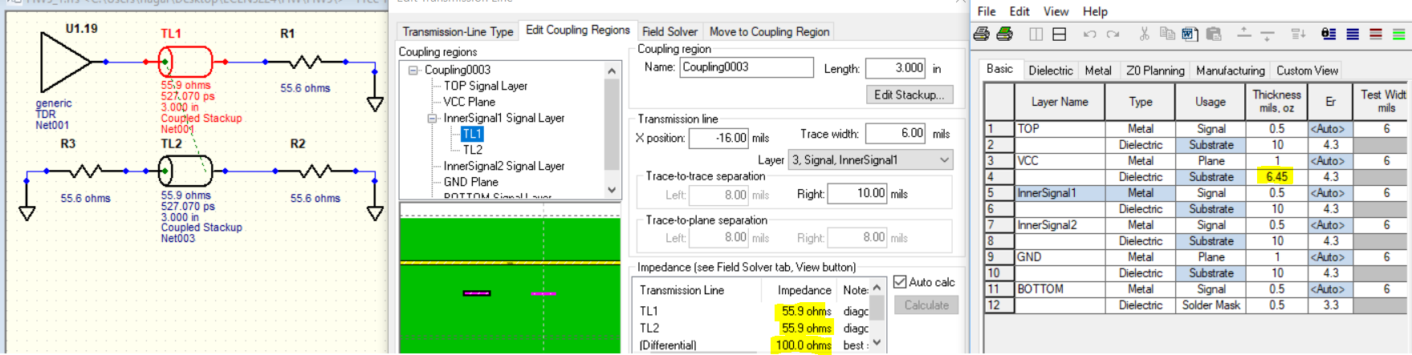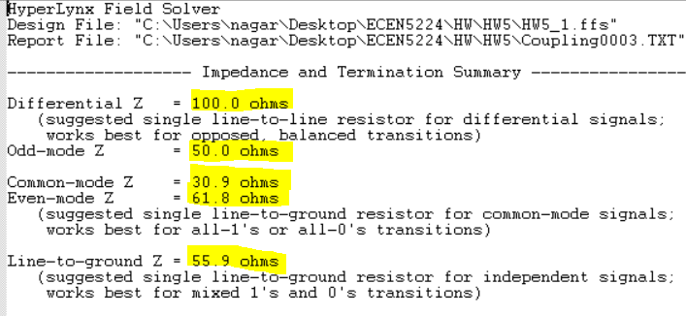

|  |  |  |  |
| --- | --- | --- | --- |
| **Coupling** | **Trace width (mil)** | **Zsingle (ohm)** | **Comment** |
| Loose | 6 | 55.6 | If the separation is blindly increased from the above condition (tight coupling), Zdiff would be more than 100 ohms. So, to compensate, trace is made wider. In case of As per the above figure, Single ended impedance Zsingle=55.6 ohm nearly equal to half of Differential Impedance (Zdiff) of 100 ohms. Due to increase in trace width, Zsingle is lesser than the corresponding value in tight coupling. Since spacing is increased, Dielectric thickness needs to be reduced to retain the Differential Impedance of 100 ohm. Zeven decreases as the common mode fringe field interference decresases (hence, displacement current increases); so does Zcomm. Zodd is theoretically half of Zdiff, its observed that Zodd = 50 ohm. Also, **Zeven>Zodd,** but definitely lesser than Zdiff which can be verified by the figure. All the above discussed ideas are valid from above figures. |

**Uncoupled condition:**

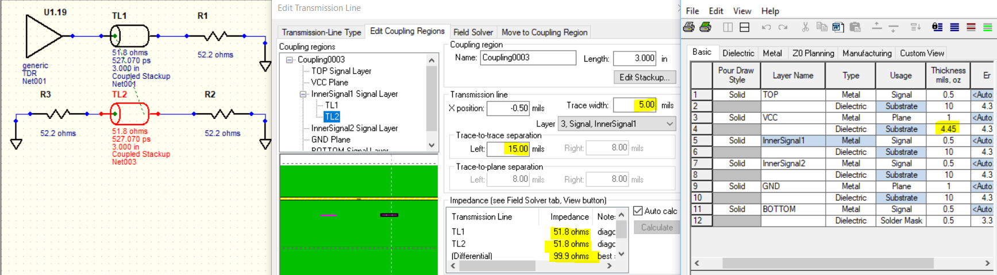

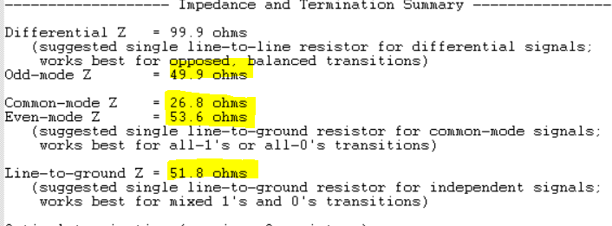

|  |  |  |  |
| --- | --- | --- | --- |
| **Coupling** | **Trace width (mil)** | **Zsingle (ohm)** | **Comment** |
| Uncoupled | 6 | 51.8 | If the separation is blindly increased from the above condition (tight coupling), Zdiff would be more than 100 ohms. So, to compensate, trace is made wider. As per the above figure, Single ended impedance Zsingle=52.2 ohm nearly equal to half of Differential Impedance (Zdiff) of 100 ohms. Due to increase in trace width, Zsingle is lesser than the corresponding value in loose coupling. Since spacing is increased, Dielectric thickness needs to be reduced to retain the Differential Impedance of 100 ohm . Since spacing is increased, Zeven decreases as the common mode fringe field interference decresases (hence, displacement current increases); so does Zcomm. Zodd is theoretically half of Zdiff, its observed that Zodd = 50 ohm. Also, **Zeven>Zodd,** but definitely lesser than Zdiff which can be verified by the figure. All the above discussed ideas are valid from above figures. |

**Conclusions/ Lessons Learnt:**

1. **In any case, Zdiff > Zeven>Zodd**
2. **Tight coupling should be the first approach as it gives more dielectric thickness, low cost and more interconnect density; the downside being more conductor loss due to narrow width**
3. **As separation increases compared to trace width, Differential Impedance increases and Even mode impedance decreases. So configure the parameters accurately**
4. **Its not a good idea to decrease the dielectric thickness to get lower impedance as this leads to higher fabrication cost**