**Goal:** The goal of this lab is to get a hands-on experience to inspect and verify the factors that affect the S parameters in a Transmission Line and Differential pair and tabulate their respective advantages and disadvantages. Tool used is Hyperlynx.

**Plan:** The plan is to theoretically anticipate the features of both the Transmission Lines and verify the same through simulation. The same needs to be verified in Hyperlynx.

1. **Build a uniform transmission line not 50 Ohms (turn on losses).**

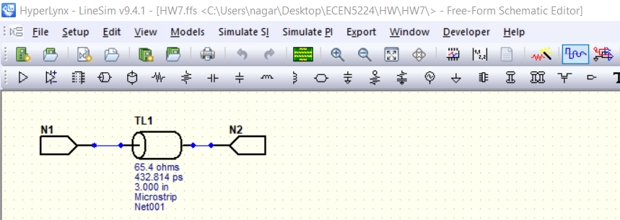

1. **Build a uniform differential pair, not 100 Ohms (turn on losses)**

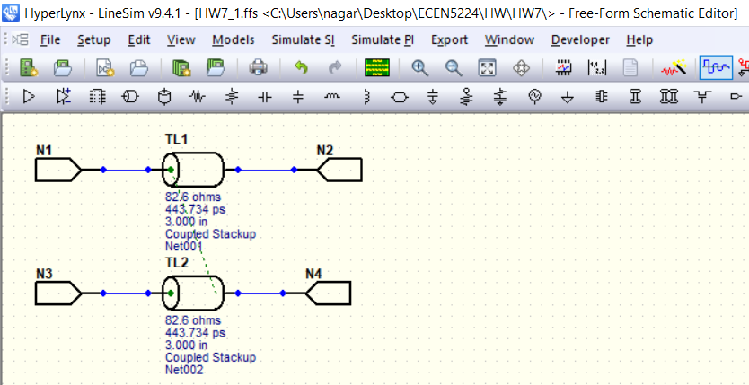

1. **Identify the features of the transmission lines and how each feature affects each single-ended or diff S-parameter**

**Single Ended S parameters:**

|  |  |  |
| --- | --- | --- |
| **Parameter varied** | **Affected? (Yes/No)** | **Comments** |
| Z0 not equal to port Impedance | Yes, both S11 and S21 | One of the main factors that varies S11 is the Impedance mismatch from the driver launch pin till the end of the Transmission line. If the port impedance (in this case, 50 ohm) is different from the Z0 of Transmission line, the reflection co-efficient will be positive or negative; not zero. Hence, the S11 varies accordingly. Its practically seen that until an S11 of -13dB, S21 is monotonic and has no ripples i.e unaffected by change in S11. This corresponds around 30% approximate. So, if the variation in impedance between port and Transmission line is kept within 30% (in this case 30% of 50 ohm is 15 ohm), then S21 is almost negligible as per the image on the left. The relation between S11 and S21 is S112+ S212=1. As the difference between Z0 and port impedance moves to Positive, reflection coefficient moves farther away from 0. So, S11 increases (approaches 0dB) as seen in the middle. As the difference between Z0 and port impedance moves to negative, reflection coefficient moves farther away from 0. So, S11 increases (approaches 0dB) as seen in the right image. Also, note that the first dip at nearly 1 GHz. As per theory, the first frequency point f where maximum destructive interference occurs is at f=v/2l; where v is speed of light in medium, l is transmission line length. In FR4, v= 6in/ns. So, l=6/2*1 = 3in which is same as in schematic. It is also to be noted that S21 starts from 0dB at low freq which is kind of consistency test. Since, this is a symmetric network, S11=S22 and S21 = S12 which is verified in touchstone file too. |
|  | | |
| Length of Transmission line | Yes, both S11 and S21 | Even Length of Transmission line affects the Magnitude plot of S11 and S21. The amplitude of S21 is directly proportional to length as per eqn. S21 = sqrt(f)/w+2.3*f*Df* sqrt(Dk)*l. Q1length.s2p and Q1morelength.s2p correspond to a transmission line length of 3 in and 6 in. So, if l is doubled, S21 should also double by 2 which is verified in the image. However, the amplitude of S11 don’t vary that much as reflection coefficient / Return loss quantity is dependent on Impedance mismatch and not on length. Also, note that the first dip at nearly 1 GHz for Q1length.s2p. As per theory, the first frequency point f where maximum destructive interference occurs is at f=v/2l;. So, l=6/2*1 = 3in. The first dip at nearly 0.5 GHz for Q1length.s2p. The first frequency point f where maximum destructive interference occurs is at f=v/2l;. So, l=6/2*0.5 = 6in which matches with the actual lengths of Transmission lines used. The peak compressing phenomenon in S11 can be observed in S21 too. As per simulation, the S21 values are -0.8 dB and -1.6dB for length of 3 in and 6in. As per calculations, they are -0.57 dB and -1.15 dB. It is self evident that the attenuation per unit length per unit GHz is around 0.2 dB/in/GHz. |
|  | | |
| Dissipation factor / Loss Tangent | Yes, both S11 and S21 | The amplitude of S21 is directly proportional to Dissipation factor Df as per eqn. S21 = sqrt(f)/w+2.3*f*Df* sqrt(Dk)*l. Q1Df.s2p and Q1moreDf.s2p correspond to a Df of 0.02 and 0.04. So, if Df is doubled, S21 should also double by 2 which is verified in the image. However, the amplitude of S11 don’t vary that much as reflection coefficient / Return loss quantity is dependent on Impedance mismatch and not on Df. Also, note that the dips in S11 for Df of 0.04 is almost half of that for Df of 0.02. This is because of decrease in Df. As per simulation, the S21 values are -1.4 dB and -2.2 dB for Df of 0.02 and 0.04. As per calculations, they are -1.14 dB and -2.28 dB. It is self-evident that the attenuation per unit length per unit GHz is around 0.2 dB/in/GHz. S11 is unaffected with Df variation. |
|  | | |
| Dielectric constant | Yes, both S11 and S21 | The amplitude of S21 is directly proportional to root of Dielectric constant Dk as per eqn. S21 = sqrt(f)/w+2.3*f*Df* sqrt(Dk)*l. Q1Dk.s2p and Q1moreDk.s2p correspond to a Dk of 4.3 and 16. So, if Dk is quadrupled, S21 should also double by 2 which is verified in the image. However, the amplitude of S11 goes half when Dk is quadrupled because this makes Z0 go decrease by half which doubles the Reflection co-efficient. Hence, S11 for Dk of 16 is half of amplitude which can be verified from the image below. However, there are two peaks instead of one when Dk is quadrupled. This is because, as Dk is raised by 4 times, speed of travel reduces by half and TD doubles. So, even though the physical length is constant in both cases, decrease in speed which Dk is made 4 times apparently makes the signal to reach the far end later than the original Dk making it to believe that length has been increased. So, the first dip frequency reduces by half as seen in the figure. |
|  | | |
| Frequency | Yes, both S11 and S21 | The amplitude of S21 is directly proportional to signal frequency f as per eqn. S21 = sqrt(f)/w+2.3*f*Df* sqrt(Dk)*l. As evident from the all the aboe graphs, as f increases, S21 proportionately decreases |

**Diff Ended S parameters:**

**Note: All the below observations are made in a tight coupled condition.**

|  |  |  |
| --- | --- | --- |
| **Parameter varied** | **Affected? (Yes/No)** | **Comments** |
| Z0 not equal to port Impedance | Yes, S11, S21, SDD11, SDD21 | One of the main factors that varies S11 is the Impedance mismatch from the driver launch pin till the end of the Transmission line. If the port impedance (in this case, 50 ohm) is different from the Z0 of Transmission line, the reflection co-efficient will be positive or negative; not zero. Hence, the S11 varies accordingly. Its practically seen that until an S11 of -13dB, S21 is monotonic and has no ripples i.e unaffected by change in S11. This corresponds around 30% approximate. So, if the variation in impedance between port and Transmission line is kept within 30% (in this case 30% of 50 ohm is 15 ohm), then S21 is almost negligible as per the image on the left. The explanation for this is same as that of Single ended line. Since, this is a symmetric network, S11=S22 and S21 = S12 which is verified in touchstone file too. Also, S11 amplitude decreases with Freq due to attenuation along the line. As expected, S21 and SDD21 start from 0dB in the snaps below. S21 decreases with freq as expected as its directly proportional to the same. Also, we know that the broad dips in S21 may be due to excess crosstalk or 1/4th wave stub resonance. Since, there are no stubs / via in the present ffs and S11 did not show any abrupt increase, its due to crosstalk; which should be reflected in S31 or S41 response. Since, S31 (NEXT) is almost independent of freq, the energy lost in S21 should be found in S41. As S21 decreased, S41 should increase in freq which is found in the images below. SDD11 = 0.5(S11+S33-S31-S13). SDD21 = 0.5(S21+S43-S23-S41). Under an uncoupled condition, S31, S13, S41, S23 are highly negative. So, SDD21 is nearly S21 and SDD11 is nearly S11 as seen in second row of images. Under a tightly coupled condition, the differential impedance in the ffs used is 120 ohm which is 20% mismatched from a differential port impedance of 100 ohm . Hence, SDD11 should be the same as the formula described before. As seen from the image in 2nd row, at 500 MHz, S11, S33 are -7.5 dB and -12.5 dB; SDD11 is -15 dB as expected from the formula. Also for both S21 and SDD21, the attenuation is around 0.2 dB/in/GHz as expected. Also, SDD21 is almost constant as expected since the energy lost in S21 is gained in S41. When the impedance mismatch is made lesser than 30%, S11, S33 reduces below -13 dB which would make S21 ripple free. Also, since it’s a symmetrical network, the common and Differential S parameters would be same which is verified from 3rd row images. Also, since it’s a symmetric and identical differential pair network, SCDX and SDCX are of high negative value. |
|  | | |
| Length of Transmission line | Yes, S11, S21, SDD11, SDD21 | Even Length of Transmission line affects the Magnitude plot of S11 and S21. The amplitude of S21 is directly proportional to length as per eqn. S21 = sqrt(f)/w+2.3*f*Df* sqrt(Dk)*l. Q2length.s4p and Q2morelength.s4p correspond to a transmission line length of 3 in and 6 in. So, if l is doubled, S21 should also double by 2 which is verified in the image. The explanation is similar to that of a single ended line. It is self-evident that the attenuation per unit length per unit GHz is around 0.2 dB/in/GHz. The first-row image verifies that as length gets doubled, no. of peaks in S11 gets half within a given frequency range. It can also be seen that energy lost with freq in S21 is gained back in S41. Hence, SDD21 is nearly 0 dB. Also, in an uncoupled condition, SDD11 would be nearly S11 and also SCC11, which can be verified in the 2nd row. Also, since it’s a symmetric and identical differential pair network, SCDX and SDCX are of high negative value. |
|  | | |
| Frequency | Yes, S11, S21, SDD11, SDD21 | The amplitude of S21 is directly proportional to signal frequency f as per eqn. S21 = sqrt(f)/w+2.3*f*Df* sqrt(Dk)*l. As evident from the all the aboe graphs, as f increases, S21 proportionately decreases. The same applies to SDD21 also. Same applies to S11, SDD11 and SDD21. |

**Conclusions:**

1. A tradeoff between tight and loose coupling depends on what factor has more priority; tight coupling results in more interconnect density but the trace widths need to be reduced resulting in more power dissipation. Loose coupling suppresses crosstalk but comes with more cost
2. Its required to maintain a perfect symmetrical identical Differential pair to avoid mode conversions
3. As S21 sees a dip with increase in freq, S41 increases proportionately keeping SDD21 almost linear
4. Change in trace width and Df has no effect on S11.
5. Z0 is independent of Length