**Goal:** The goal of this lab is to get a hands-on experience to inspect and verify the factors that affect the S parameters in a Single ended Stripline and tabulate their respective advantages and disadvantages. Tool used is Hyperlynx.

**Plan:** The plan is to theoretically anticipate the features of Single ended Stripline and verify the same through simulation. The same needs to be verified in Hyperlynx.

1. **Build a lossy stripline.**

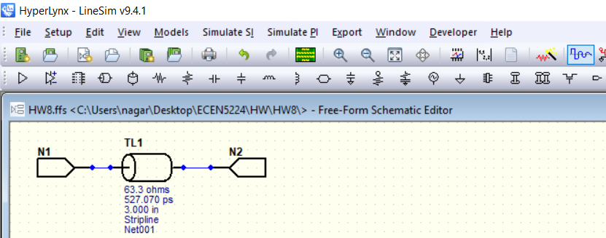

1. **Estimate the attenuation you expect to see at 1 GHz, 10 GHz, and 20 GHz.**

|  |  |  |
| --- | --- | --- |
| **Df** | 0.02 |  |
| **Dk** | 4.3 |  |
| **l(in)** | 3 |  |
| **width (mil)** | 15 |  |
| **Freq (GHz)** | **Attenuation (dB)** | **Comments** |
| **1** | **-0.35282956** | Df = 0.02, Dk =4.3, len = 3in , Attenuation (dB) = -(sqrt(f)/w+2.3*freq*sqrt(Dk)*Df*len) |
| **10** | **-3.07244742** |
| **20** | **-6.02140021** |

1. **Use an impedance that is 75 Ohms, then make it 50 Ohms, just by changing the dielectric thickness. How do you interpret S11 and S21?**

One of the main factors that varies S11 is the Impedance mismatch from the driver launch pin till the end of the Transmission line. If the port impedance (in this case, 50 ohm) is different from the Z0 of Transmission line, the reflection co-efficient will be positive or negative; not zero. Hence, the S11 varies accordingly. Its practically seen that until an S11 of -13dB, S21 is monotonic and has no ripples i.e unaffected by change in S11. This corresponds around 30% of Impedance mismatch between Z0 of Transmission line and Port impedance. So, if the variation in impedance between port and Transmission line is kept within 30% (in this case 30% of 50 ohm is 15 ohm), then S21 is almost negligible as per the image on the left. The relation between S11 and S21 is Radiation+ Scattering+ S112+ S212=1. As the difference between Z0 and port impedance moves to Positive, reflection coefficient moves farther away from 0. So, S11 increases (approaches 0dB) as seen in the middle. As the difference between Z0 and port impedance moves to negative, reflection coefficient moves farther away from 0. So, S11 increases (approaches 0dB) as seen in the right image. Also, note that the first dip at nearly 1 GHz. As per theory, the first frequency point f where maximum destructive interference occurs is at f=v/2l; where v is speed of light in medium, l is transmission line length. In FR4, v= 6in/ns. So, l=6/2*1 = 3in which is same as in schematic. It is also to be noted that S21 starts from 0dB at low freq which is kind of consistency test. Since, this is asymmetric network, S11=S22 and S21 = S12 which is verified in touchstone file too. As per the snapshot below, for a Zo and Port Impedance of 50ohm, the S11 is very negligible (around -40 dB) and S21 linearly decreases monotonically with practically no ripples. When the Impedance mismatch is more than 30% (Z0 is 75 ohm) , S11 increases more than -12 dB. Hence, ripples in S21 are more pronounced. Its also observed that attenuation in S21 for a 50 ohm line and 75 ohm line are 0.13 dB/in/GHz is around 0.1 dB/in/GHz and S21 starts from 0dB in both cases which are kind of consistency tests. Also, S11 has peaks in sine format.

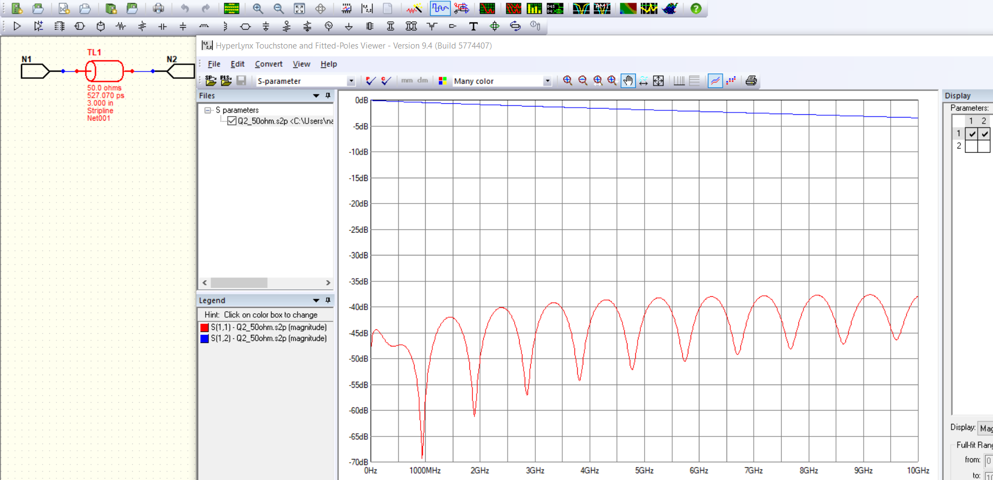 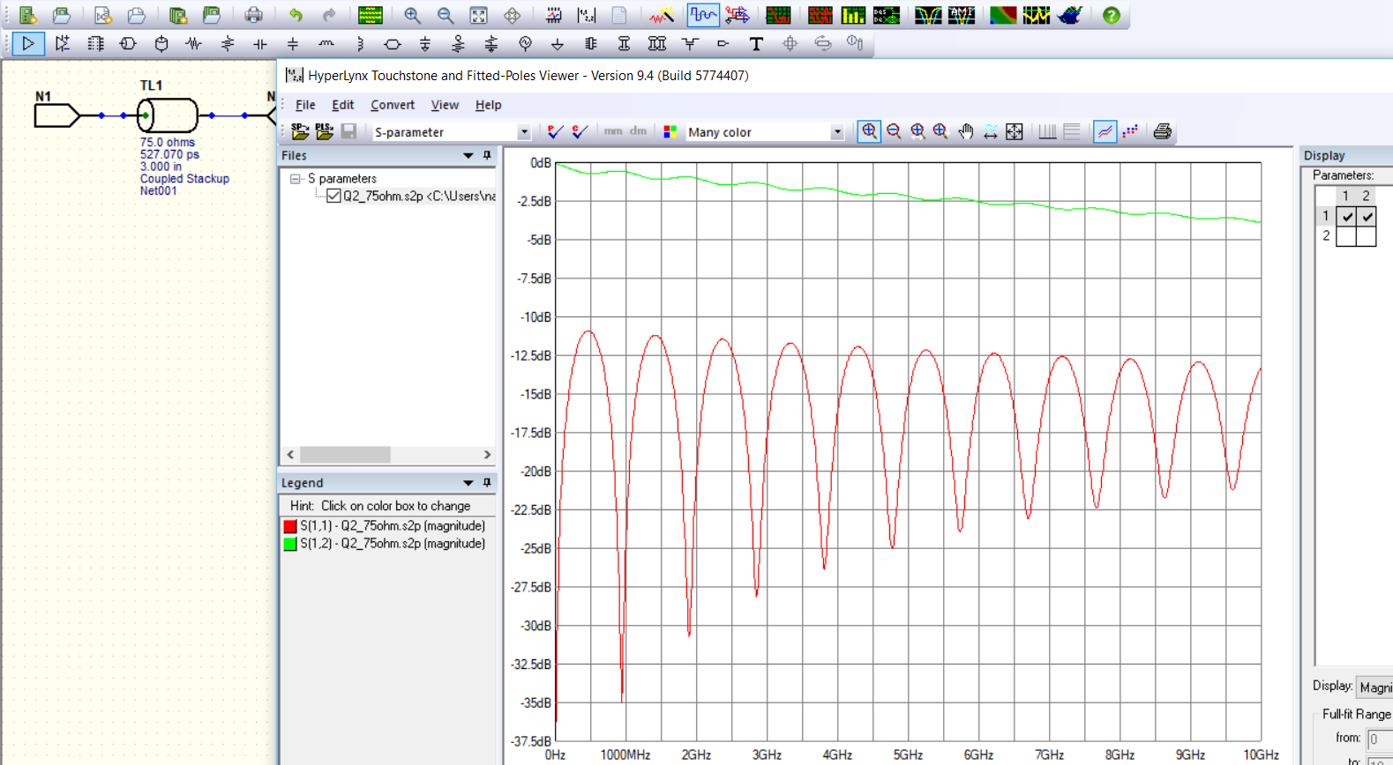

1. **Simulate the S-parameters for the single ended 50 Ohm transmission line. How close is your estimate tot the simulation?**

**As per the snapshot below,**

|  |  |  |
| --- | --- | --- |
| **Freq (GHz)** | **Attenuation (dB) from simulation** | **Calculated Attenuation (dB)** |
| **1** | **-0.43** | **-0.35282956** |
| **10** | **-3.25** | **-3.07244742** |
| **20** | **-6.11** | **-6.02140021** |

**Conductor loss is made negligible to simulate attenuation by highly increasing the conductivity of the material and through proper termination where Port Impedance = Z0 of Stripline.**

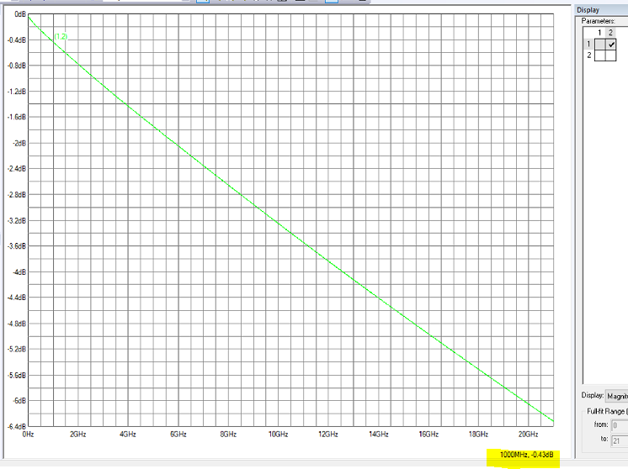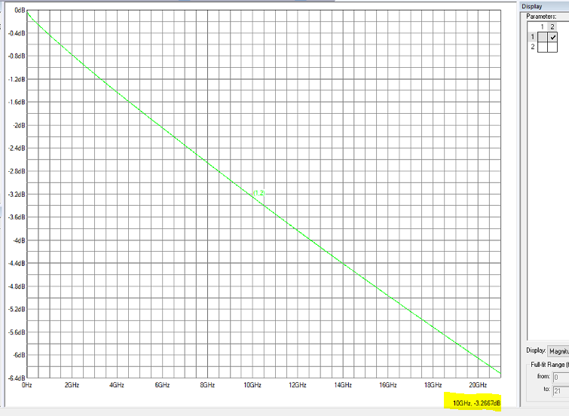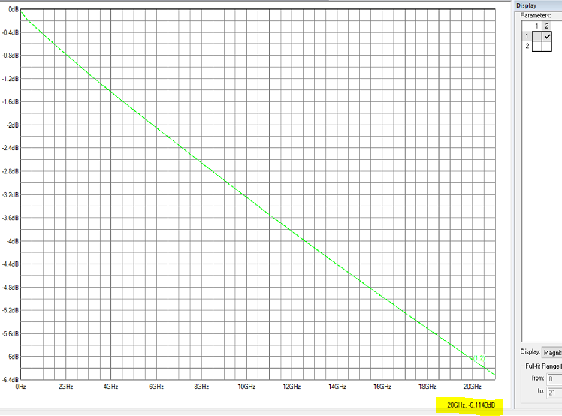

1. **Explore how the line width, length and Df will affect the S21, while keeping the impedance the same. As you change the line features, how does S11 change? Why?**

|  |  |  |
| --- | --- | --- |
| **Parameter varied** | **Affected? (Yes/No)** | **Comments** |
| Length of Transmission line | Yes, both S11 and S21 | Even Length of Transmission line affects the Magnitude plot of S11 and S21. The amplitude of S21 is directly proportional to length as per eqn. S21 = sqrt(f)/w+2.3*f*Df* sqrt(Dk)*l for negligible conductor loss. Q1length.s2p and Q1morelength.s2p correspond to a transmission line length of 3 in and 6 in. So, if l is doubled, S21 should also double by 2 which is verified in the image. However, the amplitude of S11 don’t vary that much as reflection coefficient / Return loss quantity is dependent on Impedance mismatch and not on length. Also, note that the first dip at nearly 1 GHz for Q1length.s2p. As per theory, the first frequency point f where maximum destructive interference occurs is at f=v/2l;. So, l=6/2*1 = 3in. The first dip at nearly 0.5 GHz for Q1length.s2p. The first frequency point f where maximum destructive interference occurs is at f=v/2l;. So, l=6/2*0.5 = 6in which matches with the actual lengths of Transmission lines used. The peak compressing phenomenon in S11 can be observed in S21 too. As per simulation, the S21 values are -0.8 dB and -1.6dB for length of 3 in and 6in. As per calculations, they are -0.57 dB and -1.15 dB. It is self evident that the attenuation per unit length per unit GHz is around 0.2 dB/in/GHz. |
|  | | |
| Dissipation factor / Loss Tangent | Yes, both S11 and S21 | The amplitude of S21 is directly proportional to Dissipation factor Df as per eqn. S21 = sqrt(f)/w+2.3*f*Df* sqrt(Dk)*l for negligible conductor loss. Q1Df.s2p and Q1moreDf.s2p correspond to a Df of 0.02 and 0.04. So, if Df is doubled, S21 should also double by 2 which is verified in the image. However, the amplitude of S11 don’t vary that much as reflection coefficient / Return loss quantity is dependent on Impedance mismatch and not on Df. Also, note that the dips in S11 for Df of 0.04 is almost half of that for Df of 0.02. This is because of decrease in Df. As per simulation, the S21 values are -1.4 dB and -2.2 dB for Df of 0.02 and 0.04. As per calculations, they are -1.14 dB and -2.28 dB. It is self-evident that the attenuation per unit length per unit GHz is around 0.2 dB/in/GHz. S11 is unaffected with Df variation. |
|  | | |
| Dielectric constant | Yes, both S11 and S21 | The amplitude of S21 is directly proportional to root of Dielectric constant Dk as per eqn. S21 = sqrt(f)/w+2.3*f*Df* sqrt(Dk)*l for negligible conductor loss. Q1Dk.s2p and Q1moreDk.s2p correspond to a Dk of 4.3 and 16. So, if Dk is quadrupled, S21 should also double by 2 which is verified in the image. However, the amplitude of S11 goes half when Dk is quadrupled because this makes Z0 go decrease by half which doubles the Reflection co-efficient. Hence, S11 for Dk of 16 is half of amplitude which can be verified from the image below. However, there are two peaks instead of one when Dk is quadrupled. This is because, as Dk is raised by 4 times, speed of travel reduces by half and TD doubles. So, even though the physical length is constant in both cases, decrease in speed which Dk is made 4 times apparently makes the signal to reach the far end later than the original Dk making it to believe that length has been increased. So, the first dip frequency reduces by half as seen in the figure. |
|  | | |
| Frequency | Yes, both S11 and S21 | The amplitude of S21 is directly proportional to signal frequency f as per eqn. S21 = sqrt(f)/w+2.3*f*Df* sqrt(Dk)*l for negligible conductor loss. As evident from the all the aboe graphs, as f increases, S21 proportionately decreases |
| Trace width | Yes, both S11 and S21 | Dielectric loss is made negligible by making Dk=1. Conductor loss is increased by increasing the bulk resistivity. As trace width varies, Zo of Stripline varies. So to compensate, the dielectric thickness in Stackup is varied accordingly. When the bulk resistivity is increases to encount the conductor loss, and width is doubled, then S11 should not be affected as it depends only on Impedance mismatch. Since, S21 is a combination of Conductor loss and Dielectric loss, conductor loss is inversely proportional to width (i.e sqrt(f)/w), so, as width doubles, S21 nearly decreases by half at a given frequency. At a freq of 1GHz , for a Df = 0.02, Dk =1, l=3 in, Dielectric loss = -2.3 *f*Df*sqrt(Dk)*l = - 0.13dB. Conductor loss for a width of 7.5 mil is -0.4dB. So, total S21 is -0.53 dB. For a width of 15 mil, S21 is -0.338 dB. As per the snaps below, S21 is -0.54dB and -0.4dB . Also, S11 is almost not affected as expected. A Figure of Merit of 0.2dB/in/GHz can be observed from the S21 graph. |
|  | | |

**Conclusions:**

1. S parameters contain every data required to understand the features of a Transmission line or channel
2. To suppress FEXT, use a Stripline
3. Only when S11 increases more than -12 dB, S21 practically has ripples. So, not much time and effort to be put if S11 is below -12 dB to improve S21.
4. Z0 is independent of Length
5. As length increases, the peak to peak distance in S11 decreases and vice versa.
6. Dielectric thickness has no effect on S11 and S21
7. S21 can be decreased by decreasing Df, Dk of Dielectric and length of Transmission line
8. If Dk is varied, then TD of the line varies; so speed varies and hence time of travel varies even though the length of the discontinuity is constant. So, the number of peaks for a given frequency dip will vary as the signal is made to believe that the length has increased
9. Change in trace width and Df has no effect on S11.