[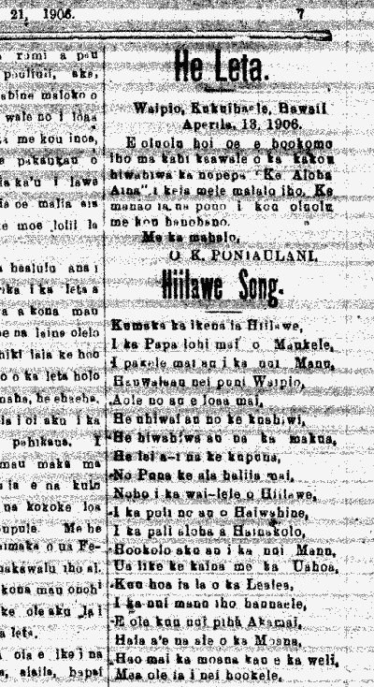](http://amykstillman.files.wordpress.com/2012/03/1-of-2.png)

[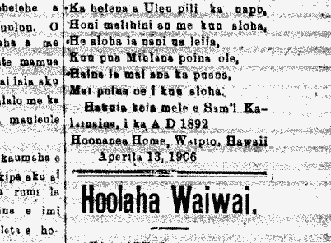](http://amykstillman.files.wordpress.com/2012/03/2-of-2.png)

April 21, 1906 the newspaper Ke Aloha ʻĀina