23122023

11:35

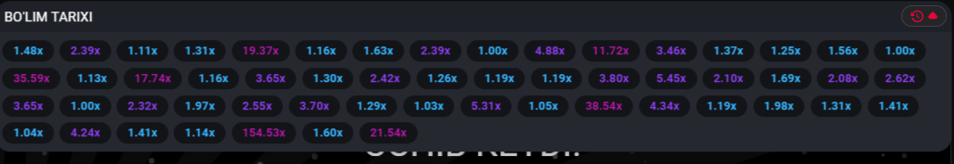

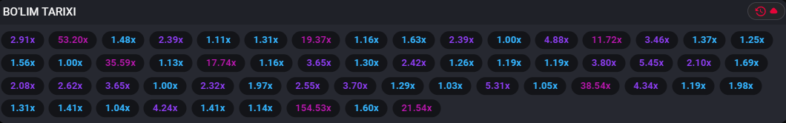

11:38

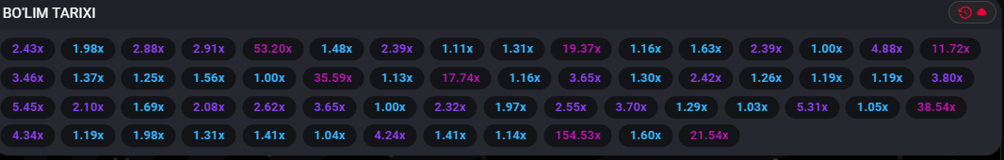

11:47

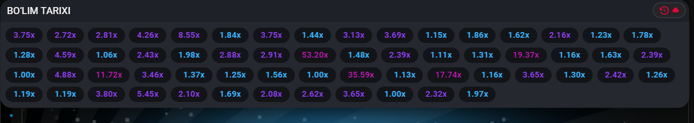

11:50

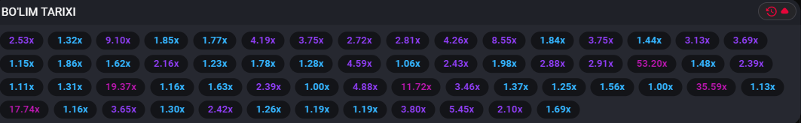

11:53

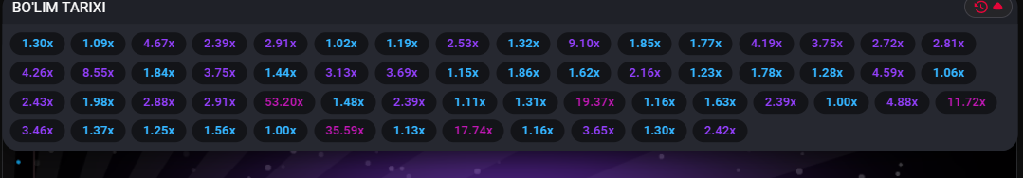

12:00

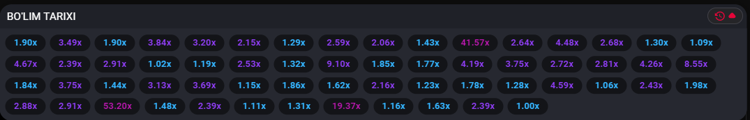

12:04

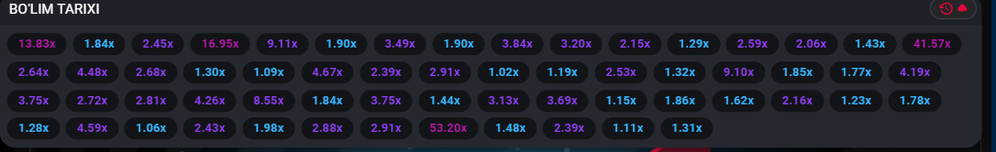

12:03

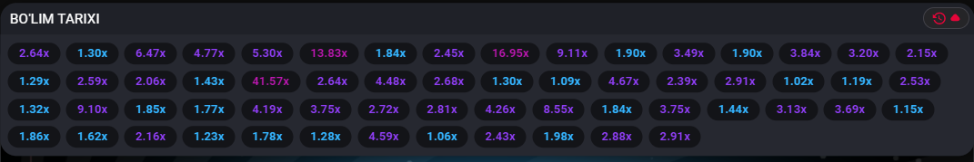

12:07

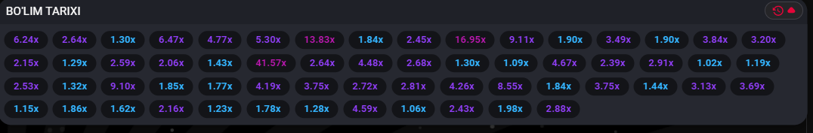

12:07

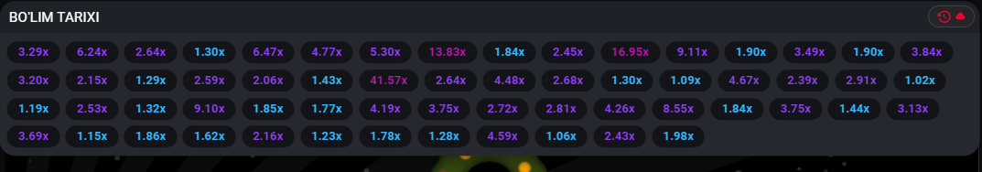

16:29

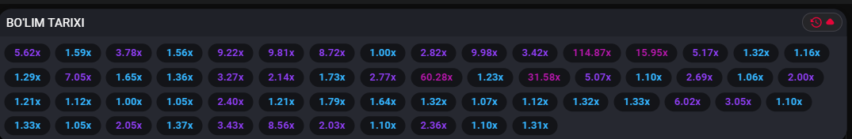

16:32

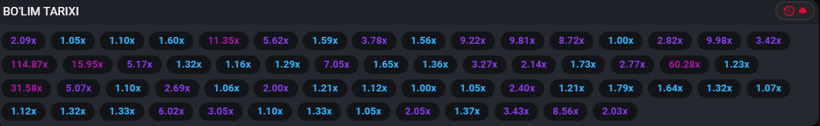

16:36

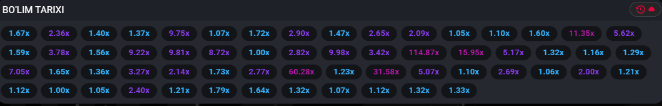

16:42

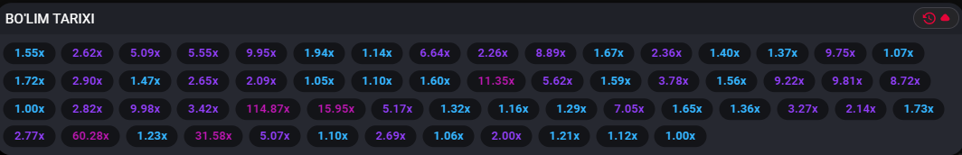

16:44

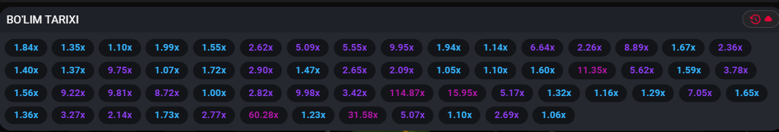

16:56

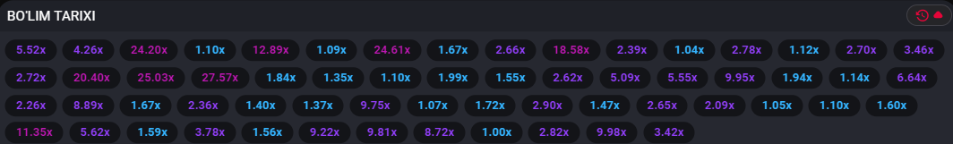

17:16

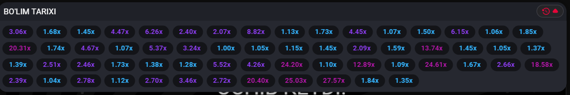

17:31

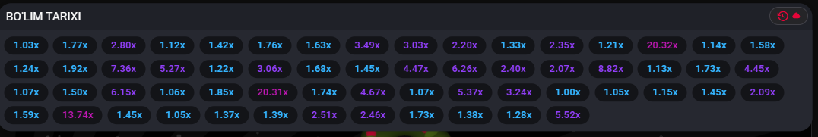

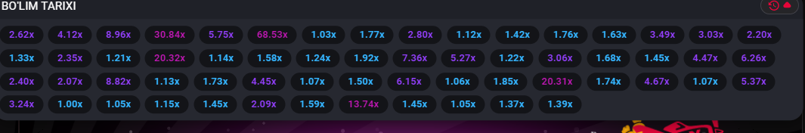

17:42

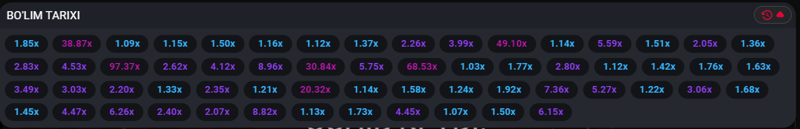

17:45

l

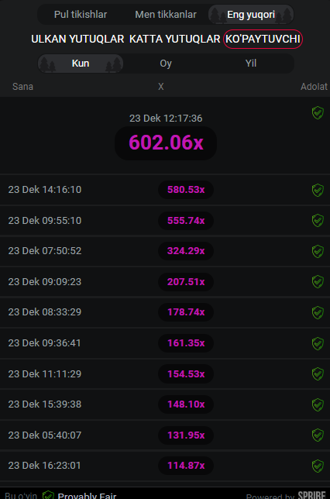

18:09

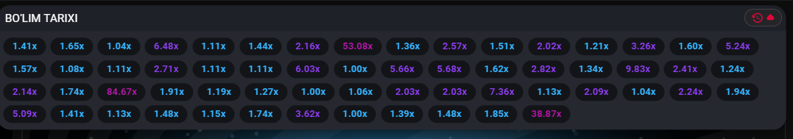

18:21

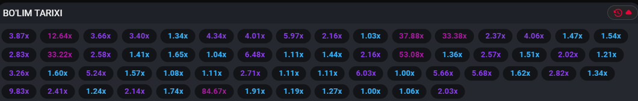

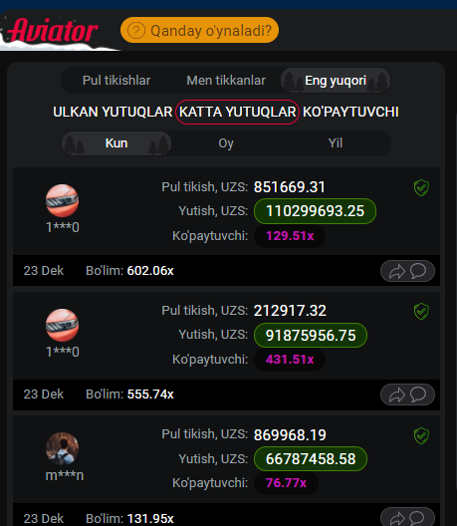

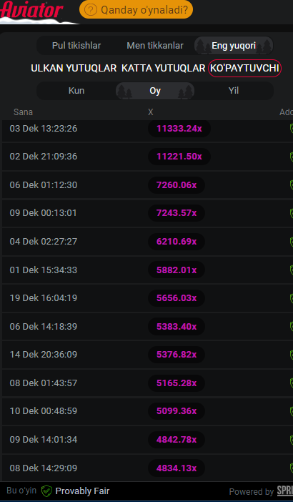

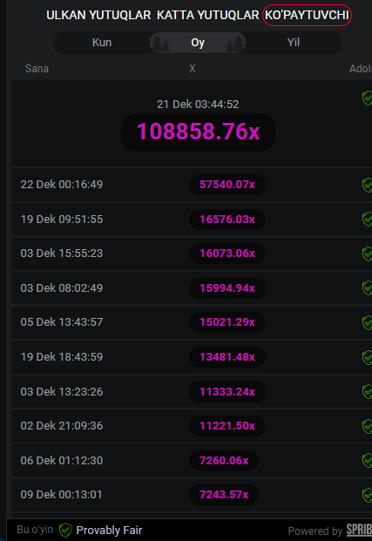

18:43