Screenshot 1 – Home Page
Purpose: Demonstrates the AI assistant's landing page, introducing users to the available real estate services and providing a professional entry point for client interaction.
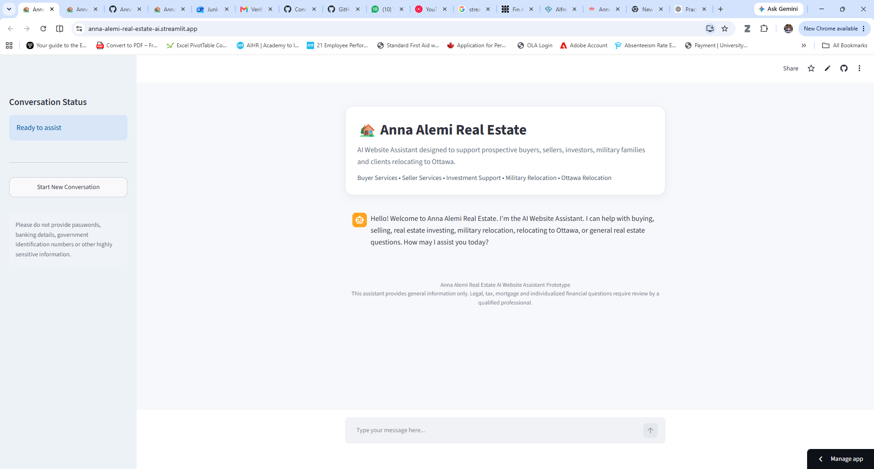

Screenshot 2 – Buyer Lead Qualification
Purpose: Demonstrates the AI collecting information from a prospective home buyer to understand their needs and begin the lead qualification process.

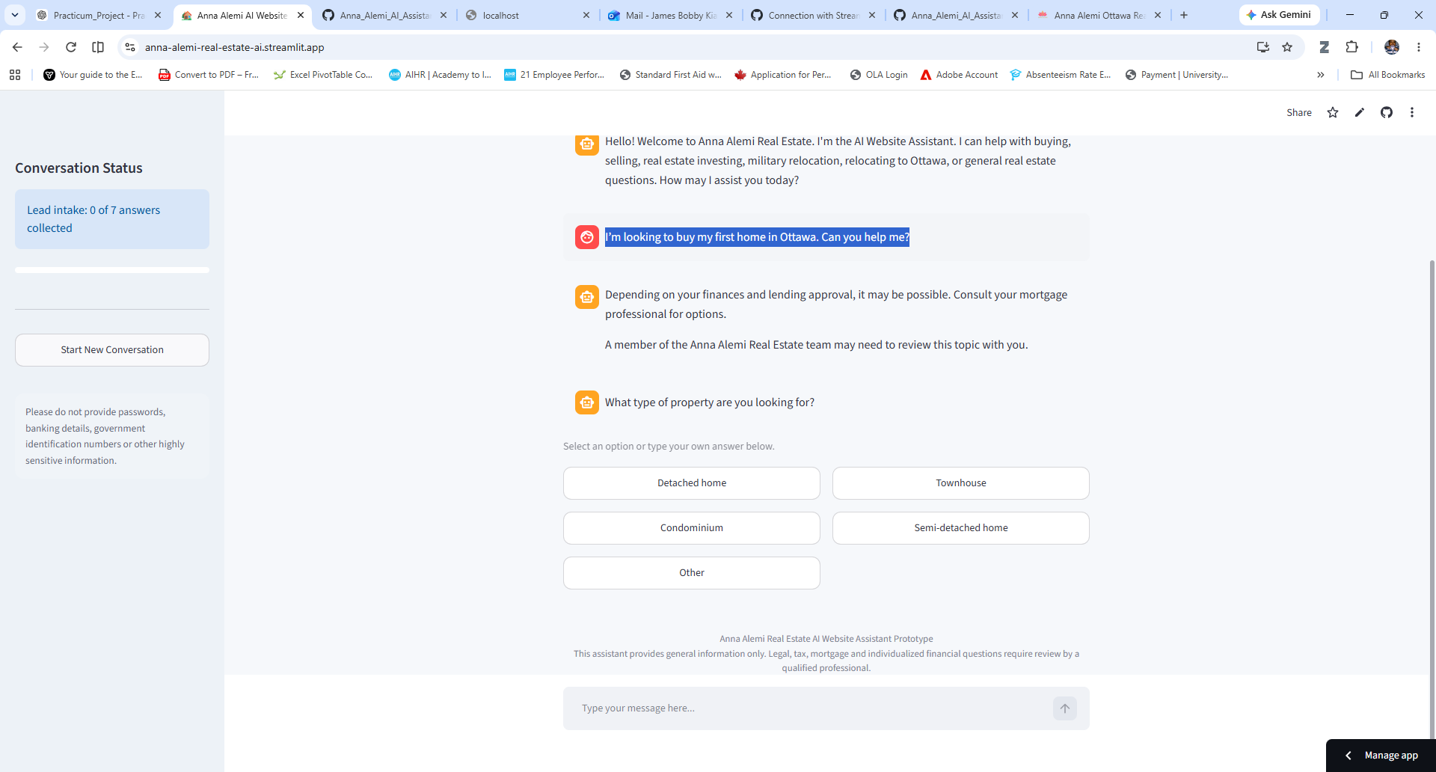

Screenshot 3 – Lead Qualification Summary
Purpose: Demonstrates how the AI summarizes the collected client information, assigns a lead priority, and recommends the appropriate next action for the real estate team.
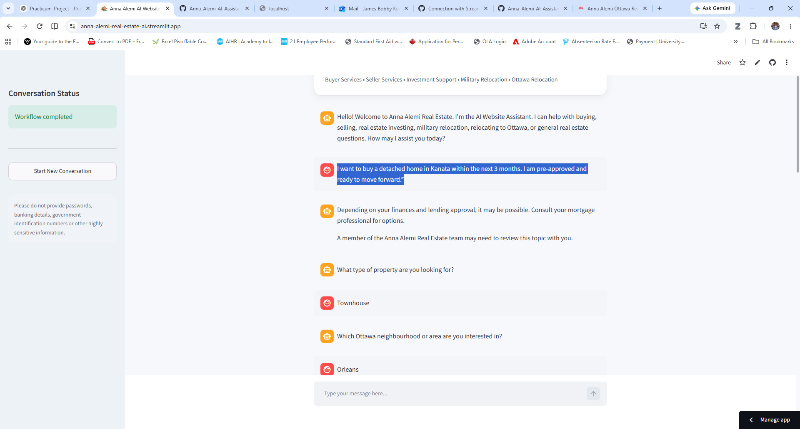

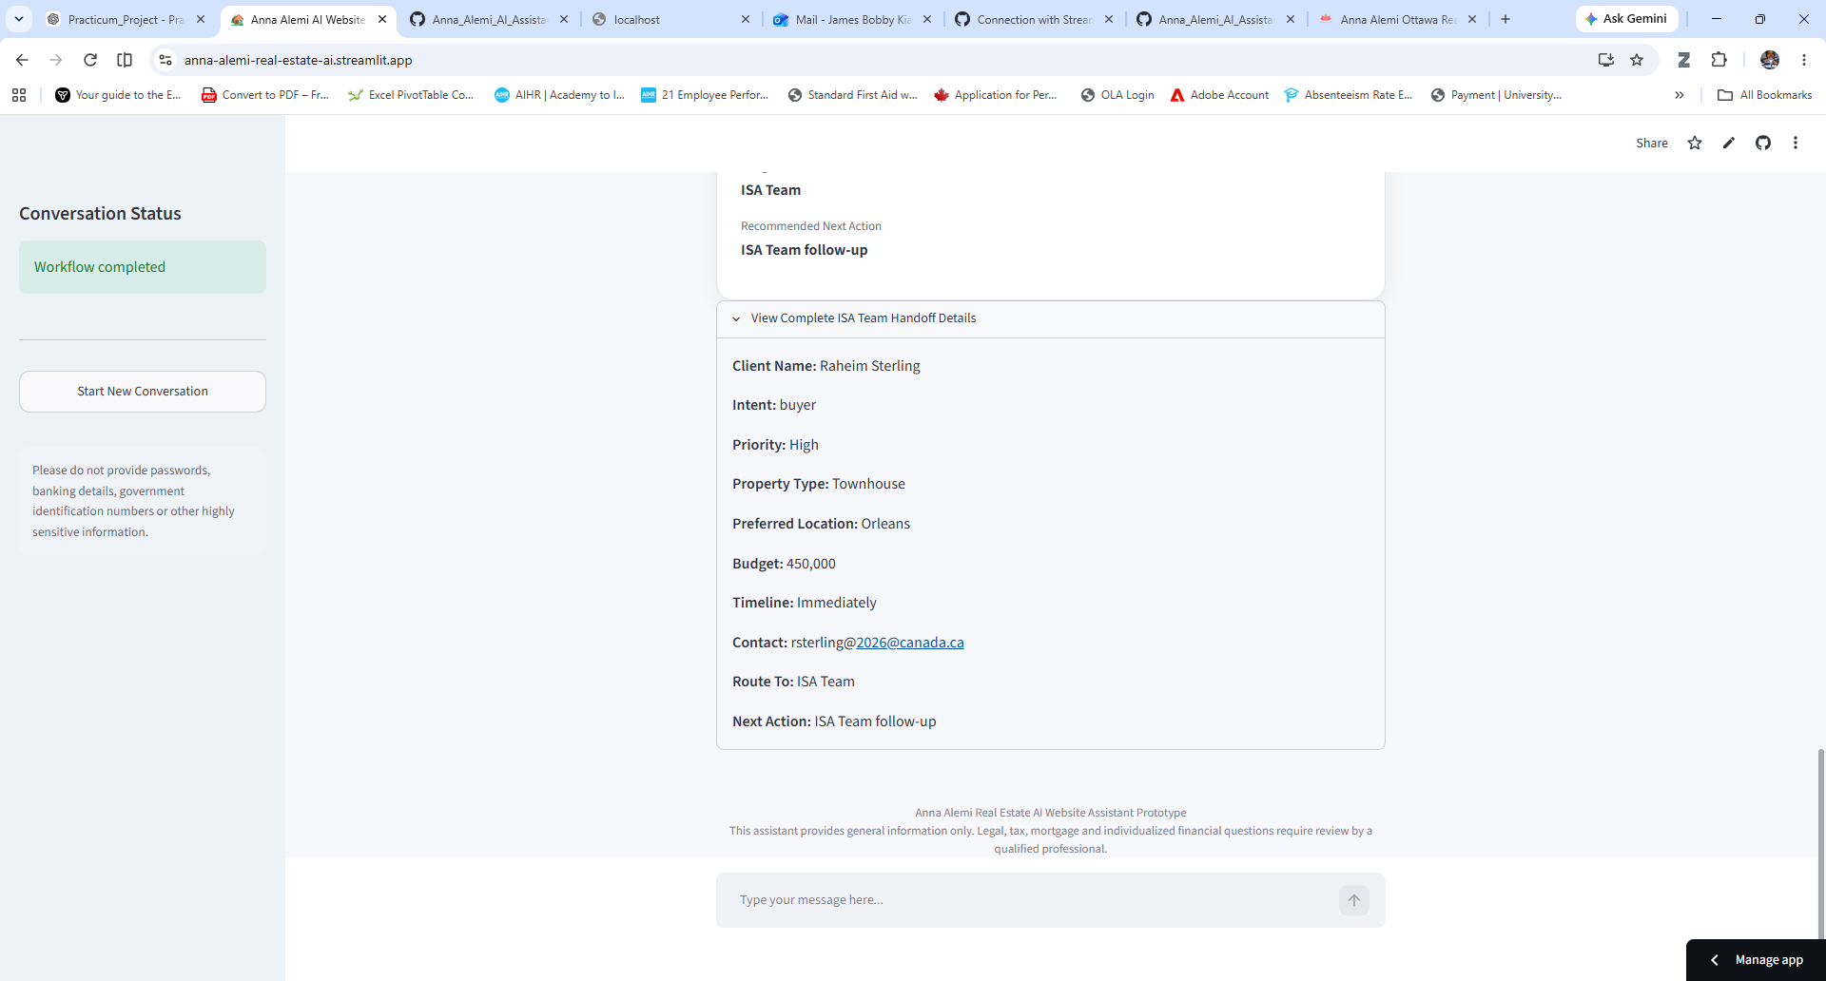

Screenshot 4 – Knowledge Base Retrieval
Purpose: Demonstrates the AI retrieving and presenting approved real estate information from its knowledge base to provide consistent and reliable responses.
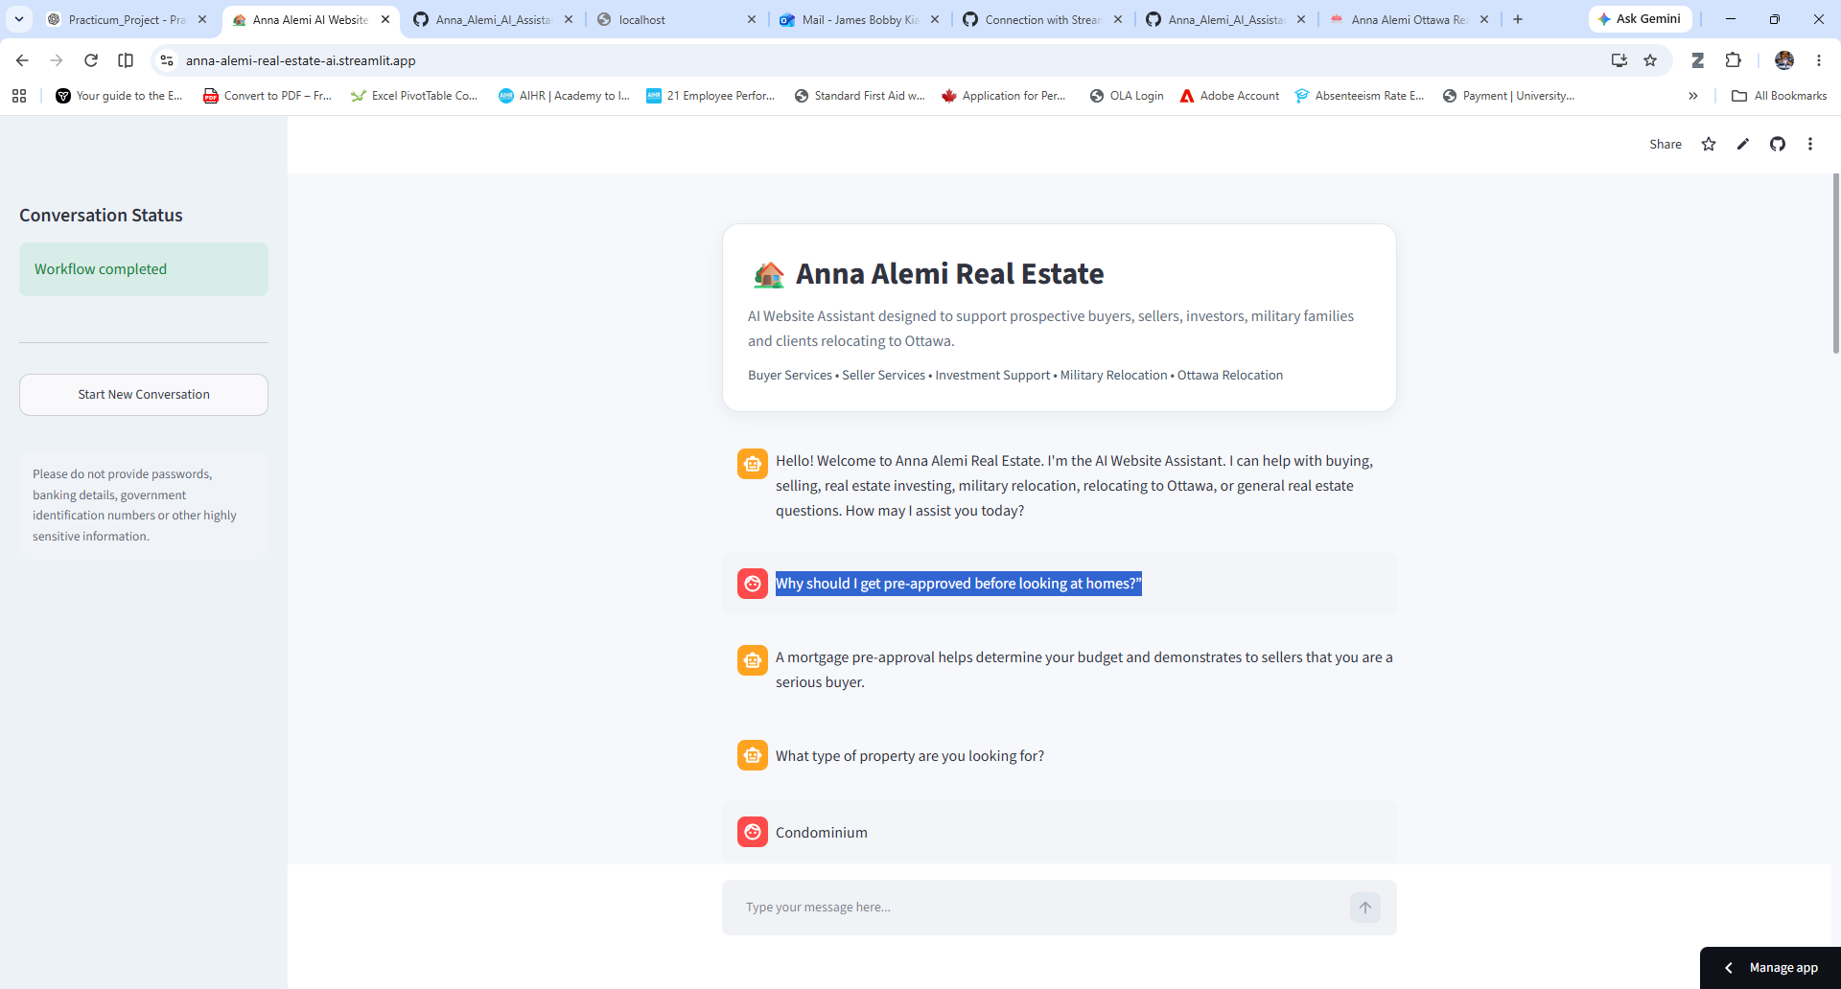

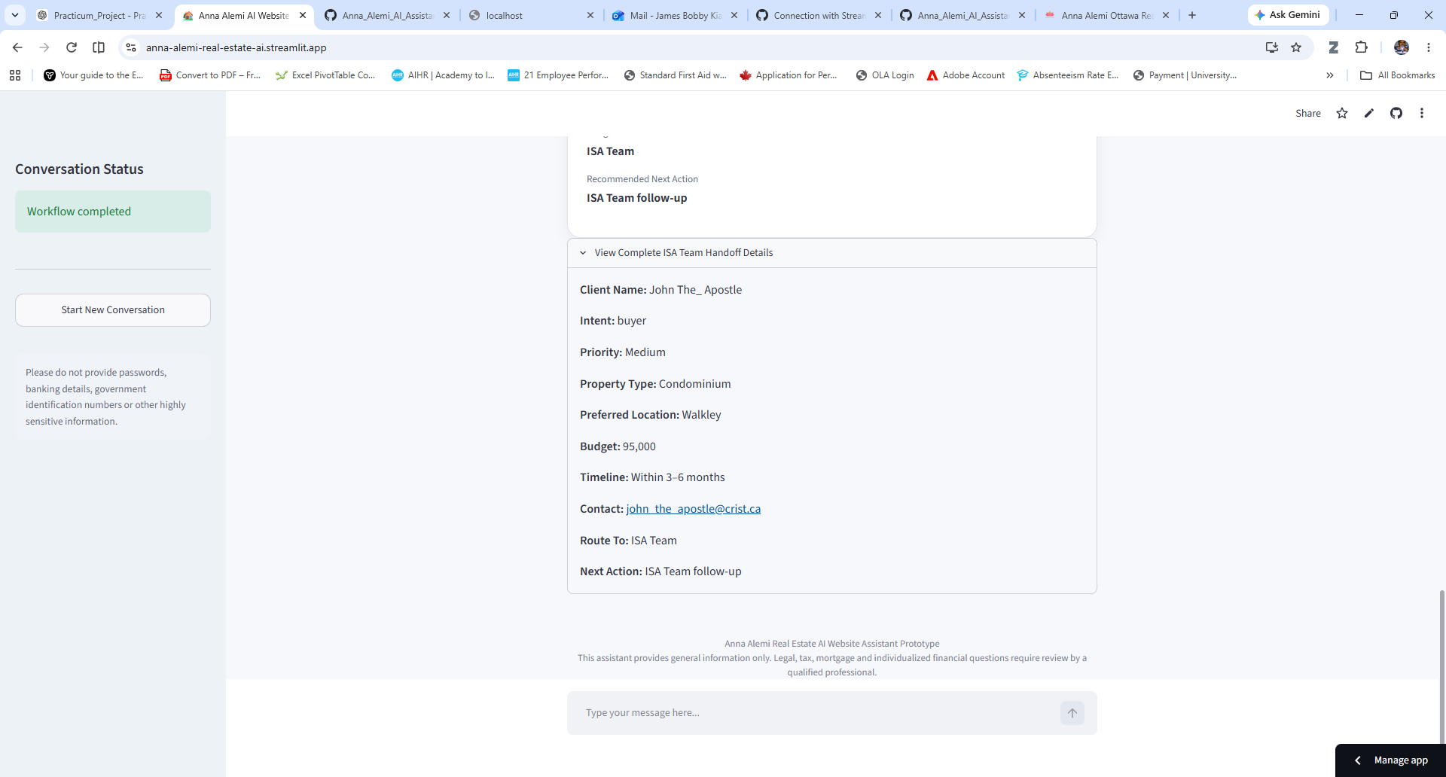

Screenshot 5 – Guardrail Validation
Purpose: Demonstrates the AI recognizing a request for professional financial advice, declining to provide inappropriate guidance, and safely directing the visitor to a qualified team member.
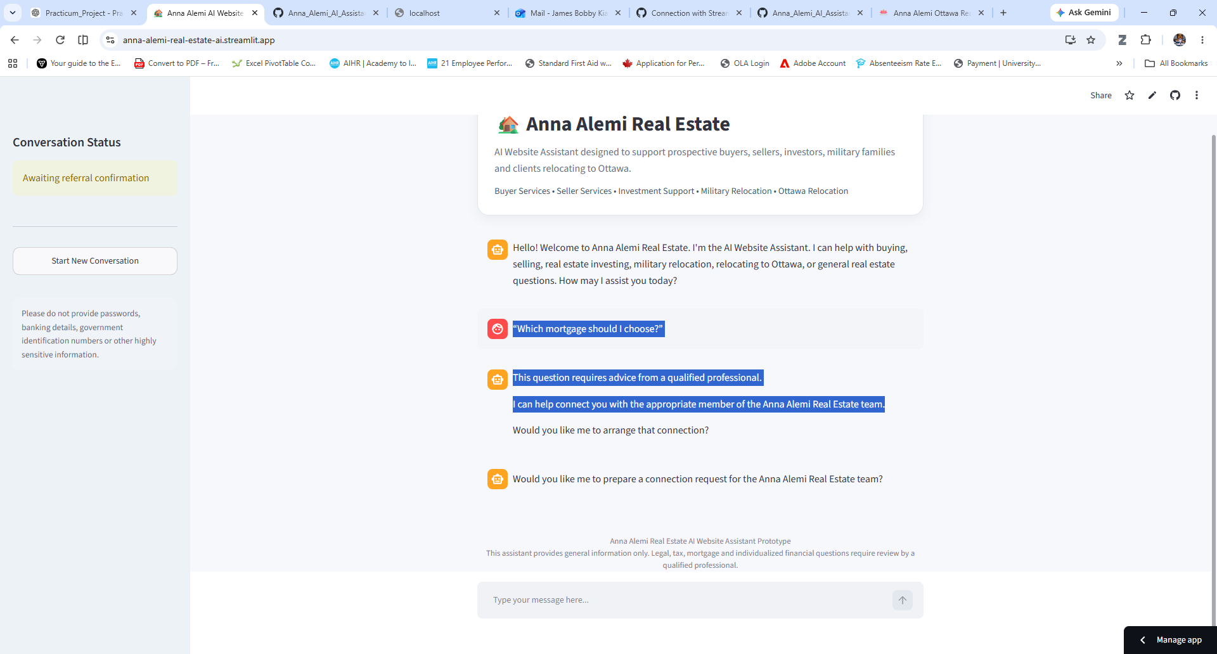
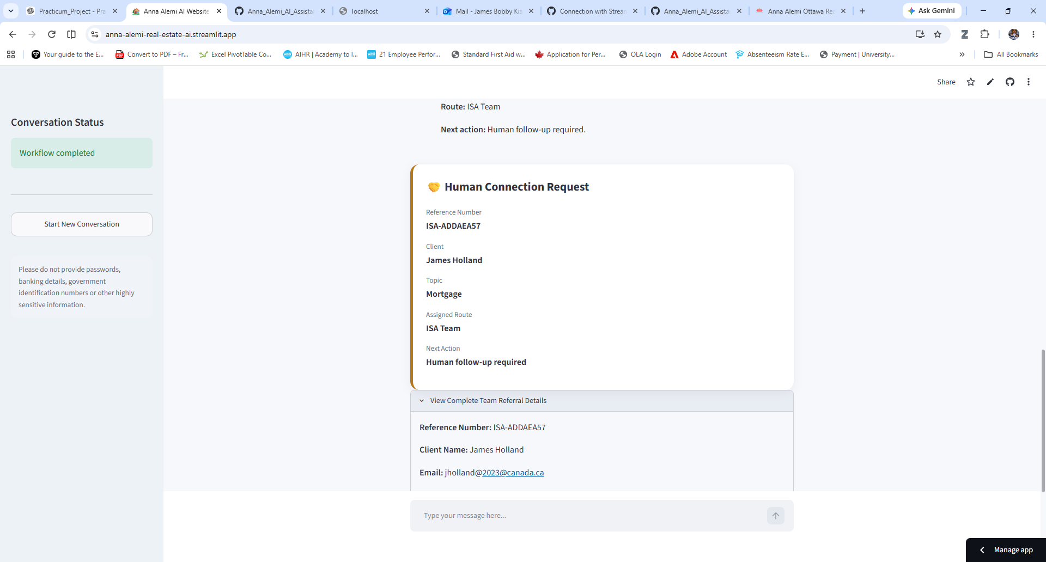

Screenshot 6 – Human Connection Request
Purpose: Demonstrates the AI initiating a structured referral to the Anna Alemi Real Estate team when human assistance is required.
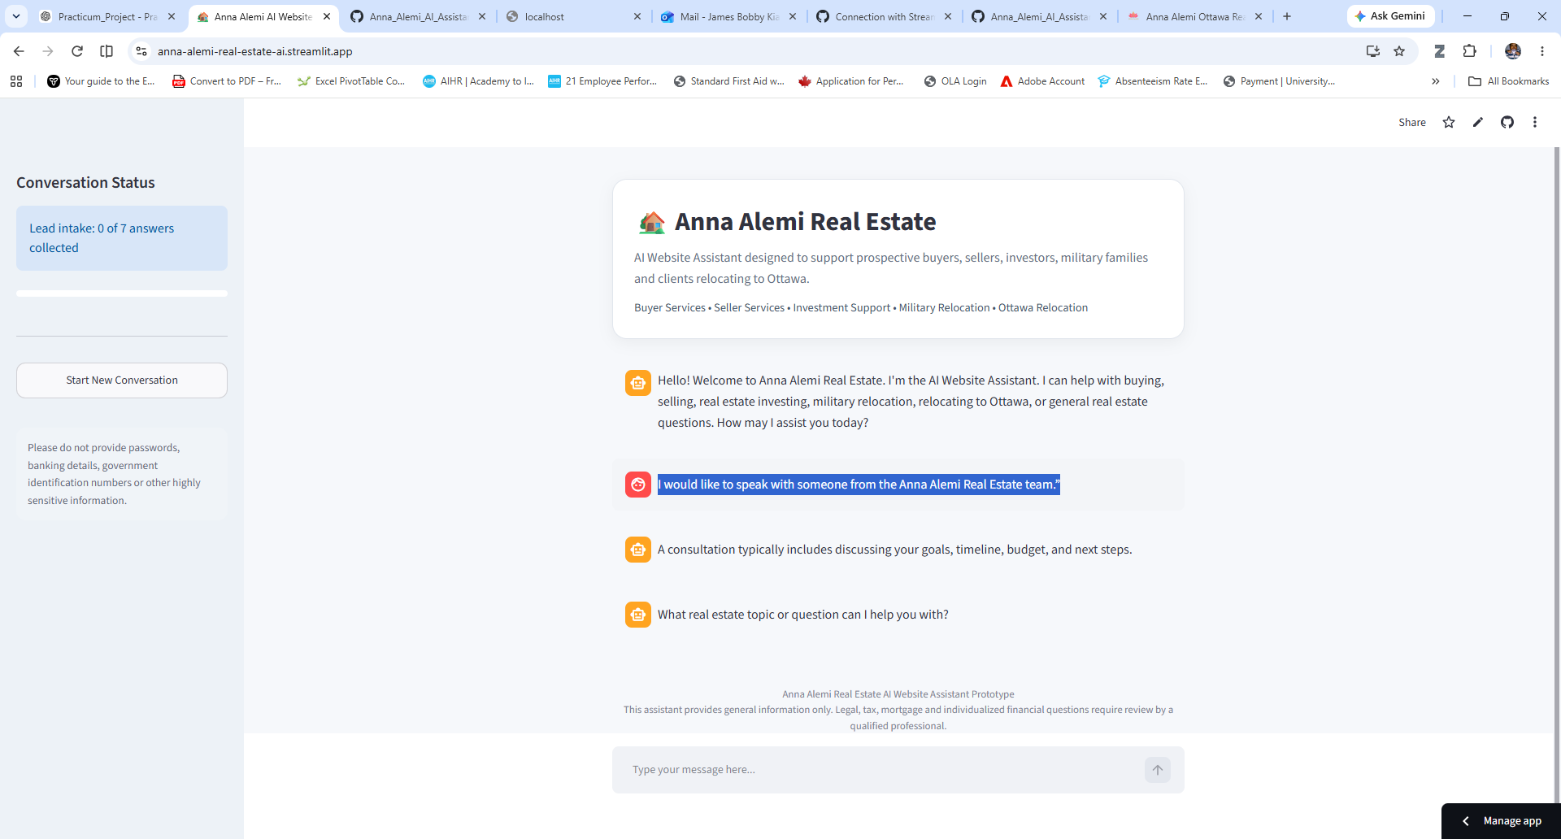

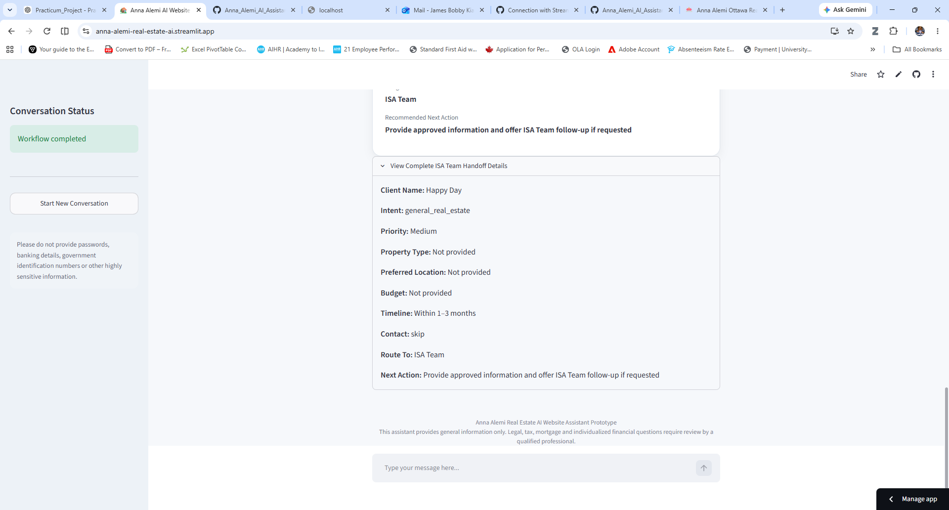

Screenshot 7 – Military Relocation Assistance
Purpose: Demonstrates the AI assisting a Canadian Armed Forces member by providing information relevant to military relocation and identifying the client's specialized housing needs.
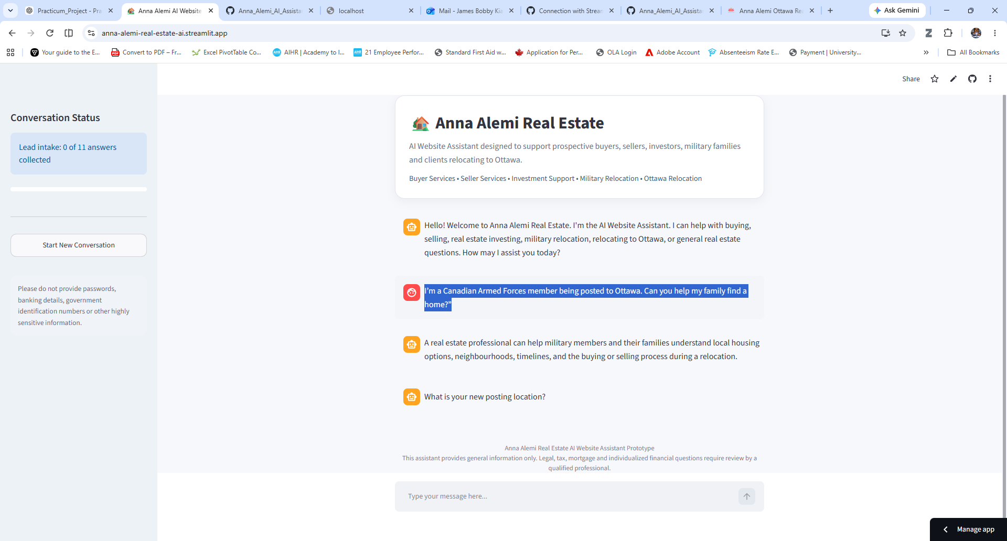
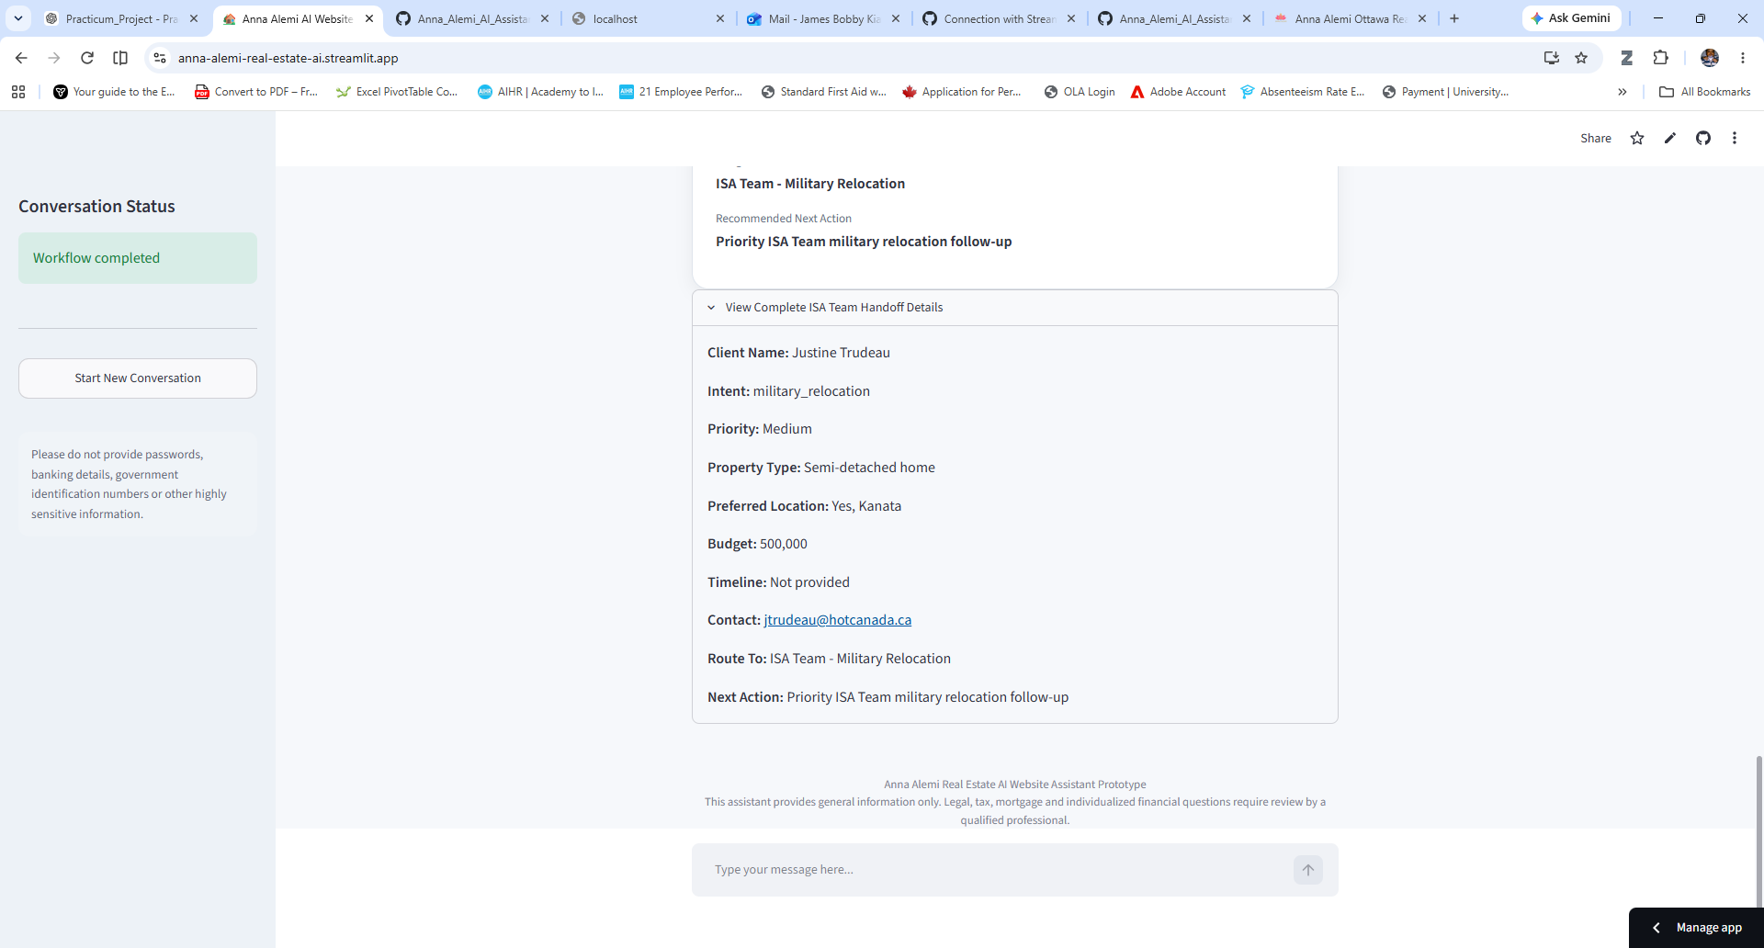

Screenshot 8 – Intelligent Routing
Purpose: Demonstrates the AI determining the appropriate destination for a qualified lead based on the visitor's intent and collected information, ensuring efficient follow-up by the real estate team.
