UI Interaction Walkthrough — GitHub Issues Gateway Service
CMPE 272 HW#2 — screenshots of the running service being exercised against a real test repo (jkibort928/272-hw2-testrepo) via curl, with the corresponding GitHub state shown alongside.

1. Health check
Confirming the service is up and responding before testing anything else.
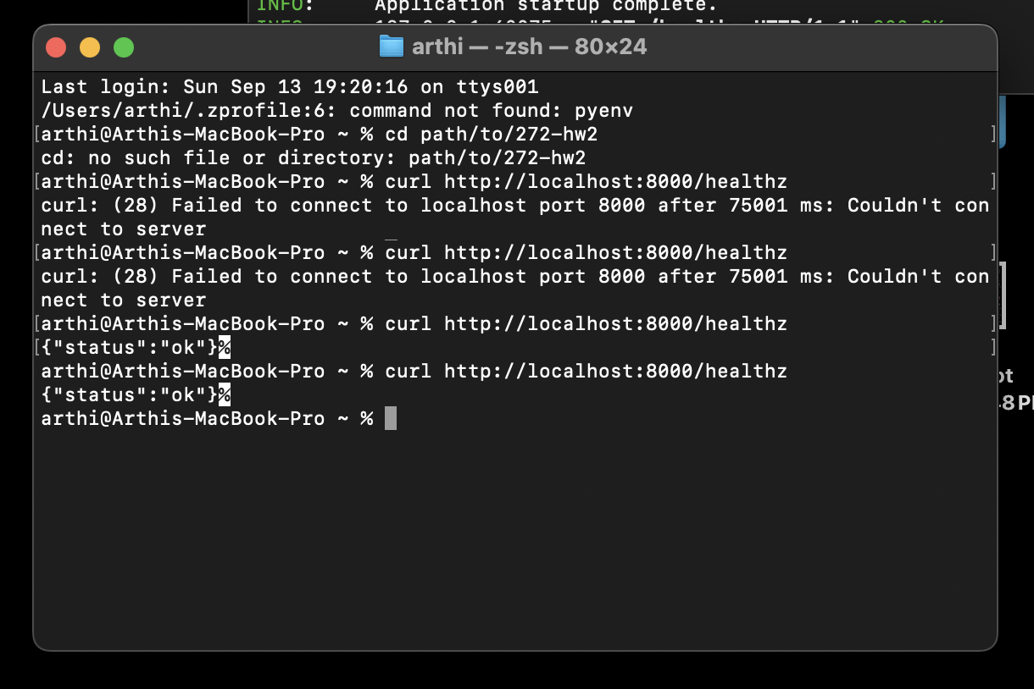
curl http://localhost:8000/healthz returns {"status":"ok"}

2. Creating an issue
POST /issues was called with a title and body. The service created a real issue (#1) on GitHub through the wrapped API.
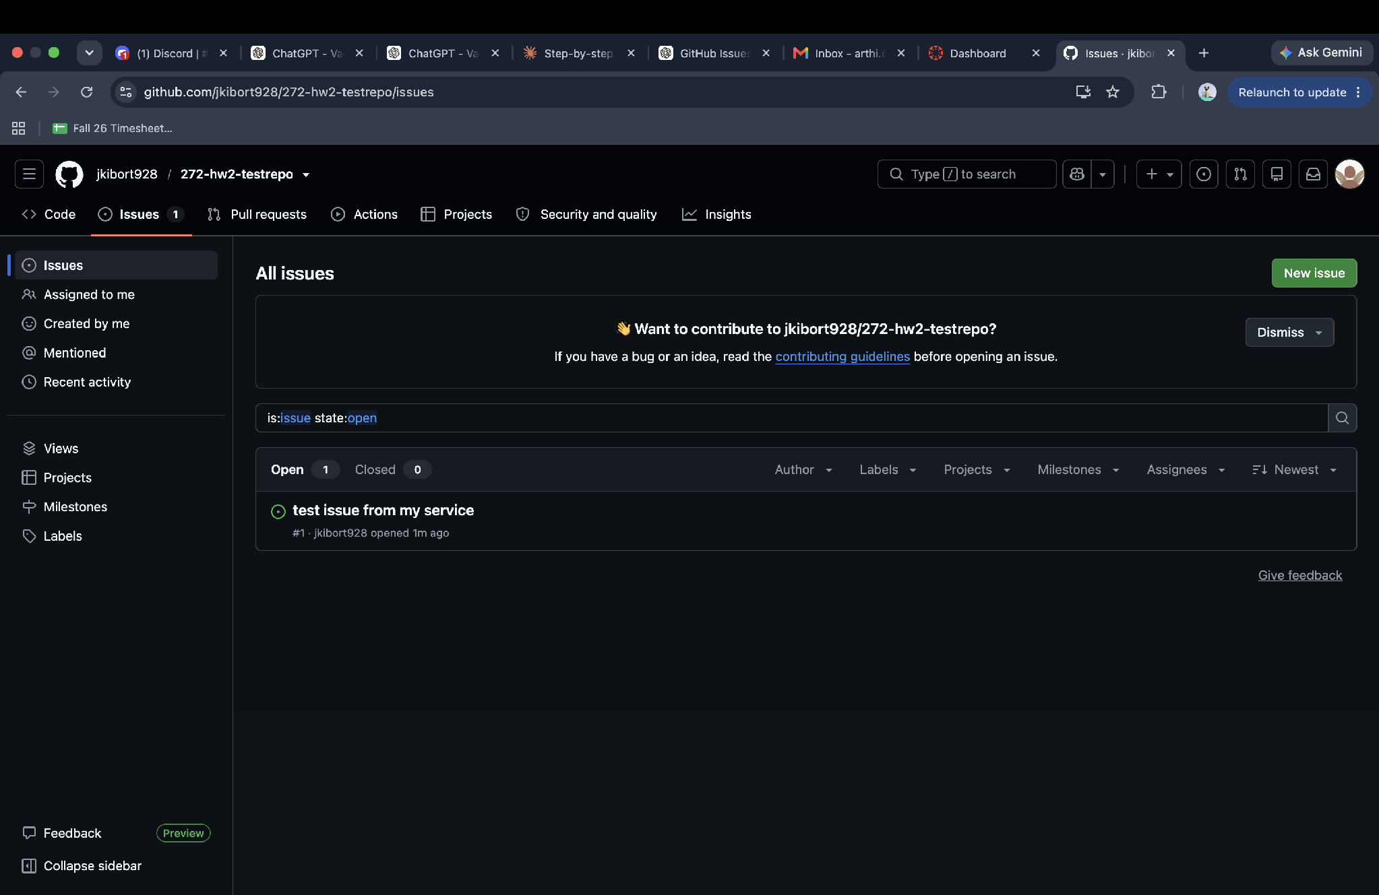
The created issue appears immediately in the test repo's Issues tab.

3. Full CRUD + comment flow (terminal output)
The sequence below shows, in order: closing issue #1, reopening it, adding a comment, fetching it back, creating a second issue (#2), fetching #1 again, closing/reopening it again, adding a second comment, and finally listing all issues.
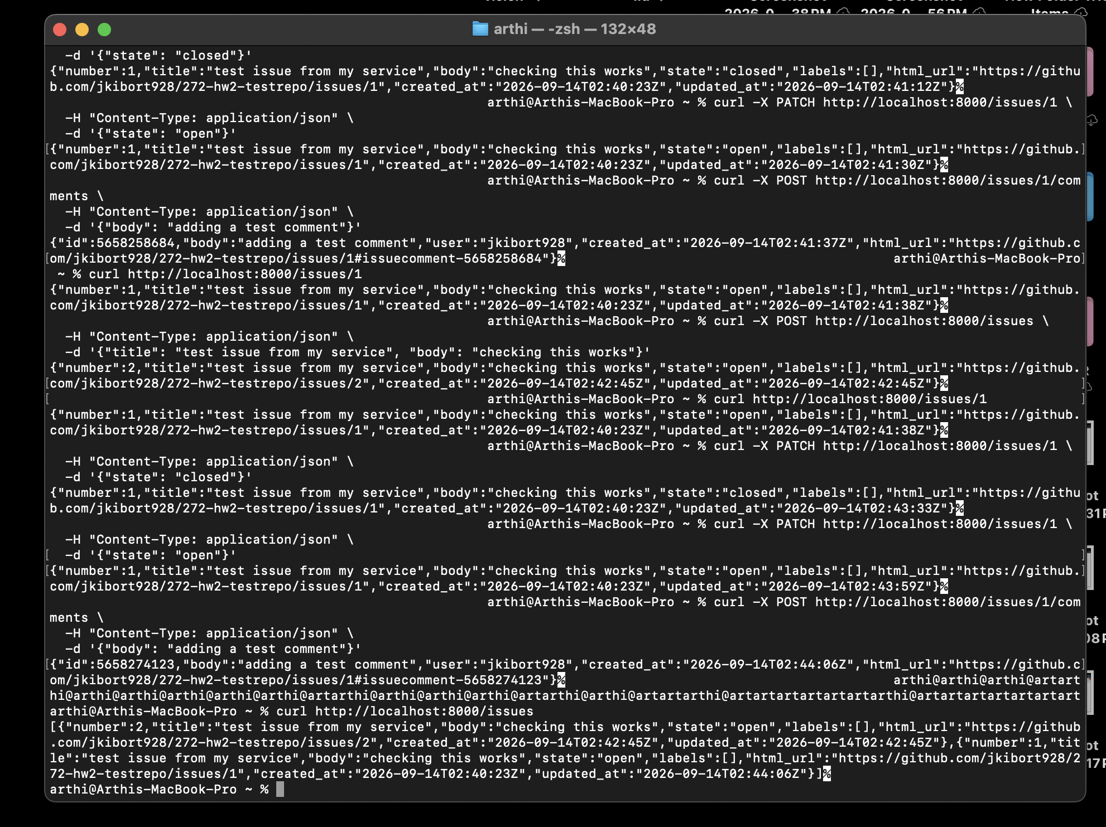
Each curl call and its JSON response — state changes and comments are reflected in the response body (see updated_at timestamps changing).

4. GitHub reflecting the changes
After creating the second issue via POST /issues, both issues show as open in the GitHub UI:
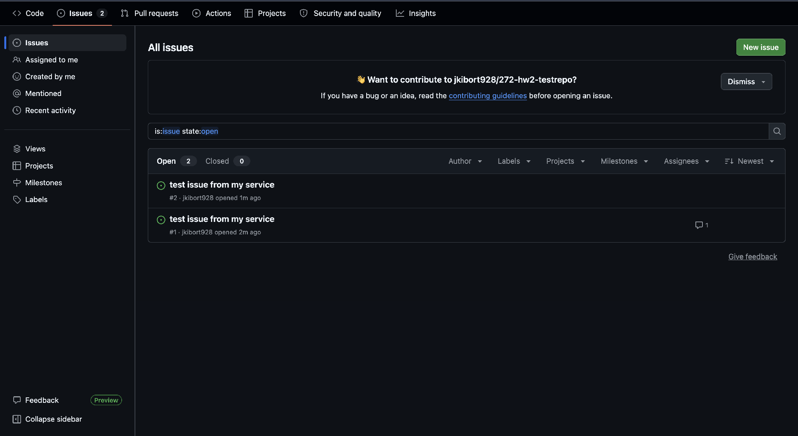
Two open issues, #2 and #1, both created through the service.
After closing issue #1 via PATCH /issues/1 with {"state": "closed"}:
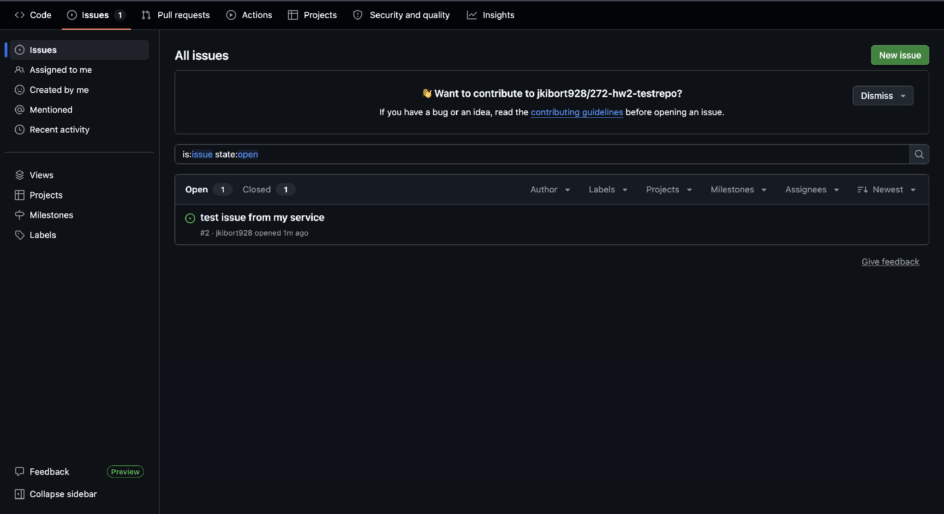
Issue #1 now shows under Closed (1), confirming the PATCH request actually updated GitHub's state.
After reopening #1 and adding a second comment via POST /issues/1/comments:
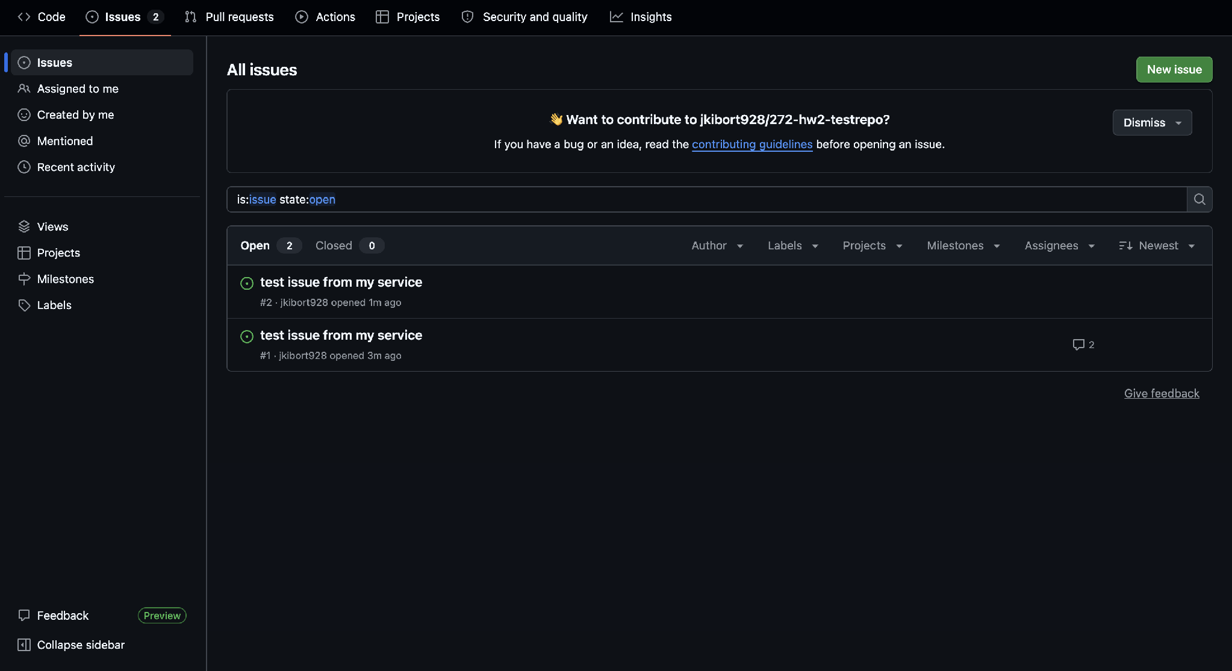
Issue #1 is open again and now shows 2 comments, matching the two comment-creation calls made against it.

5. Extra credit: conditional GET / ETag on GET /issues/{number}
GET /issues already supported conditional requests; this session extended the same ETag/If-None-Match handling to GET /issues/{number}. Number = 22 in our case. First call returns 200 with an ETag header from GitHub:
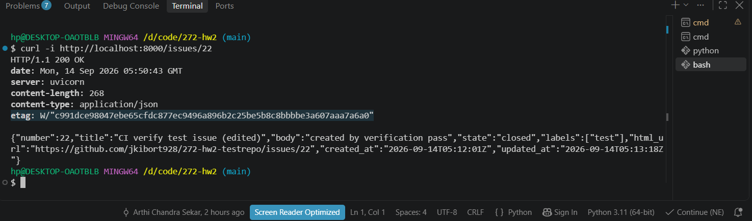
Sending that ETag back as If-None-Match on the next request returns 304 Not Modified with an empty body, instead of a full re-fetch from GitHub - this is what saves a rate-limit hit:
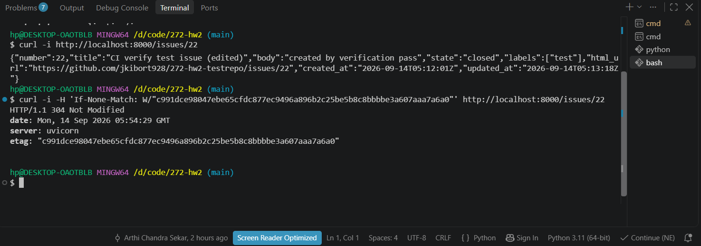

6. Extra credit: CI/CD pipeline
A GitHub Actions workflow (.github/workflows/ci.yml) runs on every push: lint, OpenAPI spec validation, unit tests with a coverage gate, and a Docker build + healthz smoke test. Both jobs passing on a real push to main:
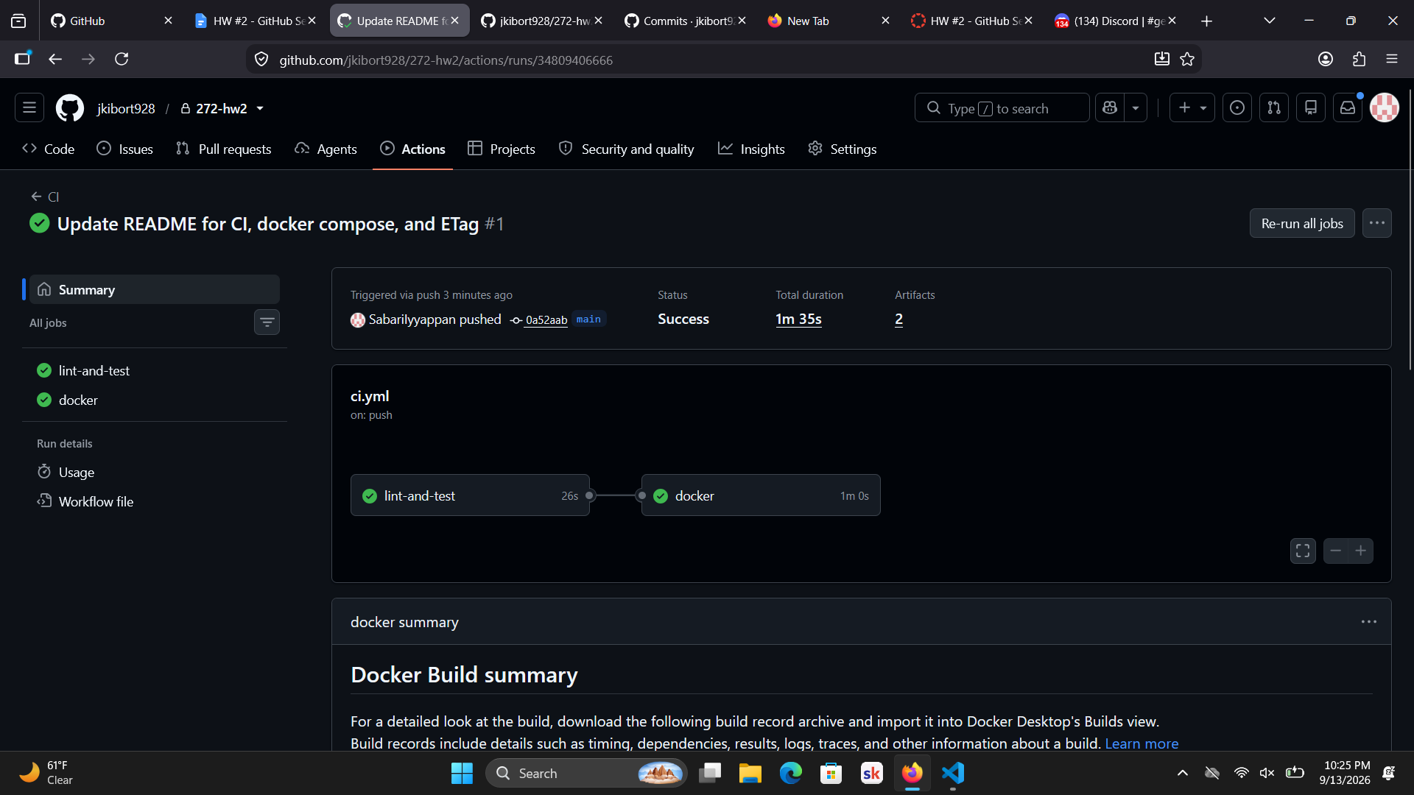

Summary
All of the required CRUD flows were verified against a real repository: create → 201 with the issue reflected on GitHub, get → 200 with matching data, update (close/reopen) → GitHub state changes accordingly, and comment creation → shows up under the issue on GitHub. The service was run locally with uvicorn, not inside Docker, for this walkthrough, but the same requests work identically against the Dockerized version since both read from the same env vars.

